Module 2 | REASONING, ARGUMENTATION  &  CRITICAL THINKING  Gultekin Cakmakci  Hacettepe University  STEM & Maker Lab  hstem.hacettepe.edu.tr/en

This outline is based on the work within the project Environmental Socio-Scientific Issues in Initial Teacher Education (ENSITE). Coordination: Prof. Dr. Katja Maaß, UNIVERSITY OF EDUCATION FREIBURG, Germany. Partners: UNIVERSITEIT UTRECHT, Netherlands; ETHNIKO KAI KAPODISTRIAKO PANEPISTIMIO ATHINON, Greece; UNIVERSITÄT KLAGENFURT, Austria; UNIVERZITA KARLOVA, Czech Republic; UNIVERSITA TA MALTA, Malta; HACETTEPE UNIVERSITY, Turkey; NORGES TEKNISK-NATURVITENSKAPELIGE UNIVERSITET NTNU, Norway; UNIVERSITY OF NICOSIA, Cyprus; INSTITUTE OF MATHEMATICS AND INFORMATICS AT THE BULGARIAN ACADEMY OF SCIENCE, Bulgaria; UNIVERZITA KONSTANTINA FILOZOFA V NITRE, Slovakia.

The project Environmental Socio-Scientific Issues in Initial Teacher Education (ENSITE) has received co -funding by the Erasmus+ programme of the European Union (grant no. 2019-1-DE01-KA203-005046). Neither the European Union/European Commission nor the project's national funding agency DAAD are responsible for the content or liable for any losses or damage resulting of the use of these resources.

© ENSITE project (grant no. 2019-1-DE01-KA203-005046) 2019-2022, lead contributions for ENSITE Module 2 by Hacettepe University STEM & Maker Lab, Turkey. CC BY-NC-SA 4.0 license granted.

General overview and aim
This module aims to enhance pre-service teachers’ competences in reasoning, argumentation and critical thinking through the use of media reports on environmental SSIs. This module provides resources and strategies to help pre-service teachers to grasp underlying ideas and to create effective learning environments for reasoning, argumentation and critical thinking. At the end of this module pre-service teachers will get an overview on how to use media reports in their classroom practices.
The module promotes pre-service teachers’ understanding about socio-scientific issues (SSI) through STEM-related media reports. Popular media is something that all students are aware of it and virtually surrounds their daily lives. Our goal is to use popular media reports as an instructional tool to help pre-service teachers, and, in return, their future students to become better informed and more discerning consumers of scientific information and to increase their motivation and willingness to learn STEM. We put a particular emphasis on reasoning, critical thinking and argumentation skills, which includes evaluating the credibility of evidence, establishing the validity of explanatory conclusions, models or predictions, and evaluating sources of both conclusive and inconclusive science. Advanced reasoning and argumentation skills are necessary to grasp the underlying ideas behind media reports of STEM related to environmental SSI. Accordingly, this module is part of:
- LEARNING: Developing competences in reasoning, argumentation and critical thinking through the use of media reports on environmental SSIs
- TEACHING: Acquiring teaching skills to supporting their students in developing these competences
The expected impact is that HEI teaching staff and pre-service science and maths teachers will gain awareness on how to use STEM media reports to extract relevant data and become better informed but also understand how to form an opinion on through media-provided data. In the long-run, we expect that a general awareness on the complexity of information provided through media will evolve and an awareness on how individuals can critically question provided information.
The module is designed in a way as to make it transferable to other educational contexts such as in-service teacher training or classroom teaching.

Relevant topics
This module focuses on following topics media literacy, reasoning, argumentation and critical thinking and using media reports as a starting point to discuss environmental SSIs. Competences in reasoning, argumentation and creative/critical thinking are seen essential components of public engagement with science and technology and they are also given priories in the OECD Programme for International Student Assessment (PISA) 2021 Mathematics Framework (OECD, 2019a), PISA 2021 Creative Thinking Framework (OECD, 2019b), and OECD Social and Emotional Skills Framework (OECD, 2018). Competences in reasoning, argumentation and critical thinking can be improved with an appropriate instruction and practice (OECD, 2018). Accordingly, pre-service teachers will get a first insight in how to include them in their lessons. They will work on examples that can be dealt with at student level and plan a lesson with these examples.

Learning Outcomes

Pre-service teachers will acquire
- The experience in analyzing a text from everyday life by identifying the claim, counter claim and the evidence that supports them (Activities 1.1).
- Awareness that scientific knowledge is characterized by proper scientific explanations or arguments involving the coordination of the data and the claim (product of observation vs. product of interpretation of those observations) to support or refute an explanatory conclusion, model or prediction (Activities 1.1, 1.2 and 2.1).
- Awareness that they should be able to explain, in an informed manner, the grounds on which they agree or disagree with the viewpoints presented in a news article (Activities 2.1 & 3.1).
- Awareness that scientific literacy and citizenship education in a democratic society are crucial (Activity 2.1).
- Awareness that citizens make their decisions based on their knowledge, beliefs, social values, worldviews, as well as based on the understanding about science and its nature (Activities 2.1 & 3.2).
- The knowledge and skills to evaluate new information by comparing it to what they already know and to information from other sources (Activity 3.3).
- Awareness that they should recognize the power but also the limitation of science in respect of challenging SSIs (Activity 3.1).
- Knowledge and skills on how to use media reports of environmental SSIs in their classroom practices (Activities 3.1, 3.2 & 3.3).

Flowchart and Module plan

This module involves three sections, all structured into several activities. It includes 190 minutes of sessions, 90 minutes of homework and 45 mins presentations of homework and discussion session. It includes lecture parts, group discussions, debates and student presentations. The structure is as follows:
- What are reasoning, argumentation & critical thinking?: 55 min
- Analyzing media reports of environmental SSIs: 55 min
- How may media reports of environmental SSIs be used as a tool for teaching reasoning, argumentation and critical thinking?: 80 min + 90 min homework + 45 mins presentations of homework and discussion session.

1. What are reasoning, argumentation & critical thinking? (55 mins)

1.1. Is Mr Briggs guilty of speeding?
 | 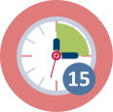Duration: 25 minutes
This is a “warm up” activity. The intention is to allow pre-service teachers to analyze a text and find out claim, counter claim and evidence that support them.
Teacher Educators introduce the module using the ppt presentation [1] and then present the activity 1.1 to pre-service teachers.
This session contributes to the achievement of the following learning outcomes:
- Students will experience in analyzing a text from everyday life by identifying the claim, counter claim and the evidence that supports them (Activities 1.1).

1.2. What are the features of a scientific argument?
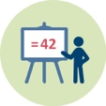 | 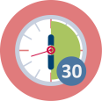 Duration: 30 minutes
The intention of this activity is to discuss the differences between explanation and argument. As a result, future teacher will get insights into the features of scientific argument. In IO2, Toulmin’s model of argumentation, among others, will be used to analyse media reports of scientific research related to environmental SSI. Others have also used this model for methodological purposes (e.g., see Erduran et al., 2004). Based on this model, the nature of an argument can be framed in terms of claims, data, warrants, backings, rebuttals, and qualifiers (Toulmin, 1958). It should be noted that, in order to interpret statements about environmental SSI or risk assessment, an understanding the concepts of correlation, cause and effect is also required. Correlation is a statement of numerical facts; it does not necessarily imply causation and effects.
Teacher Educators present the activity 1.2 to pre-service teachers and then introduce the module using the ppt presentation [1].
This session contributes to the achievement of the following learning outcomes:
- That scientific knowledge is characterized by proper scientific explanations or arguments involving the coordination of the data and the claim (product of observation vs. product of interpretation of those observations) to support or refute an explanatory conclusion, model or prediction.

2. Analyzing media reports of environmental SSIs (55 mins)

2.1. Voters decide not to water down wolf protection
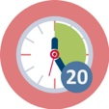 Duration: 55 minutes
Media reports of environmental SSIs can be used to develop skills associated with aspects of scientific literacy that students need to play a full part of a modern democratic society where reasoning, argumentation and critical thinking play a key role in shaping their lives-as active and informed citizens (Cakmakci & Yalaki, 2012). The teaching sequence (Think-Pair-Share) is provided as a suggestion for teacher educator. Five alternative worksheets are provided to the teacher educator. Depending on the time and priorities, the teacher educator can decide which one(s) to use. Aims of this activity are to engage pre-service teachers on the participation of public in policy debates about environmental SSIs and to highlight how this participation is essential to maintain a healthy democracy.

Teacher Educators present the activity 2.1 to pre-service teachers and then introduce the module using the ppt presentation [1] and worksheets.

This session contributes to the achievement of the following learning outcomes:
- Awareness that scientific knowledge is characterized by proper scientific explanations or arguments involving the coordination of the data and the claim (product of observation vs. product of interpretation of those observations) to support or refute an explanatory conclusion, model or prediction.
- Awareness that they should be able to explain, in an informed manner, the grounds on which they agree or disagree with the viewpoints presented in the news article.
- Awareness that roles scientific literacy and citizenship education in a democratic society are crucial.
- Awareness that citizens make their decisions based on their knowledge, beliefs, social values, worldviews, as well as based on the understanding about science and its nature.

3. How may media reports of environmental SSIs be used as a tool for teaching reasoning, argumentation and critical thinking?

3.1. Insecticide harmful to bees temporarily allowed in France
Duration: 55 minutes
This session provides an example on how to use media reports of environmental SSIs in classroom practices for discussing reasoning, argumentation, and critical thinking. The activity may be used to open up teacher students’ own ideas about pesticides, biodiversity, and ecosystem and also to introduce and support the development of these ideas.

The teacher presents the activity 3.1 to pre-service teachers and then introduce the module using the ppt presentation [1] and worksheets.

This session contributes to the achievement of the following learning outcomes:
- Awareness that they should be able to explain, in an informed manner, the grounds on which they agree or disagree with the viewpoints presented in a news article.
- Awareness that roles scientific literacy and citizenship education in a democratic society are crucial.
- Awareness that citizens make their decisions based on their knowledge, beliefs, social values, worldviews, as well as based on the understanding about science and its nature.
- Awareness that they should recognize the power but also the limitation of science in respect of challenging SSIs
- Knowledge and skills on how to use recent media reports of environmental SSIs in their classroom practices.

3.2. What do students learn when dealing with media reports of environmental SSIs ?
Duration: 25 minutes
Pre-service teachers reflect on what students learn when dealing with such a task and why media reports of environmental SSIs need to be included in science and mathematics lessons. After the discussion the teacher educator presents rationales for using science-related media reports as a medium in science and mathematics teaching in the light of current research.
This session contributes to the achievement of the following learning outcomes:
- Awareness that roles scientific literacy and citizenship education in a democratic society are crucial.
- Knowledge and skills on how to use media reports of environmental SSIs in their classroom practices.

3.3. How to design a lesson on the use of media reports of environmental SSIs?
Duration: 90 mins + + 45 mins presentations of homework and discussion session.
Teacher students are expected to plan a lesson which deals with the use of media reports of environmental SSIs they worked on before. Later they are supposed to present the task to the overall group. The intention is to promote students competences on reasoning, argumentation and critical thinking. They may use different media sources on a similar topic and compare how the news is presented in different sources.

This session contributes to the achievement of the following learning outcomes:
- Knowledge and skills on how to use media reports of environmental SSIs in their classroom practices.

 | Materials and resources
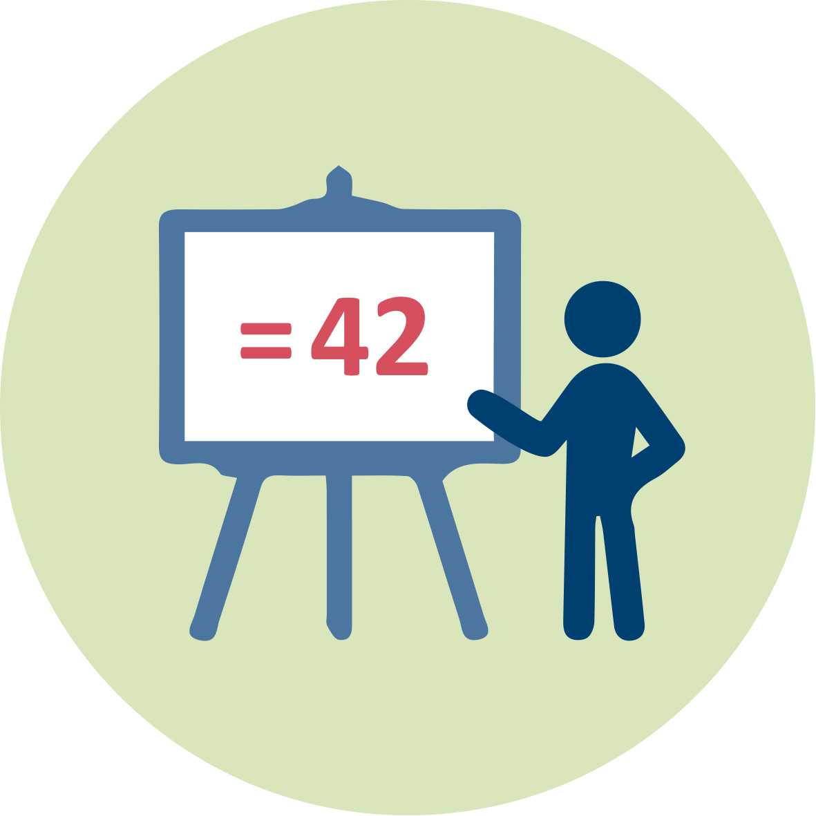 | Presentation 1 (pptx). Teacher Educator “Reasoning, Argumentation, and Critical Thinking”
 |  | Readings and students’ handouts
 | Access to computers for internet research and collaborative work

Granularity
- Five alternative worksheets are provided for Activity 2.1. Depending on time constrain and priorities, the teacher educator can decide which one(s) to use.

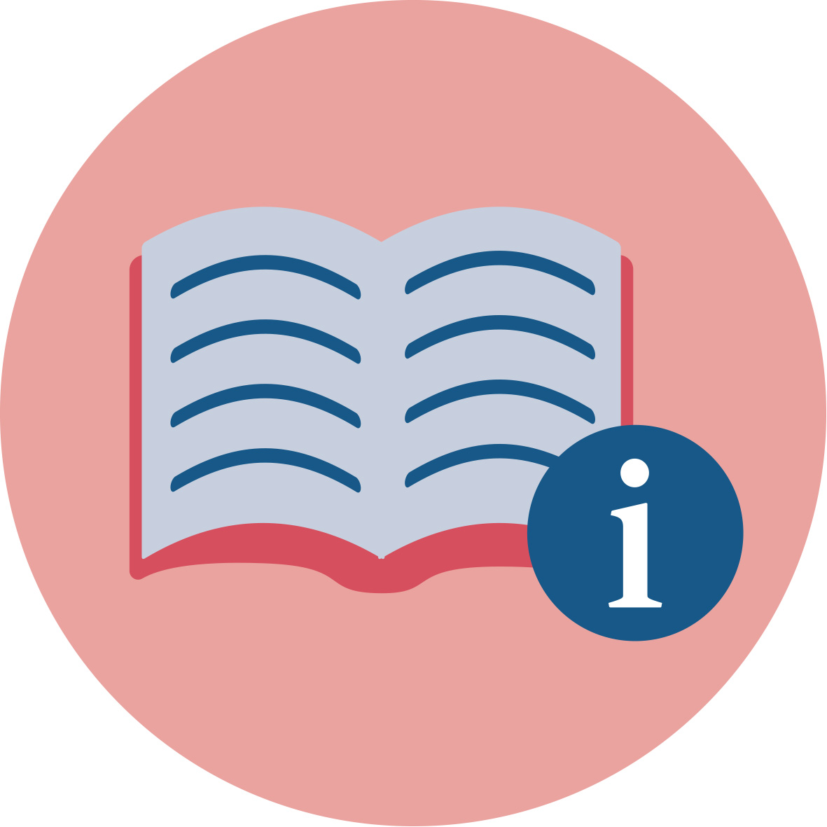 | References
OECD. (2019a). PISA 2021 Mathematics Framework. Retrieved from https://pisa2021-maths.oecd.org/
OECD. (2019b). Creative Thinking Framework. Retrieved from https://www.oecd.org/pisa/publications/PISA-2021-creative-thinking-framework.pdf
OECD (2018). Social and Emotional Skills: Well Being, Connectedness, and Success. Paris: OECD Skills Studies.

Further readings
Cakmakci, G. & Yalaki, Y. (2018) Promoting pre-service teachers’ ideas about nature of science through science-related media reports. In O. Tsivitanidou, P. Gray, E. Rybska, L. Louca & C. Constantinou (Eds.), Professional Development for Inquiry-Based Science Teaching and Learning (pp. 137-161). Dordrecht: Springer. ISBN 978-3-319-91406-0
Jarman, R. & McClune, B. (2007). Developing scientific literacy: Using news media in the classroom. Maidenhead: Open University Press.
Ratcliffe, M., & Grace, M. (2003). Science education for citizenship: Teaching socio-scientific issues. Maidenhead: Open University Press.

Assessment
Pre-service teachers’ homework and short presentation of their homework to peers would be used in a formative assessment manner.

