Module 9 | DEVELOPING AN SSI LESSON I  – FOCUS ON DIDACTIC ASPECTS

This outline is based on the work within the project Environmental Socio-Scientific Issues in Initial Teacher Education (ENSITE). Coordination: Prof. Dr. Katja Maaß, UNIVERSITY OF EDUCATION FREIBURG, Germany. Partners: UNIVERSITEIT UTRECHT, Netherlands; ETHNIKO KAI KAPODISTRIAKO PANEPISTIMIO ATHINON, Greece; UNIVERSITÄT KLAGENFURT, Austria; UNIVERZITA KARLOVA, Czech Republic; UNIVERSITA TA MALTA, Malta; HACETTEPE UNIVERSITY, Turkey; NORGES TEKNISK-NATURVITENSKAPELIGE UNIVERSITET NTNU, Norway; UNIVERSITY OF NICOSIA, Cyprus; INSTITUTE OF MATHEMATICS AND INFORMATICS AT THE BULGARIAN ACADEMY OF SCIENCE, Bulgaria; UNIVERZITA KONSTANTINA FILOZOFA V NITRE, Slovakia.

The project Environmental Socio-Scientific Issues in Initial Teacher Education (ENSITE) has received co -funding by the Erasmus+ programme of the European Union (grant no. 2019-1-DE01-KA203-005046). Neither the European Union/European Commission nor the project's national funding agency DAAD are responsible for the content or liable for any losses or damage resulting of the use of these resources.

© ENSITE project (grant no. 2019-1-DE01-KA203-005046) 2019-2022, lead contributions by Ragnhild Lyngved Staberg, Annette Lykknes, Jardar Cyvin, Hilde Ervik and Ellen Marie Andersson, Norwegian University of Science and Technology, Norway. CC BY-NC-SA 4.0 license granted.

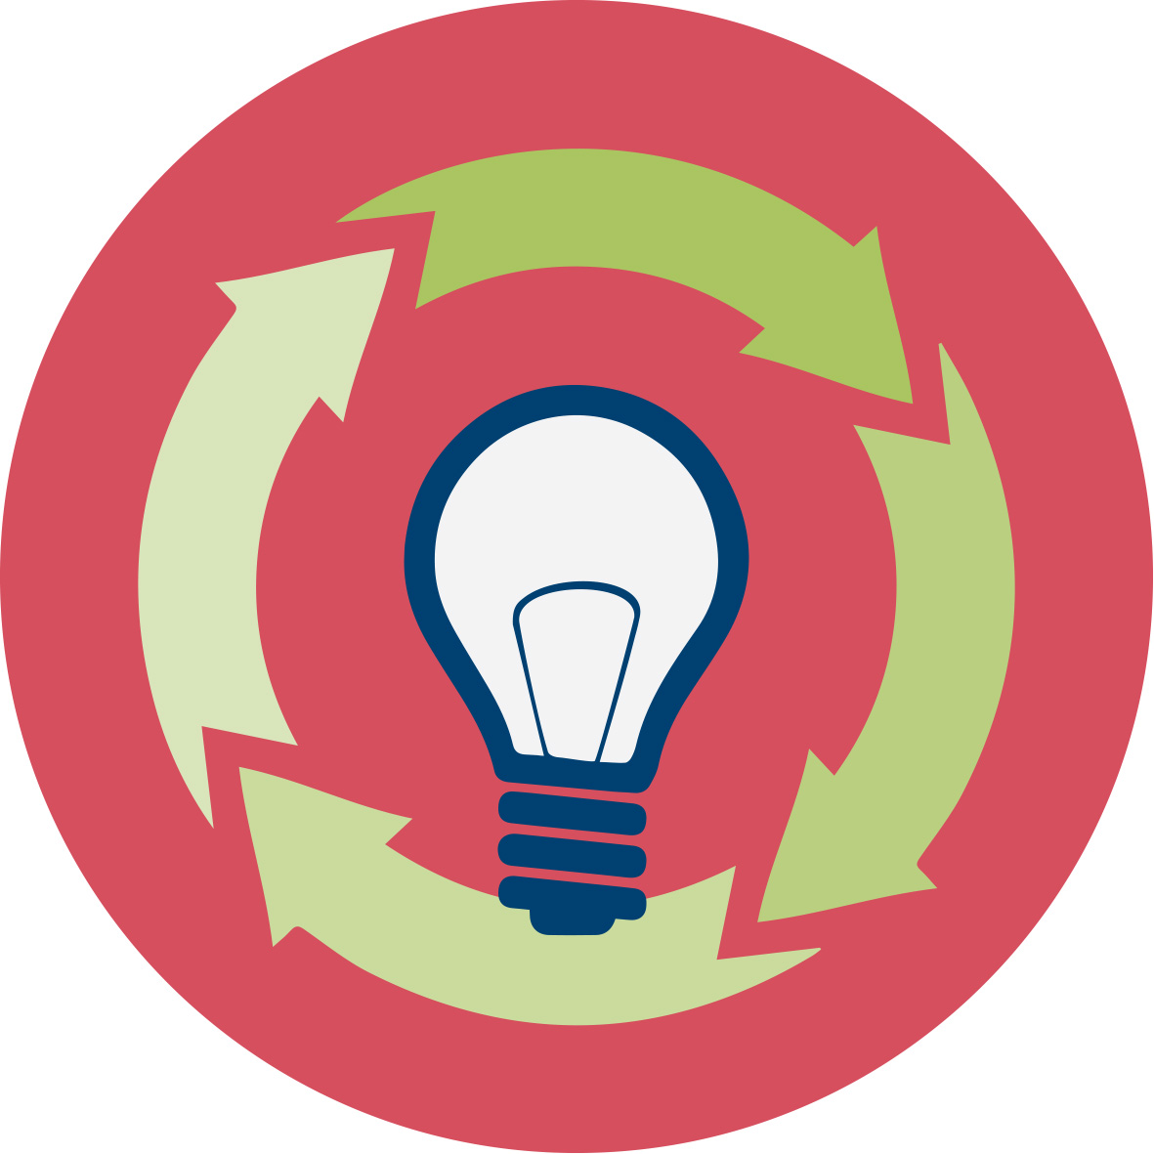 | General overview and aim
This module is produced for higher education, to be used in lectures/seminars for mathematics and science students in initial teacher education (ITE).
In this module future teachers are introduced to ideas on how to design a lesson, based on the plastic dilemma. On one side it is based on research related to socio-scientific issues (SSI) and on the other side on education for sustainable development (ESD). The module also draws on the educational approach of inquiry-based learning. As an example, we use the huge challenge of “plastic waste”, implications for humankind and nature, and proposals on how to deal with this in an educational context.
What to do with urban waste and how to use urban waste are still among today’s most important environmental problems. The aim of this module 9 is to present an up-to-date status of the research on SSI issues related to plastic waste and contribute to raise public awareness among the young generations. In this work schools and teachers have an important role to increase students’ knowledge and awareness about plastic as a waste problem, as well as the scale of the problem. While amount and types of plastics/micro plastics waste are quite well documented, there is still a lack of knowledge on physiological impacts. In the field of SSI and education related to plastic waste, the research is fragmented, and results related to public awareness and public induced actions are incoherent.
A recent study shows that children from fourth grade to high school (9–18 years old) have a limited systematic understanding of marine plastic waste (Uehara, 2020). Thus, there is a need to raise their awareness. Several studies have analysed effects of waste prevention programs on students’ knowledge, attitudes and behavioural changes, from primary school to university level. For example, a project-based program has shown a positive effect on 4th grade students' conceptual understanding of the recycling concept (Coruhlu & Nas, 2018) and recycling education has shown a positive effect on 10th grade students’ conceptual understanding about ecology (Ugulu, Yorek & Baslar, 2015). Intervention studies at university level show a change in waste separation behaviour among students and employees, and intentions, social norms, personal norms, perceived behavioural control and habits also changed after the intervention period (Tobolova, 2015).
A study from 2017 examined the effectiveness of three teaching strategies (direct teaching, hands-on teaching, and simulation game-based teaching) on change in knowledge, attitude, and behavior in students toward plastic waste management among 61 primary school students age 8-12 participating in a 9 h (one and a half day) course (Chow et al., 2017, p.125). Direct teaching is here used on teacher directed teaching mainly supported by PowerPoint slides, hands-on-teaching is used on inquiry-based teaching with the students as the active part, and in the simulation game-based teaching the students were involved in face-to-face role play about the “plastic city”. Chow et al. found that all three teaching strategies could significantly improve pupils’ knowledge, while the hands-on and simulation game-based strategies could facilitate attitudes and behavior, though insignificantly. One recommendation from these authors is to expand the project period for such projects to increase the possibilities for more significant results. The findings of Chow et al. (2017) is in accordance with a literature review by Stern, Powell & Hill (2013) studying peer-revied papers from 1999 to 2010 about the outcomes of environmental education.
A study of four primary schools, with close to one thousand students, tried to understand students’ knowledge, attitudes and behavioural changes in relation to the water plastic bottle of 500 ml. The results indicated that the students’ behaviours differ from class to class for many reasons; most of them are related with what their parents believe, and how themselves or the synergies between them reacts and affected (Zorpas, Voukkali & Loizia, 2017). To conclude, we can state that behaviours are complex and non-linear, and determined by various factors. To move the agenda forward on waste prevention, campaigns or awareness events might be helpful. But, first of all particular emphasis on behavioural change must be done starting from young ages (ibid). Children can be effective advocates in changing their parents’ lifestyles (Maddox, Doran, Williams & Kus, 2011) and household recycling behaviour can be positively impacted by intergenerational influence via practical school-based waste education programmes (ibid). Therefore, waste management should be emphasized by the educational system. Thus, this module is a starting point, aiming to introduce environmental SSIs on waste management in schools.

This module is part of:
- LEARNING: Developing competences in dealing with environmental SSI themselves
- TEACHING: Acquiring teaching skills to supporting their students in developing these competences
Both aspects relate to (i) scientific competences, (ii) transversal skills like critical thinking, innovative mind-sets and forward-looking skills and (iii) taking into account the social, ethical and cultural aspects related to SSI when making decisions.
IO9 will exemplify how to deal with a complex, cross-subject theme and through this include more classic science content, as well as environmental SSI related themes.
Crosslinks to other modules:
IO1 introduces the nature of SSI, aims and learning outcomes, by giving specific examples. Activities 1 (What are environmental SSI?), 2 (How do environmental SSI connect to mathematics and science education?) and 3.1 (What do students learn when dealing with SSI?) from IO1 will serve as a good starting point before going on to IO9.
Regarding IO2 (Reasoning, argumentation & critical thinking), the general principles of argumentation (Activity 1) may support students in their preparation for the wicked dilemma debate in activity 1.7 of IO9.
Regarding IO3 (Collecting data) and IO4 (Analysing big data), the general principles of collecting, preparing and analysing data links well to the parts of IO9 where you have assignments that include inquiry, for example Activity 1.6 “How much water, oil, carbon dioxide and money can you save if you don’t use plastic water bottles?”.
IO9 links well to IO7 on SSI and the curricula, especially the dilemmas about plastic vs. paper bags (IO7 Activity 1.1. and 3.1). IO8 connects to IO9 in that it raises awareness about cultural differences in dealing with, and perceiving environmental dilemmas, e.g related to waste treatment, energy resources and new materials (IO8 Activity 1.5).
IO12 (Assessment) links well to IO9, because it helps pre-service teachers to plan the assessment of their SSI lessons, e.g. Activity 3 introduces formative assessment ideas.

Relevant topics
Module 9 is innovative in that it introduces future teachers to SSI and their relevance with regards to “teaching for sustainable development” which is still greatly missing. Even if this topic has received attention in the last decade by UN, declaring this decade as the “Decade of Education for Sustainable Development”, educational reforms on sustainable development are lacking both within the STEM subjects as well as in cross-disciplinary approaches.
The expected impact is to raise future science and mathematics teachers’ awareness on challenges of education for sustainability and gain extensive knowledge on environmental issues relating to plastics/micro-plastics. They widen their teaching scope and learn how to deal with plastic as a cross-subject theme in science and mathematics lessons, including attitudes and action competence as important parts of children’s journey to be responsible citizens.
In the longer run, we expect an awareness among future science and mathematics teachers – and thus their students at school – of sustainable development and how science and mathematics can contribute to it.

Learning Outcomes

Learning dimension:
Students will acquire
- Understanding of what plastic and micro-plastic are and their effects on nature and humankind (Activities 1.1, 2.1, 2.3, 2.4, 2.5, 3.7, 4.1, 4.3, 4.4, 4.5
- Insights into sustainable development aspects (environmental, social and economic) in relation to the plastic dilemma (Activities 1.3, 1.6, 2.1, 2.3, 2.4, 2.5, 3.2, 3.6, 4.1, 4.3, 5.1, 5.2, 5.3, 5.4)
- Knowledge on the life cycle of plastic bottles, from production to waste, mainly in their own country, but also with an international perspective (Activities 3.1, 3.2, 3.3, 3.4, 3.5, 4.1, 4.3, 5.1,
- Knowledge on different dimensions of the plastic dilemma (historic, economic, social, environmental – local and international) and take part in discussions on this dilemma (Activities 1.1, 1.2, 1.3, 1.5, 1.6, 1.7, 2.1, 2.2, 2.3, 2.4, 2.5, 3.2, 3.6, 4.2, 4.4, 5.2)
- Basic knowledge and skills that enable them to take critical action (action competence) (Activities 1.3, 1.6, 1.7, 2.1, 2.4, 2.5, 3.2, 3.6, 4.1, 4.6, 4.7, 5.2, 5.3, 5.4)
Teaching dimension:
Students will acquire
- Awareness about plastic pollution as a “wicked problem” in their national and/or local curriculum (Activity 1.4, 2.4, 2.5)
- Experience in how to apply plastic dilemmas to teach about the role of science in society (Activities 1.2, 1.6, 1.7, 2.3, 2.4 3.2, 3.4, 3.6, 3.7, 4.2, 4.4, 4.5, 5.2, 5.3, 5.4, 6.1)
- Experience in using inquiry-based learning approaches to teach plastic dilemmas in an SSI-perspective (Activities 2.3, 3.7, 4.2, 4.4)
- Knowledge on how to set up socio-scientific issues (“wicked problems”) on plastics in their context (Activities 4.1. 6.1)
- Basic knowledge and skills on how to deal with environmental socio-scientific issues (e.g. identify and argue for different perspectives) in their future teaching (Activities 1.6, 1.7, 2.4, 2.5, 3.2, 3.4, 3.6, 4.1, 4.2, 4.4, 4.6, 4.7, 5.2, 5.3, 5.4, 6.1)

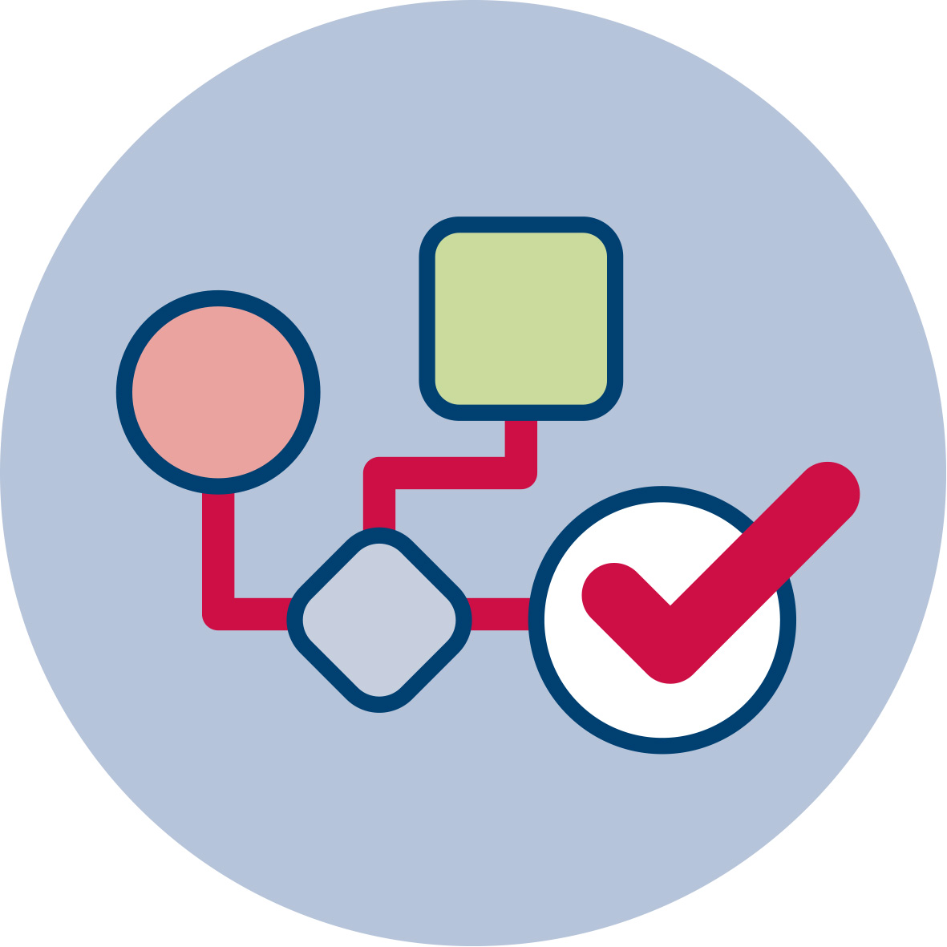 | Flowchart and Module plan
Module 9 involves six sections, most of them structured into several activities. It includes 1000 minutes of sessions, but several activities can be given as homework. It includes lecture parts, group discussions, debates, practical activities and experiments. The structure is as follows:

- Part 1: Plastics – history and background:275 mins
- Part 2: Exploring plastics: 150-170 mins
- Part 3: Case story – The plastic bottle and recycling: 185 mins
- Part 4: Case story – The plastic bottle and marine waste: 180 mins
- Part 5: Case story – The plastic bottle and landfill: 145 mins
- Part 6: Designing a lesson: 45 mins

1. Plastics – history and background (275 mins)

1.1. Plastics is everywhere around us
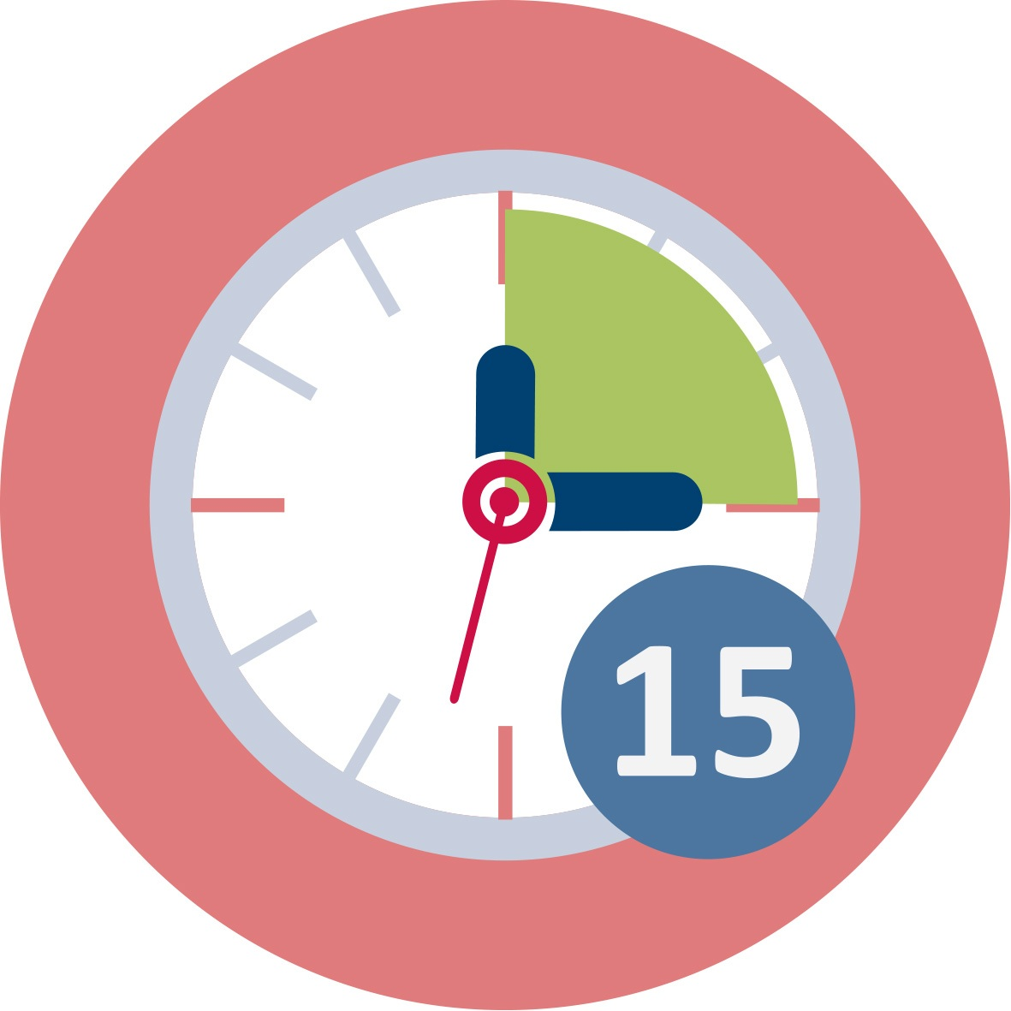
Duration: 20 min group work, 15 min plenary discussion OR 20 min homework
This is a “warm-up” activity. The intention is firstly to make the students conscious about the extensive use of plastics and how much each of us use plastics in our everyday lives, secondly to make them to reflect on the necessity of using plastics in all of these situations. Thirdly, we would like the students to reflect on potential benefits and drawbacks of each of these uses.

Alternatively, the student might think about these questions before the lesson (homework):
For one day, between the time you leave this classroom until you return, record every item you touch that is made of plastic. (Record each item only once; you don’t have to count each time you pick up the same pen).
(From the Science History Institute’s resource Science Matters: The Case of Plastics: https://www.sciencehistory.org/learn/science-matters/case-of-plastics/home)

Related activity: Ask students to bring plastic bottles to the classroom. They might be used in activity 4.2 and 4.5.
Teacher Educators introduce this activity either orally or by showing the questions on a power point (using [1]), blackboard or similar.

For more sources, and images, see the following websites:
https://hoxsie.org/2018/09/17/albany-home-of-the-first-plastic-celluloid/
https://americanhistory.si.edu/collections/search/object/nmah_2947
https://www.sciencehistory.org/distillations/celluloid-the-eternal-substitute

Images: Structure of bakelite: https://commons.wikimedia.org/wiki/File:Structure_of_Bakelite.png
Knobs bakelite: https://commons.wikimedia.org/wiki/File:Knobs_bakelite.jpg
Bakelite letter opener: https://commons.wikimedia.org/wiki/File:Bakelite_letter_opener.jpg
This session contributes to the achievement of the following learning outcomes:
- Understanding of what plastic and micro-plastic are and their effects on nature and humankind (learning dimension)
- Knowledge on different dimensions of the plastic dilemma (historic, economic, social, environmental – local and international) and take part in discussions on this dilemma (learning dimension)

1.2. Introduction to the history of plastics
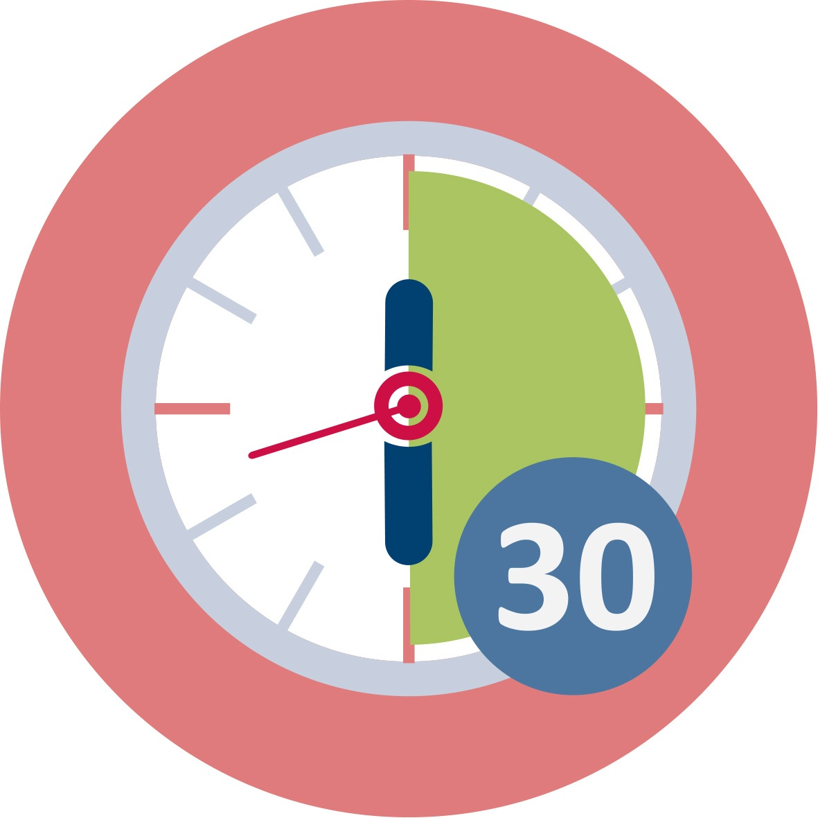
Duration: 30 min presentation + 15 min group discussion
The objective of this activity is to present the students with an overview of the history of plastics, from the first semi-synthetic “Parkesine” appeared in 1850 when the plastics substituted luxury goods to the expansion of uses after World War II and the growing concern with environmental problems associated with plastics in the 1960s. This swipe through history introduces the students to the cultural meaning of plastics, common products such as buttons, clocks, telephones and other electrical equipment, and nylon, and how plastics shaped societal needs and vice versa. Main points include:
- Plastics created a need in society and pushed for consumption of goods
- Plastics was a super material that could be molded into any shape, hence its popularity
- Eventually plastics came to represent the cheap and became a symbol of a consumer culture
Teachers could use the following resource to select highlights of interest to them and their local context: https://www.sciencehistory.org/the-history-and-future-of-plastics
See also: Jeffrey L. Meikl, American Plastic – a Cultural History (1995) and Susan Freinkel, Plastic – a Toxic Love Story (2011)

After the presentation, the student are invited to discuss what it is important for them (and their students) to learn about the history of plastics, and why. What are the lessons learnt from the examples/the introduction to the history of plastics that can be useful in their own teaching practice?

Teacher educators might use the pre-made slides [1], or they can select part of the content or adjust the slides to their purpose or local context.

This session contributes to the achievement of the following learning outcomes:
- Knowledge on different dimensions of the plastic dilemma (historic, economic, social, environmental – local and international) and take part in discussions on this dilemma (learning dimension)
- Experience in how to apply plastic dilemmas to teach about the role of science in society (teaching dimension)

1.3. Wicked dilemma about plastics
Duration: 20 minutes (group discussion)
The intention of this activity is to make the students reflect on a plastics-related dilemma relevant for all during the pandemic. Overnight the concern with exaggerated use of plastics in daily life has been taken over by a concern for spread of disease, and it sheds light on important dilemmas where quite often there are no clear solutions. Refer to power point [1]
This session contributes to the achievement of the following learning outcomes:
- Insights into sustainable development aspects (environmental, social and economic) in relation to the plastic dilemma (learning dimension)
- Knowledge on different dimensions of the plastic dilemma (historic, economic, social, environmental – local and international) and take part in discussions on this dilemma (learning dimension)
- Basic knowledge and skills that enable them to take critical action (action competence) (learning dimension)

1.4. Plastics and your school context

Duration: 45 minutes
The intention of this activity is to provide future teachers with knowledge about their local curricula and how the plastic dilemma can be linked to the curricula. Please encourage pre-service teachers to think interdisciplinary, and analyse the curriculum in different subjects, like science, mathematics, social sciences, food and health, languages.
Teacher educators present activity 1.4 to pre-service teachers using ppt presentation [1].
Country specific information about plastic related contents in curricula:
Norway: The new curricula for grades 1-10, implemented autumn 2020, introduced three interdisciplinary topics: sustainable development, health and life skills, and democracy and citizenship. These three interdisciplinary topics in the curriculum are based on prevailing societal challenges which demand engagement and effort from individuals and local communities, nationally and globally. The pupils develop competence in connection with the interdisciplinary topics by working with issues from various subjects. They shall gain insight into challenges and dilemmas in these topics. In upper secondary school (biology, chemistry), students are supposed to learn about materials, ecosystems, and how environmental toxins are concentrated in food chains. Thus, the plastic dilemma is highly relevant, even though it isn’t explicit mentioned.
Germany: The plastic dilemma is not explicitly mentioned, but pollution in general is a part of biology. Plastic and ways of its recycling is studied in chemistry. Explicitly plastic and environment is mentioned in science education on several occasions (however, plastic pollution is not mentioned explicitly). The plastic dilemma can therefore be included in biology, chemistry and mathematics in multiple ways. Furthermore, it can be (and often is) a topic in primary education, where science and its relevance is studied in a general way (Sachkunde). The plastic dilemma is a popular topic for project days or weeks in Germany.
In the Curriculum in Baden-Württemberg they have some general objectives of education, to which all subjects are supposed to contribute. One of these objectives is “Education for sustainable development” which offers space to include environmental issues in all STEM subjects.
Austria: In biology pupils should learn to see principles, relationships, cycles and dependencies and acquire understanding of biological and scientific ways of thinking and they should gain understanding of people's dependence on nature and the environment and acquire knowledge, skills/abilities that motivate and enable them to use our livelihoods in an environmentally conscious, sustainable manner (ecological competence)
In chemistry they should gain understanding of material cycles, for the interrelation between economy and ecology and thus for environmentally conscious action as well as for saving energy and raw materials.
Slovakia: Plastic pollution as a special topic does not exist in Slovak curriculum. Some isolated tasks or examples can be found in mathematics, chemistry, biology, geography and civics topics. Cross curricular projects could be designed for 14-15 years old pupils or older ones. At the annual conference ŽIVEKO pupils present their “research” articles and posters dealing with various eco-topics, problems with plastic waste is discussed every year, too.
Cyprus: Environmental Education, a separate course in primary school and high-school. The main aims are to engage students in recycling activities and promote positive attitudes towards recycling. The issue is not discussed in a critical way. Additionally, a lot of schools in Cyprus participate in a program called: Environmental School. As part of this program they have special actions related to recycling and they need to design actions related to recycling and their schools (e.g. recycle in their school, invite parents to recycle).
Malta: In the National Curriculum Framework (NCF) – Education for Sustainable Development is one of five cross-curricular themes. Thus, it should be learnt through the subjects that students learn at school. Teachers may use plastic dilemmas.
Chemistry programme: Age 14-16
- Describe how certain organic substances, other than fuels, can contribute to environmental problems (Limited to non-biodegradable plastics; the ongoing effect of CFCs on ozone depletion and their replacement.)
- List uses of polyethene, PTFE and PVC.
- Discuss how applying a strategy of “reduce, reuse, recycle” can alleviate environmental problems caused by organic substances.
- Model the production of polymers from alkenes and other unsaturated monomers by addition polymerization (Limited to polyethene, PTFE and PVC.)
The national curriculum framework: https://education.gov.mt/en/Documents/A%20National%20Curriculum%20Framework%20for%20All%20-%202012.pdf
The chemistry programme: https://www.um.edu.mt/__data/assets/pdf_file/0003/435288/SEC06.pdf
Greece: Plastic pollution and plastic dilemmas are almost absent from Greek curricula. There are general references to recycling but not something special for plastic pollution. It can be possible to introduce plastic dilemmas in the Environmental Education course, in Physics, Chemistry and in mathematics courses. The plastic dilemma in schools is not very well covered. There are some collective actions or activities from associations and communities.
Bulgaria: Not explicit mentioned in Bulgaria curriculum. But there is awareness in schools. In teaching materials you can find problems related to this: for example in math -> what is ‘gained’ by banning plastic bags? Could be included in STEM program on cross curricular topics.
Turkey: School and undergraduate science education programs addresses the plastic dilemma in different courses. For instance, there is a section in secondary school curriculum called “Environmental Chemistry”. In this program the effect of plastics on environment is discussed (page 24). http://mufredat.meb.gov.tr/ProgramDetay.aspx?PID=347
Netherlands: There are possibilities to connect to the chemistry curriculum, for example, since 2016 the exam program includes substantive sustainability-related final objectives in the examination program (see E and F domain)
https://www.examenblad.nl/examenstof/syllabus-2020-scheikunde-vwo/2020/f=/scheikunde_2_versie_vwo_2020.pdf
Sustainability (including a relation to plastic) is also part of the biology final exam program (often indicated as a context)
https://www.examenblad.nl/examenstof/syllabus-2020-biologie-vwo/2020/vwo/f=/biologie_2_versie_vwo_2020.pdf (Context D)
In all science final examination programs they have domain A9 'Valuing and Judging'.
The cross curricular course Nature, Live and Technology (NLT) for upper secondary schools has a module on ‘Plastic Soup’ (it is not freely available for everyone). Schools can decide by themselves whether they offer this course to their students. University of Utrecht organizes events for regional secondary school students on plastic soup:
https://u-talent.nl/activiteit/plastic-soep-2/ (in Dutch)
https://u-talent.nl/450-leerlingen-doen-mee-met-plastic-soep-campusdag/

This session contributes to the achievement of the following learning outcomes:
- Awareness about plastic pollution as a “wicked problem” in their national and/or local curriculum

1.5. Introducing the plastic bottle and its part in society
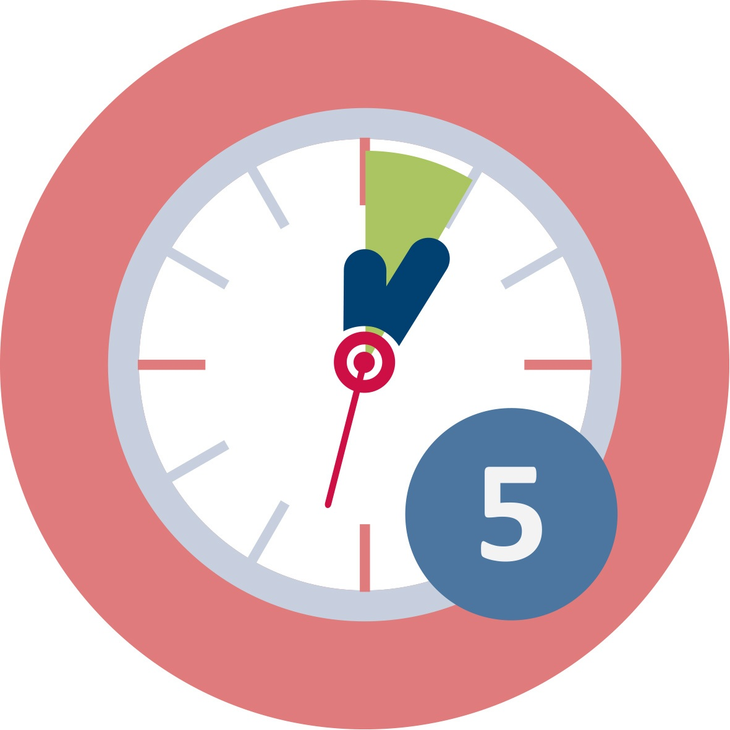

Duration: 15 min group discussion + 15 min plenary discussion + 5 min watching a video + 15 min presentation
Through this activity the students are going from general discussion about the uses of plastics to the plastic bottle as a focal point. The students will discuss the benefits and disadvantages of using plastic bottles for water and other drinks, and compare the plastic bottle with the glass bottle. They will also discuss if the plastic bottle is really needed in their local context. In many countries, the tap water quality is excellent, while in other countries bottled water is a necessity.
Some points to teacher educator:
Benefits:
- The plastic bottle is as clear as glass, shatterproof and just a fraction of the weight of a glass bottle
- PET (polyethylene terephtalate) makes the bottle strong enough to be streched both lengthwise and widhtwise (necessary because of the pressure of carbonation when filled with soda)
- Can be recycled
(some of these points can be introduced in a presentation instead, see below.)

Disadvantages:
- More and more frequent consumption of soda, „consuming on the go“ (not good for dental health)
- Waste associated with single use (check what is the custom in your country)

Recommended reading. Susan Freinkel, Plastic: A Toxic Love Story (2011)
We recommend that the students watch the following short video as a teaser: https://thekidshouldseethis.com/post/plastic-bottle-life-cycle-ted-ed (only 5 minutes, and subtitles is available in many languages)
It is possible to include a brief presentation by the teacher educator: Historical overview of the development of the plastic bottle, where the students get to learn when the bottle was introduced, and why (the many benefits it offered).
Recommended reading: How the plastic bottle went from miracle container to hated garbage (nationalgeographic.com) as well as Susan Freinkel, Plastic – A Toxic Love Story (2011)

Refer to power point [1]
This session contributes to the achievement of the following learning outcomes:
- Knowledge on different dimensions of the plastic dilemma (historic, economic, social, environmental – local and international) and take part in discussions on this dilemma

1.6. How much water, oil, carbon dioxide and money can you save if you don’t use plastic water bottles?

Duration: 15 minutes
The intention of this activity is to provide pre-service teachers with awareness of the water footprint and carbon footprint that are generated by production of bottled water. The activity also includes oil consumption for production and transport, and own costs for buying these bottles. Thus, the environmental and the economic aspects of the plastic water bottles are highlighted. The students must estimate the number of bottles they buy in a year, and calculate how much water, oil, and carbon dioxide this number of bottles corresponds to. The aim is to increase their awareness and knowledge by relating the task to their own life and consumption. While experiencing this task themselves, the intention is that they get inspired to apply similar tasks in their future teaching. The task might also trigger their own and their students action competence.
Facts and sources for further information:
ENERGY
Bottled water requires energy throughout its life cycle. Energy is required to draw the fossil fuels used in the bottles, to capture, treat, and send water to the bottling plant; fill, package, transport, and cool the bottled water; and recycle or dispose of the empty containers. The total amount of energy depends on several factors, like location of water source, consumer, type of material and packaging, type of transportation. Example from U.S.: Bottled water consumption in 2006 required one million tons of PET, the equivalent of around 17 million barrels of oil, which is enough energy to fuel one million American cars for one year.
https://pacinst.org/wp-content/uploads/2007/02/bottled_water_factsheet.pdf ​
WATER
The water footprint of a product is calculated by adding up all of the water required for each step of the production process. There are several water footprint calculators available, e.g. ​https://www.watercalculator.org/footprint/the-hidden-water-in-everyday-products/
There are different estimates on how much water it takes to produce 1 litre of bottled water, from about 3-7 litres.
OIL
The estimates for oil consumption also differs, from about a quarter of a litre to one litre to produce a single one-litre water bottle.
CARBON DIOXIDE
Manufacturing a one-litre bottle creates over 100g of greenhouse gas emissions (10 balloons full of CO2) per empty bottle. ​
This website gives lots of interesting facts: https://www.coolaustralia.org/bottled-water-secondary/
Teacher educators present activity 1.6 to pre-service teachers using ppt presentation [1] and worksheets [1]. First, we suggest that each student calculate their own consumption. If time, they can share in plenary and discuss the consequences for the whole community, and thus highlight the social dimension as well.
This session contributes to the achievement of the following learning outcomes:
- Insights into sustainable development aspects (environmental, social and economic) in relation to the plastic dilemma
- Knowledge on different dimensions of the plastic dilemma (historically, economically, socially, environmentally – locally and internationally) and take part in discussions on this dilemma
- First knowledge and skills that enable them to take critical action (action competence)
- Experience in how to apply plastic dilemmas to teach about the role of science in society
- First knowledge and skills on how to deal with environmental socio-scientific issues (e.g. identify and argue for different perspectives) in their future teaching

1.7. Wicked dilemma - debate

Duration: 30 min group discussion and reading + 30 min debate + 5 min group discussion
This activity aims at providing students with experiences, knowledge and skills which enables them to take critical action, to identify different perspectives and argue for them. Furthermore, the activity will give the students experience, knowledge and skills to be able to teach about wicked dilemmas in school.
First, students shall discuss pros and cons about the use of plastic bottles. They might draw on previous discussions (activity 1.5). They might look up arguments on the internet. The arguments they identify will be used to prepare role cards for a debate about the use of plastic bottles, whether it should be forbidden or not. Roles could include producer, government, environmental organizations, consumers, health organizations, or animal protection groups. Each role card should include a statement, arguments to substantiate that statement, and possibly defense of possible criticism raised by opponents from other groups/roles.
Recommended reading: Debora H. Cook: Conflicts in Chemistry: The Case of Plastics, A Role-Playing Game for High School Chemistry Students (J. Chem. Ed. 2014)
At the end, let the students reflect upon and discuss what they think their own students can learn from being exposed to such dilemmas in school. Refer to power point [1]
This session contributes to the achievement of the following learning outcomes:
- Basic knowledge and skills that enable them to take critical action (action competence) (learning dimension)
- Experience in how to apply plastic dilemmas to teach about the role of science in society (teaching dimension)
- Basic knowledge and skills on how to deal with environmental socio-scientific issues (e.g. identify and argue for different perspectives) in their future teaching (teaching dimension)

2. Exploring plastic (150-170 mins)

2.1 What is plastic?
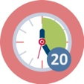Duration: 20 minutes
This is an activity that is a lesson about the chemical properties of plastic. We look at how plastic is build up from smaller molecules to polymers. This is a classroom-lesson where the teacher informs the students about the chemistry behind plastic with the support of the slides. There is no difficult chemistry, and any science teacher can easily do this lesson.
With some of the slides more info coms as notes.
This session contributes to the achievement of the following learning outcomes:
- Understanding of what plastic and micro-plastic are and their effects on nature and humankind
- Insights into sustainable development aspects (environmental, social and economic) in relation to the plastic dilemma
- Knowledge on different dimensions of the plastic dilemma (historic, economic, social, environmental – local and international) and take part in discussions on this dilemma
- Basic knowledge and skills that enable them to take critical action (action competence)

2.2. Collect different plastic
Duration: 10 minutes
This is to activate the students to find different sort of plastic in their home environment. The idea is that every student pick 3-4 different types of plastic from what they find at home and bring it back to school. If there is no time for this, the teacher can collect diverse types of plastic. Because we do not need big amounts of plastic; you cut the plastic in to small pieces.
The plastic pieces are going to be used in activity 2.3
It is important that there is diverse types of plastic.
Examples of plastic to collect.
- PET: soda bottles (polyethylene terephthalate)
- PS: eg plastic cutlery (polystyrene)
- PVC in e.g. water bottles (polyvinyl chloride)
- Nylon: eg toothbrush handle, fishing line
- PC: CD (NOTE: a layer of aluminum and acrylic). (Polycarbonate)
- Bakelite: old electrical outlet/old telephone (bakelite)
- HDPE: Vitamin container (high density polyethylene)
- LDPE: plastic around e.g., multipack sodas/beers (low density polyethylene)
- PP: Some food containers (which can withstand high temperatures in the dishwasher) (polypropylene)
This session contributes to the achievement of the following learning outcomes:
- Experience in how to apply plastic dilemmas to teach about the role of science in society
- Knowledge on different dimensions of the plastic dilemma (historic, economic, social, environmental – local and international) and take part in discussions on this dilemma

2.3. Identifying different plastic
Duration: 60 minutes
This is an activity that requires a science room or laboratory.
Students can work together in groups of two or three.
Make sure that you have all security demands covered.
Students should wear safety goggles and flame test must be carried out under exhaust hood.
Make sure you have all you need for the experiment and that each group have sufficient equipment and plastic examples.
Each group needs:
- 4-6 small pieces of different types of plastic
- pH paper
- Beaker
- Bunsen burner
- Spatula
- Pliers
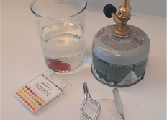
Before you start; go through the procedures together with the students and give out worksheet for each student.
The tests are well described in the slides.
In the worksheet there is a table over different types of plastic and how they respond to the tests.
With the help of this table the students should identify their 4 different pieces of plastic.
If you see the plastic identification-number.

See Students handouts.
Alternative approaches:
- You can give pupils a problem to solve such as: when recycling plastic, how can we automatically sort plastic? The easiest way is to sort plastic by its density.
- Use table salt to mix different concentrations of salt water. This makes it easier to separate PET, PVC, and possibly nylon, which have all a slightly different density. Start with the most concentrated saline solution and dilute with water until the plastic sinks.
- A variant of this is that one can have different liquid substances that we know the density of (water, methanol, etc.) and examine whether plastic flows or sinks. One can thus determine the density of the plastic more accurately.
Explanation
Flow test: The density of water is 1,000 kg/dm3. If the sample floats, it means that the density is less than 1,000 kg/dm3. The density of the plastic varies between 0.9 kg/dm3 (LDPE, PP) and 1.38 kg/dm3 (PVC). Elastomers weigh 1.5 kg/dm3. Porous products, such as foam, have a lower density. PE contains only carbon and hydrogen. This is relatively simple. PVC contains chlorine atoms that are heavier than carbon and hydrogen and therefore sink in water.
The color of the flame: A green flame color indicates that the plastic contains chlorine or bromine in one form or another. Plastic composed of aromatic rings burns and emits black smoke.
The pH value is a measure of acidity, ie the concentration of hydrogen ions (H +) in a solution (actually oxonium ions, H3O +, a water molecule with an extra proton, ie an extra H +). Combustion of PVC produces hydrogen chloride which is acidic.

Polymers
Plastic consists chemically of hydrocarbon chains. The word polymer derived from Greek: poly means "many" and more "parts" polymer and thus "many parts". There are two main types of polymers - rigid and elastic. The elastics can be divided into thermoplastic elastomers and rubbers. Rubber materials have great elasticity. The rigid polymers (plastics) can be divided into thermoplastic and thermosetting plastics. Thermoplastic consists of linear or branched polymer chains that melt and are produced at high temperatures and solidify on cooling. Tempered plastics consist of a tightly cross-linked network of polymer chains, which solidify in production. The polymers are prepared by polymerizing many small molecules, monomers into long polymer chains. Depending on where the chains are assembled and which other chemical groups they are attached to, we get plastic with different properties. In normal use, polymers are almost completely odorless. In production, machining, cutting, high temperatures and extreme combustion or other use, the raw materials, additives, residues or low molecular weight migration products may emit odors. Plastic is a multifaceted concept, and it is reflected in the many different uses - plastic bags, boxes, bottles, housings for cameras and white goods, car parts, cables, pipes, sports equipment, etc. Although some polymers are classified as non-flammable or self-sealing, they can be a risk from a fire safety point of view. They can melt or char in a fire, which can cause heat droplets and soot, or cause the products to lose their functionality. Burning materials can also emit toxic or corrosive gases and contribute to the spread of fire. An overview of polymeric materials given in these two tables.

This session contributes to the achievement of the following learning outcomes:
- Understanding of what plastic and micro-plastic are and their effects on nature and humankind.
- Insights into sustainable development aspects (environmental, social and economic) in relation to the plastic dilemma.
- Knowledge on different dimensions of the plastic dilemma (historic, economic, social, environmental – local and international) and take part in discussions on this dilemma.
- Experience in how to apply plastic dilemmas to teach about the role of science in society.
- Experience in using inquiry-based learning approaches to teach plastic dilemmas in an SSI-perspective

2.4. Plastic as an environmental hazard
Duration: 30 minutes
This section is also a lecture about hazards concerning plastic in the environment. We look at plastic as a micro-plastic and the additives in plastic.
This is a classroom-lesson where the teacher informs the students about the chemistry behind plastic with the support of the slides. There is no difficult chemistry, and any science teacher can easily do this lesson.
Some of the slides are supported with more information as notes.
As an alternative, you could consider expanding this section with a discussion among the students at the end.
This session contributes to the achievement of the following learning outcomes:
- Understanding of what plastic and micro-plastic are and their effects on nature and humankind
- Insights into sustainable development aspects (environmental, social and economic) in relation to the plastic dilemma
- Knowledge on different dimensions of the plastic dilemma (historic, economic, social, environmental – local and international) and take part in discussions on this dilemma
- Basic knowledge and skills that enable them to take critical action (action competence)
- Awareness about plastic pollution as a “wicked problem” in their national and/or local curriculum
- Experience in how to apply plastic dilemmas to teach about the role of science in society
- Basic knowledge and skills on how to deal with environmental socio-scientific issues

2.5. Chemical additives in plastic
Duration: 20 minutes investigation + X minutes presentation
In this activity the students can investigate on the internet and find out about chemical additives in plastic.
- what kinds of additives are we using in plastic?
- what effect do they have on the environment and on humans?
- where do they find information on the additives?
The students can present it to the other students oral or as a newsletter.
This session contributes to the achievement of the following learning outcomes:
- Understanding of what plastic and micro-plastic are and their effects on nature and humankind
- Insights into sustainable development aspects (environmental, social and economic) in relation to the plastic dilemma
- Knowledge on different dimensions of the plastic dilemma (historic, economic, social, environmental – local and international) and take part in discussions on this dilemma
- Basic knowledge and skills that enable them to take critical action (action competence)
- Awareness about plastic pollution as a “wicked problem” in their national and/or local curriculum
- Basic knowledge and skills on how to deal with environmental socio-scientific issues

3. Case story – The plastic bottle and recycling (185 mins)

3.1. Introduction to recycling
Duration: 5 minutes
The intension of this activity is to provide future teachers with knowledge of the life cycle of the plastic bottle, from oil to recycling. These are the main steps:
- First, the oil is extracted from the earth​
- Then the oil is cleaned at the refinery​
- At a plastics factory the oil is transformed into plastic pellets then bottle pre-forms​
- The pre-forms are heated and shaped into bottles
- The bottles are brought to the bottling plant where they are filled with water
- The bottles are ready and are transported to the store​
- You purchase the bottle of water and bring it to your house​
- Most of the plastic bottles are thrown in the trash and end up in landfills, some end op as marine waste, and some are recycled
- The process of recycling: The plastic bottles are sorted by the type of plastic they're made from. Then, the bottles are cleaned – they remove any food, liquid, or chemical residue. Next, the bottles are ground up and shredded into flakes. Finally, they are melted down and formed into small pellets, from which the factories can produce new pre-forms. ​Some bottles are recycled and brought to a factory that turns them into other items like carpet, fleece and other plastic items. Eventually, those items are disposed of in the trash and also end up in the landfill.​
For more information, see e.g. https://www.oberk.com/how-are-plastic-bottles-recycled
Teacher educators present activity 3.1 to pre-service teachers using ppt presentation [1].
This session contributes to the achievement of the following learning outcomes:
- Knowledge on the life cycle of plastic bottles, from production to waste, mainly in their own country, but also with an international perspective

3.2. Recycling plastic bottles – as an SSI
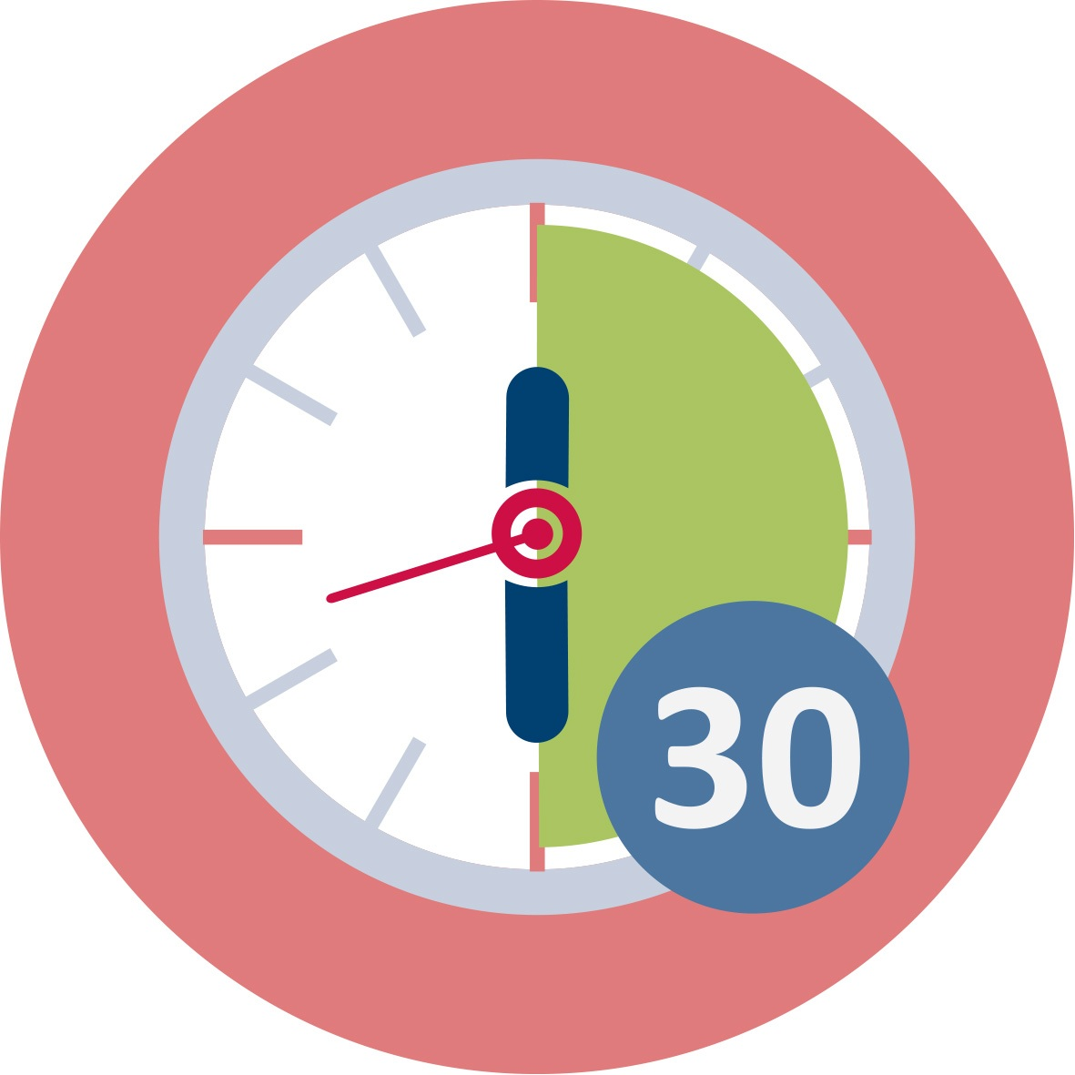 Duration: 45 minutes
The intension of this activity is to provide future teachers with insight into the sustainable development aspects of the recycling process. They are encouraged to think of advantages and disadvantages of recycling. Some aspects are given here:
ADVANTAGES: ​
- Exploration, extraction, refining, processing and plastic production processes are saved​
- Reduce CO2 emissions and save energy
- Reduce oil consumption (usage of fossil fuels)
- Circular vs linear economy
- Bottle refund helps to reduce waste
- Facilitate zero waste stores​
DISADVANTAGES: ​
- You must collect and transport the plastic for sorting, washing, grinding and granulation​
- To be suitable for recycling, the materials must contain sufficient antioxidants to avoid degradation of the materials through the production process and product life​
- For recycled plastic, odor can be a problem. It can be solved by adding chemicals, but one will generally avoid adding additives if one can.
- The additives in the plastic materials may lose properties during the recycling process. It is therefore common to add substances to maintain desired properties​
- The oil price is so low that new plastic is cheaper than recycled plastic​

​To ensure that the recycling of plastic is environmentally beneficial, it is important that the plastic that is recycled replaces new plastic and is used for products that would otherwise be made of new plastic. ​
Teacher educators present activity 3.2 to pre-service teachers using ppt presentation [1]. Mind-maps can be drawn on the blackboard, whiteboard or smartboard, or the students can be encouraged to work on an online class-mind map, using e.g.:
Mindmeister: https://www.mindmeister.com – ideal for creating mind maps. The created mind maps can be designed intuitively, shared and edited together. Promotes co-creation and brainstorming, but subject to charge as soon as more than 3 mind maps are designed.
Flinga: https://flinga.fi/ - Flinga whiteboard offers versatile visualization tools for collaborative knowledge building. The entire classroom can simultaneously participate and make mind maps together. You can have 5 active Flinga sessions. If you reach the maximum limit you need to delete one of the older sessions (go to Sessions) before you can create a new one.
Miro: https://miro.com/ - An online collaborative whiteboard platform
Mural: https://www.mural.co/ - A digital worskspace for visual collaboration
Mindmup: https://www.mindmup.com/ - Another free online mind mapping tool
This session contributes to the achievement of the following learning outcomes:
- Insights into sustainable development aspects (environmental, social and economic) in relation to the plastic dilemma
- Knowledge on the life cycle of plastic bottles, from production to waste, mainly in their own country, but also with an international perspective
- Knowledge on different dimensions of the plastic dilemma (historically, economically, socially, environmentally – locally and internationally) and take part in discussions on this dilemma
- First knowledge and skills that enable them to take critical action (action competence)
- Experience in how to apply plastic dilemmas to teach about the role of science in society
- First knowledge and skills on how to deal with environmental socio-scientific issues (e.g. identify and argue for different perspectives) in their future teaching

3.3. Teaser: The case of Norway
Duration: 25 minutes
The intension of this activity is to give a country specific example of recycling. The activity includes a video teaser (You Tube, 16:35, English subtitles) and three slides. With this background, the students are encouraged to find out more about recycling in their own context, Activity 3.4.
Teacher educators present activity 3.3 to pre-service teachers using ppt presentation [1].
This session contributes to the achievement of the following learning outcomes:
- Knowledge on the life cycle of plastic bottles, from production to waste, mainly in their own country, but also with an international perspective
- Knowledge on different dimensions of the plastic dilemma (historically, economically, socially, environmentally – locally and internationally) and take part in discussions on this dilemma
- First knowledge and skills that enable them to take critical action (action competence)
- Experience in how to apply plastic dilemmas to teach about the role of science in society
- First knowledge and skills on how to deal with environmental socio-scientific issues (e.g. identify and argue for different perspectives) in their future teaching

3.4. Recycling in your country
Duration: 45 minutes
(30 mins group work + 15 mins plenary)
The intention of this activity is to make students reflect on their local and national contexts with regard to recycling. They are asked to carry out a research on the Internet and can profitably work in groups and share in plenary. The activity can also be given as homework. Similar activities can be applied in their future teaching. The activity lay the foundation for Activity 6.1.
Country specific information about recycling and links to national policy documents that handle the plastic dilemmas:
Germany: In Germany they have two types of plastic bottles. One for reuse and another type for single use. Buying both types require bottle deposit. 40% of the single use type will be reused in Germany (new bottles or in the fashion industry). 93,5% of PET-bottles are recycled in Germany. There is a refund for plastic bottles in Germany of 0.25Euros, which is supposed to support people to bring bottles back for recycling.
Austria: Plastic bottles are collected but not refunded. Even collecting systems differ from community to community. In some all plastic waste is collected in yellow tons (consumers have to do the transport), in others plastic waste is picked up periodically. Some systems foresee the collection just of plastic bottles, other all plastic waste, some mix bottles and metallic waste. For citizens it is very complicated to do recycling in the right way. https://www.umweltbundesamt.at/en/news_events_reports/news_eaa/en_news_2020/news_en_200415_1
Slovakia: Compared to other countries of the Organization for Economic Co-operation and Development (OECD), Slovakia lag significantly behind in waste management. Up to 54% of the total amount of waste produced in Slovakia ends up in landfills. 422 kg of waste is produced per capita per year (2018). The recycling rate of municipal waste in Slovakia in 2018 was 38%. The share of landfills decreased positively from 61% to 54% by the end of year 2019.
At present, 1 billion PET bottles (34,000 tons) are launched on the Slovak market every year. Of this, 400 million end up in landfills, or in the worst case, freely thrown in nature, rivers or on roads. Of the drinks that are packaged in PET bottles is dominantly mineral water. This is up to 60% of all beverage packaging in PET bottles.
The two largest companies - General Plastic and Ekolumi - operate on the Slovak market with the recycling of PET bottles. General Plastic, a.s. (https://www.generalplastic.sk/; https://www.generalplastic.sk/sluzby/recyklacia-pet-flias) is the largest processor of recycled PET materials in Slovakia and is also one of the largest producers of PET preforms in Central Europe. The company processes approximately 12,000 tons of PET bottles per year and has 2 plants: in Kolárov (recycling of PET bottles, production of LDPE foil and production of washed flakes) and in Senice (production of PET preforms, production of HDPE closures and decontamination of flakes).
https://www.oecd.org/environment/waste/Policy-Paper-Making-the-Slovak-Republic-a-more-resource-efficient-economy.pdf
https://www.epi.sk/zz/2019-302
Czech Republic:
Growing production of wastes – in year 2018 in Czech Republic produced in total 28 million tons wastes, an increase of 3.4 million tons compared to year 2017 (14% more). Municipal waste 3.7 million tons, an increase of 2.5% compared to 2017, per capita 351 kg - https://www.czso.cz/csu/czso/graf-vyvoj-produkce-odpadu, http://www.enviweb.cz/114889 , http://www.enviweb.cz/114889
Recycling and reuse - The present level of recycling of communal waste is 39%, the challenge is to achieve European aim to separate 60% (recycle 55%) till 2025 and separate 70% (recycle 65%) till 2030. Distribution of separated waste: paper 30 %, plastics 25 %, glass 23 %, a metals 7 % - http://www.caoh.cz/data/action/odpady-csu-za-rok-2018.pdf, https://www.mzp.cz/cz/odpady_podrubrika , https://www.mzp.cz/cz/premena_odpadu_na_zdroje
Management and use of communal biological waste/composting, biogas – mandatory sorting - biowaste makes up 40 - 50% of the total amount of municipal waste, in 2018 670 000 tons of biowaste were sorted in the Czech Republic, 3% more than in 2017 https://www.trideniodpadu.cz/bioodpad , http://www.kompostuj.cz/:
Returnable bottles with deposit – only glass bottles, not plastic bottles (a few exceptions); https://www.zalohujme.cz/ (a call on the public to support the introduction of back-up plastic bottles)
Efficiency of the Waste Sorting System in the Czech Republic and Chosen EU countries - http://4liberty.eu/efficiency-of-the-waste-sorting-system-in-the-czech-republic-and-chosen-eu-countries/
Catalogue of the waste (In Czech: Katalog odpadů) - https://www.katalogodpadu.cz/#top
Generation, Recovery and Disposal of Waste at Czech Statistical Office - https://www.czso.cz/csu/czso/generation-recovery-and-disposal-of-waste-2018
Cyprus: People are advised to recycle. The bottles are collected from outside the houses (you have to put the bottles is special bags) and are taken to factories in Cyprus. The plastic bottles are packaged and shipped abroad for recycling.
Links to numbers here: http://greendot.com.cy/en/public/recycling-results
http://www.moa.gov.cy/moa/environment/environmentnew.nsf/page20_en/page20_en?OpenDocument
Greece: Greece is ranked 6th among the top bottled water markets worldwide by per capital consumption which amounts to a consumption of 111 litres of bottled water per capita. As less than one third is recycled in Greece the rest of it ends up in landfills or in marine environment. The environmental threats of plastic bottles are more acute during the summer due to the high temperatures, the arrival of tourists and the fact that most islands lack the infrastructure for drinkable tap water. Almost, every year 2 billion plastic bottles (for water and soft drinks) are used.
https://www.plasticfreegreece.com/greek-govt-action-plan.html
https://greece.greekreporter.com/2014/07/21/58-of-greeks-recycle-on-a-daily-basis/
Bulgaria: Only bottle caps are collected and recycled. Results are made public.
Turkey: There isn’t a systematic structure for separation of plastics from houses, but many institutions and factories etc. have separate bins for plastics. Some municipalities have garbage separation sites.
Netherlands: Currently, only plastic bottles larger than 1 liter have a deposit in the Netherlands. On the 1st of July 2021, small bottles under 1 liter will come with a deposit amount of minimum 0.15 euro. Each year, 1 billion small plastic bottles are sold in the Netherlands. Between 50 and 100 million of them end up in litter. The Dutch authorities are also preparing legislation for deposits on beverage cans.
In the Netherlands, a deposit return system for small plastic bottles will come into effect on the 1st of July 2021.
https://recyclingnetwerk.org/2020/04/24/dutch-government-decides-deposit-on-plastic-bottles-excellent-news-for-the-environment/
In general – they have a debate in NL on whether or not households should keep separating plastics from general waste. Industry (in waste collecting) seems to be able to separate better.
In the following link you can find the Directive (EU) 2015/720 of the European Parliament and of the Council of 29 April 2015 amending Directive 94/62/EC as regards reducing the consumption of lightweight plastic carrier bags (Text with EEA relevance) in all languages
https://eur-lex.europa.eu/legal-content/EL/TXT/?uri=CELEX%3A32015L0720
This issue became Greek low on August 10, 2017 (Government newspaper, 2812/part b/ August 10, 2017).

Teacher educators present activity 3.4 to pre-service teachers using ppt presentation [1] and worksheets [1].
This session contributes to the achievement of the following learning outcomes:
- Knowledge on the life cycle of plastic bottles, from production to waste, mainly in their own country, but also with an international perspective
- Experience in how to apply plastic dilemmas to teach about the role of science in society
- First knowledge and skills on how to deal with environmental socio-scientific issues (e.g. identify and argue for different perspectives) in their future teaching

3.5. Recycling around the world
Duration: 5 minutes
The intension of this activity is to provide future teachers with knowledge on recycling around the world. The activity includes two slides only. First, we highlight recycling in general, next recycling of plastic bottles – with a focus on numbers.
Numbers are taken from the report published by Eunomia Research and Consulting & European Environmental Bureau (EEB)​, Recycling – Who Really Leads the World? (Issue 2), 11th December 2017, a recent article from Science Advances on production, use and fate of all plastics ever made (Geyer et al, 2017) and statistics from Statista, 2020 (see references).
Teacher educators present activity 3.5 to pre-service teachers using ppt presentation [1].
This session contributes to the achievement of the following learning outcomes:
- Knowledge on the life cycle of plastic bottles, from production to waste, mainly in their own country, but also with an international perspective

3.6. Recycling and energy saving: Energy calculator
Duration: 15 minutes
The intension of this activity is to provide future teachers with awareness on energy saving when recycling – which tough into important environmental, social and economic aspects of the plastic dilemma. They are introduced to an energy calculator, which they also can apply in their own teaching lessions later on. Knowledge gained through this activity might be a first step that enable pre-service teachers and their students to take critical action in their lives. The results might also lay a foundation for interesting discussions in the class.
Teacher educators present activity 3.6 to pre-service teachers using ppt presentation [1] and worksheets [1].
This session contributes to the achievement of the following learning outcomes:
- Insights into sustainable development aspects (environmental, social and economic) in relation to the plastic dilemma
- Knowledge on different dimensions of the plastic dilemma (historically, economically, socially, environmentally – locally and internationally) and take part in discussions on this dilemma
- First knowledge and skills that enable them to take critical action (action competence)
- Experience in how to apply plastic dilemmas to teach about the role of science in society
- First knowledge and skills on how to deal with environmental socio-scientific issues (e.g. identify and argue for different perspectives) in their future teaching

3.7. How to make clothes from plastics?
Duration: 45 minutes
This activity is an experiment that requires few materials and little equipment. In fact, students can do it at home in their kitchen.
One intension of this activity is to provide future teachers with knowledge on why plastic can be recycled into clothes. By melting different types of plastic, they will get familiar with properties and possibilities of these plastics – and hopefully understand why plastic can be recycled and formed into clothes like fleece garments. The aim is to make long strands of plastics – like thread. The only thing they need to do is to place an aluminium cup or container on the top of a hob for heating, put the plastic pieces in this cup and wait until they are melted. Then, dip a toothpick into the melted plastic and try to make long strands out of it. They can hold or move the warm cup with a wooden clip.
The intension of this activity is also to provide future teachers with beginning experience in inquiry-based activities related to the plastic dilemma. Thus, it is important that they don’t get a cookbook receipt on how to do the experiment. Before the experiment starts, it is important that they set up a hypothesis and plan their own experiment – e.g. decide on what types of plastic they will test. At the end, pre-service teachers should reflect on the suitability of this experiment for their student group. Do they need to make adaptions to simplify or add extra challenges? They should also be guided through a meta-reflection on the openness of this experiment (whether they think it represents an open inquiry, guided inquiry, structured inquiry or confirmation exercise, see Tafoya et al, 1980). They could also reflect on the inquiry level of this experiment, see Fradd et al (2002).
Open Inquiry: Students ask questions, design procedures, carry out investigations and communicate results.
Guided Inquiry: The teacher provides the research question, students design the procedure.
Structured Inquiry: The question and procedure are provided, students generate an explanation supported by the evidence they collect
Confirmation Inquiry: The question and procedure are provided, results are known in advance.
Source for inspiration:
http://chem-www4.ad.umu.se:8081/Skolkemi/Experiment/experiment.jsp?id=169 (Swedish language only, acceptance to reuse and change is given)
Teacher educators present activity 3.7 to pre-service teachers using ppt presentation [1] and worksheets [1].
This session contributes to the achievement of the following learning outcomes:
- Understanding of what plastic and micro-plastic is and its effects on nature and humankind
- Experience in how to apply plastic dilemmas to teach about the role of science in society
- Experience in using inquiry-based learning approaches to teach plastic dilemmas in an SSI-perspective

4. Case story – The plastic bottle and marine waste (180 mins)

4.1. Introduction to marine litter
Duration: 20 minutes
The intention of this activity is to get an overall view of which priority areas individual countries prioritize, based on the three dimensions of sustainable development: environment, economy and social conditions. In this case the UN's sustainability goals are used for this. The theme is marine litter and plastic bottles are used as an example in this case. We start to take a closer look at what the bottles were used for, before they ended up as marine litter. The bottles once had a function where they were used as water bottles, soda bottles, soft drinks of various kinds. They were also beautifully designed with different shapes and colors. As the picture demonstrate, the bottles come with the ocean currents from many different countries.
Students get experience in:
- discussing the three dimensions, environment, economy and social conditions within sustainable development in relation to the UN's sustainability goals. Use this source to get an overview over the 17 UNs goal:
THE 17 GOALS | Sustainable Development (un.org)
- understanding why many people have the attitude that functional products are thrown away in terrestrial and marine environment and not returned as plastic waste, residual waste, or delivered where there are deposit schemes. It will depend on where in the world you live and which of the 17 UN goals are given priority.
- in how to get an "ownership" of global environmental issues such as the plastic problem is, based on the premise that it is a local environmental problem.
In Norway, to use it as an example, there is no poverty, everyone can go to school and it is a good health care system. In Norway, one can use resources to ensure that there is a clean ocean. Therefore, the UN's goal No. 14, Life below water, is one of the priority goals.
Teacher educators present pictures from 4.1 to pre-service teachers using ppt presentation [1].
This session contributes to the achievement of the following learning outcomes:
Students will acquire:
- Understanding of what plastic and microplastic are and their effects on nature and humankind.
- Knowledge on how to set up socio-scientific issues (“wicked problems”) on plastics in their context (Activity 6.1)
- Basic knowledge and skills on how to deal with environmental socio-scientific issues (e.g. identify and argue for different perspectives) in their future teaching.
- Insights into sustainable development aspects (environmental, social and economic) in relation to the plastic dilemma Knowledge on the life cycle of plastic bottles, from production to waste, mainly in their own country, but also with an international perspective

4.2. Documentation of the collected plastic bottles
Duration: 30 minutes
The purpose of this activity is to give future teachers experience that working in a scientific way with documentation, such as origin registration, dating and use of collected waste, leads to an awareness of environmental issues. The bottles to be used in this activity are either from activity 1.1, or alternatively that bottles are collected from nature, which are brought to the teaching.
This session contributes to the achievement of the following learning outcomes:
- Experience in presenting data in an appropriate way for a specific target group.
- Knowledge on different dimensions of the plastic dilemma (historic, economic, social, environmental – local and international) and take part in discussions on this dilemma.
- Experience in using inquiry-based learning approaches to teach plastic dilemmas in an SSI-perspective.

4.3. How plastic is fragmented and degrades
Duration: 45 minutes
The intention of this activity is that the future teachers are able to convey knowledge about what happens to plastic when it is left in nature, both on land and in water, and that is harmful to the organisms.
First, students reflect individually what happens if plastic bottles lay out in the nature? Then they, in pair, carry out an internet search.
Source about plastic fragmentation and degradation:
M918.pdf (miljodirektoratet.no)
Two and two students share what they find. Finally, in plenary discuss their findings. Further follow up with 4.4 using ppt presentation [1].

This session contributes to the achievement of the following learning outcomes:
- Awareness of the necessity of teaching science in order to raise awareness of challenges around environmental issues and prevent damage to animals and the environment.

4.4. Plastic is fragmented into pieces
Duration: 10 minutes
The intention of this activity is that the future teachers are able to convey knowledge about what happens to plastic when it is left in nature, both on land and in water, and that is harmful to the organisms.
The pictures are from coastal fresh waters and these are drinking water sources for birds and animals.

Teacher educators present pictures from 4.4 to pre-service teachers using ppt presentation [1].

This session contributes to the achievement of the following learning outcomes:
- Awareness of the necessity of teaching science in order to raise awareness of challenges around environmental issues and prevent damage to animals and the environment.

4.5. How you can calculate the amount of microplastics from plastic waste in nature
Duration: 20 minutes

The intention of this session is to make students reflect on their own beliefs and knowledge about the possibilities of estimation in mathematics and science. Estimation makes it possible to predict the consequences that plastic waste in nature can cause. Teacher educators present activity 4.5 to pre-service teachers using ppt presentation [1] and worksheets [1].
This session contributes to the achievement of the following learning outcomes:
- Awareness about the necessity that teaching science and mathematics should also include dealing with environmental SSI.
- Experience how inquiry-based learning can be carried out by estimating different outcomes on a specific task.
- Experience in using inquiry-based learning approaches to teach plastic dilemmas in an SSI-perspective.
- Knowledge on different dimensions of the plastic dilemma (historic, economic, social, environmental – local and international) and take part in discussions on this dilemma.

4.6. Examples of Art projects
Duration: 10 minutes

The intention of this session is to make students able to shift the focus from the negative perspective of marine waste to using collected plastic products for something positive, such as making art. Examples of Art Projects:
The Plastic Sun (2020), The plastic Crab (2019) and The Plastic Halibut (2018) are art sculptures made of plastic bottles and other marine plastic waste. The artsculpturs are made by norwegian visual artist and journalist Eirik Audunson Skaar and 420 secondary school students.
This session contributes to the achievement of the following learning outcomes:
- Get acquainted with art that is made from marine waste such as plastic materials with different colors. Plan a new art which can be done with students. Teacher educators present activity 4.6 to pre-service teachers using ppt presentation [1].
- Basic knowledge and skills on how to deal with environmental socio-scientific issues

4.7. Art Project
Duration: 45 minutes

In this session the students are planning an art-project. The intention of this session is to make students able to shift the focus from the negative perspective of marine waste to using collected plastic products for something positive, such as making art.
This session contributes to the achievement of the following learning outcomes:
- Get acquainted with art that is made from marine waste such as plastic materials with different colors. Plan a new art which can be done with students. Teacher educators present activity 4.6 to pre-service teachers using ppt presentation [1].
- Basic knowledge and skills on how to deal with environmental socio-scientific issues

5. Case story – The plastic bottle and landfill (145 mins)

5.1. Introduction to plastic and landfills
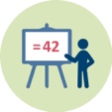 | Duration: 45 minutes
In this activity the intention is to get a better understanding of the complex field of production, consumption and use of plastic, with a special focus on the challenges of plastic waste and landfills. The activity is a mix of reading text, investigate several internet links, and discuss in groups. Themes to be discussed are the role of oil, the growth in demand of oil, and the waste challenge due to the huge number of plastic products.

Background oil and plastic
Oil as raw material has a dual role: it is used as fuel and as a chemical for production of goods. Oil as fuel has a decreasing trend, while the use of oil for plastic production is increasing, due to our plastic-dependent lifestyle. Globally there are growth in demand of plastic products, which means that the market for ethylene, one of the most important chemical components in plastic production, is continuously growing. In the next step, this is making an increasing amount of plastic waste on both macro and micro level. At the global level this means a huge amount of plastic waste, less than 10 % is recycled, and more than 80 % goes to landfill. The new way of thinking about the economy as a circular economy, with increased focus on repair and reuse, in addition to reduced consumption, is raising av lot opportunities and challenges for the public as well as the politicians and the producers.
The different ways of thinking about use, reuse and disposal of plastic can be presented in hierarchical model where the most preferred solutions to the dilemma of plastic use are on the top of the triangle, while the least preferred are at the bottom.
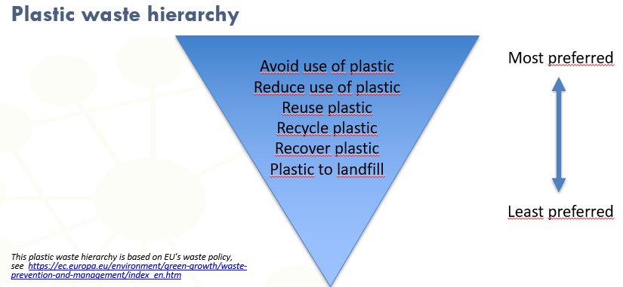

Plastic reuse statistics in different parts of the world
Europe
Approx. 27 % plastic waste went to landfill (2016), the trend is very positive, and less plastic goes landfill compared to some few years ago. But there are still big differences between the European countries, the northern part of Europe is recycling/recovering more than 90 % of all plastic waste, while several countries in the southern and eastern part still send 60-80 % to landfill.

Sources for further readings:
https://journals.openedition.org/factsreports/pdf/5102
https://denuo.be/sites/default/files/AF_Plastics_the_facts-WEB-2020-ING_FINAL.pdf
https://www.plasticseurope.org/en/focus-areas/circular-economy/zero-plastics-landfill
https://www.procarton.com/wp-content/uploads/2018/06/PC-Carton-Plastic-Sustainability.pdf

USA
In USA 75 % of all municipal solid waste plastic (MSW) were landfilled (2018).
Source for further readings:
https://www.epa.gov/facts-and-figures-about-materials-waste-and-recycling/plastics-material-specific-data

Globally
Ther situation globally is still challenging, only 9 % of plastic waste is being recycled according to UN. And due to a much better situation in Europe, many countries recycle less than 9%.
Here are some pictures illustrating the plastic waste situation:
https://www.efe.com/efe/english/world/un-warns-globally-only-9-percent-of-plastic-waste-is-recycled/50000262-3638548

But there are several examples of innovation projects that includes bringing single-use-plastic into new products in countries that until today has received huge amount of plastic waste from all over the world.
Here is an example from an UN supported project in India, where plastic waste is used for road construction, and to produce fuel cement furnaces which could be very useful in development countries with lack of energy resources:
https://news.un.org/en/story/2019/12/1052551

For further readings:
https://www.globalpolicyjournal.com/blog/23/06/2020/plastic-dilemma-brief-essay-big-problem

Teacher educators present activity 5.1 to pre-service teachers using ppt presentation [1] and worksheets [1].

This session contributes to the achievement of the following learning outcomes:
- Increase the understanding of the society's dependence of oil and oil products.
- Gives insight to the huge plastic waste problem and where the plastic waste goes in different parts of the world.
- Introduction of the concept of circular economy and its opportunities and challenges.

5.2. Alternatives to plastic bottles
 | Duration: 5 minutes introduction + 10 minutes reading + 30 min. group work + 15 minutes preparation, and presentation for whole class
Background
During history several materials have been used for storage of liquids.
Examples of materials for liquid storage (to replace plastic bottles)
- Paper/cardboard
- Wood
- Metal
- Glass
- Ceramics
- Stone
- Leather
All of these materials are available in different variants.
The purpose of this activity is to get knowledge about several materials that could be used for producing bottles and through a variant of life cycle assessment (LCA) examine and compare it to the plastic. Important questions to examine are: where the materials come from, and challenges connected to upscaling bottle production from alternative materials. The analysis of these questions is proposed to be done by looking at factors as:
- Extraction of raw materials - e.g. soil, land, seed, fertilizer, irrigation
- Manufacturing and processing - e.g. heating, water, ventilation, electricity
- Transportation - e.g. truck, rail, airplane
- Use & trade - e.g. disposable or reusable, life cycle
- Waste disposal - e.g. renewable/non-renewable raw materials, energy consumption,
release of pollutant
In all these considerations, it is useful to pay attention to several parameters as:
- Greenhouse gas emissions, e.g. carbon dioxide (CO2) or methane (CH4)
- Water consumption
- Land consumption (e.g. through cultivation of raw materials): On average, how many m² of land (or number of trees) must be planted to get paper/cardboard for 1 million plastic bottles. 1 million bottles are the number of bottles produced every minute globally!
https://www.theguardian.com/environment/2017/jun/28/a-million-a-minute-worlds-plastic-bottle-binge-as-dangerous-as-climate-change?CMP=Share_AndroidApp_Outlook

The main point her is that there are no exact results to be achieved. The most important is to come up with assumptions, and even speculations, and to try to discuss them based on evidence and research.
An analysis table template and some more information on Life Cycle Assessment (LCA) are available as worksheets. As worksheet you will also find some more infiormation, statistics and calculators on plastic vs. other materials when it comes to energy need for production, water consumption and waste.

As a part of the introduction – show this 3 min.film:
Carton vs. Plastic container (Youtube film):
https://www.youtube.com/watch?v=lxg9F2CC89k
Resources useful for this activity and the Life Cycle Analysis:
Soft drink sin plastic bottles, glass bottles or aluminium cans:
https://theconversation.com/ranked-the-environmental-impact-of-five-different-soft-drink-containers-149642
Milk in glass, plastic or cardcoard containers?
https://slate.com/technology/2011/03/should-i-buy-milk-in-glass-plastic-or-cardboard-containers.html

This session contributes to the achievement of the following learning outcomes:
- Contribute to the understanding of the complexity of use of different materials in plastic bottle production.
- Contribute to the understanding of different aspects of use of materials: Extraction of raw materials, manufacturing and processing, transportation, use & trade and waste disposal.
- Contribute to the understanding of how water consumption, CO2 emission, land use and human footprints are affected different by different raw materials used for plastic bottle production.

5.3. Advantages and disadvantages of new materials – for consumer
 | Duration: 20 minutes
In this activity the intention is to get a deeper understanding of the complexity of exchanging one material with another through groups discussions. The topic to be discussed is the advantages and disadvantages for the customer of the new product.
Results from Activity 5.2 is a background for the discussion.
This session contributes to the achievement of the following learning outcomes:
- Knowledge about pro et cons for the consumer related to one alternative material to plastic for production of bottles. With complex problems like this the discussion process is the most important as there is seldom only one answer.

5.4. Advantages and disadvantages of new materials – for nature
 | Duration: 20 minutes
In this activity the intention is to get a deeper understanding of the complexity of exchanging one material with another through groups discussions. The topic to be discussed is the advantages and disadvantages of the new product related to nature and waste challenges.
Results from Activity 5.2 is a background for the discussion.
This session contributes to the achievement of the following learning outcomes:
- Knowledge about pro et cons for nature related to one alternative material to plastic for production of bottles. With complex problems like this, the discussion process is the most important as there is seldom only one answer.

6. Designing a lesson – a case approach (45 mins)

6.1. Designing a lesson based on a local dilemma
Duration: 45 minutes
The intension of this activity is to provide future teachers with experience in planning their own session based on a local plastic dilemma. Group work is suggested, eventually as homework. Pre-service teachers are encouraged to think of a dilemma in their local community and explain this dilemma. Then, they should reflect on the dilemma from different perspectives, like environmental, social and economic – what makes it an SSI and how this SSI can be used in a lesson for students. They are supposed to develop and describe a case story based on their dilemma. For them to do this properly, it is suggested to write half a page describing this case. The video teaser in Activity 1.5 could be used as inspiration. Finally, they should plan a session for their selected student group. Criteria are given in the ppt presentation.
Teacher educators present activity 6.1 to pre-service teachers using ppt presentation [1] and worksheets [1].
This session contributes to the achievement of the following learning outcomes:
- Experience in how to apply plastic dilemmas to teach about the role of science in society
- Knowledge on how to set up socio-scientific issues (“wicked problems”) on plastics in their context
- First knowledge and skills on how to deal with environmental socio-scientific issues (e.g. identify and argue for different perspectives) in their future teaching

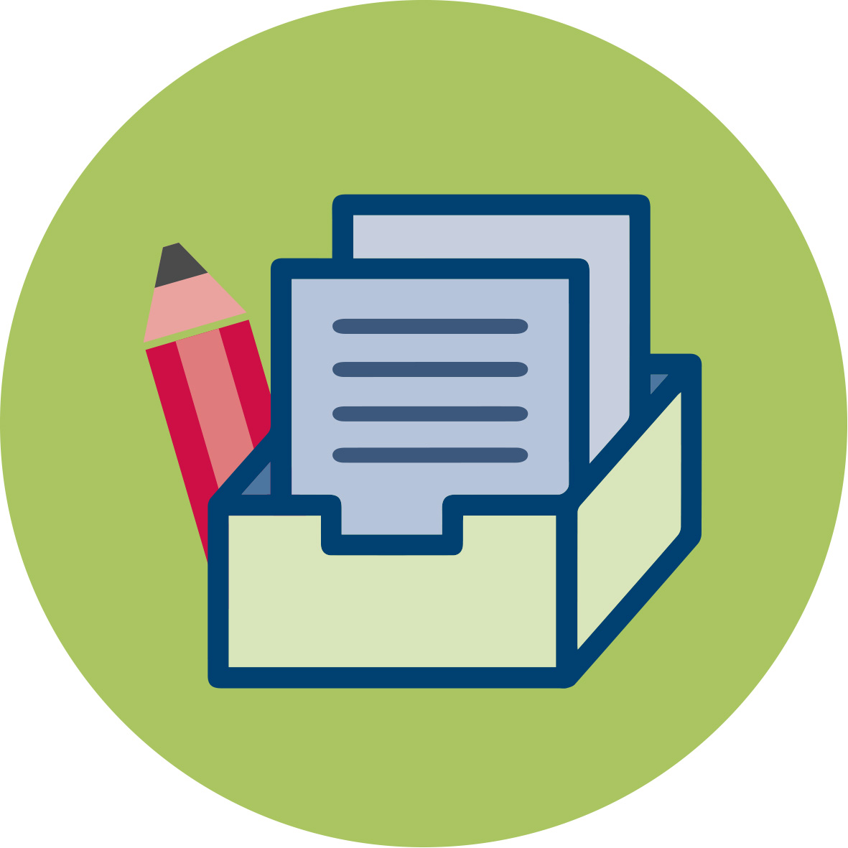 | Materials and resources
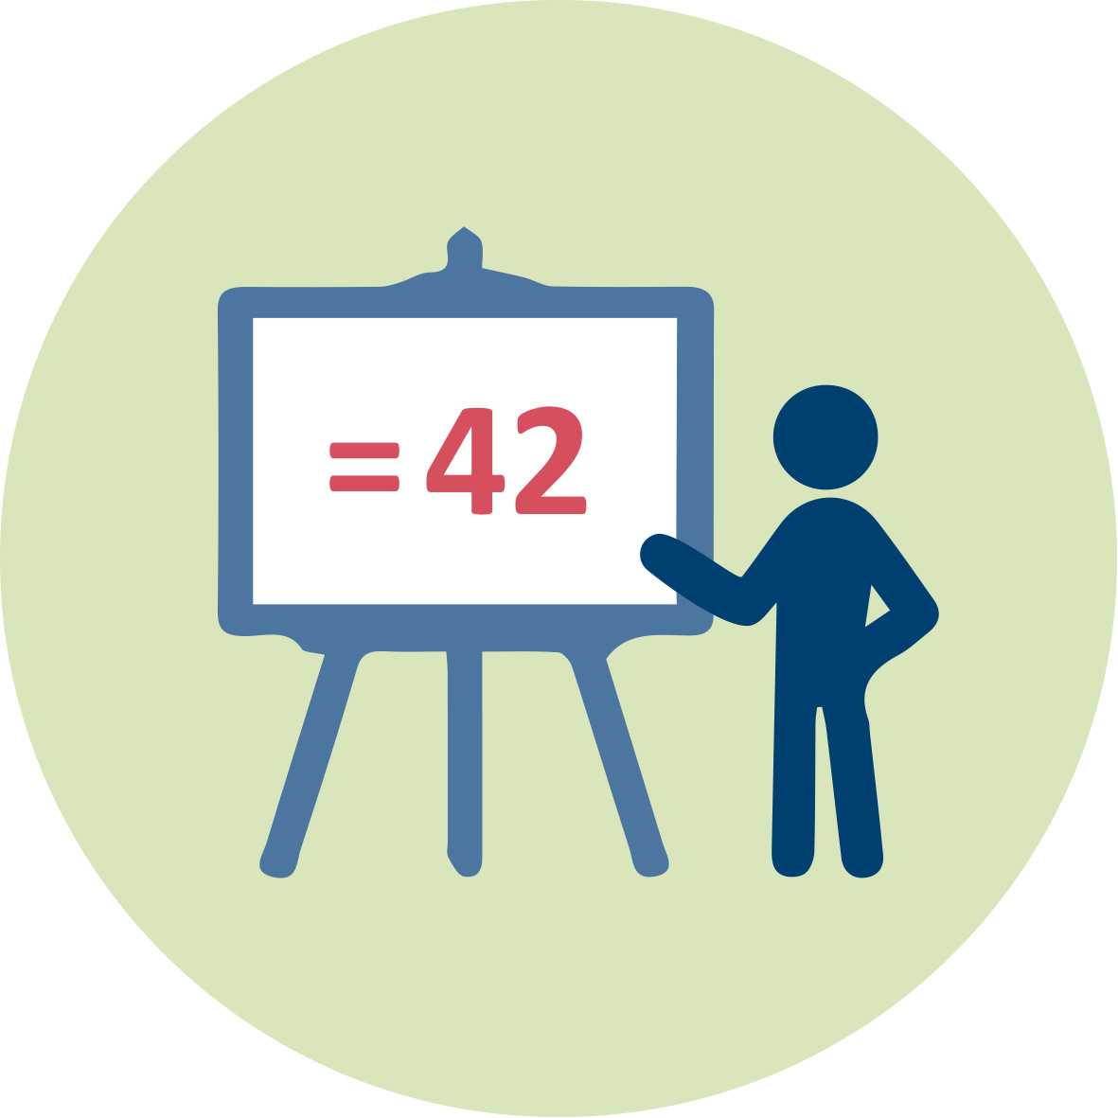 | Presentation [1] (pptx) for Teacher Educator  Worksheets [1] for student teachers  Students’ handouts  Access to computers for internet research and collaborative work

Granularity
- Skip one or two of the case stories.
- Skip activity 1.6 (debate)
- Skip practical activity 2.3 (experiment)
- Skip activity 3.3 (video teaser) and 3.7 (experiment) (video can be given as homework – flipped classroom – experiments can also be performed at home)
- Skip activity 4.6 and 4.7 (art project)
- Activity 6.1 can be given as homework or as an assignment

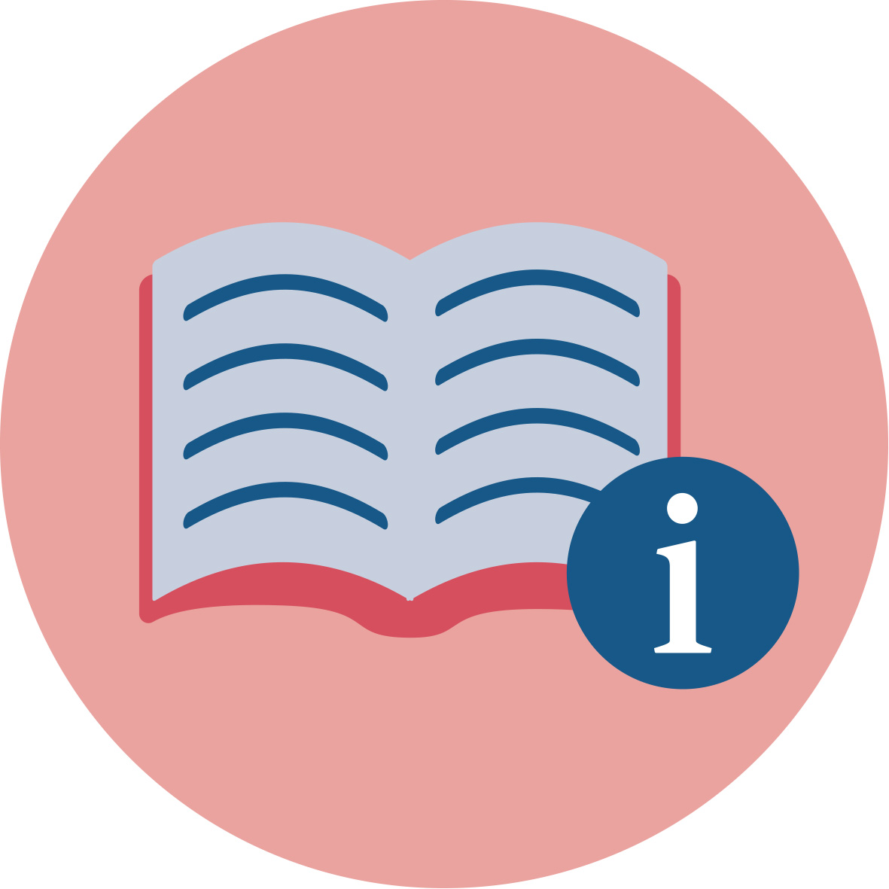 | References
- Agencia EFE (2018, 5 June). UN warns globally only 9 percent of plastic waste is recycled.
https://www.efe.com/efe/english/world/un-warns-globally-only-9-percent-of-plastic-waste-is-recycled/50000262-3638548
- Andrady, A. L. (2015). Plastics and Environmental Sustaiability. New Jersey: John Wiley & Sons.
- Barker, T. 2018. Comparison of Carton and Plastic Packaging Sustainability. Pro Carton & Truffula ltd. https://www.procarton.com/wp-content/uploads/2018/06/PC-Carton-Plastic-Sustainability.pdf
- Chow, C-F., So, W-M W., Cheung, T-Y. & Yeung, S-K. D. (2017). Plastic Waste Problem and Education for Plastic Waste Management. In Kong, S.C., Wong, T.L., Yang, M. Chow, C.F. & Tse, K.H. Emerging Practices in Scholarship of Learning and Teaching in a digital Era (pp.125-140). https://doi.org/10.1007/978-981-10-3344-5_8
- Cook, D. H. (2014). Conflicts in Chemistry: The Case of Plastics, A Role-Playing Game for High School Chemistry Students. J. Chem. Ed. 91: 1580-1586
- Çoruhlu,T. S., & Nas, S. E. (2018). The impact of project-based learning environments on conceptual understanding: The "Recycling" concept. Asia - Pacific Forum on Science Learning and Teaching; 19(1), 1-23.
- d’Ambrières, W. (2020). Plastic recycling worldwide: current overview and desirable changes. Field Actions Science Reports [Online], Special Issue 19. Reinventing Plastics.
https://journals.openedition.org/factsreports/pdf/5102
- Ecochain (n.d.) Glass vs. Plastic – What’s the more climate-friendly packing material? Ecochain Technologies B.V.
https://ecochain.com/story/case-study-packaging-plastic-vs-glass/
- EPA – United States Environmental Protection Agency. (n.d.). Plastics: Material-Specific Data.
https://www.epa.gov/facts-and-figures-about-materials-waste-and-recycling/plastics-material-specific-data
- Fradd, S. H., Lee, O., Sutman, F. X., & Saxton, M. K. (2001). Promoting science literacy with English language learners through instructional materials development: A case study. Bilingual Research Journal, 25, 4, 479-501.
- Freinkel, S. (2011). Plastic – a Toxic Love Story. Melbourne, Vic.: TextPub.
- Geyer, R., Jambeck, J. R., & Law, K. L. (2017). Production, use, and fate of all plastics ever made. Sci Adv, 3 (7), e1700782.
https://doi.org/10.1126/sciadv.1700782
- Gillies, R., Jones, P., Papineschi, J. (2017). Recycling – Who Really Leads the World? (Issue 2)​. Eunomia Research and Consulting & European Environmental Bureau (EEB)​. 11th December 2017​
- Groh, K. J., Backhaus, T., Carney-Almroth, B., Geueke,B., Inostroza, P. A., Lennquist, A., … Muncke, J. (2019). Overview of known plastic packaging-associated chemicals and their hazards. Science of The Total Environment, 651(2), 3253-3268. https://doi.org/10.1016/j.scitotenv.2018.10.015
- Gutowski. T.G., Sahni, S., Allwood, J.M., Ashby, M.F. & Worrell, E. (2013). The energy required to produce materials: constraints on energy-intensity improvements, parameters of demand. Philosophical Transactions of The Royal Society A 371: 20120003. The Royal Society Publishing. https://royalsocietypublishing.org/doi/pdf/10.1098/rsta.2012.0003
- Laville, S. & Taylor, M. (2017, 28 June). A million bottles a minute: world’s plastic binge’as dangerous as climate change. The Guardian. https://www.theguardian.com/environment/2017/jun/28/a-million-a-minute-worlds-plastic-bottle-binge-as-dangerous-as-climate-change?CMP=Share_AndroidApp_Outlook
- Maddox, P., Doran, C., Williams, I.D, & Kus, M. (2011). The role of intergenerational influence in waste education programmes: The THAW project. Waste management (Elmsford), 31 (12), 2590-2600.
- Mastro, P. F. (2016). Plastics Product Design. Austin, Texas: Scrivener Publishing LLC.
- Meikel, J. L. (1995). American Plastic – a Cultural History. New Brunswick, New Jersey: Rutgers University Press
- Montgomery, S. (2020, 23 June). Plastic Dilemma: A brief Essay on a Big Problem. Global Policy. https://www.globalpolicyjournal.com/blog/23/06/2020/plastic-dilemma-brief-essay-big-problem
- Onstad, E. (2019, 17 October). Plastic bottles vs. aluminium cans: who’ll win the global wate fight. Reuters. https://www.reuters.com/article/us-environment-plastic-aluminium-insight-idUSKBN1WW0J5
- Palmer, B. (2011, 1 March). Disoriented in the Dairy Aisle. Should I buy milk in glass, plastic or cardboard containers? SLATE. Graham Holding Company.https://slate.com/technology/2011/03/should-i-buy-milk-in-glass-plastic-or-cardboard-containers.html
- Parker, L. (2019, 23 August). How the plastic bottle went from miracle container to hated garbage. National Geographics.
https://www.nationalgeographic.com/environment/2019/08/plastic-bottles/
- Plastic Europe – Association of Plastics Manufactures (n.d.). Zero Plastic to landfill. https://www.plasticseurope.org/en/focus-areas/circular-economy/zero-plastics-landfill
- Plastic Europe – Association of Plastics Manufactures (2020). Plastics – The Facts 2020. An analysis of European plastics production, demand and waste data. https://denuo.be/sites/default/files/AF_Plastics_the_facts-WEB-2020-ING_FINAL.pdf
- Statista (2020). PET plastic bottle recycling rates in selected countries as of 2018. https://www.statista.com/statistics/1166550/plastic-bottle-recycling-rates-in-select-countries/
- Stern, M. J., Powell, R. B., & Hill, D. (2014). Environmental education program evaluation in the new millennium: What do we measure and what have we learned? Environmental Education Research, 20(5), 581–611, https://doi.org/10.1080/13504622.2013.838749
- Tafoya, Sunal, & Knecht. (1980). Assessing Inquiry Potential: A Tool For Curriculum Decision Makers. School Science & Mathematics, 80(1):43-48. ​
- Tobolova, M. (2015). Understanding NTNU's students' and employees' recycling behaviour based on intervention strategies by applying a comprehensive psychological model. Master thesis, NTNU.
- Turner, A., Arnold, R., & Williams, T. (2020). Weathering and persistence of plastic in the marine environment: Lessons from LEGO. Environmental Pollution, s. 114299. https://doi.org/10.1016/j.envpol.2020.114299
- Uehara, T. (2020). Can Young Generations Recognize Marine Plastic Waste as a Systemic Issue? Sustainability, 12(7), 2586.
- Ugulu, I., Yorek, N., & Baslar, S. (2015). The effect of recycling education on high school students conceptual understanding about ecology: A study on matter cycle. Educational research and reviews, 10(16), 2207-2215.
- Zorpas, A. A., Voukkali, I., & Loizia, P. (2017). Effectiveness of waste prevention program in primary students' schools. Environmental Science and Pollution Research, 24(16), 14304–14311.

Further readings
History of plastics:
- Meikel, J. L. (1995). American Plastic – a Cultural History. New Brunswick, New Jersey: Rutgers University Press
- Freinkel, S. (2011). Plastic – a Toxic Love Story. Melbourne, Vic.: TextPub.

Lesson plans and laboratory manuals from a course dealing with plastics:
- Fagnani, D. E., Hall, A. O., Zurcher, D. M., Sekoni, K. N., Barbu, B. N., & McNeil, A. J. (2020). Short Course on Sustainable Polymers for High School Students. J. Chem. Educ., 97, 2160−2168.
- Report from a two-week summer camp for high school students focused on sustainable polymers. Include links to supporting Information (https://pubs.acs.org/doi/10.1021/acs.jchemed.0c00507): Laboratory manual with course syllabus, tentative schedule, lesson plans with materials and supplies list, and UV−vis operating instructions and troubleshooting, daily schedule, lesson plans with graphics, materials and supplies lists, and links to supplementary content, figure of refurbished plastic piece after melt-processing, and tables of student survey responses.
Quarterly problem, ICSE, Green Edition: Sustainability of masks. Incl. Helpsheet - "Life Cycle Assessment - how to do it", see https://icse.eu/materials/quarterly-problem-green-edition/

Assessment
Assessment methods
Individual portfolio of students’ work, based on the activities 1.1, 1.4-1.7, 2.3, 3.2, 3.4, 3.6, 3.7, 4.2, 4.4, 4.5, 5.2-5.4, and 6.1, depending on the granularity.

Assessment criteria
The assessment criteria are based on the scientific content (learning dimension) and the pedagogical aspects (teaching dimension).
Learning dimension:
Students should be able to
- describe what plastic and micro-plastic and their effects on nature and humankind are
- assess sustainable development aspects (environmental, social and economic) in relation to the plastic dilemma
- explain the life cycle of plastic bottles, from production to waste, mainly in their own country, but also with an international perspective
- discuss different dimensions of the plastic dilemma (historic, economic, social, environmental – local and international)
- take part in discussions on the plastic dilemma
- acquire basic knowledge and skills that enable them to take critical action (action competence)
Teaching dimension:
Students should
- know about plastic pollution as a “wicked problem” in their national and/or local curriculum
- have experience in how to apply plastic dilemmas to teach about the role of science in society
- master inquiry-based learning approaches to plastic dilemmas in an SSI-perspective
- know how to set up socio-scientific issues (“wicked problems”) on plastics in their context
- acquire basic knowledge and skills on how to deal with environmental socio-scientific issues (e.g. identify and argue for different perspectives) in their future teaching
Of course, teacher educators can modify or add their own criteria according to what suit them best.

