Module12 | SOCIO-SCIENTIFIC ISSUES AND ASSESSMENT

This outline is based on the work within the project Environmental Socio-Scientific Issues in Initial Teacher Education (ENSITE). Coordination: Prof. Dr. Katja Maaß, UNIVERSITY OF EDUCATION FREIBURG, Germany. Partners: UNIVERSITEIT UTRECHT, Netherlands; ETHNIKO KAI KAPODISTRIAKO PANEPISTIMIO ATHINON, Greece; UNIVERSITÄT KLAGENFURT, Austria; UNIVERZITA KARLOVA, Czech Republic; UNIVERSITA TA MALTA, Malta; HACETTEPE UNIVERSITY, Turkey; NORGES TEKNISK-NATURVITENSKAPELIGE UNIVERSITET NTNU, Norway; UNIVERSITY OF NICOSIA, Cyprus; INSTITUTE OF MATHEMATICS AND INFORMATICS AT THE BULGARIAN ACADEMY OF SCIENCE, Bulgaria; UNIVERZITA KONSTANTINA FILOZOFA V NITRE, Slovakia.

The project Environmental Socio-Scientific Issues in Initial Teacher Education (ENSITE) has received co -funding by the Erasmus+ programme of the European Union (grant no. 2019-1-DE01-KA203-005046).Neither the European Union/European Commission nor the project's national funding agency DAAD are responsible for the content or liable for any losses or damage resulting of the use of these resources.

© ENSITE project (grant no. 2019-1-DE01-KA203-005046) 2019-2022, lead contributions by Farrugia, J. and Musumeci, M. University of Malta, Malta. CC BY-NC-SA 4.0 license granted.

General overview and aim
The main aim of this module is to provide student-teachers with the opportunity to reflect on how students’ learning may be assessed in lessons involving SSI. The module will introduce assessment related to SSI and debates surrounding this issue.

Student-teachers are provided with a concrete example of an environmental SSI such that they experience learning through this context. They will go through the inquiry process proposed in the module and experience the assessment process themselves. Future teachers will reflect on different aspects of assessment, such as assessing content and argumentation and providing feedback to move students towards desired learning outcomes.

This module is related to:
LEARNING: Developing competences and inquiry skills required in dealing with environmental SSI
TEACHING: Acquiring competences related to teaching and assessment of content and skills related to SSI with the aim of improving learning and acquisition of skills.

This module assumes that prospective science and mathematics teachers have already been introduced to SSI and the use of SSI in science and mathematics education. Reference to Module IO1 is recommended. This module is also linked to other modules such as IO2, IO5, IO8, IO9, IO10 and IO11.

Relevant topics
This module emphasises the importance of formative assessment in the development of skills and competences required when dealing with socio-scientific issues. Student-teachers will reflect on the challenges involved in learning these competences and will get an insight on how formative assessment may be included in their lessons.

Learning Outcomes

Student-teachers will be able to:
- List possible outcomes that may be achieved by students when learning through SSI (Activity 1.1, 1.2).
- List possible challenges involved in achieving learning outcomes related to SSI (Activity 1.2, 1.3).
- List possible challenges involved in assessing learning outcomes related to SSI (Activity 1.2, 1.3).
- Identify limitations of tests or classroom exercises in assessing certain learning outcomes related to skills and competences associated with SSI (Activity 1.3).
- Describe the characteristics of an inquiry process related to a SSI (Activity 2.1,2.4, 2.5, 2.6).
- Discuss the dilemma involved in taking a position related to a SSI (Activity 2.1, 2.2, 2.3, 2.6, 2.7).
- Describe how students can arrive at a decision related to a SSI based on a number of considerations (Activity 2.6, 2.7).
- Discuss the skills and competences that teachers need in order to lead and support an inquiry activity related to SSIs (Activity 2.1, 2.2, 2.3, 2.4, 2.5, 2.6).
- Describe the knowledge and competences required when dealing with environmental socio-scientific issues in their future teaching (Activity 2.1, 2.3, 2.6, 2.7).
- Use a given rubric to evaluate competences (self and peer) related to science/mathematics content and argumentation (Activity 3.1).
- Discuss the benefits of self-evaluation and peer-evaluation on further development of skills and competences related to SSI (Activity 3.1).
- Outline how a rubric may be used for formative assessment as part of SSI lessons (Activity 3.2)
- Prepare a rubric for formative assessment for a SSI lesson with a specific year group (Activity 3.2).

Flowchart and Module plan

This module consists of three sections, each composed of a number of activities. It includes 275 minutes of class sessions and homework. It includes tutor input, group discussions, an inquiry, a debate, production of a short video and student presentations.

The structure is as follows:

- What are the challenges associated with assessing skills and competences required in SSI lessons? 45 minutes
- What knowledge and competences do teachers need when assigning an inquiry dealing with environmental socio-scientific issues? 110 minutes + 60 minutes + home work
- How can formative assessment support students in the development of skills and competences required for dealing with SSIs? 70 minutes + home work

1. What are the challenges associated with assessment of skills and competences required in SSI lessons? (45 minutes)

1.1. Introduction
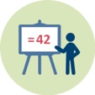 | Duration: 5 minutes
This activity is intended to introduce the challenge of assessment of SSIs to prospective science and mathematics teachers. Teacher educators introduce the module using the ppt presentation.
This activity will contribute towards achievement of the following learning outcome:
- Student-teachers will be able to list possible outcomes that may be achieved by students when learning through SSI.

1.2. What outcomes are we after when we teach through SSI?
 | Duration: 30 minutes
This activity is intended to lead student teachers to reflect on challenges related to the assessment of skills and competences needed for dealing with SSIs.
Teacher educators will involve student teachers in a think-pair-share brainstorming activity. Reflections related to outcomes sought through the use of SSI in lessons and challenges involved in achieving these outcomes are initiated.
This activity will contribute towards achievement of the following learning outcomes:
- Student teachers will be able to list possible outcomes that may be achieved by students when learning through SSI.
- Student teachers will be able to list possible challenges involved in achieving learning outcomes related to SSI.
- Student teachers will be able to list possible challenges involved in assessing learning outcomes related to SSI.

1.3. What challenges are involved in assessing these outcomes?
 | Duration: 10 minutes
This activity will introduce students to literature related to how skills and competences related to SSIs have been assessed and the challenges involved.
The teacher educator will give a short ppt presentation of key findings from literature.
This activity will contribute towards achievement of the following learning outcomes:
- Student teachers will be able to list possible challenges involved in achieving learning outcomes related to SSI.
- Student teachers will be able to list possible challenges involved in assessing learning outcomes related to SSI.
- Student teachers will be able to identify limitations of tests or classroom exercises in assessing certain learning outcomes related to skills and competences associated with SSI.

2. What knowledge and competences do teachers need when assigning an inquiry dealing with environmental socio-scientific issues? 110 + 60 minutes + HW

2.1. Introducing a dilemma
Duration: 20 minutes
This activity is intended to provide student teachers with a concrete example of an environmental SSI such that they experience learning through SSI.
Student-teachers will be presented with a dilemma related to an environmental SSI. The teacher educator will present the issue using a handout with newspaper reports. The dilemma being suggested is related to the use of pyrotechnics in the vicinity of towns and villages as part of celebratory events. A case study of the use of fireworks in Malta is given as an example. If this dilemma is not relevant enough for a particular group of student-teachers one may use the context of a theme park that has a fireworks display every night or the use of pyrotechnics by the military for training purposes. If these two are not relevant or compelling enough one may replace this SSI with another.
This activity will contribute towards achievement of the following learning outcomes:
- Student teachers will be able to describe the characteristics of an inquiry process related to a SSI.
- Student teachers will be able to discuss the dilemma involved in taking a position related to a SSI.
- Student teachers will be able to discuss the skills and competences that teachers need in order to lead and support an inquiry activity related to SSIs.
- Student teachers will be able to describe the knowledge and competences required when dealing with environmental socio-scientific issues in their future teaching.

2.2. Initial opinion forming
Duration: 10 minutes
This activity is intended to place student-teachers in a position where they need to form an opinion related to a specific environmental SSI.
Student-teachers are invited to think on an individual basis about the dilemma, write down notes and form an opinion.
This activity will contribute towards achievement of the following learning outcomes:
- Student teachers will be able to discuss the dilemma involved in taking a position related to a SSI.
- Student teachers will be able to discuss the skills and competences that teachers need in order to lead and support an inquiry activity related to SSIs.

2.3. Taking a position on a controversy line
Duration: 20 minutes
This activity is intended to encourage student-teachers to share an opinion on the dilemma.
Student-teachers will be asked to position themselves along a line depending on their extent of agreement with a statement related to the dilemma. They will also explain and discuss their position and ask questions.
The position on the controversy line may be a physical position on a line formed in the classroom or a position marked using digital tools.
This activity will contribute towards achievement of the following learning outcomes:
- Student teachers will be able to discuss the dilemma involved in taking a position related to a SSI.
- Student teachers will be able to discuss the skills and competences that teachers need in order to lead and support an inquiry activity related to SSIs.
- Student teachers will be able to describe the knowledge and competences required when dealing with environmental socio-scientific issues in their future teaching.

2.4. Asking questions related to the controversy
Duration: 30 minutes
Through this activity student-teachers will experience working on an inquiry.
They will start working on the inquiry related to the given SSI by formulating questions related to the dilemma. Students are invited to think, on an individual basis, of questions they would like to ask. Then they work in small groups on the questions they wish to investigate.
This activity will contribute towards achievement of the following learning outcomes:
- Student teachers will be able to describe the characteristics of an inquiry process related to a SSI.
- Student teachers will be able to discuss the skills and competences that teachers need in order to lead and support an inquiry activity related to SSIs.

2.5. Planning an inquiry related to the SSI
Duration: 30 minutes + Home Work
This activity will give student-teachers the opportunity to experience working on an inquiry.
Through this activity students will plan an inquiry related to the given SSI exercising their ability to recognize information that is not available regarding the issue as well as the ability to consider ways in which this information may be generated.
A handout may be used to introduce the task. Students are given time to start the planning of their inquiry during the session. They are then given two weeks to work on the inquiry and produce a video in which they present their findings and their position with respect to the dilemma. Instead of the video, the teacher educator may opt to invite student teachers to research a particular aspect and then share the expertise gained with the rest of the class.
Alternatively one may opt to provide students with data from a study investigating the effect of fireworks on air quality. Students are required to find ways of analysing the data provided and using the information when presenting their arguments. This may be particularly useful with mathematics student-teachers.
This activity will contribute towards achievement of the following learning outcomes:
- Student teachers will be able to describe the characteristics of an inquiry process related to a SSI.
- Student teachers will be able to discuss the skills and competences that teachers need in order to lead and support an inquiry activity related to SSIs.

2.6. Presenting results of the inquiry
Duration: 40 minutes
This activity will enable student-teachers to reflect on their work on the inquiry.
They will be given the opportunity to present the videos and discuss the inquiry, methods used, findings and their position with respect to the dilemma
This activity will contribute towards achievement of the following learning outcomes:
- Student teachers will be able to describe the characteristics of an inquiry process related to a SSI.
- Student teachers will be able to discuss the dilemma involved in taking a position related to a SSI.
- Student teachers will be able to discuss the skills and competences that teachers need in order to lead and support an inquiry activity related to SSIs.
- Student teachers will be able to describe how students can arrive at a decision related to a SSI based on a number of considerations.

2.7. Arriving at a decision
Duration: 30 minutes
This activity is intended to give student-teachers the experience and challenge of trying to arrive at an evidence-informed decision related to the SSI.
Through this activity student-teachers will arrive at a decision with respect to the dilemma after considering different arguments, different interests, values, scientific ideas and scientific uncertainties. They are invited to take action based on their decision such as writing a letter to a newspaper or an authority and so on. This action is only intended as a classroom action.
This activity will contribute towards achievement of the following learning outcomes:
- Student teachers will be able to discuss the dilemma involved in taking a position related to a SSI.
- Student teachers will be able to describe how students can arrive at a decision related to a SSI based on a number of considerations.

3. How can formative assessment support students in the development of skills and competences required for dealing with SSIs?

3.1. Introduction to the rubric
Duration: 10 minutes
This activity is intended to introduce the rubric and the terms used in the rubric so that student teachers will be able to use it. Other modules may be consulted too.
This activity will contribute towards achievement of the following learning outcome:
- Student teachers will be able to use a given rubric to evaluate competences (self and peer) related to science/mathematics content and argumentation.
3.2. Reflection and Evaluation using self- and peer-assessment
Duration: 40 minutes
This activity is intended to help student-teachers reflect on the benefits of self- and peer-assessment for their students when teaching through SSIs.
Through this activity student-teachers will work as a group and use a given rubric (handout) to evaluate competences demonstrated in the videos related to the SSI dilemma. The rubric, developed for this module, is based on Simon, Erduran and Osborne (2006); Schen (2013); Christenson and Rudgren (2015). The teacher educator will invite them to reflect on the benefits of such an exercise on further development of skills and competences related to SSI.
This activity will contribute towards achievement of the following learning outcomes:
- Student teachers will be able to use a given rubric to evaluate competences (self and peer) related to science/mathematics content and argumentation.
- Student teachers will be able to discuss the benefits of self-evaluation and peer-evaluation on further development of their students’ skills and competences related to SSI.

3.3. How can a rubric be used for formative assessment as part of SSI lessons?
Duration: 20 minutes + Home Work
This activity is intended to introduce students to the use of formative assessment during SSI lessons.
Student-teachers will reflect on how a rubric may be used for formative assessment as part of SSI lessons to provide feedback to students. They will work as a group to prepare a modified rubric with wording appropriate for use with students of a particular year group.
This activity will contribute towards achievement of the following learning outcomes:
- Student teachers will be able to outline how a rubric may be used for formative assessment as part of SSI lessons.
- Student teachers will be able to prepare a rubric for formative assessment for a SSI lesson with a specific year group.

 | Materials and resources
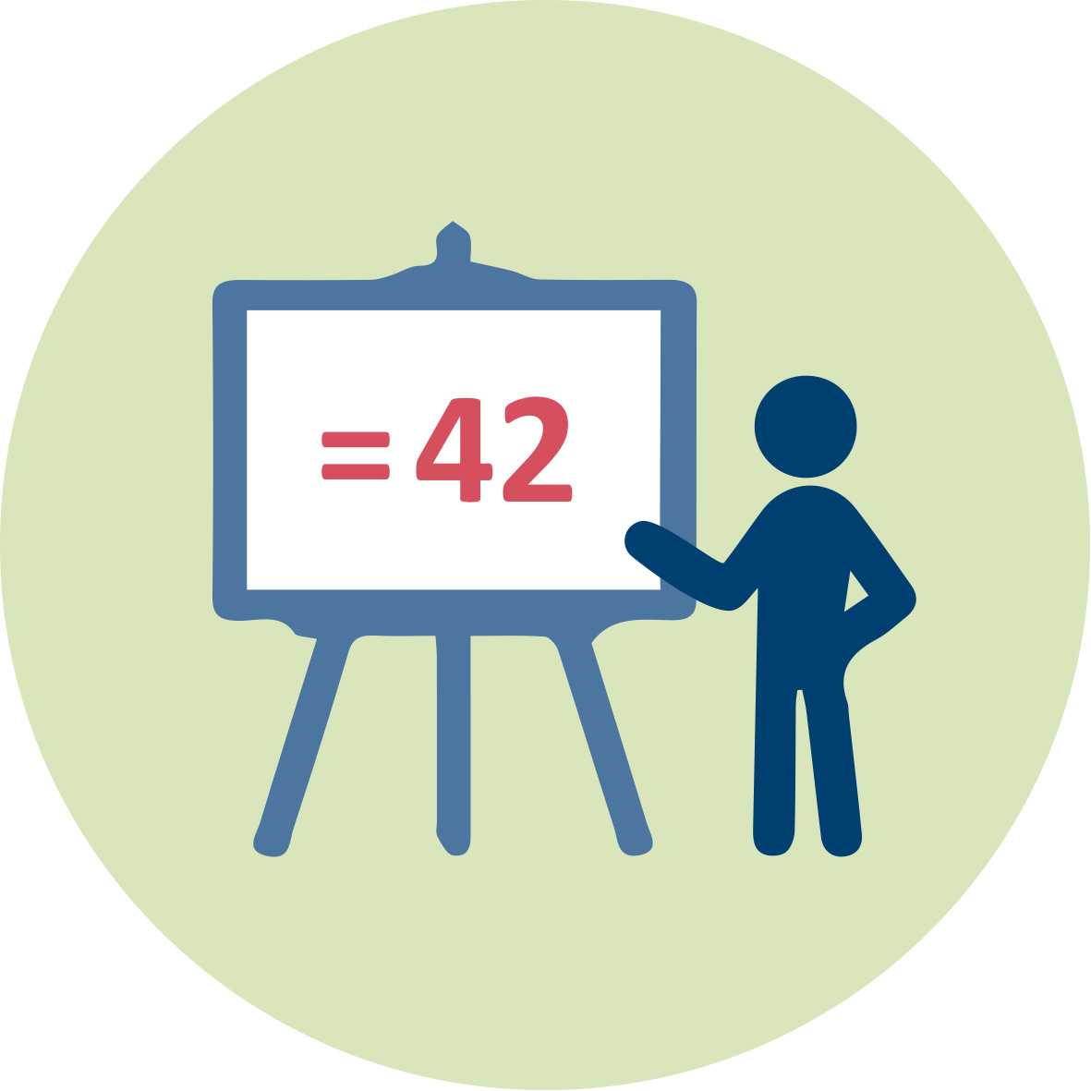 | Presentation 1 (pptx). Teacher Educator “Socio-scientific issues and Assessment”
 | Students’ handouts
 | Access to computers for internet research and collaborative work

Granularity
- In Activity 2.3, the formation of the line may be skipped and replaced by a discussion of views.
- Activity 2.5 may involve an open inquiry or an alternative task where students analyse given experimental data.
- The Home Work related to activity 2.5 may be skipped.
- Activity 2.6 involving the videos prepared by the students may be replaced by a discussion about the dilemma in order to arrive at a decision.

References
Christenson, N., & Chang Rundgren, S. N. (2015). A framework for teachers’ assessment of socio-scientific argumentation: an example using the GMO issue. Journal of Biological Education, 49(2), 204-212.

Driver, R., Newton, P., & Osborne, J. (2000). Establishing the norms of scientific argumentation in classrooms. Science Education, 84, 287–312.

Foong, C. C., & Daniel, E. G. (2010). Assessing students’ arguments made in socio-scientific contexts: The considerations of structural complexity and the depth of content knowledge. Procedia-Social and Behavioral Sciences, 9, 1120-1127.

Kolstø, S. D. (2001). 'To trust or not to trust,…'-pupils' ways of judging information encountered in a socio-scientific issue. International Journal of Science Education, 23(9), 877-901.

Sadler, T.D., Barab, S.A., & Scott, B. (2007). What do students gain by engaging in socioscientific inquiry? Research in Science Education, 37, 371–391.

Sadler, T. D., & Zeidler, D. L. (2009). Scientific literacy, PISA, and socioscientific discourse: Assessment for progressive aims of science education. Journal of Research in Science Teaching: The Official Journal of the National Association for Research in Science Teaching, 46(8), 909-921.

Schen, M. (2013). A comparison of biology majors’ written arguments across the curriculum. Journal of Biological Education, 47(4), 224-231.

Simon, S., Erduran, S., & Osborne, J. (2006). Learning to teach argumentation: Research and development in the science classroom. International journal of science education, 28(2-3), 235-260.

Further readings
Black, P., & Wiliam, D. (1998). Inside the black box. Phi Delta Kappan, 80(2), 139-148.

Black, P., & Wiliam, D. (2010). Inside the Black Box: Raising Standards through Classroom Assessment. Phi Delta Kappan, 92(1), 81–90. doi:10.1177/003172171009200119 url to share this paper: sci-hub.do/10.1177/003172171009200119

Pouliot, C. (2008). Students’ inventory of social actors concerned by the controversy surrounding cellular telephones: A case study. Science Education, 92, 543–599.

Puig, B., & Jiménez-Aleixandre, M. P. (2011). Different music to the same score: teaching about genes, environment, and human performances. In Socio-scientific Issues in the Classroom (pp. 201-238). Springer, Dordrecht.

Ryder, J. (2001). Identifying science understanding for functional scientific literacy. Studies in Science Education, 36(1), 1-44.

Walker, K. A., & Zeidler, D. L. (2007). Promoting discourse about socioscientific issues through scaffolded inquiry. International journal of science education, 29(11), 1387-1410.

Zeidler, D. L., Sadler, T. D., Applebaum, S., & Callahan, B. E. (2009). Advancing reflective judgment through socioscientific issues. Journal of Research in Science Teaching: The Official Journal of the National Association for Research in Science Teaching, 46(1), 74-101.

Zohar, A., & Nemet, F. (2002). Fostering students’ knowledge and argumentation skills through dilemmas in human genetics. Journal of Research in Science Teaching, 39, 35–62.

Assessment
Different formative assessment strategies, among others, are introduced in the module.

