Module 4 | ANALYSING (BIG) DATA

This outline is based on the work within the project Environmental Socio-Scientific Issues in Initial Teacher Education (ENSITE). Coordination: Prof. Dr. Katja Maaß, UNIVERSITY OF EDUCATION FREIBURG, Germany. Partners: UNIVERSITEIT UTRECHT, Netherlands; ETHNIKO KAI KAPODISTRIAKO PANEPISTIMIO ATHINON, Greece; UNIVERSITÄT KLAGENFURT, Austria; UNIVERZITA KARLOVA, Czech Republic; UNIVERSITA TA MALTA, Malta; HACETTEPE UNIVERSITY, Turkey; NORGES TEKNISK-NATURVITENSKAPELIGE UNIVERSITET NTNU, Norway; UNIVERSITY OF NICOSIA, Cyprus; INSTITUTE OF MATHEMATICS AND INFORMATICS AT THE BULGARIAN ACADEMY OF SCIENCE, Bulgaria; UNIVERZITA KONSTANTINA FILOZOFA V NITRE, Slovakia.

The project Environmental Socio-Scientific Issues in Initial Teacher Education (ENSITE) has received co -funding by the Erasmus+ programme of the European Union (grant no. 2019-1-DE01-KA203-005046). Neither the European Union/European Commission nor the project's national funding agency DAAD are responsible for the content or liable for any losses or damage resulting of the use of these resources.

© ENSITE project (grant no. 2019-1-DE01-KA203-005046) 2019-2022, lead contributions by International Centre for STEM Education (ICSE) at the University of Education Freiburg, Germany. CC BY-NC-SA 4.0 license granted.

General overview and aim
In this module future teachers in initial teacher education are introduced to the role of (big) data in the context of environmental socio scientific issues (SSI).
The module is designed to be relevant to day-to-day teaching. Therefore, concrete examples are chosen. In the module ITE students explore the structure of datasets and explore different visualisations of the same data telling ‘different stories’. Students are provided with some theoretical background on ‘big data’ and the dilemma’s and challenges the use of big data presents for society. They also get some practice in analysing data on environmental socio-scientific issues themselves. concrete examples of lessons give them the chance to plan to use (big) data on environmental socio-scientific issues in their own teaching. The methods chosen prioritize students’ active learning.

This module is part of:
LEARNING: Developing competences in analysing and visualizing (big) data related to environmental SSI.
TEACHING: Acquiring teaching skills to support their secondary school students in developing similar competences.

Both aspects relate to (i) scientific competences, (ii) transversal skills like critical thinking, innovative mind-sets, and forward-looking skills and (iii) considering the social, ethical, and cultural aspects related to SSI when making decisions.

IO4 is a module focusing on using, analysing, and visualising data in the context of environmental SSI and is closely related to the other ‘data module’: IO3 Collecting data.
IO4 can also be used in relation to other modules, where in those modules data are involved for example in relation to making and validating arguments when discussing SSI.

These crosslinks are intended and are a strength of the approach, as they help to deepen the knowledge on a certain aspect and shed light on it from different perspectives. They also serve the purpose that the individual modules also can be used as stand-alone modules. If several modules are used it is of course the decision of the user whether he uses them.

Relevant topics
In this module the emphasis is on connecting environmental socio-scientific issues to data and statistics. Students in ITE will learn how (big) data and data analysis can be used when exploring and discussing socio-scientific issues. Themes in this module are global warming and the ecological footprint, these are related to (among others) the Sustainable Development Goals (SDG) of the United nations (UN)

Students will work first on the theme of Global Warming. Next they will get some background on (big) data: what do we mean by ‘big data’? Who is using big data, for what purposes? What issues and dilemmas are involved in the use of big data? Students then get the opportunity to analyse and visualise a large set of data on the ecological footprint. In the last part they will work on examples of teaching materials that can be used in classrooms in (lower) secondary education and they (re)design a lesson or an activity based on these examples for their own teaching.

Learning Outcomes

Students will
- Get experience in dealing with environmental socio-scientific issues involving data (All activities)
- Develop understanding of the way data can be used to reason about SSI (1.1, 1.2, 1.3, 3.2)
- Understand how different visualisations influence the ‘story the data tells’. (1.1, 1.2, 3.3)
- Acquire knowledge about the role of (big) data, algorithms, and data-analysis in everyday live and when dealing environmental socio-scientific issues (2.1 and 2.2)
- Expand (or refresh) their skills on how to explore, analyse and visually represent (big) data (3.1, 3.2, 3.3)
- Become aware that dealing with environmental socio-scientific issues can be linked to the goals of statistics (STEM) education (4.1, 4.2)
- Become aware of the possibilities and necessity to connect environmental SSI and statistics (analysing data) in their (mathematics or STEM) teaching (4.1, 4.2)

Flowchart and Module plan

This module involves four sections, all structured into several activities. It includes 305-400 minutes of sessions; homework is optional and can replace session time. The structure is as follows:

- Part I: Introduction to environmental SSI and (big) data - global warming. (120-135 minutes)
- Part II: Background on big data. (60-90 minutes)
- Part III: Analyzing and representing data. (80 minutes + optional time for 3.1)
- Part IV: Classroom teaching: Analyzing and designing a lesson. (45 minutes + 45 minutes optional for 4.2)

- Introduction: environmental SSI and (big) data – the example of global warming

1.1. Global warming
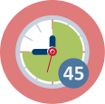
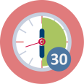
Duration: 30-45 minutes
This is a “warm up” activity. The intention is to have future teachers think about the ‘worldwide problem’ of global warming (climate change) and make them aware of the way their opinion on this is formed and how data play in role this.

Some background information:
‘Climate Change’ is one of the sustainable development goals of the UN. See: https://sustainabledevelopment.un.org/sdgs. The EU adopted these goals and Eurostat (the European bureau of statistics) is monitoring progress towards the SDGs in an EU context at https://ec.europa.eu/eurostat/web/sdi/indicators. On this site representations of data and data sets can be found.

Part A (15 min)
Introduce the topic of Climate change for example by holding a poll (on paper or in a polling tool) using questions like the ones below (see also worksheet 1.1a).
1. In your opinion: is global warming ‘real’?
2. In your opinion: what is causing global warming?
3. On what sources do you base your opinions?

Notes:
- We suggest you use Think-Pair-Share (see worksheet 1.1a)
- If you wish, you as an educator can provide a list with sources for the third question. See also below.

Part B (15-30 min)
In the discussion on the result of the poll focus on question 3: The sources mentioned by your students. You may do this part in the whole group or in small groups.

Note: If you expect your student have difficulty to come up with sources, have some diverse (also local) sources available for them to explore. For example: from news-media (newspapers, websites, news channels…); from social media (twitter, Facebook, Instagram….); from research institutions (Nasa, Eurostat, meteorological institutions, ….) etc.. Distribute available sources over the groups.

Have students in small groups find out if and how in one of their source(s) the use of data is made ‘visible’ for example in a graph or table or in a reference and have them explore characteristics of these data using the questions on worksheet 1.1.b.

If you wish you may insert an optional activity to go more in depth on the reliability of sources. This is a however a little bit ‘off topic’ for this module since it does not so much focus on data itself. See module Oxx

This activity contributes to the achievement of the following learning outcomes:
- Get experience in dealing with environmental socio-scientific issues involving data
- Acquire knowledge about the role of (big) data and data-analysis in dealing with environmental socio-scientific issues

1.2. Exploring data and visualizations on global temperature change
Duration: 45 minutes
Start by presenting the ‘warming stripes graphic’ to your students (see ppt). This graphic has been designed by climate scientist Ed Hawkins, University of Reading, U.K. Each stripe represents the mean global temperature of one year, ranging from 1850 tot 2018.
https://en.wikipedia.org/wiki/Warming_stripes
Discuss what this graphic shows, before telling your students this. Next discuss the range (note: color scales range is about 0.1°C, so a total difference of about 2°C) and ask student what story this graphic tells and what ‘feelings’ it evokes. How do the colors effect this?

Next your ITE- students explore data and data-representations on global temperature ‘anomalies’ (differences with respect to long-time average) from different websites (see worksheet 1.2). On these websites (and on similar local websites) the same data have been used, but representations differ. Students explore and analyse the data representations. They also think about how the ‘raw’ data have been collected and summarized into the available datasets to make these visualisations.
Each small group makes a short presentation on global temperature change, using information from these websites, to present to class. E.g. 2 ppt sheets: one showing the data representation), the other with the reviews in bullet points. See: worksheet 1.2.

Notes for the educator:
- If your students for some reason cannot explore the websites, and alternative version B with a copy of the graphs from the websites is included in the worksheet.
- Depending on your number of students, instead of having each small group compare all three sites, you can choose to use ‘the expert method’.
  - Make three groups. Each group becomes the expert for one of the sites. They explore and review the data and the data-visualisations (10 min).
  - Then remix the groups into small groups of 3 students with an expert on each site in each group. These trio’s compare and connect the information of all three websites into a presentation. (10 minutes)
  - Discuss the presentations in the whole group. (10 minutes)
  - At the end, after the presentations, show the graph on the average annual global temperature from the part “When line graphs ought not include zero” on https://www.callingbullshit.org/tools/tools_misleading_axes.html Discuss how the choice of scaling on the axes influences the ‘story’.
- As homework you may have students read the full blog on ‘misleading’ graphs (see link above). You may ask them to formulate a statement about the axes and origin in a graph and bring this to your next session.
- In part iv of this module students may use their presentations as the basis for a lesson they design for pupils in lower secondary school.
Note:
All sources for this activity are also available on: https://www.fisme.science.uu.nl/toepassingen/28928/

This activity contributes to the achievement of the following learning outcomes:
- Develop understanding of the way data can be used to reason about SSI.
- Understand how different visualisations influence the ‘story the data tells’.

1.3: National/local temperature change

Duration: 45 minutes
In this activity your ITE-students explore national (or local) datasets on temperature and temperature change. They investigate which ‘raw’ local data are being collected (temperature measurements e.g. spread and number over time and location) and they think about the ways these measurements are mathematically ‘condensed’ to get datasets like the one on the NASA site. They also compare different representations that are being used by national or local meteorological institutions.
Ask students in the end of this activity to find out how national temperature change compares to the global one (see 1.2) and have them present their findings using at least one visual representation such as a graph/diagram. The presentation can be a pitch, a poster, a flyer, a blog-post, a newspaper article……..etc.

NOTE: As an example, on worksheet 1.3, we present the Dutch situation. This means that all links on worksheet 1.3 refer to websites in the Dutch language. You can use this worksheet as a template for a similar activity in which you insert your own data, pictures, and references. This information is most likely available from websites of your national meteorological institute or your national bureau of statistics.
This activity contributes to the achievement of the following learning outcomes:
- Expand skills on how to explore, analyse and represent (big) data

2. Background on Big data

2.1. What is big data?
Duration: 30-45 minutes
In this introductory activity students find out what is meant by big data and how these data can and cannot be analysed.

- Start this introduction with a question for the whole group to inventorise prior knowledge. For example: Ask each student to characterize the meaning of ‘big data’ in one or two words. Collect these on post-its, a white board or in a digital tool. Then as a group try to make one definition/description to characterize ‘big data’
- Next students explore two (or more) sources with descriptions, definitions, and explanations. You can either have all your students explore all sources or you can divide the sources among small groups of students and have them share their main findings. We present two sources (in English), but you may want to use local sources as well (like blogs, video clips, Wikipedia etc.). Note: This activity can also be used as homework prior to the session.

Sources:
- TED talk: Kenneth Cukier (2014)
Students watch the talk and extract characteristics and definitions (and applications) of Big Data. Ask them to think about changes that may have occurred in the past years compared to the time of the Ted-talk.
https://www.ted.com/talks/kenneth_cukier_big_data_is_better_data?referrer=playlist-talks_for_when_you_realize_you#t-936693

- Wikipedia on Big Data
https://en.wikipedia.org/wiki/Big_data
This is a large item from Wikipedia. You may have students focus on the definition and characteristics. They may also look at some case studies (examples). Have them think about applications they encounter in their own lives.

Activity in whole group (after students have studied the sources)
- Discuss the findings from the sources in the whole group. Focus on characteristics of big data and examples and experiences from your students daily life.
- A point to discuss is the way big data is being analysed. This is mostly done ‘by machines’ using ‘algorithms’ that make use of patterns in the data, without human interference. Compare this to analysis of smaller data sets – often done by a statistician.

2.2. Big data as an SSI: dilemmas and other issues (A-D)
Duration: 40-55 minutes
The aim of this activity is to create awareness for the role of big data and algorithms in our (future) society, and ethical issues and potential dilemmas created by big data such as dealing with data gaps, algorithms, and feedback loops in data-based policy measures.

We offer 4 examples (See worksheets 2.2A-2.2D) of such dilemmas. You can choose between these or use them all depending on your ITE group.

End this activity with a discussion on whether and how ITE students would deal with these issues in their own life and in their teaching. You may also choose to have the discussion on their own teaching in part IV of the module, especially if your ITE students have little or no teaching experience.

Introduction with whole group (5-10 minutes)
Before having students work on the examples A-D you may start with a statement to open the discussion and to explore students’ experiences with and knowledge of data-based algorithms in our society (refer to activity 2.1):

Big data analytics and artificial intelligence (AI) increasingly replace human decision making.

With your students discuss:
- What issues arise when this happens?
- What are examples of AI making decision from your own live)?
- How is big data involved in this? What is the role of algorithms?
- What is meant by ‘algorithmic ethics’ ?

Small groups work on issues A-D (30 minutes)
Have students in small groups select one of the activities A-D to explore in more depth dilemma’s regarding the use of big data and algorithms. Note you can add your own (local) examples or use them to replace the ones below.

A: Big data and algorithms in the Smart city (worksheet 2.2A)
What is a Smart City? How do big data and algorithms impact policy measures or decision making in the context of smart cities? What ethical issues are discussed?

C: Algorithmic bias: Feedback loops (worksheet 2.2C)
Algorithms help in defining samples, analysing data, and formulating results. However, this can have negative side effects (see e.g., Weapons of Math Destruction by Cathy O’Neill). One of these is unexpected feedback loops that create or overestimate patterns in the data. Suggested reading: https://en.wikipedia.org/wiki/Algorithmic_bias .

D: Information bias (worksheet 2.2D)
Mechanism: we like to read messages that confirm our (pre)judices. The number of young people reading newspapers decreases.
Suggested reading: https://en.wikipedia.org/wiki/Filter_bubble.

Reflection with whole group (5-10 minutes)
In the whole group reflect on issues related to the use of big data (A through D) and connect this with educational practice. Have students react on questions:
- What did you learn?
- How can we address big data as an SSI in (statistics) education?
- What can you do as a teacher? Note: this may also be addressed in part IV when designing a lesson.

This session contributes to the achievement of the following learning outcomes:
- Acquire knowledge about the role of (big) data, algorithms, and data-analysis in everyday live and when dealing environmental socio-scientific issues

3: Analyzing and representing (big) data

3.1 Data analysis and visualization: some basic techniques refreshed (optional)
Duration: depending on your choices
Note that in this module we assume students have already acquired (basic) statistical skills and are able to analyse (large) data sets with appropriate software. Depending on your student’s proficiency in working with (large) data sets, especially analysing, and representing these data, you may want them to spend more or less time on this.
For some students it may be necessary to refresh these skills. This may be done individually and as homework or you may choose to spend some teaching time.

Additional material (for 2 lessons) is added as an addendum to the Worksheets. These lessons are designed to refresh some of these basis skills (lesson 1) and to practice working with more advanced visualisations of data (lesson2).

Make sure to use these or other (existing) materials on statistical analysis that are fitting your students background and educational goals.

We expect your students to be able to (use appropriate software to):
- read and interpret data sets
- select and filter data (to solve a problem, or visualise outcomes)
- summarize data with measures of centre and spread
- explore connections between data(sets)
- formulate statistical statements
- make appropriate visualizations of data
They will need these skills in activity 3.3

Guidelines for using lesson 1 (see addendum in Worksheets)
We suggest to have your students working in pairs so that each pair shares one computer. During the lesson, materials and data from online document will be used.

The tasks are designed for Google Sheets, but other programs might be used as well.
Depending on the size of your group, we suggest working in one of the following ways:
- In case your group is smaller than 20 students or if there are almost no students of one of the genders, work with the prefilled data. Ask each student pair to make a copy of the file and work on the data in their own documents. Ask the students to add their data to the Sheet PreFilledData (see Task 1).
- In case your group is relatively large, and students of different genders are present, make a copy of the document yourself and send it to the students. Ask all students to fill in their data in the Sheet FillInData (see Task 1). Further, ask each student pair to make a copy of the file and work on the data in their own documents.

Ask pairs to share their ideas, outcomes, and difficulties with the whole class after tasks 5, 6, and 8. Discuss with the whole class
Materials can be used as homework for students that struggle with simple visualizations; however, the opportunity to discuss the questions with peers will enhance understanding and learning outcomes. In case peers work from different locations, this can be done using screen share facilities in a videoconference.

Guidelines for using Lesson 2 (see addendum in Worksheets)
This lesson has the following aims:
- Have students become familiar with different advanced visualizations that represent relevant information for citizenship (SSI).
- Facilitate students’ critical attitude and analysis of visual information.
- Promote students in active analysis and construction of visualizations.

The lesson materials consist of two parts: Tasks and Diagrams. The part Tasks outlines a sequence of the tasks that need to be applied to each of the visualizations presented in Diagrams. We recommend printing these parts as separate sheets or opening them in separate files.

Note that materials are designed so that working on paper is possible. However, accessing the online source for each diagram is beneficial: online versions of many diagrams provide interactive instruments that support an exploration of the diagram.

Consider the following possible classroom interactions when planning your lesson:

- Expert method (suitable for a group of 20-30 students)

Below we outline the structure of the lesson for 25 students. You can adapt the structure to your number of participants.

Divide the students into five groups of five students.
Round 1
Solve in groups tasks from 1 to 4 for Diagram 1.
Further, each group becomes an expert group for one of Diagrams 2-6, and solves the tasks 1 to 4 for this diagram.

Round 2
Regroup the class, so that in new groups, there is one expert on each Diagram (each new group consists of 5 participants, where each one comes from different groups of Round 1).
In each group, an expert shares the findings for a diagram she or he was investigating.
Further, the group works on Tasks 5 and 6.

- Work in small groups (choose this method if your group is small or if you wish each student to work with each type of visualization in depth)

Divide the students into groups of 3-4 participants. Let each group pass through all the tasks for each diagram. Share the groups’ ideas for tasks 4, 5, and 6 at a plenary discussion with the whole class.

This activity contributes to the achievement of the following learning outcomes:
- Expand (or refresh) skills on how to explore, analyse and visually represent (big) data

Activity 3.2.: SSI and data: (global) ecological footprint

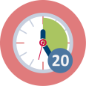
+ Duration:30 + 30 minutes
The second environmental SSI addressed in this module is the ecological footprint. Students are introduced to the definition and characteristics of this footprint first.
In part A they estimate and calculate their personal ‘ecological footprints’ on: https://www.footprintcalculator.org/
In part B they compare national footprints of several countries and of the world using information from https://www.footprintnetwork.org/
Note: in activity 3.3 they analyse data from this website.

Part A: What is meant by ‘ecological footprint’ and how big is yours? (20-30 min.)
- Present the following definition to your students (see ppt):
The ecological footprint is a metric that compares the ecological resource demand of individuals, governments, and businesses against Earth's capacity for biological regeneration. Humans use as much ecological resources as if we lived on 1.6 Earths.
In a brief class discussion find out what your students know about the ecological footprint and if they can name some examples of ‘ecological resources’.
Note: If this is too hard, postpone it until the end of Part A when students have calculated their personal footprint using the footprintcalculator. The questions in the calculator refer to ecological resources.
- Pose the question: “How fair do you think is your (ecological) consumption compared with other people all around the world?”
Pre-service teachers each take a position on an imaginary line in the room ranging: fair – neutral – unfair.
- Discuss some of their positions and ask your students.
  - What knowledge and feelings have you used to decide on your position?
  - What data would you need to be better able to determine your own position?
- Next refer your students to the website: https://www.footprintcalculator.org/ to calculate, compare and discuss their personal footprints, use worksheet 3.2.
- You may also ask them to use the results of the whole group to make an estimate for their national ecological footprint in ‘earths’. Discuss this briefly. They can check this estimate in part B.

Part B. Comparing countries by analysing graphs and data (30 minutes)
Make pairs of students. Assign each pair a country. Make sure the countries are spread over continents and ecological deficit/reserve (see worldmap on https://data.footprintnetwork.org).

Ask each pair to select the country assigned to them on the worldmap on the website and investigate the ecological footprint (over time) of this country by exploring the graphs as well as the data shown on the website when clicking on ‘learn more’. See worksheet 3.2. (20 minutes).

In the whole group have pairs share their results and discuss (10 minutes).
- What are the similarities and differences between the trends in the countries?
- How fair is the consumption of each of these countries compared to the world? Compared to your own national footprint?
- What can you tell about the data used on this website? Try to imagine the structure and size of the database underlying this website. (Students will work with these data in the next activity 3.3).
- Note: you as an educator may also want to design other activities using the data of the Open Data Platform on footprintnetwork.org.

- Optional: discuss what measures can be taken to reduce our footprints. You may want to use the information/suggestions on the website https://www.overshootday.org/100-days-of-possibility/ or use other (national or local) sources.
For further reading on the ecological footprint as a method you can start here: https://en.wikipedia.org/wiki/Ecological_footprint

This activity contributes to the achievement of the following learning outcomes:
- Get experience in dealing with environmental socio-scientific issues involving data
- Acquire knowledge about the role of (big) data and data-analysis in dealing with environmental socio-scientific issues

Activity 3.3 – Analysing a large data set
Duration: 30 minutes
In the previous activity students used the tools embedded on the website to find and compare the ecological footprint and biocapacity of countries. The website made the graphs for them. So, there was no real need for your students to analyse and represent the data themselves.

In this activity your students use their knowledge and skills on data analysis (see activity 3.1) on a large data set of the ecological (global) footprint. They will use the dataset in an excel file (with the accompanying codebook) which are available from:
https://www.fisme.science.uu.nl/toepassingen/28926/
Direct link to the Excel file:
https://www.fisme.science.uu.nl/toepassingen/28926/documents/footprint.xlsx

Have students work in pairs to make a combined line graph comparing the ‘ecological footprint per person’ and ‘the biocapacity per person’ over time for two countries (which they may select themselves). They first explore the full dataset (see note!), next they select the data they need and finally they graph the data is excel (see worksheet 3.3).

You may have pairs share their findings or you may want to discuss in the whole group how students succeeded in analysing the data and producing the graphs in Excel.

Notes:
- The data in this excel file* was downloaded from the website and has been smoothed somewhat to make it easier to analyse (for example: missing data were removed, and number formats were adjusted).
- There are two versions of the worksheet:
  - Worksheet 3.3A has an open version of the student task, with no guidance on how to work in Excel.
  - A more structured version with direct instructions ‘on how to make a line graph in Excel’ for 2 selected countries can be found on worksheet 3.3B. This version is also available on: https://www.fisme.science.uu.nl/toepassingen/28926/
- Before handing your students a worksheet, you may want to explore the excel-sheet in the whole group using the questions on worksheet 3.3A.

*) Source of data: Global Footprint Network National Footprint and Biocapacity Accounts, 2021 Edition Downloaded January 2021, from https://data.footprintnetwork.org.

This activity contributes to the achievement of the following learning outcomes:
- Expand (or refresh) skills on how to explore, analyse and visually represent (big) data
- Get experience in dealing with environmental socio-scientific issues involving data
- Acquire knowledge about the role of (big) data and data-analysis in dealing with environmental socio-scientific issues

4. Teaching

4.1. Exploring and reviewing a lesson
 |  | 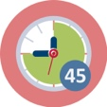 Duration: 15 + 30 minutes
The aim of this activity for your ITE students is to review a lesson on SSI and data. In an appendix to the worksheets of this module we provide two exemplary lessons designed for lower secondary education: one for each of the two SSIs that students explored in part 1 and 3 of this module: Global Warming and the ecological footprint.

Have your students in small groups select one of these lessons and do the following:
- Have students first individually work through the tasks in the lesson as if they were secondary school students (15 min). They may use the outcomes of the activities in section 1 and 3 of this module. This can also be done as homework preceding this session (have them bring their work).
Next have students in small groups (25 min):
- share their results on the lesson tasks and discuss their experiences and opinions: the level of difficulty – the time it took - their interest in the topic – improvements they would make (and why) etc.
- find out how this topic would fit in the curriculum of their subject (or other STEM subjects). Which curricular topics and goals are addressed in this lesson?
- think about what is needed for them to teach this lesson.
Refer to module O1 part 3 about why and how to teach a lesson with an SSI?

In the reflection (5 min) you can discuss what decisions the students made for this lesson to be ‘teachable’.
Note: you can also have your students review existing lessons on the two topics, for example materials on the NASA website. https://www.jpl.nasa.gov/edu/teach/tag/search/Climate+Change

This activity contributes to the achievement of the following learning outcomes:
- Become aware that dealing with environmental socio-scientific issues can be linked to the goals of (statistics) STEM education
- Become aware of the possibilities and necessity to connect environmental SSI and statistics (analysing data) in their (mathematics) teaching

4.2. Optional: (Re)designing a lesson or Data talk activity
or | 45 - 60 minutes (+ homework)
In activity 4.1 students reviewed a lesson and discussed adjustments to make it ‘teachable’. In this activity your students either redesign the lesson they reviewed in activity 4.1 or they design a lesson or data-talk-activity* themselves on an environmental SSI involving data. See also module O1 and O10.

Make sure they design:
- A lesson plan
- A teachers guide: including some background on teaching goals, pre-requisite knowledge, content/context (environmental SSI), relations to the curriculum, pedagogical approach
- The teaching materials for the students/pupils.

If your students are teaching in lower secondary classes, you may ask them to pilot their lesson/activity in their class or with a small group of their pupils.

You may have your ITE students share their materials with their peers and include peer review or you may use it as an assessment-task for this module.

*) Note: A data talk activity is an activity in which you discuss with your students/pupils a data visualization, using questions such as:
- what do you see? What do you notice?
- what are you curious about? What makes you wonder?
See for more background (and examples):
https://www.youcubed.org/wp-content/uploads/2020/05/What-is-a-Data-Talk-1.pdf
More examples can be found on: https://www.nytimes.com/column/whats-going-on-in-this-graph

 | Materials and resources
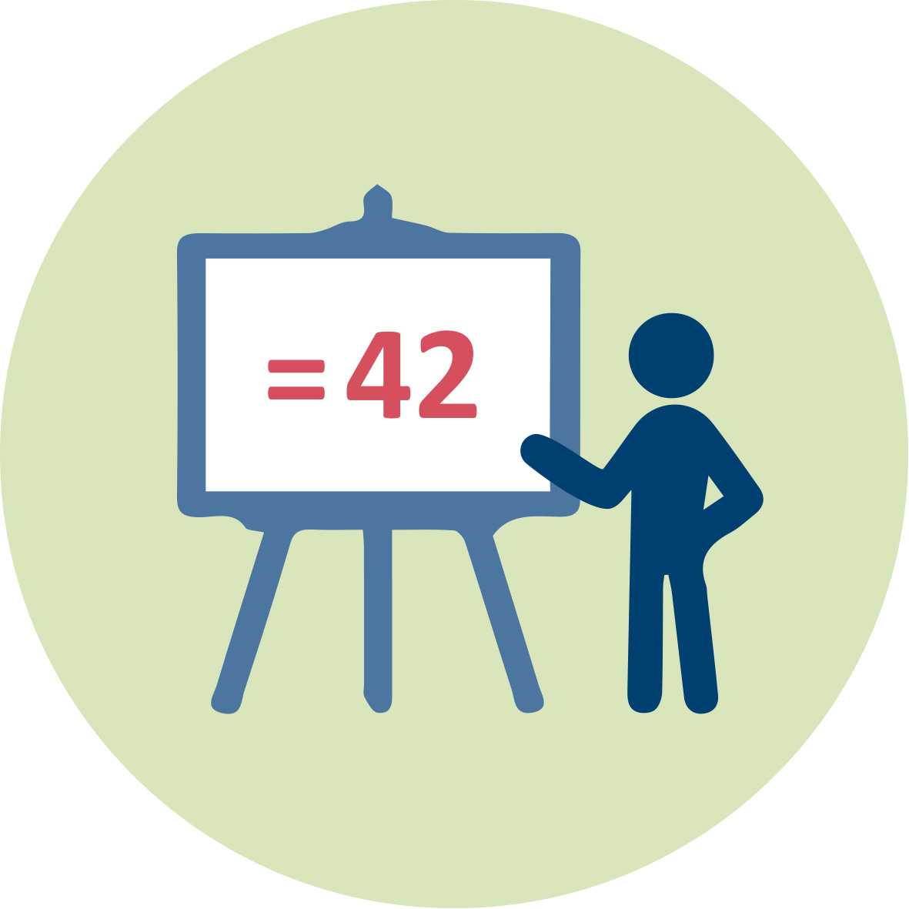 | This outline, the worksheets (including the addendum) and the presentation (pptx).
 |  | Readings and students’ handouts (see worksheets)
 | Access to computers for internet research and collaborative work

Granularity
There are several options to adjust the materials to your ITE-group and to the available time.
- Parts from some activities can be used as homework (as is indicated in the description of these activities). This reduces the time in sessions.
- For activity 1.2 you can choose between two version of the worksheet. Version A is for working online using websites, version B is the ‘paper’ version.
- Activity 3.1 is optional. The aim of this activity is to make sure your students have the required basic statistical knowledge and skills in data-analyses (using Excel) for activities 3.2 and 3.3. For this activity additional materials (2 lessons) are available in the Worksheet booklet. Instead of using these you can select (existing) materials on statistical analysis fitting your students background and your educational goals. You can have whole groups sessions, or have students work individually on a personal track or give them tasks as homework.
- For activity 3.3 you can choose between two version of the worksheet based on your students’ Excel skills. Version B step-by-step guides the students in the use of Excel, while version A is more open.
- Activity 4.2 – (re)designing a lesson or activity for secondary school students – is optional. You can skip this activity for example when your ITE-students have no classes to teach or have little or none teaching experience.
- If time is an issue you may choose to skip activity 2.2.

References
Websites
- UN sustainable development goals: https://sdgs.un.org/goals
- Eurostat: https://ec.europa.eu/eurostat/web/sdi
Websites for retrieving graphs on global temperature change:
  - Nasa: https://climate.nasa.gov/vital-signs/global-temperature/
  - Eurostat: https://ec.europa.eu/eurostat/databrowser/view/sdg_13_30/default/line?lang=en
  - University of East Anglia, Climate Research Unit: http://www.cru.uea.ac.uk/
- Blog: https://www.callingbullshit.org/tools/tools_misleading_axes.html
- Dutch meteorological institute (KNMI): https://www.knmi.nl
- Ted-talk Kenneth Cukier (2014) https://www.ted.com/talks/kenneth_cukier_big_data_is_better_data?referrer=playlist-talks_for_when_you_realize_you#t-936693
- Wikipedia: https://en.wikipedia.org/wiki/Big_data
- Global footprint network: https://www.footprintnetwork.org/
- About data Talk:
https://www.youcubed.org/wp-content/uploads/2020/05/What-is-a-Data-Talk-1.pdf

Further readings
Further reading on smart cities for educator:
- Hashem, I. A. T., Chang, V., Anuar, N. B., Adewole, K., Yaqoob, I., Gani, A., Ahmed, E., & Chiroma, H. (2016). The role of big data in smart city. International Journal of Information Management, 36(5), 748–758. https://doi.org/10.1016/j.ijinfomgt.2016.05.002
- Araral, E. (2020). Why do cities adopt smart technologies? Contingency theory and evidence from the United States. Cities, 106. https://doi.org/10.1016/j.cities.2020.102873
- Giest, S., Samuels, A. ‘For good measure’: data gaps in a big data world. Policy Sci 53, 559–569 (2020). https://doi.org/10.1007/s11077-020-09384-1

Websites for further reading (background on several topics in this module)
- https://yjolt.org/algorithmic-transparency-smart-city https://en.wikipedia.org/wiki/Algorithmic_bias .
- https://en.wikipedia.org/wiki/Filter_bubble.
- https://www.overshootday.org/100-days-of-possibility/
- https://en.wikipedia.org/wiki/Ecological_footprint
- https://www.nytimes.com/column/whats-going-on-in-this-graph
- https://www.jpl.nasa.gov/edu/teach/activity/graphing-global-temperature-trends/

Assessment
- For all activities student work (worksheets and presentation) may be used for formative assessment of the aims related to the activity (learning). You may also include peer review.
- You can use the result of activity 4.2 as an integral assessment of your student abilities related to teaching.

