Module 5 | THE DECISION-MAKING BASED ON CONFRONTING SCIENTIFIC POSITIONS

This outline is based on the work within the project Environmental Socio-Scientific Issues in Initial Teacher Education (ENSITE). Coordination: Prof. Dr. Katja Maaß, UNIVERSITY OF EDUCATION FREIBURG, Germany. Partners: UNIVERSITEIT UTRECHT, Netherlands; ETHNIKO KAI KAPODISTRIAKO PANEPISTIMIO ATHINON, Greece; UNIVERSITÄT KLAGENFURT, Austria; UNIVERZITA KARLOVA, Czech Republic; UNIVERSITA TA MALTA, Malta; HACETTEPE UNIVERSITY, Turkey; NORGES TEKNISK-NATURVITENSKAPELIGE UNIVERSITET NTNU, Norway; UNIVERSITY OF NICOSIA, Cyprus; INSTITUTE OF MATHEMATICS AND INFORMATICS AT THE BULGARIAN ACADEMY OF SCIENCE, Bulgaria; UNIVERZITA KONSTANTINA FILOZOFA V NITRE, Slovakia.

The project Environmental Socio-Scientific Issues in Initial Teacher Education (ENSITE) has received co -funding by the Erasmus+ programme of the European Union (grant no. 2019-1-DE01-KA203-005046). Neither the European Union/European Commission nor the project's national funding agency DAAD are responsible for the content or liable for any losses or damage resulting of the use of these resources.

© ENSITE project (grant no. 2019-1-DE01-KA203-005046) 2019-2022, lead contributions by International Centre for STEM Education (ICSE) at the University of Education Freiburg, Germany. CC BY-NC-SA 4.0 license granted.

General overview and aim
In this module future science teachers in initial teacher education are introduced to develop competences in decision-making based on confronting scientific positions on example of food provision for the world. The decision making is experienced as weighing up different perspectives - scientifically based ones as well as personal ones. The module provides clues to reflect on this process in planning, realization and evaluation of instruction.
The intention is to present conditions and influences for decision making in food world and to provide orientation on food market, on aspects like food sources, food production, food distribution and food consumption. Whilst the focus in this module is on learning, we will also give insights into including these aspects into science teaching at school.
The module will introduce future teachers into decision making in environmental issues. They will learn how to deal with topics connected with food world, it will address future teachers values and attitudes as regards their dealing with them as active citizens and as regards including them in teaching. It will also include concrete ideas on how to include these issues in science and maths teaching and learning.
The module contents concrete examples were chosen to give students experience in dealing with environmental socio-scientific issues concerned different consequences of food market from science point of view together with society point of view.
This module O5 is based on module O1 and provides more details on the aspect of decision-making both in learning for developing competences in dealing with environmental SSI themselves and in teaching for acquiring teaching skills to support their students in developing these competences. Development and using of the module O5 are in close cooperation with module O6 as the social, political, or ethical dimensions on SSI influence the decision-making process.

Relevant topics
In the module are developed and offered activities for initial teachers education intended to equip prospective teachers with the knowledge, skills, values and resources necessary to make decision in relation to science and to include decision-making in their future science teaching. Students – future science teachers – have possibilities to learn what socio-scientific issues are and how to deal with them on examples of food world. Future teachers of mathematics and science could prepare their lessons using examples of methods, forms and contents proposed in this module. In this way they will get a first insight in how to include socio-scientific issues in their lesson’s scenarios. They can work on examples and modify them by own creativity and experience.
The module will be oriented to the following exemplary challenges in connection to mathematics and science education:
- Working with information sources and assessing information
- Brainstorming and brain writing activities
- Story telling as support of communication
- Role playing as support of communication
- Practical (incl. experimental) activities as evidence based (science) communication which one enables a good connection of the teaching content to the students' living world.

Learning Outcomes

Students will acquire
- Different strategies for decision-making
- Understanding of decision-making process, i.e. steps needed to be carried out, evaluation of conditions, results, and consequences
- Examples of decision-making strategies connected with food-world
- Reflection on specific characteristics of decision-making strategies and their relation to mathematics and science education
- Beliefs on decision-making in relation to food market and their influence on human being
- Examples of own decision-making cases from everyday life connected with food consumption
- Skills to compare different ways of dealing with decision making. i.e. acting in the sense of active and critical citizenship versus ignoring evidence and following “leaders” on examples from food-world
- Reasons for including decision-making in science education
- Experience in decision making in classroom teaching: an example with food topic for use on secondary level
- Reflections on what students learn when dealing with such a task
- Readiness to include decision-making in day-to-day teaching
- First introduction into pedagogical concepts for dealing with topic decision making
- And specific formative learning outcomes formulated at concrete activities.

Flowchart and Module plan

This module involves three sections, structured into different activities. It includes 360 minutes of sessions and 90 minutes of homework. It includes lecture parts, group discussions, student presentations and lab work. The structure is as follows:
- Introduction into the topic (“warm-up): 90 min
- Immersion tasks („multi-context“): 90 min + 90 min Homework
- Application tasks (“everyday decisions): 180 min

I. Introduction into the topic Decision-making in confronting scientific positions

1.1 Ambience evocation
Duration: 45 minutes
This is a “warm up” activity. The intention is to introduce some facts about a decision making in everyday life concerned ecological problems. In this case is food used as an example and to explore students´ previous knowledge, beliefs, experiences, and attitudes related to this topic.
Teacher educator introduces the topic in connection with the “food world”. He /she can offer a different examples of food in the classroom (bio-vegetables and traditional vegetables, food without and with preservatives, food from different origins etc.) or the activity can be situated to place with food like meeting in the food-market, in the garden, in the food-company, in the food waste collection yard etc. (as demonstration of everyday self-evident thing for us). At the start he/she initiates a short discussion through the questions:
What is the impact/effect of food production on our life/life of people? or
Can food production change our life? or
What we can contribute to food sustainability?
And then present the interactive activity. The activity consists on work in pairs preparing title and short commentary to elected picture about food (bio-banana, food-waste, palm oil production, molecular food, big agricultural production, farm products, malnutrition, obesity, food transport, allergy and food, adventure food, overproduction of the food etc.). After work in the pairs students present own results and discuss them with others.
This session contributes to the achievement of the following learning outcomes:
- Master strategies to create a safe classroom atmosphere supporting communication and argumentation.
- To recognize one of the current ecological topic in different natural, social and cultural contexts.

I. Introduction into the topic Decision-making in confronting scientific positions

1.2 Mapping the field of interest
Duration: 45 minutes
This activity serves to mapping of elected global environmental problem – decision making related to food world – in detailed different contexts. At the beginning is brainstorming recommended (with right setting – time, prohibited words, technical realization etc. – see literature about brainstorming realization). Central term for brainstorming can be “FOOD” or “FOOD CHOICE” or something with relation to food as self. Next step is clustering, it means classification of groups of produced words. Students propose groups such as science, economics, politics, culture… Last step is creation of concepts maps in each group of words and next to create common concept map about phenomena FOOD in DECISION MAKING connected with discussions about different experiences mainly with everyday contexts.
Notices for alternatives: Topic of brainstorming can be more sophisticate, it means e.g. producing only adjectives for food (bio, vegan, vegetarian, healthy, addictive, harmful, fat, natural, artificial etc.) or producing names or words containing the different word connected with food (names of cities, geographical terms, foods and their examples in different languages etc.).
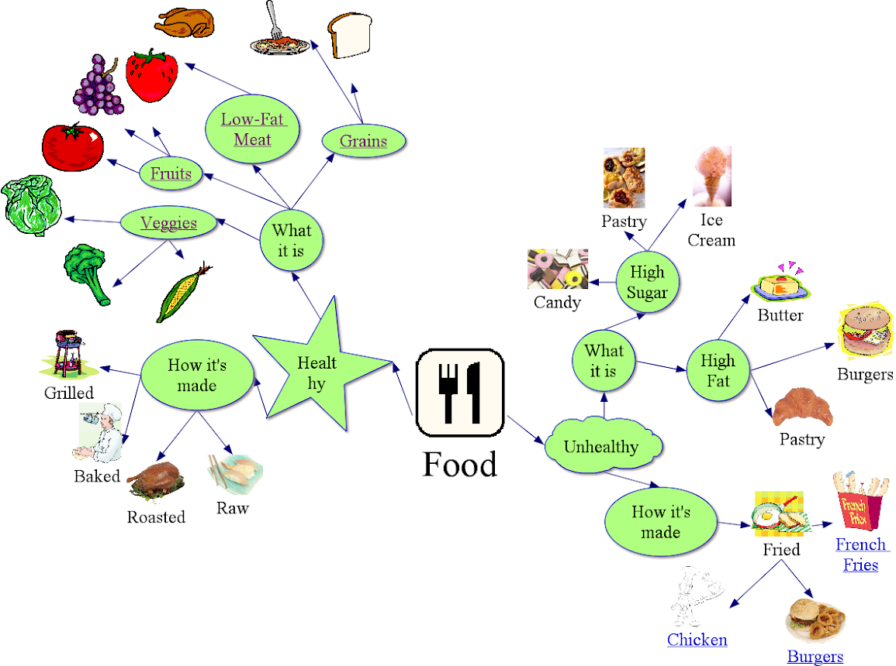
Figure Example of concept map on the topic FOOD
(https://sites.google.com/site/saranderson155class/food-concept-map-3)
This session contributes to the achievement of the following learning outcomes:
- To recognize one of the current ecological topics in different natural, social, and cultural contexts.
- Get familiar with teaching methods which have potential to connect ecological topics to STEM learning.

II. Immersion into the topic Decision-making in confronting scientific positions

2.1. Decision-making about food as multi contexts phenomenon
and and | Duration: 30 minutes
In this session the teacher educator evokes atmosphere about food choice as borderless phenomena of decision-making. Then teacher students, working first individually, next in pairs and finally in groups. Results from groups are presented and discussed and summarized in a plenary session. It is application of “snow-ball” method. At the beginning all watch interesting short movie (video shots, no longer as 5 minutes) about food or food choice. It can be use something from YouTube or from different Web sources e.g. “Factors affecting food choice” at the link https://www.youtube.com/watch?v=D6eor1wkNFY or “Food Choices” at the link https://www.youtube.com/watch?v=XVzXcBoufyU.
After the video presentation each student receives card (it can be especially “food” designed by color, border etc.) and elects one of the eight contexts related to approach to food choice: Sensory assessment, Content assessment, Tradition in use, Advertising influence, Following the leaders, Packaging and Branding, Costs limits, Own beliefs about (it can be elected less like eight or to add next). Next each student writes (with using different sources) one page about the characteristics of food choice in elected context. Next students create pairs and received next cards for task to work together in max. 3 elected contexts. It can be 1 or 2 from previous individual work and 1 or 2 new. The last round starts after collection of all cards ordered by context. Students create eight groups (less or more by applied contexts) and each one draws one context and elaborates one compromise final version of context characteristics. Each group uses related cards from previous individual and pairs work. The activity is finished by presentation of each group and common discussions.
This session contributes to the achievement of the following learning outcomes:
- Acquire skills to build a classroom atmosphere of communication and respect.
- Get familiar with teaching methods which have potential to connect everyday related topics to learning.

II. Immersion into the topic Decision-making in confronting scientific positions

2.2. My decision to buy a food
or | +  Duration: 30 minutes + 90 minutes homework
In this session students deal with identification of buyer behavior. They recognize different theories about buyer behavior and search data for confirmation of them among the society (classroom, school, community). At the beginning students analyze four different strategies of buyer behavior:
- Generic Theory of Buying Behavior (the buyer will initiate research on products and pricing…),
- Cultural Theory of Buying Behavior (set of values and beliefs learned in the context of a community…),
- Environmental Theory of Buying Behavior (behavior based upon the situation…),
- Internal Theory of Buying Behavior (decision by kind of personality…).
For the homework students prepare questionnaire or semi-structured interview based on formulated research questions. They analyze sources for this kind of survey and sources about buyer behavior theories to prepare appropriate items (questions) for questionnaire or interview. Next they elect the research sample and gain the data (quantitative or qualitative) and elaborate them. At the end they publish data in form of poster, public presentation, article for school or other journal etc.
A few links for inspiration:
https://www.youtube.com/watch?v=5oyjXg4qWyA
https://www.wur.nl/en/article/Understanding-consumers-food-choice.htm
https://www.bbc.co.uk/bitesize/guides/z7fw7p3/revision/1
https://www.youtube.com/watch?v=pMLrVP_E-jA

This session contributes to the achievement of the following learning outcomes:
- To support of creative thinking without prejudice to different approaches to decision-making.
- Learn how to make survey and elaborate obtained data for confirmation of the estimating answers to formulated research question (hypothesis).

II. Immersion into the topic Decision-making in confronting scientific positions

2.3. Food market and food consumption in different regions
or | Duration: 30 minutes
In this activity students search and analyze differences in food market and food consumption in different countries (regions, cultural customs, religions…) and ages. They identify natural (science elements) and social (cultural elements) and ecological (global and local elements) contexts of the food market and food consumption. The activity is not based only on data searching and their interpretation, but it can be use different approaches. It is possible to prepare productions or dramatization by prepared scenarios with different cultural contents. Or they can prepare collections for exhibition of products (with appropriate case study) organized in school day (project day) etc. Students analyze information sources or own experiences or ask parents, grandparents etc. Finally they can prepare own competitions by voting of classroom or school… It is possible to use multicultural context by possibilities in the classroom or school or in on-line form based on interregional or international cooperation.
A few links for inspiration:
https://www.un.org/en/sections/issues-depth/food/index.html
https://ec.europa.eu/info/sites/info/files/food-farming-fisheries/farming/documents/market-brief-food-challenges-sep2019_en.pdf
https://www.nationalgeographic.com/what-the-world-eats/
https://www.youtube.com/watch?v=fp87QsWzJn4
https://www.youtube.com/watch?v=cJK44cOOH30
https://www.encyclopedia.com/religion/dictionaries-thesauruses-pictures-and-press-releases/food-and-religion

This session contributes to the achievement of the following learning outcomes:
- To connect food decision making to local and global consequences with connections to global ecological problems.
- Acquire skills to build a classroom atmosphere of communication and respect.

III. Applications into the topic Decision-making in confronting scientific positions

3.1. Decision-making about food in numbers
or | Duration: 30 minutes
Main topic of the activity is searching, analyzing and interpreting of data concerned food and food management important for decision-making in this area. Data will be sourced from the internet, from relevant links based of relevant authors and guarantee institutions. Main direction can be follow:
- Food consumption in different part of the world (e.g. per country, per capita, per age group; consumption in household, numbers of production, numbers of waste etc.)
- Calculation of different footprints connected with different products and activities (connected with comparison food needs in different part of the world)
- Calculation of food consumption in different areas and what we can do with these calculations (calculations connected with food production, transport, consumption and waste)
Links for inspiration:
Global food supply and demand. Consumer trends and trade challenges:
https://ec.europa.eu/info/sites/info/files/food-farming-fisheries/farming/documents/market-brief-food-challenges-sep2019_en.pdf

What the World eats? Daily Diet. Meet consumption:
https://www.nationalgeographic.com/what-the-world-eats/

Work in pairs or in groups with access to Internet sources and discussion of the findings. Important it is comparison of price (not only in economic sense) of the food in different regions.
This session contributes to the achievement of the following learning outcomes:
- To formulate the critical approach to data analyzing and interpretation.
- To create ability to search relevant data from open access media.

III. Applications into the topic Decision-making in confronting scientific positions

3.2. Decision making for food storage and transportation
or | Duration: 30 minutes
Students deal with aspects of storage (expiration, durability etc.) and transportation (distances, needs, “hidden business”, etc.).
The task for discussion is to look on the sources about food storage and transportation. Discussed can be historical aspects as well as proposal for simple model experiments. Students work individually or in group to prepare “mind map” or “flowchart” or “lab manual for model experiment” and own product show and discuss in classroom or in wider forum.
This session contributes to the achievement of the following learning outcomes:
- To formulate the critical approach to data analyzing and interpretation.
- To approach from complex point of view to problem solving as base for decision making.

III. Applications into the topic Decision-making in confronting scientific positions

3.3. Decision making about food in confrontation of different contexts
or | Duration: 30 minutes
The activity is oriented to problems with food world and it is close connected with all activities in the part III. Key words are preparation and consumption of food in history and in current situation and also in prognosis for the future in view of different cultures. As motivation can be video “The Hidden Costs of Hamburgers” at the link: https://youtu.be/ut3URdEzlKQ .
Next will follow discussion about science context (contents, mechanical, physical, chemical and biological properties) and social context (culture, history and nowadays and future, fair trade, solidarity etc.).
What we can do for saving environment in different regions? Are there any next influences like only science principles or only social principles?
This session contributes to the achievement of the following learning outcomes:
- To approach from complex point of view to problem solving.
- To recognize one of the current ecological topic in different natural, social and cultural contexts.

III. Applications into the topic Decision-making in confronting scientific positions

3.4. Decision-making about food in simple science experiments
Duration: 90 minutes
This activity is a complex of simple experiments oriented to recognize food from microscopic and macroscopic levels. Simple experiments show principles valid in all the world but their realization and setting can be different depending on traditions, possibilities and different next local conditions. Proposals of experiments groups:
- Food as multi component objects (chemical content, physical properties, biological activity, paradoxes, coherency etc.)
- Food cleaning (filtration, crystallization, distillation, etc.)
- Food conservation (chemicals, procedures, etc.)
- Food as power of life (energy consumption, energy production, energy conservation etc.)
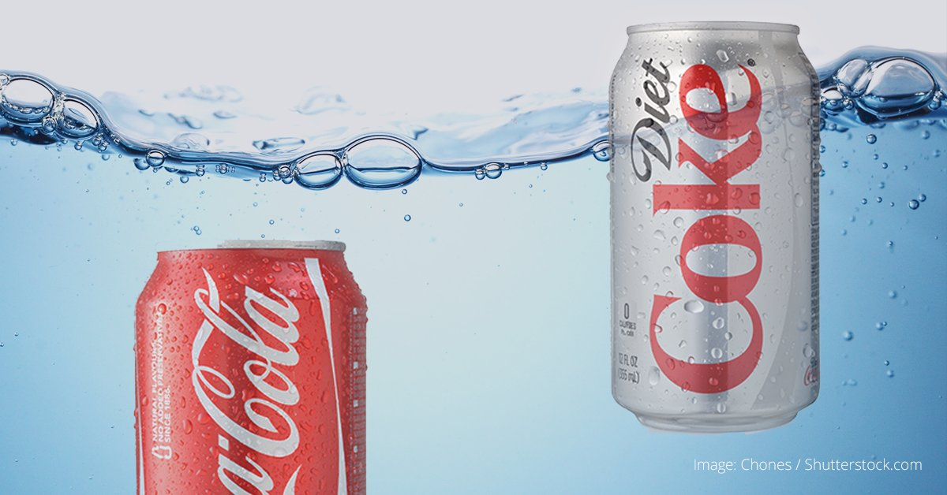
Figure. Example of experiment with sugar content in Coke (https://twitter.com/curiositydotcom/status/840472372570423297/photo/1)

This session contributes to the achievement of the following learning outcomes:
- To use science literacy for understanding of food and use it for appropriate decision-making.
- To support of creative thinking connected with hands-on activities.

Materials and resources

Worksheets. Includes all student activities for module 5
Set of Pictures “Pictures about food”. Introduction 1.1
YouTube video: Introduction to Food Choice. Immersion 2.1.
Writing Cards for snow-ball method. Immersion 2.1.
Access to computers for internet research – links at activity. Immersion 2.2. and 2.3.
Access to computers for internet research at activity. Application 3.1.
YouTube video: “The Hidden Costs of Hamburgers”. Application 3.3.
Laboratory devices and chemicals for activities. Application 3.4.

Granularity
- Select fewer examples in part III from each activity
- Connect by your possibilities selected activities in part III
- In activity 1.2 you can use different types of brainstorming by level of teaching practice
- For activity 3.4 including experimental activities is necessary preparation of lab equipment and chemicals

References
ABS Packaging. (2019) How You Can Fix the Biggest Problems In Food Marketing. [on-line], Accessible on: https://www.standuppouches.net/blog/how-you-can-fix-the-biggest-problems-in-food-marketing (cit. 2019-02-16)
Grosser, A. E. (1984). Cooking With Chemistry. J.Chem.Ed. 61/4, 362-363.
Hollar, K. A., Sorensen, P. M., Maini Rekdal, V. (2018). SteamEd: training educators in science and cooking. Abstr. Pap. Am. Chem. Soc. Vol. 256.
Rose, D., Heller, M. C., Roberto, Ch. A. (2019). Position of the Society for Nutrition Education and Behavior: The Importance of Including Environmental Sustainability in Dietary Guidance. Journal Of Nutrition Education And Behavior. Vol. 51, Nr. 1, 3.
Sorensen, P. M., Mouritsen, O. G. (2018). Science education and public understanding of science via food, cooking, and flavour. International Journal of Gastronomy and Food Science. Vol. 15, Nr. APR, 36-47.

Further readings

Assessment
Assessment criteria and methods

