Module 7 | AIMS OF SSI AND THE CURRICULUM

This outline is based on the work within the project Environmental Socio-Scientific Issues in Initial Teacher Education (ENSITE). Coordination: Prof. Dr. Katja Maaß, UNIVERSITY OF EDUCATION FREIBURG, Germany. Partners: UNIVERSITEIT UTRECHT, Netherlands; ETHNIKO KAI KAPODISTRIAKO PANEPISTIMIO ATHINON, Greece; UNIVERSITÄT KLAGENFURT, Austria; UNIVERZITA KARLOVA, Czech Republic; UNIVERSITA TA MALTA, Malta; HACETTEPE UNIVERSITY, Turkey; NORGES TEKNISK-NATURVITENSKAPELIGE UNIVERSITET NTNU, Norway; UNIVERSITY OF NICOSIA, Cyprus; INSTITUTE OF MATHEMATICS AND INFORMATICS AT THE BULGARIAN ACADEMY OF SCIENCE, Bulgaria; UNIVERZITA KONSTANTINA FILOZOFA V NITRE, Slovakia.

The project Environmental Socio-Scientific Issues in Initial Teacher Education (ENSITE) has received co -funding by the Erasmus+ programme of the European Union (grant no. 2019-1-DE01-KA203-005046). Neither the European Union/European Commission nor the project's national funding agency DAAD are responsible for the content or liable for any losses or damage resulting of the use of these resources.

© ENSITE project (grant no. 2019-1-DE01-KA203-005046) 2019-2022, lead contributions by International Centre for STEM Education (ICSE) at the University of Education Freiburg, Germany. CC BY-NC-SA 4.0 license granted.

General overview and aim
In this module, future mathematics and science teachers, in initial teacher education, are introduced to the aspects of Environmental Socio-Scientific Issues (EnvSSI) that are related to the educational goals and to ways how these issues could be embedded in the curriculum. This module is closely connected with social and socio-political everyday life decisions, teacher education, the design of teaching scenarios and the STEM movement.
The intention of module O7 is to raise awareness among future science and maths teachers about the need of including EnvSSI in their day-to-day teaching, as well as to prepare them to be able to analyse mathematics and science curricula (and related materials) in relation to such issues. Additionally, this module prepares future teachers to find points of contact in mathematics and science curricula that make it possible to address such issues, and how to deal with some of the requirements of curricula when integrating EnvSSI, such as students’ engagement in dialogue, discussion and argumentation, etc.
The module was designed so as to be relevant to day-to-day teaching and to prioritize students’ active learning. Therefore, it offers future teachers concrete examples and tasks in order to give them experience in dealing with EnvSSI themselves, as well as a theoretical background in order to enhance their understanding and to acquire the necessary skills and knowledge to enact these issues in their classroom practices.

XXX Crosslinks need to be inserted at the end, when further modules are ready

Relevant topics
In this module, the emphasis is set on the aims of EnvSSIs in relation with mathematics and science curriculum. Through some examples of EnvSSIs, students will study, on one hand, the role of maths and science while dealing with such issues, and on the other hand, their connection to maths and science educational goals.
Then, through the provided theoretical framework, they will learn about the Socio Scientific Issue movement, its relation to STEM education, and about the specific features that EnvSSI based teaching requires. Also, they will study ways how to enact EnvSSIs in classroom (such as a role-playing scenario design, and theoretical frameworks for analysing students’ arguments). What’s more, they will be brought to reflect on challenges and dilemmas that teachers experience when integrating EnvSSIs into mathematics or science teaching.
Then, students will experience how to enact EnvSSIs in mathematics and science classrooms through two specific issues as from learner’s perspective and teacher’s perspective. They will connect these examples to relevant theories and teaching practices. Also, they will design mathematics and science tasks related to thematic areas included in the issues examples.
In the end, they will get a first insight in how to include EnvSSI in their lessons by designing an EnvSSI-based mathematics and science lesson and connecting it to the national curriculum.

Learning Outcomes

Students will acquire
- Experience in dealing with environmental socio-scientific issues (Activities 1.1, 1.2 and 4.1)
- Awareness about some characteristics of environmental socio-scientific issues such as controversy and uncertainty (Activities 1.1 and 1.2)
- Awareness about the role of mathematics and science when dealing with environmental socio-scientific issues (Activity 1.1)
- Awareness about the role and the relation of environmental socio-scientific issues in the mathematics and science curriculum (Activities 1.2, 2.1 and 4.2)
- Awareness about the challenges and dilemmas when integrating environmental socio-scientific issues into mathematics or science teaching (Activities 1.2, 2.2 and 4.2)
- Knowledge about aspects of socio-scientific issues and their role in the environmental education (Activity 2.1)
- Knowledge on how to enact environmental socio-scientific issues in classroom (Activity 2.3)
- Skills on how to design and analyse a role-playing scenario (Activity 2.3)
- Skills on how to analyse students’ arguments in response to a socio-scientific issue (Activity 2.4)
- Experience in debating and in argumentation (Activity 3.1)
- Knowledge in handling a debate in classroom and in managing the different storylines in a debate (Activity 3.1)
- Awareness about the multiplicity of factors that could be involved in an environmental socio-scientific issue (Activity 3.2)
- Skills on how to identify aspects of mathematics and science teaching related to an environmental socio-scientific issue (Activity 3.2)
- Awareness about how to deal with the uncertainty while teaching environmental socio-scientific issues (Activities 3.2 and 4.2)
- First knowledge and skills on how to implement a mathematics or science lesson based on an environmental socio-scientific issue (Activity 4.1)

Flowchart and Module plan

This module involves four sections, all structured into several activities. It includes 300 minutes of sessions and 60 minutes of homework. It includes lecture parts, group discussions, a debate and student presentations. The structure is as follows:
- Introducing the environmental socio-scientific issues (EnvSSIs) and understanding their connection with mathematics and science curriculum: 40 min
- Exploiting research findings on connecting EnvSSIs to mathematics and science educational goals: 80 min
- Experiencing how to enact EnvSSIs in mathematics and science classrooms: 120 min
- Implementing an EnvSSI-based maths and sciences lessons and connecting it to the national curriculum: 60 min + 60 min homework

1. Introducing the environmental socio-scientific issues (EnvSSIs) and understanding their connection with mathematics and science curriculum. ( 40 min)

1.1. Brainstorming about EnvSSIs.
Duration: 20 minutes
This is a brainstorming activity. Through two examples of EnvSSI, the intention of this activity is to let future teachers discuss and argue their opinions about these specific issues and to let them experience their controversial character. Additionally, first reflections on the role of mathematics and science in defending their claims and in handling these issues are initiated.
Teacher Educators introduce the module using the ppt presentation [1] and then present the activity 1.1 to pre-service teachers. For one of the two issues presented here, they can also refer to the module IO4: Analysing (Big) Data, Activity 1.1.
This session contributes to the achievement of the following learning outcomes:
- Experience in dealing with environmental socio-scientific issues (Activities 1.1, 1.2 and 4.1)
- Awareness about some characteristics of environmental socio-scientific issues such as controversy and uncertainty (Activities 1.1 and 1.2)
- Awareness about the role of mathematics and science when dealing with environmental socio-scientific issues (Activities 1.1)

1.2. Reflecting on EnvSSIs’ connections with mathematics & science education.
Duration: 20 minutes
The intention of this activity is to let future teachers think about the importance of teaching such controversial issues and about their role in achieving expected learning outcomes of mathematics and sciences curriculum. Also, future teachers are invited to reflect about the eventual concerns if they were asked to teach such issues.
This session contributes to the achievement of the following learning outcomes:
- Experience in dealing with environmental socio-scientific issues (Activities 1.1, 1.2 and 4.1)
- Awareness about some characteristics of environmental socio-scientific issues such as controversy and uncertainty (Activities 1.1 and 1.2)
- Awareness about the role and the relation of environmental socio-scientific issues in mathematics and science curriculum (Activities 1.2, 2.1 and 4.2)
- Awareness about the challenges and dilemmas when integrating environmental socio-scientific issues into mathematics or science teaching (Activities 1.2 and 2.2 and 4.2)

2. Exploiting research findings on connecting EnvSSIs to mathematics and science educational goals. (80 min)

2.1. EnvSSIs and education.
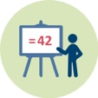 |  | Duration:10 minutes
This activity provides future teachers by insights about the theoretical background of the SSI movement and its relation to STEM. Also, it allows them to discover different aspects of socio-scientific issues and their role in the environmental education. Then, future teachers, working in groups, have to reflect on how this type of issues could be related to the national curriculum.
This session contributes to the achievement of the following learning outcomes:
- Knowledge about aspects of socio-scientific issues and their role in the environmental education (Activity 2.1)
- Awareness about the role and the relation of environmental socio-scientific issues in mathematics and science curriculum (Activities 1.2, 2.1 and 4.2)

2.2. Readings on Teachers’ challenges.
 | Duration: 10 minutes
In this session, future teachers are invited to read about challenges and dilemmas that are faced when integrating EnvSSIs into mathematics or science teaching. Then, future teachers, working in groups, discuss and reflect on issues that they recognize to mathematics and science curriculum objectives and their enactment in the classroom.
This session contributes to the achievement of the following learning outcomes:
- Awareness about the challenges and dilemmas when integrating environmental socio-scientific issues into mathematics or science teaching (Activities 1.2, 2.2 and 4.2)

2.3. Example of enacting EnvSSIs in classroom: The case of role-playing scenario.
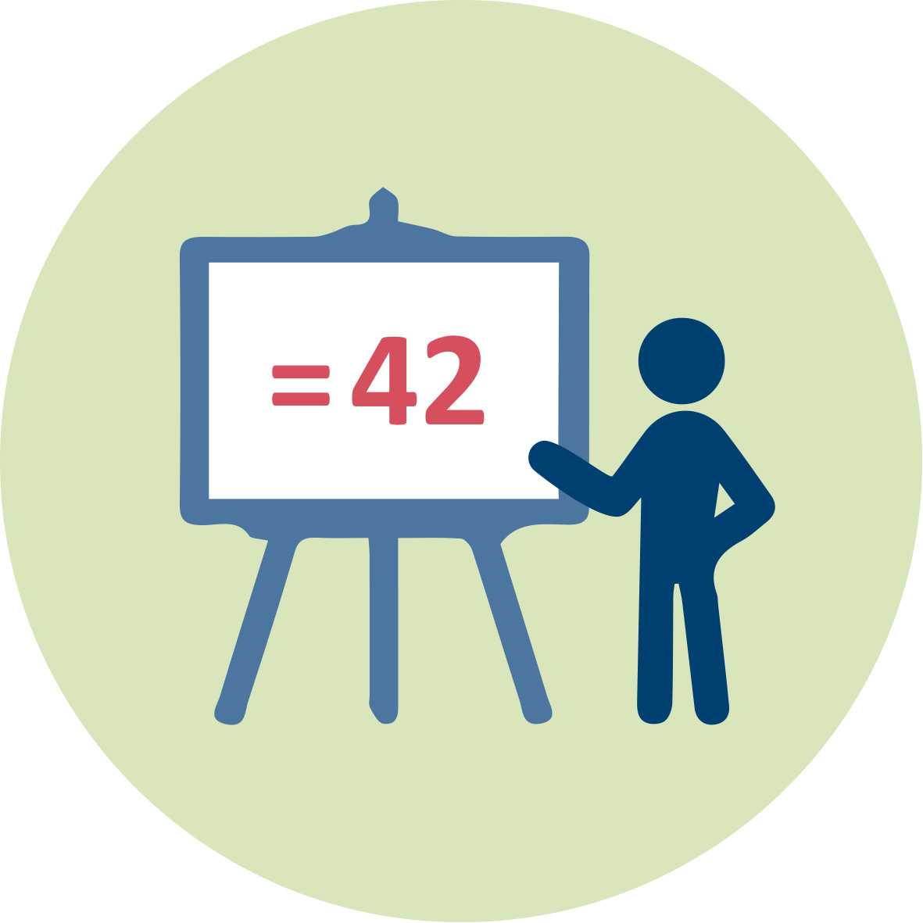 |  |  |  | Duration: 10+20 minutes
The intention of this session is to provide future teachers with the knowledge and skills to enact EnvSSIs in classroom with the special case of role-playing scenario. Given some examples, future teachers will discuss in groups and reflect on how to enact EnvSSIs in classroom in terms of the school subject, the resources used, the content knowledge and curriculum aims and the design of a role-playing scenario. Afterwards, they are given an example of a role-playing scenario and, working in groups, they are asked to analyse it. Finally, they are asked to design by groups their own role-playing scenario related to an environmental socio-scientific issue and to analyse it.
This session contributes to the achievement of the following learning outcomes:
- Knowledge on how to enact environmental socio-scientific issues in classroom (Activity 2.3)
- Skills on how to design and analyse a role-playing scenario (Activity 2.3)

2.4. Theoretical frameworks for analysing students’ arguments.
 |  |  | Duration: 30 minutes
The intention of this session is to provide future teachers by some theoretical frameworks for analysing students’ arguments. Teacher educators introduce first the Toulmin’s framework and Belova et al.’s framework to the students. For the Toulmin’s framework, they can also refer to the module IO2: Reasoning, Argumentation & Critical Thinking.
Then, utilising these two frameworks, future teachers are asked to analyse a student’s response to a specific environmental socio-scientific issue.
This session contributes to the achievement of the following learning outcomes:
- Skills on how to analyse students’ arguments in response to a socio-scientific issue (Activity 2.4)

3. Experiencing how to enact EnvSSIs in mathematics and science classrooms. (120 min)

3.1. Dealing with the Paper or Plastic Bag issue: Role-playing scenario.
Duration:60 + 20 minutes
In this session, future teachers will play a role scenario based on a universal environmental issue, and then they will reflect on their debate from teacher’s perspective.
To this end, future teachers first reflect on the issue: “Are plastic bags or paper bags better for the environment?” by reading an extract of a newspaper that compares both bags. Then, working in three groups, they are supposed to form a debate and prepare a recommendation to the City Council.
This session contributes to the achievement of the following learning outcomes:
- Experience in debating and in argumentation (Activity 3.1)
- Knowledge in handling a debate in classroom and in managing the different storylines in a debate (Activity 3.1)

3.2. Dealing with a specific Lake Drainage and re-creation issue: Multiplicity of the factors & “Uncertainty”.
Duration:20 + 20 minutes
In this session, future teachers will deal with a national environmental issue for Greece, which is the drainage and re-creation of a lake. First, future teachers are invited to review the multiple factors involved in the decision to drain the lake, the consequences of the drainage and the decision to re-create the lake. Then, they have to identify aspects of mathematics and science teaching related to this issue. They, also, have to think about the “uncertainty” involved in this issue and consider how they can deal with it in a classroom lesson.
This session contributes to the achievement of the following learning outcomes:
- Awareness about the multiplicity of factors that could be involved in an environmental socio-scientific issue (Activity 3.2)
- Skills on how to identify aspects of mathematics and science teaching related to an environmental socio-scientific issue (Activity 3.2)
- Awareness about how to deal with the uncertainty while teaching environmental socio-scientific issues (Activities 3.2 and 4.2)

4. Implementing an EnvSSI-based maths and sciences lessons and connecting it to the national curriculum. (120 min)

4.1. Lesson design.
Duration: 15 minutes
+ 60 minutes homework
In this session, future teachers, working in groups, are expected first to select an environmental SSI from their own choice, and to reflect on this issue by describing its aspects and identifying connections with the national curriculum. Then, they are asked to design a lesson which deals with the SSI they selected before taking into account some given criteria for assessing the lesson designs.
This session contributes to the achievement of the following learning outcomes:
- Experience in dealing with environmental socio-scientific issues (Activities 1.1, 1.2 and 4.1)
- First knowledge and skills on how to implement a mathematics or science lesson based on an environmental socio-scientific issue (Activity 4.1)

4.2: Reflecting on the lesson designs.
Duration: 45 minutes
In this session, future teachers are asked first to present their lesson designs to the overall classroom. Then, they are invited to discuss in groups about the mathematical or scientific knowledge involved in their lesson design, and about the possible connections between the EnvSSI chosen and the curriculum. In addition, they will have to think about the uncertainty of the issue dealt with in their lesson design, and to discuss about the difficulties encountered when designing the lesson.
This session contributes to the achievement of the following learning outcomes:
- Awareness about the role and the relation of environmental socio-scientific issues in mathematics and science curriculum (Activities 1.2, 2.1 and 4.2)
- Awareness about how to deal with the uncertainty while teaching environmental socio-scientific issues (Activities 3.2 and 4.2)
- Awareness about the challenges and dilemmas when integrating environmental socio-scientific issues into mathematics or science teaching (Activities 1.2, 2.2 and 4.2)

Materials and resources

Presentation (pptx). Teacher Educator “Socio-Scientific Issues (SSI), aims of SSI and the curriculum”
Readings and students’ handouts
Access to computers for internet research and collaborative work

Granularity
- In Activity 1.1 and Activity 1.2 skip some questions.
- Skip Activity 2.1.
- Skip one of the two tasks in Activity 2.3.
- In Activity 3.1 skip the reflections in Task 2.
- Skip Task 2 in Activity 3.2.
- Skip some reflection questions in Activity 4.2.

References
Barwell, R. (2013). The mathematical formatting of climate change: critical mathematics education and post-normal science. Research in Mathematics Education, 15(1), 1-16.
Belova, N., Eilks, I., & Feierabend, T. (2015). The evaluation of role-playing in the context of teaching climate change. International Journal of Science and Mathematics Education, 13(1), 165-190.
Dawson, V., Carson, K. (2020). Introducing Argumentation About Climate Change Socioscientific Issues in a Disadvantaged School. Res Sci Educ 50, 863–88.
Höttecke, D., Hössle, C., Eilks, I., Menthe, J., Mrochen, M., Oelgeklaus, H., & Feierabend, T. (2010). Judgment and decision-making about socio-scientific issues: A fundament for a cross-faculty approach towards learning about climate change. In I. Eilks & B. Ralle (eds.), Contemporary science education (pp. 179-192), Aachen: Shaker.
Toulmin, S. E. (1969). The uses of argument. Cambridge, UK: Cambridge University Press.

Further readings

Assessment
Assessment criteria and methods

