Activity 1.7: Role cards for debate - Wicked dilemma

Description of role and aim of organization (if relevant)
(e.g., producer, government, environmental organization, consumer, health organization, animal protection group)
Main standpoint/statement in the debate
Argument(s) to substantiate the statement and defend the position
Possible criticism from other (identified) groups
Defense against criticism from above mentioned group(s)
Activity 5.2: Template for Life Cycle Assessment (LCA)
Use this table template as a frame for your analysis of the two different materials, and as help to look at the materials from several perspectives.
 | Original plastic bottle | Bottle from Alternative material
Extraction of raw materials
- e.g. soil, land, seed, fertilizer, irrigation

Manufacturing and processing
- e.g. heating, water, ventilation, electricity
Transportation
- e.g. truck, rail, airplane

Use & trade
- e.g. disposable or reusable, life cycle

Waste disposal
- e.g. renewable/non-renewable
Raw materials, energy consumption, release of pollutant
Activity 5.2: Information about, and example of a
Life Cycle Assessment (LCA)
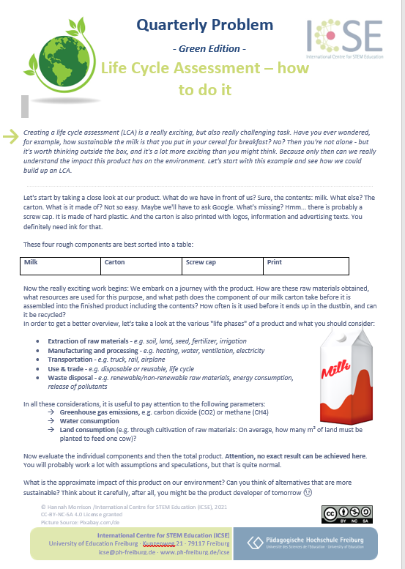

Activity 5.2-5.4

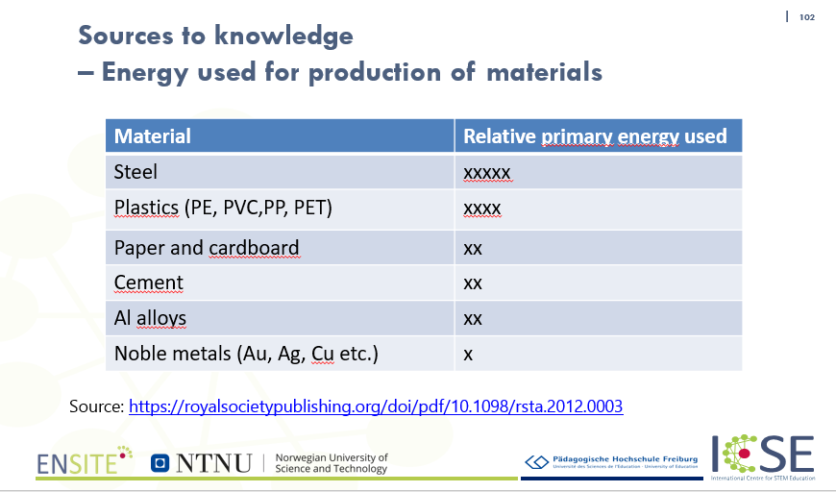

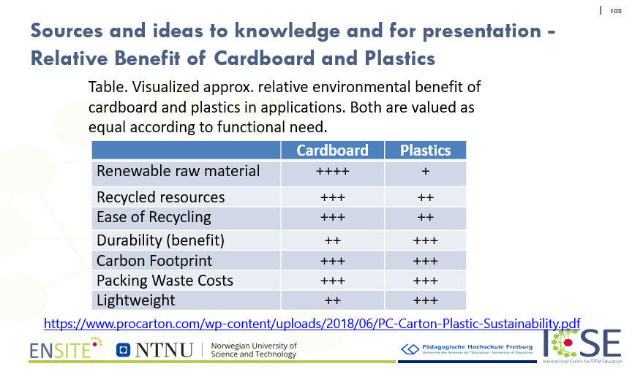

Activity 5.2-5.4
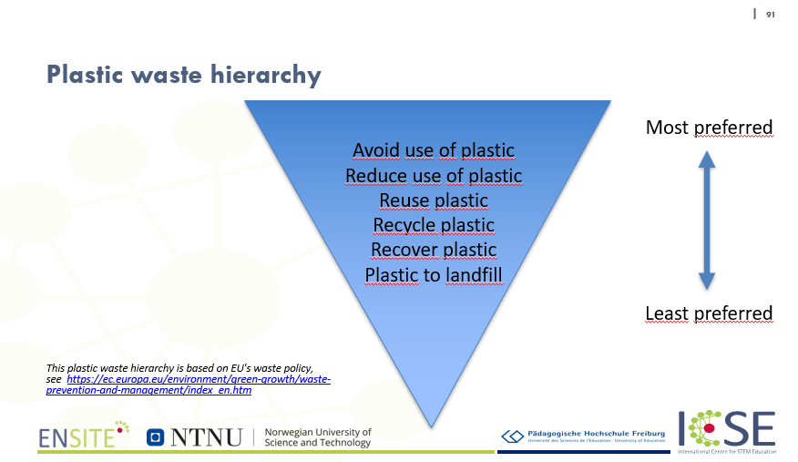

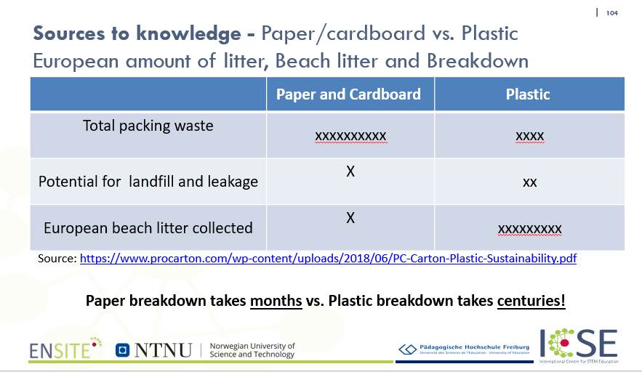
Activity 5.1-5.4
Sources to knowledge – information, statistics and calculators

- Energy used for production of materials
https://royalsocietypublishing.org/doi/pdf/10.1098/rsta.2012.0003
- Relative benefit of cardboard and plastic
https://www.procarton.com/wp-content/uploads/2018/06/PC-Carton-Plastic-Sustainability.pdf
- Water footprint calculator:
https://www.watercalculator.org/
- Environmental footprint calculator. Compare mixed paper, commingled materials, scrap metal and electronics:
https://www.montgomerycountymd.gov/sws/footprint/
- Benefit of cardboard and plastic:
https://www.procarton.com/wp-content/uploads/2018/06/PC-Carton-Plastic-Sustainability.pdf
- Water consumption - Plastic bottles vs. Aluminium cans:
https://www.reuters.com/article/us-environment-plastic-aluminium-insight-idUSKBN1WW0J5
- CO2 impact – glass vs plastic bottles:
https://ecochain.com/story/case-study-packaging-plastic-vs-glass/
- Energy used for production of materials:
https://royalsocietypublishing.org/doi/pdf/10.1098/rsta.2012.0003
- Ranked: the environmental impact of five different soft drink containers
https://theconversation.com/ranked-the-environmental-impact-of-five-different-soft-drink-containers-149642
- Should I buy milk in glass, plastic, or cardboard containers?
https://slate.com/technology/2011/03/should-i-buy-milk-in-glass-plastic-or-cardboard-containers.html
- Cartons vs. Plastic containers (FIlm)
https://www.youtube.com/watch?v=lxg9F2CC89k

