Module 1 | THE NATURE OF ENVIRONMENTAL SOCIO-SCIENTIFIC ISSUES

This outline is based on the work within the project Environmental Socio-Scientific Issues in Initial Teacher Education (ENSITE). Coordination: Prof. Dr. Katja Maaß, UNIVERSITY OF EDUCATION FREIBURG, Germany. Partners: UNIVERSITEIT UTRECHT, Netherlands; ETHNIKO KAI KAPODISTRIAKO PANEPISTIMIO ATHINON, Greece; UNIVERSITÄT KLAGENFURT, Austria; UNIVERZITA KARLOVA, Czech Republic; UNIVERSITA TA MALTA, Malta; HACETTEPE UNIVERSITY, Turkey; NORGES TEKNISK-NATURVITENSKAPELIGE UNIVERSITET NTNU, Norway; UNIVERSITY OF NICOSIA, Cyprus; INSTITUTE OF MATHEMATICS AND INFORMATICS AT THE BULGARIAN ACADEMY OF SCIENCE, Bulgaria; UNIVERZITA KONSTANTINA FILOZOFA V NITRE, Slovakia.

The project Environmental Socio-Scientific Issues in Initial Teacher Education (ENSITE) has received co -funding by the Erasmus+ programme of the European Union (grant no. 2019-1-DE01-KA203-005046). Neither the European Union/European Commission nor the project's national funding agency DAAD are responsible for the content or liable for any losses or damage resulting of the use of these resources.

© ENSITE project (grant no. 2019-1-DE01-KA203-005046) 2019-2022, lead contributions by International Centre for STEM Education (ICSE) at the University of Education Freiburg, Germany. CC BY-NC-SA 4.0 license granted.

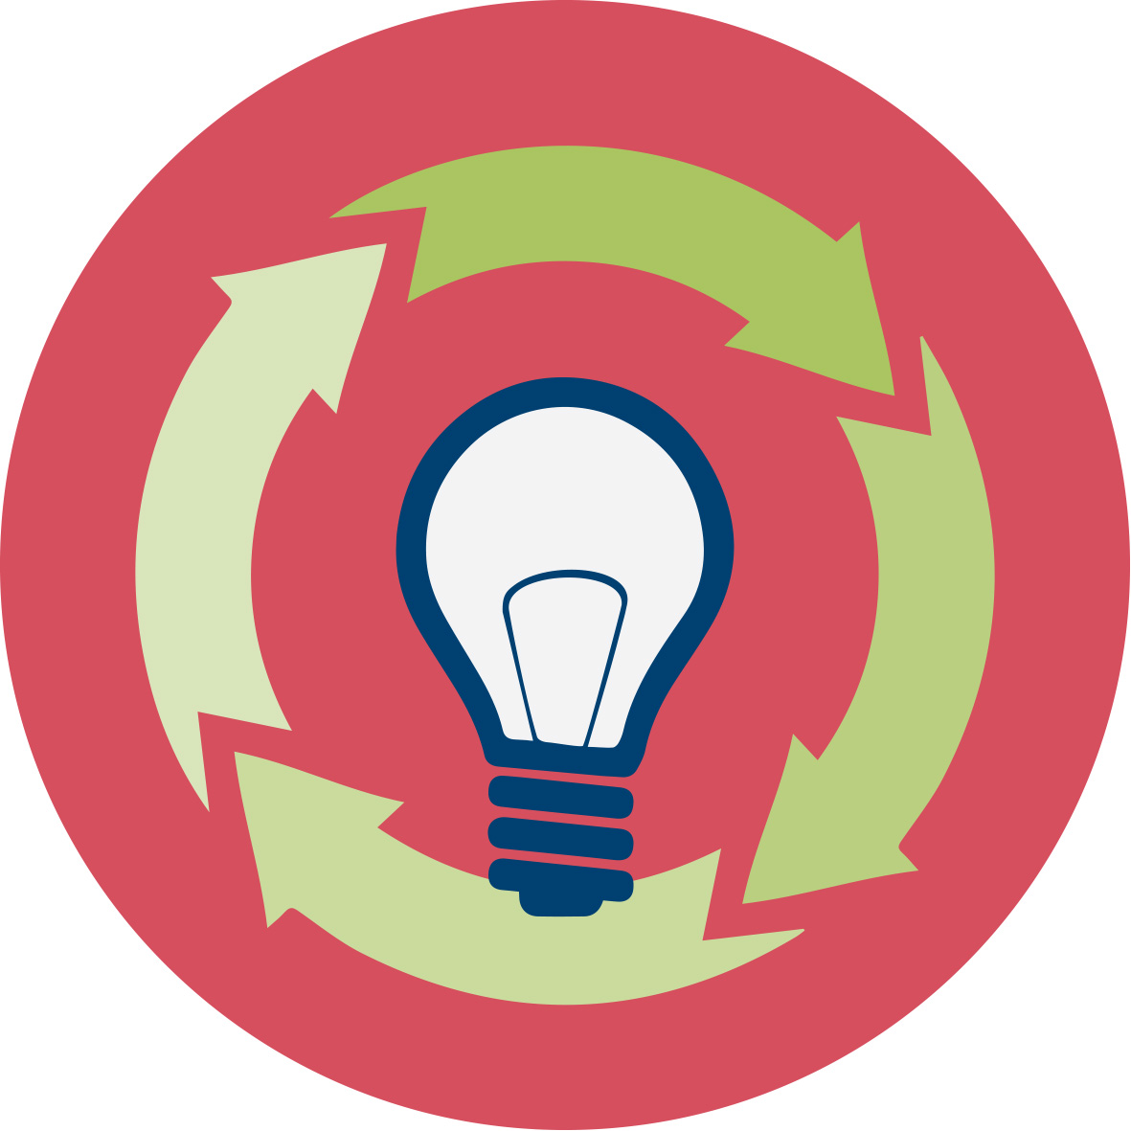 | General overview and aim
In this module future teachers in initial teacher education are introduced to environmental socio-scientific issues. The intention is to make student teachers familiar with the topic by giving them concrete examples and connect these examples to a broader theoretical background. They will learn what environmental socio-scientific issues are and then connect dealing with them to goals of mathematics and science education. In particular they will reflect on the connection between maths and science and citizenship education and then connect citizenship education to socio-scientific issues. At the end of this introductory module students will get an overview about the modules to follow.
The module was designed so as to be relevant to day-to-day teaching. Therefore concrete examples were chosen to give future teachers experience in dealing with environmental socio-scientific issues themselves. Further examples give them the chance to plan using socio-scientific issues in their teaching. Additionally, we also provide the theoretical background on aims of science and mathematics education to balance theory and practice and connect both aspects. The methods chosen prioritize student teachers’ active learning.

This module is part of:
- LEARNING: Developing competences in dealing with environmental SSI themselves
- TEACHING: Acquiring teaching skills to support their future school students in developing these competences
Both aspects relate to (i) scientific competences, (ii) transversal skills like critical thinking, innovative mind-sets and forward-looking skills and (iii) taking into account the social, ethical and cultural aspects related to SSI when making decisions.
IO 1 is an introductory module and therefore the basis of every other module developed within the ENSITE project. Module O1 intends and strengthen the approach as it helps to deepen the knowledge of SSI and sheds light on it from different perspectives. The individual modules also can be used as stand-alone modules in combination with IO1, used as an introduction.

Relevant topics
In this introduction high emphasis is set on introducing environmental socio-scientific issues and their specific features to future teachers. Student teachers will learn what socio-scientific issues are and how to deal with them. Then we will connect dealing with them in maths and science lessons to the aims of mathematics and science education by using the key competence concept of the European Commission (COM 2019).
Then future teachers will get a first insight in how to include them in their lessons. They will work on examples that can be dealt with at student level and plan a lesson with these examples.

Learning Outcomes

Future teachers will
- Be able to deal with environmental socio-scientific issues in an appropriate way (Activities 1.1, 1.2 and 1.3)
- Know that dealing with environmental socio-scientific issues includes transversal skills like critical thinking as well as ethical, social, economic and moral issues (Activity 1.3)
- Be able to describe the features of environmental socio-scientific issues and see that are different to “traditional” science and maths tasks (Activity 1.3)
- Be aware that dealing with environmental socio-scientific issues can be linked to the goals of mathematics and science education (Activity 2.1)
- Be aware about the necessity to link citizenship education to mathematics and science education (Activity 2.2)
- Be aware about the necessity that teaching science and mathematics should not only include learning science and mathematics but also learning about science and mathematics to dispel myths about science and maths (Activity 2.2)
- Be aware about the necessity that teaching science and mathematics should also include dealing with environmental SSI (Activity 2.2 und 3.1)
- Develop skills on how to deal with environmental socio-scientific issues in their future maths and science teaching (Activity 3.2)

Flowchart and Module plan

This module involves three sections, all structured into several activities. It includes 215 minutes of sessions and 120 minutes of homework. It includes lecture parts, group discussions, debates and student presentations. The structure is as follows:
- What are environmental socio-scientific issues (SSI)?: 45 min
- How do environmental SSI connect to mathematics and science education? : 75 min
- How may environmental SSI be included in teaching: 100 min + 90 min Homework
- Outlook on the other modules: 5 min
What are environmental SSI?
Activity 1.1:Should wind power plants be set up everywhere?
Activitiy 1.2: Should the SARS-Covid-2 vaccination be obligatory?
Activity 1.3: Comparing the examples with "traditional" tasks of mathematics and science education.
Activity 1.4: How to deal with SSI?

How do environmetal SSI connect to mathematics and science education?
Activity 2.1: What are the aims of mathematics and science education?
Activity 2.2: What does citizenship education mean for maths and science education?
Activity 2.3: What are possibilities and limitations of maths and science education?

How to include environmental SSI into teaching?
Activity 3.1: What do students learn when dealing with an SSI?
Activity 3.2:How to design a lesson dealing with this SSI?

1. What are environmental SSI? (45 mins)

1.1. “Should wind power plants be set up everywhere?” or “Should the SARS-Covid-2 vaccination be obligatory?”
Duration: 45 minutes
This is a “warm up” activity. The intention is to allow future teachers to gain first insights on environmental SSI and let them experience the controversial character of SSI. Additionally, first reflections on the connections of SSI to science and mathematics education are initiated

To introduce SSI’s we chose two well-known but fairly complex examples. “Should wind power plants be set up everywhere?” and “Should the SARS-Covid-2 vaccination be obligatory?”
It is important that the lecturer will choose one of the two examples, depending on the student’s background (it is not necessary to discuss both)

This session contributes to the achievement of the following learning outcome:
- Experience in dealing with environmental socio-scientific issues (Activity 1.1)

1.2. Reflection on the use of these examples in class
Duration: 30 minutes
Future teachers will reflect on what students can learn from these examples and to what extant they can be used in class to teach science.
This session contributes to the achievement of the following learning outcomes:
- Experience in dealing with environmental socio-scientific issues

1.3. Comparing the examples with traditional tasks of mathematics and science education
Duration: 45 minutes
The intention of this activity is to let future teachers reflect on the features of SSI in comparison to “traditional” mathematics and science tasks. They are supposed to discover that SSI are controversial and involve social, ethical, economic or moral aspects.
Teacher Educators introduce the module using the ppt presentation [1] and then present the activity 1.3 to preservice teachers.
This session contributes to the achievement of the following learning outcomes:
- Knowledge that dealing with environmental socio-scientific issues includes transversal skills like critical thinking as well as ethical, social, economic and moral issues.
- Knowledge on the features of environmental socio-scientific issues and see that are different to “traditional” science and maths tasks.

1.4. How to deal with SSI

Duration: 45 minutes
The intention of this activity is to provide future teachers with the knowledge and skills to deal with environmental issues. They will acquire meta-knowledge on how to do so.
Teacher Educators introduce the module using the ppt presentation [1] and then present the activity 1.4 to preservice teachers.
This session contributes to the achievement of the following learning outcomes:
- Skills on how to deal with them in an appropriate way

2. How do environmental SSI connect to mathematics and science education?

2.1. What are the aims of mathematics education and science education?
 | Duration: 20 minutes
Prospective teachers are expected to reflect on the aims of mathematics and science education based on their experiences. The intention of this activity is to make their own beliefs on the aims transparent.
This session contributes to the achievement of the following learning outcomes:
- Awareness that dealing with environmental socio-scientific issues can be linked to the goals of mathematics and science education

2.2. What does citizenship education mean for maths education and science education? (65 min)
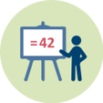 | Duration: 25 minutes
In this session the teacher educator presents key competence concept of the European commission (including not only key competences in mathematics and science but also the key competence “citizenship”. Then student teachers, working in groups, have reflect on how to connect citizenship competence to mathematics and science teaching.
This session contributes to the achievement of the following learning outcomes:
- Awareness about the necessity to link citizenship education to mathematics and science education

2.3. What are possibilities and limitations of science?
 | Duration: 20 minutes
The intention of this session is to make student teachers reflect on their own beliefs and knowledge about the possibilities of mathematics and science.
Student teachers will think about what mathematics and science can offer to find solutions to global challenges and what they cannot offer. Afterwards they reflect on typical myths about mathematics and science. Afterwards these myths will be discussed. Afterwards they are given a list of myths about mathematics and science and are asked to correct them. Finally, they are asked if these reflections on the possibilities and limitations of science and mathematics should be included into science and maths education.
This session contributes to the achievement of the following learning outcomes:
- Awareness about the necessity that teaching science and mathematics should not only include learning science and mathematics but also learning about science and mathematics to dispel myths about science and maths (Activity 2.2)
- Awareness about the necessity that teaching science and mathematics should also include dealing with environmental SSI (Activity 2.2 und 3.1)

3. How to include environmental SSI into teaching? (100 min + 90 min homework)

3.1. What do students learn when dealing with a socio-scientific issue?
Duration: 40 minutes + 90 homework
The intention of this session is to make prospective teachers reflect on their beliefs whether or not such tasks should be included in their teaching.
To this end, future teachers first deal with an environmental SSI at school students’ level. They are supposed to solve the task and reflect on what school students learn when dealing with this task. They also have to reflect on their beliefs whether or not such tasks should be included in mathematics and science teaching.
This session contributes to the achievement of the following learning outcomes:
- Awareness about the necessity that teaching science and mathematics should also include dealing with environmental SSI (Activity 2.2 und 3.1)

3.2. How to design a lesson dealing with environmental SSI?
Duration: 40 minutesDuration: 20 minutes for presentation
Student teachers are expected to plan a lesson which deals with the SSI they worked on before. Later they are supposed to present the task to the overall group.
This session contributes to the achievement of the following learning outcomes:
- First knowledge and skills on how to deal with environmental socio-scientific issues in their future maths and science teaching (Activity 3.2)

 | Materials and resources
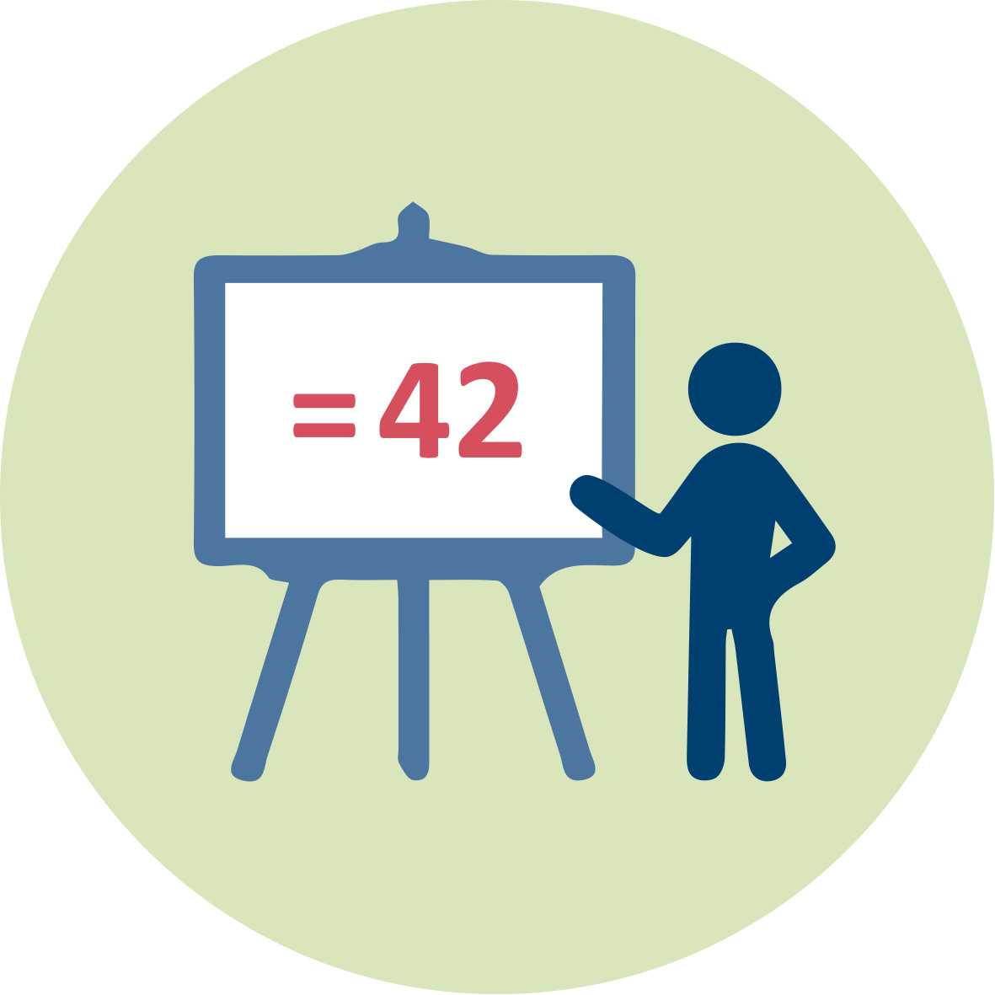 | Presentation 1 (pptx). Teacher Educator “The nature of environmental socio-scientific issues
 |  | Readings and students’ handouts
 | Access to computers for internet research and collaborative work

Granularity
- Skip one of the examples of part 3.
- In activity 2.2, skip the reflections about the myths of mathematics and science
- Skip activity 3.2

References
COM (2019): Key Competence development for lifelong learning. DOI: 10.2766/569540

Further readings
Since the module O1 is an introductory module we recommend all other ENSITE modules as further readings.

Assessment
The lesson plan will show to what extend the student teachers understood SSI and teaching SSI and whether they reached the objectives.

