Module 7 |  | AIMS OF SSI AND THE CURRICULUM

Worksheets

This worksheet is based on the work within the project Environmental Socio-Scientific Issues in Initial Teacher Education (ENSITE). Coordination: Prof. Dr. Katja Maaß, UNIVERSITY OF EDUCATION FREIBURG, Germany. Partners: UNIVERSITEIT UTRECHT, Netherlands; ETHNIKO KAI KAPODISTRIAKO PANEPISTIMIO ATHINON, Greece; UNIVERSITÄT KLAGENFURT, Austria; UNIVERZITA KARLOVA, Czech Republic; UNIVERSITA TA MALTA, Malta; HACETTEPE UNIVERSITY, Turkey; NORGES TEKNISK-NATURVITENSKAPELIGE UNIVERSITET NTNU, Norway; UNIVERSITY OF NICOSIA, Cyprus; INSTITUTE OF MATHEMATICS AND INFORMATICS AT THE BULGARIAN ACADEMY OF SCIENCE, Bulgaria; UNIVERZITA KONSTANTINA FILOZOFA V NITRE, Slovakia.

The project Environmental Socio-Scientific Issues in Initial Teacher Education (ENSITE) has received co -funding by the Erasmus+ programme of the European Union (grant no. 2019-1-DE01-KA203-005046). Neither the European Union/European Commission nor the project's national funding agency DAAD are responsible for the content or liable for any losses or damage resulting of the use of these resources.

© ENSITE project (grant no. 2019-1-DE01-KA203-005046) 2019-2022, lead contributions by International Centre for STEM Education (ICSE) at the University of Education Freiburg, Germany. CC BY-NC-SA 4.0 license granted.

Content Index

AIMS OF SSI AND THE CURRICULUM 1
Worksheets 1
Activity 1.1: Brainstorming about EnvSSIs 1
Activity 1.2: Reflecting on EnvSSIs’ connections with mathematics & science education 2
Activity 2.1: EnvSSIs and education 3
Activity 2.2: Readings on Teachers’ challenges 4
Activity 2.3: Example of enacting EnvSSIs in classroom: The case of role-playing scenario 5
Activity 2.4: Theoretical frameworks for analyzing students’ arguments 7
Activity 3.1: Dealing with the Paper or Plastic Bag issue: Role-playing scenario 9
Activity 3.2: Dealing with a specific Lake Drainage and re-creation issue: Multiplicity of the factors & “Uncertainty” 11
Activity 4.1: Lesson design 14
Activity 4.2: Reflecting on the lesson design 15

 | Activity 1.1: Brainstorming about EnvSSIs
 | Work and discussion in groups |  | 20 mins
Discuss the issues below in your group.
- Which are better for the environment, paper or plastic bags?
- Is global warming caused by human activity or by natural cyclical phenomena?
Reflect on the questions below and then share your opinions by arguing them.
- Is there a unanimous answer/ a common output? Are you certain about your viewpoint?
- What do you think you need to defend your claims & to convince opponents of your opinion?
- How can science and mathematics help you in answering these issues? Carry out a research in these issues.

 | Activity 1.2: Reflecting on EnvSSIs’ connections with mathematics & science education
 | Work and discussion in groups |  | 20 mins
Reflect on the questions below and share your opinions.
- Provide examples of EnvSSIs.
- What characteristics do you identify in such issues?
- Do you think that it is important to teach such issues in the school? Why?
- Are such controversies included in your mathematics & science national curriculum? If so, how?
- Which role can EnvSSI play in achieving expected learning outcomes of the mathematics and science curriculum?
- What would be your concerns if you were asked to teach these issues?

 | Activity 2.1: EnvSSIs and education
 | Work and discussion in groups |  | 10 mins
Read throw the following extracts from research literature:
- The Socio Scientific Issue movement has drawn from a wide swath of interrelated scholarship, e.g.
- epistemological maturation,
- socio-moral discourse,
- emotive reasoning,
- character education,
- nature of science and argumentation,
that uniquely positions it as a sociocultural progressive framework serving as a counterpoint (or a complement) to recent STEM initiatives as commonly conceived and practiced in academia (Zeidler et al, 2019).
- ‘Environmental education typically emphasizes private share environmentalism… i.e., what an individual can do to reduce negative effects on the environment. However, effective actions when dealing with environmental problems are collective…, therefore, students should be given opportunities to discuss the societal and global sphere and analyse environmental problems as public issues’ (Sternäng & Lundholm, 2012).
- EnvSSIs are controversial issues that have a basis in science and mathematics and require people to engage in discussion and debate. In the decision-making processes, they required the use of evidence-based reasoning, as well as a degree of moral reasoning or the evaluation of ethical concerns.

Discuss in your group and consider the following question:
- How can the type of issues described above be related to the national curriculum?

 | Activity 2.2: Readings on Teachers’ challenges
 | Work and discussion in groups |  | 10 mins
Read the following extracts from research literature about challenges and dilemmas that teachers experience when integrating EnvSSIs into mathematics or science teaching.
- Teachers’ value-free beliefs. Many teachers believe that science and mathematics should be objective and value-free, (Bryce & Gray, 2004), and it is not the role of science and mathematics education to attempt to solve social, political issues. Also, they feel insecure when trying to not promote their personal views at the issues involved (Gayford 2002).
- Teachers’ ill-preparedness in teaching EnvSSIs. Many teachers feel ill-prepared to select relevant socio-scientific topics and to teach them (Bryce & Gray, 2004) and to deal with the uncertainty of the students’ solutions and ideas (Evagorou, 2011).
- Classroom management in leading debates. Many teachers express difficulties in leading debates or controversial discussions, judging the non-scientific aspects of the issues involved. Thus, they feel insecure in handling conflicting aims in terms of enhancing the students’ independence as learners (in a student-centred approach) while trying at the same time to control the learning outcomes (by acquiring basic science knowledge) (Aikenhead, 2006; Bosser et al., 2015).

Discuss in your group and consider the following question:
- What issues do you recognize in mathematics and science curriculum objectives and their enactment in the classroom?

 |  | Activity 2.3: Example of enacting EnvSSIs in classroom: The case of role-playing scenario
 |  |  | Work and discussion in groups |  |  | 10 mins
Read the examples given in the following table. Then discuss in your group the analysis of enacting EnvSSIs in terms of the school subject, the resources used, the content knowledge and curriculum aim and the design of a role-playing scenario.
School subject | Resources | Curricular aims | Role-playing scenarios
Science | e.g., Magazine articles, YouTube videos, scientific presentations / reports, graphical data | e.g., greenhouse effect, climate change, recycling | e.g., a school decision not to offer meat dishes in the school restaurant
Mathematics |  | Modelling, problem solving, argumentation

 | Work in groups |  |  |  | 20 mins
Read the role-playing scenario on “Green mobility” below. Work in groups and specify the school subject, and the mathematical and scientific ideas involved and find relevant resources.

Green Mobility
As experts for Green Mobility, you stand for alternative means of transportation like electric cars, alternative fuels such as biodiesel, and public transport with buses and trains. Your goal is the reduction of greenhouse gases and climate protection with the help of alternative means of transportation and the limitation of individual transport. Individual transport means that everyone uses his own car or motorcycle. Therefore, a law on the increase of the minimum age for a driving license up to 21 years is a good idea to achieve goals, as it forces young people to use public transport and limits the overall traffic.

Work in groups and design your own role-playing scenario related to an EnvSSI from your choice and complete correspondingly the table below.
School subject | Resources | Curricular aims | Role-playing scenarios
Science
Mathematics

 | Activity 2.4: Theoretical frameworks for analyzing students’ arguments
 | Work and discussion in groups |  | 30 mins
Reflect in groups on the below theoretical frameworks for analysing students' arguments.
- Toulmin’s framework.
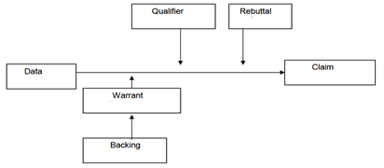

- Belova et al.’s framework.
  - Domain: Where do the arguments used by the students come from (science/everyday life/society/politics)?
  - Level of argument: How complex are the arguments?
  - Reference: Do the students make references to each others’ statements? Does a conversation arise?

Read the following classroom task on the basis of Hydrogen fuel bus extracted from the literature.
"Between 2004 and 2007, Transperth trialled three EcoBuses in Perth which ran on hydrogen fuel cells as their fuel source. The benefit of using a hydrogen fuel cell is that the only waste emissions produced are water and heat. At the conclusion of the trial, the three buses had travelled 258,000 km and carried over 320,000 passengers. Three hundred tCO2eq (tonne of CO2 equivalent) were saved by not using regular diesel buses. Although the trial was deemed a success by Transperth, the WA government has decided not to proceed any further with the EcoBuses, claiming the cost to maintain that each bus was too high a price to pay compared to a regular bus. Do you think the WA government made the right decision?"

Work in groups, consider the following analysis’s example of a student’s response (claim: Yes) according to Toulmin’s framework. Then, analyse the below student’s response (claim: No) utilizing both Toulmin’s and Belova et al.’s frameworks.
- Example: Claim: Yes.
“I think the WA government made the right decision (claim) as the buses would cost a lot of money and would put our state to bankrupt (data) meaning we will have to cut down on other expenses and Centrelink payments for those who are struggling (backing) just so we can have ecofriendly public transport. Also not many people use buses as many own cars (data) which means it is not really helping the environment. The different it will make is not very big.”
- Claim: No.
“The reason for this is because as the statistics showed, 300tCO2eq were saved by using these types of buses, which indicate that a great number of tCO2eq had been prevented from entering the atmosphere and causing further damage. Furthermore, it is also stated that the only waste emissions produced are water and heat; therefore, less harmful greenhouse gases are produced. If less greenhouse gases are produced, this means that the damage to the natural balance of producing greenhouse gases is slowed down (data), which means that by using this Ecobuses, it will be worth it for the long run as this will be beneficial for the environment. Therefore, the cost would not matter to the WA government because paying for the Ecobuses is like paying for a better future as less damage will be done to the environment.”

 | Activity 3.1: Dealing with the Paper or Plastic Bag issue: Role-playing scenario
 | Work in groups |  | 60 mins
Below, you are given an extract of the Washington Post Company newspaper (2007) that compares the paper and the plastic bag:
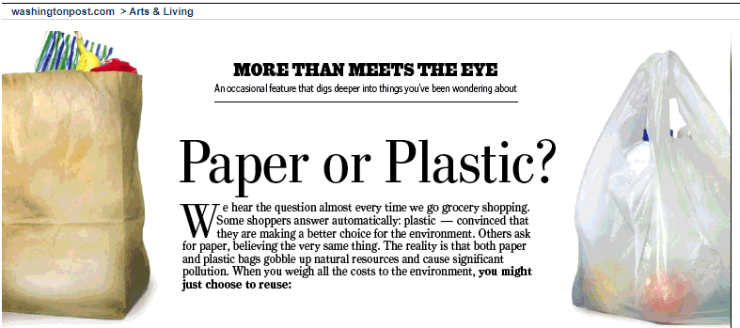

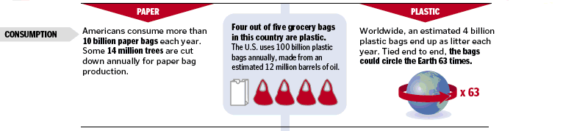
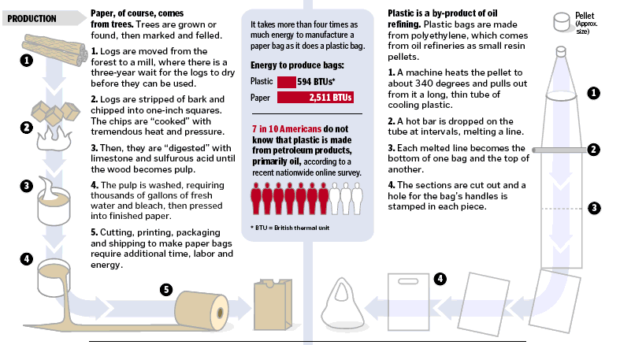

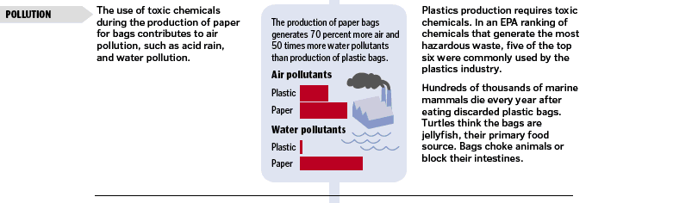
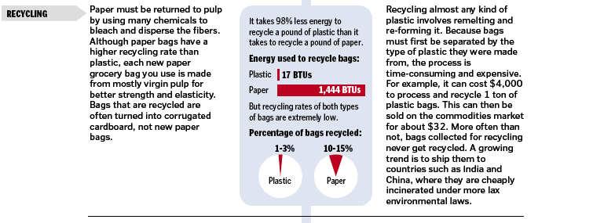
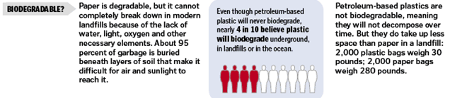

Based on the issue: Are plastic bags or paper bags better for the environment? described in the above extract, form three groups and perform a role-playing scenario as following:
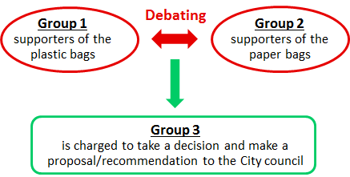

- Group 1 and Group 2 will prepare an argumentation to support their views to form a debate in front of Group 3.
- Group 3 will write a report to recommend to the city council of your city about the use of plastic or paper bags. Are the evidence-based arguments provided strong enough to persuade the city council?

To prepare this activity (debate & recommendation), you can:
- search in your national curricula for tasks, information, or resources about this issue,
- use resources or data from your everyday life,
- carry out your own internet research or/and use the references given below:
- the Environment Agency’s report: “Life cycle assessment of supermarket carrier bags: a review of the bags available in 2006”.
- the report “Life Cycle Assessment of Reusable and Single-use Plastic Bags in California”, J. Greene, 2011.
- the NGO UNEP report “Single-use plastics, a roadmap for sustainability”, 2018.

 | Activity 3.2: Dealing with a specific Lake Drainage and re-creation issue: Multiplicity of the factors & “Uncertainty”
 | Work and discussion in groups |  |  | 20 mins
Read throw the following story of the Karla Lake in Thessaly, Greece:
Karla Lake is located in the central part of Greece. It had a rich biodiversity.
It was drained in the early 1960s and then re-flooded in recent years.

- Some reasons for the decision to drain the lake:
  - The fluctuations in the water levels
  - The floods in the area
  - The need to create more farmland
  - The reduced catches
  - The need to reduce malaria epidemics

- Some environmental and social effects of the drainage:
  - Rapid fall of groundwater
  - Pollution in the closed gulf and appearance of phytoplankton
  - Appearance of deep cracks and destruction of buildings
  - Destruction of the fauna and flora of the area
  - Adverse changes in the microclimate of the region and increase of extreme weather phenomena
  - Inability to supply water for cities and villages

- The decision to re-create the lake.
  - It was found that the effects on the ecosystem of the area were greater than the benefits offered by its drainage. Thus, the recreation of the Lake was decided.
  - Today, efforts are being made to carry out the recreation, which started in December 2010.

Based on the resources provided below or other resources of your own, think about the following questions and discuss your ideas with your peers:
- Reflect on the advantages and disadvantages involved in two core decisions related to the drainage and restoration of Karla Lake.
- Identify aspects of mathematics and science teaching that you recognize in lake drainage and restoration.
Resource 1 – Yearly water balance of Karla Lake
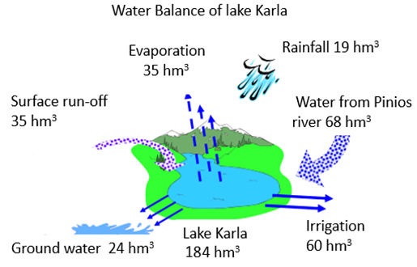

Resource 2 – Water Quality & Environmental Condition of Karla Lake
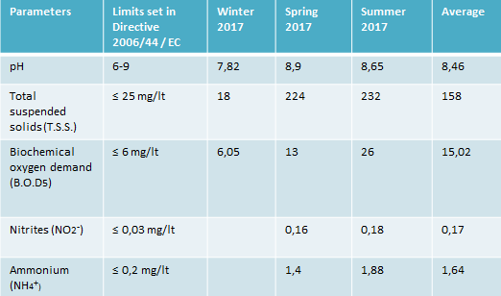

Resource 3 – An example of the salinity evolution of a lake
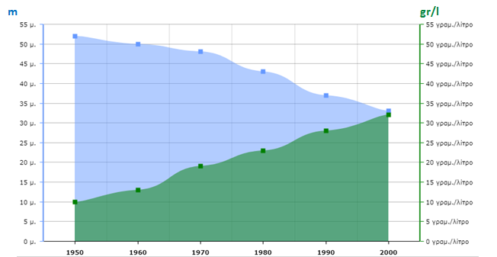

 | Work and discussion in groups |  |  | 20 mins
After reading the following extract from Barwell (2013), discuss in your group how the “uncertainty” involved in the Karla Lake issue could be dealt in a classroom lesson.

In post–normal science, values and facts cannot be separated, in part due to the problem of uncertainty. Climate models, for examples, include uncertainty and any possible action to deal with climate change will have uncertain effects to a greater or lesser extent. Deciding which information to use, which voices to hear and which methods to try, depends as much on values as it does on scientific facts.

 | Activity 4.1: Lesson design
 | Work in groups |  | 15 mins
Work in groups, select an EnvSSI and reflect on this issue by considering the following questions:
- Describe aspects of the issue (e.g., controversy, uncertainty, national or international topic, what are the social and scientific implications related to this issue)
- Identify connections with the national curriculum, to what extent the issue is addressed in the school subjects.
 | Homework + Work in groups |  | 60 mins
Design a mathematics or science lesson dealing with the EnvSSI that you have selected previously. Consider the following criteria, which will be used for assessing the lesson designs:
- Is the lesson clearly connected to the maths or science school curriculum:
  - To what extent is the lesson design connected with specific maths and science school curriculum objectives.
  - To what extent is the mathematical and/or scientific content knowledge of the EnvSSI addressed in the lesson.

- To what extent are the uncertainty and the controversy of the issue dealt with in the lesson design:
  - Does the lesson design involve a debate?
  - Is there an evaluation of peer’s claims and arguments?
  - Does it involve a scenario (e.g. a role playing, writing a report…)
  - Is it required from pupils to make a conclusion?

 | Activity 4.2: Reflecting on the lesson design
 | Presentation and discussion in groups |  | 45 mins
After presenting to the classroom the lesson that you have designed, discuss with your group and reflect on the following questions:
- What type of mathematical or scientific knowledge is involved when teaching specific EnvSSIs?
- What themes about connections of EnvSSIs and the curriculum are raised?
- How is the uncertainty of the EnvSSI you have designed dealt with?
- What difficulties have you encountered when designing the lesson (i.e. the choice of an EnvSSI, pre-requisite knowledge, connection with the curriculum, etc.)

