Module 3 |  | COLLECTING DATA

Worksheets

This worksheet is based on the work within the project Environmental Socio-Scientific Issues in Initial Teacher Education (ENSITE). Coordination: Prof. Dr. Katja Maaß, UNIVERSITY OF EDUCATION FREIBURG, Germany. Partners: UNIVERSITEIT UTRECHT, Netherlands; ETHNIKO KAI KAPODISTRIAKO PANEPISTIMIO ATHINON, Greece; UNIVERSITÄT KLAGENFURT, Austria; UNIVERZITA KARLOVA, Czech Republic; UNIVERSITA TA MALTA, Malta; HACETTEPE UNIVERSITY, Turkey; NORGES TEKNISK-NATURVITENSKAPELIGE UNIVERSITET NTNU, Norway; UNIVERSITY OF NICOSIA, Cyprus; INSTITUTE OF MATHEMATICS AND INFORMATICS AT THE BULGARIAN ACADEMY OF SCIENCE, Bulgaria; UNIVERZITA KONSTANTINA FILOZOFA V NITRE, Slovakia.

The project Environmental Socio-Scientific Issues in Initial Teacher Education (ENSITE) has received co -funding by the Erasmus+ programme of the European Union (grant no. 2019-1-DE01-KA203-005046).Neither the European Union/European Commission nor the project's national funding agency DAAD are responsible for the content or liable for any losses or damage resulting of the use of these resources.

© ENSITE project (grant no. 2019-1-DE01-KA203-005046) 2019-2022, lead contributions by International Centre for STEM Education (ICSE) at the University of Education Freiburg, Germany. CC BY-NC-SA 4.0 license granted.

Content Index
COLLECTING DATA 1
Worksheets 1
Worksheet 1: Air Pollution Perception Survey 3
Worksheet 2: Modeling the spread of a viral outbreak 1

Worksheet 1: Air Pollution Perception Survey

60 min
Collect data and discuss the questions on the example of “Air Pollution Perception Survey”. Suggest additional questions.

I. Air Pollution Perception
1. How would you rate the overall air quality in your city now compared to last year?
- Much better
- A little better
- About the same
- A little worse
- Much worse
2. What do you think are the main causes of air pollution in your city? Please select all applicable.
- Construction
- Industrial sources/manufacturing facilities
- Increasing use of air conditioner
- Motor vehicles
- Household cooking and heating
- Population growth
- Power plants
- Smoke of cigarettes
- Waste disposal
- Burning of Waste
- Pollution from other countries
3. To what extent is the air pollution affecting you?
- Very much affected
- Affected a little
- Not affected at all
4. In which of the following ways are you affected? Please select all applicable.
- Breathlessness/having more difficulty in breathing
- Doing less outdoor activities
- Doing more to look after my skin
- Doing more to stay healthy
- Feeling depressed
- Irritation to eyes/nose/throat
- Skin problems
- Wanting to move to other less polluted place
- Asthma incidences
- Poor visibility
- Worrying about the living environment for children
5. Please express how much do you agree or disagree on the following statements.
Strongly Agree Agree Undecided Disagree Strongly Disagree
- “Polluting companies should be fined even if it puts some jobs at risk.”
- “Power stations and factories should switch to cleaner processes even if consumer bills and prices have to go up.”
- “Government should do more to promote and encourage a better environment even if our taxes have to go up slightly.”
- “Police should stop and check car emissions more frequently even if it causes traffic delays.”
- “Improving the environment is the responsibility of every citizen.”
- “Recycling programs should be put in place and promoted across the whole city.”
- “I am actively involved in cleaning up the environment.”
- “The pollution is out of my control and I cannot do anything to change it.”
- “I do not see the pollution as a problem.”
- “If I knew how to better contribute to a cleaner environment, I would take action.”

II Air Pollution Perception
. How much concern do you have on the effects of these environmental issues on your personal health or well-being?
Please rank on your level of concern, with 1 - highest concern and 7 - lowest concern.
1 2 3 4 5 6 7
- Air pollution
- Drinking water pollution
- Garbage and solid waste
- Global warming and climate change
- Loss of green areas in city
- Surface water (e.g. river, lakes) pollution
- Unsafe food

Worksheet 2: Modeling the spread of a viral outbreak
90 mins
Purpose: As it has been emphasized in the Outlines, the SSI students are expected to be up to date with the major social problems of the humankind and respond to them as quickly as possible. Because of the enormous recent need of the society worldwide, an activity for “Modeling the spread of a viral outbreak” has been designed to teach the mathematics and science students in ITE to use a pre-prepared mathematical model to explore viral transmission and exponential growth. The model has been programmed within a spreadsheet (Google Sheets) and enables the students make their own research, explore different perspectives, and interpret their findings. The immediate results the spreadsheet provides allow them to numerically and graphically compare viruses with different reproduction numbers R0. In such a way, the activity challenges the students’ understand the data they use in the model, make various implications of the model, and devise strategies for reducing the R0 number of the virus and the viral transmission.
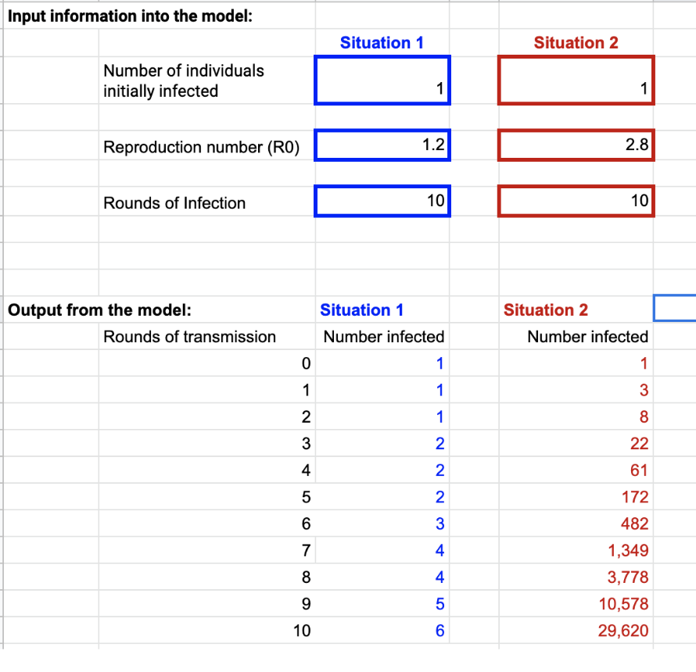
Fig. 1 Input Information into the model
Description: The activity presents to the SSI students a mathematical model of a spread of a virus through a human population. Like other models used by the scientists, this one is also based on specific data that describes the phenomenon of the virus spread. The model is to predict the number of individuals that might become infected by the virus over time. The pre-service teachers will also use it to predict the spread of different viruses with unique rates of spread.
Stage 1. Introducing the prospective mathematics and science teachers in ITE to the science foundations of the model (15 min.)
- The virus reproduction number denoted by R0 is among the most important concepts of the model. It describes how many people on average are infected by the virus by a single individual. For example, if a virus has R0=3, then a person who carries it infects 3 other people.
Scientists denote the reproduction number by the symbol R0 (pronounced R naught). Selecting the respective tab on the spreadsheet allows the students to reach a figure that describes R0 visually.
The spreadsheet-implemented mathematical model provides the future teachers with the opportunity to explore on their own the unique feature of virus infections spread: the exponential growth. The model reflects on it by means of a special parameter:
- The Rounds of transmission is a number that specifies how many steps of the viral outbreak the mathematical model will process. For example, if a person infected by a virus with R0=3 transmits it to 3 more people, and then each of these infects another 3 people (thus 9, in total), then 2 rounds of transmission are observed.
The spreadsheet automatically runs 10 rounds of transmission. The students, however, can select the round of transmissions be higher.
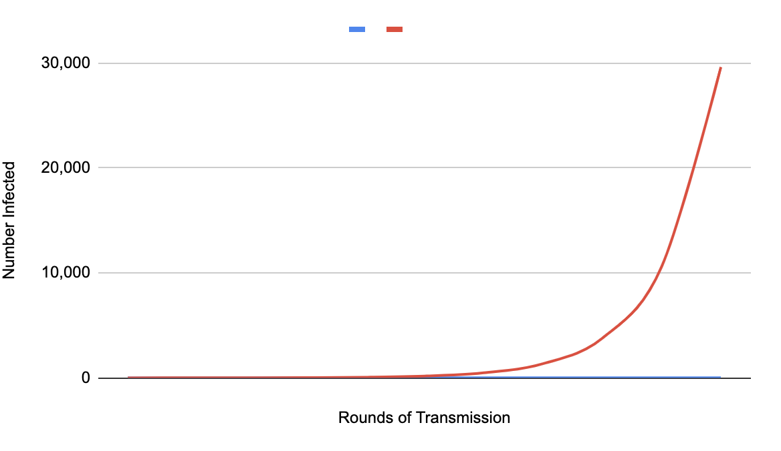
The spreadsheet is programmed in a way that enables the users to compare different viruses, different estimates of R0, or different numbers of people initially infected. To make such comparisons, they just need to run the model for Situation 1 or 2 (Fig. 1).

Fig. 2 Rounds of Transmition

Stage 2. Instructing the students to the architecture of the spreadsheet (20 min.)
The user-friendly design of the spreadsheet makes the distinction between the input and output parameters very clear and helps the students to immediately start working with it. The input values that are the virus reproduction number R0 and the rounds of infection, are to be written in special boxes shown on the screenshot in Fig. 1. The model provides estimates of the numbers of individuals predicted to be infected and automatically creates the graph shown on Fig. 2.
Stage 3. The Process of Mathematical Modeling (45 min.)
In their numerical experiments, the mathematics and science students in ITE are guided by the following list of

Research Questions

Group 1. Questions. Assume that the reproduction number R0 for COVID-19 may be as low as 1.5 or as high as 3.5.

- How many people would you expect to be infected after 5 rounds of transmission if the low R0 is accurate?
- How many people would you expect to be infected after 5 rounds of transmission if the high R0 is accurate?
- Why does the accuracy of the R0 value matter?
- Why do you think there is such a big range for the R0 value for COVID-19 at this point in time?

Group 2. Questions.

- For the common flu R0 is estimated at 1.3. If we assume R0 for COVID-19 to be equal to 3, how many more people can you expect to be infected by COVID-19 compared to the flu after 10 rounds of transmission?
- How many rounds of transmission of the flu would it take for flu to infect the number of people infected by COVID-19 after 10 rounds of transmission?
- What factors might contribute to the low rate of viral transmission of the flu compared to COVID-19?
- If you had to calculate the number of people infected after 3 rounds of transmission by hand, i.e. without the use of the spreadsheet model, explain how you would make the calculations.

Group 3. Questions. The model helps the students think about the spread of the
disease and can be used to compare the rates of spread of different viruses.

- What other aspects of different viruses spread should be considered when comparing the "intensity" of viral outbreaks?
- What are the limitations of the current spreadsheet model?

Group 4. Questions.

- What happens to a viral outbreak when R0 for the virus falls below 1?
- What things could be done to lower the COVID-19 R0?
- If we assume that 100,000 individuals are infected by COVID-19 and it’s possible to lower its R0 down to 0.2, how long (in rounds of transmission) would it take to halt the spread of the virus?

Stage 4. Classwork Summary and Reflections (10 min.)

The prospective mathematics and science teachers in ITE share their findings and conclusions and what they have learned about the virus spread from the mathematical modelling activity.

Stage 5. Reporting the Results; Students’ Reflections

As a Homework Assignment, the prospective teachers are to systematize the data and results for each experiment they have carried out and write down their interpretations.

Any reflections regarding the challenges or surprises the participants have experienced are highly appreciated. For authenticity, however, no form to fill-in will be given and the reflections are not mandatory.

