Module 5 |  | THE DECISION-MAKING BASED ON CONFRONTING SCIENTIFIC POSITIONS

Worksheets

This worksheet is based on the work within the project Environmental Socio-Scientific Issues in Initial Teacher Education (ENSITE). Coordination: Prof. Dr. Katja Maaß, UNIVERSITY OF EDUCATION FREIBURG, Germany. Partners: UNIVERSITEIT UTRECHT, Netherlands; ETHNIKO KAI KAPODISTRIAKO PANEPISTIMIO ATHINON, Greece; UNIVERSITÄT KLAGENFURT, Austria; UNIVERZITA KARLOVA, Czech Republic; UNIVERSITA TA MALTA, Malta; HACETTEPE UNIVERSITY, Turkey; NORGES TEKNISK-NATURVITENSKAPELIGE UNIVERSITET NTNU, Norway; UNIVERSITY OF NICOSIA, Cyprus; INSTITUTE OF MATHEMATICS AND INFORMATICS AT THE BULGARIAN ACADEMY OF SCIENCE, Bulgaria; UNIVERZITA KONSTANTINA FILOZOFA V NITRE, Slovakia.

The project Environmental Socio-Scientific Issues in Initial Teacher Education (ENSITE) has received co -funding by the Erasmus+ programme of the European Union (grant no. 2019-1-DE01-KA203-005046). Neither the European Union/European Commission nor the project's national funding agency DAAD are responsible for the content or liable for any losses or damage resulting of the use of these resources.

© ENSITE project (grant no. 2019-1-DE01-KA203-005046) 2019-2022, lead contributions by International Centre for STEM Education (ICSE) at the University of Education Freiburg, Germany. CC BY-NC-SA 4.0 license granted.

Content Index
THE DECISION-MAKING BASED ON CONFRONTING SCIENTIFIC POSITIONS 1
Worksheets 1
1.1 Ambience evocation 3
1.2 Mapping the field of interest 3
II. Immersion into the topic Decision-making in confronting scientific positions 4
2.1. Decision-making about food as multi contexts phenomenon 4
II. Immersion into the topic Decision-making in confronting scientific positions 5
2.2. My decision to buy a food 5
II. Immersion into the topic Decision-making in confronting scientific positions 5
2.3. Food market and food consumption in different regions 5
III. Applications into the topic Decision-making in confronting scientific positions 6
3.1. Decision-making about food in numbers 6
III. Applications into the topic Decision-making in confronting scientific positions 7
3.2. Decision-making for food storage and transportation 7
III. Applications into the topic Decision-making in confronting scientific positions 7
3.3. Decision-making about food in confrontation of different contexts 7
III. Applications into the topic Decision-making in confronting scientific positions 8
3.4. Decision-making about food in simple science experiments 8

I. Introduction into the topic Decision-making in confronting scientific positions

1.1 Ambience evocation
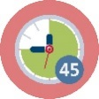Duration: 45 minutes
Observe the “real food”. It can be a bio-vegetables and traditional vegetables, food without and with preservatives, food from different origins, etc. If you are working in outdoor session, begin the activity near the place with food like a food-market, a garden, a food-company, a food waste collection yard etc.
What you can answer to these questions:
What is the impact/effect of food production on our life/life of people?
Can food production change our life?
What we can contribute to food sustainability?
Please, create groups/pairs and prepare title and short commentary to elected picture about food (pictures of bio-banana, food-waste, palm oil production, molecular food, big agricultural production, farm products, malnutrition, obesity, food transport, allergy and food, adventure food, overproduction of the food etc.). After 20 – 25 minutes present your results and discuss them with others.
(Teachers educator has for student’s choice pictures of different food phenomena (see in attachments). It can be done from WWW by different possibilities. Pictures can be elected also by lottery or competition.)

I. Introduction into the topic Decision-making in confronting scientific positions

1.2 Mapping the field of interest
Duration: 45 minutes
Start with the brainstorming (teacher will set together with students concrete conditions for the brainstorming – time, prohibited words, technical realization – writing on blackboard etc.). Central term for brainstorming will be “FOOD” or “FOOD CHOICE” as self. Produce words related to the central term in limited time.
Next step is clustering, it means a classification of groups of produced words. Propose groups such as science, economics, politics, culture… In the last step create concepts maps in each group of words and next create common concept map about phenomena FOOD in DECISION MAKING connected with discussions about different experiences mainly with everyday contexts.
Possible alternatives: topic of brainstorming can be more sophisticate, it means e.g. producing only adjectives for food (bio, vegan, vegetarian, healthy, addictive, harmful, fat, natural, artificial etc.) or producing names or words containing the different word connected with food (names of cities, geographical terms, foods and their examples in different languages etc.).

II. Immersion into the topic Decision-making in confronting scientific positions

2.1. Decision-making about food as multi contexts phenomenon
and and | Dur.: 30 min + discussion
Think about food as borderless phenomena.
Use short video with topic “Factors affecting food choice” at the link https://www.youtube.com/watch?v=D6eor1wkNFY or/and with topic “Food Choices” at the link https://www.youtube.com/watch?v=XVzXcBoufyU.

After the introduction work first individually, next in pairs and finally in groups:
- Each one of you receives “food-card” (see in attachments) and elects one of the eight contexts related to food: (1) Sensory assessment, (2) Content assessment, (3) Tradition in use, (4) Advertising influence, (5) Following the leaders, (6) Packaging and Branding, (7) Costs limits and (8) Own beliefs about. Write (with using different sources), please, one page the characteristics of food in elected context. You can produce text or graphics or schema etc. (5 min)
- Create pairs and ask next cards for task to work together in 3 elected contexts (it will be 1 or 2 from previous individual work and 1 or 2 new). Write in pair (with using different sources), please, one page for each of three characteristics of food in elected contexts. All three finished cards give back to teacher (teacher orders cards in 8 columns by eight contexts of food). (10 min)
- Create 8 groups and for each group order (by competition or by lottery) one context from eight previous. Each group receives appropriate column (collection of cards) and elaborates one compromise final version of context characteristic with focus to different consequences. (5 min)
- Each group show the elaborated context and discuss it with all in plenary session. (10 min)

II. Immersion into the topic Decision-making in confronting scientific positions

2.2. My decision to buy a food
or | +  Duration: 30 minutes + 90 minutes homework
Analyze different types of buyer behavior. Create four groups and deal with next four strategies of buyer behavior using relevant web sources (it means links to sources, authorship – author(s), institution(s), age of information, dispersion of information sources etc.):
- Generic Theory of Buying Behavior (the buyer will initiate research on products and pricing…),
- Cultural Theory of Buying Behavior (set of values and beliefs learned in the context of a community…),
- Environmental Theory of Buying Behavior (behavior based upon the situation…),
- Internal Theory of Buying Behavior (decision by kind of personality…).

Based on study in groups and its presented findings formulate together in whole classroom a few research questions concerned the estimated buyer behavior.

As the additional homework prepare in previous (or in new) groups a questionnaire or a semi-structured interview based on formulated research questions. It means, prepare appropriate items (questions) for questionnaire or interview. Next, elect the research sample and gain the data (quantitative or qualitative) and elaborate them. At the end publish data in form of poster, public presentation, article for school or other journal etc.

A few links for inspiration:
https://www.youtube.com/watch?v=5oyjXg4qWyA https://www.wur.nl/en/article/Understanding-consumers-food-choice.htm https://www.bbc.co.uk/bitesize/guides/z7fw7p3/revision/1
https://www.youtube.com/watch?v=pMLrVP_E-jA

II. Immersion into the topic Decision-making in confronting scientific positions

2.3. Food market and food consumption in different regions
or | Duration: 30 minutes
In group (national/cultural/regional groups can be good support for activity) or individually search (on memory, on Internet, or on different sources) and analyze differences in food market and food consumption in different countries (regions, cultural customs, religions…). Identify natural (science elements) and social (cultural elements) and ecological (global and local elements) contexts of the food market and food consumption. You can prepare productions or dramatization by prepared scenarios with different cultural contents. You can prepare collections for exhibition of products (with appropriate case study) i.e. in school day (project day). For your elected form of presentation collect information sources from own experiences or ask parents, grandparents etc.
A few links for inspiration:
https://www.un.org/en/sections/issues-depth/food/index.html
https://ec.europa.eu/info/sites/info/files/food-farming-fisheries/farming/documents/market-brief-food-challenges-sep2019_en.pdf
https://www.nationalgeographic.com/what-the-world-eats/
https://www.youtube.com/watch?v=fp87QsWzJn4
https://www.youtube.com/watch?v=cJK44cOOH30
https://www.encyclopedia.com/religion/dictionaries-thesauruses-pictures-and-press-releases/food-and-religion

III. Applications into the topic Decision-making in confronting scientific positions

3.1. Decision-making about food in numbers
or | Duration: 30 minutes
Individually or in pairs or in groups think about food consumption in different consequences and formulate question from this area. Questions can be from next areas:
- Food consumption in different part of the world (e.g. per country, per capita, per age group; consumption in household, numbers of production, numbers of waste etc.)
- Calculation of different footprints connected with different products and activities (connected with comparison food needs in different part of the world)
- Calculation of food consumption in different areas and what we can do with these calculations (calculations connected with food production, transport, consumption and waste)
Prepare answer to formulated question by searching, analyzing and interpreting of data concerned food from different sources (Internet, newspapers, books etc.). Data must be sourced from the relevant links based of relevant authors and guarantee institutions (see activity 2.2).
At the end present your results. Important it is comparison of price (not only in economic sense) of the food in different regions with discussion about other consequences, too.
Links for inspiration:
Global food supply and demand. Consumer trends and trade challenges:
https://ec.europa.eu/info/sites/info/files/food-farming-fisheries/farming/documents/market-brief-food-challenges-sep2019_en.pdf
What the World eats? Daily Diet. Meet consumption:
https://www.nationalgeographic.com/what-the-world-eats/

III. Applications into the topic Decision-making in confronting scientific positions

3.2. Decision-making for food storage and transportation
or | Duration: 30 minutes
After introduction about possibilities and limits of food storage and transportation (by teacher or elected students) prepare “mind map” or “flowchart” or “lab manual for model experiment” and this own product show and discuss in the classroom or in wider forum (school day, exhibition etc.).
It means that individually or in groups elect one example of food storage or one example of food transportation and prepare a plan for own product, discuss it with teacher, or other expert and prepare it. In the product presentation you can discuss historical aspects, advantages and disadvantages of elected object for food storage or transportation.

III. Applications into the topic Decision-making in confronting scientific positions

3.3. Decision-making about food in confrontation of different contexts
or | Duration: 30 minutes
Watch the video “The Hidden Costs of Hamburgers” at the link: https://youtu.be/ut3URdEzlKQ .
Think in groups about problems with food world in history and in current situation and also in prognosis for the future in view of different cultures.
Each group draws one aspect from science context (contents, mechanical, physical, chemical or biological properties) and one aspect from social context (culture, history and nowadays and future, fair trade, solidarity ) and prepare introduction and a few questions about one example of food viewed from both elected aspects. You are challenged to include also modification of next questions: What we can do for saving environment in different regions? Are there any next influences like only science principles or only social principles?
Next in whole class all groups introduce their proposals and asked questions for common discussion.

III. Applications into the topic Decision-making in confronting scientific positions

3.4. Decision-making about food in simple science experiments
Duration: 90 minutes
Propose, provide and explain simple experiments oriented to recognize different examples of food as mixture of compounds from microscopic and/or macroscopic levels.
Individually or in pair choose from list bellow (or draw lots) 1 or 2 topics and propose (by text and designed schema) for it experimental activities. Choose the simplest possible procedure, including aids (laboratory or improvised). You have 60 minutes for preparation of working place with your experiments. Your ideas discuss with colleagues and lecturer or you can ask the lecturer for starting idea (see in attachments).
In next 30 minutes you all circulate among prepared working places and try to realize experiments.
List of areas with examples of experimental proposals:
- Food as multi component objects
- Vitamins in food
- Test for lipids
- Test for starch
- Iron in cereal
- Food cleaning
- Filtration in food cleaning
- Crystallization of sugar and salt
- Distillation of alcoholic drink
- Sugar Rainbow
- Food preservation
- Food mold
- What sort of bag preserves fruit the longest?
- Does the type of container affect the amount of vitamin C in orange juice?
- Bacterial activity
- Food as power of life
- Regular and diet Coke
- Fruits ripening
- Calories in food
- Gluten impacts the properties of flour

Attachments to activities (see next pages)
Activity 1.1 Examples of Different Food Phenomena in Pictures
Activity 2.1 Proposal for Food-card
Activity 3.4 Examples of Proposals for Experiments
Attachments to activities
Activity 1.1 Examples of different food phenomena in pictures
Bio-fruits (https://www.freshbedynky.cz/banany-na-smoothie-bio-pN0502266)
Food overproduction and waste (https://en.wikipedia.org/wiki/File:Trashed_vegetables_in_Luxembourg.jpeg)
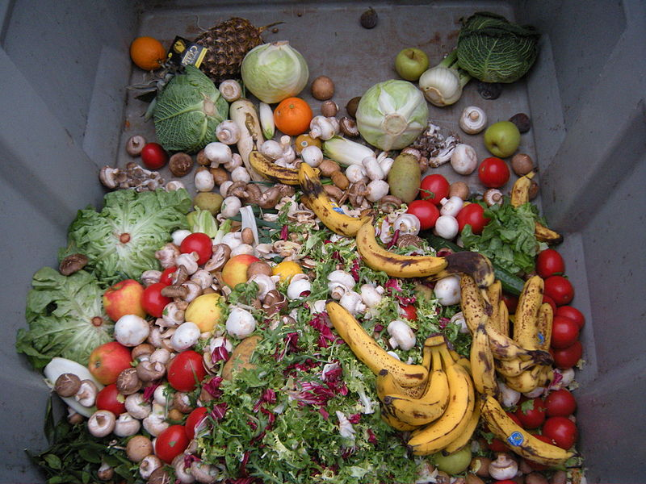
Palm oil production (https://www.czechcrunch.cz/2020/05/plantaze-palmoveho-oleje-decimuji-zemi-bill-gates-proto-investuje-do-olejove-nahrazky-jiz-lze-vyrabet-laboratorne/#gallery-132549-1)
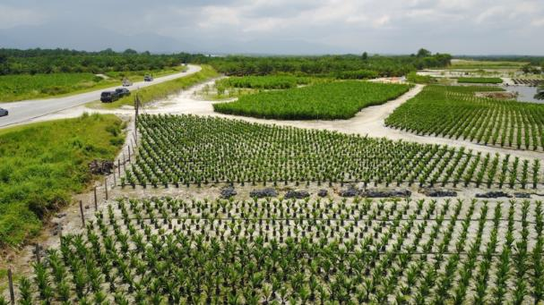

Molecular food (https://gastrostar.cz/molekularni-gastronomie/)
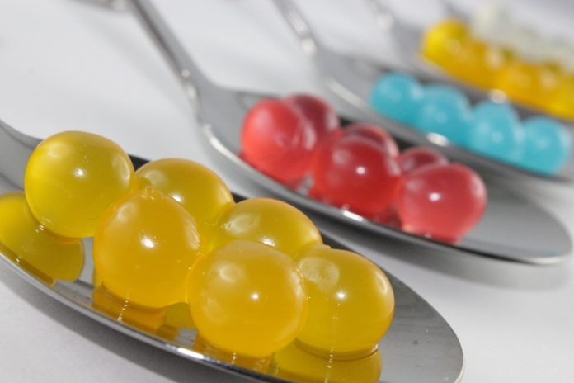

Big agricultural production (https://zpravy.aktualne.cz/ekonomika/zemedelstvi-v-cesku-dominuji-velke-podniky-spocitali-statist/r~98df52ee49f911e8aca5ac1f6b220ee8/)
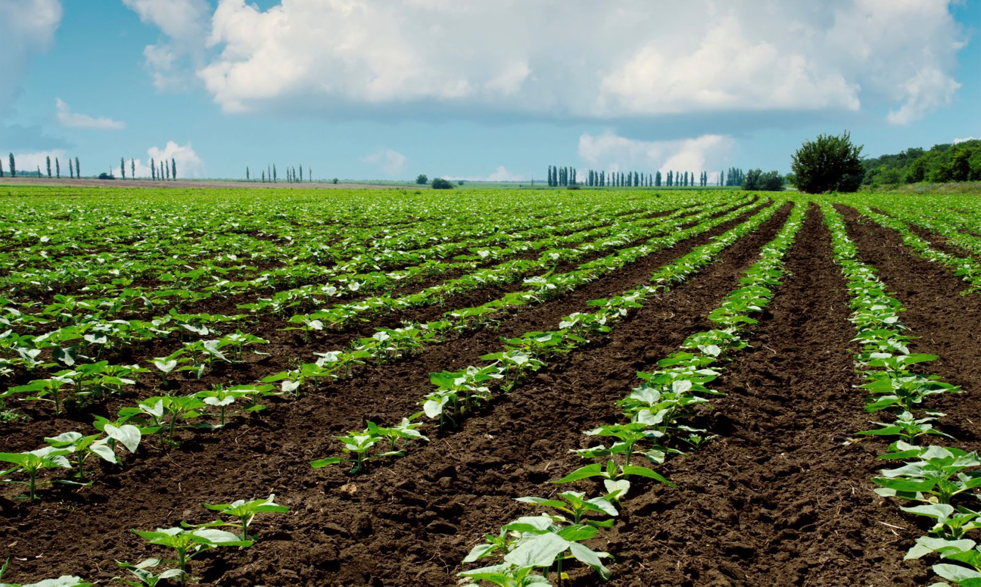
Farm products (https://www.svetbedynek.cz/product/farmarska-bedynka-tydne-pobocka?gclid=EAIaIQobChMIzsjSyarh7AIVxQh7Ch1K2QQmEAQYASABEgIOAPD_BwE)
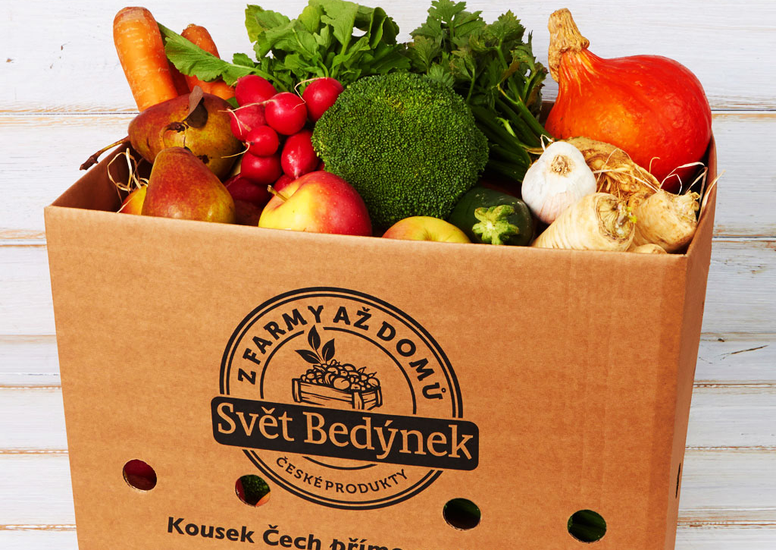

Malnutrition (https://upload.wikimedia.org/wikipedia/commons/7/79/Malnourished_child.jpg)
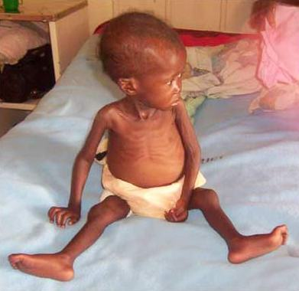
Obesity (https://prosvet.cz/wp-content/uploads/2019/06/7-13.png)
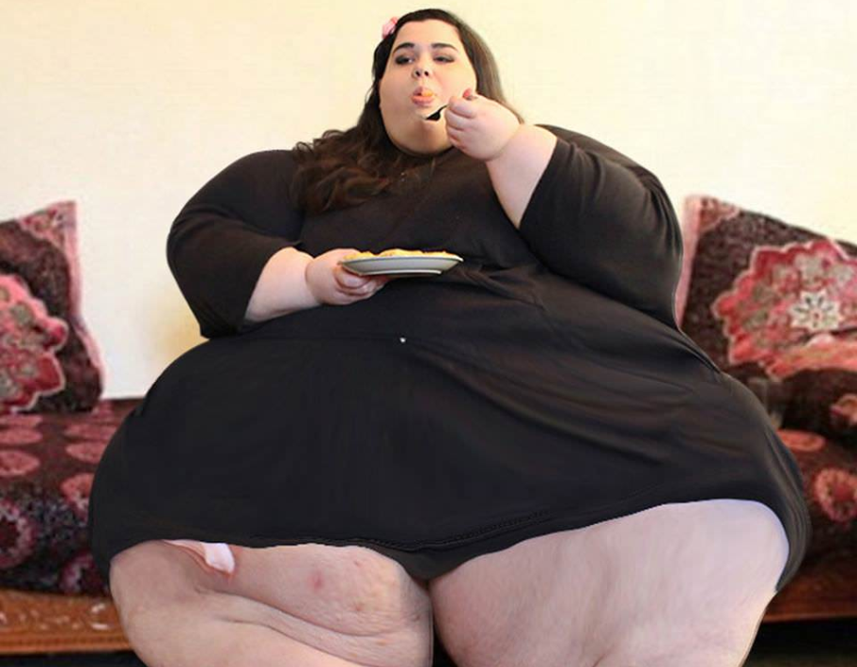
Food trasport (https://boxaroundtheworld.com/food-transportation-2/)
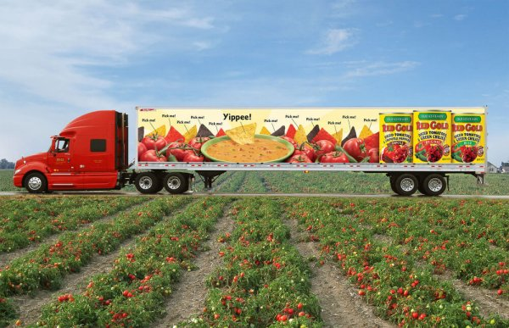

Allergy and food (https://vitalitis.cz/2017/04/05/4-potraviny-ktere-vam-mohou-zpusobit-alergickou-reakci/)
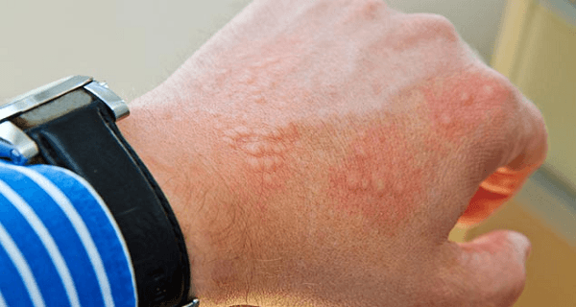

Adventure food (https://edition.cnn.com/2018/01/16/health/japanese-fugu-blowfish-intl/index.html)
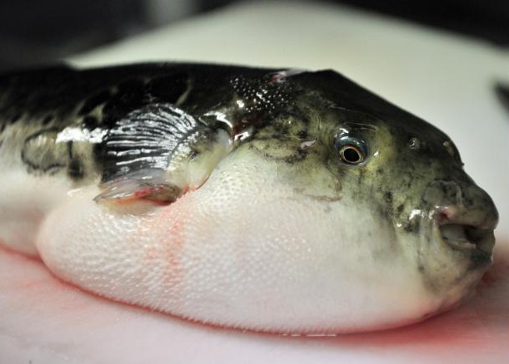

Food packaging (https://www.lidovky.cz/relax/dobra-chut/oloupane-pomerance-v-plastu-pro-nekoho-vrchol-lenosti-pro-jineho-zachrana-zivota.A160308_104840_dobra-chut_ape)
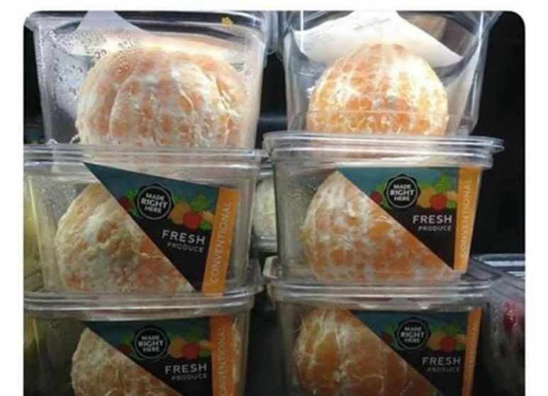
Activity 2.1 Proposal for Food-card
Food in ………………………………………….. context
(choice one of next context: (1) Sensory assessment, (2) Content assessment, (3) Tradition in use, (4) Advertising influence, (5) Following the leaders, (6) Packaging and Branding, (7) Costs limits and (8) Own beliefs about
Nr. ……

Activity 3.4 Examples of Proposals for Experiments

- Food as multi component objects

Vitamin C detection
Proof of vitamin C in different foods can be done by comparing vitamin C solution (from a pharmacy), citrus juice and fruit lemonade. Add 1 ml of FeCl3 solution to the samples and mix. Then add a few drops of red blood salt solution to them and mix again. Samples containing ascorbic acid show a color reaction - a dark blue precipitate can be observed.
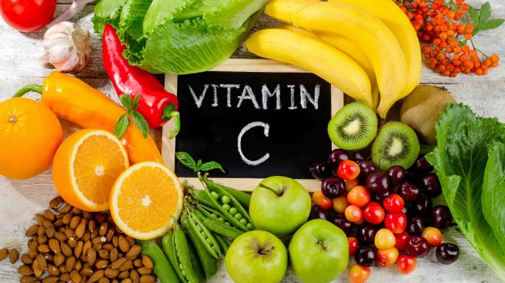
Vitamin C in food (https://www.kulturistika.com/vyziva/ostatni/vse-o-suplementech/ceho-je-moc-toho-je-prilis-nasledky-predavkovani-vitaminy)

- Food cleaning

Filtration
One of the basic separation methods is filtration. Various materials are used in filtration apparatus. For experiment we can use polluted liquid (i.e. water) and for its filtration we can examine various materials as sand, gravel, stones, but also active carbon, paper, cotton wool, etc.

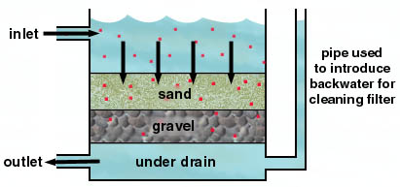

Sand filter principle (http://www.chemistry.wustl.edu/~edudev/LabTutorials/Water/PublicWater Supply/images/filtration.jpg)

- Food preservation

Food mold
The preservation of the food is important aspect of its storage and preservation. For experiment we can prepare pieces of bread and store them in different conditions. After a days we can observe them and discuss obtained results.
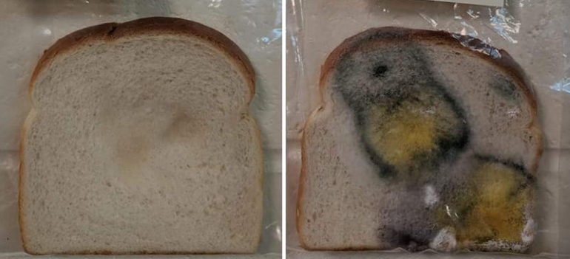
Mold on the bread without preservation (https://interezmag.cz/tento-jednoduchy-experiment-vam-ukaze-ake-je-dolezite-umyvat-si-ruky/)

- Food as power of life
Calories in food
We can demonstrate how to measure how much energy is stored in different types of food. What will be measured is the amount of heat released in the process of burning different foods. We will use improvised calorimeter which one has a reservoir of water. When the heat of the burning food is released it serves to heat the water in the reservoir in the calorimeter. We measure the temperature of the water before and after the burning of specific foods. Data obtained we can compare.
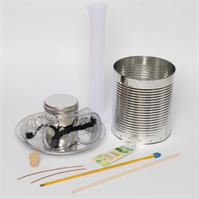
Calorimeter set for experiments “Calories in food” (https://www.sciencebuddies.org/science-fair-projects/project-ideas/FoodSci_p012/cooking-food-science/food-calorimeter)

