Module 2 |  | REASONING, ARGUMENTATION,  &  CRITICAL THINKING  Gultekin Cakmakci  Hacettepe University  STEM & Maker Lab  hstem.hacettepe.edu.tr/en

Worksheets

This worksheet is based on the work within the project Environmental Socio-Scientific Issues in Initial Teacher Education (ENSITE). Coordination: Prof. Dr. Katja Maaß, UNIVERSITY OF EDUCATION FREIBURG, Germany. Partners: UNIVERSITEIT UTRECHT, Netherlands; ETHNIKO KAI KAPODISTRIAKO PANEPISTIMIO ATHINON, Greece; UNIVERSITÄT KLAGENFURT, Austria; UNIVERZITA KARLOVA, Czech Republic; UNIVERSITA TA MALTA, Malta; HACETTEPE UNIVERSITY, Turkey; NORGES TEKNISK-NATURVITENSKAPELIGE UNIVERSITET NTNU, Norway; UNIVERSITY OF NICOSIA, Cyprus; INSTITUTE OF MATHEMATICS AND INFORMATICS AT THE BULGARIAN ACADEMY OF SCIENCE, Bulgaria; UNIVERZITA KONSTANTINA FILOZOFA V NITRE, Slovakia.

The project Environmental Socio-Scientific Issues in Initial Teacher Education (ENSITE) has received co -funding by the Erasmus+ programme of the European Union (grant no. 2019-1-DE01-KA203-005046). Neither the European Union/European Commission nor the project's national funding agency DAAD are responsible for the content or liable for any losses or damage resulting of the use of these resources.

© ENSITE project (grant no. 2019-1-DE01-KA203-005046) 2019-2022, lead contributions by International Centre for STEM Education (ICSE) at the University of Education Freiburg, Germany. CC BY-NC-SA 4.0 license granted.

Content Index
REASONING, ARGUMENTATION, 1
& 1
CRITICAL THINKING 1
Gultekin Cakmakci 1
Hacettepe University 1
STEM & Maker Lab 1
Worksheets 1
Activity 1.1: Is Mr Briggs guilty of speeding? 1
Activity 1.2: What are the features of a scientific argument? 3
Activity 2.1: Voters decide not to water down wolf protection 6
Activity 3.1: Insecticide harmful to bees temporarily allowed in France 12
Activity 3.2: What do students learn when dealing with media reports of environmental SSIs ? 16
Activity 3.3: How to design a lesson on the use of media reports of environmental SSIs? 17

 | Activity 1.1: Is Mr Briggs guilty of speeding?
 | Individual work |  |  |  | 5 mins
Please read this text and fill out the table individually by writing the claim, counter claim and the evidences that support them.

Sunday, March 7th, was a cold, sunny day. At 11.46 am Mr Briggs was observed driving along Water Street. A speed camera measured his speed at 65 km/h. This is 15 km/h above the speed limit. Mr Briggs denies that he was speeding.

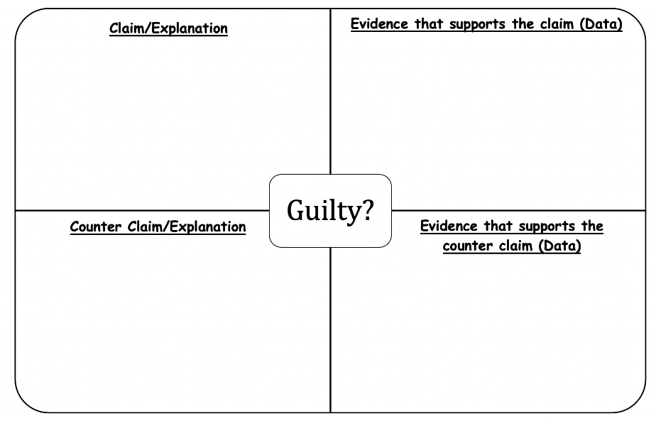

 |  | Work in groups |  |  |  | 5 + 15 mins
After students work individually for a few minutes, the teacher calls them to share their thinking with the rest of the class.

At the end of this activity, the teacher emphasizes differences among opinion, speculation, data, evidence, claim, counter claim and fact.

Opinion | Someone’s viewpoint. May not be based on evidence/data.
Speculation | What someone thinks will happen. Usually based on evidence/data.
Evidence | Information that is linked to the issue.  (A speed camera measured his speed at 65 km/h.)  Data (evidence, grounds, support) can be observations, facts, physical evidence or experimental results that are used for to support or refute a given claim.
Explanation  (Claim or Counter Claim) | Explanation: An idea to explain some evidence/data.  A claim (assertion or proposition) is “an assertion put forward publicly for general acceptance.”  (Claim: Mr Briggs is guilty of speeding)  (Counter claim: Mr Briggs is not guilty of speeding)
Fact | An idea most people accept because it hasn’t been disproved.  (This is 15 km/h above the speed limit.)
Information not linked to the issue? … was a cold, sunny day.

 | Activity 1.2: What are the features of a scientific argument?
 | Discussion in groups |  | 10 + 20 mins
- What are the differences between explanation and argument?
- What are the features of a scientific argument?

Argumentation

- Scientific knowledge is characterised by proper scientific explanations or arguments.

- While an explanation should make sense of a phenomenon and explain the phenomena or event based on other scientific facts; in an argument, however, there is not so much a feature or behaviour to be explained but a claim to be justified (Osborne & Patterson, 2011).

- A scientific argument involves the coordination of evidence (data) and theory (claim) (product of observation vs. product of interpretation of those observations) to support or refute an explanatory conclusion, model or prediction (Osborne et al., 2004a).

- In IO2, Toulmin’s model of argumentation, among others, will be used to analyse media reports of scientific research related to environmental SSI. Based on this model, the nature of an argument can be framed in terms of claims, data, warrants, backings, rebuttals, and qualifiers (Toulmin, 1958) (see Figure 1).

Figure 1. Toulmin’s model of argumentation (Toulmin, 1958)
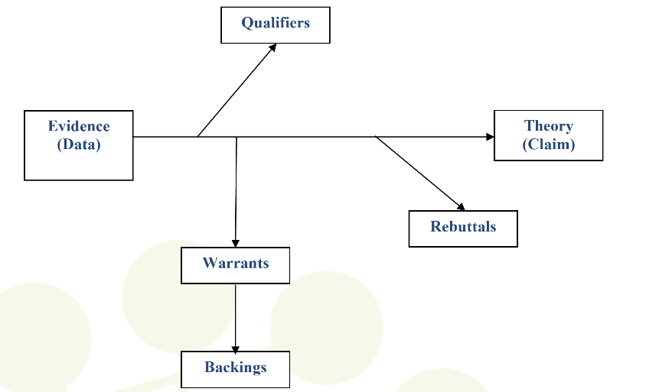

Qualifiers

Evidence
(Data)

Theory (Claim)

Rebuttals
Warrants

Backings

Figure 5. Toulmin’s model of argumentation (Toulmin, 1958).

- A claim (assertion or proposition) is “an assertion put forward publicly for general acceptance.”

- Data (evidence, grounds, support) can be observations, facts, physical evidence or experimental results that are used for to support or refute a given claim.

- Warrant (inferential leap) is the principle, provision or chain of reasoning that provides a link between the data and the claim.

- Backings are “generalizations making explicit the body of experience relied on to establish the trustworthiness of the ways of arguing applied in any particular case.” For example, An Inconvenient Truth is a wonderful documentary on climate change [claim], because it won two Oscars [data]. Being nominated for and winning Academy Awards are reliable indicators for a good documentary [warrant], because the majority [qualifiers] of the public likes documentaries with Academy Awards [backings].

- Rebuttals are “the extraordinary or exceptional circumstances that might undermine the force of the supporting arguments.” Example, Newton's law of universal gravitation only applies in weak gravitational fields; it does not apply in strong gravitational fields [rebuttals].

- Qualifiers are “phrases that show what kind of degree of reliance is to be placed on the conclusions, given the arguments available to support them.” Phrases like “probably”, “definitely”, “it depends”, “possibly”, “usually” express the degree of conditionality asserted.

- In the context of media reports of environmental SSIs, a set of expectations and questions evoked by the written text would help the reader to learn argumentation structure.

- Wolfe et al. (2009)’s argumentation scheme would be useful for doing so (see Figure 2).

Figure 2. Argumentation Scheme (Wolfe, Britt & Butler, 2009)

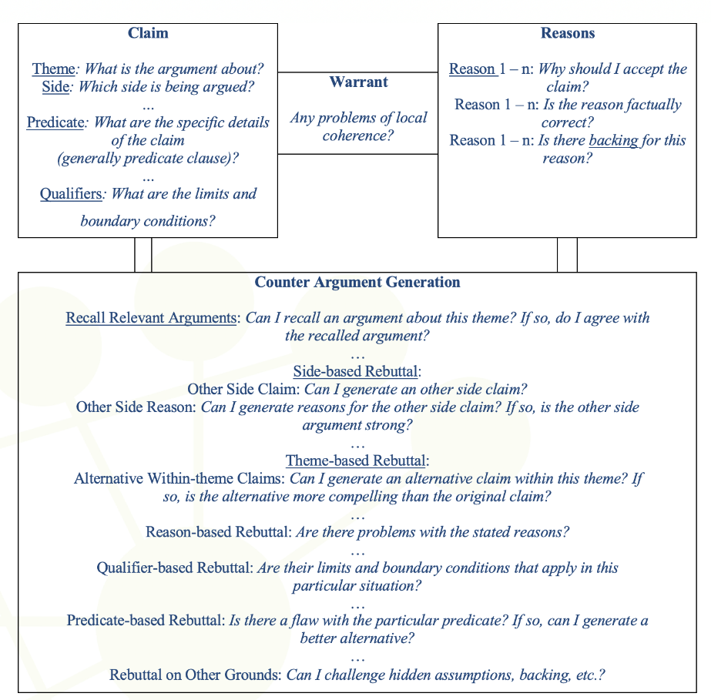

 | Activity 2.1: Voters decide not to water down wolf protection
 | Individual work  Work in groups  Discussion |  | - mins
Teaching points and possible teaching sequence:

The following teaching sequence (Think-Pair-Share) is provided as a suggestion for teacher educator. Four alternative worksheets are provided below and at the appendices. Depending on time constrain and priorities, the teacher educator can decide which one(s) to use.

1. Distribute the news article to future teachers and ask them to read the article on their own. Then they will fill in the table and answer the questions on the worksheet.

THINK: The teacher distributes the news article to the students and asks them to read the article on their own and fill the given worksheet.

2. Ask students to work in groups to talk the answers each came up with.

PAIR: Students pair up to talk about the answer each came up with. They compare their written responses.

3. After students complete the analysis, a classroom discussion may follow. During this activity encourage students to comment on the article.

SHARE: After students talk in pairs for a few minutes, the teacher calls for pairs to SHARE their thinking with the rest of the class.

News article: Voters decide not to water down wolf protection
Source: https://www.swissinfo.ch/eng/swiss-wolf-hunting-law-vote-results/46050398

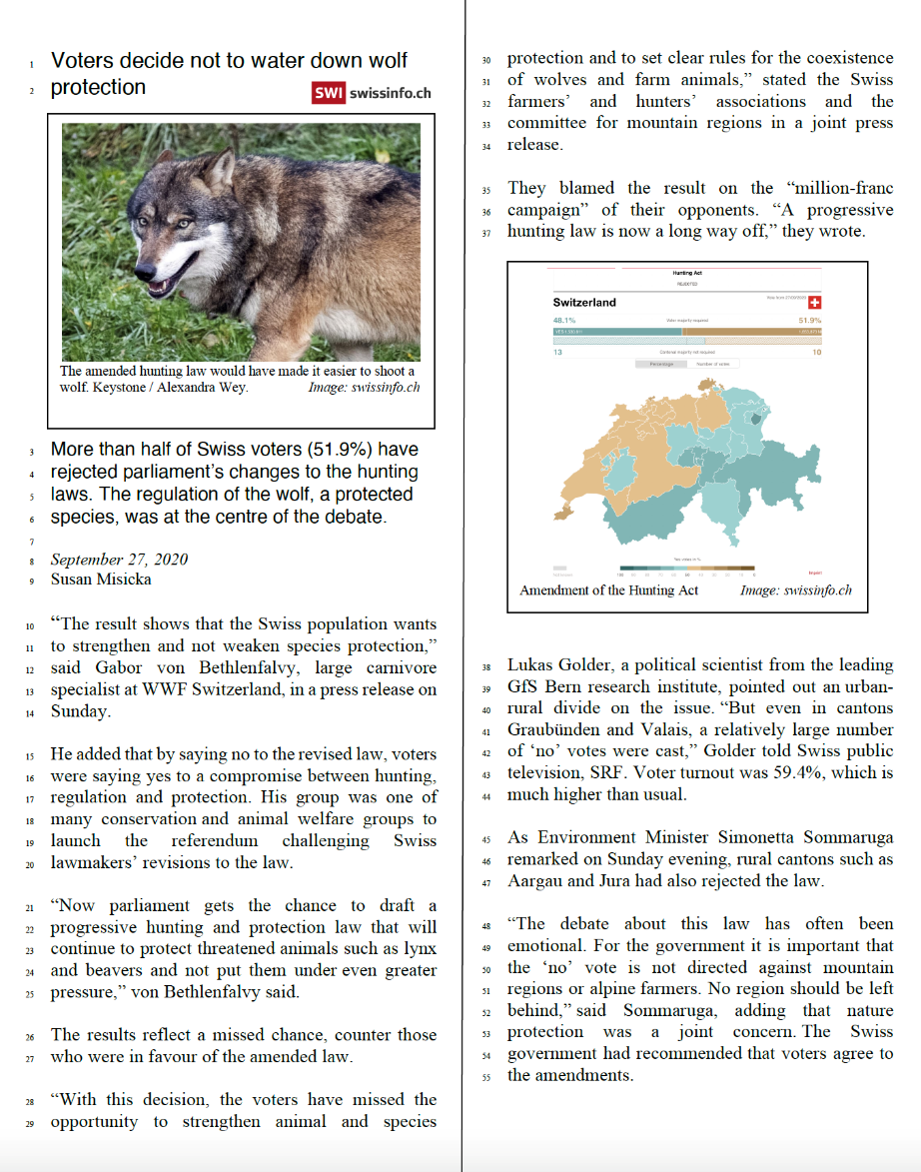

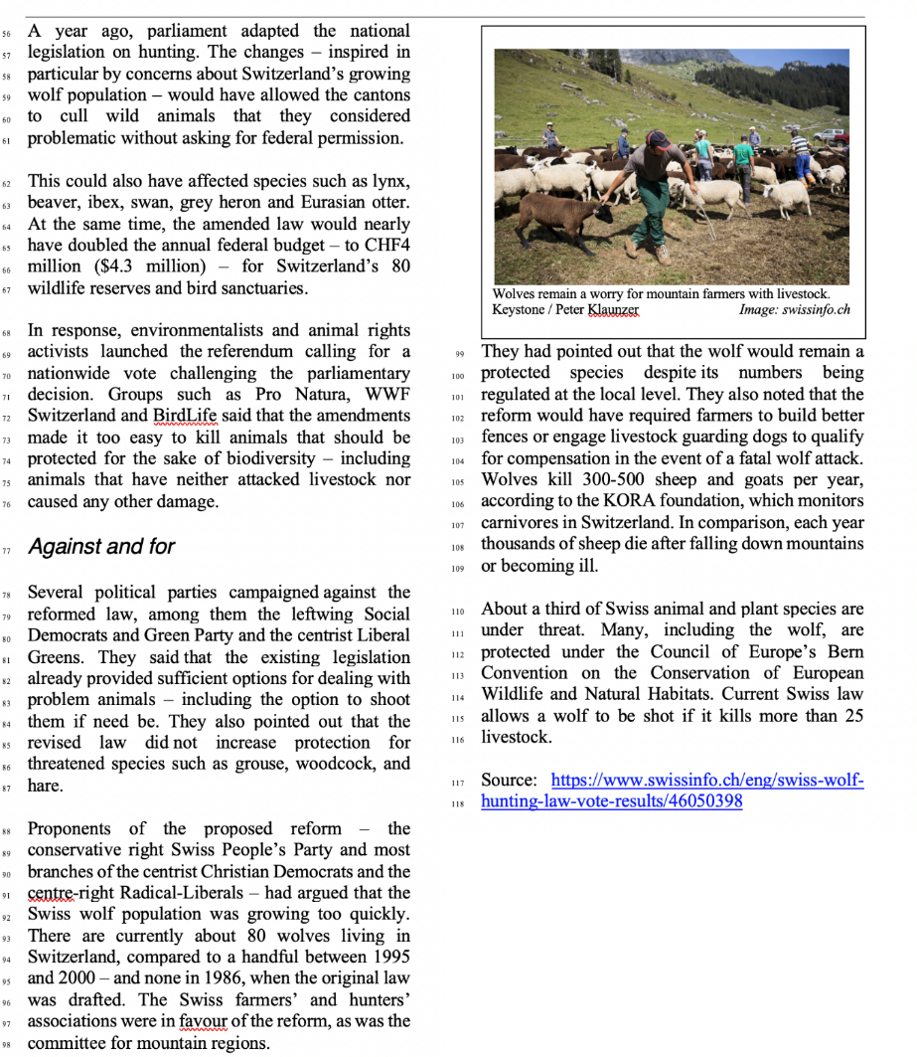

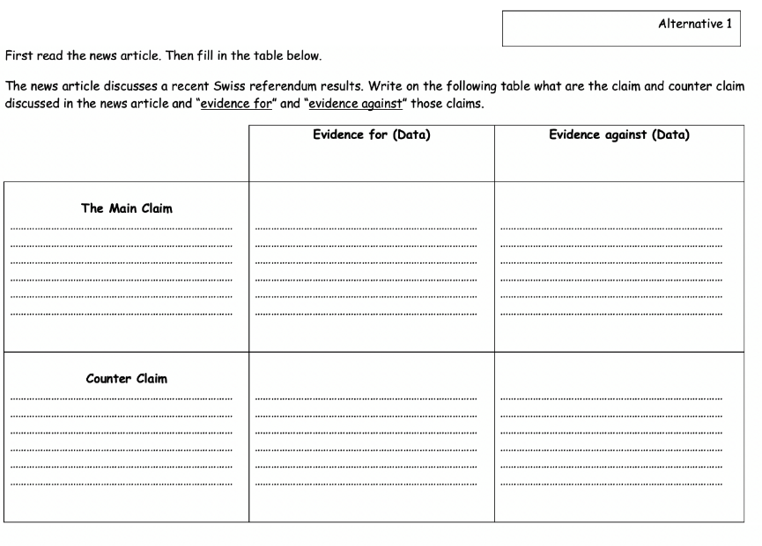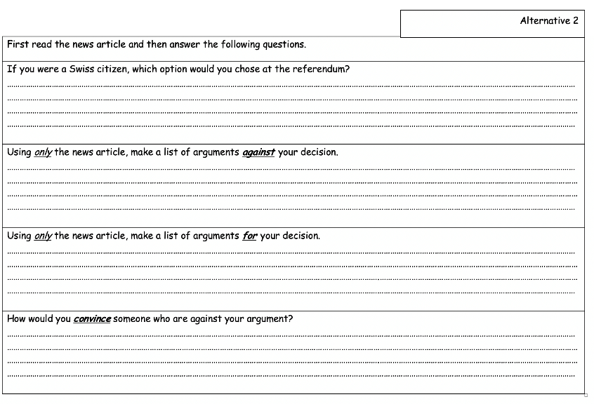

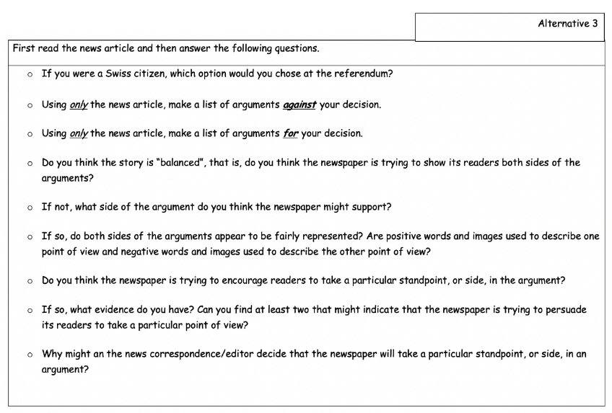

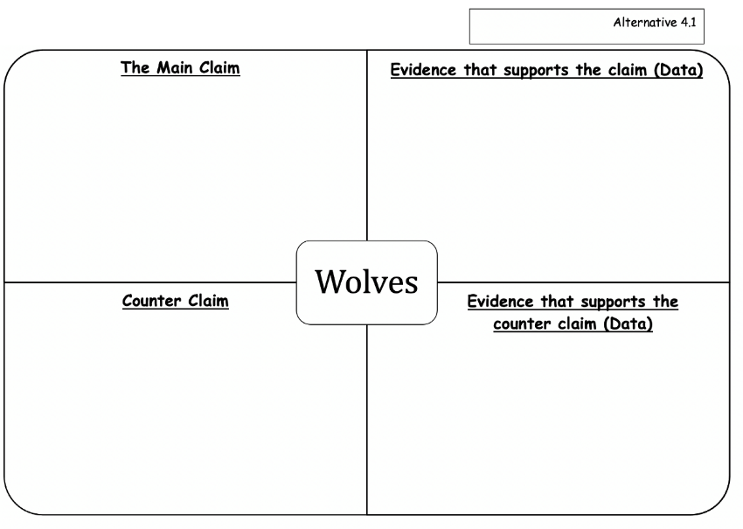

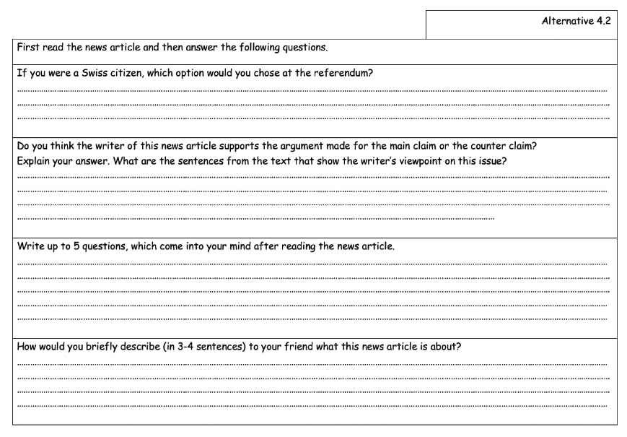

 | Activity 3.1: Insecticide harmful to bees temporarily allowed in France
 | Individual work  Work in groups  Discussion |  | - mins
Teaching points and possible teaching sequence:
The following teaching sequence (Think-Pair-Share) is provided as a suggestion for teacher educator. The worksheets are provided below and at the appendices.

1. Distribute the news article to future teachers and ask them to read the article on their own. Then they will fill in the table and answer the questions on the worksheet.

THINK: The teacher distributes the news article to the students and asks them to read the article on their own and fill the given worksheet.

2. Ask students to work in groups to talk the answers each came up with.

PAIR: Students pair up to talk about the answer each came up with. They compare their written responses.

3. After students complete the analysis, a classroom discussion may follow. During this activity encourage students to comment on the article.

SHARE: After students talk in pairs for a few minutes, the teacher calls for pairs to SHARE their thinking with the rest of the class.

News article: Insecticide harmful to bees temporarily allowed in France
Source: https://www.connexionfrance.com/French-news/French-law-approves-insecticide-deadly-for-bees

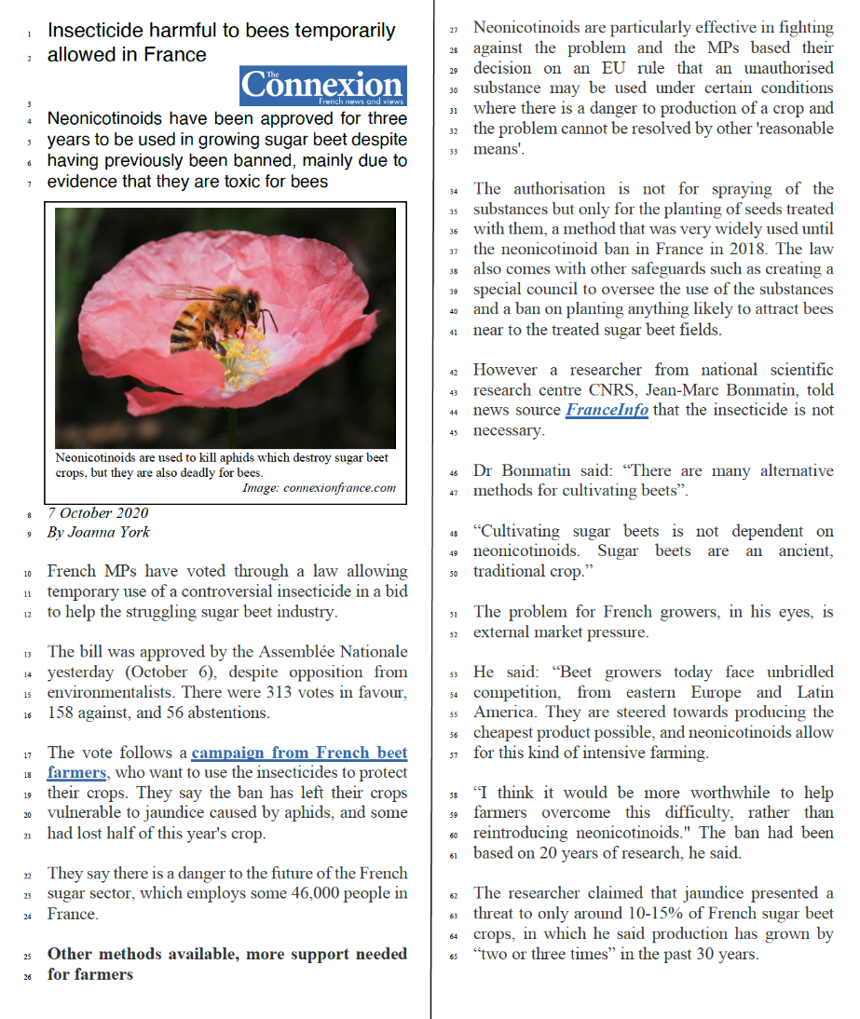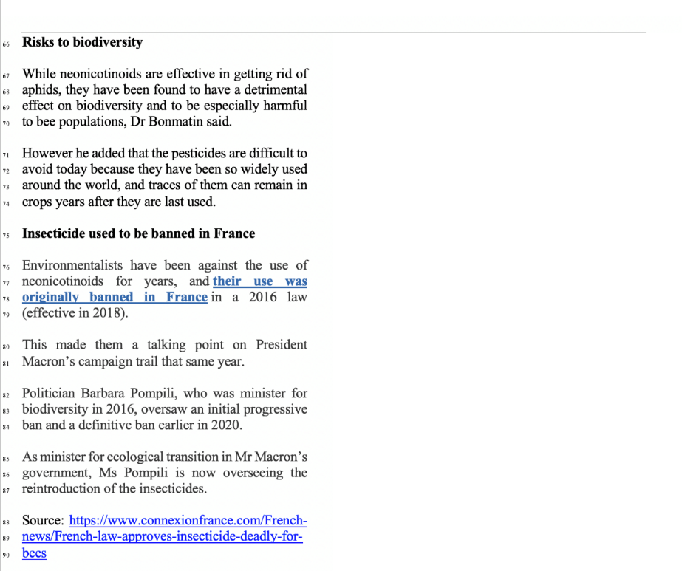

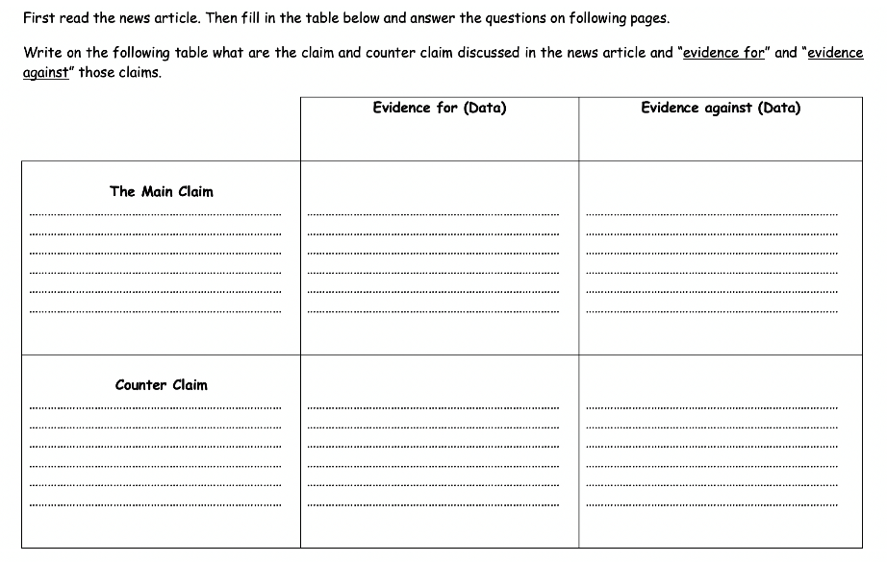

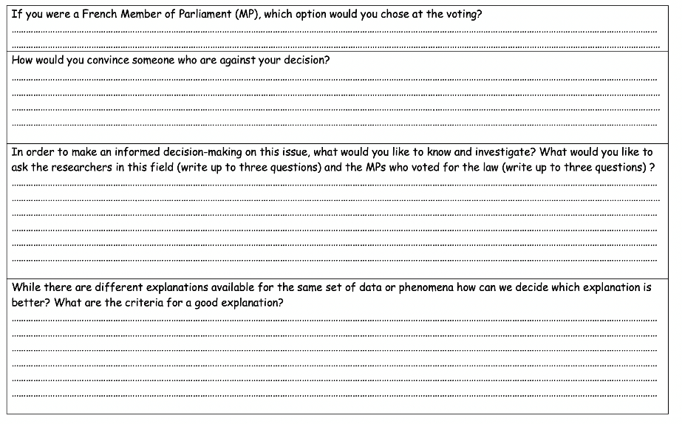
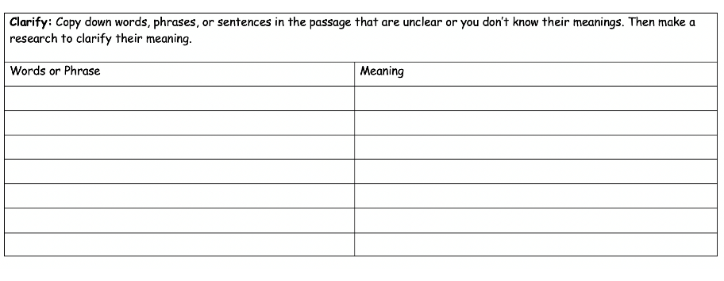

 | Activity 3.2: What do students learn when dealing with media reports of environmental SSIs ?
 | Work in groups |  | (15’ +10’)
This is an exemplary task for students. After Activity 3.1, discuss the following questions:

- What do students learn when dealing with such a task (Activites 2.1 & 3.1)?
- Should media reports of environmental SSIs be included in science and mathematics lessons? Why?
- What from this module was most valuable for you? If you had to tell someone else the three most significant from this module, what would they be?

 | Activity 3.3: How to design a lesson on the use of media reports of environmental SSIs?
 | Homework |  | 90 mins + 45 mins presentations of homework and discussion session.
- Teacher students are expected to plan a lesson which deals with the use of media reports of environmental SSIs they worked on before. Later they are supposed to present the task to the overall group.
- Plan a science lesson on the use of media reports of environmental SSIs to promote students competences on reasoning, argumentation and critical thinking. Future teachers may use different media sources on a similar topic and compare how the news is presented in different sources. Two presentation (each in 15 mins) can take place with 15 mins discussion at the end (45 mins presentations of homework and discussion session).

