Module 8 |  | TEACHERS’ BELIEFS ON SOCIO-SCIENTIFIC ISSUES

Worksheets

This worksheet is based on the work within the project Environmental Socio-Scientific Issues in Initial Teacher Education (ENSITE). Coordination: Prof. Dr. Katja Maaß, UNIVERSITY OF EDUCATION FREIBURG, Germany. Partners: UNIVERSITEIT UTRECHT, Netherlands; ETHNIKO KAI KAPODISTRIAKO PANEPISTIMIO ATHINON, Greece; UNIVERSITÄT KLAGENFURT, Austria; UNIVERZITA KARLOVA, Czech Republic; UNIVERSITA TA MALTA, Malta; HACETTEPE UNIVERSITY, Turkey; NORGES TEKNISK-NATURVITENSKAPELIGE UNIVERSITET NTNU, Norway; UNIVERSITY OF NICOSIA, Cyprus; INSTITUTE OF MATHEMATICS AND INFORMATICS AT THE BULGARIAN ACADEMY OF SCIENCE, Bulgaria; UNIVERZITA KONSTANTINA FILOZOFA V NITRE, Slovakia.

The project Environmental Socio-Scientific Issues in Initial Teacher Education (ENSITE) has received co -funding by the Erasmus+ programme of the European Union (grant no. 2019-1-DE01-KA203-005046).Neither the European Union/European Commission nor the project's national funding agency DAAD are responsible for the content or liable for any losses or damage resulting of the use of these resources.

© ENSITE project (grant no. 2019-1-DE01-KA203-005046) 2019-2022, lead contributions by International Centre for STEM Education (ICSE) at the University of Education Freiburg, Germany. CC BY-NC-SA 4.0 license granted.

Content Index
TEACHERS’ BELIEFS ON SOCIO-SCIENTIFIC ISSUES 1
Worksheets 1
Activity 1.1: The invasion of species 1
Activity 1.2: Role play game 2
Activity 1.3: Two case studies of how beliefs, cultural background and identity can affect socio-scientific issues 4
Activity 1.4: Understanding your own beliefs 6
Activity 2.1: What are your own beliefs? A questionnaire on SSI beliefs 8
Activity 2.2: What strategies can you use to support students 9
Activity 3.1: Designing an SSI taking beliefs into account 11

 | Activity 1.1: The invasion of species
 | Work in groups and homework |  | 40 mins
According to the instructions in the step, either take personal notes or discuss the questions below in your group. You can also search online for evidence depending on the step.
The question: Do you agree or not with the decision of the local authority to trap and remove the grey squirrel?

Step 2. Explain why you agree or disagree. What kind of evidence do you have for your decisions? Take personal notes here.

……………………………………………………………………………………………………………………………………………………………………………………………………………………………………………………………………………………………………………………………………………………………………………………………………………………………

Step 3. In your groups or pairs discuss your response and your explanations. Then write your group response or add your evidence in the table below and present it during the whole classroom discussion.

Claim | Evidence
I agree with this decision because…. | 1.  2.  3.
I disagree with this decision because …. | 1.  2.  3.
I neither agree or disagree with this decision because ….. | 1.  2.  3.

Step 4: Write down as a group an explanation on why some people agree and some other people disagree.

……………………………………………………………………………………………………………………………………………………………………………………………………………………………………………………………………………………………………………………………………………………………………………………………………………………………

Step 5. Search online to find information about the topic and write below as a group if you agree or disagree now that you have learned more. You can use the table below to help you organize the evidence you collect.

Claim | Evidence
I agree with this decision because…. | 1.  2.  3.
I disagree with this decision because …. | 1.  2.  3.
I neither agree or disagree with this decision because ….. | 1.  2.  3.

Your response:

Step 7: Reflect on the reasons that have let you to the decision to change or not to change your initial response. What kind of evidence did you use in Step 1 and what kind of evidence did you use in Step 7?

z
 | Activity 1.2: Role play game
 | Work in groups |  | 40 mins
Work in your groups under the role you have been assigned by your Teacher Educators. Prepare the following:

- Evidence supporting your role (i.e. if you have the role of the local authorities what would you say to support your decisions).

- Opposing questions (i.e. what would someone say to support you are wrong) and how you would respond to them.

- After the end of the activity reflect on the process using the following questions:
  - What difficulties did you have when debating from a specific role?
  - What does that tell you about a person’s beliefs and identity during the discussion of an environmental socio-scientific issue?
  - What impact did the role have on what you could say during the discussion?

 | Activity 1.3: Two case studies of how beliefs, cultural background and identity can affect socio-scientific issues
 | Work in groups |  | 45 mins
In your groups read the case study that follows and discuss the questions below.
“In the beginning of 2005 scientists were worrying about the declining population of the red squirrel in the UK and the huge increase of the population of the grey squirrel. Scientists announced that if the situation continued, the red squirrel would become an extinct species. Thefore, the British government, in an effort to help save the red squirrel, decided to encourage people to trap and kill the grey squirrel in the areas with the biggest problem. A researcher working at that time in the UK and interested in environmental socio-scientific issues, developed a lesson around the question: Do you agree or not with the government’s decision to kill the grey squirrel in order to save the red?
The lesson was implemented in two different classrooms – a class in east-London were most of the students were 1st of 2nd generation migrants (Class A), and a class in a village in the south of the UK were all students were native British citizens (Class B). When first asked to state their opinion on the question, the responses in both classes were very similar: almost all students in both countries stated that they agree with the government’s decision and they supported that we should either kill all the grey squirrel or find way to remove them from the area in order to support the red squirrel.
After engaging with the information about the two types of squirrels (i.e. one is indigenous and the other an invasive species, their food, diseases, reproduction) the students were asked again to state their opinion. You can see a table with their decision after finding information in the table below.
Claim/Decision
 |  |  | Class A  N=11 | Class B  N=12
Kill the grey |  | All | 2 | 1
 |  | Part | 4 | 2
 | Move greys | Unidentified location | 2
 |  | Back to their country | 3
 | Do not kill because is inhuman |  |  | 9
Note: Data are from Evagorou, Jimenez-Aleixandre & Osborne (2011).

Remember that both classes had the same question and the same information and data. The teacher was the same, and their initial response to the question was also the same. Before you are provided with examples from their responses, in your groups reflect on the following questions:
- Why did students in Class A and Class B offer very different responses to the SSI question after they learned more about the red and the grey squirrel?

- Can you hypothesize about some of the explanations they might have provided for their responses?

As mentioned earlier in the description, Class A and Class B were very different in terms of their cultural backgrounds, identities and probably beliefs as well. Class A was a class with 1st and 2nd generation migrants from Asia, whilst Class B was a class with white British students with no exposure to migrants, especially within their school settings. One important information about the two types of squirrel is the following: red is an indigenous species in Europe (and therefore the UK) and the grey is an invasive species that was introduced in the UK from north America. Below you can see two responses from students in Class A and Class B when they learned about this information.

“We should not kill the grey squirrels but send them off to different places so the red squirrels can live there, if the greys start taking over then capture them and put them back where they came from because they have a right to live. Just because they came from a different country does not mean that we have to kill them.” (Class A)

“We believe that the government should abduct all grey squirrels and put them in America. Our evidence is that the red squirrels are magnificent creatures and greys are killing them, and the red squirrel is one of Britain's best-loved mammals. (Class B)

Now that you have read these responses and explanations, discuss again the following questions:
- Why did students in Class A and Class B offer very different responses to the SSI question after they learned more about the red and the grey squirrel?

- How can students’ or your own beliefs, cultural backgrounds and identities can affect how one discusses a socio-scientific issue?

 | Activity 1.4: Understanding your own beliefs
 | Work in groups |  | 15 mins
Identify some environmental socio-scientific issues that you might introduce in the curriculum and discuss with the students. The picture below can help you identify some topic.

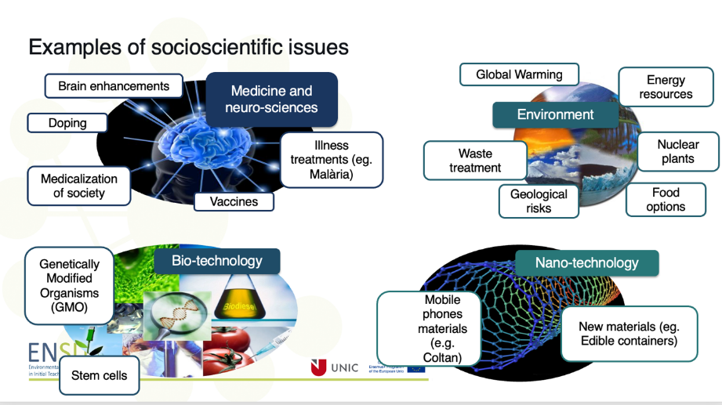

Discuss the following questions:
- Choose one topic from each area (i.e. medicine, environment, bio-technology) and for this topics discuss some beliefs that you have and might hinder how you talk about this issue. The beliefs might be: personal interests, moral concerns, cultural knowledge, limited knowledge.
- Discuss how your beliefs might affect how you teach one of these topics.

 | Activity 2.1: What are your own beliefs? A questionnaire on SSI beliefs
 | Discussion in groups and Individual work |  | 35 mins
A questionnaire has been designed and piloted especially for the ENSITE project. The purpose of the questionnaire is to help you understand how your own personal beliefs, cultural background and identity can affect how you present SSI in your class, and also how the aforementioned can affect how your students discuss the SSI.
Step 1. Complete the questionnaire on your own. You can find the link here https://docs.google.com/forms/d/e/1FAIpQLSeeckaecREw0AlEdMLAWxHXIJF31-bbN_by_7wicU0BRM20yA/viewform or as an appendix at the end of the worksheets.
Step 2. Discuss your responses with your group members and reflect on how similar or different these might be.
Step 3. Discuss what difficulties you might have as a teacher when introducing an SSI in your class because of the differences in beliefs.

 | Activity 2.2: What strategies can you use to support students
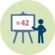 | Work in groups and presentation |  | 25 mins
You have been asked to prepare a lesson that introduces the following environmental SSI: Should we eat insects instead of meat as a way to help the environment?
Step 1. In your groups discuss what beliefs and cultural concerns might hinder the discussion of this topic.
Step 2. Search online to find information about eating insects as a way to replace protein consumption and help the environment. Organize the information in two categories: supporting the idea and rejecting the idea.
Step 3. Label each category that might be related to beliefs (i.e. some people do not eat insects for religious reasons, others for ethical reasons). Think of ways to support someone to see the benefits beyond their personal beliefs.
Step 4. Reflect on the process. Discuss the implications of findings in slides 18-19.

 | Activity 3.1: Designing an SSI taking beliefs into account
 | Work in groups and homework |  | (40 minutes + 90 minutes)
This is an exemplary task for students, solve the exercise yourself.
In your groups explore the material on how to introduce dilemmas in STEM courses (SSI): https://www.engagingscience.eu/en/video-library/

Then in your groups design a lesson plan on the topic of Activity 2.2. Adapt your topic to include STEM related competences. When designing your lesson including some strategies introduced in the video above that can help you scaffold students as they talk about their beliefs. When you finish the lesson plan exchange it with another group for feedback.

Homework: Read this paper for more ideas
Simonneaux, L. & Simonneaux, J. (2009). Socio-scientific reasoning influenced by identities. Cultural Studies in Science Education, 4(3), 705-711.
https://www.researchgate.net/publication/225406610_Socio-scientific_reasoning_influenced_by_identities

