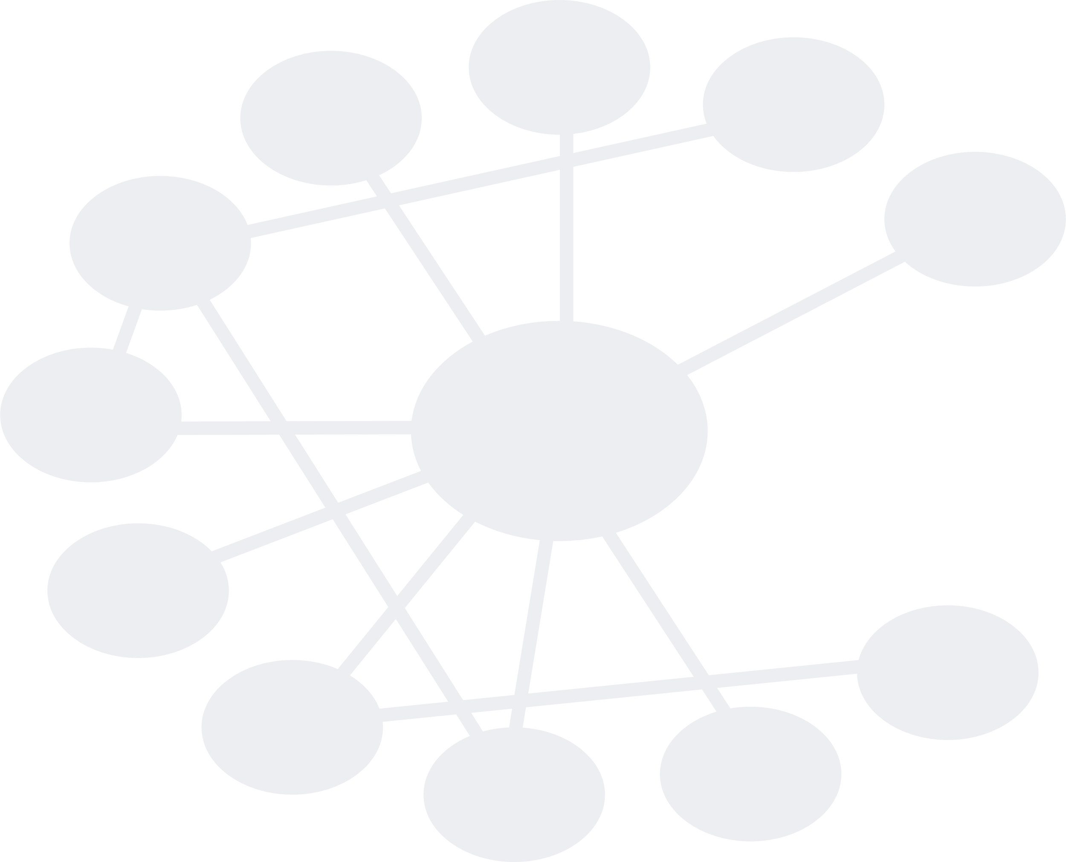
ICSE Academy Summer school

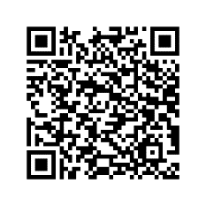
Utrecht University, Netherlands, August 21-25, 2023
https://utrechtsummerschool.nl/courses/science/mathematics-and-science-stem-education
The focus of this STEM Education summer school is bringing participants up to date in research and teaching practices in the field of the STEM subjects (Science, Technology, Engineering and Mathematics), and refreshing and deepening the knowledge of meaningful and relevant educational practices. Topics will include inquiry-based learning and interdisciplinarity, cultural diversity and inclusion, connections to sustainable development goals (SDGs), and the use and impact of technology on STEM education.
The summer school offers a blend of lectures, seminars and workshops on educational research and towards the diverse interests of student-teachers, doctoral students, teachers, teacher educators and researchers. Credits (1,5 ECTS) will be provided by Utrecht University.
The goals of this summer school are an increased awareness with regards to diversity in STEM education and to values such as sustainability and inclusivity in STEM classrooms, an enrichment of thematic knowledge and practical skills, and first-hand intercultural experiences.
The Summer School is organized by the Freudenthal Institute of the Faculty of Science of Utrecht University in collaboration with ICSE Academy (https://icse.eu/icse-academy/). The collaboration with ICSE addresses in particular the potential of IBL for taking opportunities offered by diverse and multi-cultural classrooms and for connecting STEM education to socio-scientific issues and sustainable development goals.

Tentative program
The program of the days is organized around key themes with working groups at the end of each day. These working groups are established by the participants’ interests (e.g. research, practice in primary/secondary/teacher education) and work together each afternoon. We expect these groups to work interdisciplinary and present their findings at the poster gallery on Friday.
Day | Topics
Monday | Introduction to the summer school and the diverse educational systems in the world  Cultural diversity in STEM education  Coming to know each other through STEM estimation activities  Group work
Tuesday | Socio-scientific issues, transformative skills, sustainability in STEM education  Group work: choose an issue to work on
Wednesday | Technology-enhanced STEM education and computational thinking  Group work: digest new input and integrate in your issue
Thursday | Inquiry-based learning and it’s relevance for (inter)disciplinary teaching, diversity and inclusion  Group work: digest new input and integrate in your issue
Friday | Group work and finalizing posters  Poster gallery and closure of the summer school
