Module 10 |  | INTERCULTURAL MATHEMATICS LEARNING OUTSIDE OF SCHOOL

Worksheets

This worksheet is based on the work within the project Intercultural learning in mathematics and science initial teacher education (IncluSMe). Coordination: Prof. Dr. Katja Maaß, International Centre for STEM Education (ICSE) at the University of Education Freiburg, Germany. Partners: University of Nicosia, Cyprus; University of Hradec Králové, Czech Republic; University of Jaen, Spain; National and Kapodistrian University of Athens, Greece; Vilnius University, Lithuania; University of Malta, Malta; Utrecht University, Netherlands; Norwegian University of Science and Technology, Norway; Jönköping University, Sweden; Constantine the Philosopher University, Slovakia.

The project Intercultural learning in mathematics and science initial teacher education (IncluSMe) has received co-funding by the Erasmus+ programme of the European Union under grant no. 2016-1-DE01-KA203-002910. Neither the European Union/European Commission nor the project's national funding agency DAAD are responsible for the content or liable for any losses or damage resulting of the use of these resources.

IncluSMe project (grant no. 2016-1-DE01-KA203-002910) 2016-2019, lead contributions by Constantine the Philosopher University in Nitra, Slovakia.
CC-BY-NC-SA 4.0 license granted (find explicit terms of use at: https://creativecommons.org/licenses/by-nc-sa/4.0/deed.en)

I. Introduction to education program Architects
 | Activity 1.1: Playground as intercultural milieu
 |  | Work in groups, group discussion, video | 45 min
Warming up activity
- Learning mathematics outside of school - what does it mean? What is your experience?
- How your childhood playground looked like?
- Is the playground the topic rich enough for looking for mathematics or making mathematics outside of school?

Work in groups. Watch the movie carefully and try answer questions:
- Why are children’s playgrounds important?
- Which common multicultural features and differences is possible to notice and observe between European playgrounds and those in the south Africa?
Movie is available online at: https://www.youtube.com/watch?v=vTYPLY1dYYk&t=

I. Introduction to education program Architects
 | Activity 1.2: Playground from usage through design to building
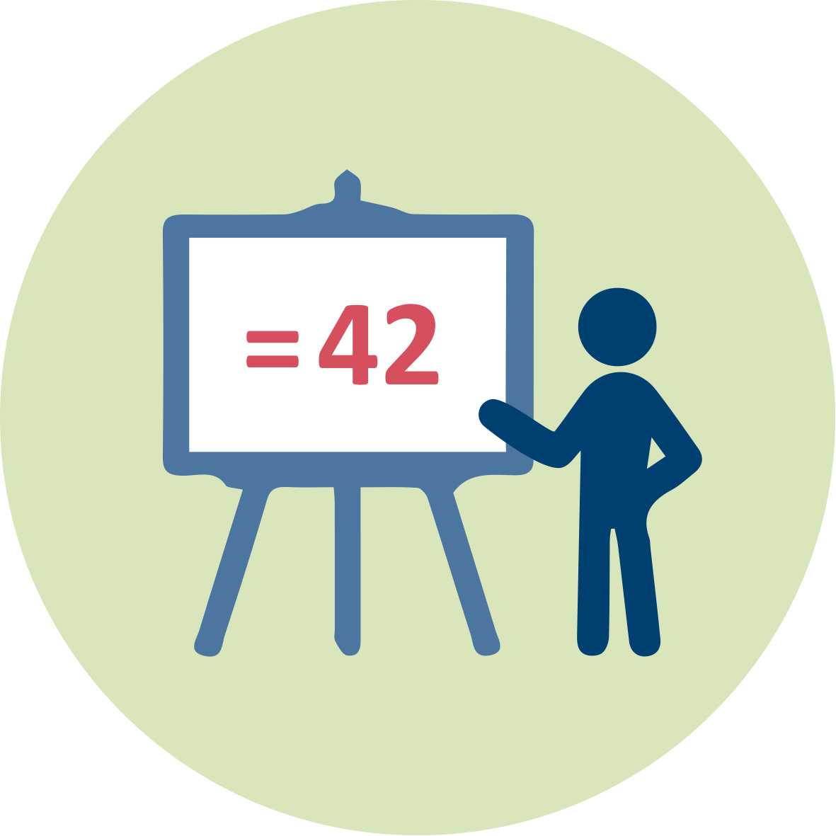 |  | Group work, group discussion | 45 min
Presentation of the module 10 describes the steps oft he education program Architects in details:

- Setting of the task: children’s playground design
- Selection of the external area and the space for children’s playground.
- Analysis of the external area.
- Definition of aims of proposal.
- Definition of the playground proposal criteria.
- Selection of potential playing elements.
- Location of playing elements and budget.
- Playground proposals presentations.
- Evaluation proposals and feedback.

Off-line applet: Future map can be introduced in this phase.

II. Education program Architects under pedagogical supervision
 | Activity 2.1: Pedagogical approaches applications
 |  | Group work and group discussion | 45 min
Work in groups. Create the conceptual map explaining the pedagogical approaches used in the education program Architects.
- The basic level of the conceptual map is the title of education program Architects.
Based on this common starting point, Architects, choose next levels, which represent educational approaches used in the program (e.g. small groups work, role playing, outdoor education, out of school education, IBL, ICT).

II. Education program Architects under pedagogical supervision
 | Activity 2.2: Key competences development
 |  | Group work and group discussion, work sheet filling | 45 min
Worksheet of activity 2.2 and activity 3.1:

 | Methodical steps | Math  knowledge, skills  (Activity 2.2) | Science  knowledge, skills  (Activity 2.2) | Intercultural  dimension  (Activity 3.1)
1 | Setting the task and discussion
2 | Selection of external area and its analysis
3 | Definition of aims and playground proposal criteria
4 | Playing elements selection
5 | Future playground map design
6 | Playground project budget proposal

III. Education program Architects under pedagogical supervision
 | Activity 3.1: Conductive diversity
 |  | Work in groups, group discussion |  | 45 min
Continue in group work and in the work with the worksheet
- Focus on the last column - Intercultural dimension.
- Try to describe how the intercultural approach would influence each methodical step of the education program Architects.
Intercultural approach can be understood in two different levels:
- The first level of the intercultural approach represents the case when the education program Architects is realized in multicultural environment (pupils come from different cultures, e.g. gypsy community or other national minorities, refugees etc.).
- The second level of the intercultural approach represents the case when children’s playground is designed for some multicultural target group of children.
Discussion
- How can a multicultural target group of children influence the process of planning and creating a playground?
- Which phases of the playground design and building will be the most affected by the multicultural target group of children?
- How intercultural approaches involving designers (architects) from different cultures can influence a playground design?
- In which phase can intercultural approach be the most beneficial in the education program Architects implementation and why?

