Module 11 | INTERCULTURAL SCIENCE LEARNING OUTSIDE OF SCHOOL

This Module is based on the work within the project Intercultural learning in mathematics and science initial teacher education (IncluSMe). Coordination: Prof. Dr. Katja Maaß, International Centre for STEM Education (ICSE) at the University of Education Freiburg, Germany. Partners: University of Nicosia, Cyprus; University of Hradec Králové, Czech Republic; University of Jaen, Spain; National and Kapodistrian University of Athens, Greece; Vilnius University, Lithuania; University of Malta, Malta; Utrecht University, Netherlands; Norwegian University of Science and Technology, Norway; Jönköping University, Sweden; Constantine the Philosopher University, Slovakia.

The project Intercultural learning in mathematics and science initial teacher education (IncluSMe) has received co-funding by the Erasmus+ programme of the European Union under grant no. 2016-1-DE01-KA203-002910. Neither the European Union/European Commission nor the project's national funding agency DAAD are responsible for the content or liable for any losses or damage resulting of the use of these resources.

IncluSMe project (grant no. 2016-1-DE01-KA203-002910) 2016-2019, lead contributions (in alphabetical order) by Cyvin, J., Febri, M.I.M., Lund, A.C.B., Sachdeva, S. and Staberg, R.L., Norwegian University of Science and Technology, Trondheim, Norway.
CC-BY-NC-SA 4.0 license granted (find explicit terms of use at: https://creativecommons.org/licenses/by-nc-sa/4.0/deed.en)

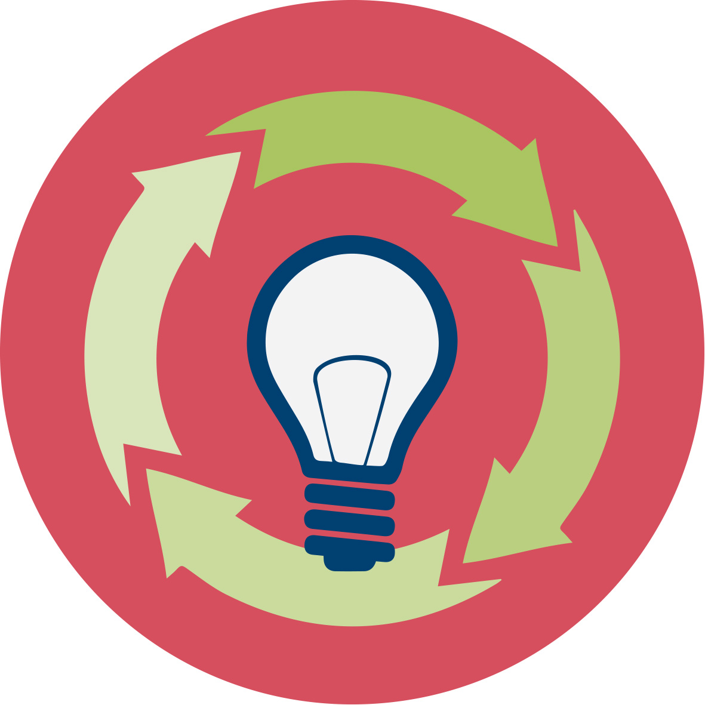 | General overview and aim
In this module, teachers at ITE (initial teacher education) are introduced to intercultural science learning outside of school.
The environmental challenges being encountered by the society are growing simultaneously with the challenges faced by the current school system due to increasing cultural diversity. Being at the intersection between out-of-school pedagogy, intercultural pedagogy and science education, this module aims to equip future science teachers with knowledge and skills to teach the topics relating education for sustainable development in an out-of-school intercultural context.
In an intercultural pedagogical practice, it is important to focus on the dynamics and interactions that occur between students having diverse cultural backgrounds. The focus of such practice lies on relationships and interaction where backgrounds or contrasts are substantiated and made visible, and mutual understanding is developed through interaction and dialogue (Lahdenperä, 2004; Lorentz & Bergstedt, 2006; Østberg, 2013). Emphasis is not only laid on making children aware of the differences but also the similarities between different cultures, countries and diversity of all other kinds.
In this module, we focus on science and school organized activities outside the classroom. Different cultural backgrounds and pre-knowledge of preservice teachers are seen as resources. Interactions between preservice teachers having diverse cultural backgrounds are at focus. Preservice science teachers will acquire subject and culturally relevant pedagogical content knowledge on education for sustainable development starting with biodiversity in different ecosystems, processes and factors influencing them, followed by fieldwork and classification of species (e.g. plants), then moving towards developing action competencies. The cultural aspects will be integrated throughout the whole phases of the module.

This module is part of:
- Personal dimension: values, attitudes and intercultural competences of prospective teachers;
- Mathematics and Science Subject dimension: (inter)cultural perspectives on the subjects themselves;
- Mathematics and Science Education dimension: pedagogical issues, in particular in respect to dealing with diversity in classrooms.

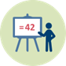 | Relevant topics
The global society is going to encounter a series of environmental challenges in the years to come. The school as an institution has an important role to play in preparing children and youth for tomorrow's society. In 1992 the United Nations composed the declaration «Agenda 21, think globally – act locally” as a result of the UN conference: "Conference on Environment & Development" in Rio de Janeiro, Brazil (https://sustainabledevelopment.un.org/content/documents/Agenda21.pdf).
The declaration is relevant until today and can be considered as a background for reflections related to education for sustainable development. Moreover, a pedagogical model like "The Environmental Staircase" (Halvorsen 1993; Jelavic 2014; Jordet 2000; Lysklett 2013) provides a realistic approach for this field of education. The main idea of this approach is to move forward gradually, from engaging children and youth into admiring nature and providing them with knowledge about nature, to applying this knowledge in a model and system thinking. Finally on the top of the staircase stands evaluation and management competence, which means the knowledge and skills that enable the students to use and utilize their knowledge in the context of society (Figure 1 and Presentation [1]).
The focus of the module described below is to provide preservice teachers with special competence in some of the "building blocks" of the knowledge that is necessary to climb the staircase from admiring the nature to becoming a conscious and responsible citizen of a society characterized by constantly increasing diversity. In order to achieve this aim, it is important to attain the knowledge about diversity of life found in different ecosystems, abiotic factors that co-operate with these diverse organisms, and the ecological processes and ecosystems. We hope that this module could develop students’ nature admiration and empathy, support their concrete biological knowledge about some key elements of ecology, and help them to be aware of the need of system thinking competence. This will hopefully increase their management ability faced to complex challenges connected to nature and environment.
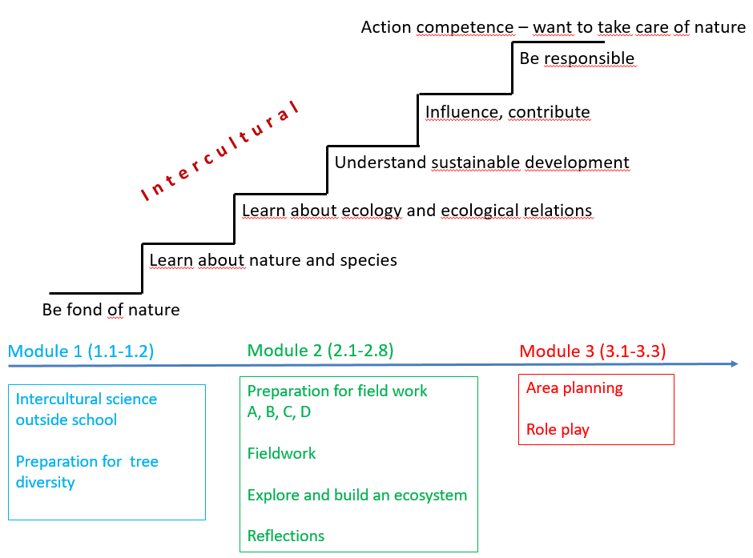
Figure 1. The Environmental Staircase and Timeline of Module IO11
(Designed by Cyvin, J. with ideas from Jelavic 2014; Lysklett 2013).

Learning Outcomes

This module will enable prospective science teachers to:
- Become aware of the benefits of “outside of school” opportunities for learning scientific concepts and procedures in an intercultural context;
- Learn to value the importance of concrete out-of-school experiences to bridge communication/language problems;
- Appreciate the intercultural background and pre-knowledge of students as resources rather than barriers for learning scientific concepts and procedures;
- Develop pedagogical approaches by using different arenas (e.g. urban or rural areas, museums, local factories) – to promote creativity, language learning and conceptual understanding;
- Develop competency in teaching topics related to the diversity of nature (ecology, evolution, energy, and nutrient cycles) in an intercultural context.

Flowchart and Module plan

This module involves a number of sections, with 3 alternative routes.
The module is structured in 3 main parts according to the environmental staircase, 1) Admiring the nature: Introduction, 2) Discovering and understanding: Diversity and ecosystems, 3) Influencing and contributing: Action plan.
Part one includes one plenary “warm-up” activity (1.1) and a homework task (1.2). Part two includes eight activities connected to outdoor science (2.1-2.8, where 2.7 and 2.8 are optional). Part three includes three activities connected to action competency (3.1, 3.2, 3.3). Part three is optional.

Among the thirteen activities, there is a mixture of face-to-face sessions, practical tasks (preparations, outdoor fieldwork, model building, production of an action plan, role play) and homework. See flowchart for alternative options and duration.

For the practical work, divide the class into groups of 4-6 students.

There should be a geographical diversity in each group. If the class is geographically homogeneous and / or sharing the same cultural background, the teacher assigns a geographical belonging to each group member in such a way that within each group there will be a diversity in relation to natural presuppositions and cultural backgrounds. Alternatively, the students themselves, instead of the teacher, can select geographical belongings that are different from each other to create a heterogeneous group.
This intercultural pedagogical practice should focus on both similarities and dissimilarities, and discuss these in the light of subject-specific content in order to develop an increased understanding for their own and others' cultural backgrounds and experiences.

Alternative 1 (minimum, duration: 250 min + 60 min homework):

Alternative 2 (duration: 340 min + 60 min homework):

Alternative 3 (duration: 460 min + 120 min homework):

I. Admiring the nature: Introduction into the topic “Intercultural science learning outside of school”

1.1. General Introduction - What is intercultural science learning outside of school?
Duration: 30 minutes
This is a “warm up” activity. The intention is to explore previous knowledge and beliefs about central topics of this module “intercultural science learning outside of school”. Teacher Educator introduces the module using the PowerPoint presentation [2] and then presents the activities 1.2 and activities 2.1-2.8 to preservice teachers (part 2.7 and 2.8 are optional).
This session contributes to the achievement of the following learning outcome:
- Become aware of the benefits of “outside of school” for learning scientific concepts and procedures in an intercultural context.

I. Admiring the nature: Introduction into the topic “Intercultural science learning outside of school”

1.2. Preparations to group work on diversity (flipped classroom)
Duration: 60 minutes (homework)
Each student is given a designated geographical area, and is supposed to choose four common tree species from that area, find information about those tree species, the climate, growth conditions and growth site. In addition to biological knowledge, students are encouraged to collect cultural knowledge about the same trees, as well as information on what people use these kind of trees for. See worksheet, Activity 1.2. Pictures and information should be stored in a PowerPoint file. This information will be brought forward in activity 2.3 (Preparation to fieldwork, Collecting pre-knowledge about trees).
This session contributes to the achievement of the following learning outcome:
- Appreciate diverse backgrounds and pre-knowledge of students as resources rather than barriers for learning scientific concepts and procedures in an intercultural manner.
- Develop competency in teaching topics related to the diversity of nature (ecology, evolution, energy, and nutrient cycles) in an intercultural context.

II. Discovering and understanding: Diversity and ecosystems

2.1. Introduction to Diversity (Preparations to fieldwork, part A)
 |  | Duration: 15 minutes
Teacher Educator introduces diversity, taxonomy, and the role of “keys” as an approach for understanding biodiversity and the history behind nomenclature (eg. The importance of giving animals and plants names due to food collection and survival in different cultures), using the PowerPoint presentation [3]. The teacher educator also introduces how you can design a dichotomous key (the concept of classification based on similarities and differences).

This session contributes to the achievement of the following learning outcomes:
- Develop competency in teaching topics related to the diversity of nature (ecology, evolution, energy, and nutrient cycles) in an intercultural context
II. Discovering and understanding: Diversity and ecosystems
2.2. Modelling Diversity (Preparation for field work, part B)
 | Duration: 30 minutes
Task: Modelling diversity using “The nuts and bolts of classification”
Students´ handouts [1]. Task and guides for student activity Modelling diversity (Activity 2.2)

This activity lead by teacher educator (PowerPoint presentation [4]) exemplifies how teachers can approach the concepts of classification and identification. The idea is to simplify tasks. The nuts and bolts exercise is an inexpensive and effective way of explaining the use, construction and value of a dichotomous key. It readily reinforces the concept of classification dealing with similarities and differences. The exercise can be used for students at any level. The exercise can also be a door opener for many topics as families of organisms, similarities in fruits and animals. The equipment is inexpensive, and can be collected at the local hardware store.

A dichotomous key is “a series of paired statements that describe physical characteristics of different organisms”. This key is not limited to the identification of living things. The term dichotomous means “divided into two parts”; thus, at each stage of a dichotomous key, two choices are presented. Each choice leads to another alternative until the organism or object is identified.

Task for students (see student handout [1]):

- In pairs: Construct a dichotomous key based on available nuts and bolts
- Exchange your key with another pair of students
- In pairs: Use the dichotomous key designed by another student group, to classify your nuts and bolts
- Discuss your experiences with the other group

Optional: Further reading, see handouts:
Watson, S. & Miller, T. 2009. Classification and the Dichotomous Key. Tools for teaching identification. The Science Teacher, 76(3), 50-54.
Glasenapp, D.T. 1986. The Nuts & Bolts of Classification. The American Biology Teacher, 48(6), 362-363.

This session contributes to the achievement of the following learning outcomes:
- Develop competency in teaching topics related to the diversity of nature (ecology, evolution, energy, and nutrient cycles) in an intercultural context
- Appreciate the intercultural background and pre-knowledge of students as resources rather than barriers for learning scientific concepts and procedures.

II. Discovering and understanding: Diversity and ecosystems
2.3. Collecting pre-knowledge about trees (Preparation for field work, part C)
 |  | Duration: 30 minutes
Group Work: Collecting pre-knowledge (based on Activity 1.2)
This is a “warm up” activity with the intention of building students’ awareness for biodiversity and a reasonable landscape planning with regard to sustainable development. In this session, preservice teachers are preparing investigation of the diversity of trees in the neighbourhood of their campus. They are encouraged to come up with pre-knowledge of trees and leaves, and terminologies to categorize trees, leaves and seeds based on their background or languages. Teacher Educator introduces the activity using PowerPoint presentation [5].
During this session, preservice teachers are expected to share within their group and discuss within the whole class:
- Their knowledge of trees and leaves, terminologies to categorize trees, leaves and seeds based on their own background and language. They are supposed to use the information they have collected during the homework (Activity 1.2).
- Narratives (if any) about the trees in the area/country they come from or have grown up in: e.g. What people use these kinds of trees for (handcraft/art/music/survival/food/industry etc.)? Any legend about the trees? (see Activity 1.2)

Teacher Educator is using PowerPoint presentation [5] – see separate file.

This session contributes to the achievement of the following learning outcomes:
- Develop competency in teaching topics related to the diversity of nature (ecology, evolution, energy, and nutrient cycles) in an intercultural context
- Learn to value the importance of concrete out-of-school experiences to bridge communication/language problems.
- Appreciate the intercultural background and pre-knowledge of students as resources rather than barriers for learning scientific concepts and procedures.
II. Discovering and understanding: Diversity and ecosystems
2.4. Introduction to Fieldwork (Preparation for fieldwork, part D,Trees)
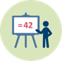 |  | Duration: 10 minutes
Teacher Educator introduces the activity for the fieldwork using PowerPoint presentation [5] – see separate file.

Student handout [2] –Common leaf morphology, see Task and guide for Fieldwork (Activity 2.5. in the Worksheet)

This session contributes to the achievement of the following learning outcomes:
- Develop competency in teaching topics related to the diversity of nature (ecology, evolution, energy, and nutrient cycles) in an intercultural context.
II. Discovering and understanding: Diversity and ecosystems

2.5. Fieldwork
 |  | Duration: 90 minutes
In this session, preservice teachers, working in groups, collect data about trees in their school’s neighbourhood (without necessarily being able to name the tree species), observe number of different species using shape, colour and characteristic traits of trees, characterize areas as natural habitats or planted habitats, inhabited or uninhabited, compare these with regard to diversity and measure green areas. Students can be grouped according to biotopes in the area, exploring one biotope each. In absence of trees, fruits and herbs can be used as alternatives. During the work, discuss as well about how to transfer the acquired knowledge into knowledge for teaching.
During this session the preservice teachers will acquire:
- subject matter knowledge on:
  - Species diversity, description and classification based on observation
  - Relations and interactions between biotic and abiotic factors
- specialized content knowledge (see Ball, Thames & Phelps, 2009) by:
  - Developing experience and knowledge using specific hands-on biological objects in open-air; in this case trees and leaves.
  - Using a digital system for registration of species, for example a net site like Google site, or a smartphone App like iNaturalist, British tree identification.

This session contributes to achievement of the following learning outcomes:
- Develop competency in teaching topics related to the diversity of nature (ecology, evolution, energy, and nutrient cycles) in an intercultural context.
II. Discovering and understanding: Diversity and ecosystems

2.6. Reflections/Summary after fieldwork
 |  | Duration: 45 minutes
In this session, preservice teachers have to summarize their findings: Discussion, reflections, reporting. Preservice teachers are encouraged to think creatively, use scientific language and show their understanding of scientific concepts. This session will further help them to develop knowledge and skills in looking at a case from different sides and to use language actively to build arguments. Discussion on how to transfer acquired knowledge into knowledge for teaching will be an integral part of the session. First, they are given tasks for group work, and finally some of these tasks should be shared/discussed within the whole class. See below. Task is available in PowerPoint presentation [5].

Task, Group Work:
- Classify the leaves you picked up according to similarities and differences (try to combine everyday language and scientific concepts when classifying)
- Construct a dichotomous key based on your collected leaves
(if time allows; Use the dichotomous key designed by another student group to classify your collected leaves)
- Reflect on how out of school activities can promote intercultural understanding in science education, e.g.
  - How concretes from outdoor can help you to develop scientific language/knowledge of scientific concepts. Impact of cultural difference between students? How all senses can be utilized, if language barriers appear
  - What could be learnt from the fieldwork activity, regarding being a future teacher. Special emphasis on the different phases (preparation tasks, fieldwork tasks, summary tasks – and how they were or can be performed) and emphasis on diversity of students.

Plenary: Discuss within the whole class. Possible orientations/focuses:
- Characterize the different areas with regard to diversity
(each group present their area)
- Reflections on how the how out of school activities can promote intercultural understanding in science education, e.g.:
  - On the role of concretes/artefacts in building scientific language, knowledge of concepts and procedures
  - How the preparations, the pedagogical approach during fieldwork and the reflections after fieldwork can facilitate intercultural learning
  - How the use of own words and senses can facilitate learning of science content in intercultural context

This session contributes to the achievement of the following learning outcomes:
- Become aware of the benefits of “outside of school” opportunities for learning scientific concepts and procedures in an intercultural context
- Develop pedagogical approaches by using different arenas (e.g. urban or rural areas, museums, local factories) – to promote creativity, language learning and conceptual understanding
- Develop competency in teaching topics related to the diversity of nature (ecology, evolution, energy, and nutrient cycles) in an intercultural context
- Learn to value the importance of concrete out-of-school experiences to bridge communication/language problems.
- Appreciate the intercultural background and pre-knowledge of students as resources rather than barriers for learning scientific concepts and procedures.
II. Discovering and understanding: Diversity and ecosystems
2.7. Exploring an ecosystem (optional)
 |  | Duration: 60 minutes
Based on the geographical diversity in each group, they have to select one ecosystem or one local biotop, typical for a geographical area one or some of you come from or have grown up in. It is expected that through collaborative work rich in discussion and exchange of ideas that communication problems will be bridged and creativity blossoms. Tasks for students:
    - Discuss where you find this kind of ecosystem or biotop.
    - Discuss different types of plants that will endure this ecosystem or biotope. Choose one of these plants and visualize it in the following way:

- Find information on its geographic location(s), climate conditions (e.g. coast, inland, mountain,…), growth conditions (biological knowledge)
- Try to find out if this plant is used in any symbols, paintings, pictures, mysteries, legends and/or stories in the area or country you come from or have grown up in (cultural knowledge)
- Find information on what people use these kind of plant for (handcraft/art/music/survival/food/industry etc.)

- Make a presentation for rest of the class where different approaches of using plants are described in connection to the cultural traditions, climatic and culinary specialities.
For this session Teacher Educator uses PowerPoint Presentation [6] to guide the students (as an example).

This session contributes to the achievement of the following learning outcomes:
- Develop pedagogical approaches by using different arenas (e.g. urban or rural areas, museums, local factories) – to promote creativity, language learning and conceptual understanding
- Learn to value the importance of concrete out-of-school experiences to bridge communication/language problems.
II. Discovering and understanding: Diversity and ecosystems
2.8. Building a model of an ecosystem (optional)
 |  |  | Duration: 30 minutes
In this session, preservice teachers are supervised in building an ecosystem in a small format. They grow a certain selection of plants and give reasons why they select them. Their justifications will reflect their knowledge and cultural background and pre-knowledge. They are also encouraged to think how to integrate this activity into school's syllabus/curriculum. Further, by going through this session, preservice teachers acquire relevant knowledge and skills that can be transferable to their own teaching of this topic in future. Besides, this activity can help preservice teachers understand how local actions can serve as starting point for discussion what is happening around the world, e.g. in relation to climate change and or other environmental challenges (Local Agenda 21).

For this session Teacher Educator uses PowerPoint Presentation [7] to guide the students.

This session contributes to the achievement of the following learning outcomes:
- Develop competency in teaching topics related to the diversity of nature (ecology, evolution, energy, and nutrient cycles) in an intercultural context
- Appreciate the intercultural background and pre-knowledge of students as resources rather than barriers for learning scientific concepts and procedures.

III. Influencing and contributing: Action plan (optional)
In this part students will move further from acquiring knowledge of biodiversity and interaction between biotic and abiotic factors, to developing action competency.
After the introduction part (compulsory if part III is conducted), preservice teachers are encouraged to perform the following activities:
- Drawing a land-use plan of an area in the nearby of their school
- Present their ideas in a role-play

III. Influencing and contributing: Action plan (optional)

3.1. Introduction – Area around us (flipped classroom)
Duration: 60 minutes (homework)
Based on a Youtube video or an e-lecture, reading a text and given questions, preservice teachers are to find ideas on how they can take benefit of the area in the surrounding of their school to raise awareness on action competency. Link: https://www.youtube.com/watch?v=kHhspf5IfdE
The video or e-lecture explains what is meant by action competency and why is it important in education for sustainable development.
The text to read (Reading [1]) presents excerpts from the ideas of a Norwegian school project «The Natural Backpack» (http://www.natursekken.no/), see Worksheet IO11. It serves as source of inspiration and it will by no means limit the preservice teachers' creativity.
The given questions will guide preservice teachers to reflect on (1) how the action taken (i.e. use of area) can be based on the conceptual understanding of biodiversity and on system thinking in ecology and (2) how the action taken will affect the society.
This session is preparing the preservice teachers for the step 5 of "The Environmental Staircase": Influence and Contribute (Jelavic, 2014; Jordet, 2000).
This session contributes to the achievement of the following learning outcomes:
- Develop pedagogical approaches by using different arenas (e.g. urban or rural areas, museums, local factories) – to promote creativity, language learning and conceptual understanding

III. Influencing and contributing: Action plan (optional)
3.2. Work out a plan for land use of area nearby
Duration: 90 min
In this session, preservice teachers will set up a land-use plan for their local school or an area nearby based using pedagogy, environment friendly use of the area, a scientific understanding of sustainability and its interaction with nature. They will be required to think about ecology, energy and nutrient cycles while at the same time think through on how to use the area. The preservice teachers are also expected to experience a real-life cooperation with a local municipality. On the whole this session will contribute to make preservice teachers understand the importance of diversity in urban or rural areas (depending on where the school is located) and improve their awareness of sustainable development.

For this session Teacher Educator uses PowerPoint Presentation [8] to guide the students.

This session contributes to the achievement of the following learning outcomes:
- Develop pedagogical approaches by using different arenas (e.g. urban or rural areas, museums, local factories) – to promote creativity, language learning and conceptual understanding;
- Develop competency in teaching topics related to the diversity of nature (ecology, evolution, energy, and nutrient cycles) in an intercultural context.

III. Influencing and contributing: Action plan (optional)

3.3. Role play, presentation of land-use plan, target group: local municipality
Duration: 30 minutes
Based on produced land-use plans, teacher educators will guide and establish a debate about the selected schools’ land-use plans (Role play: Meeting for local municipality). Different groups present their ideas. This requires a well-developed language, but we think it will be a useful activity for preservice teachers. They may also present a real drawing/sketch in addition to the presentations or as an alternative in case language competency becomes an issue.
This session serves as a model for preservice teachers for teaching topics related to the diversity of nature in order to develop action competency for sustainable development in an intercultural context.
For this session Teacher Educator uses PowerPoint Presentation [9] to guide the students.

This session contributes to the achievement of the following learning outcomes:
- Develop competency in teaching topics related to the diversity of nature (ecology, evolution, energy, and nutrient cycles) in an intercultural context.

 | Materials and resources
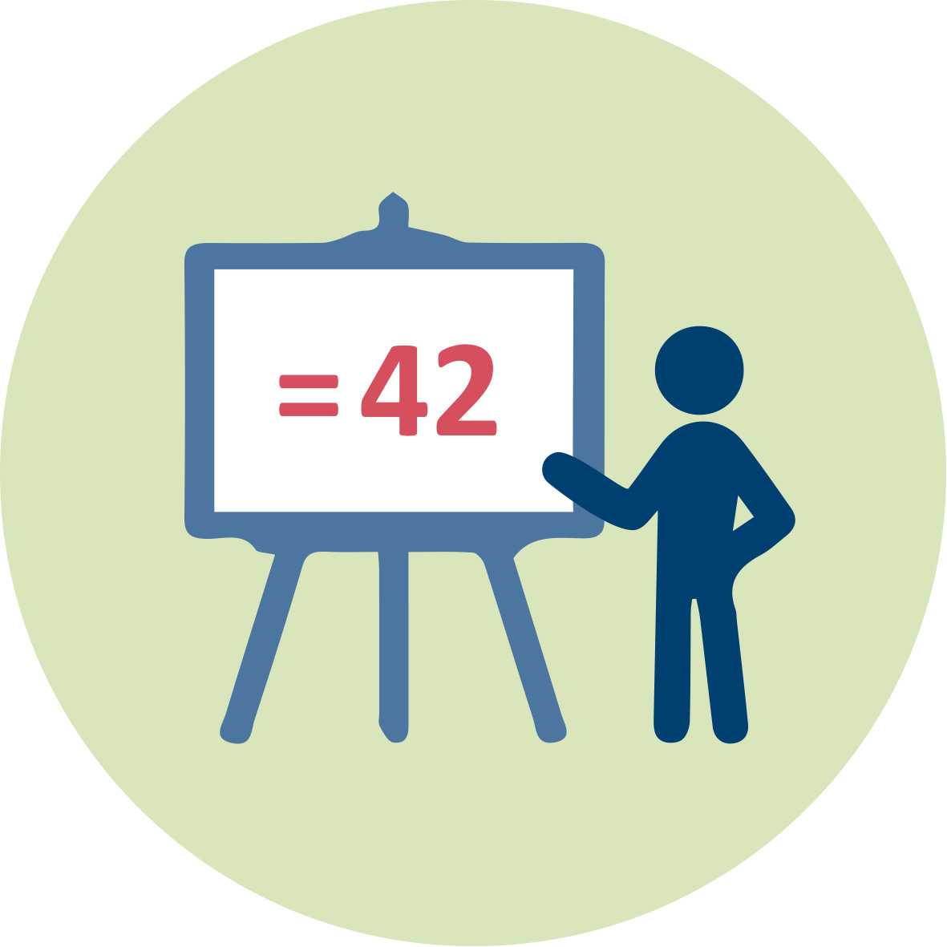 | Presentation 1 (pptx). Teacher Educator. Environmental Staircase and Timeline Module IO11.  Presentation 2 (pptx). Teacher Educator. General Introduction to “Science Learning outside of school” (Activity 1.1)
 | Presentation 3 (pptx). Teacher Educator. Introduction to Diversity (Activity 2.1)
Presentation 4 (pptx). Teacher Educator. Modelling Diversity_Bolts nuts (Activity 2.2)
Presentation 5 (pptx). Teacher Educator. Fieldwork:
Collecting pre-knowledge (activity 2.3),
Introduction to "Fieldwork" (activity 2.4)
Reflections/Summary after fieldwork (activity 2.6)
Presentation 6 (pptx). Teacher Educator. Exploring an Ecosystem. (Activity 2.7). Optional
Presentation 7 (pptx). Teacher Educator. Building a Model of an Ecosystem. (Activity 2.8). Optional
Presentation 8 (pptx). Teacher Educator. Plan for Land Use. (Activity 3.2). Optional
Presentation 9 (pptx). Teacher Educator. Role Play. (Activity 3.3). Optional

Further reading, for activity 2.2:
Watson, S. & Miller, T. 2009. Classification and the Dichotomous Key.Tools for teaching identification. The Science Teacher. 76(3), 50-54.
Glasenapp, D.T. 1986. The Nuts & Bolts of Classification. The American Biology Teacher. 48(6), 362-363.

Student handout [1]. Nuts and Bolts Cards, see Task and guides for student activity Modelling diversity (activity 2.2). Available as separate file.
Student handout [2]. Leaf Morphology, see Task and guide for Fieldwork (Activity 2.5). Available as separate file.
 | You tube video or e-lecture: Preparation for action plan (flipped classroom) https://www.youtube.com/watch?v=kHhspf5IfdE (Activity 3.1)
 | Readings 1. Preparation for action plan (flipped classroom) (reading material available in the Worksheet, Activity 3.1)
 | Internet research and collaborative work (preparations, role play) (see Worksheet, Activity 3.2)

Granularity
Select fewer activities, eg. skip Activities 2.7-2.8 AND/ OR skip Activities 3.1-3.3.

References
Ball, D.L., Thames M.H., Phelps G. (2009). Content Knowledge for Teaching. What Makes It Special? J. Teacher Education, 59(5), 389-407.
Halvorsen, Kirsti V. (1993). Barn møter framtida. [Children meet the future]. Oslo: Landbruksforlaget.
Jelavic, H.M.E. (2014). Education for Sustainable Development. Assessing the development of environmental education (EE) on Roatan, Hondura. Master Thesis. University of Agder, Norway.
Jordet, A. N. (2000). Nærmiljøet som klasserom: uteskole i teori og praksis. [Local environment as the classroom: Outdoor school theory and practice.] Oslo: Cappelen.
Lahdenperä, P. (2004). Interkulturell pedagogik – vad, hur och varför? [Intercultural pedagogy – what, how and why?] In: P. Lahdenperä (Ed.): Interkulturell pedagogik i teori och praktikk. Lund: Studentlitteratur.
Local Agenda 21. UN conference: "Conference on Environment & Development" 3rd-14th June, 1992. Rio de Janeiro, Brazil. Retrieved from https://sustainabledevelopment.un.org/content/documents/Agenda21.pdf
Lorentz, H. & Bergstedt, B. (2006). Interkulturella perspektiv - från modern till postmodern pedagogikk [Intercultural perspectives – from modern to postmodern pedagogy]. In: H. Lorentz & B. Bergstedt (red.), Interkulturella perspektiv. Lund: Studentlitteratur.
Lysklett, O. B. (2013). Ute hele uka, natur og friluftsbarnehage. [Outside all week, nature and outdoor kindergartens.] Oslo: Universitetsforlaget
Østberg, S. (2013). Interkulturell kompetanse [Intercultural competence]. In: Bjarnø, V., Nergård, E.N. & F. Aarsæther (Eds.). Språklig mangfold og læring. pp. 18-34. Oslo: Gyldendal Akademisk.

Further readings
These further readings are for those who whish to deepen the topic of intercultural science learning outside of school. They consist of a selection of research literature dealing with the value of outdoor learning, preparing for outdoor/out of school science learning, culturally responsive teaching approaches in science, preservice science teachers’and teacher educators’perception of culturally relevant pedagogy. In addition, further readings related to the dichotomous principle and classification (Activity 2.2.) are also included here.

Dillon, J., Rickinson, M., Teamey, K., Morris, M., Choi, M.Y., Sanders, M and Benefield, P. (2006). The value of outdoor learning: evidence from research in the UK and Elsewhere. School Science Review, 87(320), 107-111.
Glasenapp, D.T. (1986). The Nuts & Bolts of Classification. The American Biology Teacher, 48(6), 362-363.
Lee, O. & Luykx, A. (2007). Science Education and Student Diversity: Race/ Ethnicity, Language, Culture and Socioeconomic Status. Chap. 7 in: S.K. Abell & N.G. Lederman (Eds.), Handbook of Research on Science Education. pp. 171-197. New Jersey: Lawrence Erlbaum Associates.
Meyer, X., & Crawford, B. A. (2011). Teaching science as a cultural way of knowing: merging authentic inquiry, nature of science, and multicultural strategies. Cultural Studies of Science Education, 6(3), 525–547.
Morag, O. & Tal, T. (2012). Assessing Learning in the Outdoors with the Field Trip in Natural Environments (FiNE) Framework, International Journal of Science Education, 34(5), 745-777, DOI: 10.1080/09500693.2011.599046
Purdie, N., Neill, J. T., & Richards, G. E. (2002). Australian identity and the effects of an outdoor education program. Australian Journal of Psychology, 54(1), 32-39.
Russell, M., & Russell, J. (2014). Preservice science teachers and cultural diversity awareness. Electronic Journal of Science Education, 18(3). Retrieved from http://ejse.southwestern.edu/article/view/12813
Tolbert, S., & Knox, C. (2016). ‘They might know a lot of things that I don’t know’: investigating differences in preservice teachers’ ideas about contextualizing science instruction in multilingual classrooms. International Journal of Science Education, 38(7), 1133–1149. https://doi.org/10.1080/09500693.2016.1183266
Underwood, J. B., & Mensah, F. M. (2018). An Investigation of Science Teacher Educators’ Perceptions of Culturally Relevant Pedagogy. Journal of Science Teacher Education, 29(1), 46–64. https://doi.org/10.1080/1046560X.2017.1423457
Watson, S. & Miller, T. (2009). Classification and the Dichotomous Key. Tools for teaching identification. The Science Teacher, 76(3), 50-54.

Assessment
The assessment are related to the given learning goals:
- Become aware of the benefits of “outside of school” opportunities for learning scientific concepts and procedures in an intercultural context;
- Learn to value the importance of concrete out-of-school experiences to bridge communication/language problems;
- Appreciate the intercultural background and pre-knowledge of students as resources rather than barriers for learning scientific concepts and procedures;
- Develop pedagogical approaches by using different arenas (e.g. urban or rural areas, museums, local factories) – to promote creativity, language learning and conceptual understanding;
- Develop competency in teaching topics related to the diversity of nature (ecology, evolution, energy, and nutrient cycles) in an intercultural context.
Assessment methods
Individual portfolio of students’ work, based on the activities 1.2, 2.2, 2.3, 2.5, 2.6, 2.7, 3.2 and 3.3, depending on the granularity.

Assessment criteria
The assessment criteria are based on the scientific content and the pedagogical aspects.
Regarding the scientific content, the criteria can for instance be:

- Ability to find information on tree(species), the climate, the growth conditions and site; and relate the information to each other.
- Ability to construct a dichotomous key and apply the dichotomous principle to classify and describe the leaves collected during the fieldwork.
- Correctness in the use of scientific terminologies.
- (optional activity) How well the model of the chosen ecosystem was built and whether the model is suitable to represent the intended scientific contents.
- (optional activity) How well the student understand the concept of “Education for sustainable development”
- (optional activity) Ability to dicuss on the plan of land use
Regarding the pedagogical aspect, the criteria are related to both the reflections on the use of out-of-school pedagogy in science education and the intercultural pedagogy.
Teacher educators can look for instance to how well students are able to reflect on the following points:

- How relating the trees to the cultures (e.g. use in handcraft/art/music/survival/food/industry, etc.) can promote intercultural understanding.
- The role of concretes/artefacts in building scientific language, knowledge of concepts and procedures.
- How the preparations, the pedagogical approach during fieldwork and the reflections after fieldwork can facilitate intercultural learning.
- How the use of own words and senses can facilitate learning of science content in intercultural context.

Of course teacher educators can modify or add their own criteria according to what suit them best.

