Module 11 11 |  | INTERCULTURAL SCIENCE LEARNING OUTSIDE OF SCHOOL

Worksheets

This worksheet is based on the work within the project Intercultural learning in mathematics and science initial teacher education (IncluSMe). Coordination: Prof. Dr. Katja Maaß, International Centre for STEM Education (ICSE) at the University of Education Freiburg, Germany. Partners: University of Nicosia, Cyprus; University of Hradec Králové, Czech Republic; University of Jaen, Spain; National and Kapodistrian University of Athens, Greece; Vilnius University, Lithuania; University of Malta, Malta; Utrecht University, Netherlands; Norwegian University of Science and Technology, Norway; Jönköping University, Sweden; Constantine the Philosopher University, Slovakia.

The project Intercultural learning in mathematics and science initial teacher education (IncluSMe) has received co-funding by the Erasmus+ programme of the European Union under grant no. 2016-1-DE01-KA203-002910. Neither the European Union/European Commission nor the project's national funding agency DAAD are responsible for the content or liable for any losses or damage resulting of the use of these resources.

IncluSMe project (grant no. 2016-1-DE01-KA203-002910) 2016-2019, lead contributions (in alphabetical order) by Cyvin, J., Febri, M.I.M., Lund, A.C.B., Sachdeva, S. and Staberg, R.L., Norwegian University of Science and Technology, Trondheim, Norway.
CC-BY-NC-SA 4.0 license granted (find explicit terms of use at: https://creativecommons.org/licenses/by-nc-sa/4.0/deed.en)

I. Admiring the nature: Introduction into the topic “Intercultural science learning outside of school”

1.1. General Introduction - What is intercultural science learning outside of school?
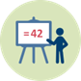 | Duration: 30 minutes
Handout: PPT Presentation for teacher educator,
PowerPoint presentation [1] – see separate file.

This is a “warm up” activity. The intention is to explore your previous knowledge and
beliefs about central topics of this module:
- Culture and what is has to do with leaning
- Intercultural science learning
- Out of school science learning
- Intercultural science learning outside of school
- Why do we need Intercultural science learning outside of school?

Teacher Educator introduces the module using the PowerPoint presentation [2].

I. Admiring the nature: Introduction into the topic “Intercultural science learning outside of school”

1.2. Preparations to group work on diversity (flipped classroom)
Duration: 60 minutes (homework)
Task:
Collect information about the most common trees from the area / county in which you live, or you have grown up.

- Choose four common tree (species) from the area you have selected.
- Find the following information about each of them: the climate (e.g. coast, inland, mountain,…), growth conditions and growth site.
Also find out whether they are thermophilic (elm, hazel,…etc ) or hardy types of trees (spruce, birch, pine,…etc.) (biological knowledge)
- Try to find out if these trees are used in any symbols, paintings, pictures, mysteries, legends and/or stories in the area or country you come from or have grown up in (cultural knowledge).
- Find information on what people use these kind of trees for (handcraft/art/music/survival/food/industry etc.)
- Collect and store your pictures and information in a PowerPoint file.
- This information will be brought forward and discussed in activity 2.3. (Preparation to fieldwork, Collecting pre-knowledge about trees).

II. Discovering and understanding: Diversity and ecosystems

2.1. Introduction to Diversity (Preparations to fieldwork, part A)
Duration: 15 minutes
Handout: PPT Presentation for teacher educator,
PowerPoint presentation [3] – see separate file.

Teacher Educator introduces diversity, taxonomy, and the role of “keys” as an approach for understanding biodiversity and the history behind nomenclature (eg. The importance of giving animals and plants names due to food collection and survival in different cultures), using the PowerPoint presentation. The teacher educator also introduces how you can design a dichotomous key (the concept of classification based on similarities and differences).

II. Discovering and understanding: Diversity and ecosystems
2.2. Modelling Diversity (Preparation for field work, part B)
Duration: 30 minutes
Task: Modelling diversity using “The nuts and bolts of classification”
Handout: PPT Presentation for teacher educator,
PowerPoint presentation [4] – see separate file.
Students´ handouts [1]: nuts and bolts cards.

The nuts and bolts exercise is an inexpensive and effective way of explaining the use, construction and value of a dichotomous key. It readily reinforces the concept of classification dealing with similarities and differences. The exercise can be used for students at any level. The exercise can also be a door opener for many topics as families of organisms, similarities in fruits and animals. The equipment is inexpensive, and can be collected at the local hardware store.

- In pairs: Construct a dichotomous key based on available nuts and bolts
- Exchange your key with another pair of students
- In pairs: Use the dichotomous key designed by another student group, to classify your nuts and bolts
- Discuss your experiences with the other group

EXPLANATION, DICHOTOMOUS KEY: A dichotomous key is “a series of paired statements that describe physical characteristics of different organisms”. This key is not limited to the identification of living things. The term dichotomous means “divided into two parts”; thus, at each stage of a dichotomous key, two choices are presented. Each choice leads to another alternative until the organism or object is identified.

Optional: Further reading, see handouts:
Watson, S. & Miller, T. 2009. Classification and the Dichotomous Key. Tools for teaching identification. The Science Teacher, 76(3), 50-54.
Glasenapp, D.T. 1986. The Nuts & Bolts of Classification. The American Biology Teacher, 48(6), 362-363.

II. Discovering and understanding: Diversity and ecosystems
2.3. Collecting pre-knowledge about trees (Preparation for field work, part C)
Duration: 30 minutes
Task Group Work: Collecting pre-knowledge

Share within the group:
- Your knowledge of trees and leaves, terminologies to categorize trees, leaves and seeds based on your own background and language. You can eventually use the information you have collected during the homework (Activity 1.2).
- Narratives (if any) about the trees in the area/ county you come from or have grown up in: e.g. What people use these kinds of trees for (handcraft/art/music/survival/food/industry etc.)? Any legend about the trees? (see Activity 1.2)

Share/Discuss with the whole class.

Teacher Educator is using PowerPoint presentation [5] – see separate file.

II. Discovering and understanding: Diversity and ecosystems
2.4. Introduction to Fieldwork (Preparation for fieldwork, part D,Trees)
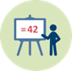 | Duration: 10 minutes
Teacher Educator introduces the activity for the fieldwork using PowerPoint presentation [5] – see separate file.

Student handout [2] –Common leaf morphology, see Task and guide for Fieldwork (Activity 2.5. in the Worksheet)

II. Discovering and understanding: Diversity and ecosystems

2.5. Fieldwork
Duration: 90 minutes
Task and guide for fieldwork

Work outside in groups to do the following:

- Study your area in general:
  - Characterize your area (natural habitat or planted habitats, inhabited or uninhabited,…)
  - Take notes on sun direction, building placement (to account for shadow), whether the plants were watered or not
  - Describe your area with regard to diversity
  - Measure green areas
- Study trees in your area:
  - Collect data about trees in your designated area
  - Observe shape, colour and characteristic traits of trees
  - Collect the leaves, categorize and describe them.
Use your own words and senses, but you can use «leave morphology» handout as support if necessary
- Take pictures of your area and the species you find
- Optional: Use a digital system for registration of species, e.g. Google site, or a smartphone App like iNaturalist, British tree identification

Remarks:
- Each group should study different areas around the school
- You don’t have to know the name of the tree species to be able to accomplish the tasks
- As you work outside, it is desirable to discuss how to transfer the knowledge you get into knowledge for teaching
- Remember to bring leave samples back to the classroom

Student handout [2] – See pictures of leaves morphology to help you out with vocabulary needed in describing leaves.

Students study the handout [2]: Common leaf morphology

(evt. printed out and copied, preferably use national versions)

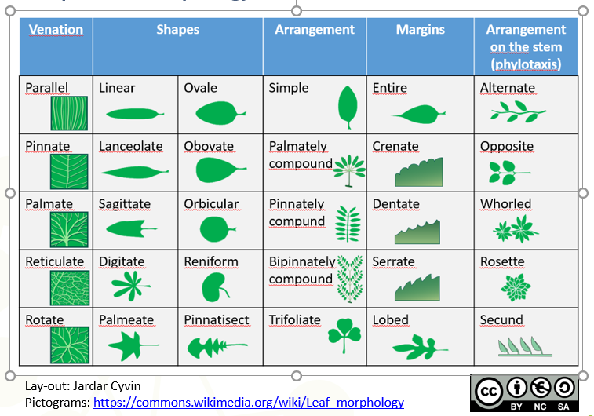

Morphology, in biology, the study of the size, shape, and structure of animals, plants, and microorganisms and of the relationships of their constituent parts. The term refers to the general aspects of biological form and arrangement of the parts of a plant or an animal. The term anatomy also refers to the study of biological structure but usually suggests study of the details of either gross or microscopic structure. In practice, however, the two terms are used almost synonymously.

Typically, morphology is contrasted with physiology, which deals with studies of the functions of organisms and their parts; function and structure are so closely interrelated, however, that their separation is somewhat artificial.

(Villee, C.A.2018. Morphology. Retrieved from: https://www.britannica.com/science/morphology-biology#ref48676 )

II. Discovering and understanding: Diversity and ecosystems

2.6. Reflections/Summary after fieldwork
Duration: 45 minutes
Teacher Educator leads the activity using PowerPoint presentation [5] – see separate file.

Task Group Work:
- Classify the leaves you picked up according to similarities and differences (try to combine everyday language and scientific concepts when classifying)
- Construct a dichotomous key based on your collected leaves
(if time allows; Use the dichotomous key designed by another student group to classify your collected leaves)
- Reflect on how out of school activities can promote intercultural understanding in science education, e.g.
  - How concretes from outdoor can help you to develop scientific language/knowledge of scientific concepts. Impact of cultural difference between students? How all senses can be utilized, if language barriers appear
  - What could be learnt from the fieldwork activity, regarding being a future teacher. Special emphasis on the different phases (preparation tasks, fieldwork tasks, summary tasks – and how they were or can be performed) and emphasis on diversity of students.

Plenary: Share with the whole class. Possible orientations/focuses:
- Characterize the different areas with regard to diversity
(each group present their area)
- Reflections on how the how out of school activities can promote intercultural understanding in science education, e.g.:
  - On the role of concretes/artefacts in building scientific language, knowledge of concepts and procedures
  - How the preparations, the pedagogical approach during fieldwork and the reflections after fieldwork can facilitate intercultural learning
  - How the use of own words and senses can facilitate learning of science content in intercultural context

II. Discovering and understanding: Diversity and ecosystems
2.7. Exploring an ecosystem (optional)
Duration: 60 minutes
Teacher Educator leads the activity using PowerPoint presentation [6] – see separate file.

Task Group Work:
- Based on the geographical diversity in your group, select one ecosystem or one local biotop, typical for a geographical area one or some of you come from or have grown up in.
- Discuss where in the world you find this kind of ecosystem or biotop.
- Discuss different types of plants that will endure this ecosystem or biotop. Choose one of these plants and visualize it in the following way:
  - Find information on its geographic location(s), climate conditions (e.g. coast, inland, mountain,…), growth conditions (biological knowledge)
  - Try to find out if this plant is used in any symbols, paintings, pictures, mysteries, legends and/or stories in the area or country you come from or have grown up in (cultural knowledge)
  - Find information on what people use this kind of plant for (handcraft/art/music/survival/food/industry etc.) (economical importance)
- Make a presentation of your plant for the class, based on
your answers to A, B and C above.

Plenary: Share/Discuss with the whole class.

II. Discovering and understanding: Diversity and ecosystems
2.8. Building a model of an ecosystem (optional)
Duration: 30 minutes
Teacher Educator leads the activity using PowerPoint presentation [7] – see separate file.

Task Group Work:
1. Collect the following equipment:
    - A transparent glass or plexiglass container of minimum 1 litre (jam glass, goldfish bowl, aquarium, terrarium or similar).
    - A transparent lid (plastic film, plastic bag, glass/plexiglass plate)
    - A cup of water
    - A light source
    - One or more green plant(s) in some soil (or OPTIONAL just in water)
    - Some small invertebrates (insects, earthworms, spiders, sow bugs etc.) - OPTIONAL
    - Data logger with one or more sensors (light, oxygen, CO2, moisture, pH) - OPTIONAL

2. Put the plant(s) and a cup of water in the glass container, with a light source outside the glass. Now you have the most essential components to start photosynthesis.

3. Cover the glass container with the lid or transparent plastic and place it in a tempered room. You now have a small ecosystem, which for a while will keep going. Evaporation from the water cup and the plants will produce drops of water under the plastic, inside the container, and after a while, it will drip back to the plant(s) (primitive rain).

4. OPTIONAL. It is possible to connect data logger sensors to the ecosystem. Recording variations in CO2, O2 for example related to light intensity, or evaporation (amount of water under the lid) related to temperature. Several other experiments related to the growth of the plants are possible, and if you introduce some invertebrates, you expand the potential for observing interactions of the species involved in the food chain of your small ecosystem.

Plenary: Share/Discuss with the whole class.

III. Influencing and contributing: Action plan (optional)

3.1. Introduction – Area around us (flipped classroom)
Duration: 60 minutes (homework)
The aim of this session is to prepare the teacher students for step 5 of "The Environmental Staircase": Influence and Contribute (Jelavic, 2014; Jordet, 2000).
TASK
Starter: see the video https://www.youtube.com/watch?v=kHhspf5IfdE
Read the text given below, reflect and answer the following tasks:
- Summarize with your own words what is meant by "education for sustainable development"
- Summarize with your own words what is meant by "competences for sustainable development"
- Why is "action competence" important?
- Why the local community can be an attractive learning arena for sustainable education

TEXT FOR THE TASK ABOVE
Reading [1] Activity 3.1. Preparation for action plan (flipped classroom)
Excerpt and translated from a Norwegian article (e-lecture):
Eldri Scheie and Majken Korsager (2015). Utdanning og undervisning
for bærekraftig utvikling [Education and teaching for sustainable development]. Naturfagsenteret. [The Norwegian Science Centre.] Retrieved 10.10.2017 from https://www.natursekken.no/c1187995/artikkel/vis.html?tid=2102114

Education and Teaching for Sustainable Development

Many of the environmental, societal and economic problems we are facing today show that local and national societies are entering into a symbiotic interaction with the global world community. Sustainable development is therefore about thinking and acting both locally, nationally and globally. Realization of sustainable development requires active participation by citizens having the competence to act right. To achieve this, it is imperative that we integrate education for sustainable development into the education system.

Sustainable development - social, economic and environmental considerations

In 1987, the World Commission for Environment and Development (WCED) with Gro Harlem Brundtland as chair defined the term "sustainable development" as "a development that meets today's needs without destroying the prospects for future generations to meet their needs" (Brundtland, 1987). Sustainable development, therefore, deals with that the human beings living both now and in the future, should get to meet their needs. In order for a development to be sustainable, it is always necessary to consider three main dimensions, viz.; social, economic and environment. These reflect the need to balance economic and social growth with respect to the environment.
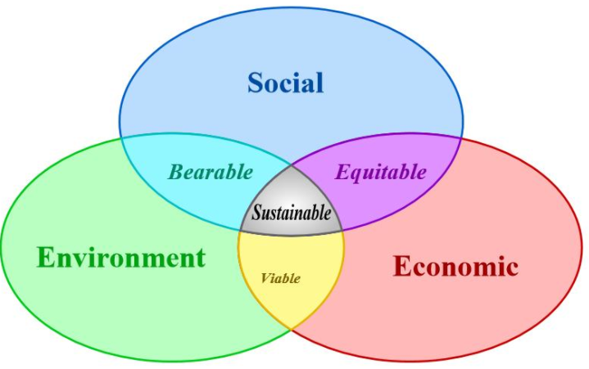

Education for Sustainable Development
The goal of ensuring sustainable development, approved in 2000, is the seventh of a total of eight goals in the “UN Millennium Development Goals”, to combat world poverty. To highlight the important role education can play in achieving sustainable development, decade 2005-2014 was defined as UN's decade of education for sustainable development. The overall goal of the decade was "to integrate principles, values and practices for sustainable development in all the aspects of education and learning" (UNESCO, 2005).
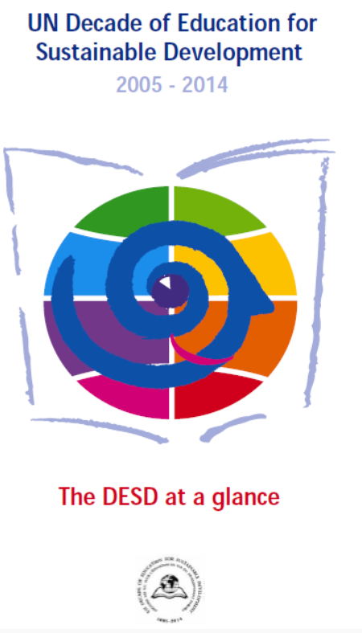
Norway and the Norwegian Ministry of Education have followed up UN's decade of education for sustainable development, by launching its own "Strategy for Education for Sustainable Development 2005-2010” with a revised edition for the period 2012-2015, “Knowledge for a Common Future". Norway's strategy regarding education for sustainable development aims at:

- Developing children's and young people's skills so that they can contribute to sustainable development in various areas of nature and society.
- Helping the kindergartens and schools in having competence and frameworks for education for sustainable development.
- Stimulating the development of network and cooperation relationships between kindergartens, schools, relevant agencies, non-governmental organizations (NGOs) and research institutions at national, regional and local levels.
- Promoting participation in international forums to exchange experiences and raise the quality of education for sustainable development both in Norway and other countries.
Education for sustainable development has to do with facilitating teaching that can develop pupils' competencies for a sustainable world in change. The overall goal is to stimulate responsibility and active participation among students.

(…)

Teaching for Sustainable Development

It is important to think of sustainable development as a dynamic process and not a definite goal. The world and society are constantly evolving, and we must continuously find new solutions and adapt ourselves to complex systems. Therefore, teaching for sustainable development is not just about giving students the knowledge, but also understanding and commitment to sustainable development (Schreiner & Sjøberg, 2005). Through teaching we can raise students' awareness by developing their knowledge, skills and attitudes, and thus helping them develop action competencies for sustainable development (Breiting & Mogensen, 1999; FN-sambandet, 2016; Jegstad & Sinnes, 2013; Jensen & Schnack, 1997; Sinnes, 2015). Such competencies are not something that can be conveyed and transferred from teacher to student, but something that can be developed through varied, multidisciplinary and inquiry based teaching. In order to create relevance and motivation, teaching should be varied using external skills as well as using other learning arenas (local environment and local communities).

Competencies for sustainable development

(Korsager, 2013; Korsager & Scheie 2014)

Knowledge

Some topics are central to having knowledge about sustainable development. These deal with climate, energy, consumption and resources, conflicts of interest, participation and democracy, biodiversity, natural areas, land use, health, waste and recycling, and water resources. Pupils can develop knowledge about these themes through multidisciplinary and inquiry based teaching where they collect and process information in different ways. Methods to give students such knowledge may be varied, for example, teaching with shorter theoretical reviews and lectures, information searches via the internet, reading scientific literature and reports. As a teacher, it is important to facilitate students' access to good and relevant sources, selecting and disseminating relevant subject matter together with supervising the pupils' under their own data collection.

Skills

Skills for sustainable development include being able to think critically, reflect, argue, collaborate, understand contexts (system understanding), communicate, innovate and create. Such skills can be trained by allowing students to work in groups, participate in debates, discuss conflicts and dilemmas, and develop solutions to the problems locally and globally. Teacher's work, in such situations, is to find out the topics that can be relevant and engaging. Current topics brought into discussion by the media or community, and problems of students' own everyday lives can be good starting points.

Attitudes

In order to act for sustainable development, it is important to have faith and hope for the future, but above all, the will to act. Such attitudes are created when students gain an insight into what opportunities they themselves have to influence. They can influence and can act positively both on their own lifestyle, for example by consumer choice, but also by participating in democratic processes through involvement in political work, or in non-governmental organizations (NGO’s), and in the future through their career choices. As a teacher, it will be important to focus on the possibilities rather than just on the challenges. An approach to that may be to work specifically with students' current consumption choices on food and clothing, or to let students advise and make proposals for solutions to local politicians or businesses.

References
Breiting, S., & Mogensen, F. (1999). Action Competence and Environmental Education. Cambridge Journal of Education, 29(3), 349-353. doi: 10.1080/0305764990290305Brundtland, G. (1987). Our common future: Report of the 1987 World Commission on Environment and Development.
FN-sambandet. (2016). FNs bærekraftsmål. Hentet 1.3, 2016, fra http://www.fn.no/Tema/FNs-baerekraftsmaal/Dette-er-FNs-baerekraftsmaal
Jegstad, K. M. and Sinnes, A. T. (2013). Chemistry Teaching for the Future – a theoretical model for upper secondary chemistry education for sustainable development. Presentation at 10th bi - annual Conference of the European Science Education Research Association, Nicosia, Cyprus 2.–7. sept. 2013
Jensen, B. B., & Schnack, K. (1997). The Action Competence Approach in Environmental Education. Environmental Education Research, 3(2), 163-178. doi: 10.1080/1350462970030205
Korsager, M. (2013). Educating pupils for a future of climate change. Objectives, opportunities and challenges for interdisciplinary education in a Norwegian school context. Trail lecture for the Degree of PhD. 13. September 2013, University of Oslo, Norway.
Kunnskapsdepartementet. (2012). Kunnskap for en felles framtid. Revidert strategi for utdanning for bærekraftig utvikling 2012 -2015 . Oslo: Retrieved from http://www.regjeringen.no/ upload/KD/Vedlegg/UH/Rapporter_og_planer/Strategi_for_ UBU.pdf
Schreiner, C., & Sjøberg, S. (2005). Empowered for action? How do young people relate to environmental challenges?. In Beyond Cartesian Dualism (pp. 53-68). Springer Netherlands.
UNESCO. (2005). United Nations Decade of Education for Sustainable Development (2005-2014) . Paris: Retrieved from http://unesdoc.unesco.org/images/0014/001416/141629e.pdf

III. Influencing and contributing: Action plan (optional)
3.2. Work out a plan for land use of area nearby
Duration: 90 min
Teacher Educator leads the activity using PowerPoint presentation [8] – see separate file.

TASK: Develop a plan for land use of an area nearby your school

- Think of an area by the school. Which possibilities for land-use can you see, using pedagogy, environmentally friendly use of the area, a scientific understanding of sustainability and interaction in the nature? Think also about ecology, energy and nutrient cycles.
- Work out a plan for land use for your selected area.
- Prepare your presentation for the role play (Activity 3.3):
  - Prepare argumentations for the plan of land use
  - Discuss possible counter arguments that might oppose your plan

Useful materials: overhead plastic sheets for making overlay maps and permanent marker pens.

III. Influencing and contributing: Action plan (optional)

3.3. Role play, presentation of land-use plan, target group: local municipality
Duration: 30 minutes
Teacher Educator leads the activity using PowerPoint [9]-see separate file.
The Teacher Educator (or other persons) plays the role of municipality staff.

TASK
Work in the same group as in activity 3.2.
Present the idea of your land-use plan to the municipality.
You can also present a drawing/sketch. Be prepared to give arguments for your plan and to answer questions from the municipality staff.

