Module 12 | ASSESSMENT IN MATHEMATICS AND SCIENCE IN MULTICULTURAL CONTEXTS

This module is based on the work within the project Intercultural learning in mathematics and science initial teacher education (IncluSMe). Coordination: Prof. Dr. Katja Maaß, International Centre for STEM Education (ICSE) at the University of Education Freiburg, Germany. Partners: University of Nicosia, Cyprus; University of Hradec Králové, Czech Republic; University of Jaen, Spain; National and Kapodistrian University of Athens, Greece; Vilnius University, Lithuania; University of Malta, Malta; Utrecht University, Netherlands; Norwegian University of Science and Technology, Norway; Jönköping University, Sweden; Constantine the Philosopher University, Slovakia.

The project Intercultural learning in mathematics and science initial teacher education (IncluSMe) has received co-funding by the Erasmus+ programme of the European Union under grant no. 2016-1-DE01-KA203-002910. Neither the European Union/European Commission nor the project's national funding agency DAAD are responsible for the content or liable for any losses or damage resulting of the use of these resources.

IncluSMe project (grant no. 2016-1-DE01-KA203-002910) 2016-2019, lead contributions by Chetcuti, D. and Farrugia, J. University of Malta, Malta.
CC-BY-NC-SA 4.0 license granted (find explicit terms of use at: https://creativecommons.org/licenses/by-nc-sa/4.0/deed.en)

General overview and aim
The main aim of this module is to enable prospective teachers to become ‘assessment literate’ with respect to multicultural contexts. ‘Assessment literate’ according to Klenowski (2014) means that prospective teachers have “a repertoire of skills and understandings to design quality assessments and to use achievement standards and evidence as a means by which to discern, monitor and improve learning as well as judge the qualities of student work” (p. 2). Therefore, this module aims to introduce prospective teachers to various procedures and help them develop skills that will allow them to take into account pupils’ diversity and support them to address issues of equity and social justice.

This module is part of:
- Personal dimension: values, attitudes and intercultural competences of prospective teachers;
- Mathematics and Science Education dimension: pedagogical issues, in particular in respect to dealing with diversity in classrooms.

Relevant topics
- Theory and background on formative and summative assessment in general
- Background on issues related to equity and fairness in assessment
- Linking theory related to equity and fairness in assessment with practice through
  - study of specific cases
  - exploring sources of unfairness
  - analysing assessment materials and classroom situations
  - designing an assessment task.

Learning Outcomes

At the end of this module students will be able to:

- gain information about the pupils in the classroom;
- assess pupils in a way that allows them to respond to the needs of diverse pupils;
- use different ways of assessing pupils’ social, emotional as well as academic skills;
- use assessment procedures that are sensitive to cultural differences;
- adapt classroom assessment to accommodate the cultural resources pupils bring to school;
- examine their own beliefs and expectations related to the pupils in their classroom and the impact these beliefs and expectations have on their assessment;
- critically evaluate the impact of assessment practices on learners, pedagogy and curriculum;
- reflect on the key issues of equity, fairness and social justice in relation to assessment practices.

Flowchart and Module plan

This module consists of seven sections each made up of a number of activities. The activities include short presentations by the educator, video clips, cartoons, role plays, work in small groups and reading tasks to be carried out at home.
The seven sections are:

- Introduction to the topic
- Purposes of assessment
- Introduction to Formative and Summative Assessment
- Assessment and Educational Achievement
- Fairness in Assessment
- Assessment strategies
- Culture-fair assessment strategies

I. Introduction to the topic “Assessment - the bridge between teaching and learning”

1.1. Your personal experience of Assessment
Duration: 10 minutes
This is a “warm up” activity. The intention is to start with students’ own experience of assessment in order to identify possible positive and negative aspects of assessment.
Students are invited to think of their own experiences of being assessed and reflect on the impact of these experiences. Students write phrases/sentences to describe their experience and share their experiences with the group.
This activity contributes to the achievement of the following learning outcome:
- critically evaluate the impact of assessment practices on learners, pedagogy and curriculum.

1.2. Reflection
Duration: 10 minutes
Students are invited to reflect on the impact of each assessment experience.
This activity contributes to the achievement of the following learning outcome:
- critically evaluate the impact of assessment practices on learners, pedagogy and curriculum.

1.3. Discussion
Duration: 10 minutes
Students discuss whether it is possible to have learning without assessment arriving at the conclusion that assessment is the bridge between teaching and learning.
This activity contributes to the achievement of the following learning outcome:
- critically evaluate the impact of assessment practices on learners, pedagogy and curriculum.

II. Purposes of assessment

2.1. Case Study
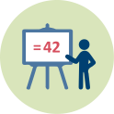 | Duration: 15 minutes
In this activity students are presented with different scenarios and are required to discuss (in groups) what they think the purpose of assessment is in each scenario. As a conclusion to the activity, the educator then presents a list of five purposes of assessment (adapted from Gipps and Stobart, 1993) shown on power point.
This activity contributes to the achievement of the following learning outcomes:
- gain information about the pupils in the classroom;
- assess pupils in a way that allows them to respond to the needs of diverse pupils;
- use different ways of assessing pupils’ social, emotional as well as academic skills.

III. Formative and Summative assessment

3.1. Introduction
Duration: 15 minutes
In this activity students are introduced to the idea of assessment practices and their link to social and educational policies, followed by an introduction to formative and summative assessment with the help of powerpoint slides.
This activity contributes to the achievement of the following learning outcomes:
- gain information about the pupils in the classroom;
- assess pupils in a way that allows them to respond to the needs of diverse pupils;
- use different ways of assessing pupils’ social, emotional as well as academic skills.

III. Formative and Summative assessment

3.2. Case Study
Duration: 15 minutes
In this activity students are invited to read a set of vignettes and to discuss in groups when the teacher was assessing students formatively or summatively.
This activity contributes to the achievement of the following learning outcomes:
- gain information about the pupils in the classroom;
- assess pupils in a way that allows them to respond to the needs of diverse pupils;
- use different ways of assessing pupils’ social, emotional as well as academic skills.

3.3. High Stakes Examinations
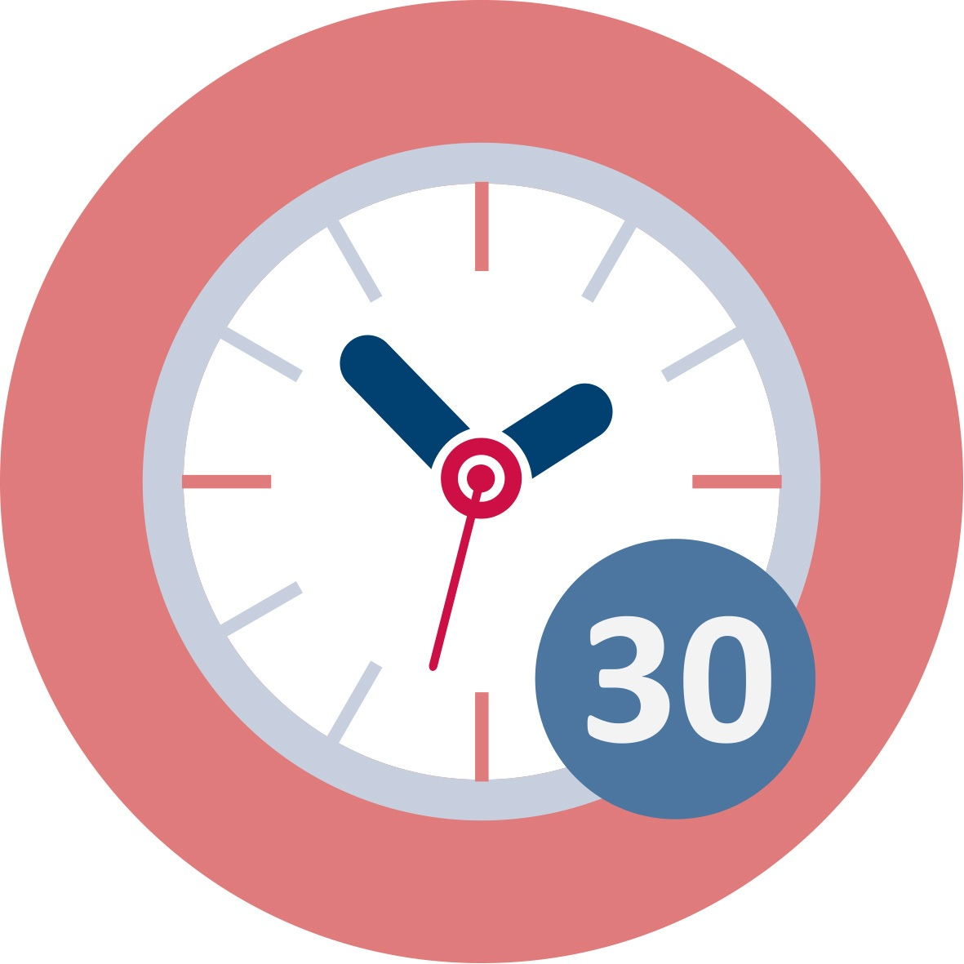 Duration: 30 minutes
In this activity, the educator introduces the topic: High stakes examinations. Students are given two statements related to high stakes examination: a statement in favour of high stakes examinations and the other a student’s perspective. They are asked to discuss the statements. This is followed by the educator’s presentation about the possible effects of examinations (no discussion of fairness at this stage).
This activity contributes to the achievement of the following learning outcomes:
- examine their own beliefs and expectations related to assessment;
- critically evaluate the impact of assessment practices on learners, pedagogy and curriculum.

3.4. Case Study
Duration: 15 minutes
In this activity the students are given a case study related to a student’s experience of high stakes examinations. They are asked to discuss the statement and the impact of high stakes examinations.
This activity contributes to the achievement of the following learning outcomes:
- examine their own beliefs and expectations related to assessment;
- critically evaluate the impact of assessment practices on learners, pedagogy and curriculum.

IV. Why do Assessment and Educational Achievement matter?

4.1. Introduction: why does assessment matter?
Duration: 10 minutes
In this activity the educator presents some ideas and research results showing how different teaching and assessment strategies influence student achievement.
This activity contributes to the achievement of the following learning outcome:
- critically evaluate the impact of assessment practices on learners, pedagogy and curriculum.

4.2. Role Play
Duration: 10 minutes
In this activity prospective teachers are placed in the position of a student who is given a handout with a science to work out. The task is in an unfamiliar language. Students then discuss how this task made them feel.
This activity contributes to the achievement of the following learning outcomes:
- critically evaluate the impact of assessment practices on learners, pedagogy and curriculum;
- reflect on the key issues of equity, fairness and social justice in relation to assessment practices.

4.3. Homework
Read: Wiliam, D. (2006). Assessment for Learning: Why, what and how. Institute of Education, University of London.
http://www.dylanwiliam.org/Dylan_Wiliams_website/Papers.html

V. Fairness in assessment: equality or equity?

5.1. Game
Duration: 15 minutes
In this activity students participate in a race in which they are expected to transfer water from one bucket to another some distance away using a plastic cup. Some students are given cups with small holes so they lose water on the way.
After the game students discuss: Who managed to win the game? How can we relate this to fair assessment?
(The activity may be replaced by others. For example prospective students may be placed in groups and asked to prepare a poster on ‘Fairness’. Each group is given different resources to use for making the poster (hence an ‘unequal’ distribution of resources). The outcomes are then discussed.)
This activity contributes to the achievement of the following learning outcomes:
- examine their own beliefs and expectations related to the pupils in their classroom and the impact these beliefs and expectations have on their assessment;
- reflect on the key issues of equity, fairness and social justice in relation to assessment practices.

5.2. Reflecting about equality and equity
Duration: 15 minutes
In this activity the educator introduces the concepts of equality and equity and how these are related to ‘fairer assessment’. Students discuss cartoons depicting equality and equity.
This activity contributes to the achievement of the following learning outcomes:
- examine their own beliefs and expectations related to the pupils in their classroom and the impact these beliefs and expectations have on their assessment;
- reflect on the key issues of equity, fairness and social justice in relation to assessment practices.

5.3. Equality vs equity in an assessment situation
Duration: 30 minutes
In this activity students relate the previous task to assessment. They work individually to come up with an assessment situation that describes inequity. They are then invited to think about how to make the assessment fairer and share with their group. This is then followed by a whole group discussion. Each group chooses one situation to share with the whole group.
This activity contributes to the achievement of the following learning outcomes:
- examine their own beliefs and expectations related to the pupils in their classroom and the impact these beliefs and expectations have on their assessment;
- reflect on the key issues of equity, fairness and social justice in relation to assessment practices.

5.4. Discussion – fairness in assessment
Duration: 30 minutes
In this activity students reflect and discuss the implications of a statement related to fairness in assessment.
This activity contributes to the achievement of the following learning outcomes:
- examine their own beliefs and expectations related to the pupils in their classroom and the impact these beliefs and expectations have on their assessment;
- reflect on the key issues of equity, fairness and social justice in relation to assessment practices.

VI. Assessment strategies

6.1. Re-examining our assessment practices
Duration: 10 minutes
In this activity prospective teachers are introduced to the notion of diversity and the need to re-examine our assessment practices.
This activity contributes to the achievement of the following learning outcome:
- reflect on the key issues of equity, fairness and social justice in relation to assessment practices.

6.2. Groups I identify with
Duration: 30 minutes
In this activity students work individually and fill in a diagram in which they identify aspects related to who they are. They then share what they have written and see whether they belong to one or more groups that can be formed within their class. This will lead students to define culture.
This activity contributes to the achievement of the following learning outcomes:
- examine their own beliefs related to cultural differences;
- adapt classroom assessment to accommodate the cultural resources pupils bring to school;
- examine their own beliefs and expectations related to the pupils in their classroom and the impact these beliefs and expectations have on their assessment.

6.3. Case Study
Duration: 10 minutes
In this activity, prospective teachers are given a case study consisting of a class and the class teacher’s journal. They are invited to discuss how she looks at diversity in her classroom and to suggest how the teacher can take into account diversity in her assessment.
This activity contributes to the achievement of the following learning outcomes:
- examine their own beliefs and expectations related to the pupils in their classroom and the impact these beliefs and expectations have on their assessment;
- reflect on the key issues of equity, fairness and social justice in relation to assessment practices.

6.4. Models of responding to diversity
Duration: 10 minutes
Students answer a questionnaire that will help them examine their own beliefs and views related to diversity.
This is followed by a short presentation related to models of responding to diversity (Shohamy, 2000) and culturally responsive assessment practices (Klenowski, 2009).
This activity contributes to the achievement of the following learning outcomes:
- assess pupils in a way that allows them to respond to the needs of diverse pupils;
- use different ways of assessing pupils’ social, emotional as well as academic skills;
- use assessment procedures that are sensitive to cultural differences;
- adapt classroom assessment to accommodate the cultural resources pupils bring to school;
- examine their own beliefs and expectations related to the pupils in their classroom and the impact these beliefs and expectations have on their assessment.

6.5. Homework
Students read the paper:
Stobart, G. (2005). Fairness in multicultural assessment systems. Assessment in Education, 12(3), 275-287.

https://cmap.helsinki.fi/rid=1G5ND3134-GLXTVW-1WM/fairness_multicultu
ral_assessmentsystems.pdf
This activity contributes to the achievement of the following learning outcomes:
- examine their own beliefs and expectations related to the pupils in their classroom and the impact these beliefs and expectations have on their assessment;
- reflect on the key issues of equity, fairness and social justice in relation to assessment practices.

6.6. Discussion
Duration: 15 minutes
Prospective teachers read an excerpt from a teacher’s journal and discuss the suggestions in view of Stobart’s paper (Activity 6.5).
This activity contributes to the achievement of the following learning outcomes:
- assess pupils in a way that allows them to respond to the needs of diverse pupils;
- use assessment procedures that are sensitive to cultural differences;
- adapt classroom assessment to accommodate the cultural resources pupils bring to school.

VII. Designing fairer assessment tasks

7.1. Steps towards a ‘fairer’ assessment
Duration: 15 minutes
The Educator presents some steps towards equity and fairer assessment.
This activity contributes to the achievement of the following learning outcomes:
- examine their own beliefs and expectations related to the pupils in their classroom and the impact these beliefs and expectations have on their assessment;
- reflect on the key issues of equity, fairness and social justice in relation to assessment practices.

7.2. Get to know someone
Duration: 10 minutes
In this activity students work in pairs and tell each other three things about themselves. Two are truths and one is an untruth. Then each student in a pair introduces the other to the whole group. As a group, they try to find the true identity of each individual. Finally, they reflect on whether they based their conclusions on stereotypes.
This activity contributes to the achievement of the following learning outcomes:
- gain information about the pupils in the classroom.

7.3. Dealing with Diversity
Duration: 10 minutes
Class discussion about possible ways of differentiating assessment.
This activity contributes to the achievement of the following learning outcomes:
- gain information about the pupils in the classroom;
- assess pupils in a way that allows them to respond to the needs of diverse pupils;
- use different ways of assessing pupils’ social, emotional as well as academic skills;
- use assessment procedures that are sensitive to cultural differences;
- adapt classroom assessment to accommodate the cultural resources pupils bring to school.

7.4. Designing a lesson plan including assessment tasks
This may be used as the assignment for assessing the prospective teachers at the end of this module.
This activity is intended to assess prospective teachers’ achievement of the learning outcomes set for this module. Prospective teachers are also invited to reflect on how they tried to be ‘fair’ and ‘equitable’ and to discuss the challenges faced in trying to develop ‘fairer’ assessment for science/mathematics students.
The activity may either be a take-home assignment that students submit for assessment or may include presentation of the lesson plans designed followed by a discussion on each presentation with all those present.

 | Materials and resources
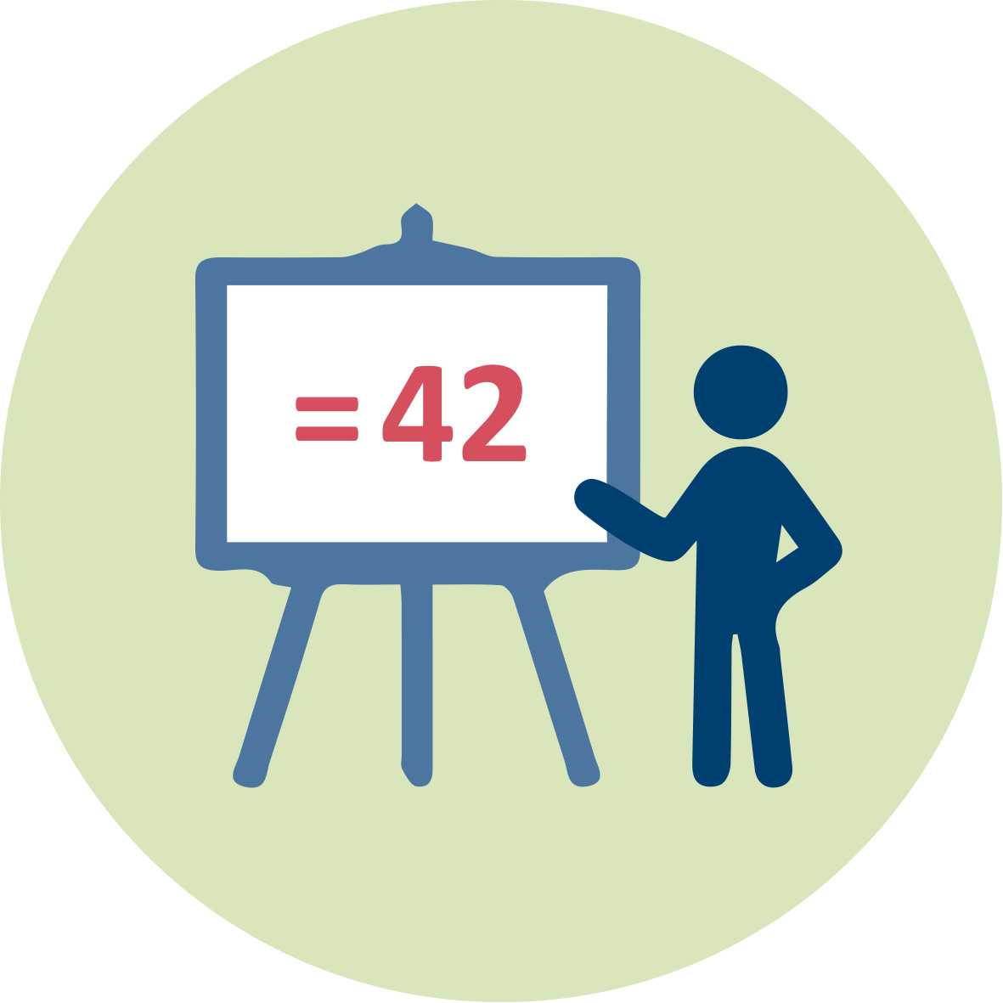 | Presentation 1 (pptx). Assessment: Formative and Summative
 | Wiliam, D. (2006). Assessment for Learning: Why, what and how. Institute of Education, University of London. http://www.dylanwiliam.org/Dylan_Wiliams_website/Papers.html
 | Stobart, G. (2005). Fairness in multicultural assessment systems. Assessment in Education, 12(3), 275-287. https://cmap.helsinki.fi/rid=1G5ND3134-GLXTVW-1WM/fairness_multicultural_assessmentsystems.pdf
 | Presentation 2 (pptx). Fairness in Assessment
 | Worksheets. Includes student activities for module 12
 | Plastic cups and buckets with water.

Granularity
- Several activities from this module can stand alone. They can be incorporated into a longer module about assessment in general.
- Skip activities example Activity 5.1. or any activity that is already included in the students’ ITE programme.
- The suggested duration of activities may be changed. Tutors may wish to continue or extend a discussion beyond the suggested time limit before moving on to another activity. Duration of activities involving discussion will also depend on the class size.

References
Banks, J.A., & Banks, C.A. (2004). Handbook of research on multicultural education (2nd ed.). San Francisco: Jossey-Bass.
Chappuis, J., Stiggins, R. J., Chappuis, S., & Arter, J. A. (2013). Classroom Assessment for Student Learning: Pearson New International Edition: Doing It Right-Using It Well. Pearson Higher Ed.
Elwood, J. (2013). Educational assessment policy and practice: A matter of ethics. Assessment in Education: Principles, Policy & Practice, 20(2), 205-220.
Elwood, J. (2012). Qualifications, examinations and assessment: Views and perspectives of students in the 14–19 phase on policy and practice. Cambridge journal of education, 42(4), 497-512.
Elwood, J., Hopfenbeck, T., & Baird, J. A. (2017). Predictability in high-stakes examinations: students’ perspectives on a perennial assessment dilemma. Research Papers in Education, 32(1), 1-17.
Elwood, J., & Lundy, L. (2010). Revisioning assessment through a children’s rights approach: Implications for policy, process and practice. Research Papers in Education, 25(3), 335-353.
Elwood, J., & Murphy, P. (2015). Assessment systems as cultural scripts: a sociocultural theoretical lens on assessment practice and products. Assessment in Education Principles Policy and Practice, 22(2), 182-192. https://doi.org/10.1080/0969594X.2015.1021568
Gardner, J., Holmes, B., & Leitch, R. (2009). Assessment and social justice (Vol. 16). Bristol: Futurelab.
Gipps, C. V. and Stobart, G. (1993). Assessment—A Teachers’ Guide to the Issues, London: Hodder & Stoughton.
Hattie, J. (2008). Visible learning: A synthesis of over 800 meta-analyses relating to achievement. Routledge.
Klenowski, V. (2009). Australian indigenous students: addressing equity issues in assessment. Teaching Education, 20(1), 77-93.
McArthur, J. (2016). Assessment for social justice: the role of assessment in achieving social justice. Assessment & Evaluation in Higher Education, 41(7), 967-981.
Montenegro, E., & Jankowski, N. A. (2017). Equity and assessment: Moving towards culturally responsive assessment. Urbana, IL: University of Illinois and Indiana University, National Institute for Learning Outcomes Assessment (NILOA).
Murphy, P., & Elwood, J. (1998). Gendered experiences, choices and achievement-exploring the links. International Journal of Inclusive Education, 2(2), 95-118.
Shohamy, E. (2000). Educational assessment in a multicultural society: issues and challenges. Paper presented at the 26th IAEA Conference, Jerusalem, 14-19 May.
Stobart, G. (2005). Fairness in multicultural assessment systems. Assessment in Education, 12(3), 275-287. https://cmap.helsinki.fi/rid=1G5ND3134-GLXTVW-1WM/fairness_multicultu ral_assessmentsystems.pdf
Wiliam, D. (2006). Assessment for Learning: Why, what and how. Institute of Education, University of London.
http://www.dylanwiliam.org/Dylan_Wiliams_website/Papers.html
Wiliam, D. (2011). What is assessment for learning?. Studies in educational evaluation, 37(1), 3-14.
Wiliam, D. (2013). Assessment: The bridge between teaching and learning. Voices from the Middle, 21(2), 15.

Further readings

Flores, M. A. (2016) Teacher Education Curriculum, in. J. Loughran & M. L. Hamilton (Eds.) International Handbook of Teacher Education, (pp. 187-230). Dordrecht: Springer Press.
This chapter provides an important overview of what the curricula of ITE programmes include; good pointers with regards to the place of educational assessment in the preparation of prospective teachers.
Alrø, H., Skovsmose, O., & Valero, P. (2009). Inter-viewing foregrounds: Students’ motives for learning in a multicultural setting. in M. César & K. Kumpulainen (Eds.), Social Interactions in Multicultural Settings, 13-37. Sense Publishers.
This chapter provides a very good introduction to what multiculturalism involves and how this is related to the experiences of students inside mathematics classrooms.
Gipps, C. V. (1994). Beyond testing: towards a theory of educational assessment. London: RoutledgeFalmer.
A seminal book that introduces the reader to a critique of traditional assessment, why the paradigm shift in assessment became so important and also provides a very good overview of the underpinnings of the alternative assessment paradigm. This has special implications for assessment in multicultural classrooms.
Gipps, C., & Murphy, P. (1994). A fair test? Assessment, achievement and equity. Buckingham: Open University Press.
A book that problematizes the issue of tests and examinations; also important due to the attention that the authors give to issue of fairness and equity in relation to educational assessment. This has special implication for assessment in multicultural classrooms.
Wiliam, D., & Black, P. (1996). Meanings and consequences: a basis for distinguishing formative from summative functions of assessment? British Educational Research Journal, 22(5), 537-548.
An important paper that provides key insights into the main subdivision in assessment namely, formative and summative. Its main contribution lies in the fact that these two dimensions are presented, possibly for the first time, in terms of the consequences of assessment rather than the assessment tools that are being applied.

Assessment
Prospective teachers are required to design a lesson and include assessment tasks. The full description of the task and the assessment criteria are given in the worksheets.

