Module 1 | INTRODUCTION TO CULTURE AND DIVERSITY FOR PROSPECTIVE MATHEMATICS AND SCIENCE TEACHERS

This module is based on the work within the project Intercultural learning in mathematics and science initial teacher education (IncluSMe). Coordination: Prof. Dr. Katja Maaß, International Centre for STEM Education (ICSE) at the University of Education Freiburg, Germany. Partners: University of Nicosia, Cyprus; University of Hradec Králové, Czech Republic; University of Jaen, Spain; National and Kapodistrian University of Athens, Greece; Vilnius University, Lithuania; University of Malta, Malta; Utrecht University, Netherlands; Norwegian University of Science and Technology, Norway; Jönköping University, Sweden; Constantine the Philosopher University, Slovakia.

The project Intercultural learning in mathematics and science initial teacher education (IncluSMe) has received co-funding by the Erasmus+ programme of the European Union under grant no. 2016-1-DE01-KA203-002910. Neither the European Union/European Commission nor the project's national funding agency DAAD are responsible for the content or liable for any losses or damage resulting of the use of these resources.

IncluSMe project (grant no. 2016-1-DE01-KA203-002910) 2016-2019, lead contributions by International Centre for STEM Education (ICSE) at the University of Education Freiburg, Germany. CC-BY-NC-SA 4.0 license granted (find explicit terms of use at: https://creativecommons.org/licenses/by-nc-sa/4.0/deed.en)

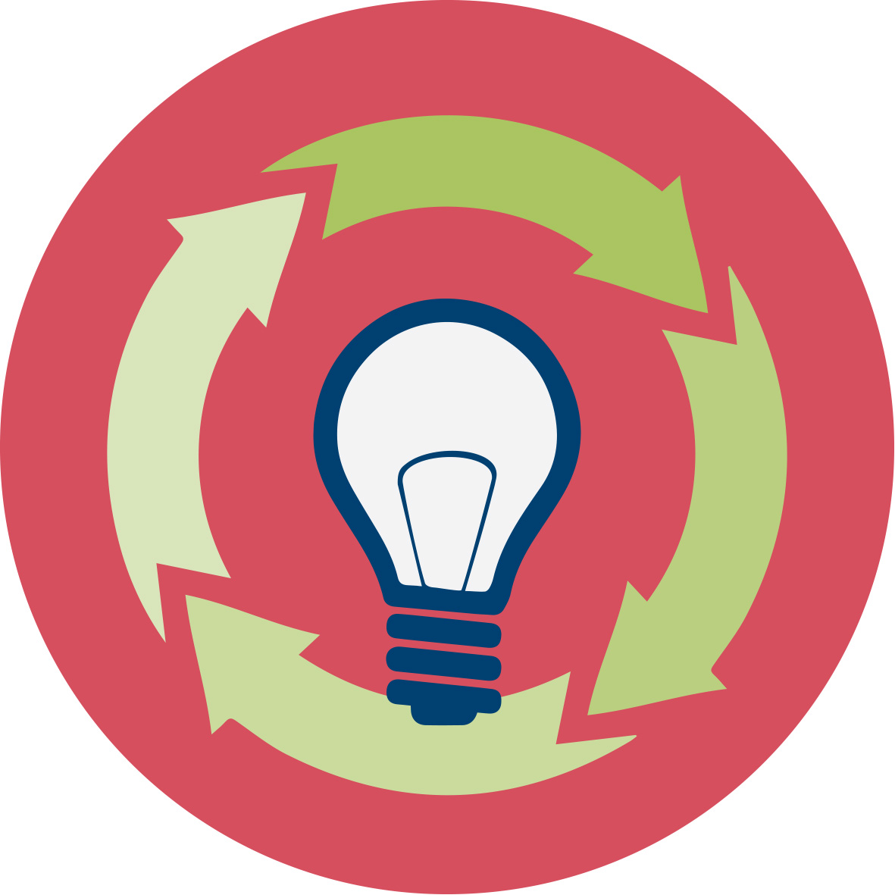 | General overview and aim
In this module future teachers in initial teacher education are introduced to intercultural learning in Science and Mathematics. The intention is to make students familiar with the topic by giving them concrete examples and connect these examples to a broader theoretical background. They will learn important definitions related to intercultural learning in general and then will connect intercultural learning to science and mathematics education. At the end of this introductory module students will get an overview about the modules to follow.
The module was designed on the one hand so as to be relevant to day-to-day teaching. Therefore concrete situations were chosen to make students experience challenges in connection to cultural diversity. On the other hand we also provide the theoretical background to balance theory and practice and connect both aspects. The methods chosen prioritize students’ active learning.

This module is part of:
- Personal dimension: values, attitudes and intercultural competences of prospective teachers;
- Mathematics and Science Subject dimension: (inter)cultural perspectives on the subjects themselves;
- Mathematics and Science Education dimension: pedagogical issues, in particular in respect to dealing with diversity in classrooms.
IO 1 is an introductory module and therefore has crosslinks to other modules. These crosslinks are intended and a strength of the approach as they help to deepen the knowledge on a certain aspect and to shed light on it from different perspectives. They also serve the purpose that the individual modules also can be used as stand-alone modules. If several modules are used it is of course the decision of the user whether or not he uses them.

This in particular refers to task where students are asked to deal with a task in a different language so as to make them experience how students with migrant background feel. You will find such a task in IO1, where students are asked to deal with an mathematics task in French, in IO9, we use a video in Finnish to track ‘language difficulties’ in understanding science concepts, and to identify what can be understood (universal understandings in science) and what not (due to another language).

Relevant topics
In this introduction high emphasis is set on introducing the theoretical basis and connecting it to science and mathematics education. Students will learn about relevant definitions but also experience the cultural situatedness of science and mathematics. We will also point to the following exemplary challenges in connection to science and mathematics education
- Different algorithms
- Contexts which are difficult to understand
- Different ways of solutions
- Different syllabus
- Language Difficulties.

Learning Outcomes

Students will acquire
- An awareness for the necessity of intercultural competences (Activity 1.1 and all other activities)
- Knowledge on definitions in relation to intercultural learning (Intercultural competence, Intercultural communication, Culture and Cultural identity, Diversity (Activities 2.1 – 2.3)
- Knowledge about the cultural situatedness of science and mathematics (Activity 3.1 and 3.2)
- An awareness about how this cultural situatedness impacts on mathematics and science education (Activity 3.1 and 3.2)
- Experience such challenges students from different cultural backgrounds might experience in science and mathematics teaching and reflect on ways to overcome them (Activity 3.3)
- Knowledge about different syllabus in different countries and reflect on ways to overcome them (Activity 3.4)

Flowchart and Module plan

This module involves three sections, all structured into several activities. It includes 215 minutes of sessions and 120 minutes of homework. It includes lecture parts, group discussions, debates and student presentations. The structure is as follows:
- Introduction into the topic: 45 min
- Theoretical background – definitions: 75 min
- Connecting Intercultural learning to mathematics and science education: 90 min + 120 min Homework
- Outlook on the other modules: 5 min

I. Introduction into the topic “Intercultural learning in Science and Mathematics teacher Education” (45 mins)

1.1. Why do we need intercultural competence?
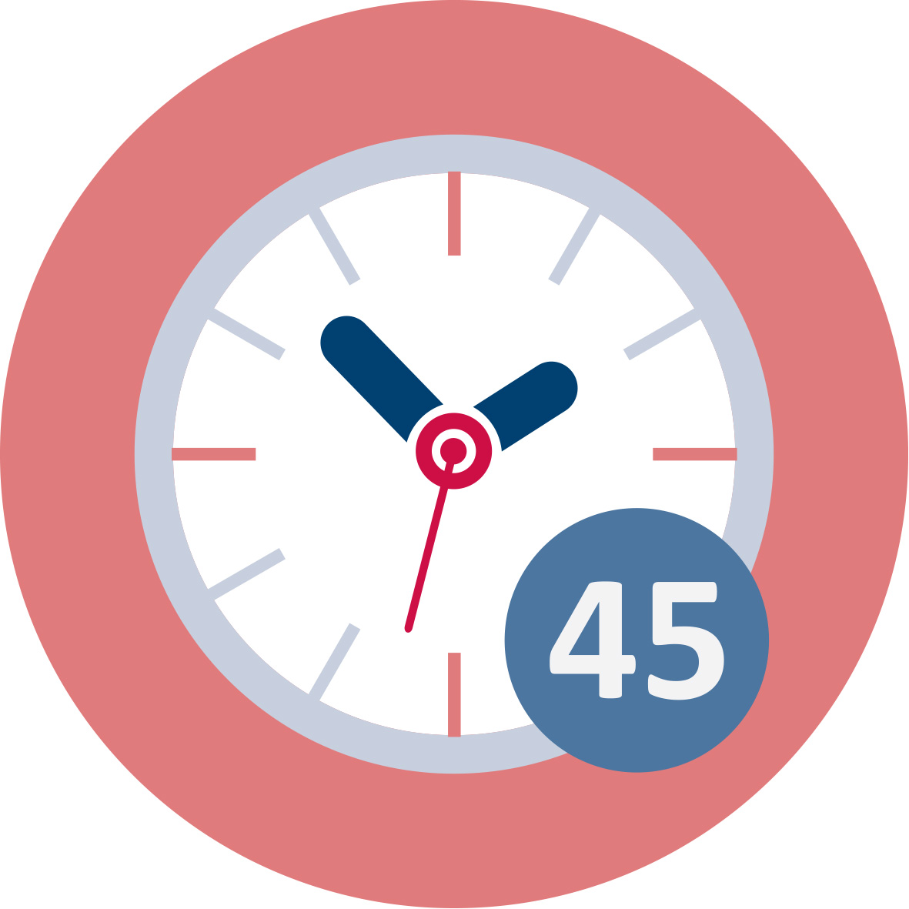Duration: 45 minutes
This is a “warm up” activity. The intention is to explore previous knowledge and beliefs about the central topic of this introductory module “Intercultural learning in Science and mathematics teacher education. Teacher Educators introduce the module using the ppt presentation [1] and then present the activity 1.1 to preservice teachers.
This session contributes to the achievement of the following learning outcomes:
- An awareness for the necessity of intercultural competences (Activity 1.1)

II. Theoretical background: Definitions of important concepts from general pedagogy

2.1. What is culture?
 | Duration: 20 minutes
Prospective teachers see a film on elements that define culture. Afterwards they are expected to set up their own definition of culture and cultural identity and how it is formed.
This session contributes to the achievement of the following learning outcomes:
- Knowledge on definitions in relation to intercultural learning (Intercultural competence, Intercultural communication, Culture and Cultural identity)

2.2. Culture and Cultural Identity
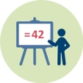 | Duration: 25 minutes
In this session the teacher educator presents some definitions. Then teacher students, working in groups, have to summarize given definitions and comment on them in a plenary session.
This session contributes to the achievement of the following learning outcomes:
- Knowledge on definitions in relation to intercultural learning (Intercultural competence, Intercultural communication, Culture and Cultural identity)

2.3. Diversity
 | Duration: 20 minutes
Teacher students, working in groups, have to read given definitions and reflect on the importance of the different aspects of the definitions for science and mathematics education.
This session contributes to the achievement of the following learning outcomes:
- Knowledge on definitions about diversity and its relevance to mathematics and science education.

III. Connecting intercultural learning to science and mathematics education

3.1. Science and mathematics in different cultures and 3.2 related Homework
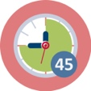 Duration: 40 minutes + 90 homework
In this session students discuss the following questions to make them realise their own beliefs: To what extend does scientific knowledge depend on the cultural context?; To what extend can indigenous people’s knowledge e.g. in Canada, Australia or the US contribute to science?; What are the contributions of Arabs to the development of mathematics and science? As homework they read texts in relation to these questions and then work on the questions again in their homework.
This session contributes to the achievement of the following learning outcomes:
- Students acquire an awareness about how this cultural situatedness impacts on mathematics and science education (Activity 3.1 & 3.2)

3.3. Examples of intercultural issues in science and maths education
Duration: 40 minutes
Teacher students work on 5 examples from day-to-day teaching: The use of different algorithms, dealing with mathematics in a foreign language, the understanding of the context of a task and different ways of solutions in different countries. They are asked to reflect on the consequences which arise from these challenges for mathematics and science education.
This session contributes to the achievement of the following learning outcomes:
- Experience challenges students from different cultural backgrounds might experience in science and mathematics teaching and reflect on ways to overcome them (Activity 3.2)

3.4. Comparing curricula - Homework
Duration: 30 minutes Homework and 10 min presentation
Teacher students have to compare the Tanzanian curriculum with their home country curriculum and reflect on consequences for a multicultural science and mathematics education.
This session contributes to the achievement of the following learning outcomes:
- Knowledge about different syllabus in different countries and on ways how to overcome them
 | Materials and resources
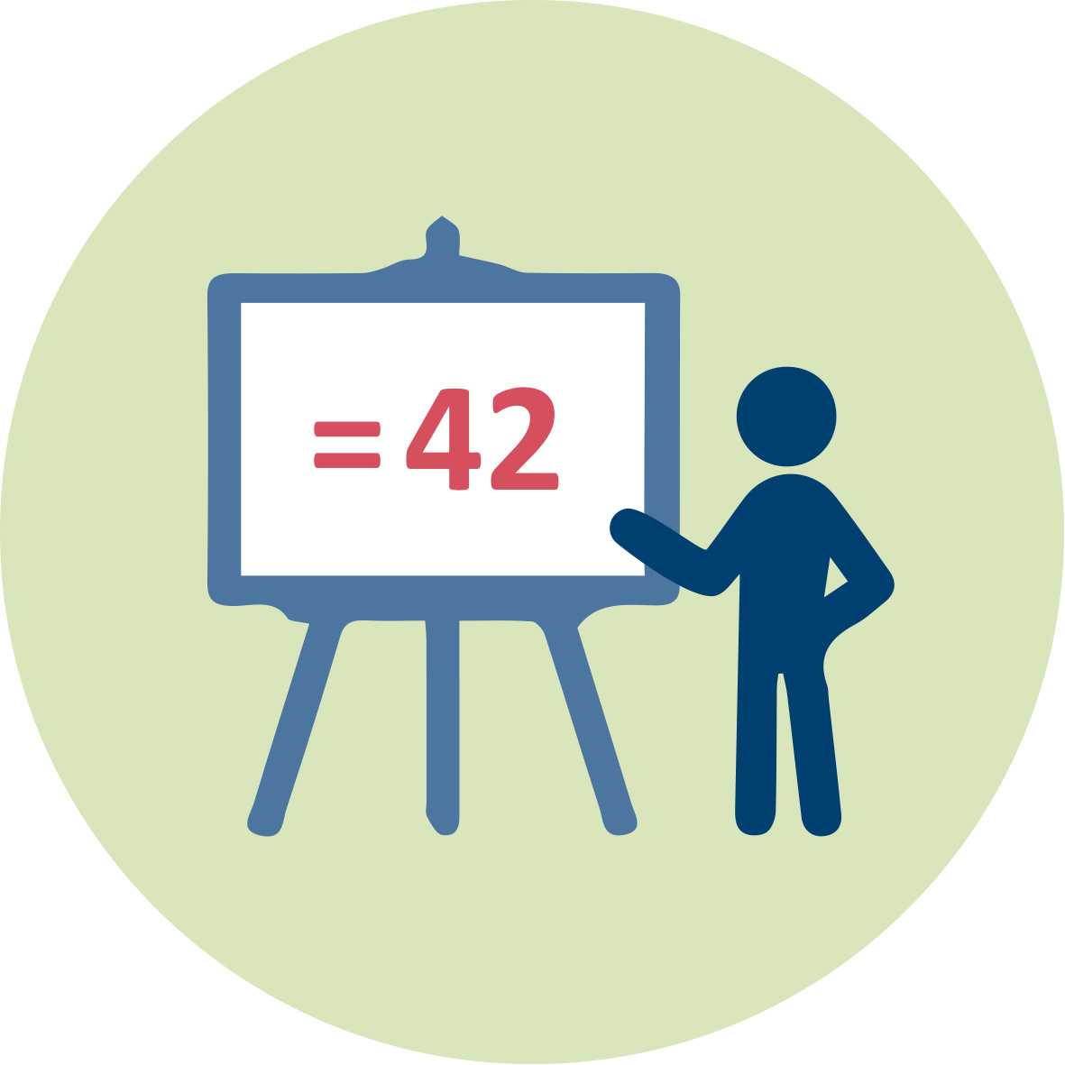 | Presentation 1 (pptx). Teacher Educator. Introduction to “Culture and Diversity”
 |  | Readings and students’ handouts
 | Access to computers for internet research and collaborative work
 | Youtube videos.

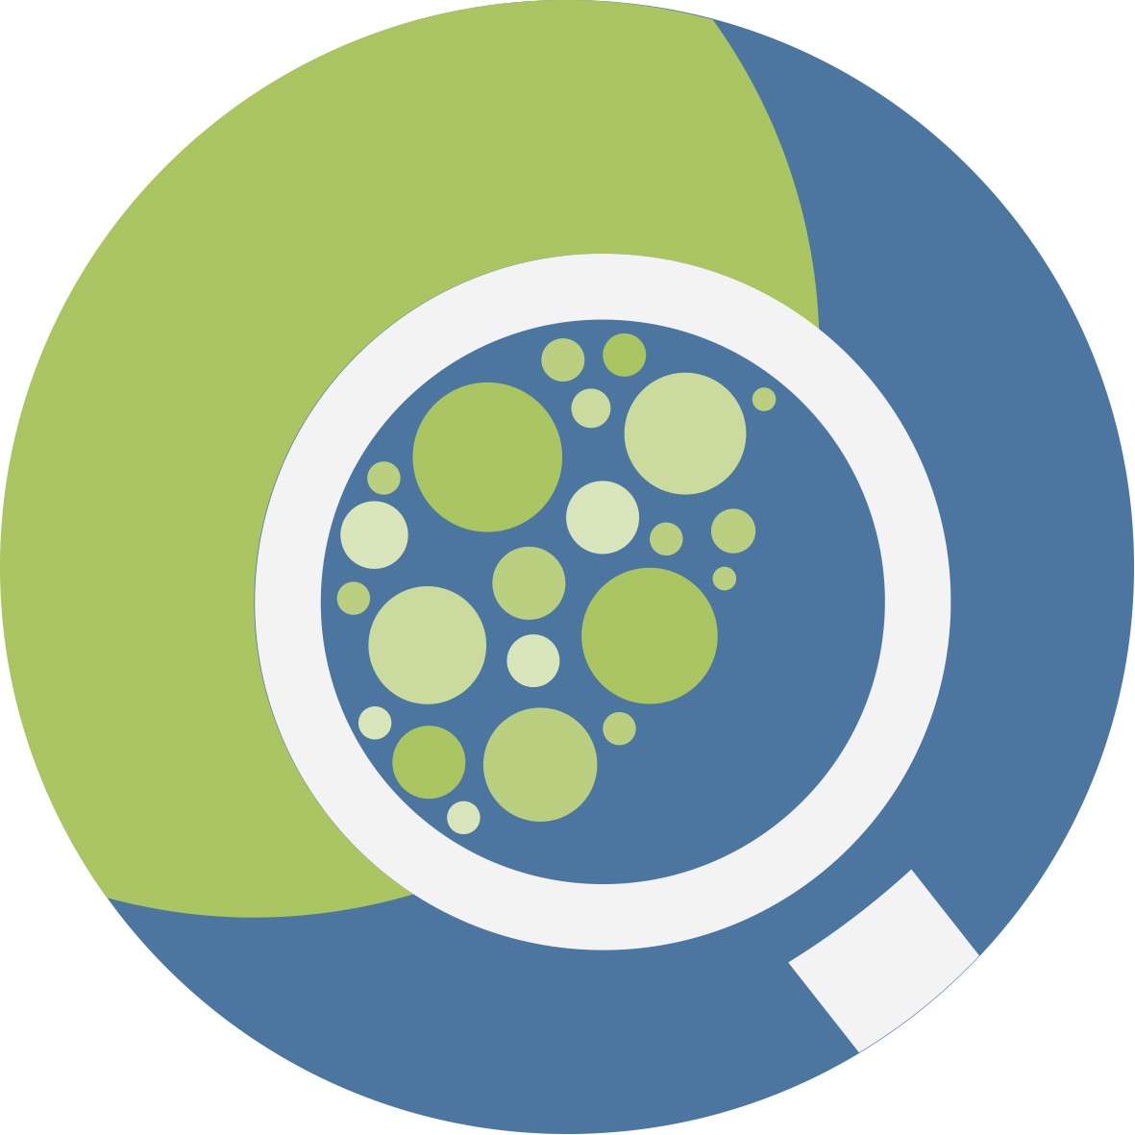 | Granularity
- Skip activity 2.1 and go directly to 2.2 in section 2.
- Select fewer examples in part 3, Activity 3
- Skip part 3, Activity 4

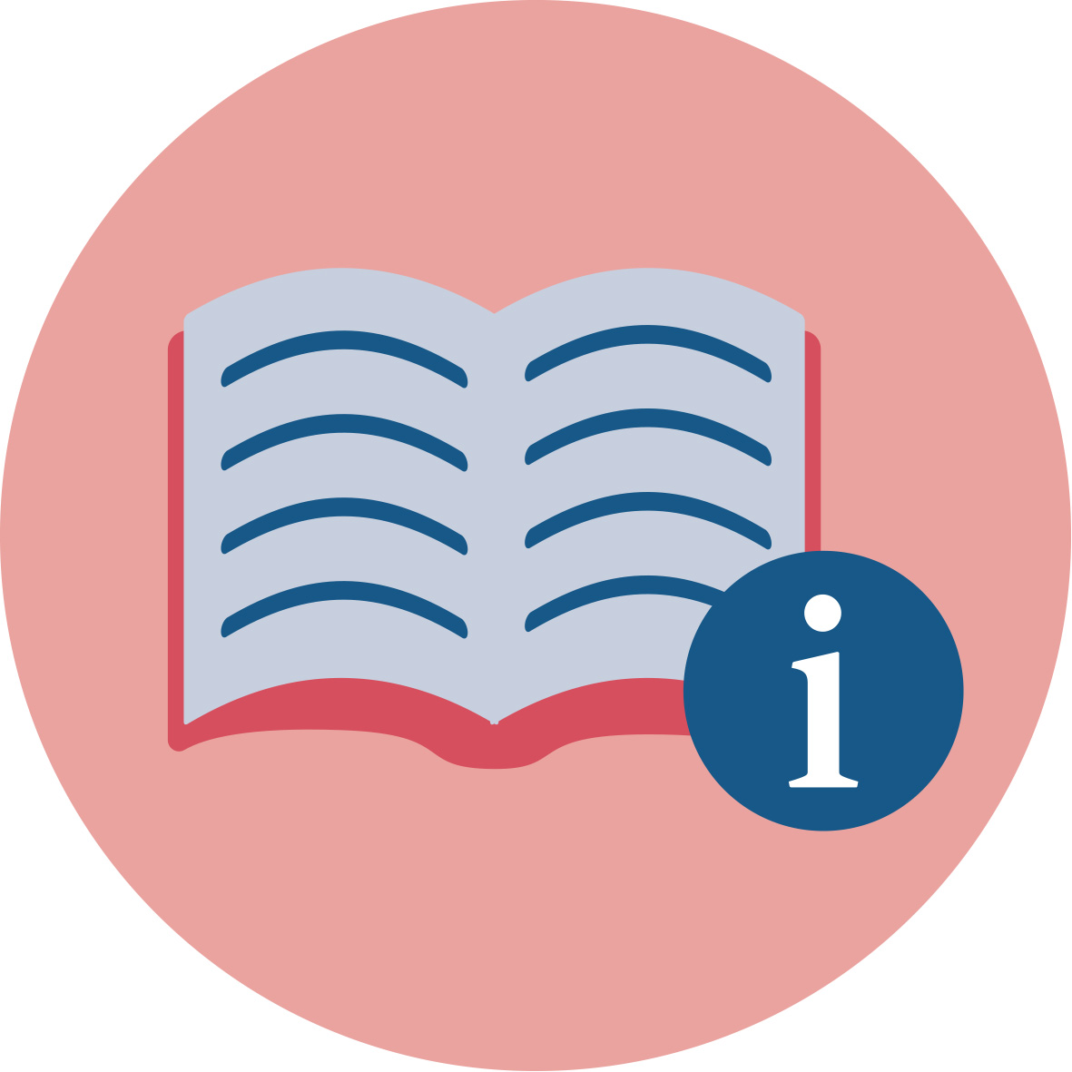 | References
Auernheimer, G. (2016). Einführung in die interkulturelle Pädagogik (8. Auflage.) Wiesbaden: Springer VS, pp. e.g. 19, 59.
Beg, Muhammad Abdul Jabbar: The Origins of Islamic Science. http://www.muslimheritage.com/article/origins-islamic-science (focus on the chapters 2.4 and 3.2)
Gifford, C., Gocsal, A., Rado, B., Gonçalves, S., & Wolodzko, E. (2007). Intercultural learning for European citizenship, p. 9.
Medin, Douglas, Lee, Carol D. & Bang, Megan (2014): Point of View Affects How Science Is Done https://www.scientificamerican.com/article/point-of-view-affects-how-science-is-done/
OECD (2010). Educating teachers for diversity: Meeting the challenge. Educational research and innovation. Paris: OECD, pp. 43 f.
Prengel, A. (2007). Diversity Education – Grundlagen und Probleme der Pädagogik der Vielfalt. In G. Krell, B. Riedmüller, B. Sieben, & D. Vinz (Hrsg.), Diversity Studies: Grundlagen und disziplinäre Ansätze. (49-68). Frankfurt: Campus.
Snively, Gloria & Corsiglia, John (2001). Discovering Indigenous Science: Implications for Science Education. Science Education, 85 (1), pp.6-34. (see below, Reading for activity 3.1 “Indigenous science”)
UNESCO. (2005). Guidelines for inclusion: Ensuring access to Education for All. Paris: UNESCO.
UNESCO. (2009). Policy Guidelines on Inclusion in Education. Paris: UNESCO.

Further readings
Ambrósio, U. d. (2006). Ethnomathematics: Link between traditions and modernity. Rotterdam: Sense Publ.
Ascher, M. (1998). Ethnomathematics: A multicultural view of mathematical ideas (1. CRC Press reprint). Boca Raton: Chapman & Hall/CRC.
Gerdes, P. (1997). Ethnomathematics and Mathematics education. In A. J. Bishop, K. Clements, C. Keitel, J. Kilpatrick, & C. Laborde (Eds.), Kluwer International Handbooks of Education: Vol. 4. International Handbook of Mathematics Education. Part 1 (pp. 909–943). Dordrecht: Springer.
Gonas, G., & Gürsoy, E. (2013). Schriftliche Rechenverfahren international. Retrieved from tps://www.uni-due.de/imperia/md/content/prodaz/schriftliche_rechenverfahren_international.pdf
Prediger, S., & Wessel, Lena, & Tschierschky, Kristine. (2012). Enabling teachers for analysing and fostering processes of second language learners: Design and research in a preservice teacher education course. Retrieved from http://www.mathematik.uni-dortmund.de/%7Eprediger/veroeff/12-Prediger_et_al_ICME-MuM_TeacherEd.pdf
Schröder, A., & Ritterfeld, U. (2014). Zur Bedeutung sprachlicher Barrieren im Mathematikunterricht der Primarstufe: Wissenschaftlicher Erkenntnisstand und Reflexion in der (Förder-)Schulpraxis. Retrieved from http://www.dgs-ev.de/fileadmin/bilder/Forschung_Sprache/Forschung_Sprache_3_Mai_2014.pdf

Assessment
The activities conducted throughout the whole module will be used as a basis for assessment in order to evaluate to what extent pre-service teachers have acquire:
- An awareness for the necessity of intercultural competences (Activity 1.1 and all other activities)
- Knowledge on definitions in relation to intercultural learning (Intercultural competence, Intercultural communication, Culture and Cultural identity, Diversity (Activities 2.1 – 2.3)
- Knowledge about the cultural situatedness of science and mathematics (Activity 3.1 and 3.2)
- An awareness about how this cultural situatedness impacts on mathematics and science education (Activity 3.1 and 3.2)
- Experience such challenges students from different cultural backgrounds might experience in science and mathematics teaching and reflect on ways to overcome them (Activity 3.3)
- Knowledge about different syllabus in different countries and reflect on ways to overcome them (Activity 3.4)

