Module 2 | CULTURE-RELATED CONTEXTS FOR MATHEMATICS AND SCIENCE

This module is based on the work within the project Intercultural learning in mathematics and science initial teacher education (IncluSMe). Coordination: Prof. Dr. Katja Maaß, International Centre for STEM Education (ICSE) at the University of Education Freiburg, Germany. Partners: University of Nicosia, Cyprus; University of Hradec Králové, Czech Republic; University of Jaen, Spain; National and Kapodistrian University of Athens, Greece; Vilnius University, Lithuania; University of Malta, Malta; Utrecht University, Netherlands; Norwegian University of Science and Technology, Norway; Jönköping University, Sweden; Constantine the Philosopher University, Slovakia.

The project Intercultural learning in mathematics and science initial teacher education (IncluSMe) has received co-funding by the Erasmus+ programme of the European Union under grant no. 2016-1-DE01-KA203-002910. Neither the European Union/European Commission nor the project's national funding agency DAAD are responsible for the content or liable for any losses or damage resulting of the use of these resources.

IncluSMe project (grant no. 2016-1-DE01-KA203-002910) 2016-2019, lead contributions by Boerée-Kamphorst, C., Jonker, V. & Wijers, M., Utrecht University, the Netherlands. CC-BY-NC-SA 4.0 license granted (find explicit terms of use at: https://creativecommons.org/licenses/by-nc-sa/4.0/deed.en)

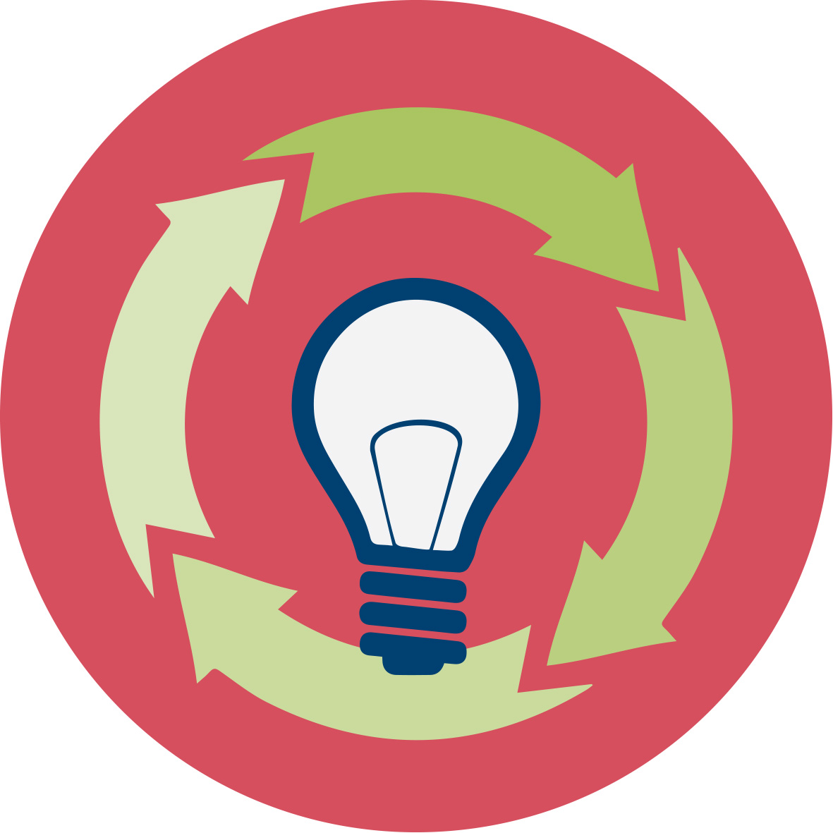 | General overview and aim
In this module student-teachers ITE (initial teacher education) at lower secondary level are introduced to the role and the use of culture-related contexts for the teaching and learning of mathematics and science.
Background
Students will perform better in science and mathematics when the central concepts are grounded in contexts that can be recognised from daily life – which is dependent on the cultural background of the students and the (prospective) teachers. To prepare future teachers for teaching in cultural diverse classrooms, acknowledging and appreciating the cultural background (including subcultures and personal cultural identities) of their students.
Aim
The aim of this module is twofold:
- To equip future teachers with the knowledge, skills, values and resources necessary to enhance science and mathematics learning in culturally diverse classrooms. We will have them involved in activities to learn to appreciate and respect the rich history and rich applications of science and mathematics. In order to do so we present them with 8 examples (based on a review of literature and a collection of good practices) of rich, diverse cultural contexts for learning science and mathematics.
- To promote an unprejudiced, open minded and appreciative attitude towards the use of mathematics and science in different cultures (including subcultures and personal cultures).

This module is part of:
- Mathematics and Science Subject dimension: (inter)cultural perspectives on the subjects themselves;

Relevant topics
In this module, the following topics will be addressed:
- Definitions of relevant terms like: culture, context, indigenous science etc.
- Theory and background on the use of contexts to enhance concept development for student in mathematics and science.
- Background on intercultural perspectives on mathematics and science, including ethno-mathematics and ethno-science.
- Connecting theory to educational practice in mathematics and science, by
  - studying specific examples
  - exploring sources of culture-related contexts
  - analysing textbooks and identifying examples and opportunities to use culture-related contexts
  - designing a lesson based on a culture-related context fitting the classroom situation and the ‘cultures’ of your students

Learning Outcomes

Through this module prospective teacher will be able to:

- Analyse the role of (diverse) cultural contexts for learning science and mathematics;
- Find and explore events in the history of mathematics and science that illustrate contributions from different cultures;
- Appreciate and respect the rich history and rich applications of science and mathematics;
- Experiment with and reflect on the use of tasks for mathematics and science teaching that are cast in contexts from different cultures;
- Refer to examples from different (sub)cultures (including personal identities) when trying to raise interest for mathematics and science in their (future) classrooms;
- Use pedagogical approaches which promote an unprejudiced, open minded and appreciative attitude towards the use of mathematics and science in different (sub)cultures (including personal culture) and allow reflection and own investigations into science and mathematics.

Flowchart and Module plan

This module involves four sections, all structured in several tasks and activities for 3 (+ 1 optional) face-to-face sessions (60-90 min.) and (optional) homework between sessions. It includes interactive presentations, group discussions, debates, small group design activities and student presentations. The structure is:

- Introduction and background (session 1):
- Introduction into the topic through the use of an exemplary culture-related context (30 min).
- Group introduction by forming cultural subgroups (30 min).
- Theoretical background on culture (30 min).

Homework (optional):
Find out at school:
  - how your STEM-colleagues and your students think and feel about 'culture' and 'contexts' in STEM-teaching.
  - To what cultural groups (some of) your students belong (according to themselves).

- Culture-related contexts (session 2):
- Discussing the roles of (culture-related) contexts by connecting an example to theory (15 min).
- Analysing examples (see worksheets) of culture-related contexts for mathematics and science education (45 min).
- Read background on sources and examples of culture-related contexts and write statement to discuss (15 min.)

Homework (optional):
Finish reading background texts and writing a statement for the debate
- Connecting to practice (session 3 and optional session 4):
- Analyze textbooks on the use of culture-related contexts (30 min).
- Design a lesson or teaching activity using a context related to culture (60 min).
- Optional: Presentation and discussion of the lessons (30-60 min).
Homework (optional):

Finish the design and (optional) try out the lesson/teaching activity.

I. Introduction and background (on culture related contexts for mathematics and science)

1.1. Warming up – an example
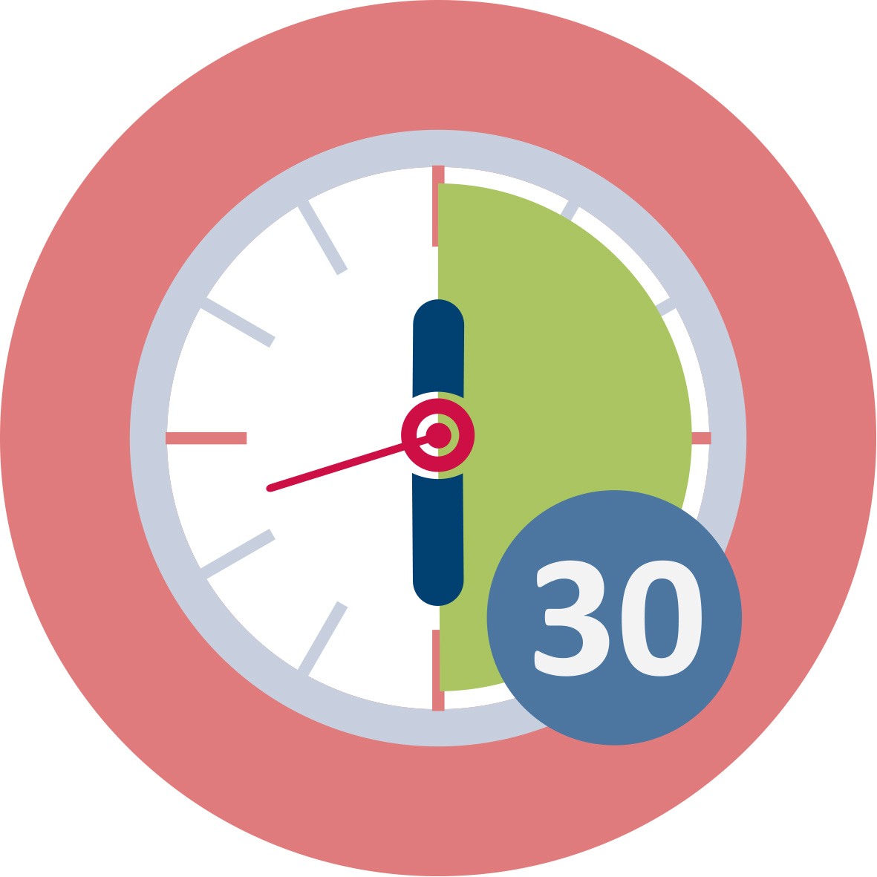Duration: 30 minutes
This is a “warming up” activity. The intention is to explore previous knowledge, experiences and beliefs about the use of culture-related contexts.
Introduce the example of building a school with bottles in Honduras briefly. This is an example of a context most European students and teachers will not be familiar with. This example is intended to make the pre-service teachers aware of different ways to think about of 'building' and about 'waste' and appreciate creative technological solutions to overcome problems. First ask participant to discuss the example in small groups using the questions on the worksheet (and in the ppt), next collect the outcomes in the whole group.
In this group discussion also ask the pre-service teachers about their own experience with using culture-related contexts in their teaching: how familiar are they with the use of contexts; what type of contexts do they use; do they know of contexts that relate to culture (including subcultures and personal cultures)? What do the mean when they use/hear 'culture'? What is their belief (and opinion) about the value of addressing culture-related aspects through the use of context?
You may also ask a more specific question to get the discussion started like: What is your favourite example of a context for your subject-teaching that is related to your personal culture?
Note: you may refer to the theoretical background (about culture) presented in module 1.
Note: definition and aspects of culture and contexts will be further explored in the next activities. So you may decide to keep the discussion brief.
This activity contributes to the achievement of the following learning outcomes:
- Investigate the role of (diverse) cultural contexts for learning science and mathematics
- Develop pedagogical approaches which promote an unprejudiced, open minded and appreciative attitude towards the use of mathematics and science in other cultures and allow reflection and own investigations into science and mathematics.

I. Introduction and background (on culture related contexts for mathematics and science)

1.2. Group introduction: cultural subgroups
Duration: 30 minutes
The intention of this assignment is to stimulate the pre-service teachers to get acquainted with each other and apply the notion of cultural diversity to their own group. Especially when the group composition is different from your normal practice, or new for this occasion, this activity is of special interest. It can alos be done in existing groups.
Give your group of pre-service teachers the following assignment:
“Divide the group into four small groups that are culturally different.”
Write down per subgroup:
- How you define your subgroup with respect to culture
- Who are members of this group and why
- Any limitations you experienced when forming the subgroup
Let the teacher-students discuss the cultural characteristics that define each of the groups and possible limitations they experienced. Is there anyone who thinks he/she should switch groups after hearing the characteristics and definitions of all four groups?
Let them debate in which group they would place you (the teacher educator) if they had to decide this.
In the next activity definitions of culture will be further explored.
Note: the groups can be based on anything, for example characteristics like: nationality, sports, subject they teach, favourite music/food/hobby etc.. The only limitation is that there have to be four groups.
A related activity you could also use instead of this example is the “giant steps” roleplay activity from module IO13.
This activity contributes to the achievement of the following learning outcomes:
- Refer to examples from different (sub)cultures (including personal cultural identities) when trying to raise interest for mathematics and science in their (future) classrooms;
- Develop pedagogical approaches which promote an unprejudiced, open minded and appreciative attitude towards the use of mathematics and science in other cultures and allow reflection and own investigations into science and mathematics.

I. Introduction and background (on culture related contexts for mathematics and science)

1.3. Theoretical background on culture
Duration: 30 minutes
In this activity the pre-service teachers deepen their knowledge of the theoretical background on the use, the benefits, characteristics and sources of culture-related contexts and they discuss their opinions (expressing their beliefs).
Text 1 is used to gain knowledge on what is meant by culture and how to define culture.
See worksheet for 1.3 for text 1 as well as for questions to discuss concerning the text. You may want to start with two questions for the whole group (see ppt). Next have pre-service teacher do the activity on the worksheet.
Pre-service teachers read the definition of culture presented by OECD and they reflect on what they perceive as their "personal cultural identity".
Come back to the two questions on the worksheet.
Homework (optional): Ask your pre-service teachers to find out at school:
- how their STEM-colleagues think and feel about 'culture' and 'contexts' in STEM-teaching.
- What the cultural groups of (some of their) students are. They may use the questions discussed in this activity and in activity 1.2.
This activity contributes to the achievement of the following learning outcomes:
- Refer to examples from different (sub)cultures (including personal cultural identities) when trying to raise interest for mathematics and science in their (future) classrooms.

II. Culture-related contexts

2.1. Roles of (culture-related) contexts-
Duration: 15 minutes

Homework (optional)
Briefly check the homework (10 min). Ask for one or two special findings (see ppt). The results of the conversations with colleagues and pupils will provide a reference when discussing examples, analysing textbooks and designing a lesson (in the next activities).

Discussing the roles of contexts
Use the example of building with bottles in Honduras discussed in the previous session, to remind your group of what we mean by culture-related contexts. Discuss what role this context has.
You are also encouraged to use another strong example of a culture-related contexts used in classroom practise (note: it should be applicable to all subjects represented in your group).
Have the students read the text (on worksheet 2.1) on the definition of the context-based approach and roles and characteristics of contexts. Have them discuss the value of using (culture-related) contexts by answering the questions on the worksheet (in pairs)
Discuss the answers briefly in the whole group.

II. Culture-related contexts

2.2. Examples of culture-related contexts
Duration: 45 minutes
On worksheet 2.2 there are eight examples of culture-related contexts (Note: these examples you can also find online at: http://www.fisme.science.uu.nl/toepassingen/28592/) . The task for the pre-service teachers is also on worksheet 2.2. You may want to discuss this task first in the whole group to make the purpose and the way of working clear (see ppt).
In this activity pre-service teachers are presented with eight contexts, that are culture-related in some sense. In small groups participants chose 2-4 of the examples to analyse and to reflect on the way each example may be used to address culture-related aspects. The focus of the analysis and discussion is on these five aspects:
- Relation to STEM-subject, -content or – concepts
- Possibilities for intercultural teaching/learning
- Connection to the ALL students’ interests and background (personal culture)
- Practical issues to deal with when using each context
- Culture-related reflection and personal appreciation of the context
Each small group prepares a poster about one of the examples to share their findings in the whole group. Organize a poster-session for all groups to see each other's work. Finally discuss the findings (see ppt).
For the discussion you may use as input what is written on the posters and you can use questions like:
- What did you learn: what was an eye-opener for you?
- Did this activity help you to become:
  - more aware of your own culture?
  - more respectful to the (personal) cultures of others?
  - more aware of cultural aspects related to mathematics and science?
- What would be the most important reason for you to use culture-related contexts? How does this reason relate to the theory (and your beliefs) about culture and contexts?
- What in your opinion are the 3 most important characteristics of a good culture-related contexts for your teaching?
Note: This last question prepares for the next activity.

Background information on the context-examples
We will briefly say something about each context here and suggest specific aspects to address in reflective questions. This is background information you may use when helping the small groups or in the discussion.
Example 1: Patterns
Main subject(s): mathematics, (biology)
Patterns are common in all cultures although they may have different characteristics. They can be studied for their mathematical (geometrical) structures and characteristics like types of symmetry, fractals, tessellations (filling the plane), geometrical shapes etc..
Some patterns may have a culture-related meaning for certain groups.
Example 2: Water
Main subject(s): biology, science (physics)
Water is a universal context and can be addressed from a lot of perspectives: access to clean water; risks of flooding; source of energy; uses of water; meaning of water; cost of water and spilling. See also module 5 about different (culture-related) perspectives to water.
Example 3: Building
Main subject(s): science, (mathematics)
Living in a house is a basic experience for everybody. The construction of houses, the use of materials, the sustainability will differ from region to region. You may connect this to students’ personal situation and the living situation of their ancestors.
Example 4: Food and Health
Main subject(s): biology
The fast growth of the world population of people is a growing concern for all countries. Who do we stay healthy? How do we produce enough food? Can the world feed us? What are eating habits and meals in different countries/cultures? You can relate this context to indigenous science about medical use of plants. Food (eating habits) is easy to relate to students’ personal cultural identitie(s).
Example 5: Pascal's Triangle
Main subject(s): mathematics
This is a more sophisticated example coming from the heart of mathematics. In much of the Western world, it is named after French mathematician Blaise Pascal, although other mathematicians studied it centuries before him in India, Persia (Iran), China, Germany, and Italy. By this example students can become aware of the non-western origins of mathematics and the cultural aspects connected to it (language, images, symbols),.
Example 6: Energy
Main subject(s): science
In 2007 the primary sources of energy consisted of petroleum 36.0%, coal 27.4%, natural gas 23.0%, amounting to an 86.4% share for fossil fuels in primary energy consumption in the world. Non-fossil sources in 2006 included nuclear 8.5%, hydroelectric 6.3%, and others (geothermal, solar, tidal, wind, wood, waste) amounting to 0.9%. At that time world energy consumption was growing about 2.3% per year. You may use this example to discuss how the production of energy impacts on peoples living conditions in different regions of the world.
Example 7: Navigation
Main subject(s): mathematics
In this example the main focus is on finding Mecca and the techniques that can be used for this purpose. Nowadays there are applications on the web and for smartphones. Like for instance: https://www.halaltrip.com/prayertimes/qibla-direction/. For Muslims Mecca is an important religious place. Other religions have important places (and orientation) well. See for example: https://en.wikipedia.org/wiki/Orientation_of_churches . This context can be used to be become more aware of other religions and cultures and the use and meaning of mathematics.
Example 8: Music and Musical instruments
Main subject(s): science, mathematics
Music is part of the tradition of every country. Music is strongly connected to personal culture and background. We like to listen to music (melody, theme, repetition), and a lot of people learn to play an instrument. The making of an (easy) instrument can be an interesting problem-solving activity involving science (physics) and mathematics. This context can be used to connect to students’ (persona) culture(s).
This part contributes to the achievement of the following learning outcomes:
- Investigate the role of (diverse) cultural contexts for learning science and mathematics
- Investigate the role of (diverse) cultural contexts for learning science and mathematics
- Explore some events in the history of mathematics and science that illustrate contributions from different cultures;
- Learn to appreciate and respect the rich history and rich applications of science and mathematics

II. Culture-related contexts
Activity 2.3. Back to the theoretical background
or | Duration: 30 minutes
This assignment is a further exploration of theoretical background followed by a whole-group discussion/debate on statements formulate by the pre-service teachers.

Texts on the following topics are used (see sources on worksheet 2.3):
- Contributions from indigenous science
- White teachers in Urban classrooms
- Concepts and contexts in engineering and technology
- The history of mathematics
- Multicultural mathematics
Note: You can find the worksheet with the five texts in English also on the web here: http://www.fisme.science.uu.nl/toepassingen/28593/
Distribute the texts among small groups of pre-service teachers and assign each group to read and discuss 1 or 2 of these texts. Ask them to formulate a statement based on the texts (relating to contexts and/or culture), to debate in the whole group in the next session.
Let the participants hand in a slide (ppt) with their statement at the end of this session or have them send it in by email before the next session. In this way you may select the most interesting or strongest statements to debate.
Also ask them to bring their textbooks to the next session.
This activity contributes to the achievement of the following learning outcomes:
- Investigate the role of (diverse) cultural contexts for learning science and mathematics
- Explore some events in the history of mathematics and science that illustrate contributions from different cultures;
- Learn to appreciate and respect the rich history and rich applications of science and mathematics

III. Connecting to practice
Activity 3.1. Debate on statements
Duration: 30
Have each group present their statement (from activity 2.3) in max. 1 minute. Next all participants choose to agree or disagree (you can use cards in 2 colours or have everybody move to a side of the room). Ask some of them to clarify their choice.
At the end wrap up the debate by asking participants to reflect on how their knowledge and appreciation of culture-related contexts have developed.
This activity contributes to the achievement of the following learning outcomes:
- Learn to appreciate and respect the rich history and rich applications of science and mathematics
- Develop pedagogical approaches which promote an unprejudiced, open minded and appreciative attitude towards the use of mathematics and science in other cultures and allow reflection and own investigations into science and mathematics.

III. Connecting to practice
Activity 3.2. Analyse textbooks and design a lesson
or optional | Duration: 60 minutes
The aim of this activity is to have pre-service teachers (individually or in small groups) design their own lesson/activity, using a culture-related context or addressing a context from an intercultural perspective or connecting to students’ cultural identities.
Working in single-subject groups participants first analyse their textbooks for the occurrence of culture-related contexts (part A on worksheet ##). Most likely not many of these contexts will be found. In that case participants explore possibilities to include such contexts for a specific topic: where would it fit?
They may use the examples they studied in the previous activities for inspiration and try to fit these in; they could also explore some of the sources addressed in previous session sessions to find appropriate contexts.
Next participants design the lesson/teaching activity (part B on the worksheet). Pre-service teachers should prepare a lesson-plan and the teaching materials. Also ask them to make clear how they addressed the cultural aspects in their design.
Note: If the time is too short to finish the design-process during the session, make this into homework (see worksheet).
At the end of this session have all student groups present, in a short 1-minute pitch, their plans for the lesson/activity.
Finishing this design and preparing a brief presentation (of 5 minutes) is the homework to be done before the last (optional) session of presentations. If possible, you can ask the pre-service teachers to try out (parts of) this lesson in class. Have them fill in the assessment evaluation form (see worksheet)
This activity contributes to the achievement of the following learning outcomes:
- Investigate the role of (diverse) cultural contexts for learning science and mathematics
- Develop pedagogical approaches which promote an unprejudiced, open minded and appreciative attitude towards the use of mathematics and science in other cultures and allow reflection and own investigations into science and mathematics.

III. Connecting to practice
Activity 3.3. Presentation of lessons designed by students
 | 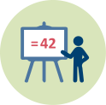 | - Duration: 30-60 minutes
Have participants present their lesson/teaching activity and experiences (see previous activity and worksheet). They should focus on:
- WHY they choose this specific context, also in relation to the content of the activity/lesson;
- HOW they address cultural aspects and connect to their students (personal) culture(s) especially in a diverse classroom;
- WHAT they learned from the try-out with students.
Have the pre-service teachers give each other feedback in the form of tips and tops.
At the end have a whole group evaluation on the learning outcomes of this module (see ppt).
This activity contributes to the achievement of the following learning outcomes:
- Investigate the role of (diverse) cultural contexts for learning science and mathematics
- Develop pedagogical approaches which promote an unprejudiced, open minded and appreciative attitude towards the use of mathematics and science in other cultures and allow reflection and own investigations into science and mathematics.

 | Materials and resources
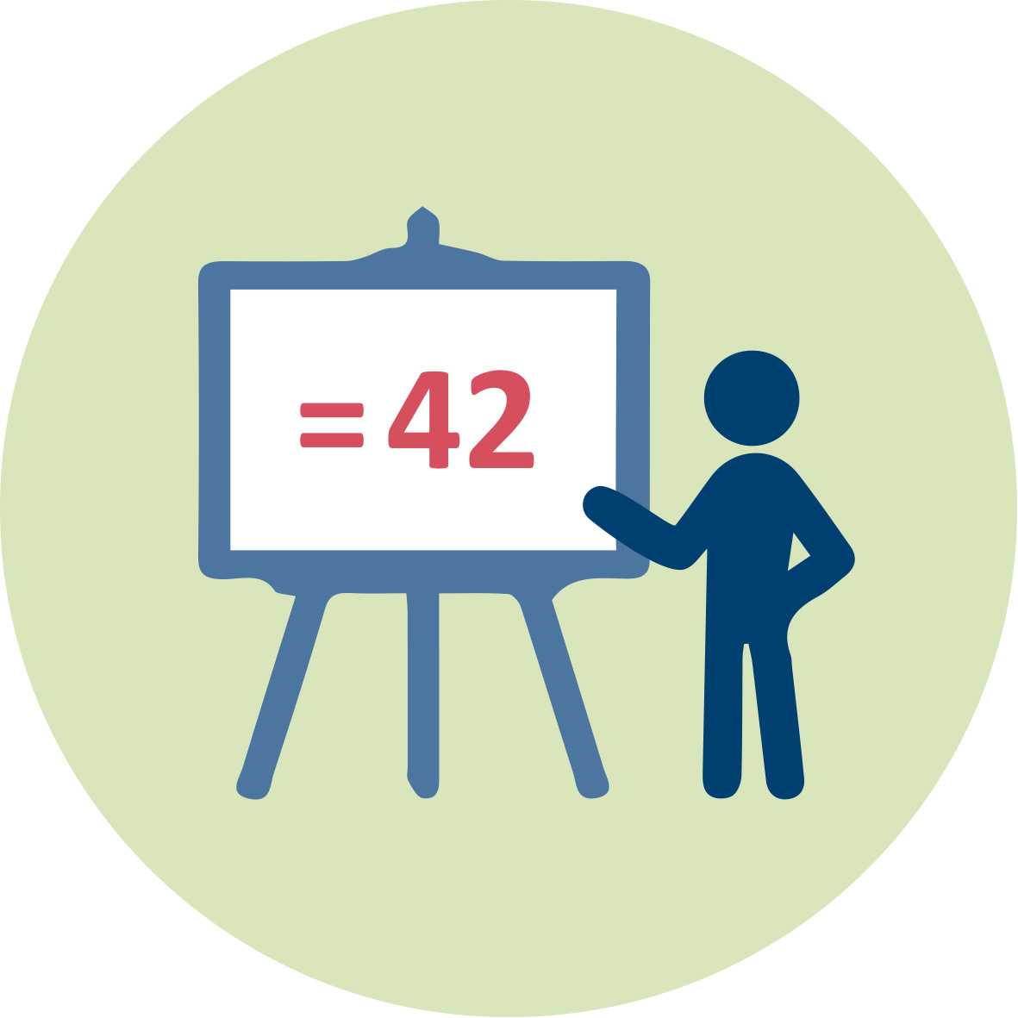 | Presentation (pptx). Teacher Educator. Includes sheets for all sessions.
Worksheets: Include all activities and links to websites and youtube videos for this module.

Textbooks: brought by pre-service teachers (or the teacher educator)
 | Access to computers for internet research, accessing some of the resources with worksheets and collaborative work.

Granularity
If fewer time is available
- Skip Activity 1.2
- Select fewer examples in Activity 2.2
- Skip activity 3.3 (session 4): Instead of presentations by pre-service teachers have them hand in the lesson/activity they designed as well as the assessment evaluation form.
If more time is available
- Have groups give each other peer-feedback in activity 3.3 during the design process
- Have an extra session for presentations of the teaching activities

References
Goldenberg, B.M., (2013) Embracing Non-White Students’ Cultural Capital For Better Teaching and Learning, Urban Education, vol. 49, 1: pp. 111-144.

Rossouw, A., Hacker, M., & de Vries, M. J. (2011). Concepts and contexts in engineering and technology education. International Journal of Technology & Design Education, 21, 409-424

Smits, de, L.G.A. (2012). Science teachers designing context-based curriculum materials: developing context-based teaching competence. Eindhoven:

Snively, G. and Corsiglia, J. (2001), Discovering indigenous science: Implications for science education. Sci. Ed., 85: 6–34.

Strutchens, M. (1995). Multicultural Mathematics: A More Inclusive Mathematics. ERIC Digest. ED380295

Further readings
Banks, J. A. (1993). Multicultural Education: Historical Development, Dimensions, and Practice. Review of Research in Education, 19(1993), 3-49. http://www.jstor.org/stable/1167339
Multicultural education is conceptualized in this review as a field that consists of the five dimensions formulated by Banks (1991a, 1992. These are (a) content integration, (b) the knowledge construction process, (c) prejudice reduction, (d) an equity pedagogy, and (e) an empowering school culture and social structure

Koski, M. I., Klapwijk, R. M., & de Vries, M. J. (2011). Connecting Domains in Concept-Context Learning: A Model to Analyse Education Situations. Journal of Design & Technology Education, 16(3), 50-61.
This article introduces a three-domain model for concept-context learning that supports both the design process as well as the idea of concept learning. The model shows how practical and abstract knowledge should be combined to improve context-concept learning.

Rivet, A. & Krajcik, J. (2008). Contextualizing instruction: Leveraging students’ prior knowledge and experiences to foster understanding of middle school science. Journal of Research in Science Teaching, 45(1), 79-100.
Contextualizing science instruction involves utilizing students’ prior knowledge and
everyday experiences as a catalyst for understanding challenging science concepts. This study of two middle school science classrooms examined how students utilized the contextualizing aspects of project-based instruction and its relationship to their science learning.

Assessment
Assessment for this module can be connected to the design and presentation of the lesson/teaching-activity.
Apart from the presentation you can have students hand in the evaluation form about the design and try-out of their lesson. See worksheet.
You can use this to assess to what extend pre-service teachers understood and used different aspects of culture-related contexts and were able to connect to their students (personal) cultural identities.

