Module 3 | DIFFERENT CULTURES – DIFFERENT APPROACHES TO  REASONING AND ALGORITHMS IN MATHEMATICS

This Module outline is based on the work within the project Intercultural learning in mathematics and science initial teacher education (IncluSMe). Coordination: Prof. Dr. Katja Maaß, International Centre for STEM Education (ICSE) at the University of Education Freiburg, Germany. Partners: University of Nicosia, Cyprus; University of Hradec Králové, Czech Republic; University of Jaen, Spain; National and Kapodistrian University of Athens, Greece; Vilnius University, Lithuania; University of Malta, Malta; Utrecht University, Netherlands; Norwegian University of Science and Technology, Norway; Jönköping University, Sweden; Constantine the Philosopher University, Slovakia.

The project Intercultural learning in mathematics and science initial teacher education (IncluSMe) has received co-funding by the Erasmus+ programme of the European Union under grant no. 2016-1-DE01-KA203-002910. Neither the European Union/European Commission nor the project's national funding agency DAAD are responsible for the content or liable for any losses or damage resulting of the use of these resources.

IncluSMe project (grant no. 2016-1-DE01-KA203-002910) 2016-2019, lead contributions by Vilnius University, Lithuania.
CC-BY-NC-SA 4.0 license granted (find explicit terms of use at: https://creativecommons.org/licenses/by-nc-sa/4.0/deed.en)

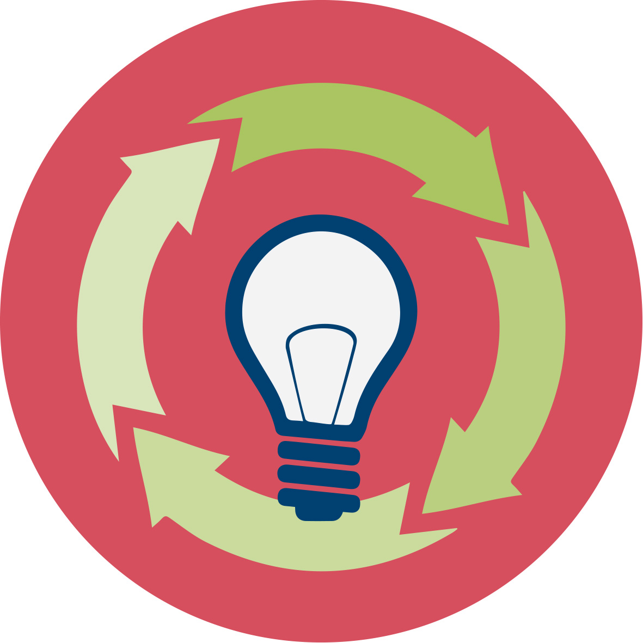 | General overview and aim
In this module, pre-service teachers are introduced to intercultural learning in mathematics using different definitions. For teacher educators, we offer a short and extended version of the training module. Teacher educator can take part of activities that are most suitable for students.
Background
For preparation future teachers, it is important to pay attention on students’ different background and experience, their cultural aspects should be appreciated. Students may perform better in mathematics when the key concepts are grounded in contexts especially recognisable from students’ daily life.
Aim
The aim of this module is:
- Introduction into the topic ‘reasoning and algorithms in mathematics’
- Theory and background is based on:
  - the role of contexts in reasoning and algorithms in mathematics, understanding ethnomathematics
  - reasoning and algorithms in mathematics by Seymour Papert
- Connecting theory to educational practice in reasoning and algorithms in mathematics
  - studying specific examples including practical activities
  - problem solving: algorithms
  - building knowledge by using constructionism method

This module is part of:

Personal dimension: values, attitudes and intercultural competences of prospective teachers;

Mathematics and Science Subject dimension: (inter)cultural perspectives on the subjects themselves;

Mathematics and Science Education dimension: pedagogical issues, in particular in respect to dealing with diversity in classrooms.

Relevant topics
- Theory and background on the use and benefits of contexts to enhance concept development for student in different approaches for reasoning and algorithms in mathematics.
- Background on Intercultural perspectives on reasoning and algorithms in mathematics, including ethno-mathematics.
- Connecting theory to educational practice in reasoning and algorithms in mathematics, by
  - discussing different texts about mathematical reasoning;
  - studying specific examples;
  - exploring sources of culture-related contexts;
  - problem solving using different approaches of reasoning and algorithms;
  - analysing textbooks and identifying examples and opportunities to use culture-related contexts;
  - building knowledge using constructionist approach.

Learning Outcomes

Through this module prospective teacher will:

- Investigate the understanding different approaches of reasoning and algorithms in mathematics;
- Explore different approaches of reasoning and algorithms in mathematics that illustrate contributions from different cultures;
- Learn to appreciate and respect the rich applications of mathematics and algorithms contributed by different cultures;
- Experiment with and reflect on the use of tasks and different approaches of reasoning and algorithms in mathematics;
- Develop skills to refer to examples from various approaches and different cultures when trying to raise interest for mathematics and algorithms in their future classrooms;
- Support of the view that practicing different algorithms we develop a deeper understanding;
- Invoke computers and other technologies to support problem solving using different approaches for reasoning and algorithms in mathematics;
- Develop pedagogical approaches which promote an open minded and appreciative attitude towards the use of different approaches in reasoning and algorithms in mathematics and allow cultural variety.

Flowchart and Module plan

This module involves four sections, all structured in several tasks and activities. It consists 4 face-to-face 60 to 90 minutes sessions and some homework. It includes interactive presentations, group discussions, debates, small group designs activities, and student presentations. The structure is:
Session 1:
- Introduction into the topic: 30 min
- Theoretical background: 60 min
Homework:
- Ask your students to find media about cultural understanding, reasoning and algorithms in learning and teaching mathematics. Note: students can search for articles in their own language or language they can read (not only from the given list in English). Ask each student to present findings and organize discussion.
- Write down the examples of media, which were favorite for you.
Session 2:
- Studying practical reasoning example: the Juggling (see worksheets) of culture-related context for mathematics education with focus on different approaches (60 min)
- Analysing steps of reasoning and focus on improving reasoning (30 min)
Homework:
- Learn juggling in your own way.
Session 2E (extra):h
- Reading and discussion about basic ideas of Logo (30 min).
- Practice in drawing geometric shapes by using Scratch (at computer lab 60 min)
Session 3:
- Algorithm problem solving and reasoning (60 min).
- Constructionism: a method for building your own knowledge (30 min).

I. Introduction: Definitions and understanding
1.1: Definitions: reasoning and algorithms in mathematics
 |  | 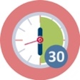 | Duration: 30 minutes
This activity involves students to discussion about cultural diversity, different reasoning approaches and algorithms.
Students have previous knowledge (Module 2) and are able to analyse examples.
Before this lecture, students should be asked to make the homework (Worksheet: Activity 1.1).
Homework (Worksheet: Activity 1.1).
- Find and view video (2-3) about cultural understanding, reasoning and algorithms in learning and teaching mathematics. This is the example of video on YouTube: https://www.youtube.com/watch?v=XUO59Emi3eo
- Give examples of video, which were favorite for you.

Video examples
(Provide the link of media and short description)

Students are asked to discuss about their findings in groups and fill the following table: Analyze social media (Worksheet: Activity 1.1).
Analyze social media
- Provide the description of the following definitions according viewed video (fill the table).

Cultural understanding | Ethnomathematics | Reasoning | Algorithms
(Describe the meaning/definition) | (Describe the meaning / definition) | (Describe the meaning / definition) | (Describe the meaning / definition)

In this session, the teacher educator presents some theoretical background about cultural diversity, ethnomathematics, reasoning and algorithmic thinking in mathematics. Due to that, firstly students are asked to work in groups including the following tasks:
- Discuss about the viewed video. Share ideas about favorite video.
- Compare tables.
- Reflect on discussion and tables focusing on the following aspects:
  - Do you see any differences?
  - What is common?
  - What are the main features of ethnomathematics, reasoning and algorithmic thinking in mathematics? Why do think so?
- Do you find the same favorite media as you friend?

Teacher educator summarizes group work.

The aim is to compare how student understand the reasoning in different culture, provide examples of different reasoning approach and understanding.

Teacher educator introduce theory related with cultural understanding, ethnomathematics, different reasoning approaches, and algorithms in mathematics.

Some remarks.
- Ethnomathematics is:
  - described as a branch of mathematics acknowledging the fundamental differences in mathematics content, mathematics understanding, and mathematics application that links culture and mathematics. (D‘Ambrosio, 1985)
  - the art or technique of explaining, knowing and understanding diverse culturally related learning styles which is found to develop the learners in mathematics. (Gerdes, 1996)
  - as subject that replace academic mathematics in the curriculum according to pedagogical philosophies, involved in the mathematics curriculum, and reviewed preparing learning situation due to diversity of cultural systems. (Rosa, Orey, 2011)
  - a program that includes relevance and builds knowledge around the local interests, needs, and culture of students. (Rosa, Orey, 2011)

Different ethnomathematics definition is discussed by Cimen (2014).
- Various teaching methods help:
  - Develop students‘ critical thinking and analysis
  - Apply mathematical skills in all areas of life
  - Provide an effective environment for developing skills to solve real-word problems
  - Achieve better results, know more about reality, culture, society
  - Engage students in the process of learning mathematics in an active fun environment. (Rosa, Orey, 2011, Rowlands, S., Carson R, 2002)

The insights about the concept “ethnomathematics’ from three perspectives: the epistemological, the political, and the educational are provided by Francois et al. (2015).

Recommended sources for deeper theory understanding:

- Cimen, O.A (2014): Discussing ethnomathematics: Is mathematics culturally dependent?, https://core.ac.uk/download/pdf/82577821.pdf
- Francois, K ; Monteiro, C; Carvalho, L; Vandendriessche, E (2015) Politics of Ethnomathematics: An Epistemological, Political, and Educational Perspective. Proceedings of the Eighth International Mathematics Education and Society Conference, Vols 1-3, Book Series: Mathematics Education and Society. Pages: 492-504
- Gerdes, P. Chapter 24: Ethnomathematics and Mathematics Education. In A. Bishop et al. (eds) International Handbook of Mathematics Education, Kluwer, pp. 909-943, http://link.springer.com/chapter/10.1007/978-94-009-1465-0_25#page-1
- Kyselka, W. (1987). An ocean in mind. Honolulu, HI: University of Hawai‘i Press. Lipka, J., Hogan, M., Webster, J., Yanez, E., Adams, B., Clark, S., & Lacy, D. (2005). Math in a cultural context: Two case studies of a successful culturally based math project. Anthropology & Education Quarterly, 36(4), 367–385.
- Presmeg, N. C. (1998) Ethnomathematics in Teacher Education in Mathematics Teacher Education 1(3), 317-339.
- Rowlands, S., Carson R. (2002). Where would formal, academic mathematics stand in a curriculum informed by ethnomathematics? A critical review of ethnomathematics in Educational Studies in Mathematics.Vol.50, No.1, pp.79-102, https://link.springer.com/article/10.1023/A:1020532926983
- Rosa, M., D’Ambrosio, U., Orey, D., Shirley, L., Alangui, W., Palhares, P., & Gavarrete, M. (2016). ICME-13 topical surveys: Current and future perspectives in ethnomathematics. New York, NY: Springer
- Rosa, M., Orey, D. C. (2011). Ethnomathematics: the cultural aspects of mathematics. Revista Latinoamericana de Etnomatemática, 4(2). 32-54
http://funes.uniandes.edu.co/3079/1/Rosa2011Ethnomathematics.pdf
- U. d’Ambrossio. Ethnomathematics and Its Place in the History and Pedagogy of Mathematics. For the Learning of Mathematics, Vol. 5, No. 1 (Feb., 1985), pp. 44-48, http://www.jstor.org/stable/40247876?seq=1#fndtn-page_thumbnails_tab_contents
This part contributes to the achievement of the following learning outcomes:
- Investigate the understanding (diverse) different approaches of reasoning and algorithms in mathematics;
- Explore different approaches of reasoning and algorithms in mathematics that illustrate contributions from different cultures and different people.

I. Introduction: Theoretical background.
1.2. Different reasoning approaches. Based on Seymour Papert’s ideas.
 |  | 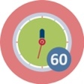 | Duration: 60 minutes
In this session, the teacher educator presents some theoretical background on the use, the benefits, characteristics and sources of culture-related contexts. Special attention should be paid on different approaches for reasoning and algorithms in mathematics based on Seymour Papert’s ideas. Participants will read and discuss texts and statements from S. Papert’s book “Mindstorms…” [see worksheet: Activity 1.2].
Students are asked to find information about Seymour Papert in the internet. Students are introduced to the book: S. Papert. MINDSTORM: Children, Computers, and Powerful Ideas, 1980 (available in many languages).
This book should be studied by each mathematics teacher: it gives view to mathematical culture and perspective how to make mathematics sttractive to every child.
Students should study following examples of tasks and share their ideas within group (worksheet: examples 1.2.1 and 1.2.2).
Example 1.2.1. Students need to explain and connect the following words.
Teacher can help them by adding more detailed information or suggestions.

Papert  Piaget  Turtle  Logo  Cognitive model  Microworlds  Mathophobia | Assimilation  Learning without being taught  Programming language  Accommodation  Mindstorm  Geometry  Children, Computers, Powerful Ideas  Constructionism  Incubators for powerful ideas  Constructivism  Concrete thinking  Formal thinking  The fear of Learning

Example 1.2.2. Read the texts 1 to 5 (S. Papert. MINDSTORM: Children, Computers, and Powerful Ideas, 1980).
Ask students to extract main ideas of each text and discuss in small groups.
Evaluate this in a whole group discussion, using questions like:
  - What would be the most important reason for you to use culture-related contexts?
  - What are in your opinion the most important characteristics of good approach of reasoning?
  - Do you have a favourite example of approach for reasoning or algorithm in mathematics that you are using personally? What is it? In what way does it relate to your culture?
Ask students to read the following “Text 6” and apply algorithm in practice.
Are they comfortable with this algorithm? What adaptations they would like to make?

TEXT 6
Difficulties experienced by children are not usually due to deficiencies in their notion of number but in failing to appropriate the relevant algorithms. Learning algorithms can be seen as a process of making, using, and fixing programs. When one adds multidigit numbers one is in fact acting as a computer in carrying through a procedure something like the program in Figure 18.

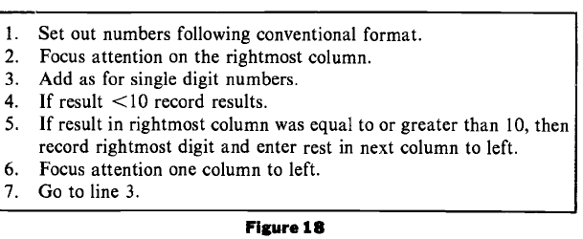
[p. 152]

Text analysis provides a deeper understanding and encourage students to share ideas. At the end of lecture, teacher educator can provide several examples, such as:
- In Austrian schools, arithmetic operations are performed quite in other methods than in Lithuania. For example, multiplication is performed not from left to right, as in Lithuania, but from right to left. Devision is also performed in a complicated way: All the intermediate operations of multiplication and subraction are performed mentally. In Australia the multiplication operation is performed in the same way as in Lithuania, only it is written in another form. (Dagiene, V., Zilinskiene, I. Localization of Learning Objects in Mathematics. In: 10th Int. Conference: Models in Developing Mathematics Education, September 11–17, 2009, Dresden, Germany, 129–133)

- Multiplication algorithms:
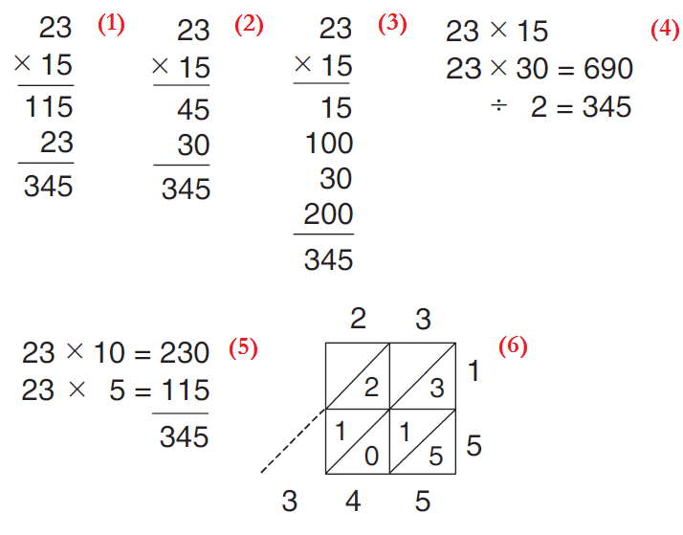

- Video source on YouTube: https://www.youtube.com/watch?v=tEMorktaLgU&list=PLRG4iHU5uhLCSlkX1N74K-vrr7ImSrDZj&index=1 (different calculation methods). Video author is Anna Ida Säfström.
This activity contributes to the achievement of the following learning outcomes:
- Explore different approaches of reasoning and algorithms in mathematics that illustrate contributions from different cultures and different people;
- Learn to appreciate and respect the rich applications of mathematics and algorithms;
- Develop pedagogical approaches which promote an open minded and appreciative attitude towards the use of different approaches in reasoning and algorithms in mathematics and allow cultural variety.

II. Culture related context: Practical reasoning example.
2.1. Juggling
Duration: 60 minutes
Starter. See the video on YouTube: https://youtu.be/kCt1bmSASCI

Ask students to discuss about the video.

In this activity participants will focus on the practical exercise of learning juggling, that is culture-related task.

Group discussion.
- Discuss the method used to juggle and its difficulties.
- Try to draw/present steps of juggling on the sheet of paper. Compare your steps with the friend’s steps.
In small groups participants read texts, analyse and discuss (worksheet: Activity 2.1).
Read the text from S. Papert “Mindstorm” (p. 105-112) and practice by using pieces of light material (it is easier then using balls).

Ask students to discuss: Are they succeed? What have they noticed?
Ask students to discuss if they have noticed different algorithms of juggling. Think, is it cultural depending. Discuss E. Papert’s insights and theory.

Point participants to the homework – learn juggling in their own way. [See worksheet: Activity 2.1]
This activity contributes to the achievement of the following learning outcomes:
- Learn to appreciate and respect the practical applications of mathematics and algorithms;
- Experiment with and reflect on the use of tasks and different approaches of reasoning and algorithms in mathematics.

II. Culture related context: Steps of reasoning.
2.2. A string around the circumference of the earth
Duration: 30 minutes
The aim of this activity is to have participants (individually or in small groups) start solving a presented task on a string around the circumference of the earth. Students can use different approaches to reasoning.
Ask students to solve the task at first by themselves. The following text of task can be shown by projector or delivered on a piece of paper.
“Imagine a string around the circumference of the earth, which for this purpose we shall consider to be a perfectly smooth sphere, four thousand miles in radius. Someone makes a proposal to place the string on six-foot-high poles. Obviously this implies that the string will have to be longer. A discussion arises about how much longer it would have to be. Most people who have been through high school know how to calculate the answer. But before doing so or reading on try to guess" Is it about one thousand miles longer, about a hundred, or about ten?”
Source: S. Papert (1980). MINDSTORM: Children, Computers, and Powerful Ideas. p.146.
Then read the S. Papert’s text and discuss:
S. Papert (1980). MINDSTORM: Children, Computers, and Powerful Ideas. pp.146-149 (worksheet: activity: 2.2)
Working in single-subject groups participants analyse the text and ways of reasoning.
This activity contributes to the achievement of the following learning outcomes:
- Experiment and reflect on the use of tasks and different approaches of reasoning and algorithms in mathematics;
- Develop skills to refer to examples from various approaches and different cultures when trying to raise interest for mathematics and algorithms in their future classrooms;
- Support of the view that practicing different algorithms we develop a deeper understanding.

II E (Extra). Culture related context: Reading and discussion about basic ideas of Logo
2.3. Logo-based ideas
Duration: 60 + 30 min
This is an extended activity in a computer lab. Scratch or similar Logo-based software is needed. Teacher educator can choose to use it or not. Using Scratch students are able to work in the multilanguage environment (in his/her origin language).
More about Scratch: https://scratch.mit.edu/

Work in computer lab

Use Scratch to practice the drawing of triangle and other shapes. Repeat the same things in the other program. Discuss in groups: what have you noticed?

Students should draw geometric shapes using a Turtle graphics:
- a square
- a rectangle
- a triangle
Then students should discuss their reasoning in small groups.

Ask students to read piece of text from the Papert’s book (worksheet: activity 2.3).

S. Papert (1980). MINDSTORM: Children, Computers, and Powerful Ideas. pp.75-76.

Discuss about S. Papert’s powerful idea of teaching mathematics using Logo.

Questions to think about and discuss in small groups:

- What is the same in the square and the rectangle?
- What is the same in the square and the triangle?
- Explain the Polya's precept, "find similarities”.
- Explain the Total Turtle Trip Theorem and its applications.
- Why the Total Turtle Trip Theorem is personnal?

The proposition of "The Total Turtle Trip Theorem is the following:
If a Turtle takes a trip around the boundary of any area and ends up in the state in which it started, then the sum of all turns will be 360 degrees.

See the video on YouTube: https://youtu.be/4qP09gofv6U Demonstration provides understanding how different calculation approaches give the same answer and different figures.

This activity contributes to the achievement of the following learning outcomes:
- Support of the view that practicing different algorithms we develop a deeper understanding;
- Invoke computers and other technologies to support problem solving using different approaches for reasoning and algorithms in mathematics;
- Develop pedagogical approaches which promote an open minded and appreciative attitude towards the use of different approaches in reasoning and algorithms in mathematics and allow cultural variety.

III. Problem solving and reasoning: Algorithms.
3.1. Solving set of algorithm tasks.
Duration: 60 minutes
- Algorithms are as steps to solve problems which are universal, and not universal across cultural and nations.
- Algorithms based on rules or procedures for solving a mathematical problem.
- When solving tasks students should:

  - Accommodate different learning styles.
  - Demonstrate that there is more than just one way to solve a problem.
  - Think about transferable skills in multicultural context.

We recommend read the article for teacher educator (or similar articles about algorithms in multicultural context):

Philipp, R. A. (1996). Multicultural mathematics and alternative algorithms: Using knowledge from many cultures. Teaching Children Mathematics, 3(3), 128-135.

In this article algorithm is defined as process by which we compute or a convention used to computing. By solving mathematical problem student have to get elementary knowledge about mathematics methods and challenge the belief that this algorithms work. Author noticed steps which describe the need of algorithms variety:

- Development of an appreciation for the fact that various cultures have developed alternative algorithms to those commonly used in the US,
- Reinforcement of view that algorithms that we use are simply matter of convention and should be seen as a way, not the way, to compute,
- Support of the view that practicing different algorithms we develop a deeper understanding.
Author suggest for teachers to collect information about algorithms that are used by students in community. Identification of algorithms and description why the algorithm works let students to rethink mathematical ideas.
Author gives examples of algorithms (add, subtract, multiply, divide) invented by a third-grade child and described by people from various cultures.

Students should solve given tasks and fill a table (Worksheet: Activity 3.1).

Compare solutions in groups. Discuss following aspects:

- An explanation of the solution of the particular task.
- Do you noticed differences, similarities on your and friend solution?
- What methods were used to get correct answer?
- Have you noticed cultural aspects?
Tasks examples and answers
All pictures of the following tasks are made by Lithuanian designer Vaidotas Kinčius under CC BY-SA 4.0 license granted.
- A BINARY SCALE

A Beaver scale shows weight both in decimal (left) and binary (right) numbers. A fish weights 1100 kg in binary number system. Which weights you need to put on the scale plates that you can see the fish’s weight in decimal numbers?
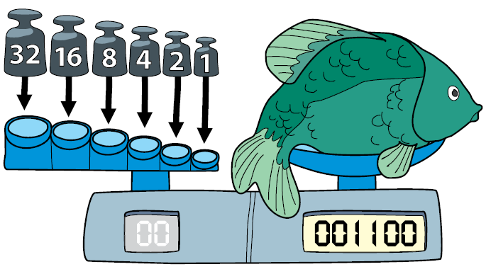
Answer

Comments. You do not need to learn binary coding, you should learn to study information in the picture: 001100 respects 8 + 4 weights, e. g. 12 kg.
Note. Students decimal numbers convert to binary in different ways – discuss about influence of culture.
- ALIEN RESIDENTS

Cute creatures live in newly discovered planets.
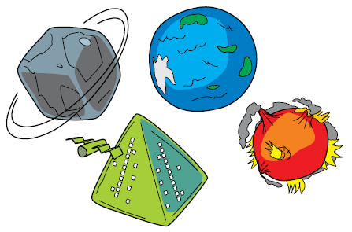
According to what feature it is possible to assign a planet to the creature?
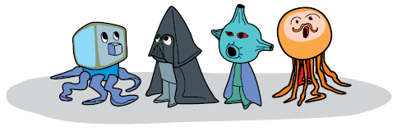
Answer
According to shape of head.
Note: reflection on problem solving - discuss about influence of culture in problem solving.

- FEATHERS
Beaver’s feather belt has lost three feathers. Which feathers should be on the belt?

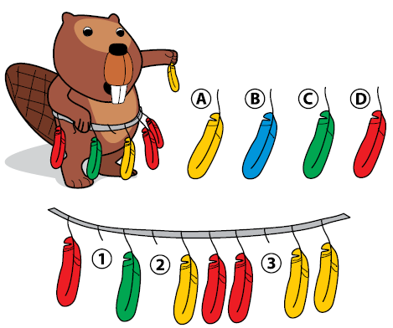
Answer
Clear rule are applied to ordering feathers: red, red, green, yellow, yellow, etc. Then 1 – D, 2 – A, 3 – C.

Note: Pay attention, how students find the pattern.

- A CITY STATUE

A little kangaroo is staying at a hotel in Beaver Town. She follows the directions below given by the hotel staff to get to the famous Beaver statue to take some pictures.
1. From the hotel’s door, immediately turn to the left.
2. Go straight forward through two intersections.
3. At the third intersection, turn right.
4. Go straight forward. At the first intersection, turn left.
5. Go straight forward. At the first intersection, turn right.
A little kangaroo found the statue and is taking a picture.

In which hotel is kangaroo staying?
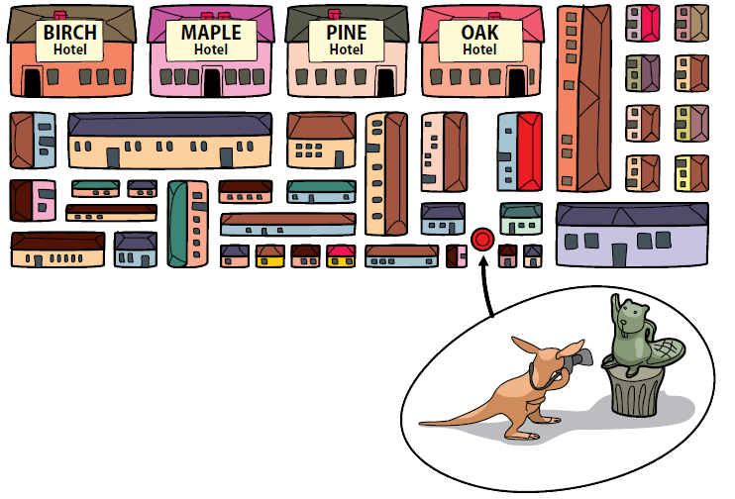
Answer
You need to follow rules, nothing else. Task requires student’s to pay attention to the initial possition: where is kangaroo, where is the left or right side. Kangaroo stays in MAPLE hotel.
Note. Pay attention, how students choose directions and apply given rules.

- ROUND DANCE
Six beavers play a game. Initially each beaver stays in one of the 6 different numbered rings (see the figure). At each ring there is an arrow with a number from 1 to 6 indicating a ring the beaver has to go next (destination). There are different destinations for the different rings. After a signal each beaver moves to the destination. This move is called round. Then the second round follows, then the third, and so on until all beavers happen to be on their initial places.
How many rounds will be needed to finish the game?
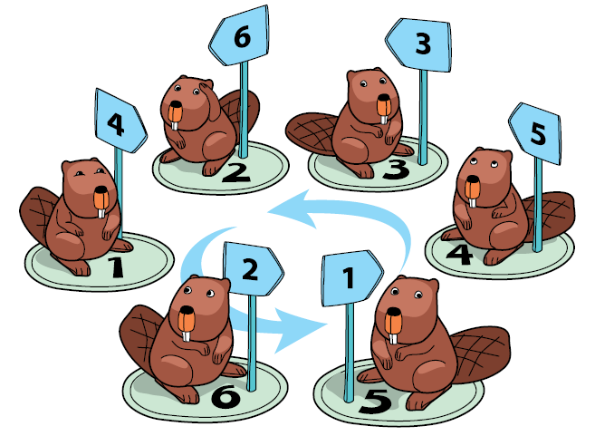
Answer
To finish the game 3 rounds are needed. Beaver, which is in the first ring, will move 3 rounds. Beaver which is in the 3rd ring will move 0 round.
Note. Pay attention, how students read and understand the task.

- DRAW A HOUSE
Draw a house by holding a pencil against paper sheet (without any lifting) and drawing the same line only once:
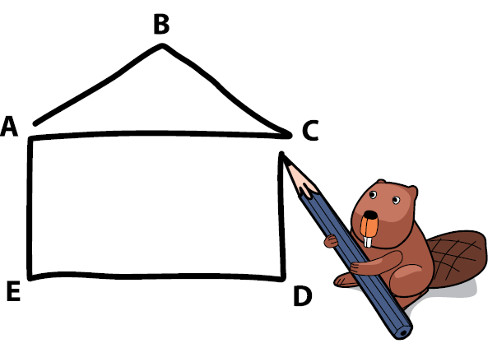

The picture shows a way from the point A.
Can you start from the other points? From which one?

Answer
Yes, we can: from A.
Note. Pay attention to reasoning approaches.

- A BIKER
A beaver biker is choosing the shortest route from A to Z. There are only one-way cycle paths. She knows a clever approach (an algorithm) how to find the route and put hints on sheets of paper at crossings. What is she writing at the moment? Write an integer which the biker has counted for the current crossing E.
h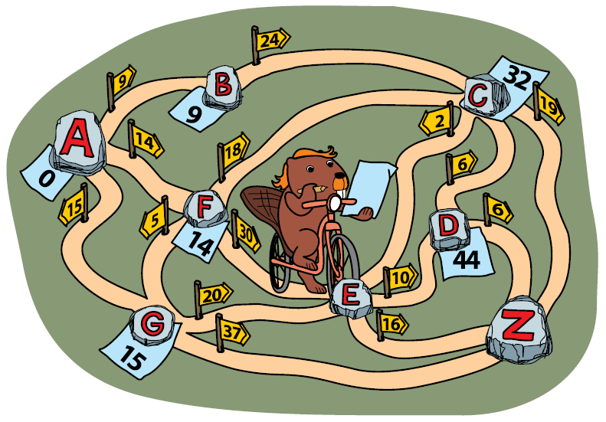
Answer
It is 34.
In this tasks students use Dijkstra’s algorithm. Dijkstra's algorithm is an algorithm for finding the shortest paths between nodes in a graph, which may represent, for example, road networks.
Note. Pay attention to reasoning approaches of different students.

- TWO BACKPACS
Two beavers are getting ready for a trip. They are packing their gear.
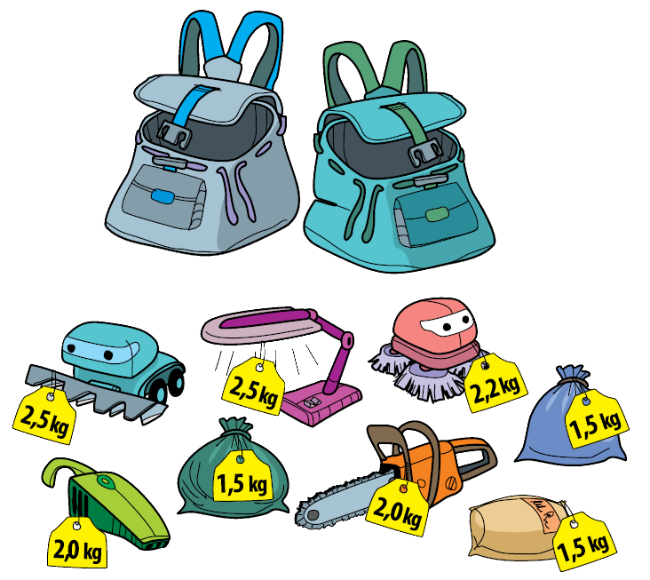
The weight of one backpack cannot exceed 8 kg. How to distribute the things between the backpacks, so that the beavers could take as many things as possible?

Answer
We can solve this task in different ways. Examples of solutions are following: 2,5+2,5+1,5+1,5 and 2+1,5+2+2,2

Note. Pay attention, how students calculate.

- BEAUTIFUL TILES
Robot-beaver is walking on tiles and decorating then with ornaments. He knows these commands:
– Advance to next tile;
– Draw a flower;

– Repeat any command 3 times, in this case ‘’Draw a flower’’.

Several flowers on the same tile are drawn one next to each other. What is the amount of flowers drawn by a robot, after these commands?

Answer
The correct answer is 5.
Robot will draw 3 flowers on the first tile, adwance to next tile and draw 2 flowers at once and 3 after. So robot painted 5 flowers on the one tile. Then robot adwance to the third tile he draw one flower and three after. On the third tile will be 4 flowers. So the amount of flowers drawn by a robot is 5.
Note. Pay attention to reasoning aproaches of students.

- STAINED GLASS
A robot is decorating the windows with pieces of glass. The pieces can be of three different colors: blue, red, or orange.
Eight pieces of glass form the basic pattern. Using several basic patterns, the robot can create a nice regular symmetric decoration.h
A three column ornament consists of 5 fragments. | A five column ornamentlooks like this:

How many square pieces of blue glass will be needed to complete a stained glass decoration with seven columns?

Answer

Eight pieces of glass form the basic pattern.
A three column ornament  consists of 5 fragments. | A five column ornament  looks like this:

The correct answer is 100.
Note: It is difficult tasks and powerful of the concepts of algoritm, pattern, repetition. Pay attention, how students find the pattern.
This activity contributes to the achievement of the following learning outcomes:
- Explore different approaches of reasoning and algorithms in mathematics that illustrate contributions from different cultures and different people;
- Learn to appreciate the rich applications of mathematics and algorithms;
- Support of the view that practicing different algorithms we develop a deeper understanding;
- Develop pedagogical approaches which promote an open minded and appreciative attitude towards the use of different approaches in reasoning and algorithms in mathematics and allow cultural variety.

III. Problem solving and reasoning: Constructionism – a method for building knowledge.
3.2. Orange game
Duration: 30 minutes
S. Papert extended constructivism-learning theory in a way that applies to practical construction and named it by constructionism (Papert, 1987). During several decades the ideas of constructionism have been applied to different activities in education and the results are promising (Brennan, Resnick, 2013; Bruckman, 2006; Resnick, 2014).
Constructivism advocates learner-centred (in our case the learners are teachers) discovery learning where learners use information they already know to acquire more knowledge (Aleksandrini, Larson, 2002).
Constructionism provides us the basic idea of an appropriate learning object. Such an object should support learner’s step-by-step understanding of the materials and concepts it represents, allowing users to construct knowledge.

Questions to students:
    - How can we support teachers to engage in constructionism?
    - How can they start to think beyond a technocentric view?
Constructivist approach can be demonstrated by using the Computer Science Unplugged Activities (under Creative Common licences):
http://csunplugged.org/wp-content/uploads/2015/03/CSUnplugged_OS_2015_v3.1.pdf

Remark: the book is translated in many languages. Check availability (if not translated you can contribute the project by translating some activities!!!).

Video of activity on YouTube: https://youtu.be/WforXEBMm5k

Practice in groups the orange game (worksheet: activity 3.2)

ORANGE GAME (p. 93)

Each student needs:
- Two oranges or tennis balls labelled with the same letter, or two pieces of fruit each (artificial fruit is best)
- Name tag or sticker showing their letter, or a coloured hat, badge or top to match their fruit
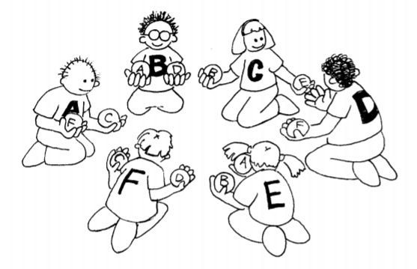

Introduction
1. Groups of five or more students sit in a circle.
2. The students are labelled with a letter of the alphabet (using name tags or stickers), or each is allocated a colour (perhaps with a hat, or the colour of their cloths). If letters of the alphabet are used, there are two oranges with each student’s letter on them, except for one student, who only has one corresponding orange to ensure that there is always an empty hand. If fruit is used, there are two pieces of fruit for each child e.g. a child with a yellow hat might have two bananas, and a child with a green hat may have two green apples, except one child has only one piece of fruit.
3. Distribute the oranges or fruit randomly to the students in the circle. Each student has two pieces, except for one student who has only one. (No student should have their corresponding orange or colour of fruit.) 4. The students pass the oranges/fruit around until each student gets the one labelled with their letter of the alphabet (or their colour). You must follow two rules:
a) Only one piece of fruit may be held in a hand.
b) A piece of fruit can only be passed to an empty hand of an immediate neighbour in the circle. (A student can pass either of their two oranges to their neighbour.)

Students will quickly find that if they are “greedy” (hold onto their own fruit as soon as they get them) then the group might not be able to attain its goal. It may be necessary to emphasize that individuals don’t “win” the game, but that the puzzle is solved when everyone has the correct fruit.
Follow up discussion
- What strategies did the students use to solve the problem?
- Where in real life have you experienced deadlock? (Some examples might be a traffic jam, getting players around bases in baseball, or trying to get a lot of people through a doorway at once.).
Extension Activities
Try different configurations such as sitting in a line, or having more than two neighbours for some students. Some suggestions are shown here.
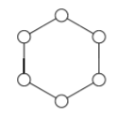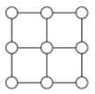

This activity contributes to the achievement of the following learning outcomes:
- Support of the view that practicing different algorithms we develop a deeper understanding;
- Develop pedagogical approaches which promote an open minded and appreciative attitude towards the use of different approaches in reasoning and algorithms in mathematics and allow cultural variety.

 | Materials and resources
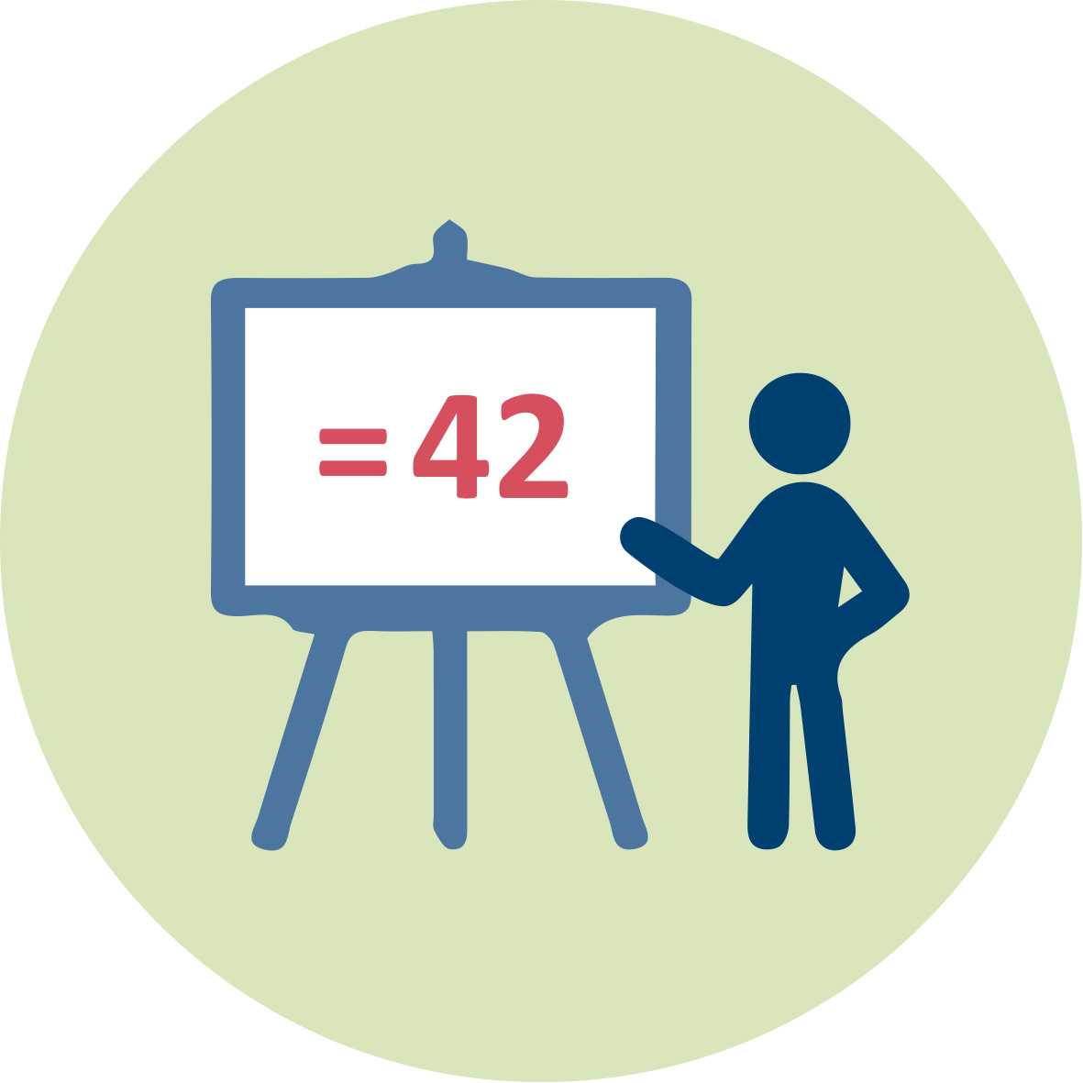 | Presentation (pptx). Teacher Educator. Introduction
 | Readings (including in Worksheets)
 | Worksheets. Includes student activities for module IO3
 | Access to computers for internet research and collaborative work
 | Youtube video
 | “Others”

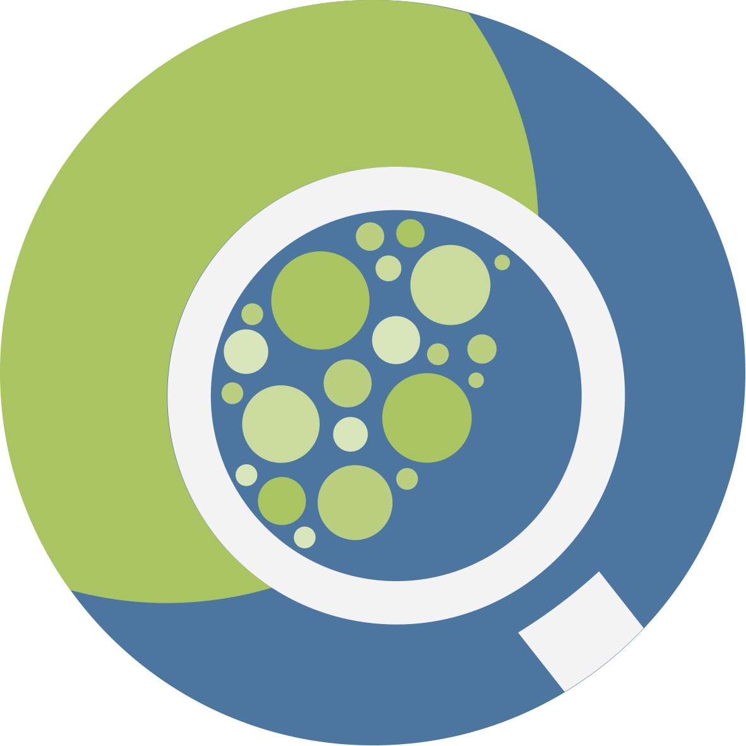 | Granularity
- Select fewer texts, Activity 1.2
- Skip Activity 2.3 (an Extra module)
- Solve fewer tasks, Activity 3.1

References
Alesandrini, K., & Larson, L. (2002). Teachers bridge to constructivism. The Clearing House, 75(3), 118-121.
D’Ambrossio U.(1985) Ethnomathematics and Its Place in the History and Pedagogy of Mathematics. For the Learning of Mathematics, Vol. 5, No. 1 (Feb., 1985), 44-48.
http://www.jstor.org/stable/40247876?seq=1#fndtn-page_thumbnails_tab_contents
Brennan K., Resnick, M. (2013). Imagining, creating, playing, sharing, reflecting: How online community supports young people as designers of interactive media. In Emerging technologies for the classroom (pp. 253-268). Springer New York.
Bruckman A. (2006) Learning in online communities. In: Sawyer K. (Eds.) Cambridge handbook of the learning siences. Cambridge University Press, New York: 461-472.
Cimen, O.A. (2014) Discussing ethnomathematics: Is mathematics culturally dependent? ERPA INTERNATIONAL CONGRESS ON EDUCATION (ERPA CONGRESS 2014). Book Series: Procedia Social and Behavioral Sciences. Volume: 152 Pages: 523-52
Gerdes. P.Chapter 24: Ethnomathematics and Mathematics Education. In A. Bishop et al. (eds) International Handbook of Mathematics Education, Kluwer, pp. 909-943. http://link.springer.com/chapter/10.1007/978-94-009-1465-0_25#page-1
Jonker, V., Wijers, M., Abels, M. and Keijzer, R. (2016). Let's have a look behind the code. The Big Mathematics Day 2016 (Netherlands) about coding without computer PATT (pp. 8). De Bilt, the Netherlands: PATT. http://www.fi.uu.nl/publicaties/literatuur/2016_jonker_wijers_abels_keijzer_patt.pdf
Papert, S. (1987). Computer criticism vs. technocentric thinking. Educational Researcher, 16(1), 22-30.
Resnick, M. (2014). Give P’s chance: Projects, peers, passion, play. In: Futschek G. & Kynigos C. (Eds.) Constructionism and creativity. Proceedings of the Third International Constructionism Conference. Austrian Computer Society, Vienna, (pp. 13-20).
Rowlands, S., Carson R. (2002). Where would formal, academic mathematics stand in a curriculum informed by ethnomathematics? A critical review of ethnomathematics in Educational Studies in Mathematics.Vol.50, No.1, pp.79-102.
Rosa, M., Orey, D.C. (2011). Ethnomathematics: the cultural aspects of mathematics. Revista Latinoamericana de Etnomatemática, 4(2). 32-54
http://funes.uniandes.edu.co/3079/1/Rosa2011Ethnomathematics.pdf
Rosa, M., Orey, D.C. (2016) Humanizing Mathematics through Ethnomodelling. Journal of Humanistic Mathematics, Volume 6 Issue 2 (July 2016), pages 3-22.
Rosa, M., Orey, D.C. (2015). A trivium curriculum for mathematics based on literacy, matheracy, and technoracy: an ethnomathematics perspective. ZDM-THE Int Journal on Mathematics Education. Volume: 47 Issue: 4 587-598

Further readings
Dagienė, V., Stupurienė, G. (2016) Informatics concepts and computational thinking in K-12 education: a Lithuanian perspective // Journal of Information Processing. Tokyo: Information Processing Society of Japan. eISSN: 1882-6652. Vol. 24, no 6, p. 732-739.
European Commission (2013). Report to the European Commission on improving the quality of teaching and learning in Europe’s higher education institutions. Luxembourg: Publications Office of the European Union.
European Commission (2014). Report to the European Commission on improving the quality of teaching and learning in Europe’s higher education institutions. Luxembourg: Publications Office of the European Union.
Nunez, I. (2015) Philosophical Underlabouring for Mathematics Education. Journal of Critical Realism. Volume: 14 Issue: 2 Pages: 181-204
Regnier, J.C., Bello, S. E. Lopez; E. M. Kuznetsova (2017) Normative Approach to Ethnomathematics: Linguistic and Philosophical Grounds. Vestnik Tomskogo gosudarstvennogo universiteta [1561-7793] psl.:57 -63
Perkins, I., Flores, A. (2002). Mathematical notation and procedures of recent immigrant students in Mathematics teaching in the middle school, 7, pp.346-351
Septianawati, T., Puspita, E. (2017) Ethnomathematics study: uncovering units of length, area, and volume in Kampung Naga Society. Journal of Physics: Conference Series, Volume 812, Number 1

Assessment
Prospective teachers are required to design a lesson and include assessment tasks.
The full description of the task and the assessment criteria are given in the worksheets.

