Module 3 |  | DIFFERENT CULTURES – DIFFERENT APPROACHES TO REASONING AND ALGORTIHMS IN MATHEMATICS

Worksheets

This worksheet is based on the work within the project Intercultural learning in mathematics and science initital teacher education (IncluSMe). Coordination: Prof. Dr. Katja Maaß, International Centre for STEM Education (ICSE) at the University of Education Freiburg, Germany. Partners: University of Nicosia, Cyprus; University of Hradec Králové, Czech Republic; University of Jaen, Spain; National and Kapodistrian University of Athens, Greece; Vilnius University, Lithuania; University of Malta, Malta; Utrecht University, Netherlands; Norwegian University of Science and Technology, Norway; Jönköping University, Sweden; Constantine the Philosopher University, Slovakia.

The project Intercultural learning in mathematics and science initial teacher education (IncluSMe) has received co-funding by the Erasmus+ programme of the European Union under grant no. 2016-1-DE01-KA203-002910. Neither the European Union/European Commission nor the project's national funding agency DAAD are responsible for the content or liable for any losses or damage resulting of the use of these resources.

IncluSMe project (grant no. 2016-1-DE01-KA203-002910) 2016-2019, lead contributions by Vilnius University, Lithuania.
CC-BY-NC-SA 4.0 license granted (find explicit terms of use at: https://creativecommons.org/licenses/by-nc-sa/4.0/deed.en)

I. Introduction: Definitions and understanding.
 | Activity 1.1: Definitions: reasoning and algorithms in mathematics
 |  | View video clips  Work in groups  Home work | 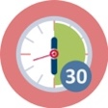  30 min
Homework.

- Find and view video (2-3) about cultural understanding, reasoning and algorithms in learning and teaching mathematics. This is the example of video on YouTube: https://www.youtube.com/watch?v=XUO59Emi3eo
- Give examples of video, which were favorite for you.
- Discuss cultural issues

Video examples
(Provide the link of media and short description)

At school. Analyze social media
- Provide the description of the following definitions according viewed video (fill the table).

Cultural understanding | Etnomathematics | Reasoning | Algorithms
(Describe the meaning/definition) | (Describe the meaning / definition) | (Describe the meaning / definition) | (Describe the meaning / definition)

Work in groups.

- Discuss about the viewed video. Share ideas about your favorite video.
- Compare tables.
- Reflect on discussion and tables focusing on the following aspects:

  - Do you see any differences?
  - What is common?
  - What are the main features of ethnomathematics, reasoning and algorithmic thinking in mathematics? Why do think so?

- Do you find the same favorite media as you friend?

I. Introduction: Theoretical background.
 | Activity 1.2: Different reasoning approaches. Based on Seymour Papert’s ideas.
 |  | Student read  Group discussion | 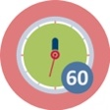 | 60 min
Find information about Seymour Papert in the internet.
Study following examples of tasks and share yours ideas within group.

Example 1.2.1. Explain and connect words.

Papert  Piaget  Turtle  Logo  Cognitive model  Microworlds  Mathophobia | Assimilation  Learning without being taught  Programming language  Accommodation  Mindstorm  Geometry  Children, Computers, Powerful Ideas  Constructionism  Incubators for powerful ideas  Constructivism  Concrete thinking  Formal thinking  The fear of Learning

Example 1.2.2. Read text (S. Papert. MINDSTORMS: Children, Computers, and Powerful Ideas. Basic Books, Inc., NY, 1980).
You can download the book for example from website: http://worrydream.com/refs/Papert%20-%20Mindstorms%201st%20ed.pdf

TEXT 1
Mathematicians interested in the nature of number have looked at the problem from different standpoints. One approach, associated with the formalists, seeks to understand number by setting up axioms to capture it. A second approach, associated with Bertrand Russell, seeks to define number by reducing it to something more fundamental, for example, logic and set theory. Although both of these approaches are valid, important chapters in the history of mathematics, neither casts light on the question of why number is learnable. But there is a school of mathematics that does do so, although this was not its intention.paralleling the way in which each of us once did some of our most effective [p.159].

TEXT 2
[…] A substantial intellectual growth is needed before children develop the "conservationist" view of the world. The conservation of volume is only one of many conservations they all learn. Another is the conservation of numbers. Again, it does not occur to most adults that a child must learn that counting a collection of objects in a different order should yield the same result. For adults counting is simply a method of determining how many objects "there are." The result of the operation is an "objective fact" independent of the act of counting. But the separation of number from counting (of product from process) rests on epistemological presuppositions not only unknown to preconservationist children, but alien to their worldview. These conservations are only part of a vast structure of "hidden" mathematical knowledge that children learn by themselves. In the intuitive geometry of the child of four or five, a straight line is not necessarily the shortest distance between two points, and walking slowly between two points does not necessarily take more time than walking fast. Here, too, it is not merely the "item" of knowledge that is missing, but the epistemological presupposition underlying the idea of "shortest" as a property of the path rather than of the action of traversing it. [p. 41] […]
The problem of making mathematics "make sense" to the learner touches on the more general problem of making a language of "formal description" make sense. So before turning to examples of how the computer helps give meaning to mathematics, we shall look at several examples where the computer helped give meaning to a language of formal description in domains of knowledge that people do not usually count as mathematics. In our first example the domain is grammar, for many people a subject only a little less threatening than math. [p.48]
[…] She understood the general idea that words (like things) can be placed in different groups or sets, and that doing so could work for her. She not only "understood" grammar, she changed her relationship to it. It was "hers," and during her year with the computer, incidents like this helped Jenny change her image of herself. Her performance changed too; her previously low to average grades became "straight A's" for her remaining years of school. She learned that she could be "a brain" after all [p.50].

TEXT 3
Turtle geometry started with the goal of fitting children. Its primary design criterion was to be appropriable. Of course it had to have serious mathematical content, but we shall see that appropriability and serious mathematic thinking are not at all incompatible. On the contrary: We shall end up understanding that some of the most personal knowledge is also the most profoundly mathematical. In many ways mathematics~for example the mathematics of space and movement and repetitive patterns of action-is what comes most naturally to children. It is into this mathematics that we sink the tap-root of Turtle geometry. As my colleagues and I have worked through these ideas, a number of principles have given more structure to the concept of an appropriable mathematics. First, there was the continuity principle: The mathematics must be continuous with well-established personal knowledge from which it can inherit a sense of warmth and value as well as "cognitive" competence. Then there was the power principle" It must empower the learner to perform personally meaningful projects that could not be done without it. Finally there was a principle of cultural resonance: The topic must make sense in terms of a larger social context. I have spoken of Turtle geometry making sense to children. But it will not truly make sense to children unless it is accepted by adults too. A dignified mathematics for children cannot be something we permit ourselves to inflict on children, like unpleasant medicine, although we see no reason to take it ourselves [p. 54].

TEXT 4
Arithmetic is a bad introductory domain for learning heuristic thinking. Turtle geometry is an excellent one. By its qualities of ego and body syntonicity, the act of learning to make the Turtle draw gives the child a model of learning that is very much different from the dissociated one a fifth-grade boy, Bill, described as the way to learn multiplication tables in school: "You learn stuff like that by making your mind a blank and saying it over and over until you know it." Bill spent a considerable amount of time on "learning" his tables. The results were poor and, in fact, the poor results themselves speak for the accuracy of Bill's reporting of his own mental processes in learning. He failed to learn because he forced himself out of any relationship to the material~or rather, he adopted the worst relationship, dissociation, as a strategy for learning. His teachers thought that he "had a poor memory" and had even discussed the possibility of brain damage. But Bill had extensive knowledge of popular and folk songs, which he had no difficulty remembering, perhaps because he was too busy to think about making his mind a blank.
Current theories about the separation of brain functions mightsuggest that Bill's "poor memory" was specific to numbers. But the boy could easily recount reference numbers, prices, and dates for thousands of records. The difference between what he "could" and "could not" learn did not depend on the content of the knowledge but on his relationship to it. Turtle geometry, by virtue of its connection with rhythm and movement and the navigational knowledge needed in everyday life, allowed Billy to relate to it more as he did to songs than to multiplication tables. His progress was spectacular. Through Turtle geometry, mathematical knowledge Billy had previously rejected could enter his intellectual world [p.65].

TEXT 5
Learners in a physics microworld are able to invent their own personal sets of assumptions about the microworld and its laws and are able to make them come true. They can shape the reality in which they will work for the day, they can modify it and build alternatives. This is an effective way to learn, paralleling the way in which each of us once did some of our most effective learning. Piaget has demonstrated that children learn fundamental mathematical ideas by first building their own, very much different (for example, preconservationist) mathematics. And children learn language by first learning their own ("baby-talk") dialects. So, when we think of microworlds as incubators for powerful ideas, we are trying to draw upon this effective strategy: We allow learners to learn the "official" physics by allowing them the freedom to invent many that will work in as many invented worlds.
[…] Each new idea in Turtle geometry opened new possibilities for action and could therefore be experienced as a source of personal power. With new commands such as SETVELOCITY and CHANGE VELOCITY, learners can set things in motion and produce designs of ever-changing shapes and sizes. They now have even more personal power and a sense of "owning" dynamics. They can do computer animation~there is a new, personal relationship to what they see on television or in a pinball gallery. The dynamic visual effects of a TV show, an animated cartoon, or a video game now encourage them to ask how they could make what they see. This is a different kind of question than the one students traditionally answer in their "science laboratory." In the traditional laboratory pedagogy, the task posed to the children is to establish a given truth. At best, children learn that "this is the way the world works." In these dynamic Turtle microworlds, they come to a different kind of understanding~a feel for why the world works as it does. By trying many different laws of motion, children will find that the Newtonian ones are indeed the most economical and elegant for moving objects around. [p.126-129]

TEXT 6
Difficulties experienced by children are not usually due to deficiencies in their notion of number but in failing to appropriate the relevant algorithms. Learning algorithms can be seen as a process of making, using, and fixing programs. When one adds multidigit numbers one is in fact acting as a computer in carrying through a procedure something like the program in Figure 18.

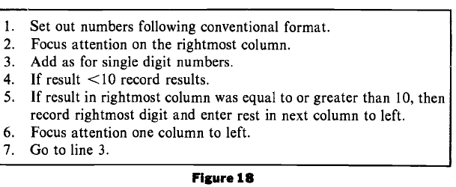

[p. 152]

S. Papert. MINDSTORMS: Children, Computers, and Powerful Ideas. Basic Books, Inc. NY, 1980.

II. Culture related context: Practical reasoning example.
 | Activity 2.1: Juggling
 |  | Work in groups |  | 60 min
Group discussion.
- Discuss the method used to juggle and its difficulties.
- Try to draw/present steps of juggling on the sheet of paper. Compare your paper with friend.
Read the following text from S. Papert. MINDSTORMS (p. 105-112) and practice by using scarfs.
There are many different kinds of juggling. When most people think of juggling, they are thinking about a procedure that is called "showers juggling." In showers juggling balls move one behind the other in a "circle" passing from left to right at the top and from right to left at the bottom (or vice versa). This takes two kinds of throws: a short, low throw to get the balls from one hand to the other at the bottom of the "circle" (near the hands), and a long, high throw to get the balls to go around the top of the circle.
Cascade juggling has a simpler struchture. There is no bottom of the circle; balls travel in both directions over the upper arc. There is only one kind of toss: a long and high one.
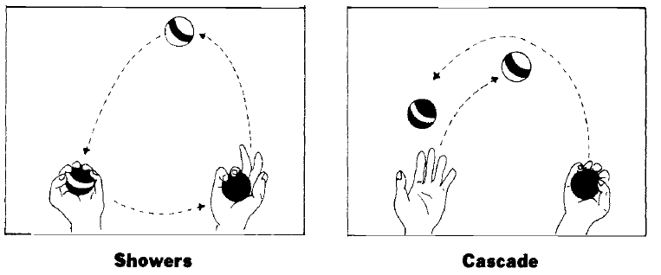
Its simplicity makes it a better route into juggling as well as a better example for our argument. Our guiding question is this: Will someone who wishes to learn cascade juggling be helped or hindered by a verbal, analytic description of how to do it? The answer is" It all depends. It depends on what materials the learner has for making analytic descriptions. We use cascade juggling to show how good computational models can help construct "people procedures" that improve performance of skills and how reflection on those people procedures can help us learn to program and to do mathematics. But, of course, some verbal descriptions will confuse more than they will help. Consider, for example, the description:
1. Start with balls 1 and 2 in the left hand and ball 3 in the right.
2. Throw ball 1 in a high parabola to the right hand.
3. When ball 1 is at the vertex throw ball 3 over to the left hand in a similar high parabola, but take care to toss ball 3 under the trajectory of ball 1.
4. When ball 1 arrives at the right hand and ball 3 is at the vertex, catch ball 1 and throw ball 2 in a trajectory under that of ball 3, and so on.
This description is basically a brute-force straight-line program. It is not a useful description for the purpose of learning. [p. 105-106] […]

[…] we add arrows to indicate a direction and obtain two state descriptions.

TOPRIGHT: The ball is at the top and is moving to the right
TOPLEFT: The ball is at the top and is moving to the left

If we assume, reasonably, that the juggler can recognize these two situations, the following formalism should be self-explanatory:
TO KEEP JUGGLING
WHEN TOPRIGHT TOSSRIGHT
WHEN TOPLEFT TOSSLEFT
or even more simply:
TO KEEP JUGGLING
WHEN TOPX TOSSX
which declares that when the state TOPRIGHT occurs, the right hand should initiate a toss and when TOPLEFT occurs, the left hand should initiate a toss. A little thought will show that this is a complete description: The juggling process will continue in a selfperpetuating way since each toss creates a state of the system that triggers the next toss.
How can this model that turned juggling into a people procedure be applied as a teaching strategy? First, note that the model of juggling made several assumptions:
1. that the learner can perform TOSSRIGHT and TOSSLEFT
2. that she can recognize the trigger states TOPLEFT and TOPRIGHT
3. that she can combine these performance abilities according to the definitions of the procedure TO KEEP JUGGLING
Now, we translate our assumptions and our people procedure into a teaching strategy.

STEP 1: Verify that the learner can toss. Give her one ball, ask her to toss it over into the other hand. This usually happens smoothly, but we will see later that a minor refinement is often needed. The spontaneous procedure has a bug.

STEP 2: Verify that the learner can combine tosses. Try with two balls with instructions:
TO CROSS
TOPRIGHT
WHEN TOPRIGHT TOSSLEFT
END
This is intended to exchange the balls between left and right hands.
Although it appears to be a simple combination of TOSSLEFT and TOSSRIGHT, it usually does not work immediately.

STEP 3. Look for bugs in the toss procedures. Why doesn't TO CROSS work? Typically we find that the learner's ability to toss is not really as good as it seemed in step 1. The most common deviation or "bug" in the toss procedure is following the ball with the eyes in doing a toss. Since a person has only one pair of eyes, their engagement in the first toss makes the second toss nearly impossible and thus usually ends in disaster with the balls on the floor.

STEP 4. Debugging. Assuming that the bug was following the first ball with the eyes, we debug by returning our learner to tossing with one ball without following it with her eyes. Most learners find (to their amazement) that very little practice is needed to be able to perform a toss while fixing the eyes around the expected apex of the parabola made by the flying ball. When the single toss is debugged, the learner again tries to combine two tosses. Most often this now works, although there may still be another bug to eliminate.

STEP 5. Extension to three balls. Once the learner can smoothly execute the procedure we called CROSS, we go on to three balls. To do this begin with two balls in one hand and one in the other. Ball 2 is tossed as if executing CROSS, ignoring ball 1. The TOSSRIGHT in CROSS brings the three balls into a state that is ready for KEEP JUGGLING. The transition from CROSS to KEEP JUGGLING presents a little difficulty for some learners, but this is easily overcome. Most people can learn to juggle in less than half an hour by using this strategy.
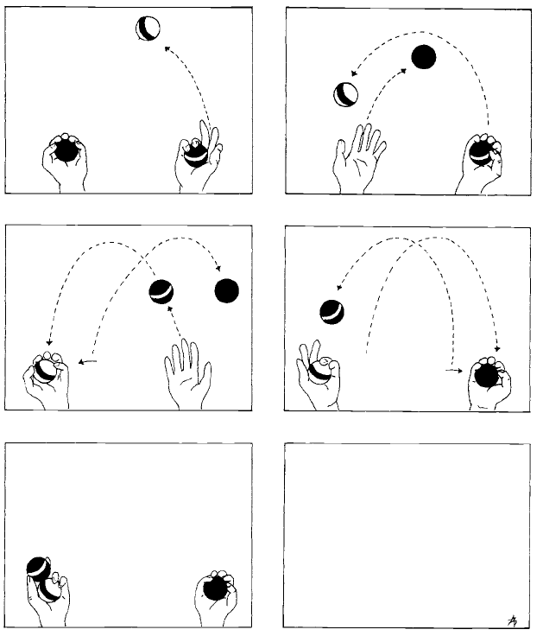

Do you succeed? What have you noticed?

II. Culture related context: Steps of reasoning.
 | Activity 2.2: A string around the circumference of the earth
 |  | Student reads  Students solves | 30 min
S. Papert. MINDSTORMS: Children, Computers, and Powerful Ideas. Basic Books, Inc. NY, 1980, pp.146-149

Analyze the following example.

Imagine a string around the circumference of the earth, which for this purpose we shall consider to be a perfectly smooth sphere, four thousand miles in radius. Someone makes a proposal to place the string on six-foot-high poles. Obviously this implies that the string will have to be longer. A discussion arises about how much longer it would have to be. Most people who have been through high school know how to calculate the answer. But before doing so or reading on try to guess" Is it about one thousand miles longer, about a hundred, or about ten?
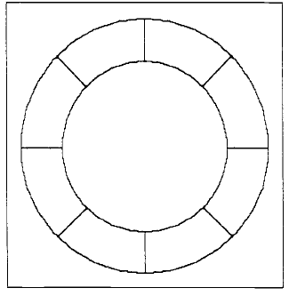
The figure shows a string around the earth supported by poles of greatly exaggerated height. Call the radius of the earth R and the height of the poles h. The problem is to estimate the difference in length between the outer circumference and the true circumference. This is easy to calculate from the formula:
$$CIRCUMFERENCE=2π x RADIUS$$
so the difference must be
$$2π \left(R+h\right)-2π R$$

which is simply $2πh$.
But the challenge here is to "intuit" an approximate answer rather than to "calculate" an exact one.

Most people who have the discipline to think before calculating-a discipline that forms part of the know-how of debugging one's intuitions-experience a compelling intuitive sense that "a lot" of extra string is needed. For some the source of this conviction seems to lie in the idea that something is being added all around the twenty-four thousand miles (or so) of the earth's circumference. Others attach it to more abstract considerations of proportionality. But whatever the source of the conviction may be it is "incorrect" in anticipating the result of the formal calculation, which turns out to be a little less than forty feet. The conflict between intuition and calculation is so powerful that the problem has become widely known as a teaser. And the conclusion that is often drawn from this conflict is that intuitions are not to be trusted. Instead of drawing this conclusion, we shall attempt to engage the reader in a dialog in order to identify what needs to be done to alter this intuition.
As a first step we follow the principle of seeking out a similar problem that might be more tractable. And a good general rule for simplification is to look for a linear version. Thus we pose the same problem on the assumption of a "square earth."
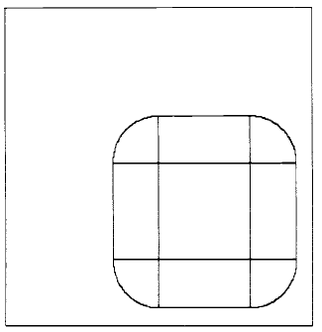
The string on poles is assumed to be at distance h from the square. Along the edges the string is straight. As it goes around the corner it follows a circle of radius h. The straight segments of the string have the same length as the edges of the square. The extra length is all at the corners, in the four quarter-circle pie slices. The four quarter circles make a whole circle of radius h. So the "extra string" is the circumference of this circle, that is to say $2πh$.
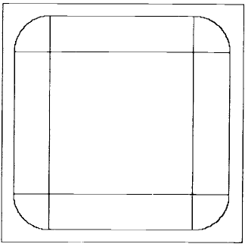
Increasing the size of the square does not change the quarter-circle pie slices. So the extra string needed to raise a string from the ground to height h is the same for a very small square earth as for a very large one.

The diagram gives us a geometric way to see that the same amount of extra string is needed here as in the case of the circle. This is itself quite startling. But more startling is the fact that we can see so directly that the size of the square makes no difference to how much extra string is needed. We could have calculated this fact by formula. But doing so would have left us in the same difficulty. By "seeing" it geometrically we can bring this case into line with our intuitive principle: Extra string is needed only where the earth curves. Obviously no extra string is needed to raise a straight line from the ground to a six-foot height.
Unfortunately, this way of understanding the square case might seem to undermine our understanding of the circular case. We have completely understood the square but did so by seeing it as being very much different from the circle.
But there is another powerful idea that can come to the rescue. This is the idea of intermediate cases: When there is a conflict between two cases, look for intermediates, as GAL in fact did in constructing a series of intermediate objects between the two one-pound balls and one two-pound ball. But what is intermediate between a square and a circle?
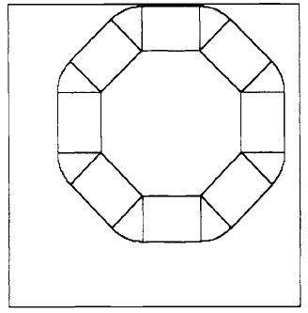
In the octagon, too, the "extra string" is all in the pie slices at the corners. If you put them together they form a circle of radius h. As in the case of the square, this circle is the same whether the octagon is small or big. What works for the square (4-gon) and for the octagon (8-gon) works for the 100-gon and for the 1000-gon.

Anyone who has studied calculus or Turtle geometry will have an immediate answer: polygons with ore and more sides. So we look at Figure 17, which show strings around a series of polygonal earths. We see that the extra string needed remains the same in all these cases and, remarkably, we see something that might erode the argument that the circle adds something all around. The 1000-gon adds something at many more places than the square, in fact two hundred fifty times as many places. But it adds less, in fact one two hundred fiftieth at each of them.

II E (Extended). Culture related context: Reading and discussion about basic ideas of Logo
 | Activity 2.3: Logo-based ideas
 |  | Student reads  Work in groups  Work in computer lab |  | 30 + 60 min
S. Papert. MINDSTORMS: Children, Computers, and Powerful Ideas. Basic Books, Inc. NY, 1980, pp.75-76

Read the text and share ideas in the group.

Consider a child who has already made the Turtle draw a square and a circle and would now like to draw a triangle with all three sides equal to 100 Turtle steps. The form of the program might be:
TO TRIANGLE
REPEAT 3
FORWARD 100
RIGHT SOMETHING
END
But for the Turtle to draw the figure, the child needs to tell it more. What is the quantity we called SOMETHING? For the square we instructed the Turtle to turn 90 degrees at each vertex, so that the square program was:
TO SQUARE
REPEAT 4
FORWARD 100
RIGHT 90
END
Now we can see how Polya's precept, "find similarities", and Turtle geometry's procedural principle, "play Turtle," can work together. What is the same in the square and the triangle? If we play Turtle and "pace out" the trip that we want the Turtle to take, we notice that in both cases we start and end at the same point and facing the same direction. That is, we end in the state in which we started. And in between we did one complete turn. What is different in the two cases is whether our turning was done "in three goes" or "in four goes." The mathematical content of this idea is as powerful as it is simple. Priority goes to the notion of the total trip--how much do you turn all the way around?

The amazing fact is that all total trips turn the same amount, 360 degrees. The four 90 degrees of the square make 360 degrees, and since all the turning happens at the corner the three turns in a triangle must each be 360 degrees divided by three. So the quantity we called SOMETHING is actually 120 degrees. This is the proposition of "The Total Turtle Trip Theorem."
If a Turtle takes a trip around the boundary of any area and ends up in the state in which it started, then the sum of all turns will be 360 degrees.
Part and parcel of understanding this is learning a method of using it to solve a well-defined class of problems. Thus the child's encounter with this theorem is different in several ways from memorizing its Euclidean counterpart: "The sum of the internal angles of a triangle is 180 degrees."
First (at least in the context of LOGO computers), the Total Turtle Trip Theorem is more powerful: The child can actually use it. Second, it is more general: It applies to squares and curves as well as to triangles. Third, it is more intelligible: Its proof is easy to grasp. And it is more personal: You can "walk it through," and it is a model for the general habit of relating mathematics to personal knowledge.
We have seen children use the Total Turtle Trip Theorem to draw an equilateral triangle. But what is exciting is to watch how the theorem can accompany them from such simple projects to far more advanced ones-the flowers in the boxes that are reproduced in the center of the book show a project a little way along this path. For what is important when we give children a theorem to use is not that they should memorize it. What matters most is that by growing up with a few very powerful theorems one comes to appreciate how certain ideas can be used as tools to think with over a lifetime. One learns to enjoy and to respect the power of powerful ideas. One learns that the most powerful idea of all is the idea of powerful ideas.

See the video in YouTube: https://youtu.be/4qP09gofv6U

Work in computer lab:
Use Scratch to practice the drawing of triangle and other shapes. Repeat the same things in the other program. Discuss in groups: what have you noticed?

III. Problem solving and reasoning: Algorithms.
 | Activity 3.1: Solving set of algorithmic tasks.
 | Work in groups | 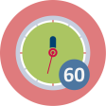 | 60 min
Solve examples of tasks below and fill the following table with correct answers.

Task | Task answer

Compare solutions in groups. Discuss following aspects:
- An explanation of the solution of the particular task
- Do you noticed differences, similarities on your and friend solution?
- What methods were used to get correct answer?
- How you were interested in task: only find the correct answer, analyze tasks and method used to solve particular task?

Task examples

- A BINARY SCALE
A Beaver scale shows weight both in decimal (left) and binary (right) numbers.
A fish weights 1100 kg in binary number system. Which weights you need to put on the scale plates that you can see the fish’s weight in decimal numbers?
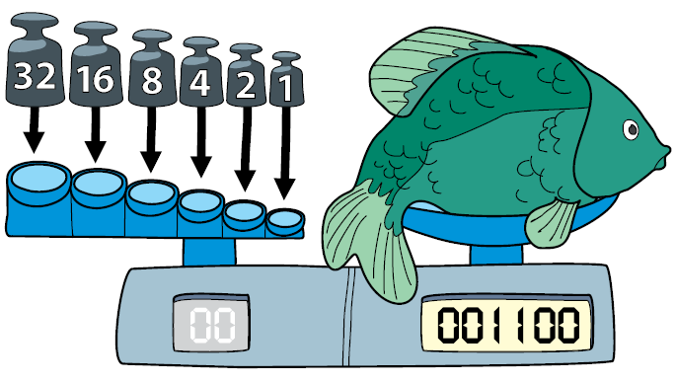

- ALIEN RESIDENTS
Cute creatures live in newly discovered planets.
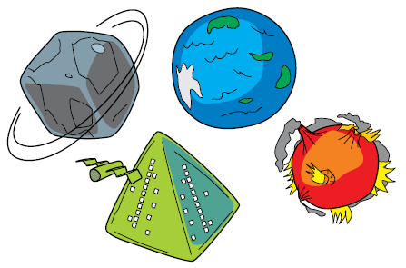
According to what feature it is possible to assign a planet to the creature?
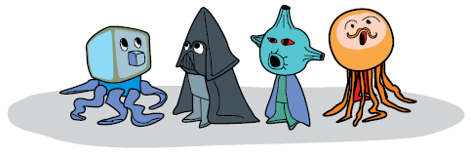

- FEATHERS

Beaver’s feather belt has lost three feathers. Which feathers should be on the belt?

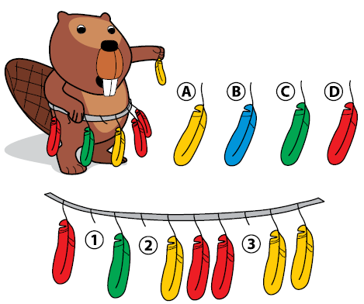
- A CITY STATUE
A little kangaroo is staying at a hotel in Beaver Town. She follows the directions below given by the hotel staff to get to the famous Beaver statue to take some pictures.
1. From the hotel’s door, immediately turn to the left.
2. Go straight forward through two intersections.
3. At the third intersection, turn right.
4. Go straight forward. At the first intersection, turn left.
5. Go straight forward. At the first intersection, turn right.
A little kangaroo found the statue and is taking a picture.

In which hotel is kangaroo staying?
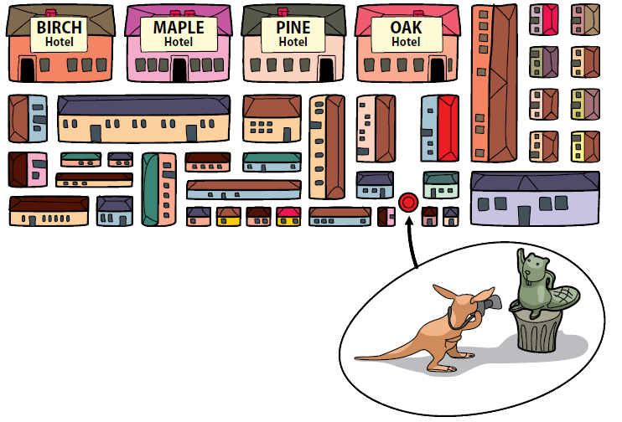

- ROUND DANCE
Six beavers play a game. Initially each beaver stays in one of the 6 different numbered rings (see the figure). At each ring there is a balloon with a number from 1 to 6 indicating a ring the beaver has to go next (destination). There are different destinations for the different rings. After a signal each beaver moves to the destination. This move is called round. Then the second round follows, then the third, and so on until all beavers happen to be on their initial places.
How many rounds will be needed to finish the game?

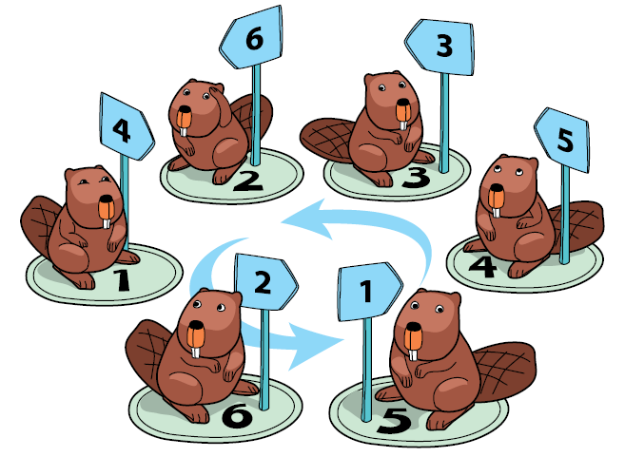

- DRAW A HOUSE
Draw a house by holding a pencil against paper sheet (without any lifting) and drawing the same line only once:
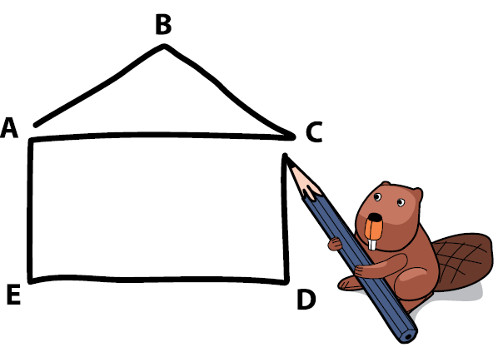
The picture shows a way from the point A.
Can you start from the other points? From which one?

- A BIKER
A beaver biker is choosing the shortest route from A to Z. There are only one-way cycle paths. She knows a clever approach (an algorithm) how to find the route and put hints on sheets of paper at crossings. What is she writing at the moment? Write an integer which the biker has counted for the current crossing E.

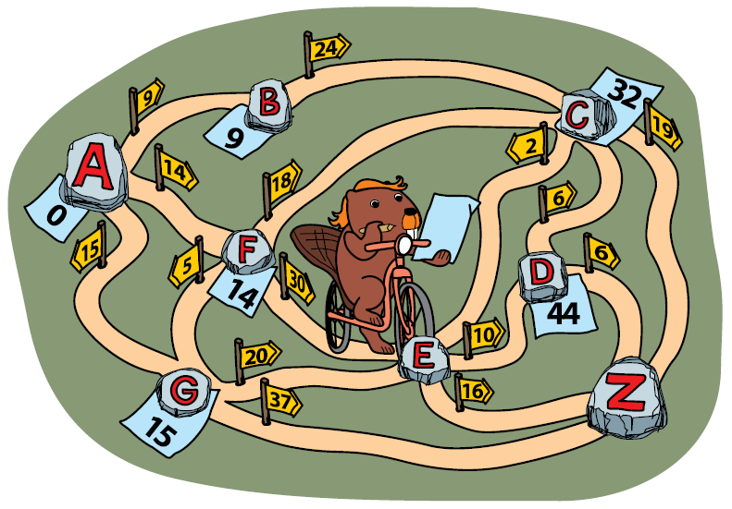

- TWO BACKPACS
Two beavers are getting ready for a trip. They are packing their gear.
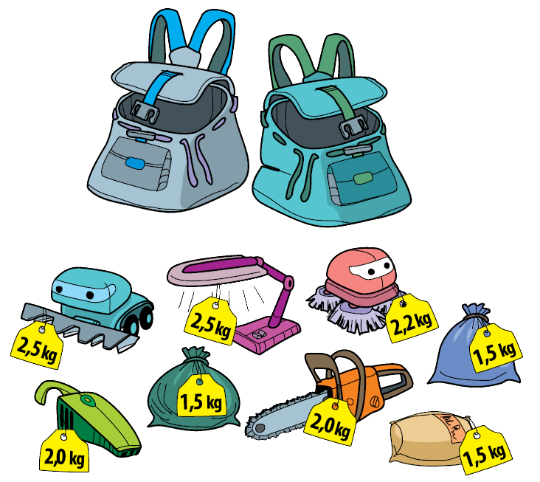
The weight of one backpack cannot exceed 8 kg. How to distribute the things between the backpacks, so that the beavers could take as many things as possible?

- BEAUTIFUL TILES
Robot-beaver is walking on tiles and decorating then with ornaments. He knows these commands:
– Advance to next tile;
– Draw a flower;

– Repeat any command 3 times, in this case ‘’Draw a flower’’.

Several flowers on the same tile are drawn one next to each other.
What is the amount of flowers drawn by a robot, after these commands?

- STAINED GLASS
A robot is decorating the windows with pieces of glass. The pieces can be of three different colors: blue, red, or orange.
Eight pieces of glass form the basic pattern. Using several basic patterns, the robot can create a nice regular symmetric decoration.

A three column ornament  consists of 5 fragments. | A five column ornament  looks like this:

How many square pieces of blue glass will be needed to complete a stained glass decoration with seven columns?

III. Problem solving and reasoning: Constructionism – a method for building knowledge.
 | Activity 3.2: Orange game
 | Work in groups |  | 30 min
Description of activity: http://csunplugged.org/wp-content/uploads/2015/03/CSUnplugged_OS_2015_v3.1.pdf

Video of activity on YouTube: https://youtu.be/WforXEBMm5k

Practice in groups the orange game.

ORANGE GAME (p. 93)

Materials
Each student will need:
- Two oranges or tennis balls labeled with the same letter, or two pieces of fruit each (artificial fruit is best)
- Name tag or sticker showing their letter, or a coloured hat, badge or top to match their fruit
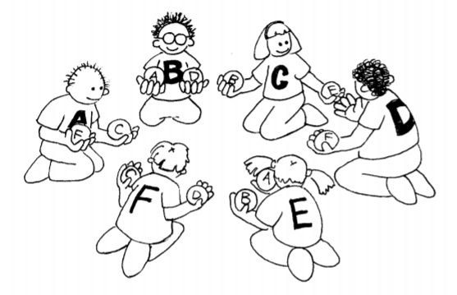
Itroduction
1. Groups of five or more students sit in a circle.
2. The students are labelled with a letter of the alphabet (using name tags or stickers), or each is allocated a colour (perhaps with a hat, or the colour of their cloths). If letters of the alphabet are used, there are two oranges with each student’s letter on them, except for one student, who only has one corresponding orange to ensure that there is always an empty hand. If fruit is used, there are two pieces of fruit for each child e.g. a child with a yellow hat might have two bananas, and a child with a green hat may have two green apples, except one child has only one piece of fruit.
3. Distribute the oranges or fruit randomly to the students in the circle. Each student has two pieces, except for one student who has only one. (No student should have their corresponding orange or colour of fruit.) 4. The students pass the oranges/fruit around until each student gets the one labelled with their letter of the alphabet (or their colour). You must follow two rules:
a) Only one piece of fruit may be held in a hand.
b) A piece of fruit can only be passed to an empty hand of an immediate neighbour in the circle. (A student can pass either of their two oranges to their neighbour.)

Students will quickly find that if they are “greedy” (hold onto their own fruit as soon as they get them) then the group might not be able to attain its goal. It may be necessary to emphasize that individuals don’t “win” the game, but that the puzzle is solved when everyone has the correct fruit.

Follow up Discussion
- What strategies did the students use to solve the problem?
- Where in real life have you experienced deadlock? (Some examples might be a traffic jam, getting players around bases in baseball, or trying to get a lot of people through a doorway at once.)

Extension Activities
Try different configurations such as sitting in a line, or having more than two neighbours for some students. Some suggestions are shown here.

