Module 4 | SOCIO-SCIENTIFIC ISSUES

This Module is based on the work within the project Intercultural learning in mathematics and science initial teacher education (IncluSMe). Coordination: Prof. Dr. Katja Maaß, International Centre for STEM Education (ICSE) at the University of Education Freiburg, Germany. Partners: University of Nicosia, Cyprus; University of Hradec Králové, Czech Republic; University of Jaen, Spain; National and Kapodistrian University of Athens, Greece; Vilnius University, Lithuania; University of Malta, Malta; Utrecht University, Netherlands; Norwegian University of Science and Technology, Norway; Jönköping University, Sweden; Constantine the Philosopher University, Slovakia.

The project Intercultural learning in mathematics and science initial teacher education (IncluSMe) has received co-funding by the Erasmus+ programme of the European Union under grant no. 2016-1-DE01-KA203-002910. Neither the European Union/European Commission nor the project's national funding agency DAAD are responsible for the content or liable for any losses or damage resulting of the use of these resources.

IncluSMe project (grant no. 2016-1-DE01-KA203-002910) 2016-2019, lead contributions by Romero-Ariza, M., Quesada, A. & Abril, A. M. University of Jaén, Jaén, Spain.
CC-BY-NC-SA 4.0 license granted (find explicit terms of use at: https://creativecommons.org/licenses/by-nc-sa/4.0/deed.en)

General overview and aim
Socio-Scientific Issues (SSI) offer powerful controversial scenarios to trigger students’ interest and engagement, the need of communication and argumentation, the consideration of different perspectives for informed and democratic decision-making, and the understanding of science and its implications in today’s societies.
This module encompasses a series of activities for Initial Teacher Education (ITE) intended at providing teachers with opportunities to experience and reflect on the potential of socio-scientific issues (SSI) to enhance science education in culturally diverse classrooms, while promoting fundamental values.
To increase the impact of the module on teachers’ knowledge, values and skills, activities will make teachers to take an active role as learners, designers and reflective practitioners (Camburn & Han, 2015; Davis & Krajcik, 2005; Girvan, Conneely & Tangney, 2016).
It offers a set of ITE activities grouped in three different tasks, any of them with a focus on a particular role (teachers as learner, teachers as designers and teachers as reflective practitioners). Additionally, some activities to learn more about specific pedagogical strategies are proposed.
The module considers granularity issues thus making it possible to select particular activities and combine them in longer or shorter sequences. ITE activities are based on research evidence about effective teacher professional development (Avalos, 2011; Desimone, 2011; Loucks-Horsley, et al., 2003; Simon & Campbell, 2012) and a literature review on the use on socio-scientific and cultural issues in the science classroom (e.g. Balgopal, Wallace & Dahlberg, 2017; Dinsmore, Zoellner, Parkinson, Rossi, Monk & Vinnachi, 2017; Dittmer & Gebhard, 2015; France, Mora & Bay, 2012; Lederman et al., 2014; Levinson, 2006; Ratcliffe & Grace, 2003; Sadler & Dawson, 2012; Vázquez et al., 2016; Venville & Dawson, 2010).
The module can be used either for pre-service primary or pre-service secondary school teachers. The teacher educator can decide which SSI are more appropriate to work on, depending on the target group.
Some of the activities described in this module has been successfully implemented in teacher initial education (Romero-Ariza, Abril & Quesada, 2017).

This module is part of:
- Mathematics and Science Subject dimension: (inter)cultural perspectives on the subjects themselves;
- Mathematics and Science Education dimension: pedagogical issues, in particular in respect to dealing with diversity in classrooms.

Relevant topics
Nowadays the number of migrants and refugees is being significantly increased in many places around the globe, making science teachers encounter very diverse students in terms of language skills, cultural background, values, knowledge and capacities. In this scenario, teachers play a crucial role since science education will certainly influence the capacity of both, natives and migrants, to get a proper job, to develop their full potential and to actively contribute to social prosperity (Ariza et al., 2017).
From this perspective, teachers need to become aware of potential barriers, acquire intercultural competences and develop culturally appropriate strategies and resources to facilitate science learning for diverse students. In this module we focus on SSI as an appropriate pedagogical approach.
Socio-Scientific Issues (SSI) is a term that refers to topics related to science and technology, which usually entail controversy due to their social, ethical and environmental implications. Research evidence shows that SSI increase students’ motivation and engagement in science learning and promote critical thinking and the understanding of science and its implications (Lederman et al., 2014; Sadler & Dawson, 2012; Vázquez et al., 2016; Venville & Dawson, 2010).
Given the above-mentioned arguments, SSI can be considered a relevant topic for ITE, since it offers interesting opportunities to enhance science education in culturally diverse classrooms. Socio-Scientific Issues and their controversial nature trigger students’ engagement and need of communication. Additionally, SSI entail a pedagogical approach based on argumentation and consideration of diverse perspectives (scientific, social, ethical, moral, cultural, economical, environmental) and require a classroom atmosphere of democratic deliberation and respect (Levinson, 2006; Ratcliffe & Grace, 2003), which is of special value in culturally diverse classrooms.

Learning Outcomes

This module will enable prospective science teachers to:
- Promote empathy, respect and mutual appreciation through the use of specific techniques.
- Recognise the potential of SSI to enhance science education in culturally diverse classrooms.
- Trigger students’ active engagement in a culturally diverse classroom by using media, recent news and events from students’ close environment.
- Use socio-scientific issues to enhance the understanding of science and its implications in our current lives, taking into consideration cultural, ethical, economical and environmental issues.
- Support the development of communication and argumentation skills in students with diverse cultural backgrounds.
- Facilitate the recognition of emotional and rational arguments and support students’ informed decision-making.
- Promote respect to others’ opinions and active listening in culturally diverse classrooms.
- Build an atmosphere of ownership within a culturally diverse group joined by fundamental values and the achievement of common goals.
- Encourage students’ meaningful application of knowledge, values and skills to take actions that will improve their close environment.
- Apply assessment criteria and processes aligned with the learning outcomes resulting from the use of SSI in culturally diverse science classrooms.
- Discuss the design of classroom activities based on the use of SSI to enhance science learning.
- Critically reflect on quality criteria for the design of good SSI-based classroom activities and how to improve science teaching in culturally diverse classrooms.

Flowchart and Module plan

The module encompasses a background activity (activity 0) and three different tasks with several activities each. The three main tasks offer pre-service teachers the opportunity to take an active role as learners, designers and reflective practitioners. The tasks and activities have enough granularity to be used separately depending on the time available and the class group. If all the activities can be implemented in a particular ITE program, we suggest the following sequence:
Generating an appropriate atmosphere
Background activity: knowing each other (20 min)

Task 3
Teachers as reflective practitioners
Task 2
Teachers as designers
Task 1
Teachers as learners

Depending on the context or the class group, teacher educators can decide to use:
- Task 1
- Task 1 + Task 2
- Task 1 + Task 2 + Task 3
Additionally, in the section entitled “further reading” we suggest papers to expand teachers’ knowledge of how culture and socio-scientific issues can influence students’ learning and understanding in science. In particular, those papers provide illustrative cases and research-based evidence on:
- How the cultural background influences students’ capacity to learn and understand science.
- The influence of different types of texts (informational, narrative and persuasive) on learners’ beliefs, attitudes towards socio-scientific issues and conceptual understanding of science.
- Strategies to support students’ argumentation skills:
  - make students’ aware of the nature of their arguments when discussing socio-scientific issues (intuition, emotion, ration…).
  - provide students with criteria to classify and evaluate arguments (i.e. subjective, objective, authentic…).
  - support students in the development of evidence-based opinions.

Generating an appropriate atmosphere

Background activity: Knowing each other
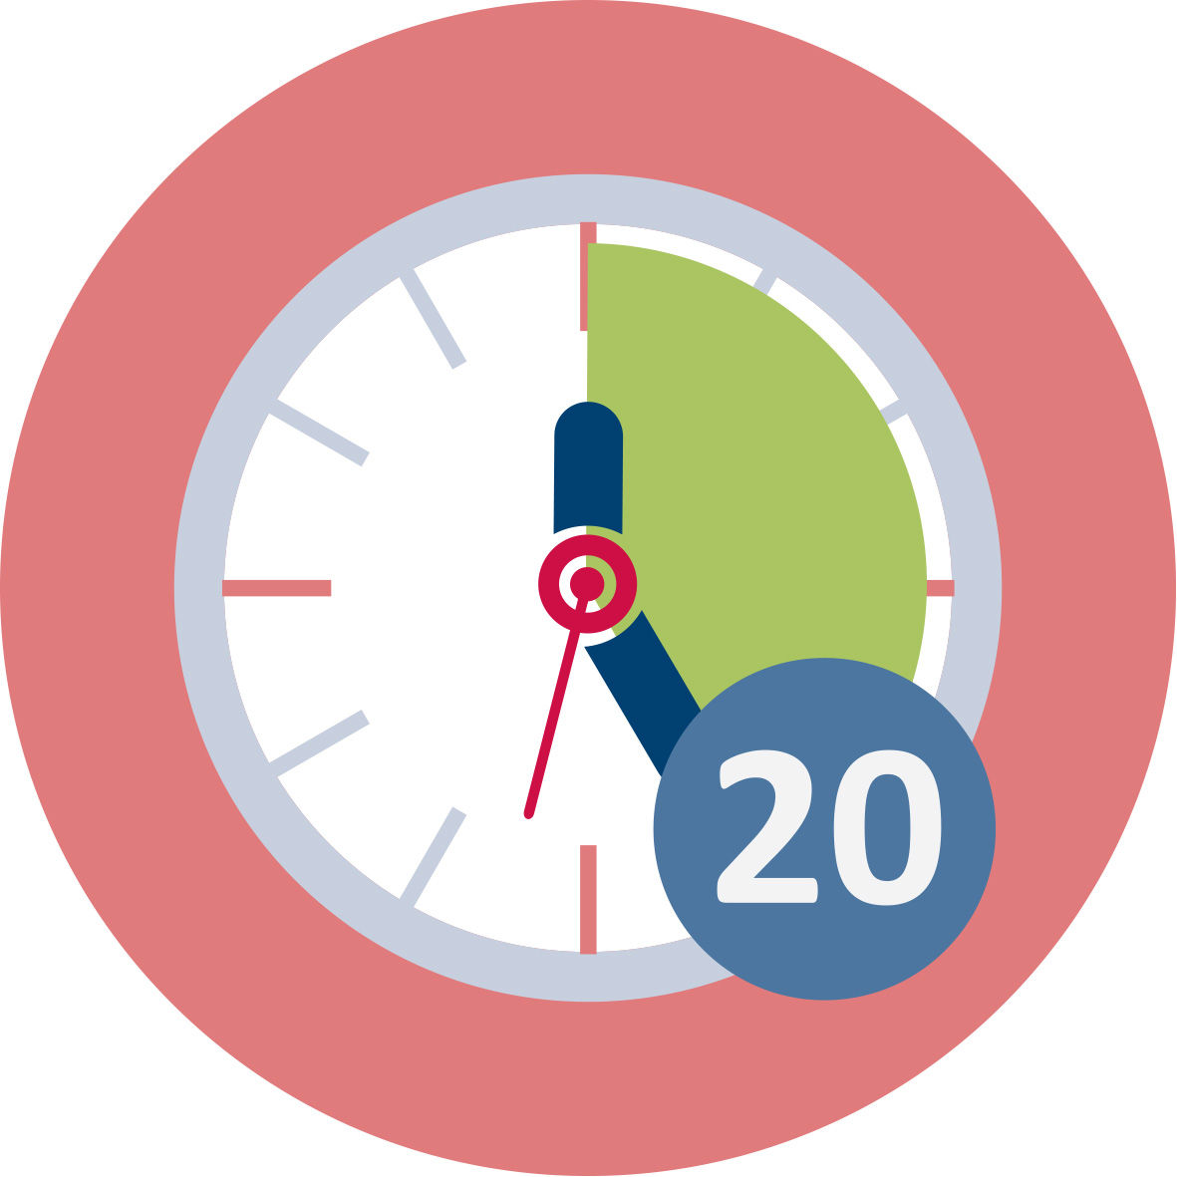
Duration: 20 minutes (total)
10 mins pairs + 10 mins in small/large groups
We recommend doing this activity as an introduction of the course. The main aim is building a classroom atmosphere of respect and mutual appreciation. Knowing your students and providing them with opportunities to better know each other is a basic requirement for recognizing others as equal human beings and building an atmosphere of respect and mutual appreciation in a culturally diverse classroom.
In this activity, pre-service teachers will experience a technique they can later use with their students to promote affective ties and an atmosphere of acceptance and recognition in culturally diverse classrooms.
Pre-service teachers will be set in pairs and asked to introduce themselves (name, age, origin) and share the following personal information:
- Two activities I enjoy doing alone are…
- Two activities I enjoy doing with others are…
- My favorite food is…
- My favorite feast is…
I am good at…
A nice memory to share is…
In my near future I would like to…
After 10 min working in pairs, any participant will introduce his/her pair to the rest of the group (10 min). Teachers/teacher educators can decide whether to set groups of 5-6 people for this second part of the activity or doing it with the whole class, depending on the characteristics and the size of the class group.
This activity contributes to the achievement of the following learning outcomes:
- Promote empathy, respect and mutual appreciation through the use of specific techniques.

I. Experiencing SSI as reflective learners

1.1. What are Socio-Scientific Issues and why are they interesting for enhancing science learning in culturally diverse classrooms
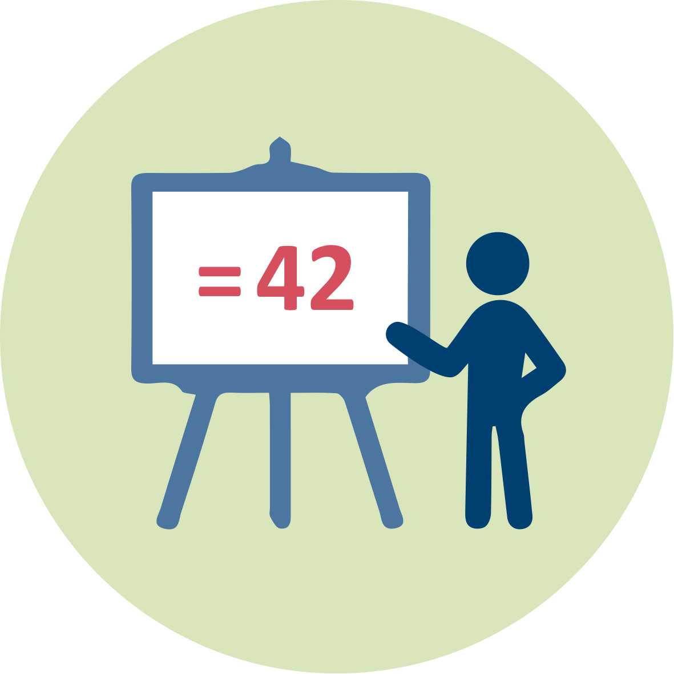 | Duration: 10 minutes
The purpose of this short activity is to briefly introduce and motivate the topic: what are Socio-Scientific Issues (SSI) and why are they interesting for science teachers working in culturally diverse classrooms. Firstly, we will clarify what is culture and then introduce SSI.
In line with the key concepts developed in IO1, we define culture as a system of beliefs, symbols, meanings, customs, and behaviours shared by a social group. Different cultures are not always equivalent to language boundaries or national borders. A complex society exists of partial cultures that are not static but change over time and influence each other (OECD, 2010). Culture can also have an impact on learning since, it mediates in the construction of meanings and the interpretation of the world and has an influence on individuals’ values and dispositions.
Identifying cultural differences and commonalities and promoting mutual understanding and appreciation is essential to build an appropriate working atmosphere. SSI offer powerful scenarios to encourage the constructive exploration of different views and perspectives.
Socio-Scientific Issues are related to science and technology in nowadays societies and usually entail controversy due to the socio-cultural, ethical and environmental implication of some scientific and technological advances. They have the potential to:
- Trigger students’ engagement with the topic and the need to express opinions, thus enhancing communication and learning.
- Provide powerful opportunities to develop a better understanding of science and its applications and implications.
- Bring a pedagogical approach based on argumentation and the consideration of diverse perspectives (scientific, social, ethical, moral, cultural, economic, environmental).
- Promote argumentation skills and critical thinking.
- Require a classroom atmosphere of democratic deliberation and respect, which is of special value in culturally diverse classrooms.
It is important to note that SSI are an interesting pedagogy for culturally diverse classrooms even when the focus of the topic is not specifically on cultural issues. The reasons for that are that SSI provide meaningful opportunities to link science and society and to explore and evaluate different perspectives of a particular issue, building a culture of respect and tolerance for others’ ideas. Additionally, SSI bring a sense of authenticity into the classroom, increasing students’ motivation and engaging students who do not usually engage in traditional science lessons.
This activity contributes to the attainment of the following learning outcome:
- Recognise the potential of SSI to enhance science education in culturally diverse classrooms.

I. Experiencing SSI as reflective learners

1.2. Immersion task: Are you in favour or against?
Duration: 20 minutes
Pre-service teachers are asked to take a personal position in relation to a particular SSI and write down arguments to justify their opinion.
Some examples of potential SSI to be discussed are:
- Are you in favour of genetically modified food?
- Are you in favour of genetic testing?
- Would you ban coke sales to under-18s?
At this very early stage, students will be asked to express their opinions based on their own ideas before inquiring on the issue in activity 1.3.
It is strongly recommended to use SSI related to recent news in the local media or to events or facts that have taken place in the neighbourhood and can be perceived as relevant or familiar to your particular group of students. Videos can be a catching and engaging way to introduce the selected SSI.
For instance, you could present the following new in the class and ask pre-service teachers whether they would continue buying pangasius fish:

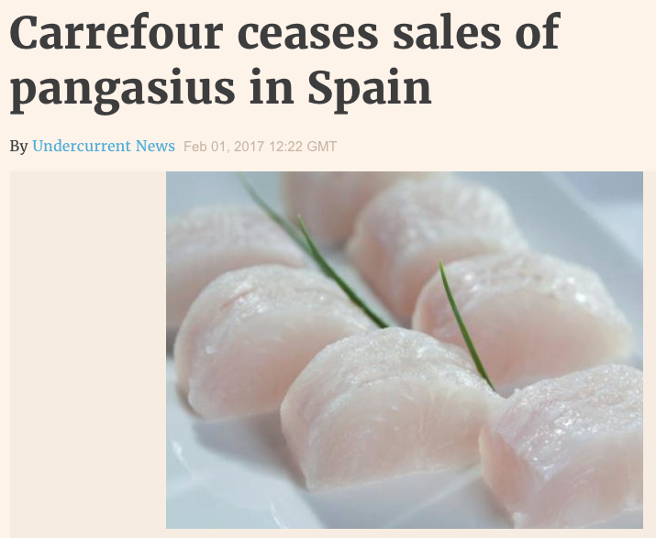
Source: https://www.undercurrentnews.com/2017/02/01/carrefour-ceases-sales-of-pangasius-in-spain/
After exploring student teachers’ initial opinions, you could ask them to further inquiring on the issue looking at different perspectives (health, environment, economy…). Finally, you can encourage them to take informed positions and responsible actions in this respect (for instance writing a letter to the school canteen with some recommendations). Working on this SSI in the classroom promotes the development of inquiry, argumentation and decision-making skills in students and allows them to better understand the social, environmental and economic implications of the way pangasius fish is raised.
The following new offers other example of a potentially interesting SSI scenario. It can be used to ask your student teachers whether they would choose gluten free pizza even though they were not celiac:
Source: https://www.everydayhealth.com/diet-nutrition/will-going-gluten-free-make-you-healthier.aspx
After a first exploration of ideas you could ask your students to further inquiry on the issue in order to make an informed decision keeping in mind the reliability of information sources and the potential existence of underlying interests. They will need to know what celiac disease is, how gluten-free wheat food is produced and whether it could be considered a healthier option for normal people. Economic issues can also be discussed based on the fact that gluten-free food is usually much more expensive. Additionally, other cultural aspects can be discussed related to food habits and social trends. Results from the use of these activities in the classroom and more information about how they enhance science learning and critical thinking may be found in Romero-Ariza et al. (2018).
There is a nice collection of SSI scenarios developed within the European project ENGAGE
In the following we include some more examples taken from the above source, which could be used to work on science content knowledge from a socio-scientific perspective:
Physics and Biology
We could present a new about the impact of mobile phones on our neck and ask students to express their views about that information.
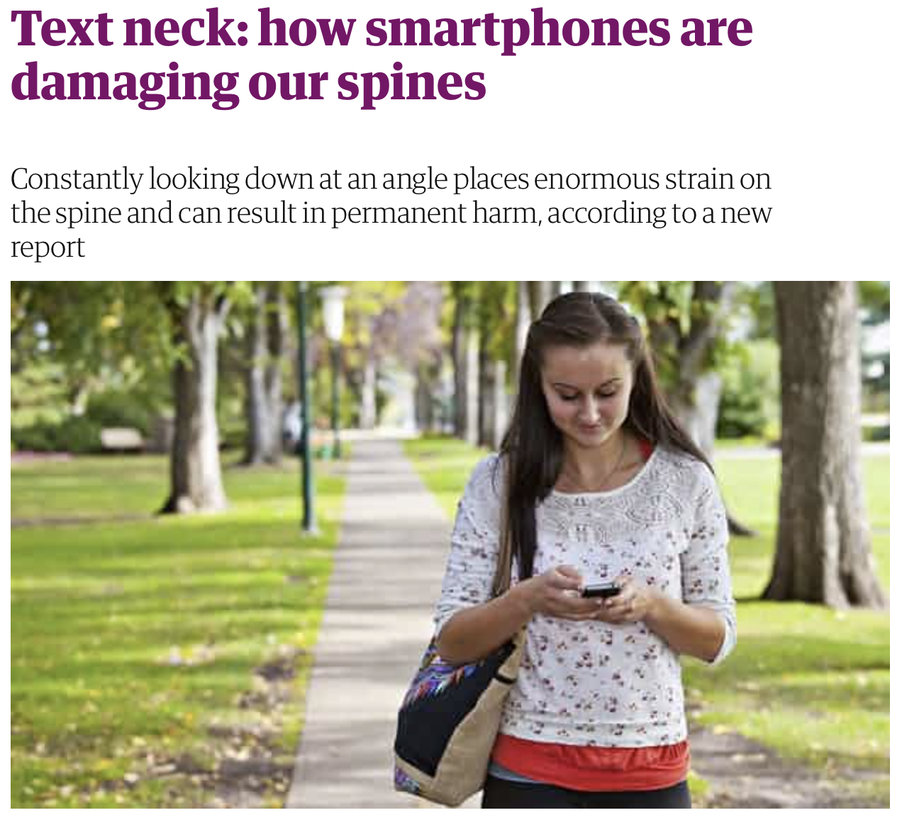
Source: https://www.theguardian.com/lifeandstyle/shortcuts/2014/nov/24/text-neck-how-smartphones-damaging-our-spines
After the initial discussion and in later stages students can be asked to explain the claim and to evaluate the reliability of the information provided. Finally, they can debate the issue and take informed positions taking into consideration different perspectives (health, society and communication, economy…). This scenario provides meaningful opportunities to apply science knowledge (the effect of forces on our body) and encourages the discussion of a strong cultural trend on the use of mobile phones and some potential impact on our health.
Chemistry, Biology and Earth Sciences
Starting from news about how eating insects could help tackling climate change we can initiate a debate in the classroom to discuss the topic and ask students to take a personal position in this respect.
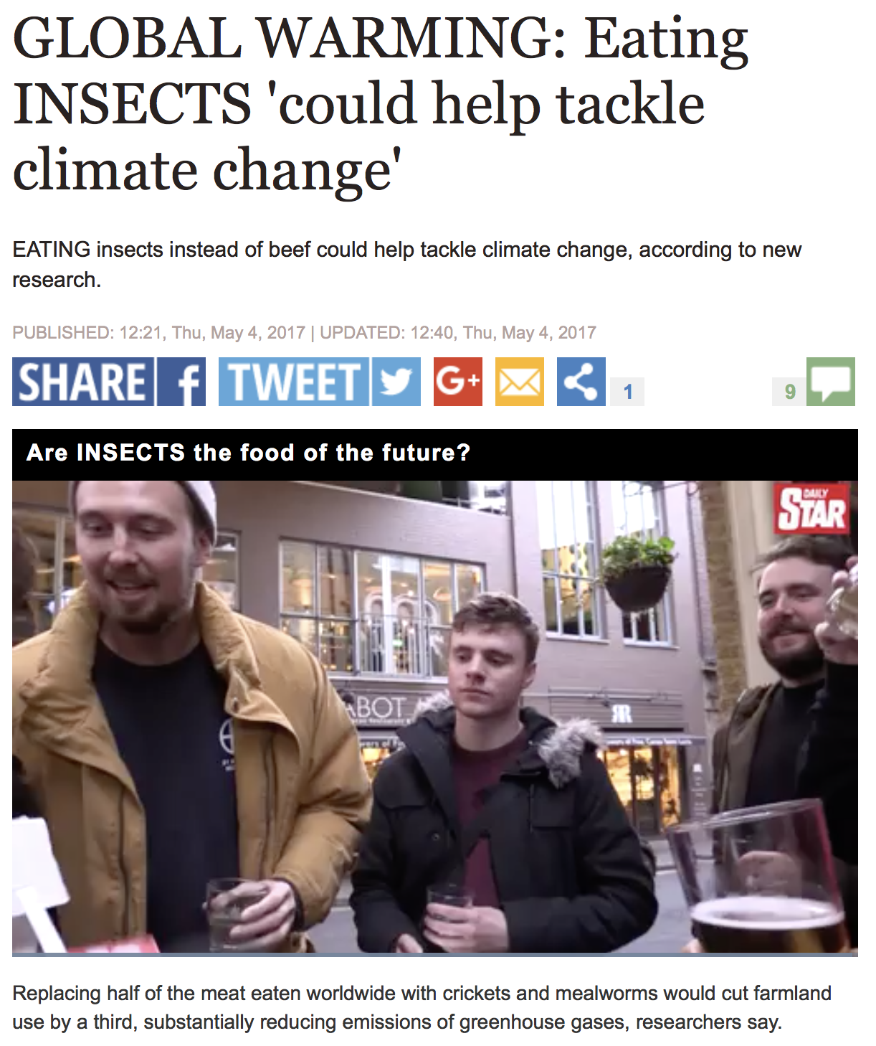
Source: https://www.express.co.uk/news/nature/800191/Global-warming-climate-change-meat-production-eating-insects-research

In latter activities we can engage students in an inquiry about the reasons for that claim working on a wide range of science topics such as the impact of human activities on CO₂ production (chemistry), global warming (earth science) or healthy food (biology). These kinds of scenarios are not only useful for applying science knowledge in a meaningful way, but also for developing inquiry and argumentation skills in students. Additionally, we can see how this latter example about eating insects allows the discussion of cultural issues related to food and personal habits.
Environmental education and Earth Sciences
The human impact on the planet partly due to current advances in science and technology is other example of SSI that might be of interest in culturally diverse classrooms. For instance, we can encourage student to inquiry about what is their ecological footprint and to discuss how culture influence our consumptions habits and the use of energy, transport, water and other resources. An interesting tool to calculate ecological footprint is available at
https://footprint.wwf.org.uk
After taking a personal position about the SSI selected and presented by the teacher educator and writing down their arguments, pre-service teachers will be asked to represent their positions using different techniques to support the development of argumentation skills:
1. The teacher educator will set a line along the classroom pointing out different levels of agreement with responses to the previous questions (for instance ‘genetically modified food should be forbidden’; ‘I will keep on buying pangasius fish’; ‘I would order gluten-free pizza’…) and ask everyone to position them along the line:
Totally disagree---------------Disagree----------------Agree---------------Totally agree
Individuals standing close to each other should exchange arguments and adjust positions. How participants position themselves along the line can promote discussion, for example, participants near each other can negotiate which one is nearer the agreement/disagreement end. Those on different ends of the spectrum can work in groups to further refine the views about which they differ.
2. To support reflection about the nature of the arguments being used, pre-service teachers can be asked to position their arguments along a line between emotion and ration and to identify pro and cons, using the following diagram:
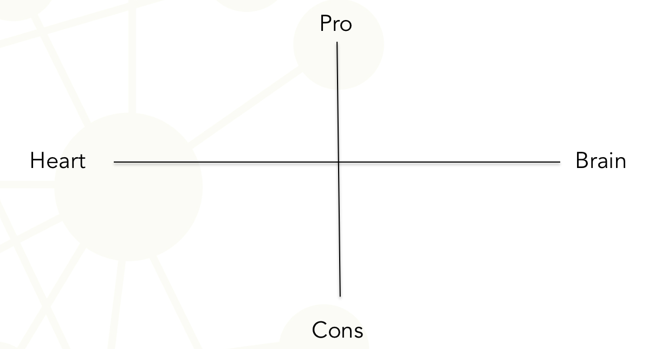
The use of relevant and engaging topics along with techniques to encourage communication and argumentation in the classroom can be especially interesting to facilitate and enhance science learning in culturally diverse groups.
This session contributes to the achievement of the following learning outcomes:
- Recognise the potential of SSI to enhance science education in culturally diverse classrooms.
- Facilitate the recognition of emotional and rational arguments and support students’ informed decision-making.
- Support the development of communication and argumentation skills in students with diverse cultural backgrounds.

I. Experiencing SSI as reflective learners

1.3. Reconsidering previous positions after inquiring about SSI
Duration: 60 minutes
Pre-service teachers will be asked to inquiry about the previously introduced SSI in order to get a deeper understanding of it. They are asked to look at different perspectives (scientific, social, ethical, environmental, health…) and to evaluate implications at different levels (individual/social; global/global).
They should be invited to reflect on reliability and biased issues concerning the sources of information consulted.
After a deeper inquiry on the issue, they will be asked to revise the personal position expressed in the activity 1.2 and to evaluate the quality of the arguments used to back up their position. For this purpose, they will have to critically analyse the kind of evidence offered (Balgopal, Wallace and Dahlberg, 2017) and to decide whether the arguments are:
- Superficial (with no evidence-based claims).
- Subjective (drawing on personal funds of Knowledge: personal experiences or beliefs…).
- Objective (based on academic/scientific evidence).
- Authentic (combining subjective and objective evidence).
This session contributes to the achievement of the following learning outcomes:
- Recognise the potential of SSI to enhance science education in culturally diverse classrooms.
- Support the development of communication and argumentation skills in students with diverse cultural backgrounds.

I. Experiencing SSI as reflective learners

1.4. Promoting active listening and empathy
Duration: 20 minutes
The main aim of this activity is to provide pre-service teachers with an opportunity to experience a strategy to promote active listening along with the development of argumentation skills, as important competences to develop in culturally diverse classroom.
One way to promote democratic deliberation and active listening is to ask two groups of participants (group A and group B) to take opposing positions in relation to a particular SSI. Both groups are given time to prepare their arguments. Group A then presents their position within a three-minute time slot. Group B listens and then has to represent Group A’s case even more strongly back to group A and, if possible, with stronger backing and evidence. The positions are then reversed and differences between the two opposing positions are discussed at the end.
This session contributes to the achievement of the following learning outcomes:
- Recognise the potential of SSI to enhance science education in culturally diverse classrooms.
- Support the development of communication and argumentation skills in students with diverse cultural backgrounds.
- Promote respect to others’ opinions and active listening in culturally diverse classrooms.

I. Experiencing SSI as reflective learners

1.5. Reflecting on what can be learned from this activity
Duration: 10 minutes
Pre-service teachers will be asked to write down and discuss in small groups what they have learned through inquiring, reflecting and arguing about SSI in terms of:
- Knowledge and information (about the foundation and implications of scientific and technological products…)
- Skills (search for, critical selection and analysis of information, evaluation of the quality of evidence, argumentation, discussion…)
- Values and dispositions (openness to take into account different perspective, critical stance to evaluate evidence and fund…)
Additionally, pre-service teachers will be asked to reflect on whether the activity could be meaningful to their students and how the activity could make them aware of their own and others’ cultural perspective and how it might influence science learning.
This session contributes to the achievement of the following learning outcomes:
- Recognise the potential of SSI to enhance science education in culturally diverse classrooms.
- Use socio-scientific issues to enhance the understanding of science and its implications in our current lives, taking into consideration cultural, ethical, economical and environmental issues.
- Support the development of communication and argumentation skills in students with diverse cultural backgrounds.
- Facilitate the recognition of emotional and rational arguments and support students’ informed decision-making.

II. Designing SSI as teachers in small groups

2.1. Engaging students
Duration: 20 min
As a first step in the design of a teaching proposal for enhancing science learning through the use of SSI, pre-service teachers will be asked to identify a ‘relevant’ and ‘engaging’ SSI topic.
The topic will be good to facilitate students’ learning and engagement if it is connected to their potential interests and well adapted to their capacities. In addition, the topic is likely to be relevant for students if they perceive it as authentic and connected to their close experience and real needs.
After reflecting on the previously mentioned conditions, pre-service teachers will be asked to have a look at current news and events to identify an adequate and engaging SSI topic for their students. They will be encouraged to make use of media (videos, news, advertisements…) to introduce the topic in a catching way.
This session contributes to the achievement of the following learning outcomes:
- Trigger students’ active engagement in a culturally diverse classroom by using media, recent news and events from students’ close environment.
- Use socio-scientific issues to enhance the understanding of science and its implications in our current lives, taking into consideration cultural, ethical, economical and environmental issues.

II. Designing SSI as teachers in small groups

2.2. Mapping controversy and preparing scaffolding
Duration 60 min
The second step in the design of a teaching proposal for enhancing science learning through the use of SSI requires the map of the controversy by the teacher and the preparation of scaffolding to support students.
At this point pre-service teachers should map the controversy themselves in order to identify key aspect to discuss and learn about, in relation to the previously selected SSI, advance possible students’ difficulties and prepare guiding questions to support effective inquiry and reasoning.
Special emphasis should be placed on:
- The identification of different types of arguments: scientific, social, ethical, economical, environmental…).
- The evaluation of contrasting points of views considering benefits versus risks and implications at different levels (individually/locally/globally).
- The critical examination of bias and reliability concerning the sources of information.
These criteria will be transferred to students later on in order to guide them in mapping the controversy. They will also be important to inform position taking and decision-making.
This session contributes to the achievement of the following learning outcomes:
- Recognise the potential of SSI to enhance science education in culturally diverse classrooms.
- Use socio-scientific issues to enhance the understanding of science and its implications in our current lives, taking into consideration cultural, ethical, economical and environmental issues.
- Support the development of communication and argumentation skills in students with diverse cultural backgrounds.

II. Designing SSI as teachers in small groups

2.3. Encouraging action taking
Duration 10 min
An interesting reason for introducing SSI into the science classroom is related to enabling students to make-informed decisions and become active and responsible citizens. The purpose of this activity is to ask pre-service teachers to think of potential ways to encourage students’ consequent actions in relation to SSI. Empowering students to make a relevant contribution to their own lives/communities can be a positive motif for active learning and engagement and add an extra value to the educational intervention, especially in culturally diverse classrooms.
For instance, after exploring and discussing the controversy related to the consumption of red and processed meat, students can decide to make a brochure to disseminate important information relating to the risk of developing cancer within the community (school and families) or write a letter to advice public canteens to reduce the intake of red and processed meat.
This session contributes to the achievement of the following learning outcomes:
- Recognise the potential of SSI to enhance science education in culturally diverse classrooms.
- Trigger students’ active engagement in a culturally diverse classroom.
- Use socio-scientific issues to enhance the understanding of science and its implications in our current lives, taking into consideration cultural, ethical, economical and environmental issues.
- Support the development of communication and argumentation skills in students with diverse cultural backgrounds.
- Build an atmosphere of ownership within a culturally diverse group joined by fundamental values and the achievement of common goal.
- Encourage students’ meaningful application of knowledge, values and skills to take actions that will improve their close environment.

II. Designing SSI as teachers in small groups

2.4. Mapping curriculum
Duration: 20 min
Once pre-service teachers had selected a relevant SSI, prepared how to introduce it in an engaging way and mapped the controversy they are asked to define students’ expected learning outcomes.
For this purpose, they will have to:
- Reflect on what students could learn by working on the selected SSI.
- Identify connections with the school curricula in terms of:
- Content knowledge.
- Competences and skills.
- Values and dispositions.
This session contributes to the achievement of the following learning outcomes:
- Recognise the potential of SSI to enhance science education in culturally diverse classrooms.

II. Designing SSI as teachers in small groups

2.5. Defining assessment criteria
Duration: 10 min
At this point, pre-service teachers will be asked to discuss how they would assess the learning goals defined in the previous activity and set consistent assessment criteria and processes.
This session contributes to the achievement of the following learning outcomes:
- Apply assessment criteria and processes aligned with the learning goals related to the use of SSI in culturally diverse science classrooms.

III. Discussing and improving SSI as reflective practitioners

3.1 Presenting and discussing the classroom activities designed as teachers
Duration: 30 min
The main purpose of this activity is offering opportunities to share and discuss the classroom activities designed by pre-service teachers in task 2. Any small group will present their activities to the rest of the class and receive constructive feedback.
This session contributes to the achievement of the following learning outcomes:
- Discuss the design of classroom activities based on the use of SSI to enhance science learning.

III. Discussing and improving SSI as reflective practitioners

3.2 Improving the design of classroom activities according to quality criteria
Duration: 30 min
Pre-service teachers will be provided with quality criteria to critically evaluate the design of SSI-based classroom activities.
Teacher educators can decide to present and discuss table 1 in the beginning of task 2 (designing SSI as teachers) instead of at this point, in order to make pre-service teachers aware of the key aspect to take into account when designing good SSI-based classroom activities.
The following table includes the quality criteria and can be used as an instrument for self and peer evaluation.
Table 1: Quality criteria to improve the design of classroom activities based on the use of SSI.
Key aspect | Quality criteria
Introduction and hook | Good use of media (videos, ads…) to introduce relevant SSI to students.  Well adapted to students’ age and interests. Motivating/engaging.  Positive and negative views.
Mapping Controversy | The topic is related to scientific/technological advances and controversial.  Different dimensions are analysed in an accurate/critical way (scientific, social, economical, environmental, health)  Counter arguments are taken into account: it might include different interest’s groups, evaluation of benefits/risks; individual/local/global.  Awareness of reliability issues and potential bias.
Curriculum | There are consistent and specific links to the school curriculum (competences, standards, content…).  Curricular elements are defined in an correct way.  Learning goals are consistent with the SSIBL approach.
Assessment | The assessment criteria and processes are consistent with the learning goals related to the use of SSI in culturally diverse classrooms.  The assessment criteria are defined (expressed) in an appropriate way.
Scaffolding | The questions for scaffolding:  - draw attention on key aspects  - advance potential students’ difficulties and guide students  - promote students’ reflection and argumentation  - are well formulated  Strategies to support students’ argumentation skills are applied: e.g. levels of disagreement, nature of the arguments, quality of the evidence…
Taking Action | Students are asked to conduct activities or make products that require informed decision making and/or action taken.
This session contributes to the achievement of the following learning outcomes:
- Discuss the design of classroom activities based on the use of SSI to enhance science learning.
- Critically reflect on quality criteria for the design of good SSI-based classroom activities and how to improve science teaching in culturally diverse classrooms.

Materials and resources

Presentation 1 (pptx). Teacher Educator: Introduction to the topic and its interest for enhancing science learning in culturally diverse classrooms.
Readings to learn more (see the section for ‘further reading’).
Worksheets for the activities related to tasks I, II and III.
Internet resources for introducing SSI scenarios

Granularity
The tasks and activities have been designed with enough granularity to be used separately depending on the time available and the class group. If all the activities can be implemented in a particular ITE program, we suggest the sequence display in the flow chart.
However, depending on the time available, the context or the class group, teacher educators can decide to skip some of the activities in any of the task or use any of the following options:
- Task 1
- Task 1 + Task 2
- Task 1 + Task 2 + Task 3
The background activity “Knowing each other” could be skipped if you perceive your students know each other quite well.
Time frames are estimations which could vary depending on the size of the class group. If less time is available some of the activities can be proposed as homework, for instance 2.2 and 2.4.
Additionally, we propose some further reading to expand pre-service teachers’ knowledge and pedagogical content knowledge, if more time is available.

References
Ariza, M. R., Abril, A. M., Quesada, A. (2017). Enhancing Science and Mathematics Education in Multicultural Contexts: Guidelines for Open Learning Environments. In L. Gómez Chova, A. López Martínez, I. Candel Torres. INTED2017 Proceedings (pp. 9458-9466). Valencia: IATED Academy.
Avalos, B. (2011). Teacher professional development in Teaching and Teacher Education over ten years. Teaching and Teacher Education, 27(1), 10-20.
Balgopal, M.M., Wallace, A.M, Dahlberg, S. (2017) Writing from different cultural contexts: How college students frame an environmental SSI through written arguments. Journal of Research in Science Teaching, 54 (2), 195-218. DOI: 10.1002/tea.21342.
Camburn, E. M., & Han, S. W. (2015). Infrastructure for teacher reflection and instructional change: An exploratory study. Journal of Educational Change, 16(4), 511-533.
Clarke, D., & Hollingsworth, H. (2002). Elaborating a model of teacher professional growth. Teaching and Teacher Education, 18(8), 947-967.
Davis, E. A., & Krajcik, J. S. (2005). Designing educative curriculum materials to promote teacher learning. Educational researcher, 34(3), 3-14.
Desimone, L. M. (2011). A primer on effective professional development. Phi delta kappan, 92(6), 68-71.
Girvan, C., Conneely, C., & Tangney, B. (2016). Extending experiential learning in teacher professional development. Teaching and Teacher Education, 58, 129-139.
Lederman, N. G., Antink, A., & Bartos, S. (2014). Nature of science, scientific inquiry, and socio-scientific issues arising from genetics: A pathway to developing a scientifically literate citizenry. Science & Education, 23(2), 285-302.
Levinson, R. (2006). Towards a theoretical framework for teaching controversial socio-scientific issues. International Journal of Science Education, 28(10), 1201-1224.
OECD, 2010). Educating teachers for diversity: Meeting the challenge. Educational research and innovation. Paris: OECD, pp. 43.
Loucks-Horsley, S., Love, N., Stiles, K. E., Mundry, S., & Hewson, P. W. (2003). Designing Professional Development for Teachers of Science and Mathematics. Thousand Oaks, California: Corwin Press, Inc.
Ratcliffe, M., & Grace, M. (2003). Science education for citizenship: Teaching socio-scientific issues. Berkshire (UK): McGraw-Hill Education.
Romero-Ariza, M., Abril, A. M., & Quesada, A. (2017). Design and Evaluation of Teaching materials for Responsible Research and Innovation. Sisyphus – Journal of Education, 5(3), 28-43. http://revistas.rcaap.pt/sisyphus/article/view/12273/10271
Romero-Ariza, M., Abril, A. M., & Quesada, A. (2018). Empowering teachers to bring authenticity and responsive action into the science classroom. School Science Review, 100(371), 40-45.
Sadler, T. D., & Dawson, V. (2012). Socio-scientific issues in science education: Contexts for the promotion of key learning outcomes. In B. J. Fraser, K. Tobin & C. J. McRobbie (Eds.), Second International Handbook of Science Education (pp. 799-809). The Netherlands: Springer.
Simon, S., & Campbell, S. (2012). Teacher learning and professional development in science education. In Second international handbook of science education (pp. 307-321). Springer Netherlands.
Vázquez-Alonso, Á., Aponte, A., Manassero-Mas, M. A., & Montesano, M. (2016). A teaching–learning sequence on a socio-scientific issue: analysis and evaluation of its implementation in the classroom. International Journal of Science Education, 38(11), 1727-1746.
Venville, G. J., & Dawson, V. M. (2010). The impact of a classroom intervention on grade 10 students' argumentation skills, informal reasoning, and conceptual understanding of science. Journal of Research in Science Teaching, 47(8), 952-977.

Further readings
Dittmer, A., Gebhard, U. (2015). Intuitions about science, technology, and nature: A fruitful approach to understand judgments about socio-scientific issues. Affective Dimensions in Chemistry Education, pp. 89-104. DOI: 10.1007/978-3-662-45085-7_5
This piece of work allows a deeper understanding of decision-making processes, which are based on culturally embedded beliefs about a science-based world or the meaning of nature. Such beliefs are part of the worldview and self-understanding of students and have effects on their decision making about socio-scientific issues. Knowledge about the intuitive dimension of ethical judgments should support a sensitive attitude of teachers toward students and toward the cultural range of science.
France, B., Mora, H.A., Bay, J.L. (2012). Changing Perspectives: Exploring a pedagogy to examine other perspectives about stem cell research. International Journal of Science Education, 34 (5), 803-824. DOI: 10.1080/09500693.2011.630427
This reference could be of interest for understanding the nature of barriers due to cultural differences when learning science and for knowing about specific strategies to facilitate communication, reasoning and science learning through the use of SSI in culturally diverse classrooms.
Dinsmore, D.L., Zoellner, B.P., Parkinson, M.M., Rossi, A.M., Monk, M.J., Vinnachi, J. (2017). The effects of different types of text and individual differences on view complexity about genetically modified organisms. International Journal of Science Education, 1-23. Article in Press. DOI: 10.1080/09500693.2017.1298871
This reference is useful to understand the potential of different types of texts to challenge students’ beliefs, promote conceptual understanding and support the use of evidence-based arguments when discussing a socio-scientific issue.
Balgopal, M.M., Wallace, A.M, Dahlberg, S. (2017) Writing from different cultural contexts: How college students frame an environmental SSI through written arguments. Journal of Research in Science Teaching, 54 (2), 195-218. DOI: 10.1002/tea.21342
This reference provides an interesting framework for classifying arguments according to the quality of the evidence used, what is of special interest to bridge the gap in argumentation skills between students of different cultural backgrounds.

Assessment
Pre-service teachers’ arguments, reactions, attitudes and dispositions to the activities developed, along with the artefacts produced (the SSI-based classroom activities designed by them) can be used as the basis to evaluate to what extent they have achieved the expected learning outcomes. The following assessment criteria can be applied:
- They positively engage in activities intended at promoting empathy and mutual appreciation in the class group.
- They actively listen to partners and show respect for others’ personal opinions.
- They evaluate arguments in a consistent way according to different criteria.
- They re-think previous positions after exploration and discussion.
- They identify appropriate SSI to enhance science education in their future classrooms, linking science learning and socio-cultural aspects.
- They select suitable videos, recent news and events to introduce a particular SSI to their future students in a relevant and engaging way.
- They display different perspectives and interest groups in the selected SSI (map of the controversy).
- They prepare appropriate questions to guide students’ exploration and discussion of the selected SSI.
- They identify key curricular elements that can be addressed through the SSI-based classroom activity.
- They formulate consistent learning outcomes for the SSI-based classroom activity.
- They define appropriate assessment criteria for the SSI-based activity.
- They critically discuss and review the design of SSI-based classroom activities.

