Module 4 |  | SOCIO-SCIENTIFIC ISSUES

Worksheets

This worksheet is based on the work within the project Intercultural learning in mathematics and science initial teacher education (IncluSMe). Coordination: Prof. Dr. Katja Maaß, International Centre for STEM Education (ICSE) at the University of Education Freiburg, Germany. Partners: University of Nicosia, Cyprus; University of Hradec Králové, Czech Republic; University of Jaen, Spain; National and Kapodistrian University of Athens, Greece; Vilnius University, Lithuania; University of Malta, Malta; Utrecht University, Netherlands; Norwegian University of Science and Technology, Norway; Jönköping University, Sweden; Constantine the Philosopher University, Slovakia.

The project Intercultural learning in mathematics and science initial teacher education (IncluSMe) has received co-funding by the Erasmus+ programme of the European Union under grant no. 2016-1-DE01-KA203-002910. Neither the European Union/European Commission nor the project's national funding agency DAAD are responsible for the content or liable for any losses or damage resulting of the use of these resources.

IncluSMe project (grant no. 2016-1-DE01-KA203-002910) 2016-2019, lead contributions by Romero-Ariza, M., Quesada, A. & Abril, A. M. University of Jaén, Jaén, Spain.
CC-BY-NC-SA 4.0 license granted (find explicit terms of use at: https://creativecommons.org/licenses/by-nc-sa/4.0/deed.en)

0. Generating an appropriate atmosphere
 | Background activity: Knowing each other
 |  | Work in pairs and in groups | 20 mins (10´+10´)
You will work in pairs to experience a technique you can later use with your students.

Introduce yourself to your partner for this activity (name, age, origin) and share the following personal information with him/her:
- Two activities I enjoy doing alone are…
- Two activities I enjoy doing with others are…
- My favorite food is…
- My favorite feast is…
- I am good at…
- A nice memory to share is…
- In my near future I would like to…

After 20 min working in pairs, any participant should introduce his/her partner for this activity to the rest of the group (20 min)

I. Experiencing Socio-Scientific Issues (SSI) as reflective learners
 | Activity 1.1: Introduction
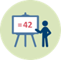 |  | Presentation |  | 10 mins
What are SSI and why are they interesting for enhancing science learning in culturally diverse classrooms

The purpose of this short activity (10 min) is to briefly introduce what culture is and motivate the topic: what are Socio-Scientific Issues and why are they interesting for science teachers working in culturally diverse classrooms?
Socio-Scientific Issues (SSI) are related to science and technology in nowadays societies and usually entail controversy due to the social, ethical and environmental implication of some scientific and technological advances. They have the potential to:
- Trigger students’ engagement with the topic and the need to express opinions, thus enhancing communication and learning.
- Provide powerful opportunities to develop a better understanding of science and its applications and implications.
- Bring a pedagogical approach based on argumentation and the consideration of diverse perspectives (scientific, social, ethical, moral, cultural, economical, environmental).
- Promote argumentation skills and critical thinking.
- Require a classroom atmosphere of democratic deliberation and respect, which is of special value in culturally diverse classrooms

I. Experiencing Socio-Scientific Issues (SSI) as reflective learners
 | Activity 1.2: Immersion task: Are you in favor or against?
 |  | Work individually and in groups |  | 20 mins
Take a personal position and write down your arguments

After being introduced to a particular socio-scientific issue by the teacher, think about your opinion and write down the arguments that justify your position.

Position yourself along the line and express your opinion
Totally disagree---------------Disagree----------------Agree---------------Totally agree
After positioning yourself, talk to the person standing on your right and the person standing on your left and exchange arguments. After discussing with them, decide wether you should keep your position or move.
Talk to the person standing at the furtherst position from yours and exchange your arguments with him/her.

Reflect on the basis of your opinion and the nature of your arguments
To support reflection about the nature and quality of your arguments you should place them along the line below. The position will show if they have a rational and/or emotional basis and to what extent they entail positive aspects (pro) or negative ones (cons).
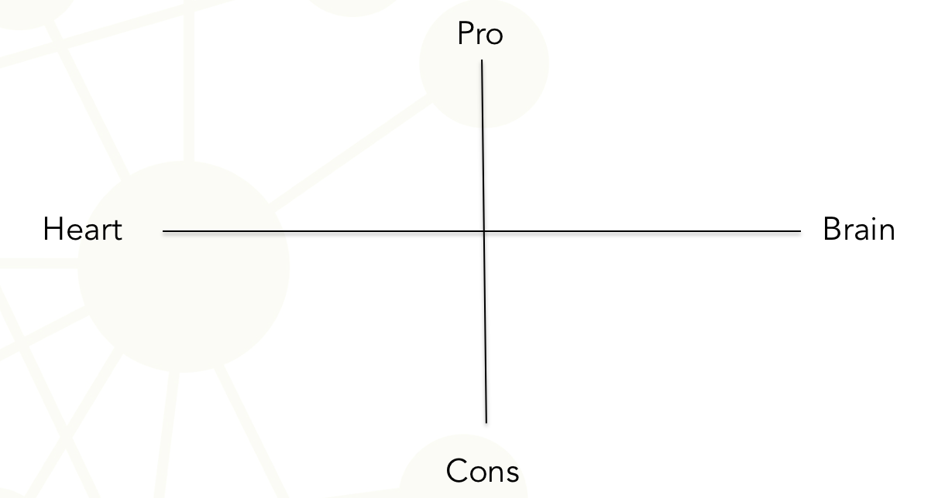

I. Experiencing Socio-Scientific Issues (SSI) as reflective learners
 |  | Activity 1.3: Reconsidering previous position after inquiring about SSI
 | Work individually |  |  | 60 mins
Getting a deeper understanding and reconsidering opinions
Search for information in order to get a deeper understanding of the SSI discussed in the previous activity. It is important to inquiry about the issue trying to unfold different perspectives (scientific, social, ethical, environmental, health…). Evaluate the implications of the issue at different levels (individual, social and global). You should reflect on the reliability of the sources of information consulted and be aware of the potential existence of bias.
After inquirying on the issue and carefully reflecting on the basis of different arguments and the wide range of implications, review the opinions and positions expressed in activity 2 and classify your arguments according to the following categories:
- Superficial (with no evidence-based claims).
- Subjective (drawing on personal funds of Knowledge: personal experiences or beliefs…).
- Objective (based on academic/scientific evidence).
- Authentic (combining subjective and objective evidence).

This reference could help you: Balgopal, M.M., Wallace, A.M, Dahlberg, S. (2017) Writing from different cultural contexts: How college students frame an environmental SSI through written arguments. Journal of Research in Science Teaching, 54(2), 195-218. DOI: 10.1002/tea.21342.

I. Experiencing Socio-Scientific Issues (SSI) as reflective learners
 |  | Activity 1.4: Promoting active listening and empathy
 | Work in group |  |  | 20 mins
Experiencing an strategy to promote active listening:
- Prepare arguments to support the position of the group you have been assigned to and present them to the opposite group in 3 min.
- The opposite group will listen to you and represent your case even more strongly back, if possible.
- Reverse the positions.
- Discuss the differences between the two opposing groups.

I. Experiencing Socio-Scientific Issues (SSI) as reflective learners
 | Activity 1.5: Reflecting on what can be learned from this activity
 |  | Work in group and compiled ideas |  | 10 mins
Reflect on the following questions:
- Could SSI be engaging and motivating to your students?
- Could SSI encourage communication, discussion and the exchange of different perspectives in the classroom?
- Could SSI scenarios allows understanding of interactions between science, technology, culture and society?

Write down and discuss in small groups what you have learned through inquiring, reflecting and arguing in the previous activities in terms of:
- Knowledge and information (about the foundation and implications of scientific and technological products…).
- Skills (search for, critical selection and analysis of information, evaluation of the quality of evidence, argumentation, discussion…).
- Values and dispositions (openness to take into account different perspectives, critical stance to evaluate evidence and fund…).

- Designing SSI as teachers in small groups
 | Activity 2.1: Engaging students
 |  | Work in small groups |  | 20 mins
As a first step in the design of a teaching proposal for enhancing science learning through the use of SSI, you will have to identify a ‘relevant’ and ‘engaging’ SSI topic.

Have a look at the media and think of recent news and events related to current socio-scientific issues. Search for a topic which could be relevant for your future students. The topic or SSI will be perceived as relevant if it is well connected to your students’ needs and interests.

Use media (videos, news, advertisements…) to introduce the selected SSI in a catching way.

II. Designing SSI as teachers in small groups
 | Activity 2.2: Mapping controversy and preparing scaffolding
 |  | Work in small groups |  | 60 mins
The second step in the design of a teaching proposal for enhancing science learning through the use of SSI requires the controversy map and the preparation of scaffolding to support students.

At this point you should inquiry into the selected SSI yourself in order to identify key aspect to discuss and learn about, advance possible students’ difficulties and prepare guiding questions to support effective inquiry and reasoning.

Special emphasis should be placed on:
- The identification of different types of arguments: scientific, social, ethical, economical, environmental…).

- The evaluation of contrasting points of views considering benefits versus risks and implications at different levels (individually/locally/globally).

- The critical examination of bias and reliability concerning the sources of information.

.

II. Designing SSI as teachers in small groups
 | Activity 2.3: Encouraging action taking
 |  | Work in small groups |  | 10 mins
An interesting reason for introducing SSI into the science classroom is related to enabling students to make-informed decisions and become active and responsible citizens. The purpose of this activity is to think of potential ways to encourage students’ consequent actions in relation to SSI. In your teaching proposal, you have to empower students to make a relevant contribution to their own lives/communities.

For instance, after exploring and discussing the controversy related to the consumption of red and processed meat, students can decide to make a brochure to disseminate important information relating to the risk of developing cancer within the community (school and families) or write a letter to advice public canteens to reduce the intake of red and processed meat.

Think about that in your SSI context and explain the action your future students could undertake in this respect.

II. Designing SSI as teachers in small groups
 | Activity 2.4: Mapping curriculum
 |  | Work in small groups |  | 20 mins
Once you have selected a relevant SSI, prepared how to introduce it in an engaging way and mapped the controversy, you are asked to define students’ expected learning outcomes.

For this purpose you will have to:

- Reflect on what students’ could learn by working on the selected SSI.
- Identify connections with the school curricula in terms of:
    - Content knowledge.
    - Competences and skills.
    - Values and dispositions.

.

II. Designing SSI as teachers in small groups
 | Activity 2.5: Defining assessment criteria
 |  | Work in small groups |  | 10 mins
At this point, you are asked to discuss how you would assess the learning outcomes defined in the previous activity and set consistent assessment criteria and processes.
.

III. Discussing and improving activities as reflective practitioners
 | Activity 3.2: Improving the design of classroom activities according to quality criteria
 |  | Work in small groups |  | 30 mins
Your small group will be provided with quality criteria to critically evaluate the design of SSI-based classroom activities.
The following table includes the quality criteria and they will be used as an instrument for self and peer evaluation. That is, the classroom activities have to be evaluated and improved according to these quality criteria.
Table 1: Quality criteria to improve the design of classroom activities based on the use of SSI (*).

(*) Teacher educators can decide to present and discuss table 1 in the beginning of task 2 (designing SSI as teachers) instead of at this point, in order to make pre-service teachers aware of the key aspect to take into account when designing good SSI-based classroom activities.

