Module 5 | DIFFERENT PERSPECTIVES ON CURRENT ECOLOGICAL PROBLEMS

This Module is based on the work within the project Intercultural learning in mathematics and science initial teacher education (IncluSMe). Coordination: Prof. Dr. Katja Maaß, International Centre for STEM Education (ICSE) at the University of Education Freiburg, Germany. Partners: University of Nicosia, Cyprus; University of Hradec Králové, Czech Republic; University of Jaen, Spain; National and Kapodistrian University of Athens, Greece; Vilnius University, Lithuania; University of Malta, Malta; Utrecht University, Netherlands; Norwegian University of Science and Technology, Norway; Jönköping University, Sweden; Constantine the Philosopher University, Slovakia.

The project Intercultural learning in mathematics and science initial teacher education (IncluSMe) has received co-funding by the Erasmus+ programme of the European Union under grant no. 2016-1-DE01-KA203-002910. Neither the European Union/European Commission nor the project's national funding agency DAAD are responsible for the content or liable for any losses or damage resulting of the use of these resources.

IncluSMe project (grant no. 2016-1-DE01-KA203-002910) 2016-2019, lead contributions by Bilek, M. & Machkova, V., University of Hradec Kralove, Hradec Kralove, Czech Republic.
CC-BY-NC-SA 4.0 license granted (find explicit terms of use at: https://creativecommons.org/licenses/by-nc-sa/4.0/deed.en)

General overview and aim
In this module preservice teachers in initial teacher education are introduced to different perspective on current ecological problems in the context of intercultural learning. The intention is to make students familiar with the topic of module through the investigation of one concrete example concerning intercultural aspects of ecological problems – The Water. They will develop teacher´s competencies: to look at selected ecological problem from different territorial and cultural perspectives and to perceive and to apply the role of different cultural contexts in their lessons.
The module is based on concrete situations to connect students to the topic of module through their own experience with designed learning activities. The emphasis is placed on balance theory and practice realized by students active learning.

This module is part of:
- Mathematics and Science Subject dimension: (inter)cultural perspectives on the subjects themselves.

Relevant topics
In this module high emphasis is set on introducing different approaches to understand wide perspectives of one global ecological problem in many intercultural contexts. Students will learn about phenomena Water more like at mathematics and science lessons and they will recognize the importance of water and water management in global/local/personal view. The module will be oriented to the following exemplary challenges in connection to mathematics and science education:
- Working with information sources
- Brainstorming and brain writing activities
- Story telling as support of intercultural communication
- Experimental activities as evidence based (science) communication

Learning Outcomes

Through this module student will:

- To master strategies to create a safe classroom atmosphere supporting communication and argumentation.
- To recognize one of the current ecological topic in different natural, social and cultural contexts.
- To get familiar with teaching methods which have potential to connect ecological topics to intercultural learning.
- To learn how to select and elaborate ecological topics to enhance learning in multicultural classrooms.
- To acquire skills to build a classroom atmosphere of communication and respect.
- To support of creative thinking without prejudice to different cultures.
- To connect science and art in learning about global ecological problems.
- To formulate the critical approach to data analyzing and interpretation.
- To create ability to search relevant data from open access media.
- To approach from complex point of view to problem solving.
- To use science literacy for understanding of diversity.

Flowchart and Module plan

General module plan

This module consists of three sections structured into several activities. It includes lecture parts, group discussions, debates, student presentations and homework. Total time needed is 360 minutes (4 teaching lessons by 2 teaching hours) for face to face learning and 90 minutes for homework.

The structure of module is as follows:

- Introduction into the topic: 90 min
- Immersion tasks: 90 min + 90 min Homework
- Application tasks: 180 min

I. Introduction into the topic Different perspectives on current ecological problems on example of water

1.1 Ambience evocation
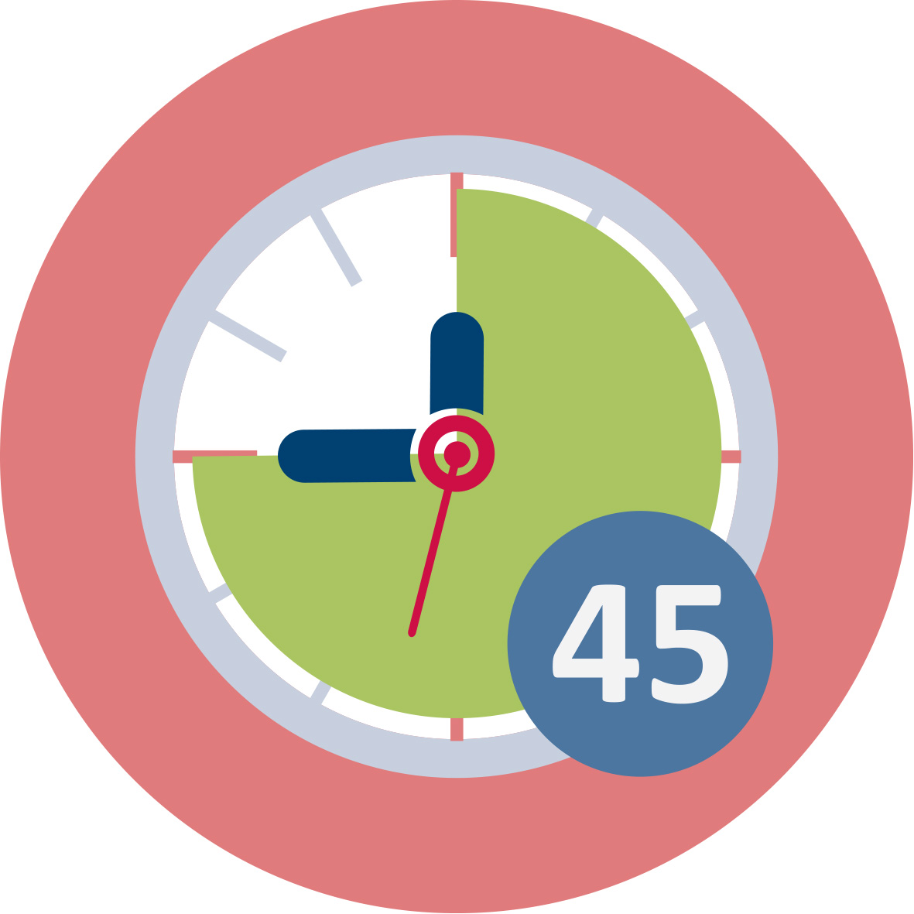Duration: 45 minutes
This is a “warm up” activity. The intention is to introduce some facts about an ecological problem, in this case is used water as example and explore students´ previous knowledge, beliefs, experiences and attitudes related to this topic.
Teacher educator introduces the topic in connection with the “real water”. He can offer a glass of water in the classroom or the activity can be situated to place with water sources like meeting at the riverbank, at the sea or lake, at the waterfall or at the small water source etc. (as demonstration of everyday self-evident thing for us). At the start he initiate a short discussion through the questions: What is the impact/effect of water on our life/life of people? or Can water change our life? or What we can contribute to water sustainability? And then present the interactive activity. The activity consists on work in pairs preparing title and short commentary to elected picture about water (glacier, flood, water fountains, forest brook, eroded soil, sewage treatment plant, drinking water treatment plant, sea, tsunami, well in the desert, water pitcher, aqueduct etc.). After work in the pairs students present our results and discuss them with others.
This session contributes to the achievement of the following learning outcomes:
- Master strategies to create a safe classroom atmosphere supporting communication and argumentation.
- To recognize one of the current ecological topic in different natural, social and cultural contexts.

I. Introduction into the topic Different perspectives on current ecological problems on example of water

1.2 Mapping the field of interest
Duration: 45 minutes
This activity serves to mapping of elected global environmental problem – water – in detailed different contexts. At beginning is recommended brainstorming (with right setting – time, prohibited words, technical realization etc. – see literature about brainstorming realization). Central term for brainstorming can be “WATER” as self. Next step is clustering, it means classification of groups of produced words. Students propose groups such as science, economics, politics, culture… Last step is creation of concepts maps in each group of words and next to create common concept map about phenomena WATER connected with discussions about different experiences mainly with intercultural contexts.
Notices for alternatives: Topic of brainstorming can be more sophisticate, it means e.g. producing only adjectives for water (salty, sweet, pure, sacred, drinking, dirty etc.) or producing names or words containing the word “water” (names of cities, geographical terms, water in different languages etc.).
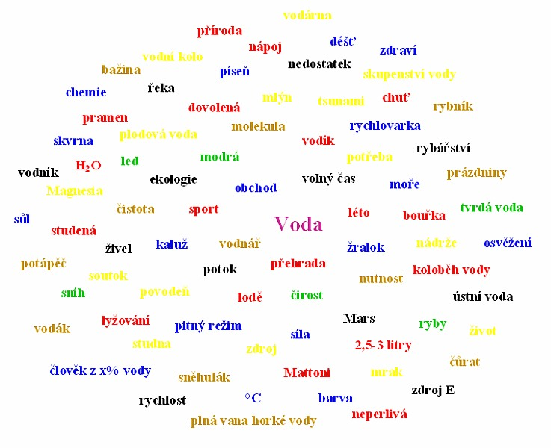
Figure Example of concept map on the topic WATER (Voda in Czech)
This session contributes to the achievement of the following learning outcomes:
- To recognize one of the current ecological topic in different natural, social and cultural contexts.
- Get familiar with teaching methods which have potential to connect ecological topics to intercultural learning.

II. Immersion into the topic Different perspectives on current ecological problems on example of water

2.1. Water as multi contexts phenomenon
and and | Duration: 30 minutes
In this session the teacher educator evokes atmosphere about water as borderless phenomena. Then teacher students, working first individually, next in pairs and finally in groups. Results from groups are presented and discussed and summarized in a plenary session. It is application of “snow ball” method.
At the beginning all watch interesting short movie (video shots, no longer as 5 minutes) about water. It can be use something from YouTube or from different Web sources e.g. Introduction to Water at link
https://www.youtube.com/watch?v=nSENolWbyYQ (by author comments it is dramatic video choreographed to powerful music introduces the viewer/student to the wonder and miracle of water. It is designed as a motivational "trailer" to be shown by Biology, Biochemistry and Life Science teachers in middle and high school and college as a visual "Introduction" to this amazing substance, and its use by life on Earth) or similar audio-visual presentation.
After presentation each student receives card (it can be especially “water” designed by color, border etc.) and elects one of the six contexts related to water: natural-microscopic, natural-macroscopic, economic, political, cultural and mysterious. Next he write (with using different sources) one page the characteristics of water in elected context. Next students create pairs and received next cards for task to work together in max. 3 elected contexts. It can be 1 or 2 from previous individual work and 1 or 2 new. Last round started after collection of all cards ordered by context. Students create six groups and each one draws one context and elaborates one compromise final version of context characteristics. Each group uses related cards from previous individual and pairs work. The activity is finished by presentation of each group and common discussions.
This session contributes to the achievement of the following learning outcomes:
- Acquire skills to build a classroom atmosphere of communication and respect.
- Get familiar with teaching methods which have potential to connect ecological topics to intercultural learning.

II. Immersion into the topic Different perspectives on current ecological problems on example of water

2.2. Water in legends and myths
or | +  Duration: 30 minutes + 90 minutes homework
In this session students deal with water as “main element” of legends and myths. They recognize different conceptions of water properties and characteristics in border real and mystic life. At beginning students are asked to prepare presentation one example of “water legends or myths” in own form. It can be individually or group homework like author reading, dramatization, artwork, video etc. In the session the will show key aspects of their work and finally they can prepare exhibition or performance or CD-ROM or Web-site or Facebook-site etc.

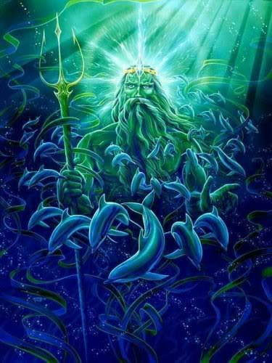
Figure God of water from Greek mythology – Poseidon (http://greekmythology-xela.blogspot.com.es/2009/10/name-poseidon-domain-all-water-weapon.html)

A few links for inspiration:
The story of drinking water by American Water Works Association
https://www.fcwa.org/story_of_water/html/story.htm

Native American Water Mythology
http://www.native-languages.org/legends-water.htm

Water Folklore and Legends
https://www.thoughtco.com/water-element-folklore-and-legends-2561689

Water Spirit Legends 1
http://www.pitt.edu/~dash/water.html
This session contributes to the achievement of the following learning outcomes:
- To support of creative thinking without prejudice to different cultures.
- Learn how to select and elaborate ecological topics to enhance learning in multicultural classrooms.

II. Immersion into the topic Different perspectives on current ecological problems on example of water

2.3. “Singing water” or water in songs
or | Duration: 30 minutes
In this activity students search and analyze songs where the water plays some roles. The activity is not based only on singing but on identification of natural (science elements) and social (cultural elements) and ecological (global ecological elements) contexts of the text and melody. Students analyze texts, authors and interprets motivation, social context etc. Finally they can prepare own hit parade by voting of classroom or school…
A few links for inspiration:

The Best Songs about Water
http://www.ranker.com/list/best-songs-about-water/reference

Top 10 Water Songs

http://ultimateclassicrock.com/water-songs/

Songs with Bodies of Water in the Title

http://www.songfacts.com/category-songs_with_bodies_of_water_in_the_title.php

This session contributes to the achievement of the following learning outcomes:
- To connect science and art in learning about global ecological problems.
- Acquire skills to build a classroom atmosphere of communication and respect.

III. Applications into the topic Different perspectives on current ecological problems on example of water

3.1. Water in numbers
or | Duration: 30 minutes
Main topic of the activity is searching, analyzing and interpreting of data concerned water and water management. Data will be sourced from the internet, from relevant links based of relevant authors and guarantee institutions. Main direction can be follow:
- Consumption of water in different part of the world (e.g. water for drinking, water per capita, water consumption in household or in agriculture or in industry)
- Calculation of water footprints for different products and activities (connected with comparison water needs in different part of the world)
- Calculation of water consumption in different areas and what we can do with these calculations (calculations of water consumption at washing, toilet cleaning, hands washing, showering etc.)
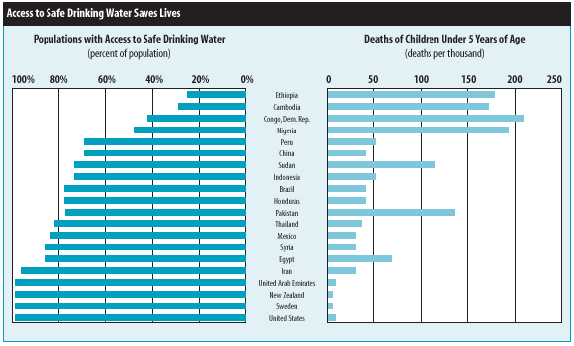
Figure Access to drinking water in selected countries
(http://www.waterandhealth.org/drinkingwater/wp.html)

Work in pairs or in groups with access to Internet sources and discussion of the findings. Important it is comparison of price (not only in economic sense) of the water in different regions.
This session contributes to the achievement of the following learning outcomes:
- To formulate the critical approach to data analyzing and interpretation.
- To create ability to search relevant data from open access media.

III. Applications into the topic Different perspectives on current ecological problems on example of water

3.2. Water storage and transportation
or | Duration: 30 minutes
Students will watch video animation (Water changes everything) about problems with clear drinking water - https://www.youtube.com/watch?v=BCHhwxvQqxg. This animation deals with facts that almost a billion people live without clean drinking water, it means we are living in real water crisis. It's a crisis because it only starts with water but water affects everything in life. Health. Education. Food security.
The task for discussion is to look on the sources about water storage (water dams and tanks, water supply etc.) and water transportation (channels, pipelines, aqueducts, water mills etc.). Discussed can be historical aspects as well as proposal for simple model experiments.
This session contributes to the achievement of the following learning outcomes:
- To formulate the critical approach to data analyzing and interpretation.
- To approach from complex point of view to problem solving.

III. Applications into the topic Different perspectives on current ecological problems on example of water

3.3. Drinking water in different contexts
or | Duration: 30 minutes
The activity is oriented to problems with drinking water and it is close connected with all activities in the part III. Key words are preparation and consumption of drinking water in history and in current situation and also in prognosis for the future in view of different cultures. As motivation can be video animation with topic “Little water” at the link:
https://www.youtube.com/watch?v=4O7fQjK36G0. Video is in Czech language, but it can be use also without audio and to try comment showed activities.
Next will follow discussion about cleaning water for drinking (mechanical, physical, chemical and biological ways). What we can use for cleaning water in different regions? Are there any next influences like science principles?
This session contributes to the achievement of the following learning outcomes:
- To approach from complex point of view to problem solving.
- To recognize one of the current ecological topic in different natural, social and cultural contexts.

III. Applications into the topic Different perspectives on current ecological problems on example of water

3.4. Water in simple experiments
Duration: 90 minutes
Last activity is a complex of simple experiments oriented to recognize water as unusual compounds from microscopic to macroscopic levels. Simple experiments show principles valid in all the world but their realization and setting can be different depending on traditions, possibilities and different next local conditions. Proposals of experiments groups:
- Water cleaning (separation methods like filtration, crystallization, decantation, flotation; making of sand filter etc.)
- Water as not simple and extraordinary chemical compound (water surface, water density, water as solution, water paradoxes – density/temperature, coherency etc.)
- Water as one of the ancient elements (water place on quadrants with fire, air and earth) – sets of simple experiments with all four elements
- Water as power (experiments with turbines, water pumps, water conservation etc.)
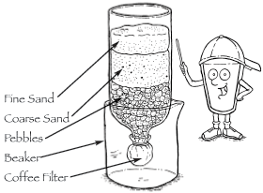

Figure. Physical model of sand filter for water treatment
(https://www3.epa.gov/safewater/kids/grades_4-8_water_filtration.html)

This session contributes to the achievement of the following learning outcomes:
- To use science literacy for understanding of diversity.
- To support of creative thinking without prejudice to different cultures.

Materials and resources

Worksheets. Includes all student activities for module 5
Set of Pictures “Pictures about water”. Teacher Educator. Introduction 1.1.
YouTube video: Introduction to Water. Immersion 2.1.
Writing Cards for snow ball method. Immersion 2.1.
Access to computers for internet research – links at activity. Immersion 2.2.
Access to computers for internet research – links at activity. Immersion 2.3.
Access to computers for internet research at activity. Application 3.1.
YouTube video: Water changes everything. Application 3.2.
YouTube video: “Little water (Vodička)”. Application 3.3.
Laboratory devices and chemicals for activity. Application 3.4.

Granularity
- Select fewer examples in part III from each activity
- Connect by your possibilities activities in part III
- In activity 3.3. you can use video in national language (activity can be faster)
- In activity 1.2 you can use different types of brainstorming by level of teaching practice
- For activity 3.4 including experimental activities is necessary preparation of lab equipment and chemicals

References
Schelwald-van der Kley, A. J. M., Reijerkerk, L. (2009). Water: A Way of Life: Sustainable Water Management in a Cultural Context. Boca Raton-London-New York-Leiden: CRC Press Taylor&Francis Group, 129 p.
Barton, A. C. (1999). Crafting a Multicultural Science Teacher Education: A Case Study. Journal of Teacher Education, 50(4), 303–314.
Lee, O., & Luykx, A. (2007). Science Education and Student Diversity: Race/Ethnicity, Language, Culture, and Socioeconomic Status. In S. K. Abell & N. G. Lederman (Eds.) Handbook of Research on Science Education. New Jersey: Lawrence Erlbaum Associates, pp. 171–197.
Machal, A. (2000). Průvodce praktickou ekologickou výchovou (Guide through Practical Ecological Education). Brno: Rezekvítek, 2000, 205 p.
Schmutzerová, L., Bílek, M. (2010). Jak hodnotili čeští patnáctiletí žáci základních škol a studenti víceletých gymnázií environmentální problémy (How Rated Czech Fifteen Years of Primary School Pupils and Students of Grammar Schools Environmental Problems?). Envigogika [online]. 7. 10. 2010, V., 2, [cit. 2011-05-04]. Accessible from: http://www.envigogika.cuni.cz/index.php/cz/recenze/98-internat/jine/404-jak-hodnotili-eti-patnactileti-aci-zakladnich-kol-a-studenti-viceletych-gymnazii-environmentalni-problemy
Činčera, J. (2007). Environmentální výchova - od cílů k prostředkům (Environmental Education- from Objectives to Means). Brno: Paido, 116 p.
Gore, A. (2006). Earth in the Balance: Ecology and the Human Spirit. New York: Rodale, 2006, XXIV, 407 p.
How Big is the Human Footprint on Earth? Global Footprint Network [online]. Oakland, CA: Global Footprint Network, © 2003-2012, 07/25/2011 [cit. 2011-08-03]. Accessible from: http://www.footprintnetwork.org/en/index.php/GFN/page/2010_living_planet_report
Janoušková, S., Kukal, P. (2008). Environmentální výchova v příbězích (Environmental Education in Stories). Praha: Fortuna.
Morrone, M., Mancl, K., Carr, K. (2001). Development of a Metric to Test Group Differences in Ecological Knowledge as One Component of Environmental Literacy. The Journal of Environmental Education. Phoenix, Arizona, Vol. 32, Nr. 4, pp. 33-43.
Palmer, J. (1998). Environmental Education in the 21st Century: Theory, Practice, Progress and Promise. New York: Routledge, XIV, 284 p.
Harris, F. (Ed.) (2005). Global Environmental Issues. New York: J. Wiley & Sons Ltd., 2005, 336 p.
Hayashi, M., Rosenberry, D. O. (2002). Effects of Ground Water Exchange on the Hydrology and Ecology of Surface Water. Groundwater, Volume 40, Issue 3, pp. 309–316.
Hawkes, H. A. (1963). The Ecology of Waste Water Treatment. Oxford-London-New York-Paris: Pergamon Press, 1963, 195 p.
Scarborough, V. L. (1998). Ecology and Ritual: Water Management and the Maya. Latin American Antiquity. Vol. 9, No. 2, pp. 135-159.

Further readings
Project Flow. Learning for a Sustainable Future (2017). [online]. [cit. 2017-03-15]. Accessible from: http://resources4rethinking.ca/en/project-flow
Intercultural Communication on the Water. [online]. [cit. 2017-03-15]. Accessible from: http://www.waterandculture.org/269_Intercultural_communication

Assessment
- They positively engage in activities intended at promoting empathy and mutual appreciation in the class group.
- They actively listen to partners and show respect for others’ personal opinions.
- They evaluate arguments in a consistent way according to different criteria.
- They identify appropriate examples to enhance science education in their future classrooms, linking science learning and environmental aspects.
- They display different perspectives and interest groups in the selected ecological problem(s).
- They prepare appropriate questions to guide students’ exploration and discussion of the selected ecological problem.
- They identify key curricular elements that can be addressed through the classroom activity.
- They formulate consistent learning outcomes for the classroom activity based on intercultural view of environmental problem(s).
- They define appropriate assessment criteria for the students/classroom activity.
- They critically discuss and review the design of classroom activities.

