Module 5 |  | DIFFERENT PERSPECTIVES ON CURRENT ECOLOGICAL PROBLEMS

Worksheets

This worksheet is based on the work within the project Intercultural learning in mathematics and science initital teacher education (IncluSMe). Coordination: Prof. Dr. Katja Maaß, International Centre for STEM Education (ICSE) at the University of Education Freiburg, Germany. Partners: University of Nicosia, Cyprus; University of Hradec Králové, Czech Republic; University of Jaen, Spain; National and Kapodistrian University of Athens, Greece; Vilnius University, Lithuania; University of Malta, Malta; Utrecht University, Netherlands; Norwegian University of Science and Technology, Norway; Jönköping University, Sweden; Constantine the Philosopher University, Slovakia.

The project Intercultural learning in mathematics and science initial teacher education (IncluSMe) has received co-funding by the Erasmus+ programme of the European Union under grant no. 2016-1-DE01-KA203-002910. Neither the European Union/European Commission nor the project's national funding agency DAAD are responsible for the content or liable for any losses or damage resulting of the use of these resources.

IncluSMe project (grant no. 2016-1-DE01-KA203-002910) 2016-2019, lead contributions by Martin Bilek & Veronika Machkova, University of Hradec Kralove, Hradec Kralove, Czech Republic.
CC-BY-NC-SA 4.0 license granted (find explicit terms of use at: https://creativecommons.org/licenses/by-nc-sa/4.0/deed.en)

I. Introduction into the topic Different perspectives on current ecological problems on example of water

1.1 Ambience evocation
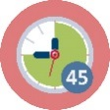Duration: 45 minutes
Observe the “real water”. It can be a glass/bottle of water or river or sea/lake or waterfall or the small water source (you can use outdoor session near the water surface) etc.
What you can answer to questions:
What is the impact/effect of water on our life/life of people?
Can water change our life?
What we can contribute to water sustainability?

Please, create pairs and prepare title and short commentary to elected picture about water (pictures of glacier, flood, water fountains, forest brook, eroded soil, sewage treatment plant, drinking water treatment plant, sea, tsunami, well in the desert, water pitcher, aqueduct etc.). After 20 – 25 minutes present your results and discuss them with others.
(Teachers educator has for student’s choice pictures of different water phenomena (see in attachments). It can be done from WWW by different possibilities. Pictures can by elected also by lottery or competition.)

I. Introduction into the topic Different perspectives on current ecological problems on example of water

1.2 Mapping the field of interest
Duration: 45 minutes
Start with the brainstorming (set together conditions for the brainstorming – time, prohibited words, technical realization – writing on blackboard etc.). Central term for brainstorming will be “WATER” as self. All participants produce words related to water in limited time.

Next step is clustering, it means classification of groups of produced words. Participants propose groups such as sources, usability, waste…

In last step create concepts maps in each group of words and next create common concept map about phenomena WATER connected with discussions about different experiences mainly with intercultural contexts.

Possible alternatives: topic of brainstorming can be more sophisticate for older participants, it means e.g. producing only adjectives for water (salty, sweet, pure, sacred, drinking, dirty etc.) or producing names or words containing the word “water” (names of cities, geographical terms, water in different languages etc.).

II. Immersion into the topic Different perspectives on current ecological problems on example of water

2.1. Water as multi contexts phenomenon
and and | Duration: 30 min plus discussion
Please, think about water as borderless phenomena. Use link https://www.youtube.com/watch?v=nSENolWbyYQ (by author comments it is dramatic video choreographed to powerful music introduces the viewer/student to the wonder and miracle of water. It is designed as a motivational "trailer" to be shown by Biology, Biochemistry and Life Science teachers in middle and high school and college as a visual "Introduction" to this amazing substance, and its use by life on Earth) or similar audio-visual presentation adduce about phenomena “Water”.

After the introduction work first individually, next in pairs and finally in groups:
- Each one of you receives “water-card” (see in attachments) and elects one of the six contexts related to water: (1) natural-microscopic, (2) natural-macroscopic, (3) economic, (4) political, (5) cultural and (6) mysterious. Write (with using different sources), please, one page the characteristics of water in elected context. You can produce text or graphics or schema etc. (5 min)
- Create pairs and ask next cards for task to work together in 3 elected contexts (it will be 1 or 2 from previous individual work and 1 or 2 new). Write in pair (with using different sources), please, one page for each of three characteristics of water in elected contexts. All three finished cards give back to teacher (teacher orders cards in 6 columns by six contents of water). (10 min)
- Create 6 groups and for each group order (by competition or by lottery) one context from six previous. Each group receives appropriate column (collection of cards) and elaborates one compromise final version of context characteristic with focus to multi and intercultural consequences. (5 min)
- Each group show the elaborated context and discuss it with all in plenary session. (10 min)

II. Immersion into the topic Different perspectives on current ecological problems on example of water

2.2. Water in legends and myths
or | + 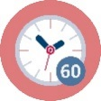  Duration: 30 minutes + 90 minutes homework
The water is in big frequency “main element” of legends and myths. In this case we can recognize water’s properties and characteristics in border real and mystic life.
In homework prepare presentation one example of “water legends or myths” in form by your preference. It can be individually or group work like author reading, dramatization, artwork, video etc. In the session show key aspects of your work and finally we can prepare exhibition or performance or CD-ROM or Web-site or Facebook-site with your works.
A few links for inspiration:
The story of drinking water by American Water Works Association
https://www.fcwa.org/education/education.htm
Native American Water Mythology
http://www.native-languages.org/legends-water.htm
Water Folklore and Legends
https://www.thoughtco.com/water-element-folklore-and-legends-2561689
Water Spirit Legends 1
http://www.pitt.edu/~dash/water.html

II. Immersion into the topic Different perspectives on current ecological problems on example of water

2.3. “Singing water” or water in songs
or | Duration: 30 minutes
In group (national/cultural/regional groups can be good support for activity) or individually search (on memory, on Internet, or on different sources) and analyze songs where the water plays some roles. Identify natural (science elements) and social (cultural elements) and ecological (global ecological elements) contexts of the text and melody. Analyze also authors and interprets motivation, social context etc. At the end you can prepare own hit parade by voting of all participants.
A few links for inspiration:
The Best Songs about Water
http://www.ranker.com/list/best-songs-about-water/reference
Top 10 Water Songs
http://ultimateclassicrock.com/water-songs/
Songs with Bodies of Water in the Title
http://www.songfacts.com/category-songs_with_bodies_of_water_in_the_title.php

III. Applications into the topic Different perspectives on current ecological problems on example of water

3.1. Water in numbers
or | Duration: 30 minutes
Individually or in pairs or in groups think about water consumption in different consequences and formulate question from this area.
Question can be i.e. “How much water we are using for different activities?” “How much water is necessary for the same activity in different world places?” Etc. Prepare answer to formulated question by searching, analyzing and interpreting of data concerned water and water management from different sources (Internet, newspapers, books etc.). Data must be sourced from the relevant links based of relevant authors and guarantee institutions.
For thinking about your “research question” you can use next direction:
- Consumption of water in different part of the world (e.g. water for drinking, water per capita, water consumption in household or in agriculture or in industry)
- Calculation of water footprints for different products and activities (connected with comparison water needs in different part of the world)
- Calculation of water consumption in different areas and what we can do with these calculations (calculations of water consumption at washing, toilet cleaning, hands washing, showering etc.)
At the end present your results. Important it is comparison of price (not only in economic sense) of the water in different regions with discussion about cultural consequences, too.

III. Applications into the topic Different perspectives on current ecological problems on example of water

3.2. Water storage and transportation
or | Duration: 30 minutes
Watch video animation (Water changes everything) about problems with clear drinking water - https://www.youtube.com/watch?v=BCHhwxvQqxg. This animation deals with facts that almost a billion people live without clean drinking water, it means we are living in real water crisis. It's a crisis because it only starts with water but water affects everything in life. Health. Education. Food security.
Individually or in groups elect one example of water storage (water dams and tanks, water supply, kinds of bottles etc.) or one example of water transportation (channels, pipelines, aqueducts, water mills etc.). Discuss historical aspects, advantages and disadvantages of elected object for water storage or transportation. You can propose also simple model experiments for demonstration of elected object.

III. Applications into the topic Different perspectives on current ecological problems on example of water

3.3. Drinking water in different contexts
or | Duration: 30 minutes
A treatment and a consumption of drinking water in history and in current situation and also in prognosis for the future is very important part of each society in view of different cultures.
In first half of the task watch individually or in groups video animation with topic “Little water” at the link: https://www.youtube.com/watch?v=4O7fQjK36G0. Video is in Czech language, but don’t use audio and try to comment showed activities. You can stop the video in different time and think individually or discuss in group topics for the second part of this task (see below).
In the second part discuss about cleaning water for drinking (mechanical, physical, chemical and biological ways).
What we can use for cleaning water in different regions?
Are there any next influences like science principles?

III. Applications into the topic Different perspectives on current ecological problems on example of water

3.4. Water in simple experiments
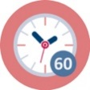Duration: 90 minutes
Propose, provide and explain simple experiments oriented to recognize water as unusual compounds from microscopic to macroscopic levels.
Individually or in pair choose from list bellow (or draw lots) 1 or 2 topics and propose (by text and designed schema) for it experimental activities. Choose the simplest possible procedure, including aids (laboratory or improvised). You have 60 minutes for preparation of working place with your experiments. Your ideas discuss with colleagues and lecturer or you can ask the lecturer for starting idea (see in attachments).
In next 30 minutes you all circulate among prepared working places and try to realize experiments.
List of topics for experimental proposals:
Water cleaning by filtration.
Water cleaning by other method like filtration.
Water has interesting surface.
Water density and swimming.
Water is interesting solvent.
Water shows paradoxes (i.e. density/temperature, coherency, ice/liquid water etc.).
Water circle.
Water has power (turbines, pumps).
Water evaporation.
Water and diffusion.
Attachments to activities (see next pages)
Activity 1.1 Examples of Different Water Phenomena in Pictures
Activity 2.1 Proposal for Water-card
Activity 3.4 Examples of Proposals for Experiments
Attachments to activities
Activity 1.1 Examples of different water phenomena in pictures
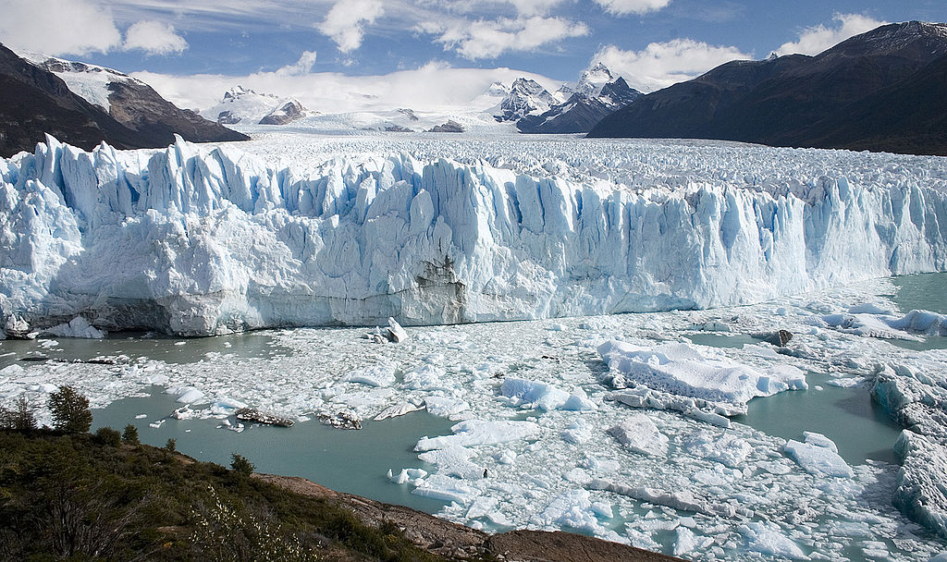
Glacier (https://en.wikipedia.org/wiki/Glacier#/media/File:Perito_Moreno_Glacier_Patagonia_Argentina_Luca_Galuzzi_2005.JPG)
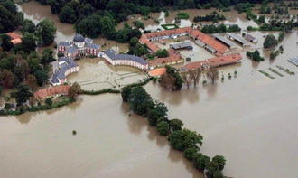
Flood (https://www.zamek-veltrusy.cz/cs/fotogalerie/6275-povodne)
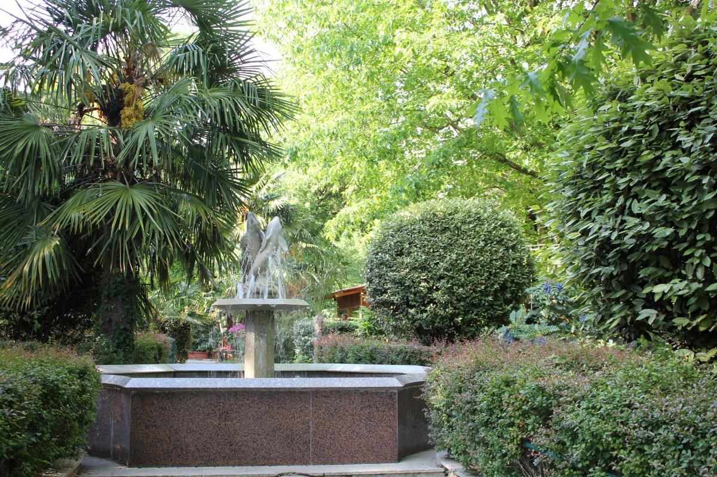
Water Fountain (https://pxhere.com/cs/photo/556009)

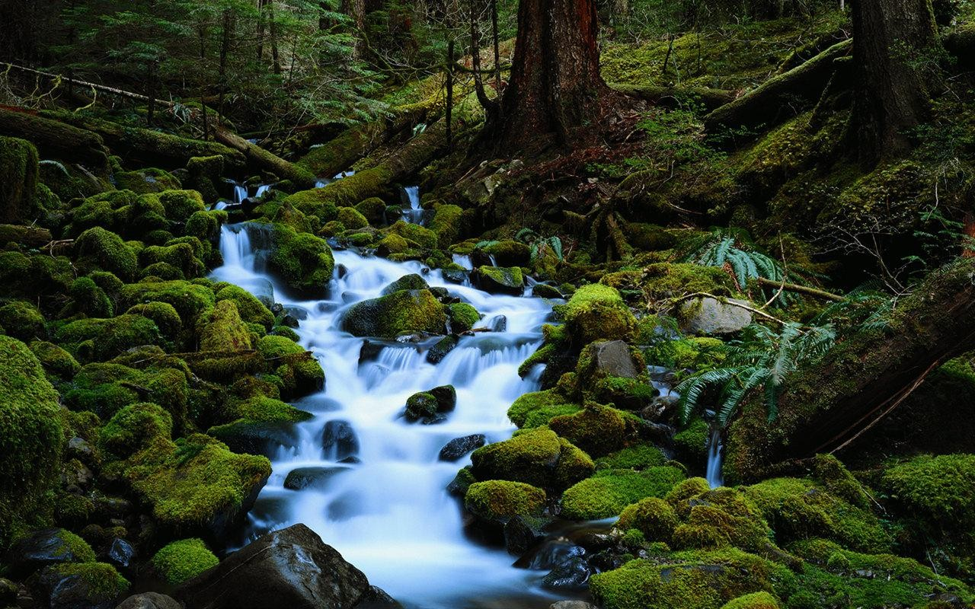
Forest Brook (http://wpnature.com/flowing-white-waters-forest-moss-nature-brook-beauty-green-desktop-wallpaper/)

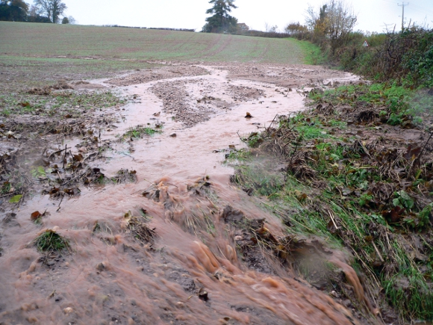
Eroded Soil (https://www.woodlandtrust.org.uk/blog/2015/06/soil-erosion-a-big-cost/)

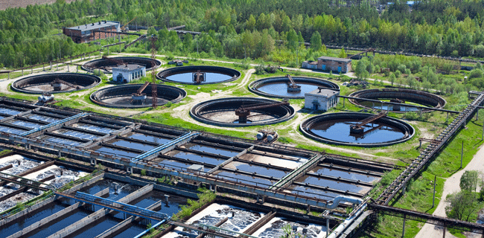
Sewage Treatment Plant (http://www.boundless.solutions/sewage-treatment-plant/)

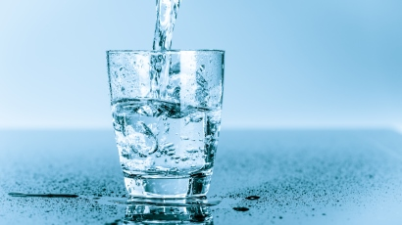
Drinking Water (https://o-ring.info/sk/priemyselne-odvetvie/vodarensky-priemysel-pitna-voda-/)

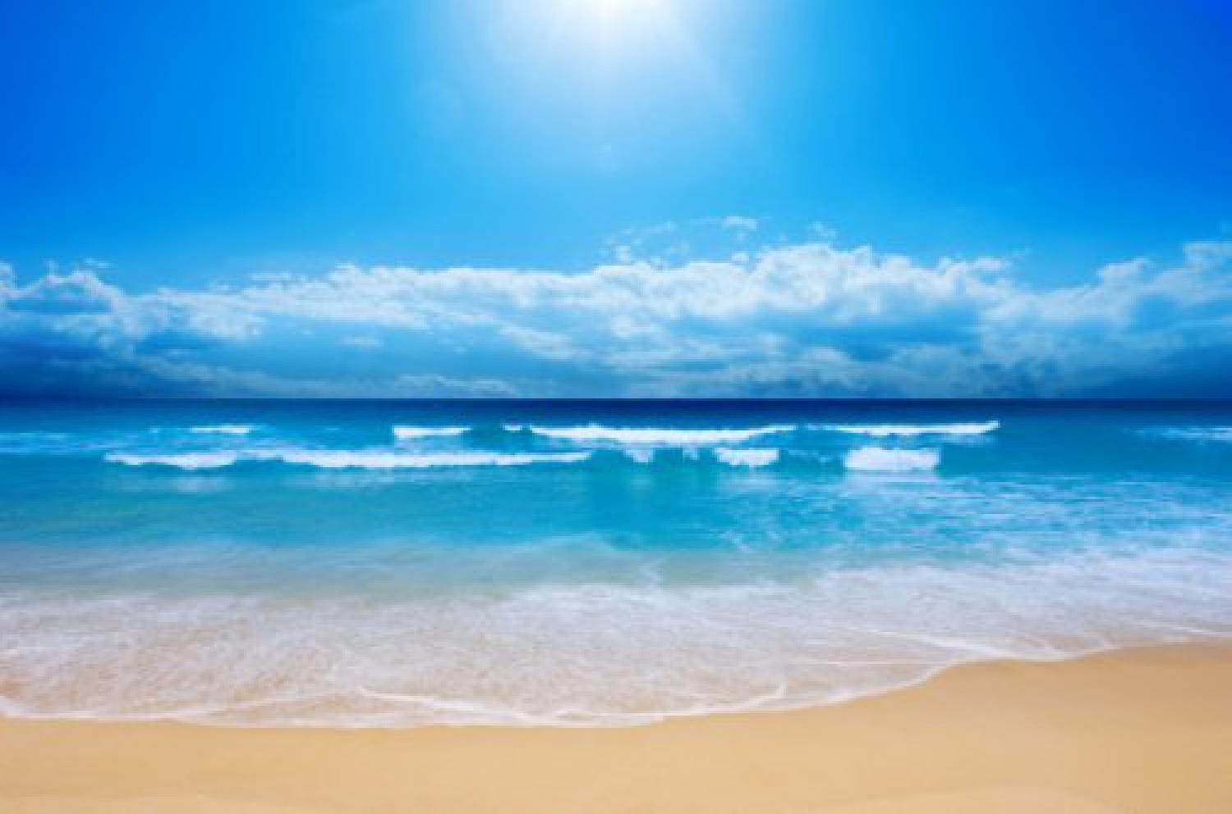
Sea (http://www.mezizenami.cz/zdravi/leciva-sila-more)

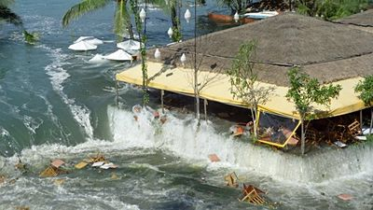
Tsunami (https://tema.novinky.cz/tsunami)
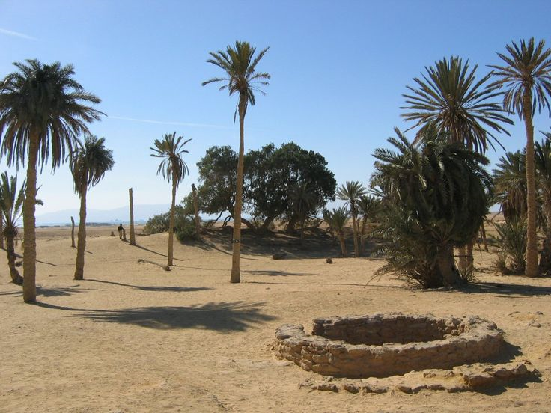
Well in the Desert (https://theholylandwithrichandcheryl.com/2017/09/08/holy-land-well-or-a-monument/)
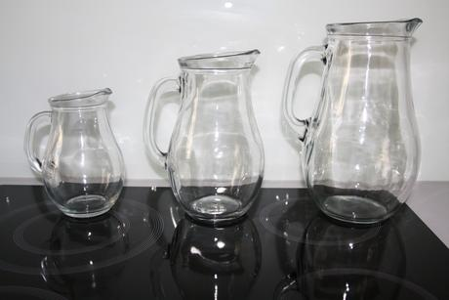
Water Pitchers (https://www.beremese.cz/market/sklenice-lahve-vino-napoje/5gnw/karafa-dzban-na-vino-vodu-nealko/)
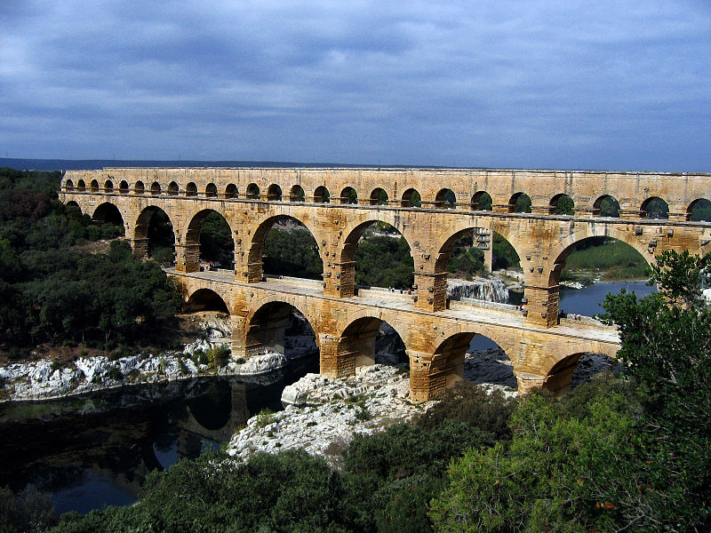
Aqueduct (https://cs.wikipedia.org/wiki/Akvadukt#/media/File:Pont_du_Gard_Oct_2007.jpg)

Activity 2.1 Proposal for Water-card
Water in ………………………………………….. context
(choice one of next context: (1) natural-microscopic, (2) natural-macroscopic, (3) economic, (4) political, (5) cultural and (6) mysterious)

Nr. ……

Activity 3.4 Examples of Proposals for Experiments
Water cleaning by filtration
One of the basic drinking water treatment methods is filtration. Various materials are used in water treatment plants. For experiment we can use polluted water and for its filtration we can examine various materials as sand, gravel, stones, but also active carbon, paper, cotton wool, etc.
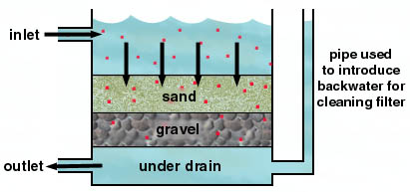 | Sand filter principle  (http://www.chemistry.wustl.edu/~edudev/LabTutorials/Water/PublicWaterSupply/images/filtration.jpg)
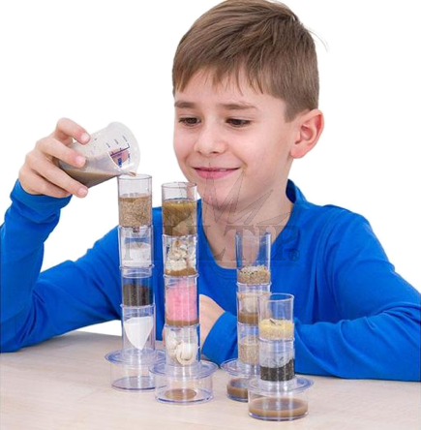 | Filtration in school lab  (http://www.multip.cz/editor/image/eshop_products/bz-84738_l.png)
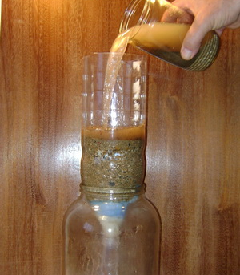 | Sand filter model  (http://www.chemiehrou.funsite.cz/img/DSC02113.JPG)

Water cleaning by other method like filtration
In the laboratory, we need to work with water that does not contain any minerals. We treat such water by a method called distillation. This method can be shown in an improvised apparatus with tea, orange juice or a food dye solution.
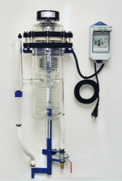 | Distilation device  (http://www.simax.com/fota/shops/367-1.jpg)
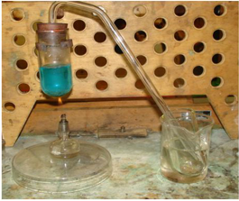 | Distilation in school lab set  (http://slideplayer.cz/slide/2468090/8/images/11/Destilace+Popi%C5%A1+zjednodu%C5%A1enou+destila%C4%8Dn%C3%AD+aparaturu+a+pr%C5%AFb%C4%9Bh+destilace+roztoku+modr%C3%A9+skalice..jpg)

Water has interesting surface
Surface tension is the effect in which the surface of the fluid acts as an elastic film. Surface tension causes some types of insects (such as water meters) to move around the water. Therefore, we can put small things on the surface and they will remain there. In second step, we can add liquid soap or detergent, the surface tension of the water decreases and the floating thing drops to the bottom.
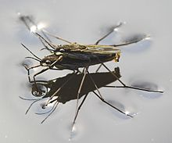 | Water insect on the surface  (https://upload.wikimedia.org/wikipedia/commons/thumb/3/36/Wasserl%C3%A4ufer_bei_der_Paarung_crop.jpg/220px-Wasserl%C3%A4ufer_bei_der_Paarung_crop.jpg)
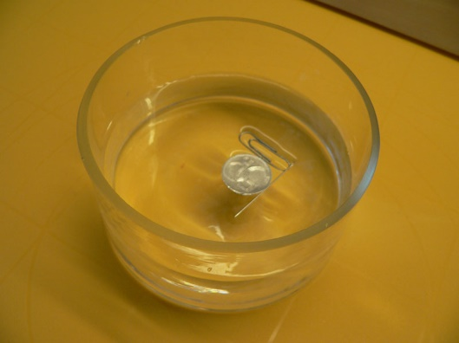 | Coin on the water surface  (http://www.zsletohrad.cz/eu/chemie/foto/pokus21/foto3.jpg)

Water density and swimming
The density of water increases with the amount of dissolved salts, so swimming in saltwater is easier. This fact can be demonstrated by a simple experiment at which we will use various objects and water in which we will gradually dissolve the salt.

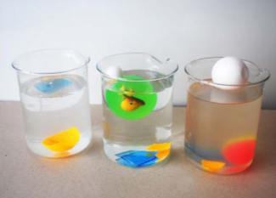 | Swimming things  (https://sf.zcu.cz/data/2013/sf2013_05_5.pdf)

Water is interesting solvent
Water is an important solvent, solvents play a significant role in analytical methods such as chromatography. It can be shown by chromatography of water-soluble marker dye on white chalk or on filtration paper (or piece of newspaper).

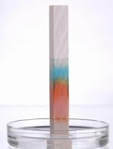 | Water-soluble marker dye (brown) on white chalk during the chromatography  (http://www.zsnachtu.cz/_/rsrc/1458232443246/vyuka/predmety/laboratornipracezchemie-8rocnik/chromatografie-jecernaopravducerna/chromatografie%20na%20k%C5%99%C3%ADd%C4%9B.jpg?height=200&width=133)
 | Paper chromatography of dye from bon-bons (brown)

Water shows paradoxes (i.e. density/temperature, coherency, ice/liquid water etc.)
Water performs many paradoxes. One of them is its density of different state. Liquid water has higher density as solid water (ice). It means that the volume of the same weight of ice (or snow) water is higher than volume of liquid water. Ice is floating on the water surface, cube of ice is faster soluble in pure water like in water solution of kitchen salt.

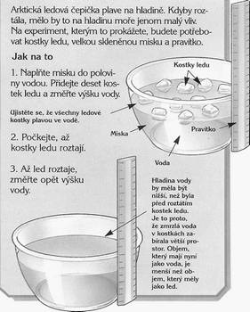 | Water level with pieces of ice and after their dissolution  (http://metmladez.wz.cz/metdeti/pokusled.jpg)
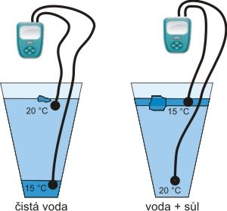 | Piece of ice in pure water (čistá voda) and in saline solution (voda + sůl)  https://translate.google.cz/?hl=cs - cs/en/solný roztok

Water circle
Water in nature is in a continuous circle cause sun energy. This principle can be shown by simple demonstration with water in small plastic bag glued on the window. More sophisticated variant of the experiment can be performed with a glass container covered with a plastic foil.
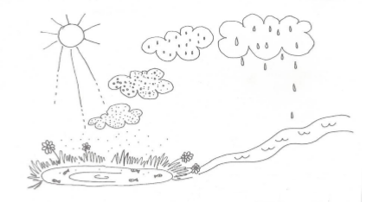 | Picture of water cycle  https://theses.cz/id/9cri13/STAG70167.pdf
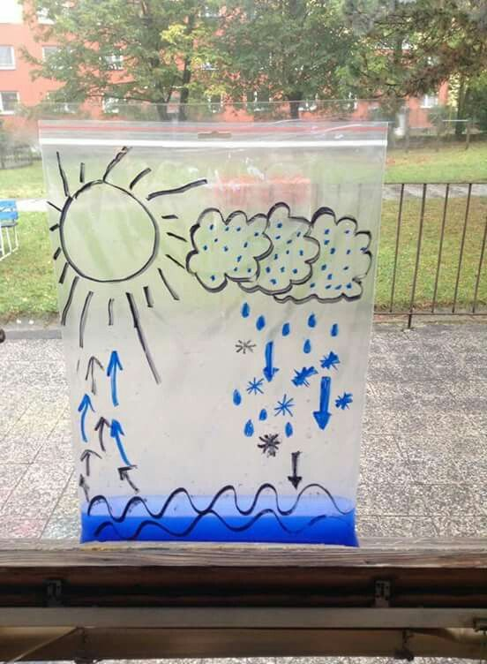 | Water cycle in platic bag  https://i.pinimg.com/564x/be/3d/8e/be3d8e051457105f1ab655f3624a8eb3.jpg
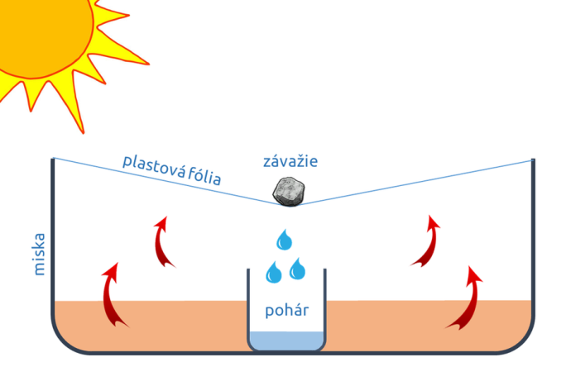 | Model of water cycle  http://www.lepsiageografia.sk/uploads/2/6/0/1/26017850/2412694_orig.png

Water has power (turbines, pumps)
Water can do work, such as water mills, water turbines ... We can demonstrate the power of water through a simple experiment with water and plastic bottle.
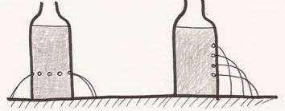 | Power of water and gravitation  http://www.fyzikahrou.cz/fyzika/jednoduche-pokusy/co-umi-voda-a-vzduch
Water evaporation
Evaporation is the conversion of the liquid state into gaseous state. Its speed is dependent on the surface size of water surface. It can be demonstrate with water in several containers with different diameters, weight loss can be monitored on scales (to obtain more representative results ethanol can be used).
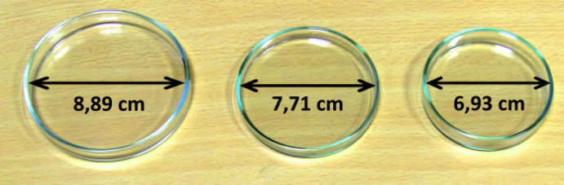
Surface size influence to liquid evaporation http://fyzikalnipokusy.cz/1721/zavislost-rychlosti-vyparovani-na-obsahu-plochy-hladiny-kapaliny

Water and diffusion
Diffusion is the movement of molecules or atoms from a region of high concentration to a region of low concentration. It can be shown with simple experiment with water and ink dye. In second step, the influence of temperature on speed of diffusion can be presented with cold and hot water and tee bag.
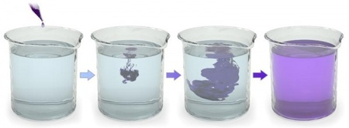
Diffusion of dye drop in water (http://www.vedanasbavi.cz/orisek-63-zs-vnb-iv-07-difuze?ID_mesta=61&IDp=5)

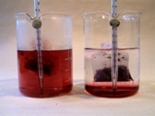

The tee bag in cold and hot water (http://www.mvp.cufo.cz/materialy/10.html)

More information about WATER you can receive for example on the link:
http://www1.lsbu.ac.uk/water/water_sitemap.html

