Module 7 | DEALING WITH DEFICIENCIES AND EXCELLENCY IN THE MATHEMATICS PROFICIENCY OF IMMIGRANT STUDENTS

This Module is based on the work within the project Intercultural learning in mathematics and science initial teacher education (IncluSMe). Coordination: Prof. Dr. Katja Maaß, International Centre for STEM Education (ICSE) at the University of Education Freiburg, Germany. Partners: University of Nicosia, Cyprus; University of Hradec Králové, Czech Republic; University of Jaen, Spain; National and Kapodistrian University of Athens, Greece; Vilnius University, Lithuania; University of Malta, Malta; Utrecht University, Netherlands; Norwegian University of Science and Technology, Norway; Jönköping University, Sweden; Constantine the Philosopher University, Slovakia.

The project Intercultural learning in mathematics and science initial teacher education (IncluSMe) has received co-funding by the Erasmus+ programme of the European Union under grant no. 2016-1-DE01-KA203-002910. Neither the European Union/European Commission nor the project's national funding agency DAAD are responsible for the content or liable for any losses or damage resulting of the use of these resources.

IncluSMe project (grant no. 2016-1-DE01-KA203-002910) 2016-2019, lead contributions by Säfström, A.I., Nyman, R., and Boesen, J., School for Education and Communication, Jönköping University.
CC-BY-NC-SA 4.0 license granted (find explicit terms of use at: https://creativecommons.org/licenses/by-nc-sa/4.0/deed.en)

General overview and aim
The aim of this module is to enable prospective teachers to foster an appreciative classroom atmosphere, create a good and shared learning environment, and develop teaching approaches in accordance to the different achievement levels of their pupils.

The module will prepare prospective teachers to work with immigrant pupils of secondary school age and above – all of them having widely divergent learning backgrounds in mathematics. On the one hand, there are those students who did not learn basic arithmetic operations or left school with only primary school knowledge. On the other hand, there are those pupils who may know mathematics on a level far ahead of the local or national curriculum. The public rhetoric about immigrant pupils often follows a deficiency perspective. But in this module, we will not only consider possible deficits, but will also take a strength-oriented perspective – and thus prepare prospective teachers for immigrant pupils who excel the local or national curriculum in parts (or entirely) (Clarkson (2006), Löwing (2000), OECD (2006), Zevenberger (2000)).

This module is part of:
- Mathematics and Science Subject dimension: (inter)cultural perspectives on the subjects themselves;
- Mathematics and Science Education dimension: pedagogical issues, in particular in respect to dealing with diversity in classrooms.

Relevant topics
In this module, students will reflect on how assessment can be used in order to organise teaching in a way that challenge and support all students, with specific attention to students of different backgrounds and language skills. Topics relevant for this module are:

- mathematical competence
- assessment
- diversity in classrooms,
- building on pupils’ knowledge and abilities

Learning Outcomes

After completing this module prospective teachers will be able to:

- Describe the connection between language, culture and teaching in mathematics;
- Assess pupils’ pre-knowledge in mathematics in order to develop valid teaching strategies – and understand the importance and interdependence of diagnosis and the development of competences of the individual learner;
- Explain how pupils’ previous experiences and cultural backgrounds can be used as a resource and a starting point in mathematics teaching;
- Discern their own and the pupils’ understandings of fundamental concepts in mathematics and know how to address different understandings in class;
- Understand the need of collaboration between teachers of different age groups as well as collaboration with language teachers – in order to get support in working with pupils whose maths/science or language proficiencies are very different from the average level in class.

Flowchart and Module plan

This module involves three sections, all structured into several activities. It includes 4 sessions of varying length, and approximately 2–3 days of homework. It includes lecture parts, group discussions, pair work, and student presentations. The structure is as follows:

- Introduction to the topic: 105 min + 45 min homework
- Cultural experiences and mathematical competence: 90 min
- Assessing and challenging all students: 90 min + 2 days homework + presentations depending on the size of the group

I. Introduction to the topic “Dealing with deficiencies and excellency in the mathematics proficiency of immigrant students”
1.1. Preparation
 | 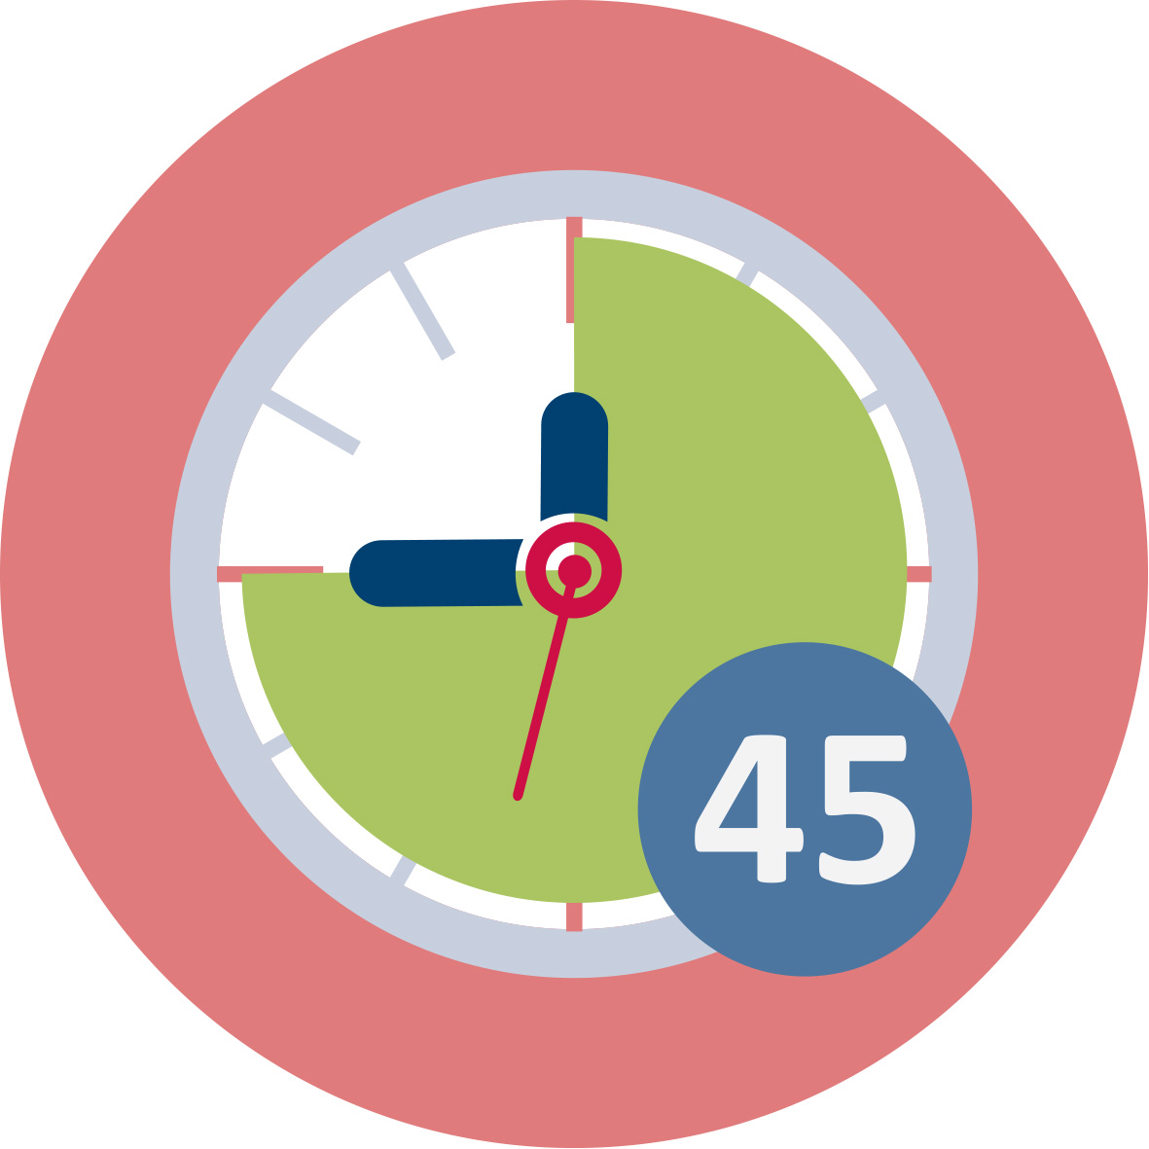 Duration: 45 minutes
Before the first in class activity the students are required to prepare by reading about mathematical competence and reflect on their own classroom experiences.
This session contributes to the achievement of the following learning outcomes:
- Describe the connection between language, culture and teaching in mathematics;
1.2. Classroom culture and mathematical competencies
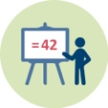 | 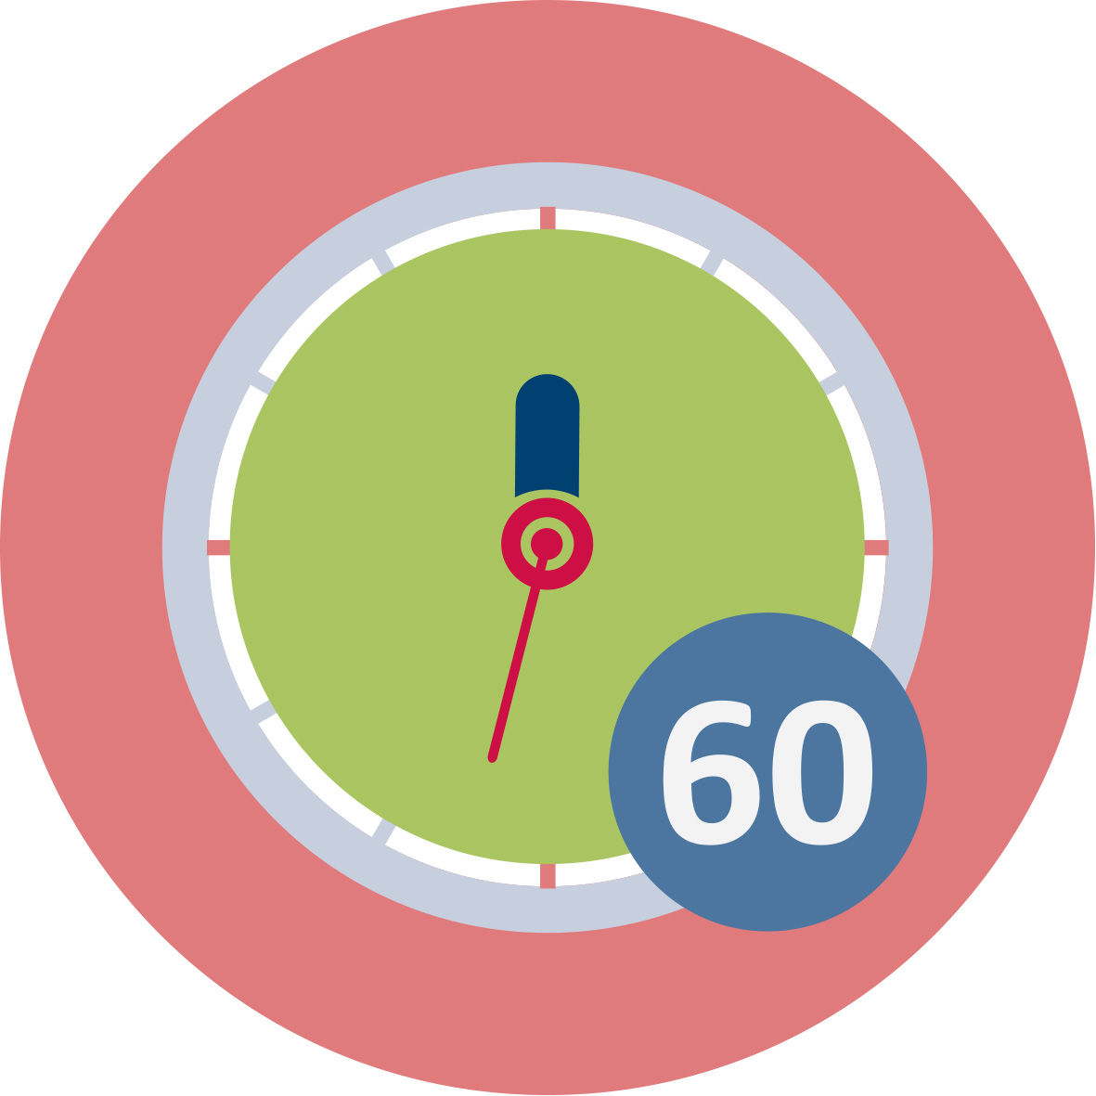Duration: 60 minutes
This activity consists of an introductory presentation of the topic (30 min), followed by a small group discussion about classroom culture (30 min), which is then summarized in the whole class. A video of an example of a classroom activity in China serves as an outset for the discussion. Other examples available to you can be used instead. The activity is meant to elicit reflection on variations in classroom culture and what and how different mathematical competencies are valued, and to sensitise the teacher students to the experience of entering into a new classroom culture.
This session contributes to the achievement of the following learning outcomes:
- Describe the connection between language, culture and teaching in mathematics;
1.3: Classroom culture and language differences
 | Duration: 45 minutes
This activity consists of a small group discussion of different strategies for dealing with language diversity in the classroom. Let the students discuss the two cases and the following questions on the worksheet in small groups, and summarize the reflections in the end of the session.
This session contributes to the achievement of the following learning outcomes:
- Describe the connection between language, culture and teaching in mathematics;

II. Cultural experience and mathematical competence
2.1. Language and mathematical concepts
Duration: 45 minutes
In this session you will introduce the idea of everyday language affecting the understanding of mathematical concepts. The table of number words in different languages is meant to raise questions about the learning of numbers and the discovery of patterns in the number system. You will then let your students discuss and reflect on the relationship between everyday language and mathematical concepts relevant for their future practice (20 min)
This session contributes to the achievement of the following learning outcomes:
- Explain how pupils’ previous experiences and cultural backgrounds can be used as a resource and a starting point in mathematics teaching;
- Discern their own and the pupils’ understandings of fundamental concepts in mathematics and know how to address different understandings in class;
2.2. Different methods
Duration: 45 minutes
This activity problematizes the mathematical and personal aspects of methods, models and tools. The students are asked to figure out how and why different methods for multiplication and division works, as a basis for reflection on building on and valuing pupils’ different abilities (20 min).
This session contributes to the achievement of the following learning outcomes:
- Explain how pupils’ previous experiences and cultural backgrounds can be used as a resource and a starting point in mathematics teaching;
- Discern their own and the pupils’ understandings of fundamental concepts in mathematics and know how to address different understandings in class;

III. Assessing and challenging all students
3.1. Assessing mathematical competence
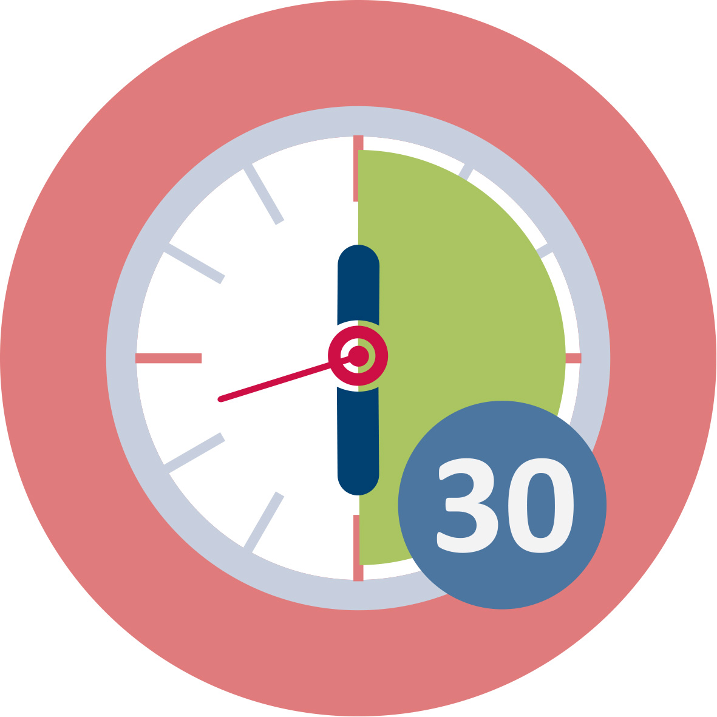 Duration: 90 min
This activity addresses different aspects of mathematical competence, and how tasks may or may not be helpful in assessing these aspects. You will discuss these issues in relation to two frameworks: imitative and creative reasoning, and mathematical competencies. Your students will then compare diagnostic materials from various sources and analyse what competencies and forms of reasoning they assess. They will also compile and/or construct a diagnostic test for use in Activity 3.2. The students’ part of the session will be 60 min.
This session contributes to the achievement of the following learning outcomes:
- Assess pupils’ pre-knowledge in mathematics in order to develop valid teaching strategies – and understand the importance and interdependence of diagnosis and the development of competences of the individual learner;
3.2. Local resources for assessment and support
Duration: 60 min
In this activity, the students carry out an interview at a local school. They will present their results in class, preferably as they present the results of activity 3.3.
This session contributes to the achievement of the following learning outcomes:
- Understand the need of collaboration between teachers of different age groups as well as collaboration with language teachers – in order to get support in working with pupils whose maths/science or language proficiencies are very different from the average level in class.
3.3. Using assessment in development of teaching
Duration: 60 min + 1 day analysis and preparation + 20 min presentation/group
This activity consists of using the diagnostic tests your students constructed in activity 3.1 in a class at a local school, compiling the results and presenting conclusions and implications in class, with special consideration of language and cultural factors.
This session contributes to the achievement of the following learning outcomes:
- Assess pupils’ pre-knowledge in mathematics in order to develop valid teaching strategies – and understand the importance and interdependence of diagnosis and the development of competences of the individual learner;
- Discern their own and the pupils’ understandings of fundamental concepts in mathematics and know how to address different understandings in class;

 | Materials and resources
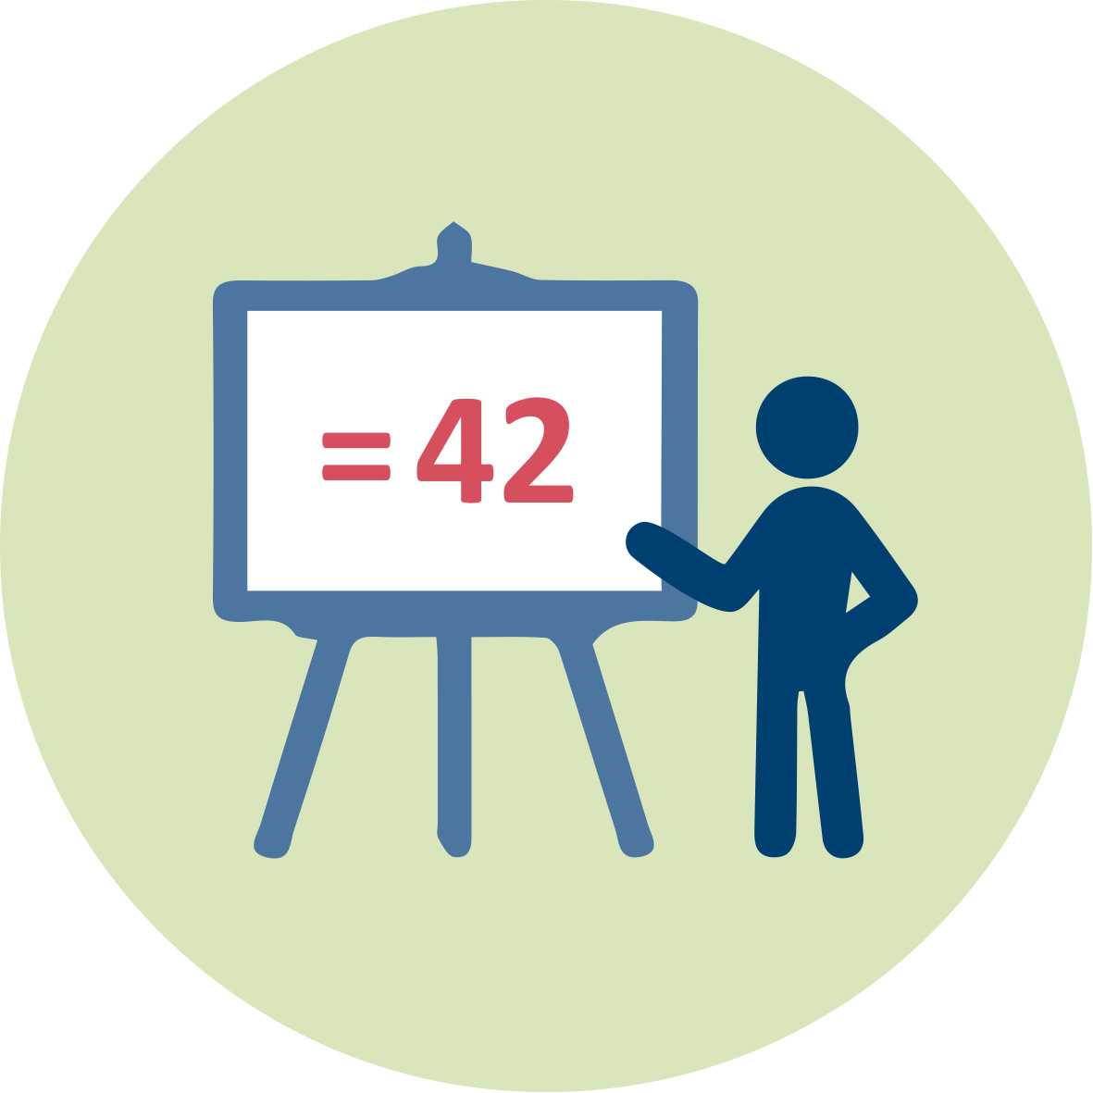 | Presentation 1 (pptx). Teacher Educator. Slides for all classroom activities included.
 | Readings (listed in the Reference section)
 | Worksheets. Includes student activities for module 7.
 | Access to computers for internet research and collaborative work
- | Youtube videos (links included in worksheets and pptx)

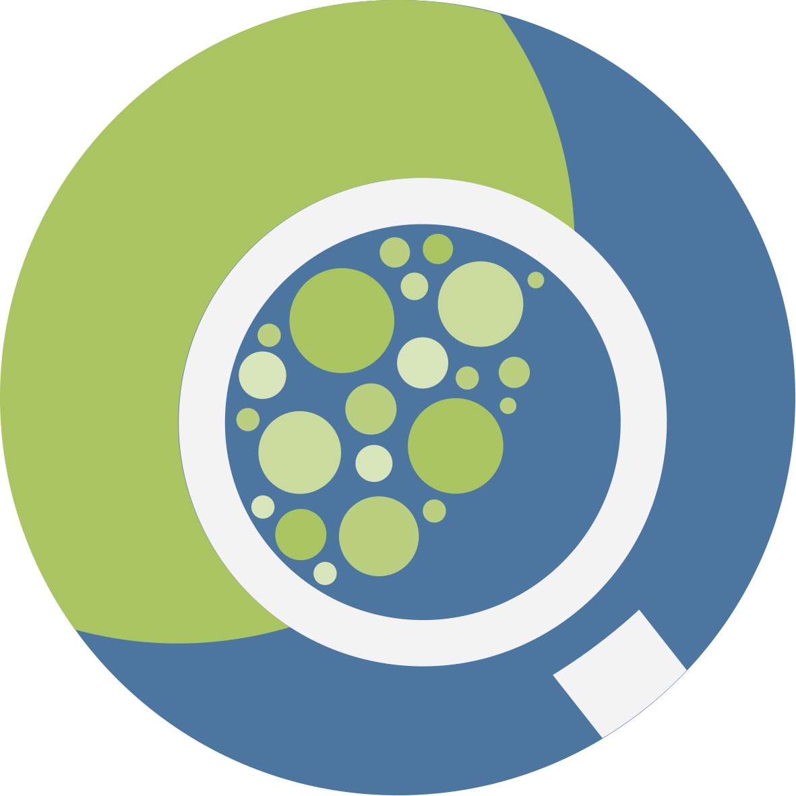 | Granularity
- Use only one of the discussions in Activity 1.2 and 1.3.
- Use only one of the discussions in Activity 2.1 and 2.2.
- Integrate part III in any similar activity you already have in your course.
- If you have a large group of teacher students, you may want to split the class up in groups of 15-25 for the presentations in Activity 3.3.
- Let the teacher students use the results of the diagnostic tests to design and conduct one or several lessons in the class they tested.

References
Boesen, J., (2006). Assessing mathematical creativity: Comparing national and teacher-made tests, explaining differences and examining impact. (Doctoral thesis, Umeå University, Umeå). Retrieved from http://umu.diva-portal.org/smash/get/diva2:144670/FULLTEXT01.pdf
Boesen, J., et al. (2014). "Developing mathematical competence: From the intended to the enacted curriculum." The Journal of Mathematical Behavior, 33 (Supplement C): 72-87.
Boesen, J., et al. (2016). Assessing mathematical competencies: an analysis of Swedish national mathematics tests. Scandinavian Journal of Educational Research, 1-16.
Lithner, J. (2008). A research framework for creative and imitative reasoning. Educational studies in mathematics, 67(3): 255–276.
Säfström, A. I. (2013). Exercising mathematical competence: Practising representation theory and representing mathematical practice. (Doctoral thesis, Gothenburg University, Gothenburg). Retrieved from https://gupea.ub.gu.se/bitstream/2077/32484/1/gupea_2077_32484_1.pdf

Further readings
More on mathematical competence:
Kilpatrick, J., Swafford, J. & Findell, B. (2001). Adding it up: Helping children learn mathematics. Washington, DC: National Academy Press.
NCTM. (2018). Process. Retrieved from http://www.nctm.org/Standards-and-Positions/Principles-and-Standards/Process/
OECD. (2017). PISA 2015 Assessment and Analytical Framework: Science, Reading, Mathematic, Financial Literacy and Collaborative Problem Solving, OECD Publishing, Paris. http://dx.doi.org/10.1787/9789264281820-en
More on using pupils’ solutions and methods in class:
Stein, M. K., Engle, R. A., Smith, M. S., & Hughes, E. K. (2008). Orchestrating Productive Mathematical Discussions: Five Practices for Helping Teachers Move Beyond Show and Tell. Mathematical Thinking and Learning, 10(4): 313–340 .

Assessment
All group discussions can be summarized by letting each group describe the highlights of their discussion, either orally or in text. Take special note to whether the students:

- Have taken active participation in the activity
- Show understanding of and reflection on differences in classroom culture, its relation to national/regional culture, and how it shapes teachers’ and pupils’ perception of deficiency and excellence (Activity 1.2)
- Reflect on the role of language proficiency in expressing mathematical compentence (Activity 1.3)
- Give and discuss examples of how pupils’ experiences and backgrounds can be used in mathematics teaching (Activity 2.1)
- Show ability to detect key mathematical ideas in concepts, methods and pupils’ solutions, and give examples of how both correct and mistaken methods can be used in teaching (Activity 2.1 and 2.2)
You could assess the diagnosis tests developed by your students before they are used, as this may increase the value of the presentation in activity 3.3. Otherwise, you use the students’ presentations in activity 3.3 to assess whether students:

- Show ability to choose or design tasks that measure pupils’ pre-knowledge in ways that give important information for the planning of teaching
- Draw reasonable conclusions from the results of their tests regarding the students’ competence and the quality of the test
- Share insights regarding the benefits and limitations of diagnosis for planning teaching
- Discuss examples of how collaborations between teachers across age groups and language teachers work, with respect to benefits and limitations for designing a challenging and supportive learning environment for pupils of different achievement levels.

