Module 7 |  | DEALING WITH DEFICIENCIES AND EXCELLENCY IN THE MATHEMATICS PROFICIENCY OF IMMIGRANT STUDENTS

Worksheets

This worksheet is based on the work within the project Intercultural learning in mathematics and science initial teacher education (IncluSMe). Coordination: Prof. Dr. Katja Maaß, International Centre for STEM Education (ICSE) at the University of Education Freiburg, Germany. Partners: University of Nicosia, Cyprus; University of Hradec Králové, Czech Republic; University of Jaen, Spain; National and Kapodistrian University of Athens, Greece; Vilnius University, Lithuania; University of Malta, Malta; Utrecht University, Netherlands; Norwegian University of Science and Technology, Norway; Jönköping University, Sweden; Constantine the Philosopher University, Slovakia.

The project Intercultural learning in mathematics and science initial teacher education (IncluSMe) has received co-funding by the Erasmus+ programme of the European Union under grant no. 2016-1-DE01-KA203-002910. Neither the European Union/European Commission nor the project's national funding agency DAAD are responsible for the content or liable for any losses or damage resulting of the use of these resources.

IncluSMe project (grant no. 2016-1-DE01-KA203-002910) 2016-2019, lead contributions by Säfström, A.I., Nyman, R., and Boesen, J., School for Education and Communication, Jönköping University.
CC-BY-NC-SA 4.0 license granted (find explicit terms of use at: https://creativecommons.org/licenses/by-nc-sa/4.0/deed.en)

I. Introduction to the topic “Dealing with deficiencies and excellency in the mathematics proficiency of immigrant students”
 | Activity 1.1: Preparation
 |  | Homework | 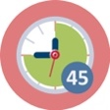 | 45 min
Read pp. 30–33 from Säfström (2013), and write down your reflections on the following questions:

- What competencies have been valued in the mathematics classrooms you have observed or participated in?
- What did constitute a successful student in these classrooms?
- What kind of activities would a student need to participate in, in order to develop these competencies?

I. Introduction to the topic “Dealing with deficiencies and excellency in the mathematics proficiency of immigrant students”
 | Activity 1.2: Classroom culture and mathematical competencies
 |  | Work in groups | 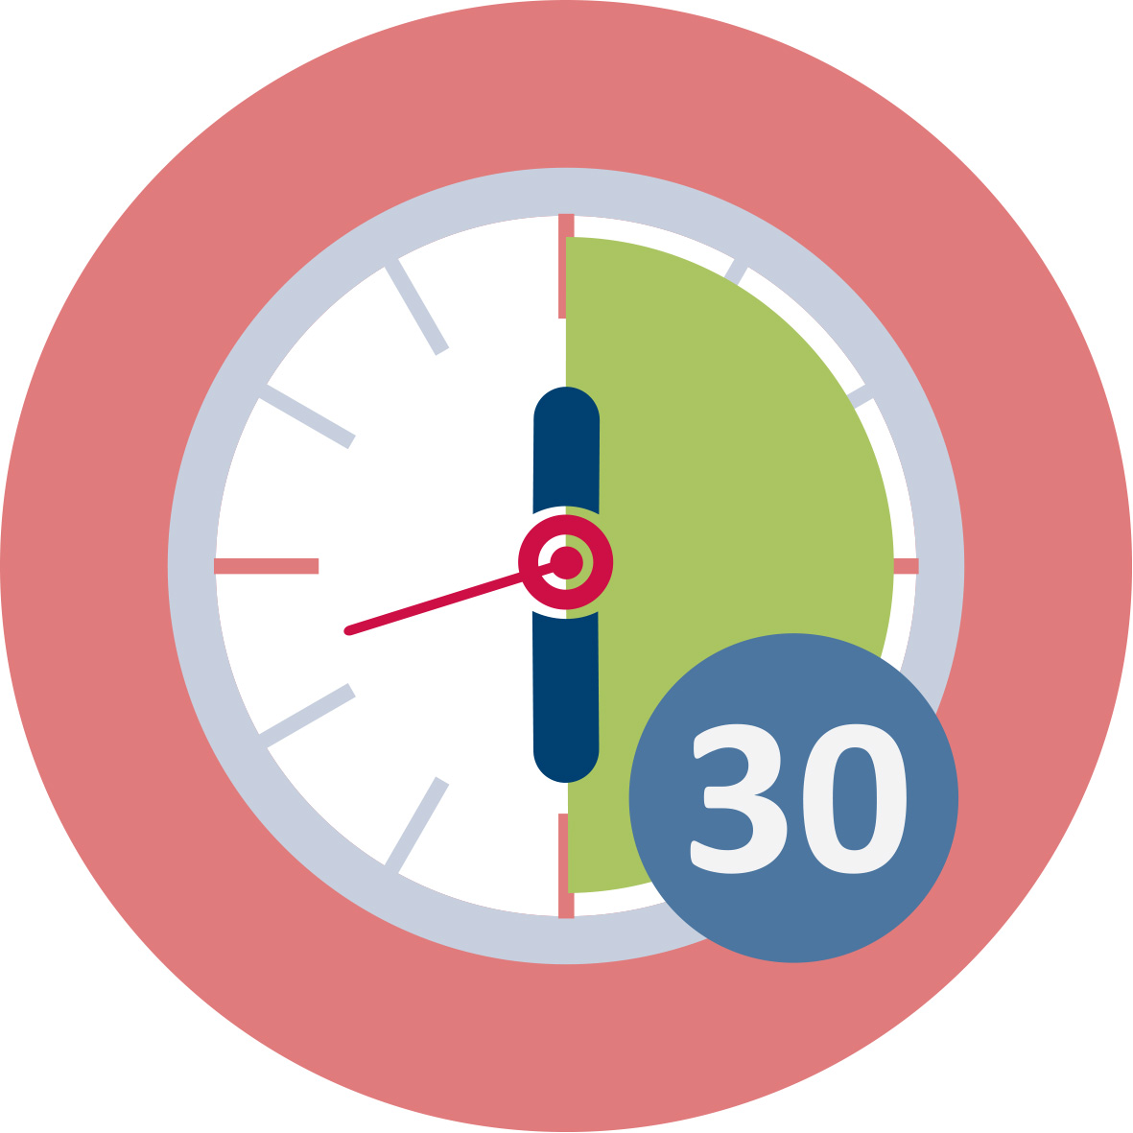 | 30 min
Watch the classroom example from China:

https://www.youcubed.org/resources/a-visit-to-china/

Discuss the following questions, and write down your reflections:
- In what way is the Chinese lesson similar or different from mathematics lessons you have participated in?
- What competencies do the Chinese students exercise, and in what way? How is that similar or different from the lessons you have experienced?
- What kind of behaviour – which mathematical actions – does the teacher value in the Chinese lesson? How is that similar or different from the lessons you have experienced?
- How do you think a student from the Chinese class would experience coming to a class in your local school? What advantages might the Chinese student have, and what potential problems? Conversely, how would a student from your local school manage in the Chinese class?
- What role does language play in the exercising of different mathematical competencies?
- What could the students at a local school learn from a Chinese student? What could the Chinese class learn from a student at the local school?

I. Introduction to the topic “Dealing with deficiencies and excellency in the mathematics proficiency of immigrant students”
 | Activity 1.3: Classroom culture and language differences
 | Work in groups | 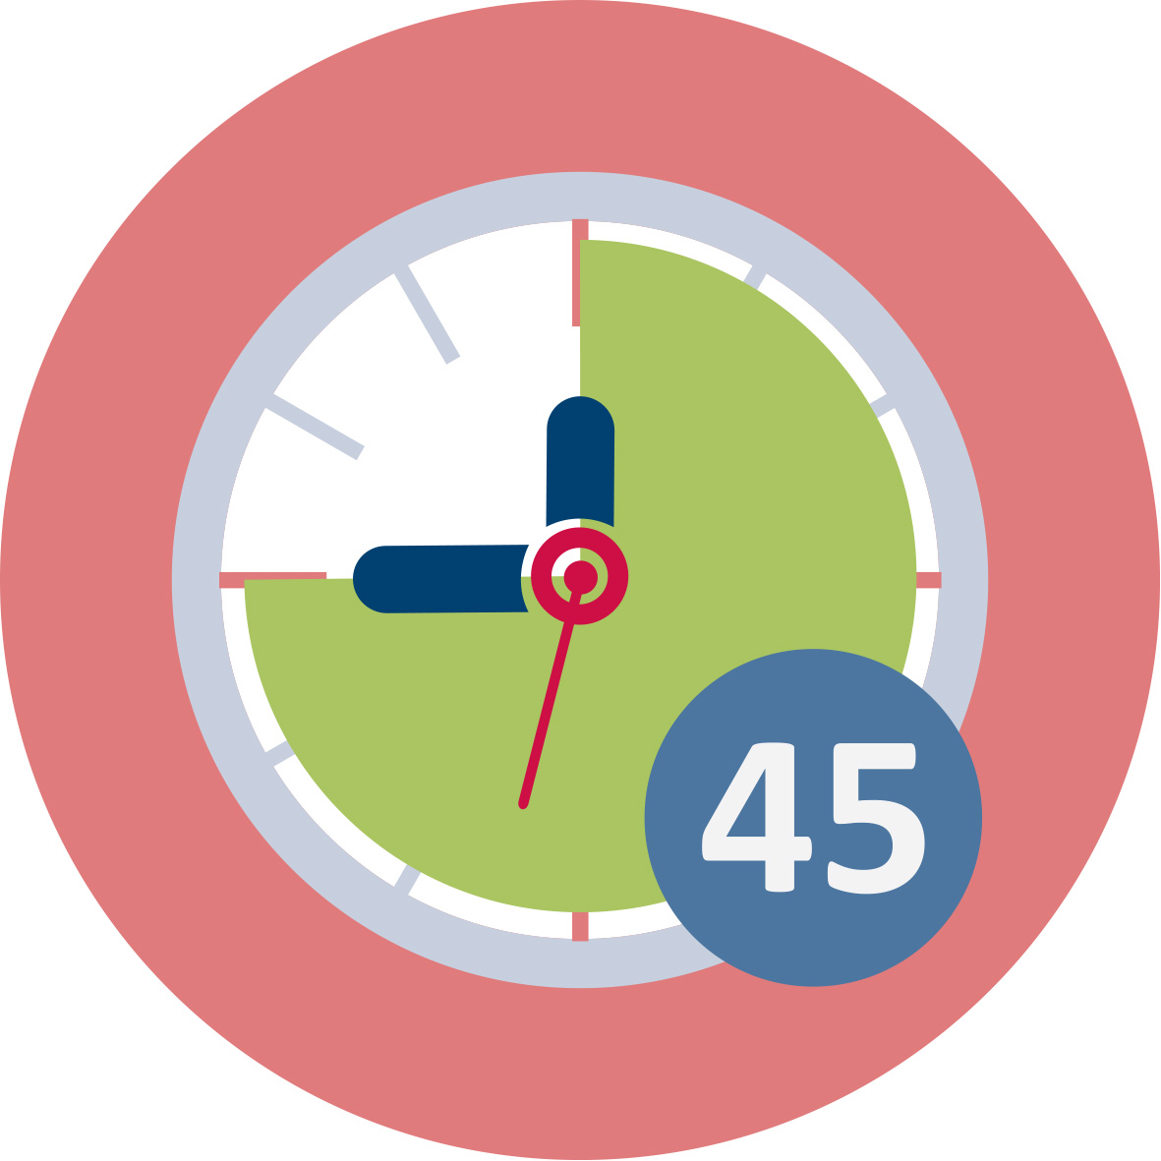 | 45 min
Read the two case descriptions and discuss the questions below.

Case 1
Anna is a Swedish mathematics teacher, teaching a class consisting of students from various countries. During the matheamtics lessons, the students are placed in small groups with others who speak the same language. During problem solving sessions, the students discuss within their group in their native language, but when Anna introduces a new topic or leads whole class discussions, she speaks Swedish.

Case 2
Bente is a Danish mathematics teacher, who also teaches a students from various countries. During the mathematics lessons, all students are required to speak exclusively in Danish. Students who share another language are spread out in the classroom to encourage them to speak Danish.
- What benefits and problems can you see in relation to Anna’s and Bente’s strategies?
- How and when would you use these strategies? Why?
- What strategies would you use if faced with teaching students who do not share any of your languages? How would you get access to those students’ mathematical competencies?

II. Cultural experiences and mathematical competencies
 | Activity 2.1: Language and mathematical concepts
 | Work in groups | 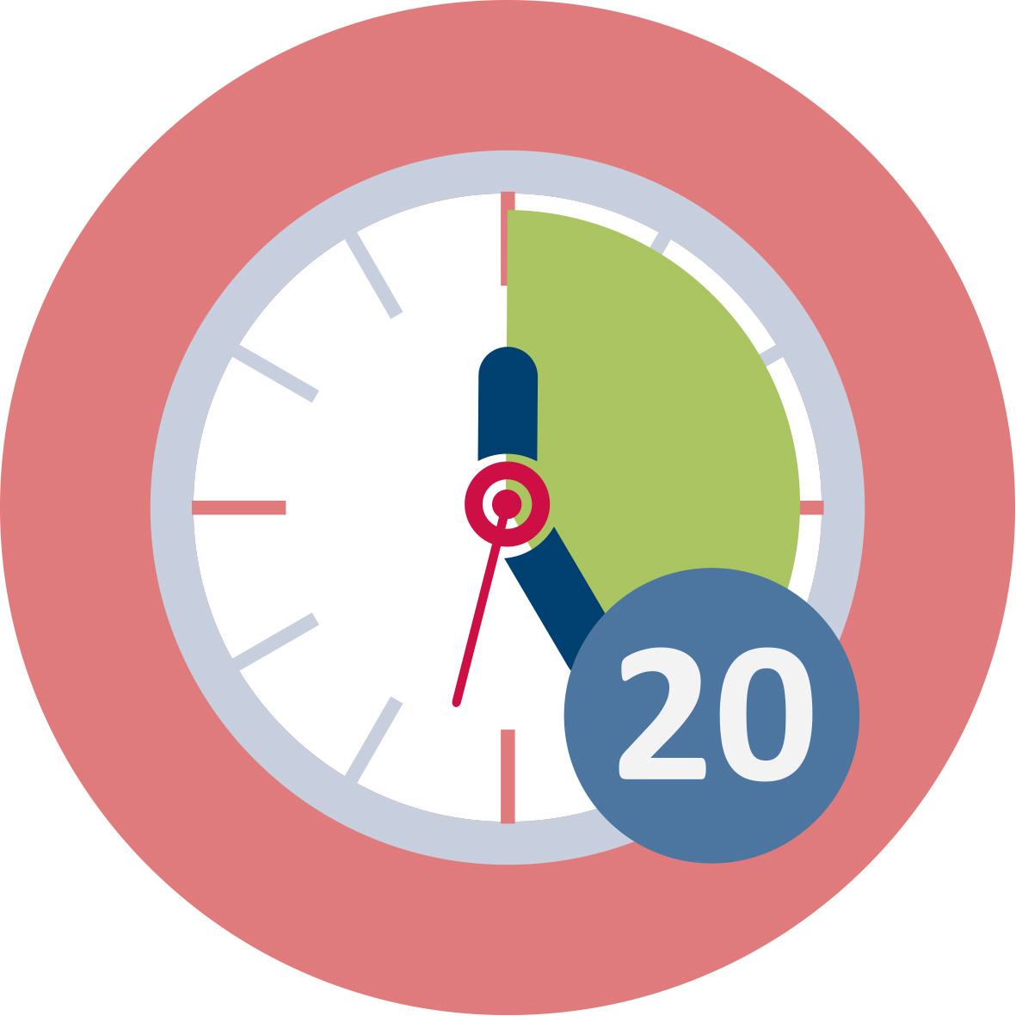 | 20 min
Pick a mathematical concept relevant for your future mathematics teaching (e.g. the number sixty-two, volume, denominator, percentage, slope), and find out what it is called in different languages known in your group.
- What else do these words mean in each language? In which everyday contexts are these words used? How may that shape the understanding of the mathematical concept?
- What other terms or expressions are used in relation to the mathematical concept in each language? How may that shape the understanding of the mathematical concept?
- How can your students and you as a teacher benefit from discussing these questions? What other questions could guide the discussion towards the development of conceptual understanding?

II. Cultural experiences and mathematical competencies
 | Activity 2.2: Different methods
 |  | Work in pairs |  | 20 min
Watch the different multiplication and/or division methods, and discuss the questions below. Write down your reflections.

MULTIPLICATION: https://www.youtube.com/playlist?list=PLRG4iHU5uhLCSlkX1N74K-vrr7ImSrDZj

DIVISION: https://www.youtube.com/playlist?list=PLRG4iHU5uhLBs34Do2bkgKfxRddBJesn8

- Work out some examples with other numbers. Can you explain how the different methods work?
- What merits and deficits do you see in the different methods? When is each method efficient, and when is it not?
- What can students learn from discussing different methods? What aspects of the underlying concepts can become visible? What aspects of students’ knowledge can become visible for you as a teacher, by means of such discussions?
- How can you arrange a learning situation so that students are able to compare and evaluate different methods? What questions would you ask students in such a situation?
- Assume you would lead a classroom discussion about multiplication or division methods. Pick three methods which you think could be used by three students in your class. In what order would you let the students present their methods, and why? What aspects would you highlight, and how would you compare and contrast the methods?
- What are the benefits of including incorrect or mistaken methods? When would you let students who made mistakes present? How would you address the mistakes, in order for the student and the class to learn from them?

III. Assessing and challenging all students
 | Activity 3.1: Assessing mathematical competence
 |  | Work in pairs | 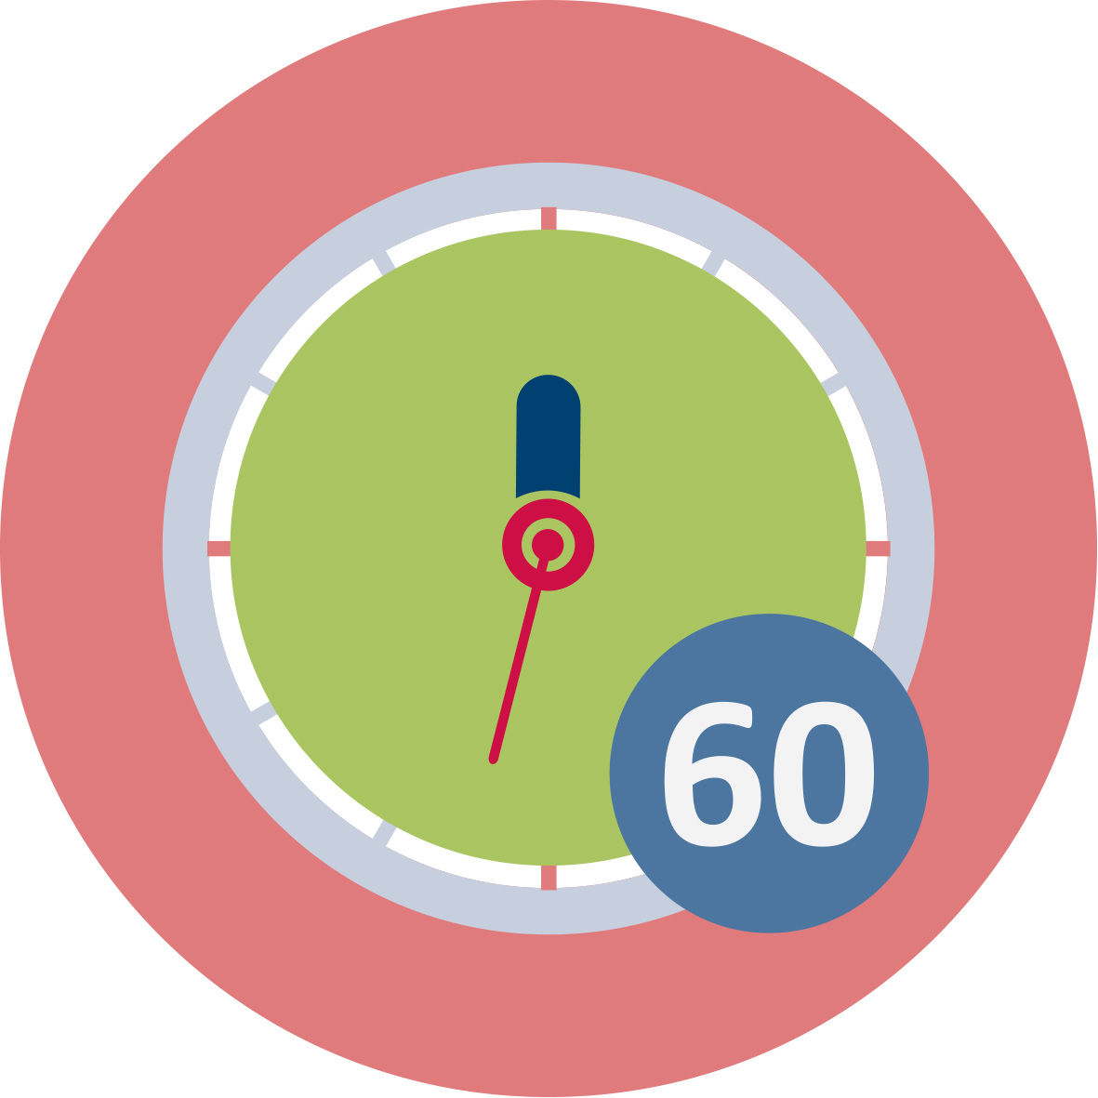 | 60 min
Compare and analyse at least two different diagnostic assessment materials.
Find out whether there are any diagnostic assessments adapted to your curriculum available. Such assessments may be provided by a national agency or developed by other organisations in your country. Choose a mathematical topic relevant for your futute students, and pick out the diagnostic assessments for this topic from two of the following sets of assessment materials:

Your own

Australia
https://numeracyskills.com.au/assessment-resources

Germany
https://mathe-sicher-koennen.dzlm.de/node/336

New Zealand
https://nzmaths.co.nz/node/1599

Sweden
https://www.skolverket.se/bedomning/bedomning/bedomningsstod/matematik/diamant-1.196205
- Which mathematical competencies are tested by the diagnostic materials? Which are not tested?
- To what extent does language skills affect the outcome of these tests? How can you as a teacher adapt the tasks for immigrant students, in order to assess their mathematical rather than their language competence?
- Besides these tests, what do you as a teacher need to do in order to assess the mathematical competence of your students?
- Compile your own diagnostic test for the topic by picking tasks from the analysed tests and constructing additional tasks. You will use this test in Activity 3.3.

III. Assessing and challenging all students
 | Activity 3.2: Local resources for assessment and support
 |  | Homework in pairs |  | 60 min
Find out what resources are available for assessing and supporting students at a local school.

Contact a local school and interview teachers and/or principals:
- Are you using any standardised or local tests for assessing students’ mathematical knowledge? Are these tests available in different languages? How do you use these tests with students who do not speak the native language?
- Are there language teachers or interpreters for the languages spoken by students at the school?
- Do teachers in different grades collaborate to support and challenge students who lie significantly above or below the average level of their class? What other strategies does the school use to address these students’ needs for challenge and support?
Write down the answers, as well as your conclusions and reflections.

III. Assessing and challenging all students
 | Activity 3.3: Using assessment in the development of teaching
 |  | Work in pairs | 1 day + | Homework 1 day and 20 min presentation/group
Use the diagnostic test you compiled in Activity 3.1 in a class or a group of students at a local school.
- Compile the results and describe the class or group as a whole. What is the overall level, and how large is the variation?
- Pick out three pupils, whose results you want to analyse in depth.
- What do these pupils know well? What deficiencies have you identified? What may be the cause of these deficiencies? To what extent may language skills have affected the outcome for these pupils?
- What teaching strategies and pupil activities do you intend to use in order to address the pupils’ deficiencies?
Make use of relevant literature from the required reading of the course in order to answer these questions.

