Invasion of the Greylag Geese
Overarching question
Is a growing goose population dangerous for other birds?
Abstract
In this activity students will explore the evolution of a population of geese in the Netherlands. Students will learn both about the meaning of biodiversity and how it can be measured. As a final product students will write a report to the bird counters of the Sovon organisation in which they explain their findings and offer advice.
Aspect | Description
Mathematical content | Functions and graphs, modelling, probability
Scientific content | Biodiversity: what does it mean and how can it be affected?
Age of students | 16
Number of lessons in mathematics | 3
Number of lessons in science | 3
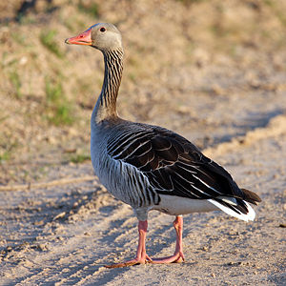

(http://commons.wikimedia.org/wiki/File:Greylag-Goose.jpg?uselang=en)
1. Overview over the teaching unit

1.1 The situation
The number of greylag geese that breed in the Netherlands and other countries in Europe is steadily increasing. This has become apparent from national bird counting events. Sovon, a Dutch bird protection organisation, organises those counting events to keep track of which birds breed in the Netherlands, where they are breeding, and the number of birds. Sovon publishes the results of these counting events in Excel tables on the Internet.
In this teaching unit you will see part of such a table. The bird counters of Sovon are worried about the increase in the number of greylag geese. They are afraid that it may endanger the diversity ofwater bird species.

1.2 Guiding questions
- Sovon counts birds. The number of greylag geese is increasing. Is this increase worrying for the diversity of water bird species?
- What does the concept biodiversity mean, how can it be described mathematically and what are itsadvantages and limitations?
- How does the biodiversity of water birds change in the Netherlands (Europe/your country) and what is the impact of the growth of the greylag goose population

1.3 Final product
Write a reportto the bird counters of Sovon with the results of your analysis. Describe the problem and indicate how serious you think it is. Illustrate your description of the problem with graphs and tables. Reflect on the value of a formula as a biodiversity index.

1.4 Suggestions
To apply the lessons learned and providea localisedversion, (water) bird watching and inventories (or inventories of other species) could beconducted in the local area. An urban park pond is as good as a nearby lake. For instance, in Germany this unit can be connected to a German site for water bird counting. If interested, students can collaborate with an official organisation for water birds in Germany or disclose their results, at the local ornithologists’ club, making a small contribution to the protection of biodiversity.European information on numbers of birds can be found through: http://www.ebcc.info/.
Investigate a situation in your country, select a varietyof birdspecies and report on trends in biodiversity during the past 10 years.

1.5 Materials
- Access to computers for internet research and, if necessary, for working with Excel.
- balls of equal size in different colours for modelling probability

1.6. The task plan
Unit | Biology | Mathematics
1 | Task 1:  Introduction to the task. The greylag goose population at risk; grasping the development of water bird populations and their proportionalities
2 | Task 2:  What is biodiversity?  Characteristics of biodiversity are discussed.
3 |  | Task 3:  What is the change in the greylag goose population in comparison to other water birds?  Draw a diagram by hand or with Excel that illustrates the development.
4 |  | Task 4:  What kind of measure can be used to describe biodiversity?
5 | Task 5:  What factors can underlie the specific changes in bird populations and the changing variety?
6 | Task 6:  Returning to the original question:  Is the increase in the numberof greylag geeseworrying for the diversity of water bird species?  Write a report on the changes in biodiversity duringthe last ten years. Explain whether the increase inthe graylag goose population is really worrying.  Proposal for practical work: survey of water birds  Establish a regional reference and application of learning through a practical investigation.

2. Description of the tasks

2.1 Task 1 – Does the greylag goose population threaten other water birds?
The aim of this task
- The students establish assumptions about the importance of population trends of greylag geese to biological diversity.
- They are able to establish alternative assumptions about the causes of population trends of some species of water birds.
- The students realise that they need more information to answer their questions and discuss how to proceed.
Scientific content
Students should become familiar with the topic. An awareness of the concept of biodiversity and certain aspects of it should be established. Students understand that data from surveys of bird populations is used to describe their evolution.
Outcomes
The issue of biodiversity can be introduced with controversial questions in a short interactive format (think, share & exchange):

Activity 1 for students:
Is MacDonald’s / H&M dangerous for the quality of life?
- You have 2 minutes to think and write individually what comes to your mind.
- You have another 2 minutes to share your results with your neighbour.

The format works as follows: students have paper and pencil in front of them. The question is posed by the teacher.
The students get two minutes to think and write individually what comes to their mind. Next, they get two minutes to share their results with neighbours and finally the teacher has two minutes (or a bit longer) to share the main statements with the whole class.
The teacher focuses on issues that are related to competition / variety / flexibility, etc. and these issues are related to biodiversity. This discussion is used to introduce a specific case study in the Netherlands about the greylag goose. Data about population trends of water birds in the Netherlands arepresented to the students (Worksheet 1).
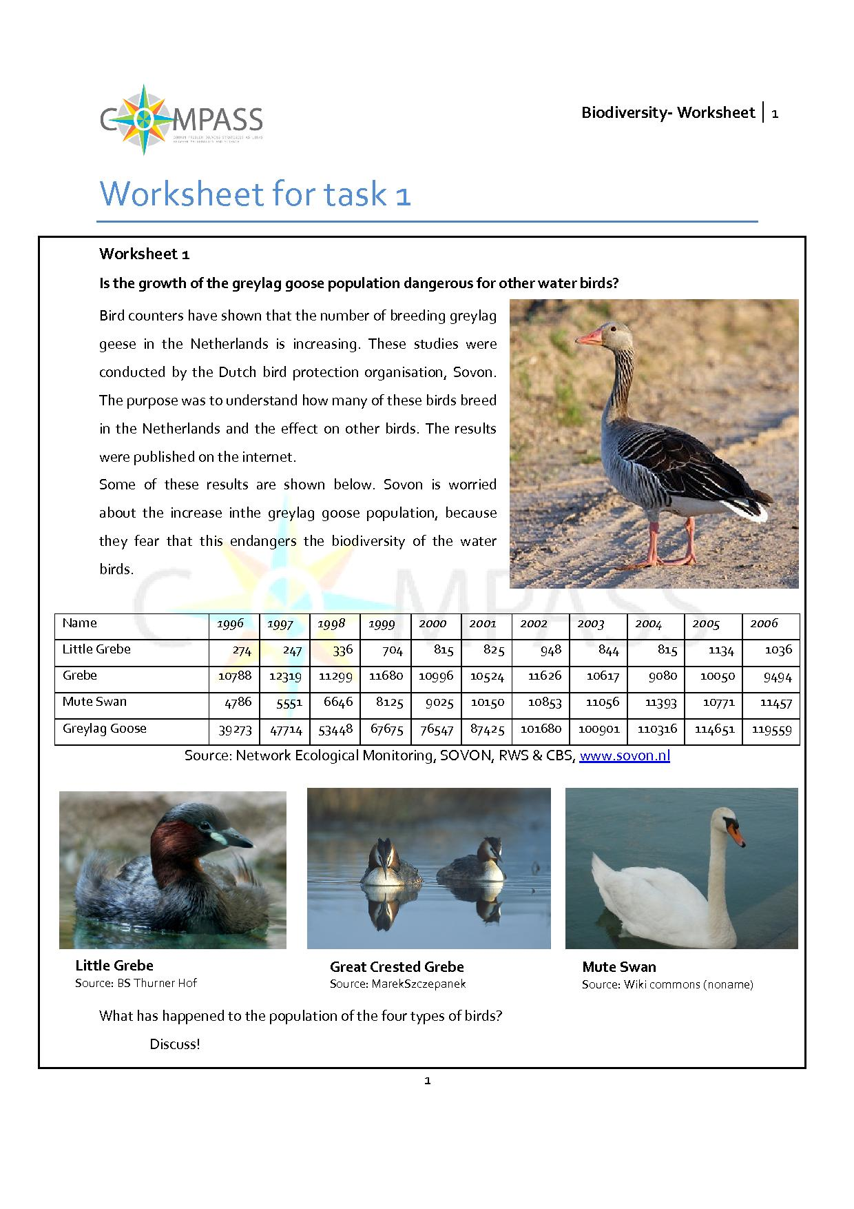
Based on the data in the table studentsshouldexpect a correlation to exist between the increase inthe greylag goose population and the stagnation or fall inthe other water bird populations. Also, some questions could arise about the uncertainty of assumptions made in creatingthe data because the table contains little extra information. More information is definitely needed to answer the initial question. Possible questions that couldarise in the discussion are:
- What is biodiversity?
- Why is biodiversity important?
- What risks are there to biodiversity?
- How do you measure biodiversity?
- Can a certain water bird speciesthreaten biodiversity?
- Can the growth in the greylag goose population lead to a decrease inother water bird populations?
- What other reasons could there be for the increase in greylag goose population and the stagnation or decline in other water birds?
Next, the concept of biodiversity should be clarified before the initial question can be investigated further. In project-based learning a brainstorming or mind mapping session couldfollow in which the situation is examined more systematically with the help of mathematics and biology. The teacher initially collects the comments of the students on the blackboard. A flow chart of the proposed procedure can be varied in accordance with the project proposals by teaching students to restructure and expand their ideas.
2.2 Task 2 – What is biodiversity?
Dodaars
The aim of this task
- Students understand that biodiversity is related to the numbers of species and their proportionalities within an ecosystem.
- They learn about the ecological interrelation between species and the possible effects of one population growing faster in relation to others.
- Students understand the concept of biodiversity and can explain why it is important.
- They are able to identify and explain factors that might change and endanger biodiversity.
Scientific content
- The concept of biodiversity.
Outcomes
Students have to know aspects of biodiversity to answer the overall question. Biodiversity is important because it measures the stability of the balance between species in an ecosystem.
The purpose of the questions on the following worksheet is to discusscriteria and measures for biodiversity.
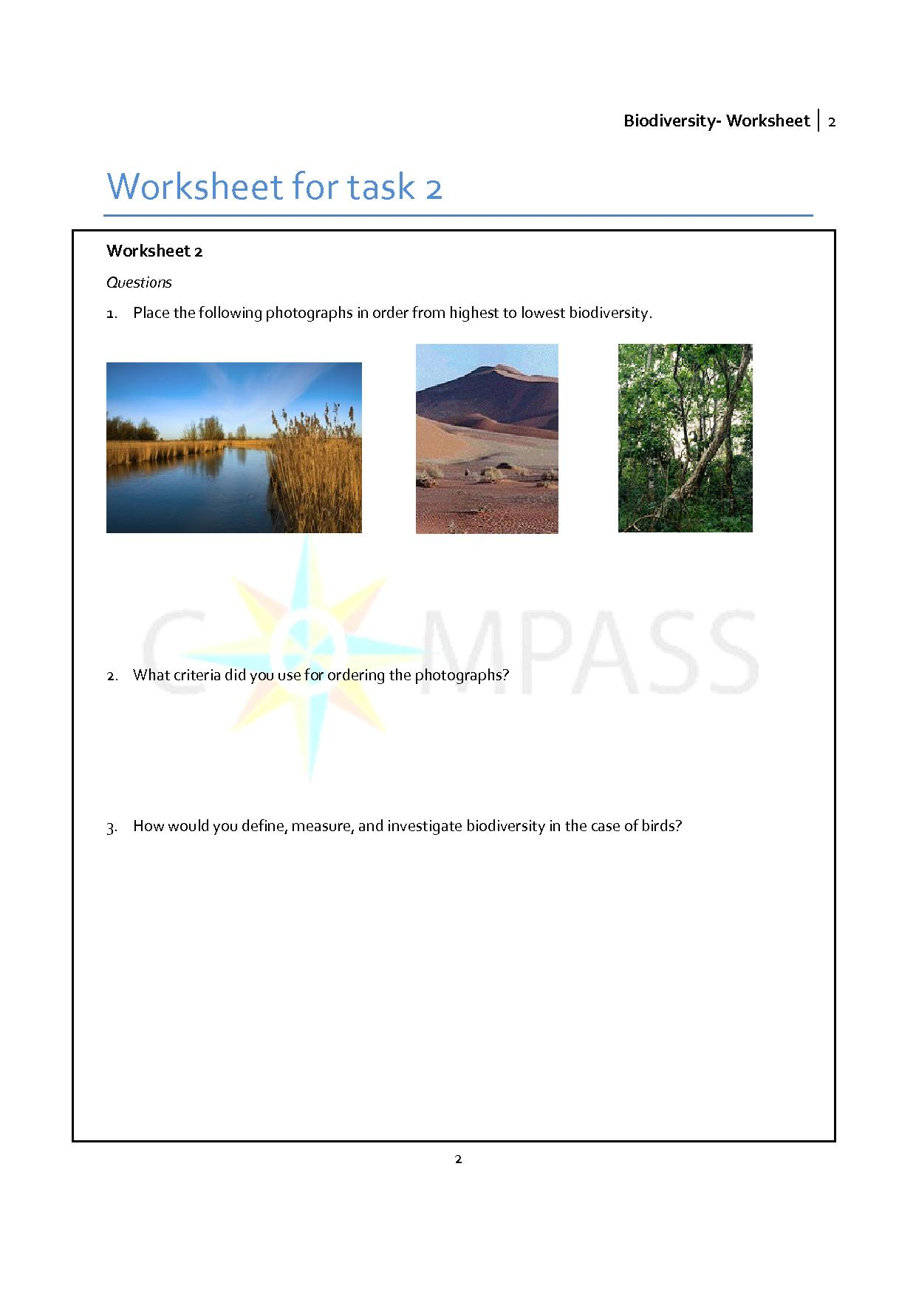
Students can also be asked to takephotographs of gardens, parks, etc. As a starting point for the activity: group the photographs and develop criteria for classification with respect to biodiversity.
Students think of aspects of and criteria for diversity between species (i.e. plants). Come up with words like ‘many’, ‘variety’, etc. The results of students’ answers should be presented and discussed. The discussion should result in a definition of biodiversity. Possible questions to enable pupils to better explain their thinking:

Possible questions during classroom discussion of students’ answers:
- How can biodiversity increase or decrease?
- Why is biodiversity important and why is it helpful to have a measure for biodiversity? What different levels of diversity can you think of?

A possible definition:
Biodiversity relates to diversity of species within different layers: genetic diversity within species, diversity of species within an ecosystem (animals, plants, mushrooms,etc.), and a diversity of ecosystems. Biodiversity relates to the total amount of genes, species and ecosystems within an area (and their proportionalities).
Finalquestionfor the class which leads to the following lesson in mathematics: How can youmeasure and investigate biodiversity?
2.3Mathematics – Task 3: How to describe the changes in the population of the water birds?
The aim of this task
- Students are able to produce graphs of the data, showing the changing proportionality between the four bird species over time.
- They develop hypotheses about the cause and consequences of the population changesof the different bird species.
Mathematical content
- Data visualisation and use of Excel.
Outcomes
Students are able to create graphs from given data by using Excel. They are able to describe the graph. The students can draw first conclusions from the presentation and draw first conclusions with respect to the changes in the population of water birds and can then set up first hypotheses about causal relationships between the four different speciesand other possible environmental factors.
Data visualisation helps to see and understand the data and the different trendsof the water birds better. This supports the students in reasoning about the possible danger of the population increase of the greylag goose to the other bird species (especially the Great Crested Grebe).
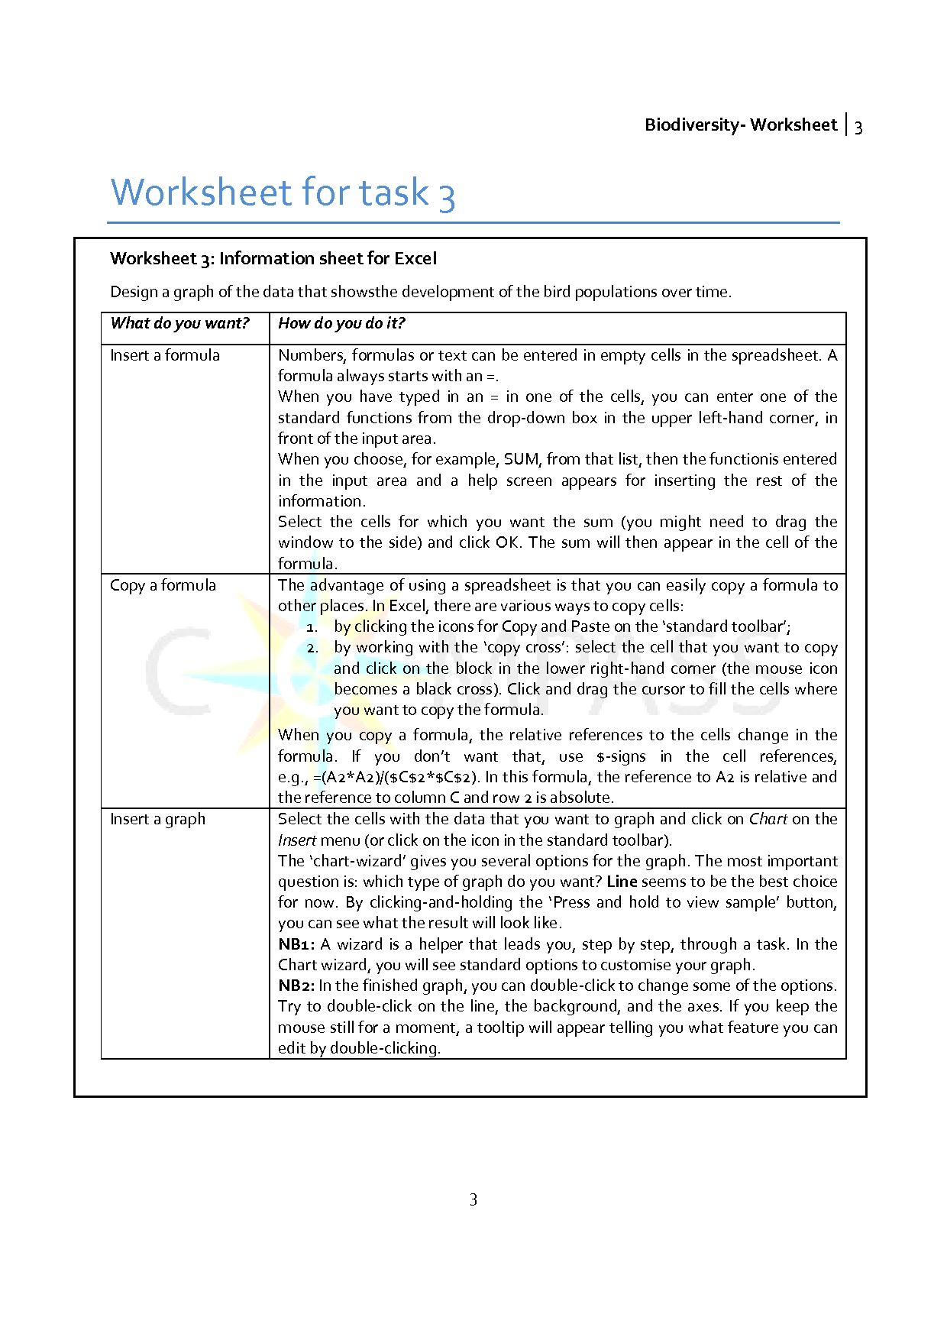
Graph of the data, showing the changing proportionality between the four speciesover time:
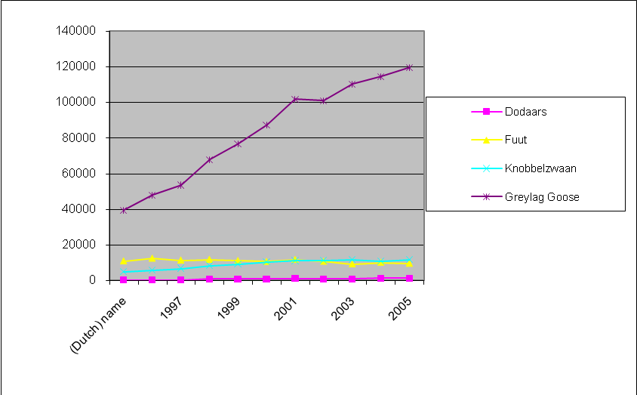
Little Grebe
Great Crested Grebe
Mute Swan
Greylag Goose
Students can either use Excel or paper and pencil. The use of Excel is preferredbecause of the possibilities to extend the Excel sheet by including calculations for a biodiversity index.
2.4 Mathematics – Task 4: How can we measure biodiversity?
The aim of this task
- Students learn that the idea behind a measure is based upon the probability that two animals of the same species meet in an area.
- Students learn about the advantages and limitations of such a measure.
- They get an impression of how the formula is calculated and how changes in the resulting value are related to changes in biodiversity.
- Students may also learn how to enter formulas in Excel (and deal with different kinds of variables: relative and absolute references to cells).
Mathematical content
- Data visualisation, probability, the value of mathematical models.
Scientific content
- An index for biodiversity, its advantages and limitations.
Outcomes
An extended Excel sheetor calculations with paper and pencil that describe the development of the biodiversity of water birds in the Netherlands.
Having a measure for biodiversity helps in describing the development over time. The index shows that the biodiversity of water birds is in danger. The index says nothing about causal relations.

In the following worksheet we will use a mathematical model to explore how to find a measure for biodiversity. This model supports students in understanding that the probability that two of the same species meet can be used for this measure: the Simpson’s index. The mathematical model helps students to work with this index in an informal way. High achieving students can be confronted with the actual formula:
Say, there are 10 species in a certain landscape type. Of the first species, there are , of the second , … and of the tenth individuals.
The total number of counted birds, then, is N = .
Simpson’s index D is calculated as follows:
These students might also be challenged to look for other measures (e.g. Shannon’s index) and discusshow they differ.
Students should be encouraged to reflect on the benefits of such a formula. One advantage is the comparability of the numbers. It is possible to specify a required standard for the countries of the EU that you want to be achieved. A problem is that such a diversity index does not indicate whether the value is based on a higher number of species or the even distribution of individuals in a small number of species. You also cannot necessarily infer what the genetic or ecological diversity is. The index can clarify the risk of biodiversity of water birds in the Netherlands. Some water birds seem to be endangered in their existence while others grow very well. The index cannot make any statement about causal correlation.
Various measures for biodiversity, like Simpson’s index, can be explored and compared with an applet.
Exploration environment for Biodiversity:www.compass-project.eu/applets/#3

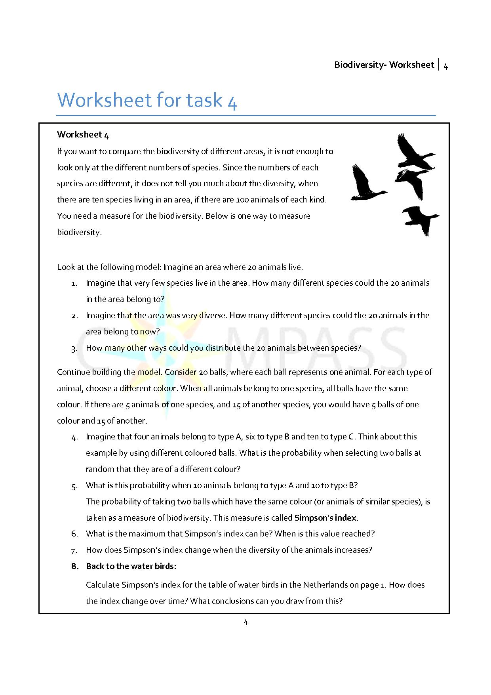
2.5 Biology – Task 5: How can changes in the population of water birds be explained?
The aim of this task
- Students can formulate hypotheses about the linksbetween cause-effect relationships.
- During the project, students are supportedin how to verify their hypotheses by a data search.
- Students can describe and compare the environmental requirementsof water birds.
- Students can apply their understanding of competition between species in order to assess the interactions between water birds and between water birds and other environmental factors.
Scientific content
Students learn about causes of population trends inwater birds, competition between species and the competition exclusion principle, organism-environment relationships (influence of biotic and abiotic environmental factors on changes in populations of species)
Outcomes
Based on the graphical representation of population trends from the previous session, the students formulate hypotheses about possible interrelations between changes in bird populationsand evaluate it by using the materials provided. In their conclusions they consider other biotic and abiotic factors which could influence the population development of the birds.
The assumptionsmade by the ornithologists of the Sovonorganisation about the relationship between the population trends of water birds should at this point be taken up again and checked.

Ask students questions that enable them to formulate hypotheses about possible causes of population trends.
Possible hypotheses:
- The increase is caused by greylag geese migrating from other parts of Europe, as their habitats are destroyed there.
- The greylag geese have become used to the environmental changes caused by humans while the other water birds are more sensitive to these changes.
- The predators of the Great Crested Grebe and Little Grebe have increased while the swan and the greylag goose don’t have any predators.
- The greylag geese are protected while the other water birds can be hunted.
- …
Some of these hypotheses can be tested by the students by working on the following tasks. Some others can better be reviewed in class projects in which students do their own research by using books, the internet or other bird associations.
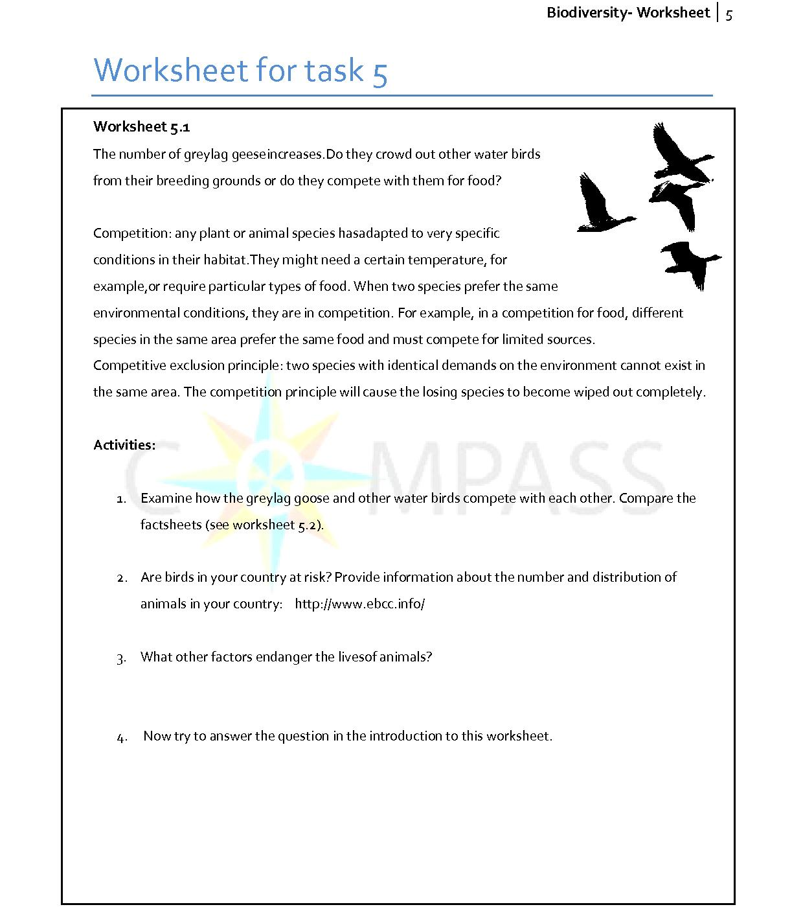
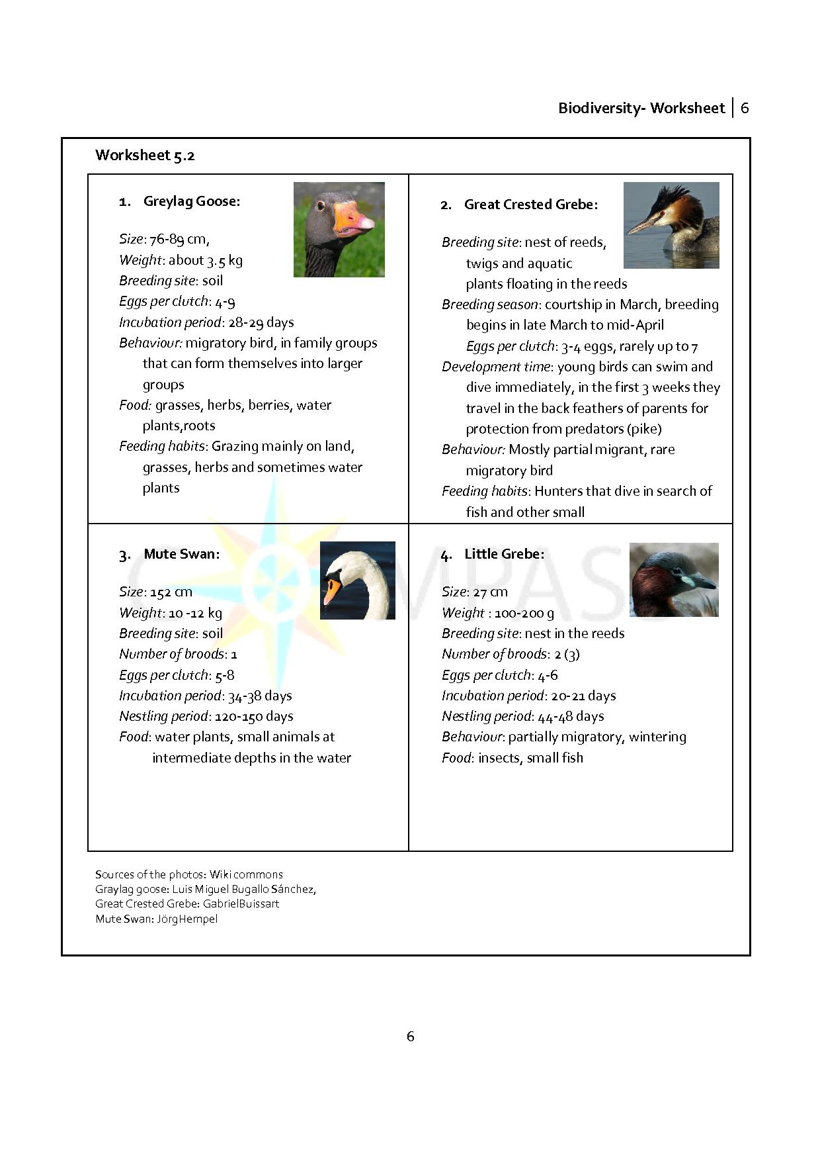
The students should find that these birds are not direct competitors for food because the food composition and location differ for each species. The swan can, for example,feedin greater water depths with its long neck than smaller ducks. There could only be competition between swans and greylag geese, but not between the greylag geese and other water birds considered here. It may be the case that other water birds are displaced by the graylag geese wherethey occur in large numbers. From a certain population size onwardsintraspeciescompetition in the greylag goose population dominates(crowding factor).
Students should compare the numbers of water birds and the distribution of water birds from the Netherlands to those from Germany and find that biodiversity currently is not in acute danger, but the grebe was very rare in Germany for a while because of hunting and eutrophic waters. The data from the internet suggest that the decline of some populations of water birds has other causes, mainly anthropogenic.
Further background information about ways in which biodiversity can be threatened:
Biodiversity (for example ofwater birds) is threatened by humans in many ways. Among the main threats are:
- Direct habitat destruction (such as the construction of settlements and infrastructure, deforestation, burning, mining, drainage, certain fishing practices, industrial agriculture)
- Over-exploitation and degradation (e.g., overgrazing, soil erosion, habitat fragmentation, unsustainable use of firewood, use of pesticides, pollutants, water pollution, unsustainable tourism traffic, unsustainable agriculture, unsustainable fishing and hunting)
- Land-use change: the abandonment of extensively used areas (e.g., grazing) or altered use (e.g., stepping through the conversion of grassland in agriculture) often has a negative impact on biological diversity.
- Non-resident species: can the conscious or unconscious release of a species outside of their natural range in new habitats have significant consequences (e.g., rabbits in Australia, giant hogweed and Himalayan balsam in Germany)
- Climate change: the climate changes too rapidly for the ecosystemsto adapt. This can lead to the extinction of isolated populations or species.
This information can be used during classroom discussion of students’ results.
2.6 Task 6 – The final report
The aim of this task
- Students are able to discuss the overarching question considering the results of their work duringscience and mathematics lessons.
- The students use their results to justify their position and develop proposals for measures to control and protect the diversity of water birds.
- They can submit their written questions to the ornithologists of Sovon (or bird watching organisations from other countries).
Mathematical content
Critical use of mathematical models.
Scientific content
Biodiversity, rivalry, reflection on a variety of arguments for a complex and unsolved biological problem.
Outcomes
The students learn that a clear conclusionis not possible. For example, there will always be reasons that make the increase inthe greylag goose population seem disturbing, but the same reasons may make the increase seem less significant. But the students shouldfind that a decisive influence ofthe number of geese on the populations of the other three species of water birdscannot be established.
Students write a report to the ornithologists of Sovon or another bird watching organisation.
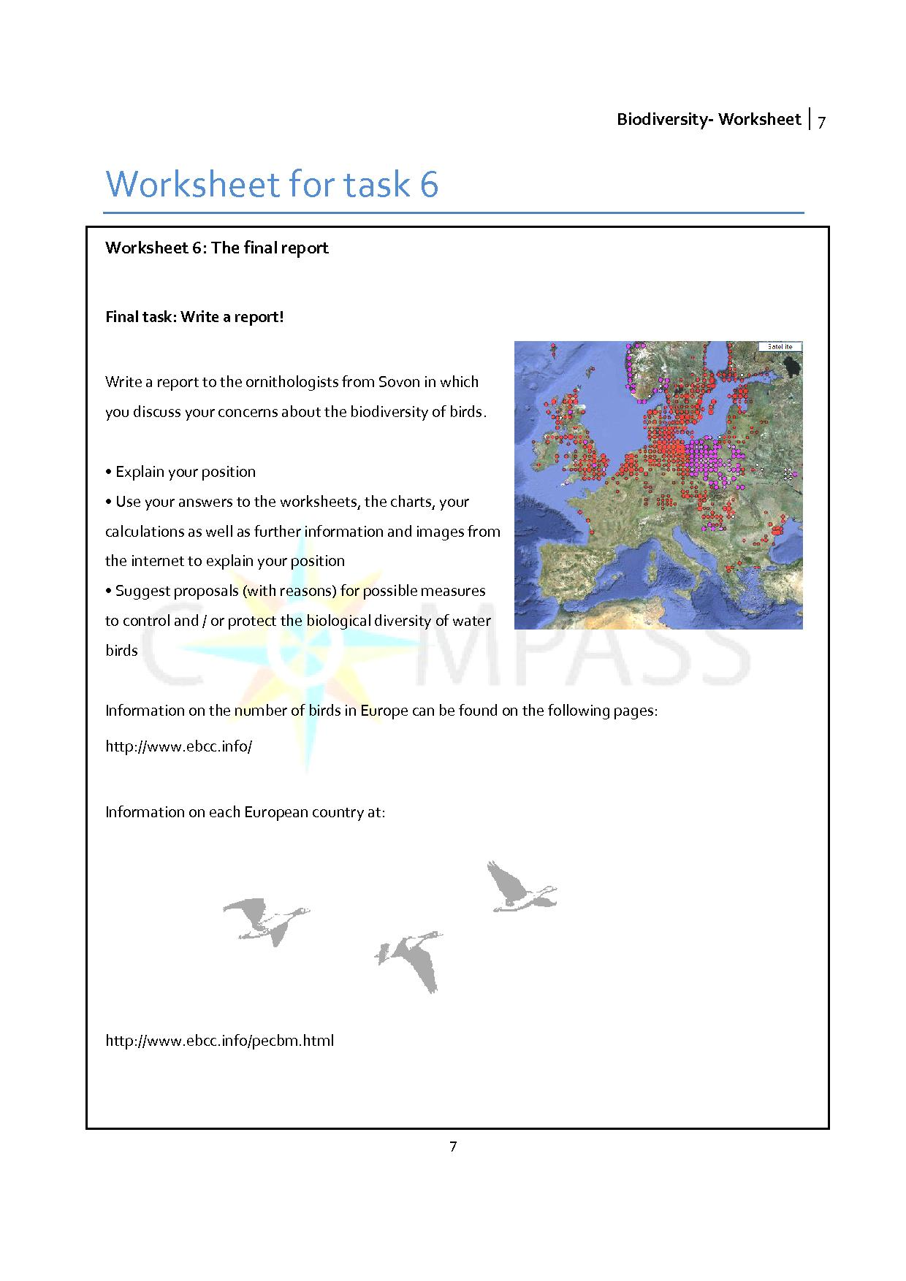
The lesson can be completed witha class discussion. Individual students can read their report to the ornithologists of Sovon so that it can be discussed as a plenary. Finally, the students can vote on the reports.

Proposal for practical work: survey of water birds
As an alternative for the writing of a report, or as an extra practical task, students might be asked to carry outa regional surveyof a bird’s population as an application of learning through a practical investigation.

