Worksheets for task 1

Worksheet 1.1
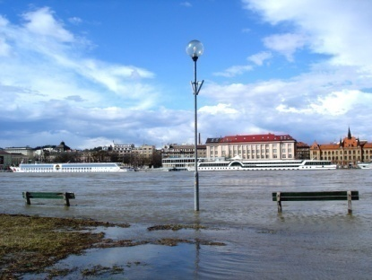  The River Danube flooding in Bratislava, Slovakia  http://commons.wikimedia.org/wiki/File:Bratislavaminorflood.jpg | 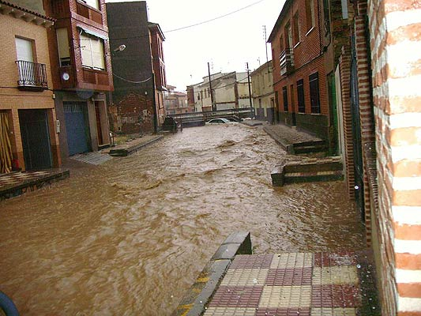  Flooding in Madridejos, in the province of Toledo, Spain  http://commons.wikimedia.org/wiki/File:598249.jpg
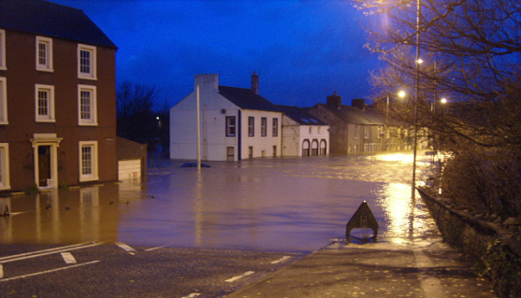
Flooding in Cumbria, England, November 2009.
http://commons.wikimedia.org/wiki/File:Workington_2009_flood.jpg
Look at these images of recent flooding in European countries. Has your town or city ever experienced anything like this? What would be the impact of floods like this on houses, schools, transport, daily life?

In November, 2009 weather conditions combined to produce three days of heavy rain in Cumbria in the North West of England. In these three days the rainfall was as much as it usually is for the whole of the month of November. The resulting floods caused huge amounts of damage with water levels in the town of Cockermouth rising to as high as 2.5 metres and the river through the town becoming so swollen and fast-flowing that a bridge was swept away.
The table below shows the rainfall at a number of weather stations in the area over that period.
Place | 17 – 18 November | 18 – 19  November | 19 – 20  November | 3 day total | Average rainfall for whole of November
 | mm | mm | mm | Mm | Mm
Shap | 55.4 | 50.2 | 91.2 | 196.8 | 196
St Bees Head | 23.4 | 13.6 | 40.6 | 77.6 | 100
Keswick | 41.8 | 39.4 | 107.8 | 189.0 | 182
Carlisle | 19.6 | 7.8 | 14.4 | 41.8 | 77
You can watch a brief video of the flooding at http://www.youtube.com/watch?v=ewSmN4rua6w&feature=related

Why are some places, like Cockermouth, particularly badly affected by heavy rainfall?

Worksheet 1.2: Water is not the only thing that flows
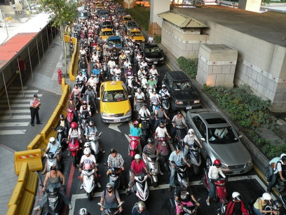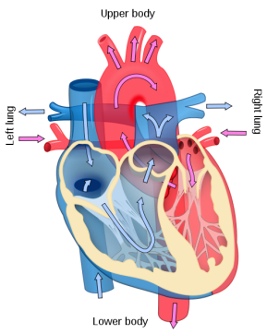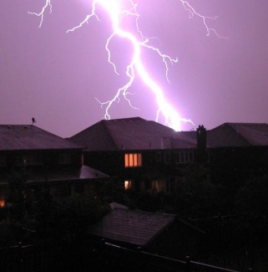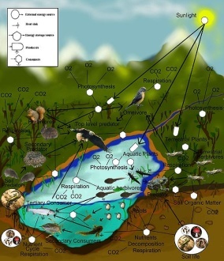
1 2 3 4

Look at the four pictures above. What is flowing in each case?

(extension)
Does traffic really flow like a liquid?

How is it similar?

How is it different?

Worksheets for task 2

Worksheet 2.1: Research environment - roof
(www.compass-project.eu/applets/#8)
A weather report says “10 millimetres of rain fell last night”  What does that mean?  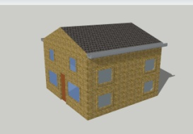 | 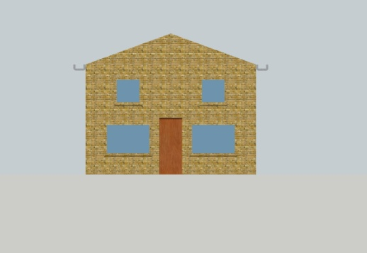
You are going to investigate the situation for different amounts of rainfall and various roof widths and slopes of roof, and make a brief report of your findings.

You can change the rainfall, roof angle and width. The three graphs show how these values affect the depth of water in the gutter.

“Trace” shows you how depth changes as you vary any one of the parameters between its minimum and maximum values. “Reset graphs” removes the traces from the graph, keeping the parameters at their most recent values. Use ‘refresh’ on your browser to reset the research environment to its original position.

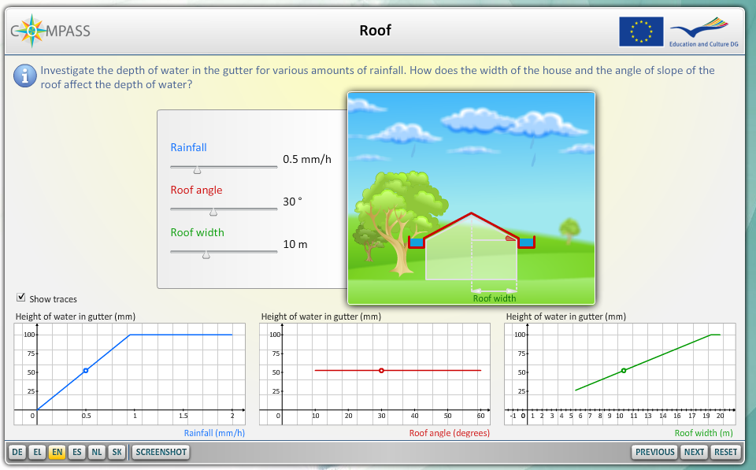 | You should carefully control variables, not change everything at random. So, you could fix the width of the house and the slope of the roof and see what happens to the height of water in the gutter for rainfalls of 0.1, 0.2, 0.3, 0.5, 1.0 mm and so on. For everything you try, you should:

predict | test | explain
Does the slope of the roof make any difference? What about the area of the roof? What difference do they make? Again:
predict | test | explain

Worksheet 2.2: Card set

5 l  1 | - l  2 | 1 l  3 | - l  4
200 ml  5 | 50 ml  6 | 0.5 l  7 | 100 cm³  8
20 ml  9 | 200 cm³  10 | 1000 ml  11 | 100 ml  12

1/20 l  13 | 2 l  14 | 10 l  15 | 500 ml  16
5 l  17 | 0.2 cm³  18 | 0.50 cm³  19 | 1/2 l  20
1/10 l  21 | 20 cm³  22 | 1000 cm³  23 | 500 cm³  24

Worksheet 2.3: Water from a roof
(www.compass-project.eu/applets/#8)

In this activity, water flows off the roof and collects in a gutter. How much water would collect in the gutter if 0.1mm of water fell on the roof of a house with a width of 10m (house width 20m).

What would be the depth of water in the gutter

Use the research environment to explore your own questions. You might like to use the following as starting points for investigation:

- What would happen if the width of the house was doubled, multiplied by three, halved and so on?

- What values of rainfall and width of roof would just fill the gutter with no overspill?

Worksheet for task 3

Worksheet 3: Many different things flow

In this lesson we will consider the flow of people, water, cars and dry sand.

A. Watch the following videos:
http://www.youtube.com/watch?v=XsPbLC8ppoU (Traffic 1)
http://www.youtube.com/watch?v=S_cf4efSfCk&feature=related (Traffic 2)
http://www.youtube.com/watch?v=cj4LrSxjTIM&NR=1 (Traffic 3)

Compare cars flowing through a traffic light junction, with cars flowing through an uncontrolled junction. Estimate the volume of flow (in this case could think of the number passing a point per second) and the speed of flow in each situation.

B. Do the same with pedestrians flowing:
http://www.youtube.com/watch?v=Lp-YfFtsiYs&feature=related (Crowd 1)
http://www.youtube.com/watch?v=iLs_XgB1FQU&feature=related (Crowd 2)

What stays the same as crowds and traffic flow? Take a large ball of plasticine and shape it into different cuboids. Measure their volumes. What stays the same? Why is this?

How would you work out the depth of 100 ml of water if you know the cross-sectional area of the container it is to be poured into?

C. Exploring constrictions: Pour sand through funnel to investigate flow through various sized constrictions. Why does the sand fall differently through the two funnels?
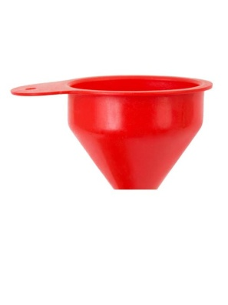
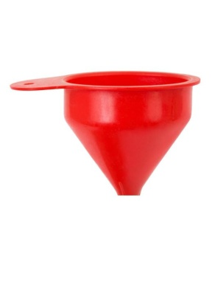
Sand poured through a funnel provides a good opportunity to for students to investigate flow through various sized constrictions.

This could be varied by cutting the spout of a plastic funnel at different positions to allow for various sized openings.

Worksheets for task 4

Worksheet 4.1: Modelling flow in and out of containers

Activity 1: Research environment: Flow (Rectangular)
www.compass-project.eu/applets/#5

A. Start with a container of volume 300 units.
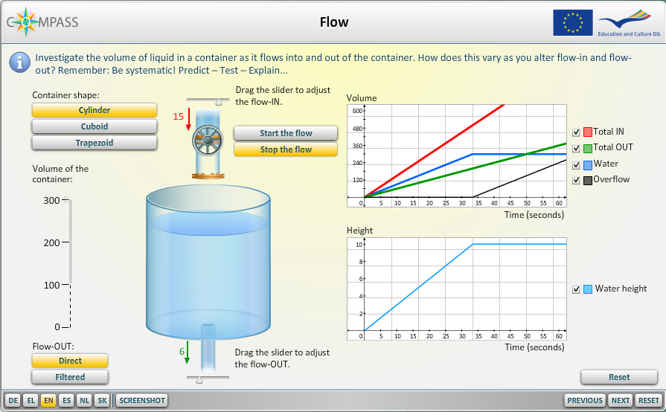
The graph shows, in different colours, against time:
- Total water flow in
- Total water flow out
- Volume of water in the container
- Total volume of water overflow from the container.

Run the simulation with flow in set at 15 and flow out at 6 – allow the flow to run for a whole minute. Repeat this a few times watching carefully what happens.

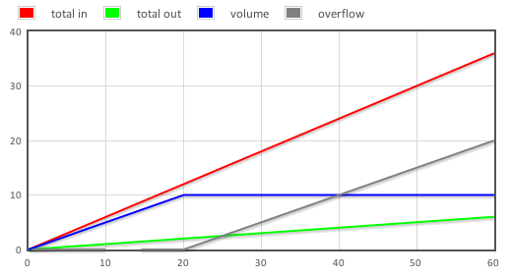
Write a descriptive account of what you notice, and try to explain why this is happening. Why does the line “Water” become horizontal? What will the totals of flow in and flow out be?

……………………………………………………………………………………………………………………………………

……………………………………………………………………………………………………………………………………

……………………………………………………………………………………………………………………………………

B. What if…..?
Test out some more situations, varying the flow in and flow out. Be systematic though. And before you do anything in the computer model, you should make a prediction:
predict | test | explain

Sketch the graph you expect to see, for each situation they decide to test. Add your results to those you got for part A.

Worksheet 4.2: How do different containers affect the flow of water?
www.compass-project.eu/applets/#5
Run the simulation with flow in set at 15 and flow out at 6 for each of the different tanks.

Volume 200
predict | test | explain
Volume 100
predict | test | explain
See if you can answer these questions:
- How can you adjust flow in and flow out so that a container overflows in half the time/ double the time?
……………………………………………………………………………………………………………………………………………………………………………………………………………………………………………………………………
…………………………………………………………………………………………………………………………………
- How can you make a container with double the width / capacity overflow in the same time as the original container? What about a container with three times the volume as the original container?
……………………………………………………………………………………………………………………………………………………………………………………………………………………………………………………………………
…………………………………………………………………………………………………………………………………
(extension) Move on to investigate flow through a trapezoidal container. Predict what the graphs will look like.
Worksheets for task 5

Worksheet 5.1: investigating how water flows through different types of soil

Examining Soil
You are going to observe some soil. Pour about 100ml of soil into a 250ml measuring cylinder. Then add water to the measuring cylinder until the water level reaches about 150ml. Put the palm of your hand tightly over the end and shake gently. Then put the measuring cylinder on the table and let it settle for at least 10 minutes.

While you are waiting, a soil scientist tells you
“soil is a mixture of (mainly) mineral materials consisting of a range of different particle sizes. Soils also have some organic matter within them. Different kinds of soil have different proportions of small, medium and large sized particles”.
What does this mean? Briefly explain this as if you were talking to a primary school pupil.
…………………………………………………………………………………………………………………………………
…………………………………………………………………………………………………………………………………
…………………………………………………………………………………………………………………………………

Now look again at the measuring cylinder. What do you notice?
……………………………………………………………………………………………………………………………….
…………………………………………………………………………………………………………………………………

Why does this happen? Which parts of the soil settle more quickly in water?
……………………………………………………………………………………………………………………………….
…………………………………………………………………………………………………………………………………
Analyse your particular soil. Measure the thickness of the different layers. Draw a pie chart to display the proportion of the soil occupied by each layer.

Who might be interested in the proportion occupied by each layer?
……………………………………………………………………………………………………………………………………..
……………………………………………………………………………………………………………………………………..

Worksheet 5.2

Investigating water draining through soils
Fill three or four beakers with different types of dry soil. Pour a measured volume of coloured water into each beaker. Observe the base of the beaker, and record how long it takes for the coloured water to reach the bottom of the beaker.

Extension: What difference does it make when the soil is already wet? And if you pour the water in more slowly, or more quickly?

…………………………………………………………………………………………………………………………………
…………………………………………………………………………………………………………………………………
…………………………………………………………………………………………………………………………………

How can you make your experimental results fair and reliable? What uncertainties are there in your data, and how could you reduce these uncertainties?

…………………………………………………………………………………………………………………………………
…………………………………………………………………………………………………………………………………
…………………………………………………………………………………………………………………………………
…………………………………………………………………………………………………………………………………

Worksheet 5.3: How quickly does water drain through soils?
Cut the base from a 2 litre plastic drinks bottle. Plug the neck of the bottle with a small ball of cotton wool and partly fill the bottle with a certain mass of the test soil. Pour a known volume of water onto the soil and measure the time taken for a proportion of the water to drain through the soil. Compare different soils.
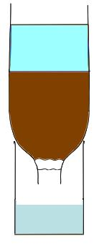
Known volume of water

Soil under test

Cotton wool plug

Collected drained water

Soil | Time to drain through (none left on surface)

Does all the water that is poured into the soil come out? If not, where does it go?

…………………………………………………………………………………………………………………………………

How is this experiment different to the last one (worksheet 3.4)? Which gives more valid results, and why?

…………………………………………………………………………………………………………………………………

Worksheets for task 6

Worksheet 6.1: The Lynmouth disaster of 1952: 34 people killed.
On the 15th and 16th August 1952, torrential rain caused flash flooding in the town of Lynmouth in Devon. 34 people were killed.
A guest at the Lyndale Hotel described the night: "From seven o'clock last night the waters rose rapidly and at nine o'clock it was just like an avalanche coming through our hotel, bringing down boulders from the hills and breaking down walls, doors and windows. Within half an hour the guests had evacuated the ground floor. In another ten minutes the second floor was covered, and then we made for the top floor where we spent the night."

Puzzle: It often rains heavily without causing flooding. Why not? Work together in groups, and use some of the following keywords in your answer:
flow rate higher lower inflow outflow bottleneck
volume permeable soil rainfall height of river equilibrium
…………………………………………………………………………………………………………………………………
…………………………………………………………………………………………………………………………………
…………………………………………………………………………………………………………………………………
…………………………………………………………………………………………………………………………………

Worksheet 6.2

The causes and consequences of the Lynmouth flood disaster
Read the notes on the following map:
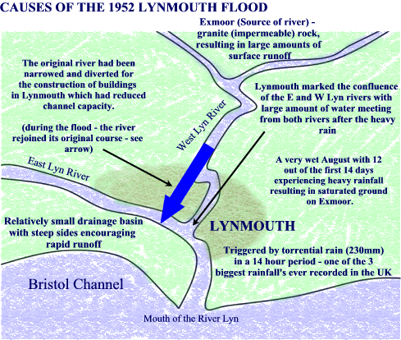
Sort the following into causes, consequences and other points, and place them on a large copy of the map of the Lynmouth drainage system.
The catchment area of the Lyn rivers covers 100 square kilometres, a flat plateau drained by steep sided valleys covered by moorland grasses on wet, peaty ground. | Since 1947 government paid for drainage of the peat to create more agricultural land. Drainage channels allowed water to flow quickly down towards the river.
In the two weeks before the flood, 15 cm of rain fell in the area around Lynmouth. This was equivalent to four months of average rainfall. | 24 hours before the flood, almost 23 cm fell on the catchment area.
The resulting run-off flowed off the moors and into the rivers East and West Lyn which came together as a raging torrent in the steep, narrow valley leading into Lynmouth. | Huge boulders made the flood worse by creating a dam upstream from Lynmouth, which gave way suddenly causing around 200,000 tonnes of rock to be washed downstream.
Streams flowed down narrow steep sided valleys, crossed by 31 small stone bridges with limited span. Boulders and other debris was caught up behind those bridges. | 130 cars and 19 boats were also lost, swept into the river or out to sea. The force of water was able to transport large amounts of debris (including gigantic boulders)
The West Lyn river had been diverted into a culvert underground to make room for housing in Lynmouth. | When the torrent came down, the river returned to its original course flowing straight through Lynmouth destroying 90 houses and hotels.
27 of the 31 bridges were destroyed.
The sides of the river valley and the underlying rock in the area are made of impermeable granite. | The streams feeding into the river are very steep, dropping over 800m in just 15 km.

Worksheet 6.3

How to avoiding another flood disaster
You are the scientific committee with the job of recommending actions that will greatly reduce the risk of this disaster happening again. Your task is to use what you have learnt about the flow of water in maths and previous science lessons to consider what changes you recommend.

Assume that similarly high rainfall could happen again in this area. Estimate the volume of water which fell on the catchment area in the 24 hours before the flood. Trace through what happened to this water.

Think about all the possible ways of ensuring that this water does not flow in the way that it did in 1952. Then use some of the experiments you have done in maths and science to give the best possible advice to

- farmers and others using and draining the land on the moors above Lynmouth
- bridge engineers planning to rebuild bridges in the valley
- engineers planning how the river should flow through the town
- people wanting to rebuild their houses and homes in Lynmouth

Where you can, include calculations in your advice to demonstrate your understanding and allow others to check the basis of your recommendations. Otherwise, why should they trust you?

Be ready to present your recommendations to an audience of your peers.

