Dangerous rain
Abstract
When is rain dangerous? Where do floods come from? How can we reduce the damage that flooding causes? Over the last decade some parts of Europe have experienced increased patterns of very heavy rainfall leading to floods whilst other regions have experienced decreased rainfall resulting in droughts. These materials aim to build the scientific and mathematical "story" of flooding through theoretical and practical investigation and through the use of an electronic research environment. The mathematical and scientific ideas of flow and the physical parameters that affect the rate and speed of flow will be brought together through a case study of flooding in a river valley.

Aspect | Description
Mathematical content | Graphical representation, rate of change, surface area and volume, modelling
Scientific content | Flow, rate of flow, conservation of volume, soil structure
Enquiry skills | Predict, test, explain; control of variables, measurement
Age of students | 11-14
Lesson time in mathematics | 150 min
Lesson time in science | 150 min

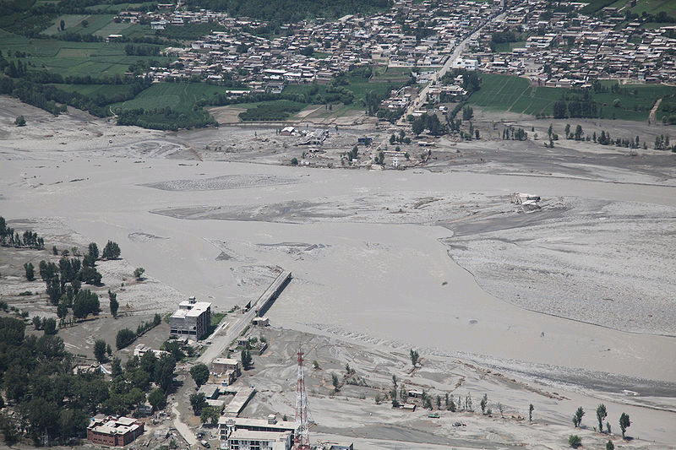
Dangerous rain
1. Overview of the teaching unit

1.1 The situation
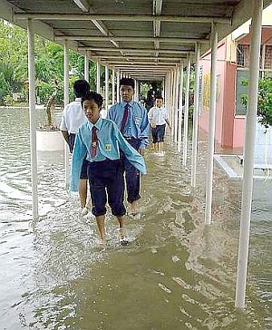
Over the last decade some parts of Europe have experienced increased patterns of very heavy rainfall leading to floods whilst other regions have experienced decreased rainfall resulting in droughts. In order to minimise the risk of environmental damage from flooding, it is vital to understand how water flows in different conditions. Flooding happens in particular locations, and is often very difficult to predict. But can a better understanding of mathematics and science help in improving our ability to make good predictions and avoid the worst case scenario?

1.2 Guiding questions
- Where does rainwater go?
- How can we model the flow of rainwater in real life?
- What can be done to prevent flooding?

1.3 Final product
Groups of students make a presentation as a scientific committee recommending actions to reduce the risk of another flood disaster in a particular location. Their task is to use what they have learned about the flow of water in maths and science lessons to make their recommendations. They use some of the experiments they have done in maths and science to give the best possible advice to farmers, engineers and residents of the affected area.

1.4 Suggestions for teachers
Choose a flooding case study which is directly relevant to your own situation – substituting pictures and case study context.
Choose an image of a house familiar to pupils to link to the applet on flow from roofs.

1.5. The task plan
Unit | Mathematics | Science
1 | Task 1: Introducing the situation: flow and floods  - How do water, traffic and blood move from place to place?  - Where does rainwater go? Under what conditions can it be dangerous?  - What can be done to reduce the risk of flooding?
2 | Task 2: Modelling flow from a roof  - How can we model the flow of rainwater from a roof?  - What factors influence the flow of water from a roof?  - How do these factors influence the flow of water from a roof?  - How does depth of water falling on the roof relate to volume of water in the gutter?  - What values of rainfall and width of roof would just fill the gutter with no overspill? | Task 3: Understanding the concept and measurement of flow in different contexts  - In what way is water like traffic or a crowd of people when it is moving?  - What happens to the volume of a substance when it is flowing?  - How does the size of hole affect the flow of a substance in and out of a container?
3 | Task 4: Modelling flow in and out of containers  - How can we model the flow of rainwater in and out of different containers?  - How can graphs represent the flow of water in and out of the container?  - What happens when flow in and out are changed?  - What happens when flow in and flow out are equal?  - How does the size and shape of the container affect the speed of a flood? | Task 5: Investigating how water flows through different types of soil  - Under what conditions does a container begin to overflow (flood)  - What is soil composed of?  - How does the composition of soil affect the rate of flow through it?  - Why does the type of soil affect the likelihood of flooding?
4 | Task 6: Pupil presentation on reducing the risk of a flood disaster  - How can rainfall on the roof of a house be used to simulate rain falling on a hillside and draining into a river?  - How can water flow in a gutter be compared to flow along a river?  - What are the critical factors to consider in predicting the flow of water from a hillside into a river?  - How can these factors be used to reduce the risk of flooding?

2. Description of the tasks

2.1 Task 1 – Introduction into the overarching question
Mathematical content
- speed
- rate of change
- volume
- capacity
- modelling
Scientific content
- Nature of flow
- importance of flow of liquids
- traffic
- current
- energy
Outcomes
Students should engage with the problem of flooding and make some connections to the idea of rainfall. They should see the flow of water as one example of the many things that flow from place to place in everyday life.

Activity 1 for students
Look at these images of recent flooding in European countries. Has your town or city ever experienced anything like this? What would be the impact of floods like this on houses, schools, transport, daily life?

You can watch a brief video of the flooding at http://www.youtube.com/watch?v=ewSmN4rua6w&feature=related

Why are some places, like Cockermouth, particularly badly affected by heavy rainfall?
(see worksheet 1.1)
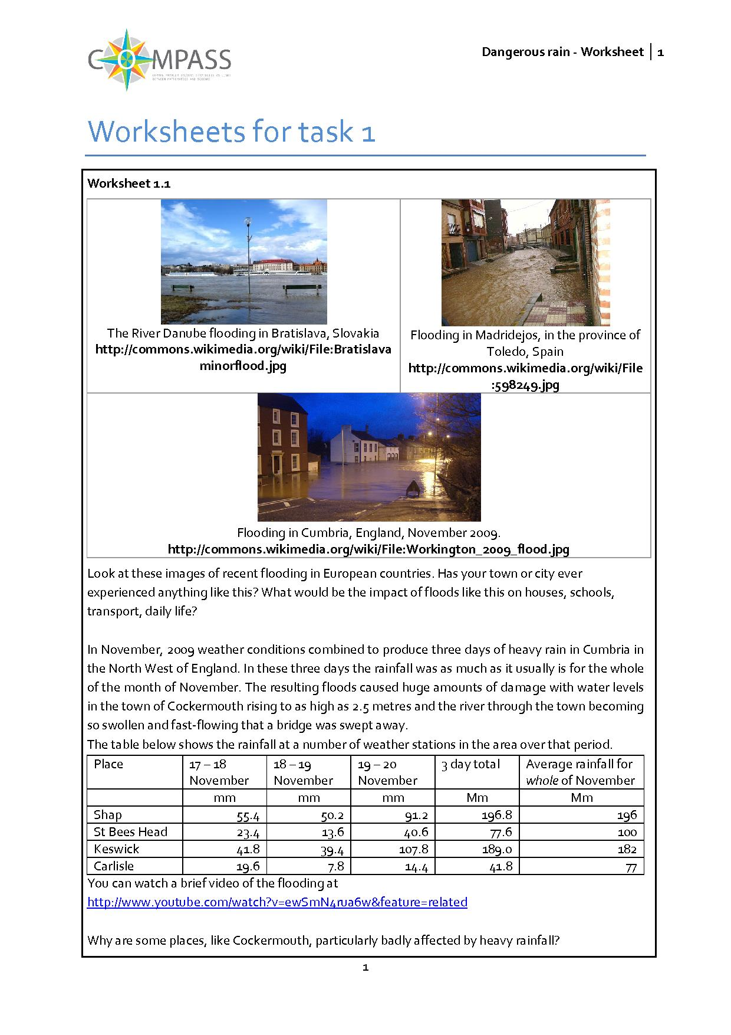
Students should engage with the problem of flooding and make some connections to the idea of rainfall, and consider why some places are particularly prone to flooding, because of the shape of the land, the way water flows through channels, the nature of the ground where the rain is falling. Initial ideas along these lines will be developed in the materials.

Activity 2 for students: water is not the only thing that flows
Look at the four pictures.
- What is flowing in each case?
extension:
- Does traffic really flow like a liquid?
- How is it similar?
- How is it different?
(see worksheet 1.2)

What is flowing? Traffic, or cars; blood (see arrows for direction); electric charge (between the ground and the cloud) or energy; energy (from the sun, and then through the ecosystem). The flow of charge, energy, fluids and information is a central characteristic of contexts ranging from electric circuits to ecosystems, from the human heart to tidal estuaries, from solar emissions to traffic management.
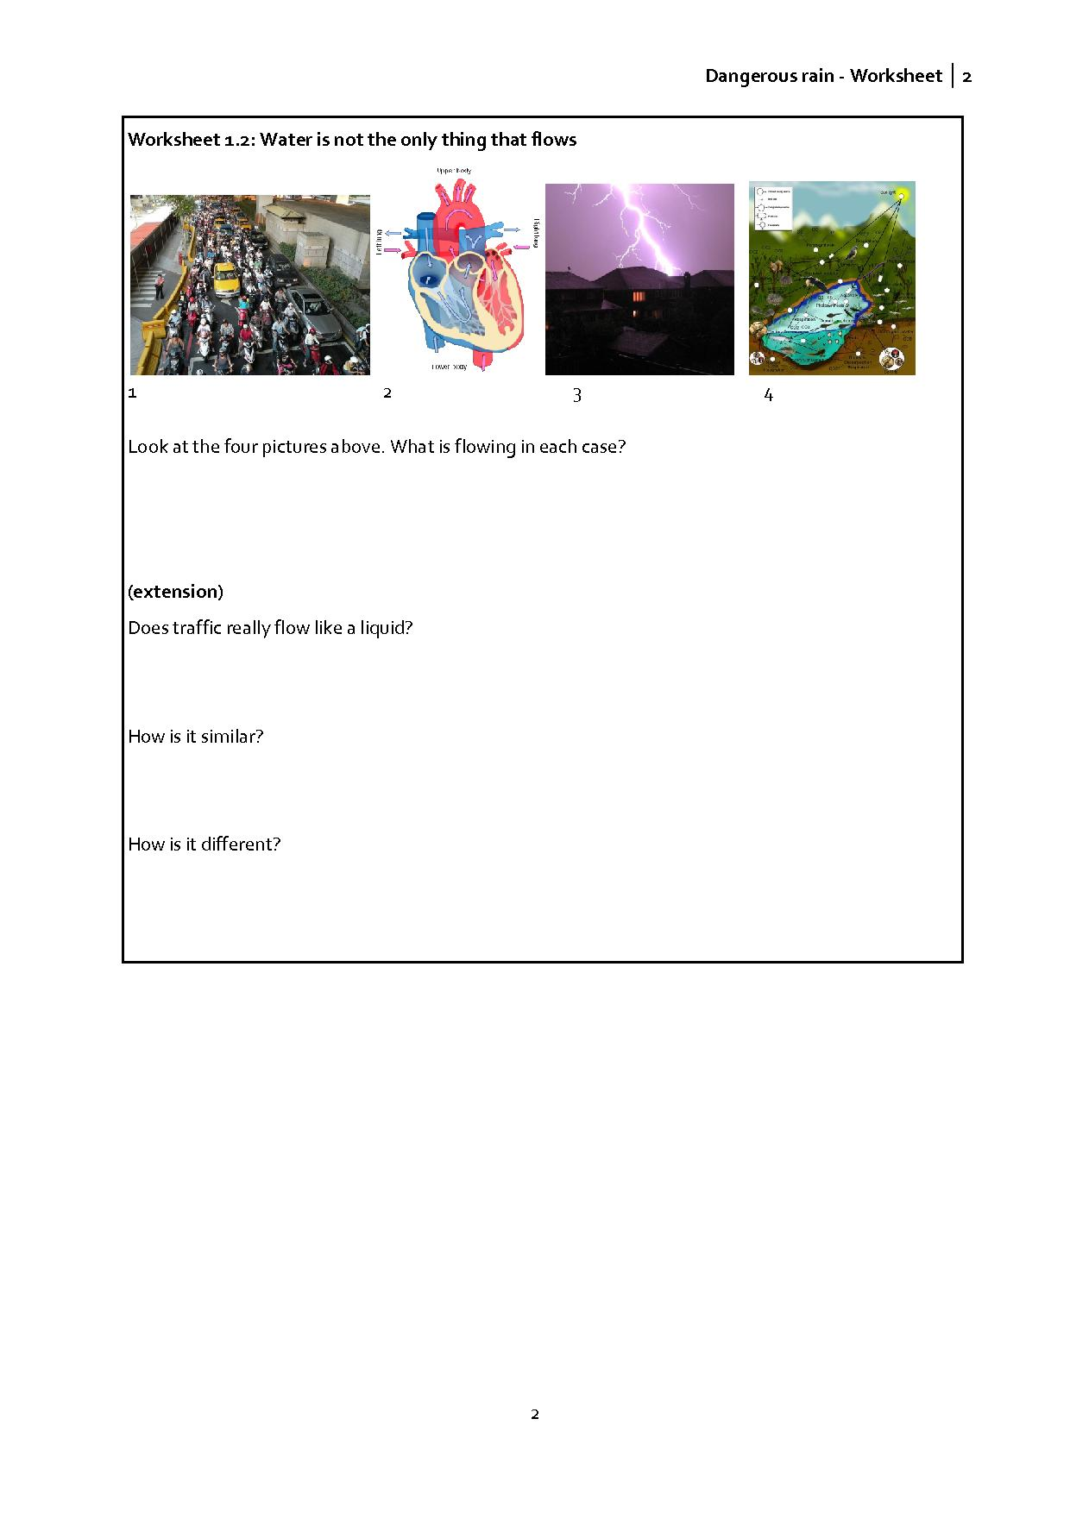
2.2 Mathematics – Task 2
Mathematical content
These materials aim to build the mathematical "story" of flooding through theoretical and practical investigation and through the use of an electronic research environment. The research environments model shows, in an idealised way, situations that students will need to understand when they come to consider flow of rainwater that may give rise to flooding in science. The research environment allows you to vary:
- the total amount of rainfall (from 0 to 2 mm);
- the angle of slope of the roof (from 10°to 60°);
- the width of the house (from 10m to 40m) giving a roof width between 5m and 20m.
Enquiry is fundamental to these materials. Students are encouraged to: predict – test – explain. That is, to pose a question and predict the outcome before they use the research environment to test this, and then explain why their prediction was correct or not. Of course in the case of incorrect predictions, we would encourage students to try again.
Outcomes
Students understand that water, being a liquid, can flow from one place to another, and that we can calculate its volume when it collects in a container. They work within the research environment: roof (http://130.88.43.249/compass/) which simulates rain falling on a roof and draining into a blocked gutter. This provides an idealised scaled down model of a hillside with rain draining into a river.

Activity 1 for students: research environment: roof
You are going to investigate the situation for different amounts of rainfall and various roof widths and slopes of roof, and make a brief report of your findings.
(see worksheet 2.1)
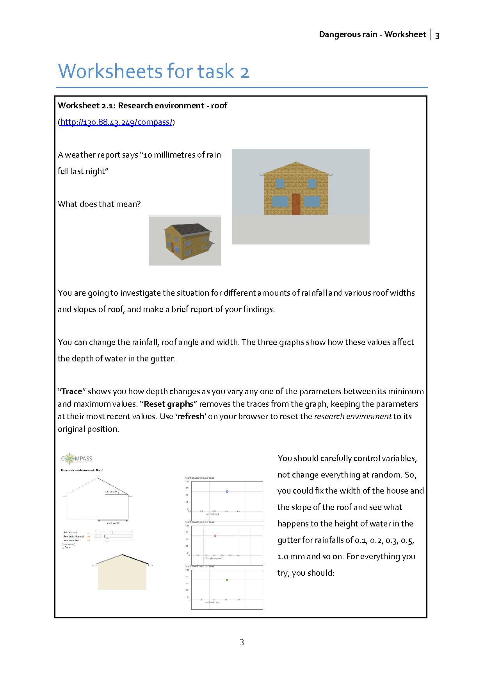

It is assumed that all of the water on the roof drains into a gutter on each side of the roof, and that the gutters are blocked so that all of the water collects there and is distributed evenly throughout the gutter. The gutter is assumed to be horizontal and that the depth of water in all parts of the gutter is the same throughout.
This task is probably best carried out starting with a whole-class demonstration and discussion followed by time where students work in pairs / small groups exploring how different factors affect the amount of water that falls on the roof of a house. The intention is that students might then be able to understand in science / geography some of the issues involved when rain falls on say, a hill and flows into a channel or river.
Activity2 for students: investigating volume and capacity
Question for discussion: If one millimetre of water fell on the roof of the house, what would be the depth of water in the gutter when it is all collected there?

Does it depend on how big the house is? Can you justify your answer?

This task introduces ideas of volume and capacity, and gives an opportunity to discuss units of volume and capacity and how these are related. By this stage it should be clear that this will depend on the dimensions of the house. Give students an opportunity to suggest this before allowing them time to make some calculations.
Resource link: Flow: Maths 1 (A) is a set of cards that you can use with a small group of three or four students asking them to match equivalent amounts of liquid.
Activity 3 for students: water from a roof
See worksheet 2.2
Discussion point:
How can rainfall on the roof of a house be used to simulate rain falling on a hillside and draining into a river? What is similar? What is different
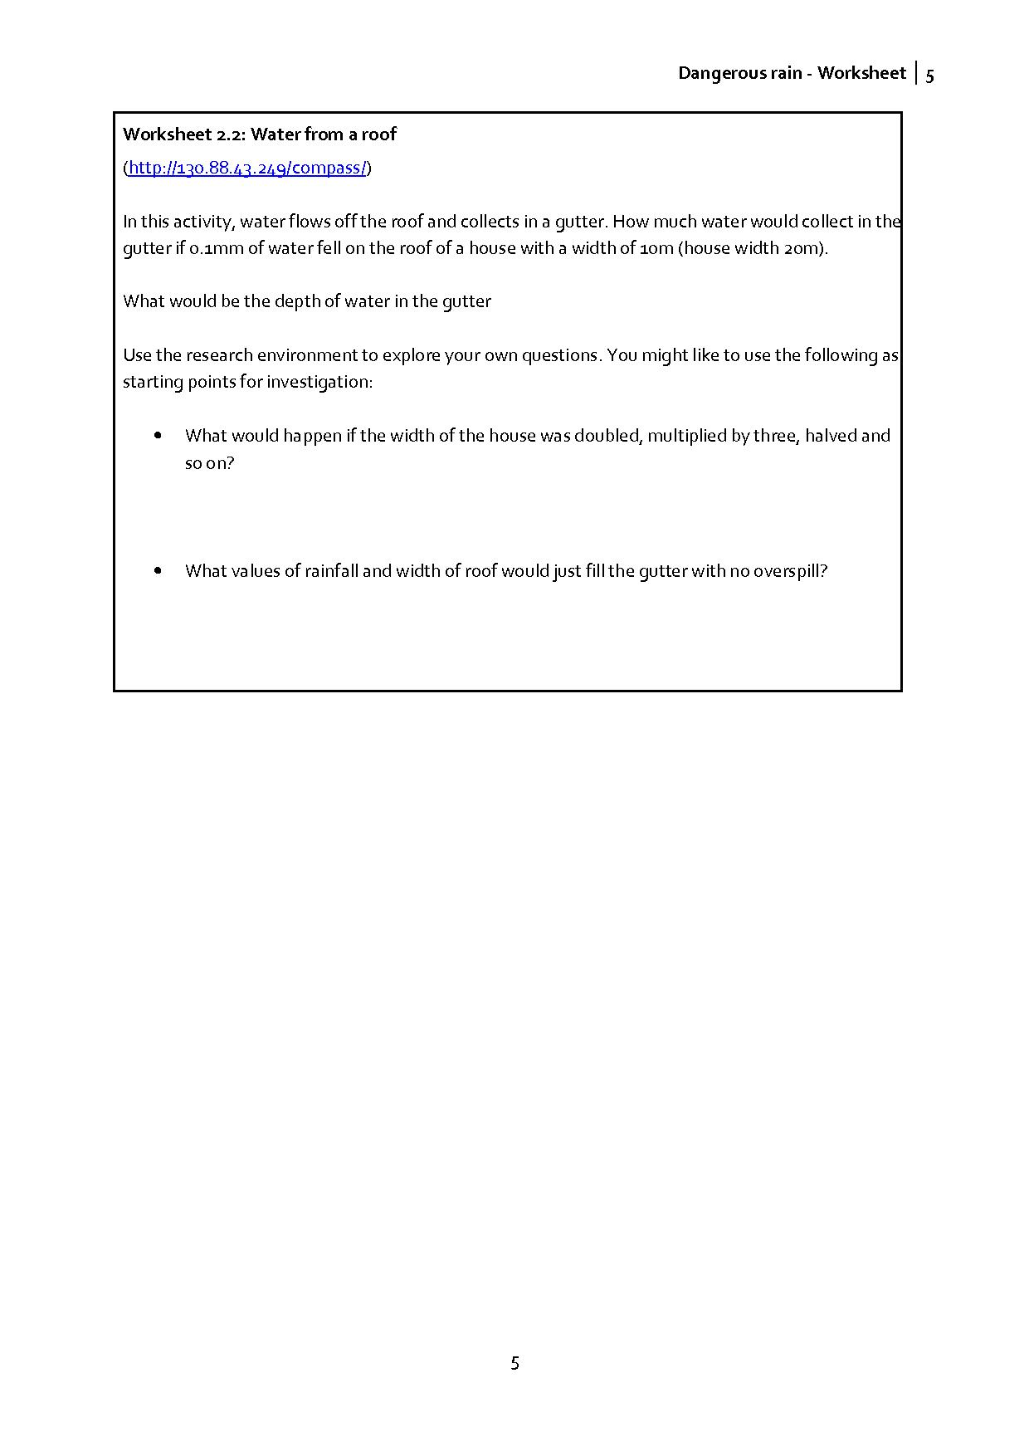

2.3 Science – Task 3
The aim of this task
- To explore, measure and control the nature of flow of different substances in a variety of situations.
- To explain conditions which affect rate of flow.
Contribution to the overall question
Understanding, measuring and qualifying flow and flow rate. Understanding how interfering with flow rate at one point could have consequences at a different point.
Scientific content
Students should use scientific ideas and models to explain phenomena and developing them creatively to generate and test theories; and critically analyse and evaluate evidence from observations and experiments. They should use a range of scientific methods and techniques to develop and test ideas and explanations, assess risk and work safely in the laboratory, field and workplace, plan and carry out practical and investigative activities, both individually and in groups. They should obtain, record and analyse data from a wide range of primary and secondary sources, including ICT sources, and use their findings to provide evidence for scientific explanations, and to evaluate scientific evidence and working methods. They should:
- understand that flow into and flow out of a ‘volume’ determines the fluid level within a container.
- understand that volume of a fluid is conserved when flowing through a system
- understand that some materials can ‘soak-up’ water and/or allow water to flow through them; other materials are impermeable and non-absorbent
- know that a fixed volume of fluid can take different depths depending on the shape
- know how people can use flow data to help make decisions
- be able to use information to plan a response to case study data

Activity1 for students: many different things flow
- Let your students work on worksheet 3

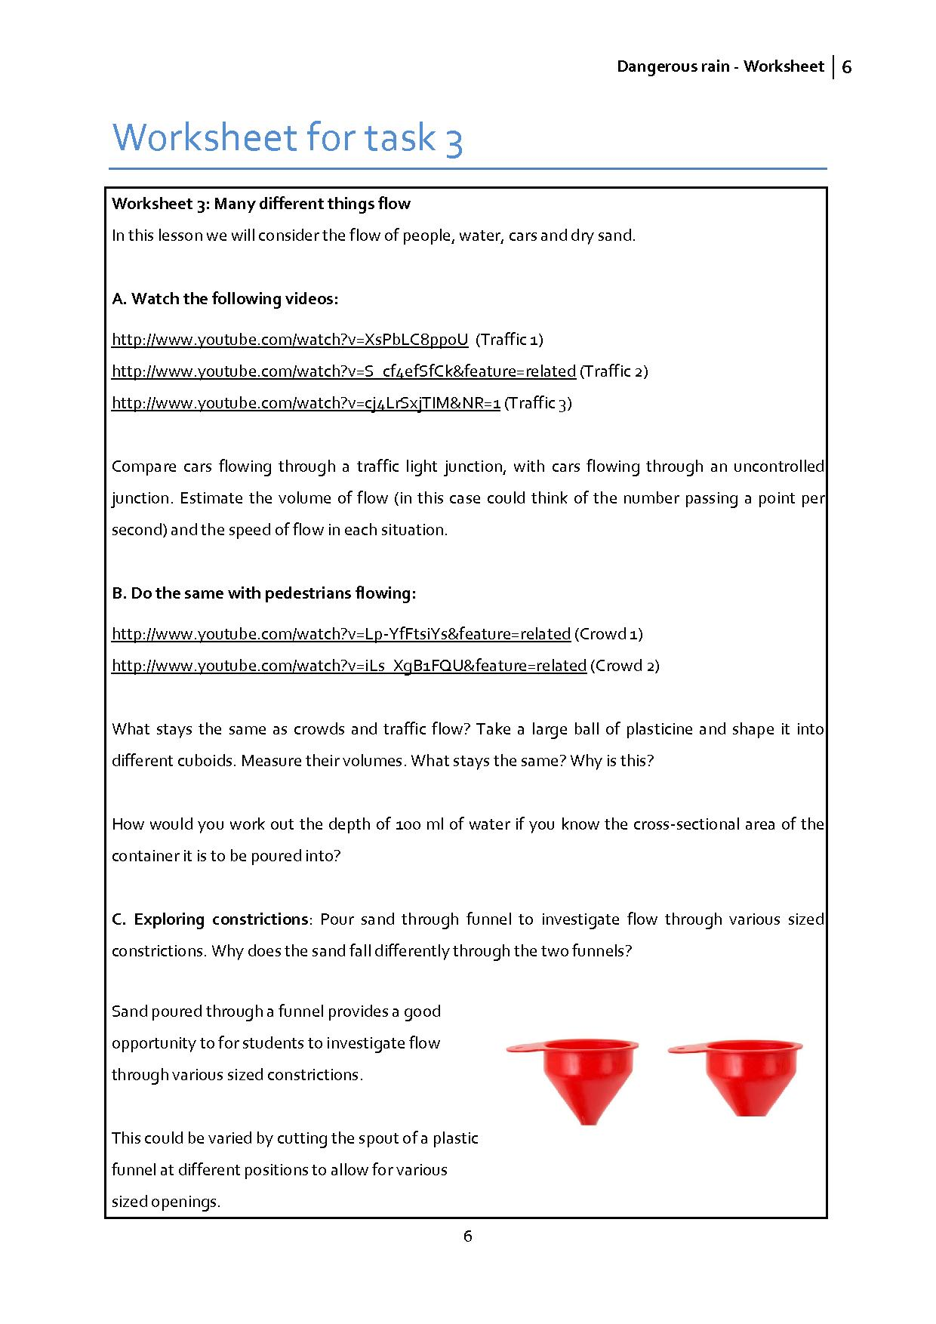
Students will:
- Be able to identify what/that something is flowing
- Understand that the flow substance is conserved
- Know that flow rate can be measured (kg/s; number/s; litres/s)
- Know that flow speed can be measured (m/s; km/h)
- Consider flow in various contexts,
e.g. water; traffic; crowds
- Explain how physical characteristics of the system affect flow,
e.g. bottlenecks

One of the important concepts of flow is that idea that the flowing medium is conserved when flowing through a system. It is also important to distinguish between the two concepts of volume of flow and speed of flow. This is particularly important when considering situations where the flow of the medium is restricted due to a constriction or ‘bottle neck’

2.4 Mathematics – Task 4
The aim of this task
Students develop skills in reasoning, interpreting, evaluating and communicating whilst carrying out calculations involving measures of capacity, understanding graphical representations and relating these to rates of flow.
Contribution to the overall question
Overflow and flooding can be explained through analysing differential flow rates in and out of a place.
Mathematical content
The research environment simulates water flowing into and out of different cuboid and trapezoidal containers. It is assumed that flow rates are constant throughout and that the containers are horizontal so that depths of water are constant throughout the container at all times.
Scientific content
- Nature of flow, representing and interpreting flow of liquids.
- Conservation of volume.

Activity 1 for students: research environment: flow (rectangular)
- Let you students work on worksheet 4.1

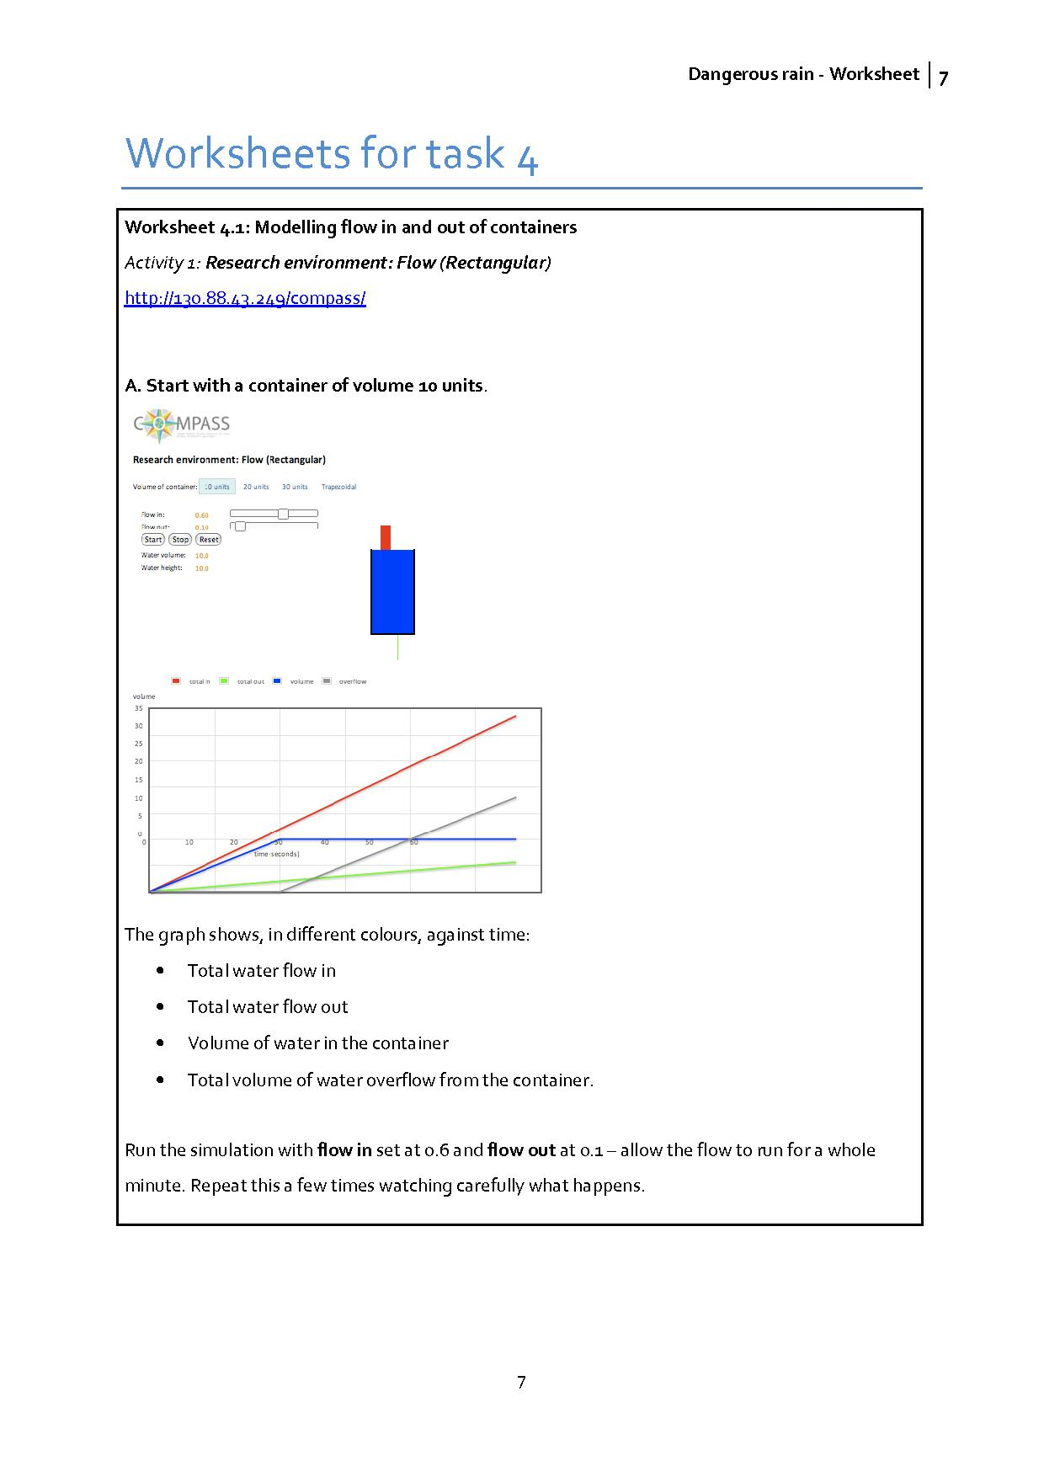
This activity can be carried out with either a whole class demonstration followed by paired or whole class discussion, or with students working in pairs with access to a computer possibly with some whole-class plenary discussion. You may ask them to do this on a poster
Resources You may want to give students print-outs of the graph provided as Resource Flow: Maths 2(A).

Activity 2 for students: how do different containers affect the flow of water?
- Let your students work on worksheet 4.2



2.5 Science – Task 5
The aim of this task
To be able to describe the composition of different types of soils. Understand how flow rate through soils is related to the soil composition. Be able to relate composition of soil to the risk of flooding.
Contribution to the overall question
Some geographical places could be more prone to flooding because of the soil composition.
Scientific content
Students will:
- Collect data and measure accurately using appropriate scientific apparatus
- Present data in ways which aids its understanding and significance and facilitates its communication
- Analyse data and understand its significance to the physical world
- Relate physical and mathematical modelling to the natural world
- Use ‘flow theory’ to aid explanation of a physical system
- Make predictions based on flow theory and mathematical modelling
Outcomes
In order to build the scientific "story" of flooding the students will examine the ideas of soil structure, water flow and the physical parameter that affect the rate of flow.

Demonstrate the water flow arrangement to the class – and ask them where they have seen this arrangement before (in maths lessons, if they have done them yet). Ask students to consider how the water level in the container could be raised, lowered, or maintained at a constant level, by adjusting the rates of water inflow and outflow. Emphasise the fact that the three factors of interest in this model are the rates of water inflow and outflow, and the resultant water level in the container. Draw students’ attention particularly to the relationships between these quantities as determinants of whether the container would fill, empty, or remain at a constant water level.

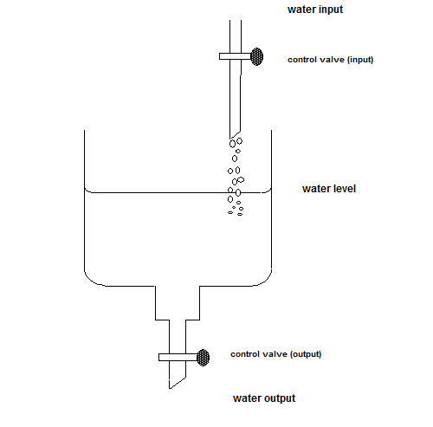
Fig. 1: Experimental arrangement for flow and equilibrium demonstration

Activity 1 for students: examining soil
You are going to observe some soil. Pour about 100ml of soil into a 250ml measuring cylinder. Then add water to the measuring cylinder until the water level reaches about 150ml. Put the palm of your hand tightly over the end and shake gently. Then put the measuring cylinder on the table and let it settle for at least 10 minutes.

While you are waiting, a soil scientist tells you

“soil is a mixture of (mainly) mineral materials consisting of a range of different particle sizes. Soils also have some organic matter within them. Different kinds of soil have different proportions of small, medium and large sized particles”.

What does this mean? Briefly explain this as if you were talking to a primary school pupil.

Now look again at the measuring cylinder. What do you notice?

Why does this happen? Which parts of the soil settle more quickly in water?

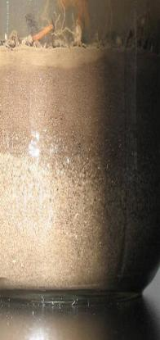
Organic matter
Clay (< 0.002mm)

Silt (0.002 – 0.06mm)

Sand (0.06 – 2mm)

Gravel (> 2mm)

Analyse your particular soil. Measure the thickness of the different layers. Could you draw a pie chart to display the proportion of the soil occupied by each layer?

Who might be interested in the proportion occupied by each layer?
(see worksheet 5.1)


Activity 2 for students: investigating water draining through soils
Fill three or four beakers with different types of dry soil. Pour a measured volume of coloured water into each beaker. Observe the base of the beaker, and record how long it takes for the coloured water to reach the bottom of the beaker.

Extension: What difference does it make when the soil is already wet? And if you pour the water in more slowly, or more quickly?

How can you make your experimental results fair and reliable? What uncertainties are there in your data, and how could you reduce these uncertainties?
(see worksheet 5.2)
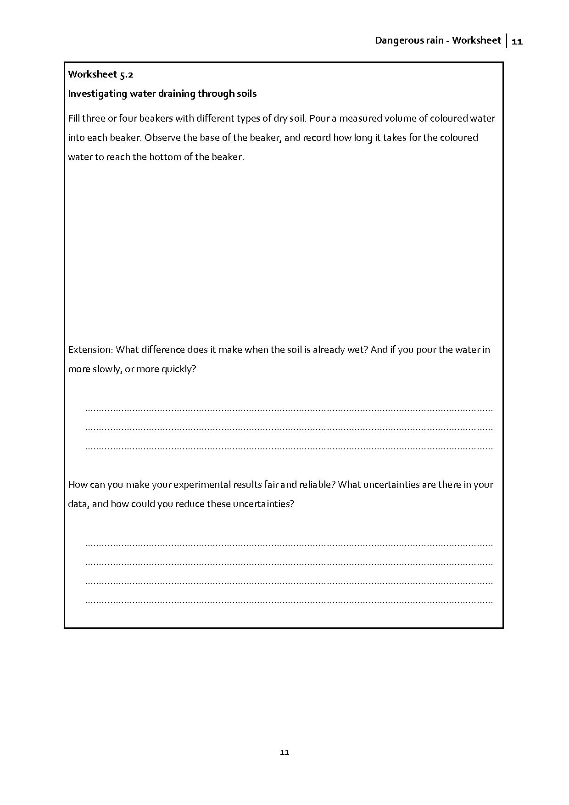
The students should observe that soil which is made up from particles of a larger grain size (sandy) drain more quickly than soils made up from particles of a smaller size (clay). The rate at which water drains though the soil is a measure of the soil’s permeability. Explanation of this can be explained by the students considering the following
- Soils contain air gaps called ‘pores’ and these help water to flow through the soil.
- The size of the pores depends on the particle sizes that make up the soil.
- Soils with large particles have large pores (sandy soils) and these drain very quickly.
- When rain falls on soil some of the water is absorbed by the soil and some of the water passes through. How much depends on the soils absorbency.
- When the soil particles are very small, as in clay, the water can ‘stick’ to the to the particles. The soils can become water-logged and can take a long time to dry.

Put dry sand in one beaker, mixtures of dry sieved and dry un-sieved soils containing varying amounts of gravel in the others. One soil could consist mainly of compost. This will give it properties similar to the peat found in the case study (Task 3)

Activity 3 for students: how quickly does water drain through soils?
- Let your students work on worksheet 5.3
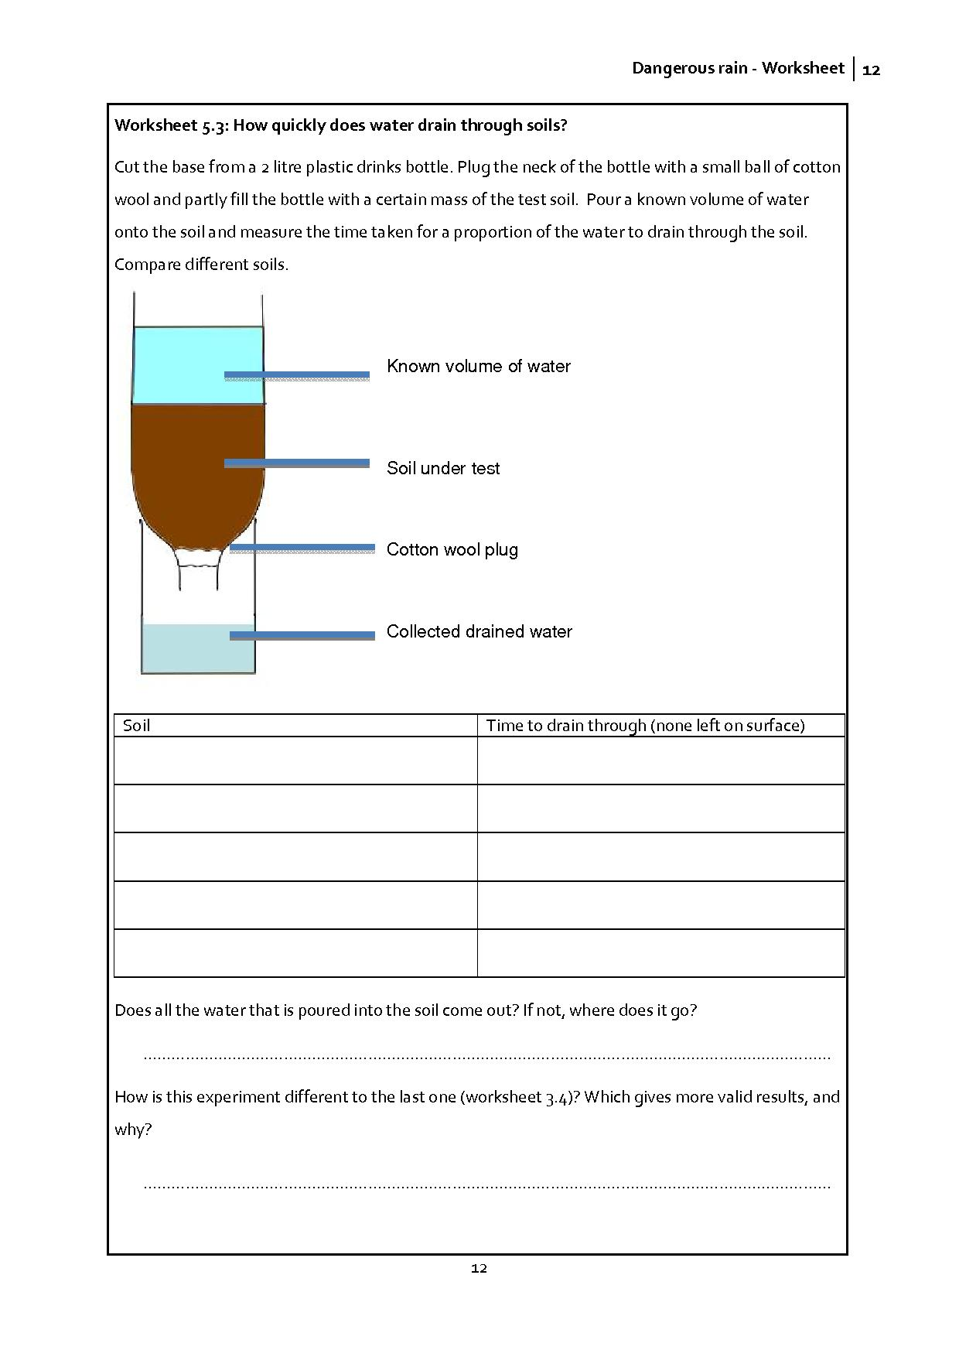
The students should observe that sandier soils drain more quickly. The way in which water flows through the pores of the soil should be a key concept to examine. Concepts of permeability and absorbency are both key issues in understanding the role of soils in flooding. If the test is carried out with dry soils then the water holding capacity of the soils could be ascertained. The amount of water that the soil can hold within it pores is a measure of the soil’s absorbency.
Emphasise the comparison between the two experiments, and the need to design experiments so that they test what you want them to test.

2.6 Mathematics and science – Task 6
Mathematical content
- How can rainfall on the roof of a house be used to simulate rain falling on a hillside and draining into a river? What is similar? What is different?
- What can water flow in a gutter be compared to flow along a river? What is similar? What is different?
Scientific content
Students will:
- Apply ideas of the flow, flow rate and the effect of disturbing flow to explain flooding within a particular case study.
- Accurately apply the terms permeability, equilibrium, flow-rate, and bottleneck; use these terms in describing and analysing the scenario of a case study.
- Explain how soil type and soil composition within the case study scenario contributes to flooding.
- Use case study data to make recommendations about how flooding might be avoided in future.
Activity 1 for students: The Lynmouth disaster of 1952: 34 people killed.
- Let your students work on worksheet 6.1
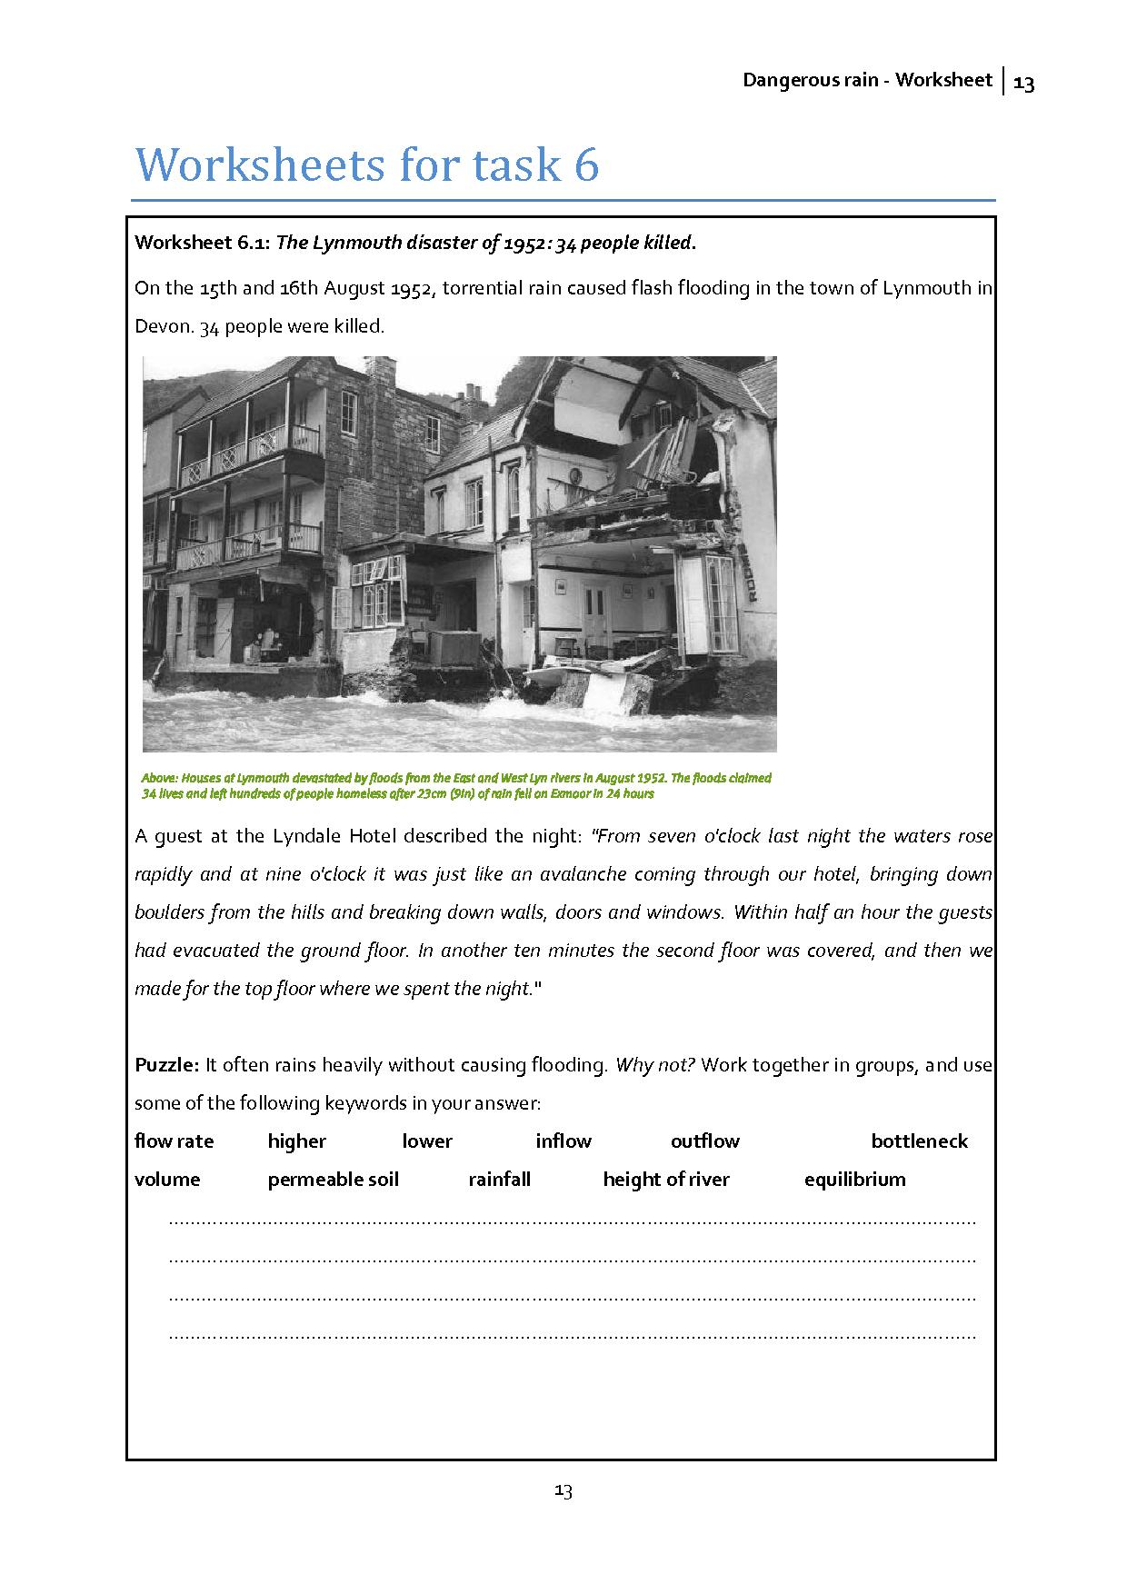
Teacher notes: Water can drain quickly through permeable soil, and if the rainfall is heavy, then the inflow to the river will increase. However, as long as the outflow is higher than the inflow (there are no serious bottlenecks, for example) then the flow rate can be high without the height of the river rising very much.
If the soil is very absorbent, then a lot of the water from heavy rain will be stored in the soil, and will reach the river only slowly over the days ahead. In this case the inflow to the river will never be very high, and the height of the river is unlikely to rise.

Link to resources: video of
http://www.bbc.co.uk/devon/content/articles/2007/07/03/lynmouth_floods_archive_video_feature.shtml

Activity 2for students: what caused the flood in Lynmouth? Build up a picture of the circumstances
Part of the problem lies outside Lynmouth, near the mouth of a river below an area of moorland called Exmoor.
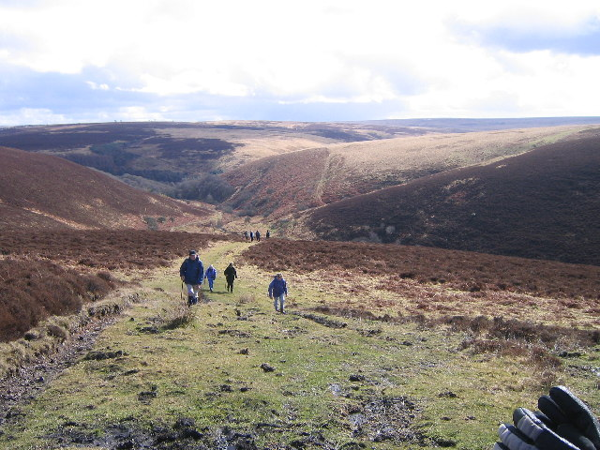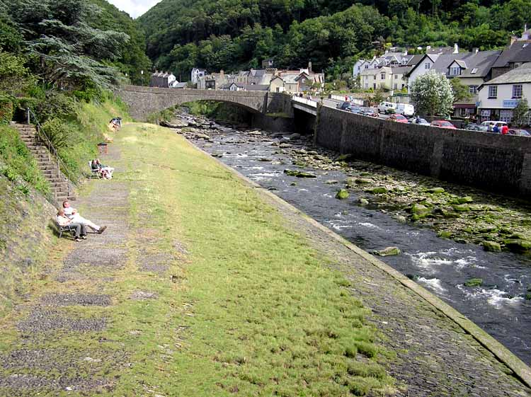
Exmoor (wikimedia…) the river near Lynmouth (wikimedia…)

Link to Ordinance Survey Map showing streams and rivers leading down to Watersmeet and then along the narrow valley to Lynmouth - you will need to search for ‘Lynmouth’ then zoom in to see the detail of the land south of Lynmouth. You may need to switch the map from ‘street view’ to ‘Ordinance Survey’.

Resources:
worksheet 6.2
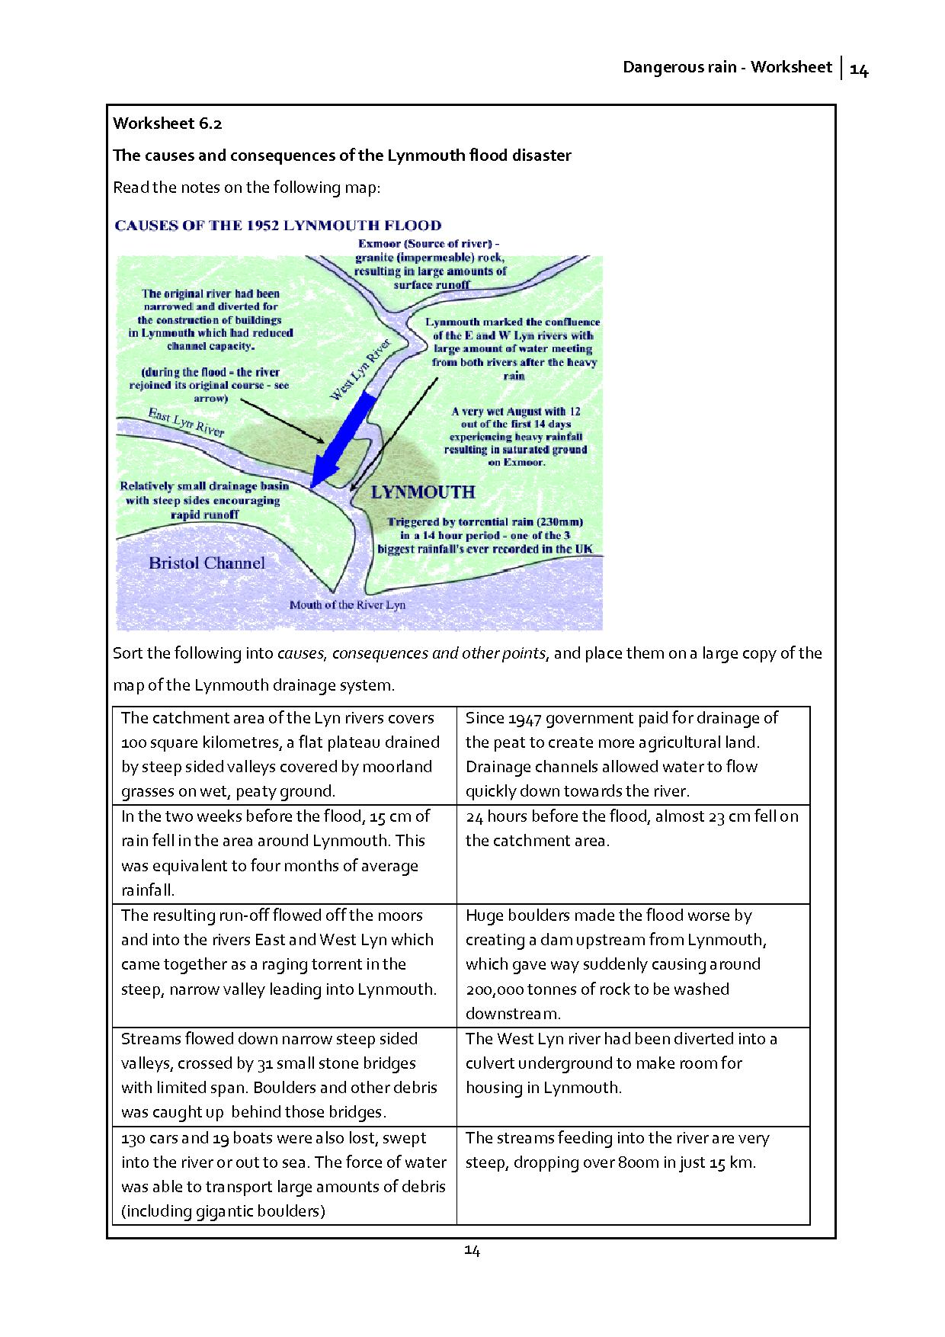

Activity 3 for students: (Main task) How to avoiding another flood disaster
You are the scientific committee with the job of recommending actions that will greatly reduce the risk of this disaster happening again. Your task is to use what you have learnt about the flow of water in maths and previous science lessons to consider what changes you recommend.
Be ready to present your recommendations to an audience of your peers.
(see worksheet 6.3)
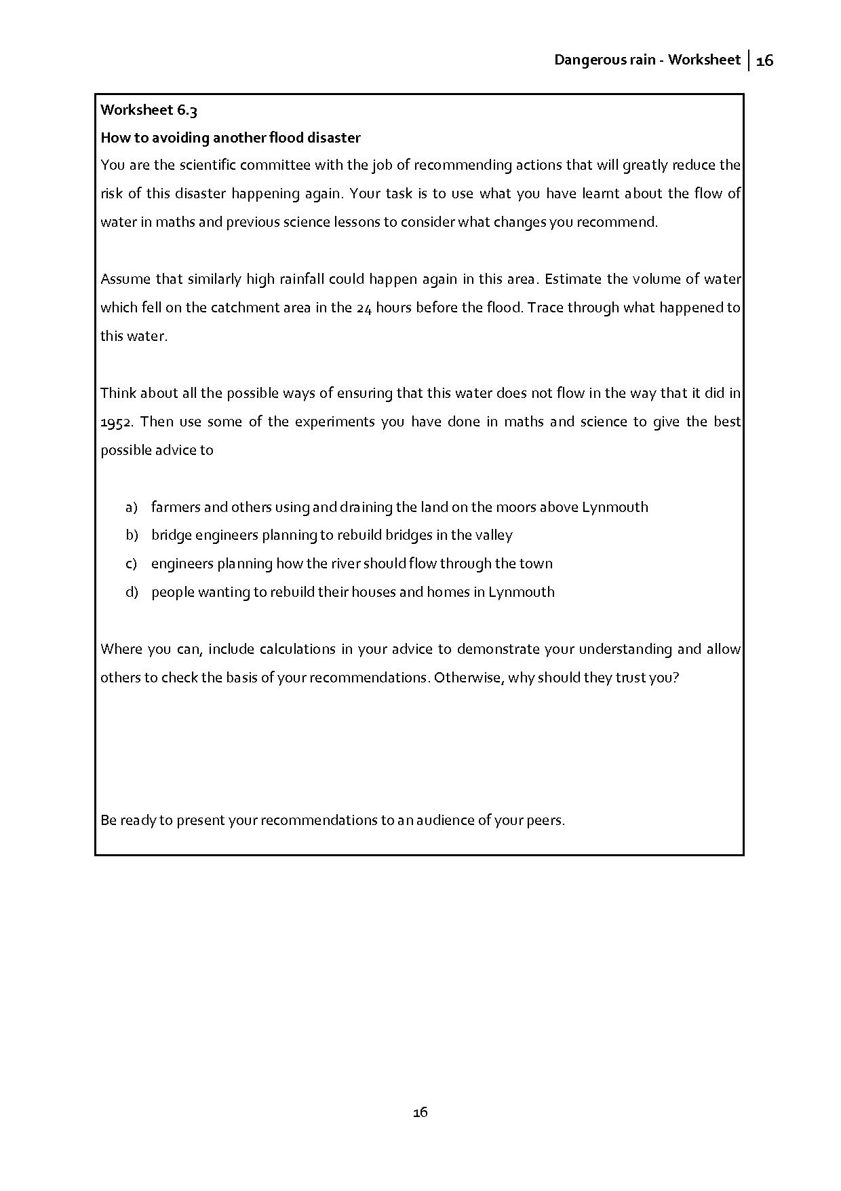
These materials involve pupils in considering a real situation and what can be done to reduce the risk of a repetition of the flooding which occurred.

Further issues to pursue
Climate change is likely to be the main factor influencing future increase in flood risk in most places. What changes in the climate might increase the possibility of flooding?

It has been suggested that the rainfall on the moors above Lynmouth 1952 was connected to government operation Project Cumulus involving cloud seeding experiments being conducted in southern England at the time. What does this mean, and do you think this is likely?

