Worksheets for task 1
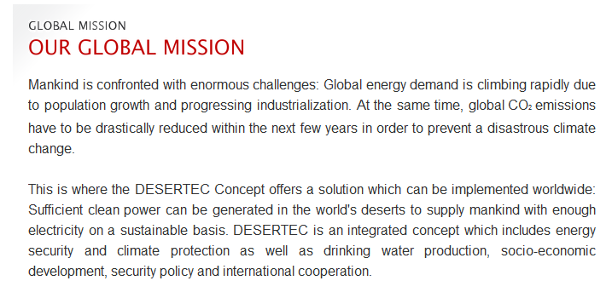
Retrieved from www.desertec.org, 30/05/2011
According to a TRANS-CSP study, 17% of Europe’s energy requirements may be met by solar imports by 2050. This would involve 2,500 km² of desert surface for the solar power plants and 3,500 km² for the high-voltage direct current transmission lines throughout the entire EU-MENA region (Europe – Middle East – North Africa).
Retrieved from www.desertec.org/en/concept/questions-answers, 30/05/2011

Green electricity from the Sahara - "Solar energy will pay"

Nuclear or solar, coal or wind? For Greenpeace Manager Roland Hipp, Germany is going to have to choose a system. In an interview for MIRROR ONLINE, he calls for a clear ‘no’ to coal, following the example of the phasing out of nuclear power and of state aid for solar energy from the Sahara.
mirror-Online: 09.07.2009 (http://www.mirror.de/wirtschaft/0,1518,634892,00.html)

Desertec Project - Expert doubt the desert energy miracle

It is one of the largest energy projects ever. Thanks to the Desertec Initiative, in the future Europe is to get its green electricity from the Sahara. But politicians and experts are sceptical: the plans are too expensive, the technology too complicated and implementation takes too long.

mirror-Online: 13.07.2009 (http://www.mirror.de/wirtschaft/0,1518,635811,00.html)

"Desertec was just hype"
One year ago saw the start of the desert energy project Desertec, which is backed by major German corporations such as Siemens and the MünchenerRück. Solar power stations in the deserts of North Africa should soon revolutionize Europe’s energy supply. But now a more realistic note has replaced the initial euphoria.
By Marc Dugge, ARD radio station in northwest Africa
A bridge of electricity from north to south, a new dimension to power supplies, an historic project – from the very beginning, talk of Desertec meant being generous with the superlatives. […] After all, 400 billion Euros makes quite an impression.
However, it soon became clear that so far the ‘investment’ has been little more than playing around with ideas; businesses are for the moment waiting to see if and how they might be a part of desert energy.
In other words, Desertec is basically just engaging in lobbying for a great idea. The aim of the initiative is to bring possible partners together. No more and no less. […]
Many uncertainties
One thing that is sure is that many people are still very unsure. Europe can’t decide whether or not it really wants the desert energy. It is also not clear who is to bear the huge costs of this massive investment. In addition, there are technical issues to contend with. For example, between Spain and France there are not enough power lines to transmit the power from the south to Central and Northern Europe.
Which is why Manfred Konukiewitz from the OECD recommends not rushing into anything: "It is important for the time being that we don’t encourage any short term hopes but remain open and honest, making it clear that such enormous visions need time.” At the moment the work is on pilot and reference projects.
Tagesschau: 21.7.2010: http://www.tagesschau.de/wirtschaft/Desertec116.html

Worksheets for task 2
Worksheet 2.1: Energy conversion – Part 1
The conversion of different kinds of energy into one another can be observed in many processes in the natural world and in technology. According to the principle of conservation of energy, no energy is lost in the process. Energy conversion can be represented with an energy flow diagram. Basically, an energy flow diagram shouldlook like this:
Energy type I
Energy type II
Energy converter
Conduct the following experiments in which different forms of energy are converted into another.
For each step, create an energy flow diagramby filling in the right-hand column of the table.

Worksheet 2.1: Energy conversion – Part 2

Experiments |  | Energy flow diagrams
1) A coin (2 Euros) is balanced on the neck of a bottle, which is placed in a bowl of warm water. The coin begins to move. | 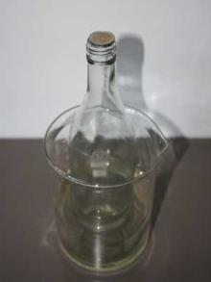
2) An immersion heater heats water in a flask. | 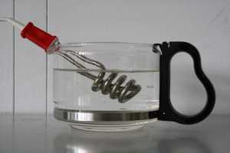
3) Batteries are charged by plugging the charging device into a socket. | 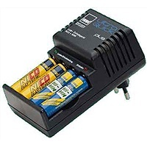
4) An electric motor lifts a load. | 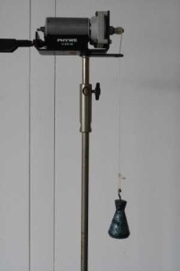
5) A solar cell is connected to the model of a cyclist. This moves when exposed to light. | 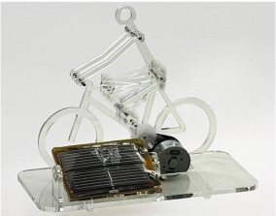
6) A candle burns. | 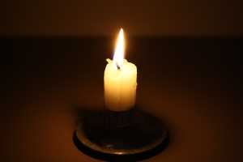
7) A circuit contains a battery and a bulb. The bulbs light up. | 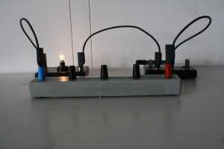

Solutions for worksheet 2.2

Experiments | Energy flow diagrams
1) A coin (2 Euro) is balanced on the neck of a bottle, which is placed in a bowl of warm water. The coin begins to move. | Thermal Energy  Kinetic energy
2) An immersion heater heats water in a flask. | Electric energy  Thermal energy
3) Batteries are charged by plugging the charging device into a socket. | Electric energy  Chemical energy
4) An electric motor lifts a load. | Electric energy  Kinetic energy
5) A solar cell is connected to the model of a cyclist. This moves when exposed to light. | Radiation energy  Electric energy  Kinetic energy
6) A candle burns. | Radiation energy  Chemical energy  Thermal energy
7) A circuit contains a battery and a bulb. The bulbs light up. | Thermal energy  Chemical energy  Electric energy  Radiation energy

Information sheet 2.2Solar power plants
Solar power plants with curved mirror troughs. Unlike gas power plants, these power plants use renewableenergy resources; in this case it is the sun’s energy. Large mirrors focus the sunlight on a pipe carrying a heat transfer fluid, or ‘working fluid’, which is located along the focal line of the trough. The working fluid is heated in the pipe to approx. 400°C. The collector is made up of the mirror and the pipe. The individual collectors are connected by a manifold (linking all the fluid pipes).
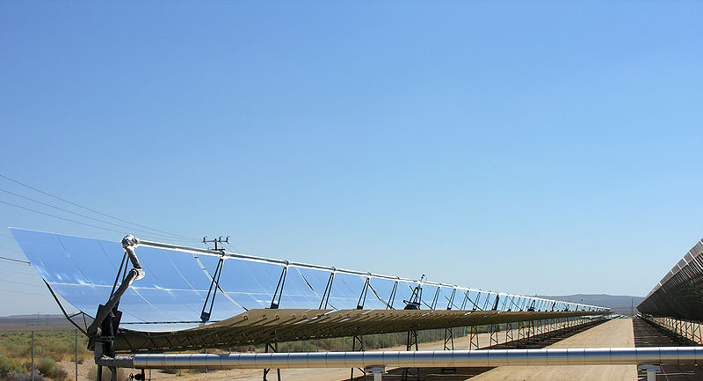
Figure 1: Curved mirror troughs to collect solar energy/radiation(retrieved from Wikimedia Commons, http://commons.wikimedia.org/wiki/File:Parabolic_trough_solar_thermal_electric_power_plant_1.jpg, 02.08.2010, image by kjkolb).

The heated working fluid is routed to a heat exchanger in which steam is produced (see Fig. 2). The steam flows via pipes and is usedto drive a steam turbine. The turbine is connected to a condenser, in which a large part of the steam’s thermal energy is transferred to the cooling water, thereby condensing, and to a generator, which is driven by the movement of the steam turbine.
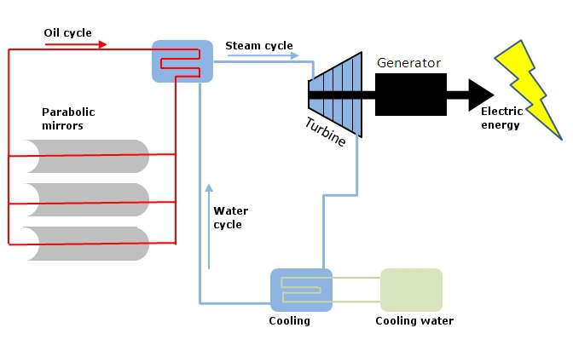
Figure 2: Solar power plant
Information sheet 2.3 – Gas power stations
Gas power stations.Gas or oil is burnt in a combustion chamber (Fig. 3). This produces a hot jet of gas which drives the paddle wheels of the turbine. The temperature of the gas before reaching the turbine is 800°C or higher; the outlet gas temperature is about 500°C. Like in the solar thermal power plant, the turbine converts thermal energy into mechanical energy. The turbine is connected to a generator, which is driven by the movement of the steam turbine, and mechanical energy is converted into electric energy.

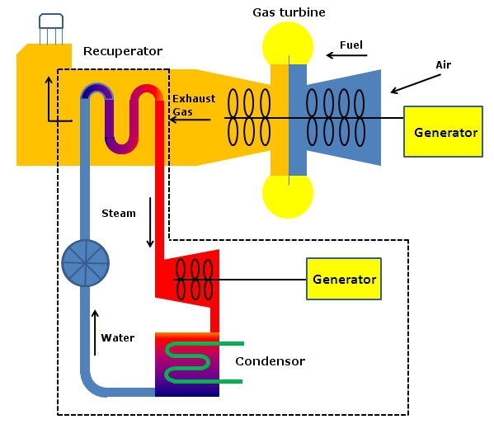
Figure 3: Gas power plant
Unlike other steam power plants, gas turbine power stations can be ready for use within minutes. They need neither cooling towers nor complicated facilities for exhaustgas cleaning, they can be erected relatively quickly and are cheaper than other steam power plants of similar output, such as coal-fired power stations. However, the power generating costs are higher than with other steam power plants. Therefore, they are usually not used as base load plants but to cover demand peaks.

Worksheets for task 3
Worksheet 3.1: Figure of a circle and a parabola
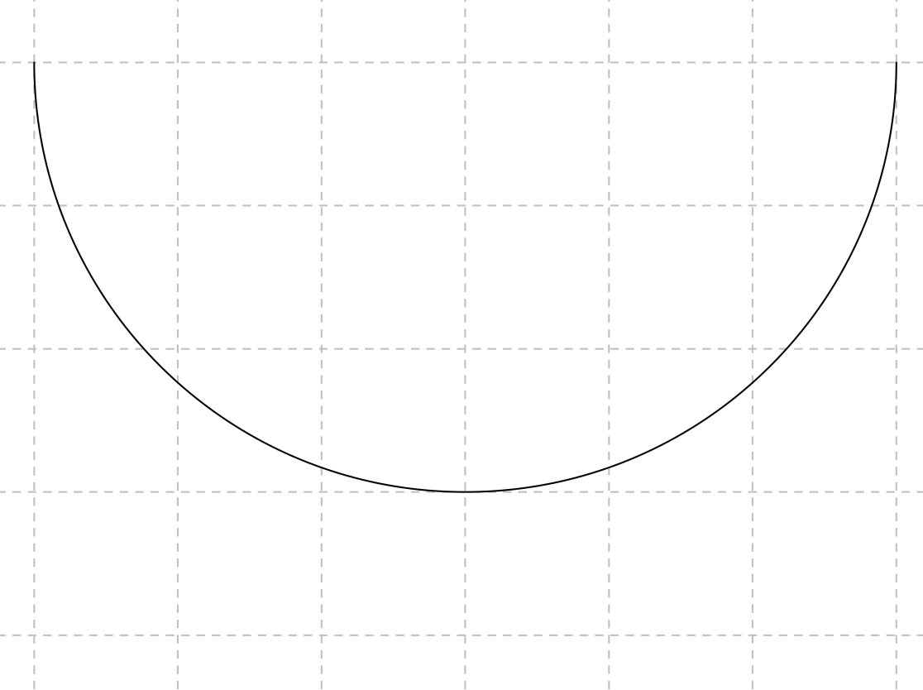

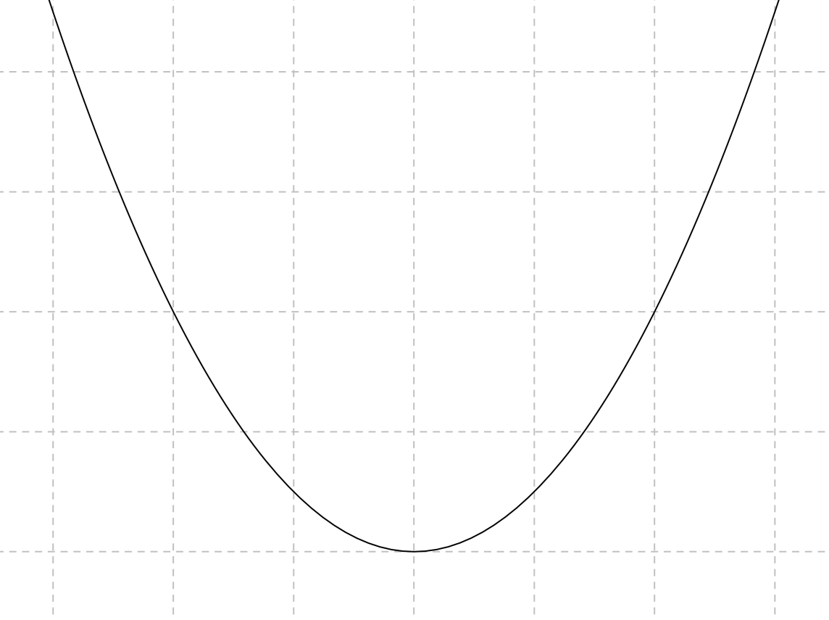
Worksheet 3.2: Figure of a parabola for construction purposes

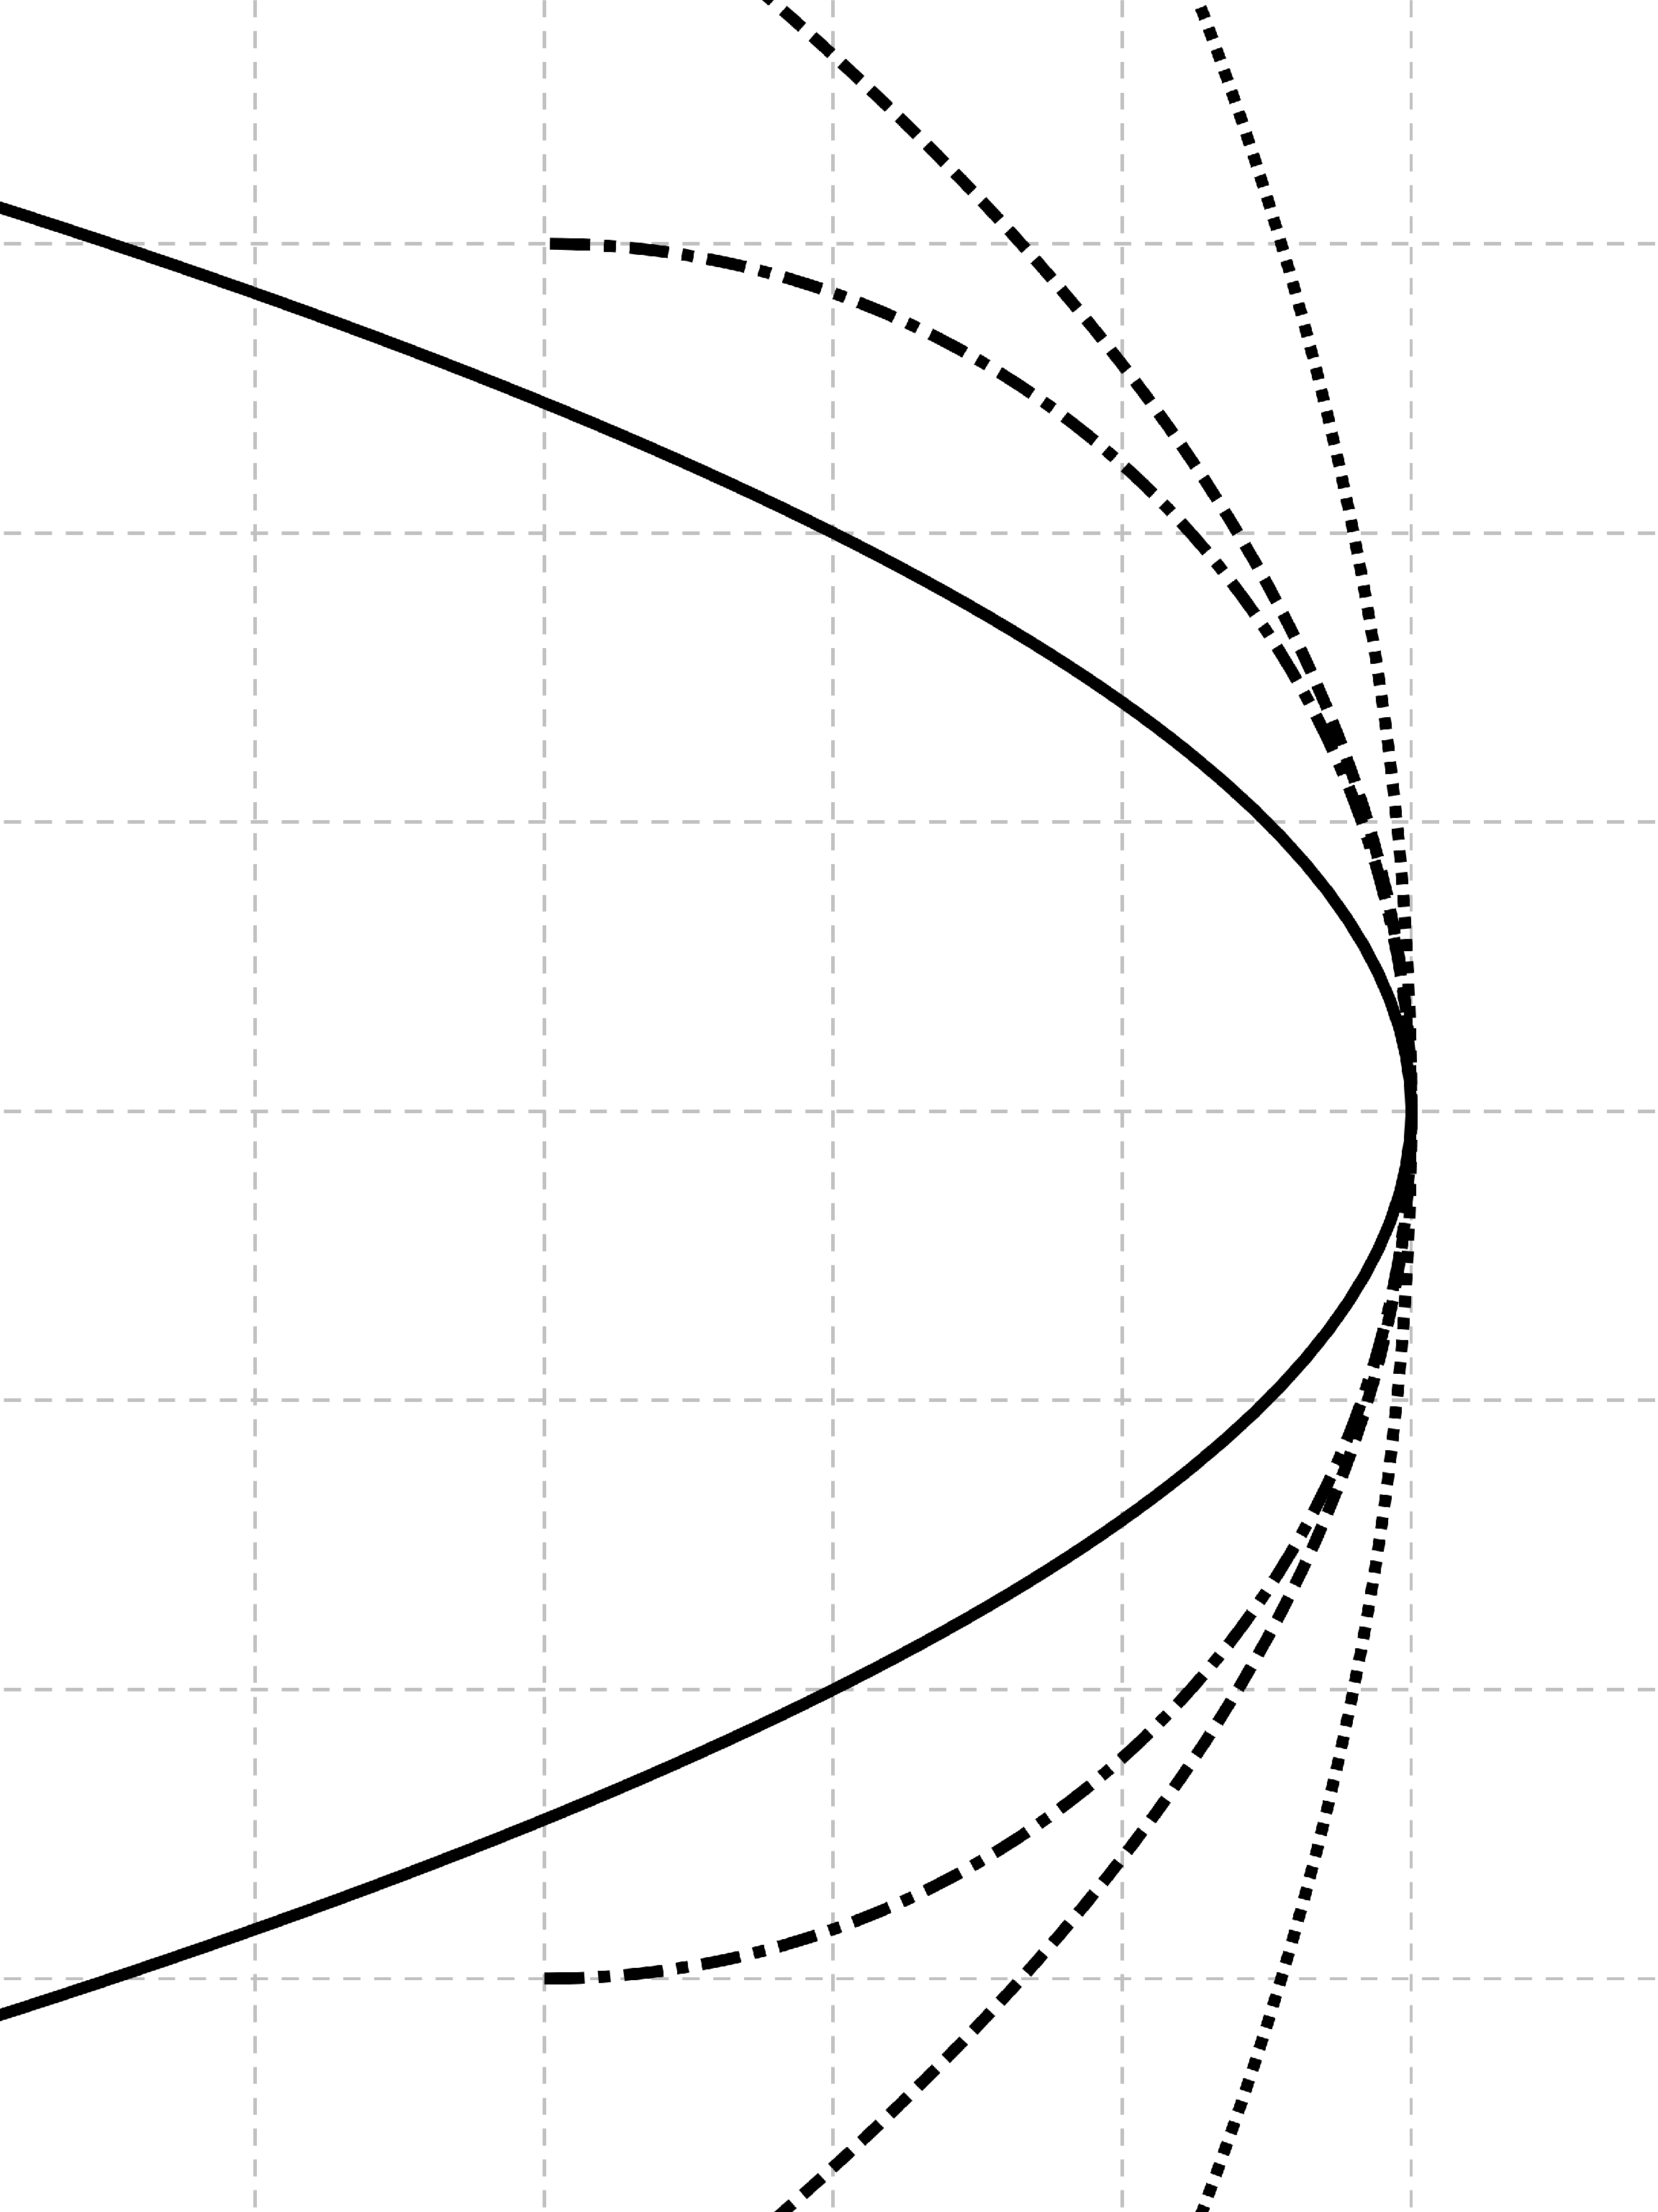

$$f(x)={\frac{x}{4}}^{2}$$
$f'(x)=$_______
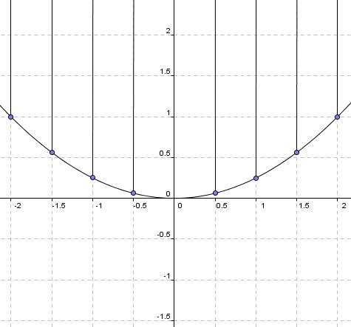

- For x₀=1 and x₁=-1.5 calculate and draw the tangents with the tangent equation. Then reflect incoming rays from the sun on these tangents.

For reflecting the light, you needed to draw the normalstothe connection points. Look atthe functionsthat describe these normals and compare them with the functions of the corresponding tangents. Describe the relation between the two. Compare your results with your neighbour.

- Calculate and draw the normals for two further points on the parabola

Worksheets for task 5
Worksheet 5.1: Energy consumption – newspaper article
Energy from the desert
The world’s largest solar project taking shape
By 2050, roughly 15 percent of Europe’s energy needs are to be met in an environmentally friendly way with the help of the desert sun. The costs are currently estimated at around 400 billion Euros. However, a starting date to begin constructing the planned solar power stations and wind parks has not yet been set. Most of the energy is to be generated in solar thermal power stations, which use mirrors to concentrate the sunlight. The concentrated sun’s energy heats the working fluid which is inside the pipes running through the focal point of parabolic mirrors. A special oil or fusible salt is generally used. The hot liquid flows to a heat exchanger in which water is made to evaporate. The ensuing pressurised steam drives the turbines which produce the power. The efficiency of this system is estimated to be between 16 and 25 percent, which is higher than with photovoltaic systems.
FAZ, 13.9.2009 (retrieved from http://www.faz.net/s/RubD16E1F55D21144C4AE3F9DDF52B6E1D9/Doc~E09310A89B87D4A8CB3CA3154A4DE2B60~ATpl~Ecommon~Sspezial.html)

Energy consumption expected to double by 2050
Global energy consumption is expected to grow considerably over the next few decades. Experts predict an increase of up to 100 percent.
According to a study conducted by the World Energy Council (WEC), which was presented on Monday at the World Energy Congress in Rome, the global demand for energy will increase by 70 to 100 percent by 2050; in other words, it is expected to more or less double. As a result, the prices for all kinds of energy – oil, gas, coal, electricity, wind, water and nuclear energy – will also increase considerably.
Focus: 12.11.2007 (retrieved from http://www.focus.de/immobilien/energiesparen/energyverbrauch_aid_138934.html, 03.08.2010)

Extract from a report conducted by an energy economics research society:
Conclusions and perspectives
The sharp decline in energy consumption, as calculated in scenarios 2 and 3, is by no means the result of a natural ‘business-as-usual’ development. Both the introduction of technologies with higher energy efficiency and changes to the needs determinants (compared to scenario 1) are the result of a huge effort which the population is only willing to carry out if provided with extensive legal provisions. A reduction in energy and CO2 emissions, however, is only possible if everyone behaves in an environmentally friendly way.
(Retrieved from http://www.ffe.de/taetigkeitsfelder/energybedarfsprognosen-struktur-and-marktanalysen/257, 3.8.2010)

Worksheet 5.2: Energy needs – technical information
Technical details for the Andasol power stations (details per power station)
Position
Project name | Andasol 1, Andasol 2, Andasol 3
Site | 10km east of Guadix in the municipality of Aldeire and La Calahorra, in the region of Marquesado del Zenete, province of Granada
Area of land | approx. 195 hectare (1,300 x 1,500 m), north-south facing
Access to overhead power lines | Connection to 400 kV power line at Hueneja (approx. 7km away)
Solar field
Parabolic trough technology used | Skal-ET
Size of solar field | 510,120m²
No. of parabolic mirrors | 209,664 mirrors
No. of receivers | 22,464 4m-long pipes
No. of sun sensors | 624 units
Annual direct normal irradiance (DIN) | 2,136 kWh/m²a
Solar field efficiency | approx. 70% peak efficiency, approx. 50% annual mean
Heat storage tank capacity | 28,500t salt for 7.5 hours at full load
Power plant capacity
Turbine output | 49.9 MW
Annual operating hours | approx. 3,500 hours at full load
Estimated total amount of energy | approx. 180 GWh
Efficiency of whole plant | approx. 28% peak efficiency, approx. 15% annual mean
Estimated life expectancy | at least 40 years
http://www.solarmillennium.de/upload/Download/Technologie/Andasol1-3deutsch.pdf (19.01.11)
Worksheets for task 6
Information sheet 6.1 - The transportation of energy
Basic physics. As we have already discovered through our work on the different types of power stations, electrical energy is usually produced through synchronous generators. This means that a three-phase current is created. The frequency of these three-phase currents in Western Europe is50 Hz.
As the power stations are generally not located anywhere near the end user/customer, it is necessary to transport, or to transmit, the electric power over long distances.
The electric power (P) transmitted in a circuit is the product of electric potential (V) and current (I). So the formula is P=V*I, with the corresponding units 1W=1V*1A.
If for example P=100kW=100 000W has to be transmitted, there are two possible ways to do this:
Potential Vin V | Current I in A | Power P in W
250 | 400 | 100,000
10,000 | 10 | 100,000

The advantages and disadvantages of this transmission are:
- If power is to be transmitted at high voltage, then it is necessary to invest quite a lot in its isolation (e.g. several meters of “air” when transmitting the power over land).
- If power is to be transmitted with a high current, then it is necessary to have power lines with a large cross section, as high currents lead to an undesirably large line loss through resistance.
For large amounts of power (approx. 1,000 MW) transmitted in a financially viable wire diameter, currents under 2,500 A are necessary – in other words with a very high voltage of more than 400 kV. Therefore, in the case of the transmission of large amounts of electric power, high-voltage power lines are preferable for distances over several hundreds of kilometres.
Transmission via alternating current:
Power stations can generate such a high voltage in alternating current mode very efficiently by means of power transformers. At the end of the overhead line the high voltage is reduced in a step-down transformer to a lower AC voltage (110 kV) or medium voltages of 10 to 30 kV.
To keep losses low when using three-phase alternating current, connections with at least three conductor lines are required with a certain separation distance,in addition to an earth potential. Above ground this is managed using typical overland power lines. For underground cables, e.g.,underwatercables, this is only possible with an enormous technological effort, and thus as a rule is limited to a maximum distance of 70 kilometres.
Transmission with direct current
Unlike AC voltage, the simple transformation of DC voltage is not possible. This means that technically complicated converters capable of carrying high voltages are needed in addition to transformers for AC voltage. However, direct current allows for transmission using onlytwo or even one cable, which may be laid subterranean or undersea cable.

