
Worksheets for task 1

Worksheet 1.1 – Nutrition information
As you have probably noticed, packaged foods must showlots of nutrition information about the product in the package. One important factor is the calorific value as this is the unit used to measure the energy they supply. A typical label for a breakfast cereal is shown in Figure 1. The energy supplied by a typical 40g serving of cereal with 125ml of milk is 202 kilocalories. Often this is quoted as just 202 Calories. The factor of 1000 is usually indicated by the capital letter when discussing dietary matters, i.e., 1 Calorie = 1kcal = 1000 calories. The standard SI unit for energy is theJoule. One calorie is approximately 4.184 J.    1 | 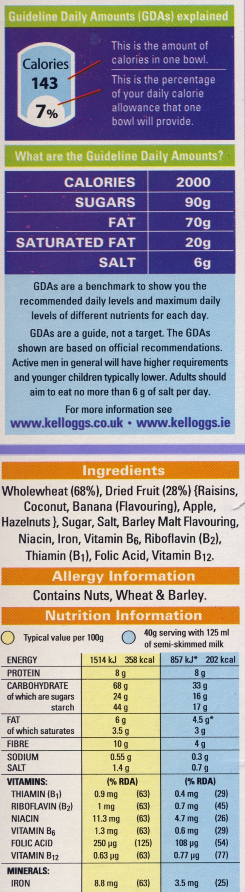
Fig. 1: Calorific value
However, for fresh foods such as vegetables, bread, eggs, fruit, etc., we can only use typical values. These can be found from a wide range of internet sources and are not often in agreement.

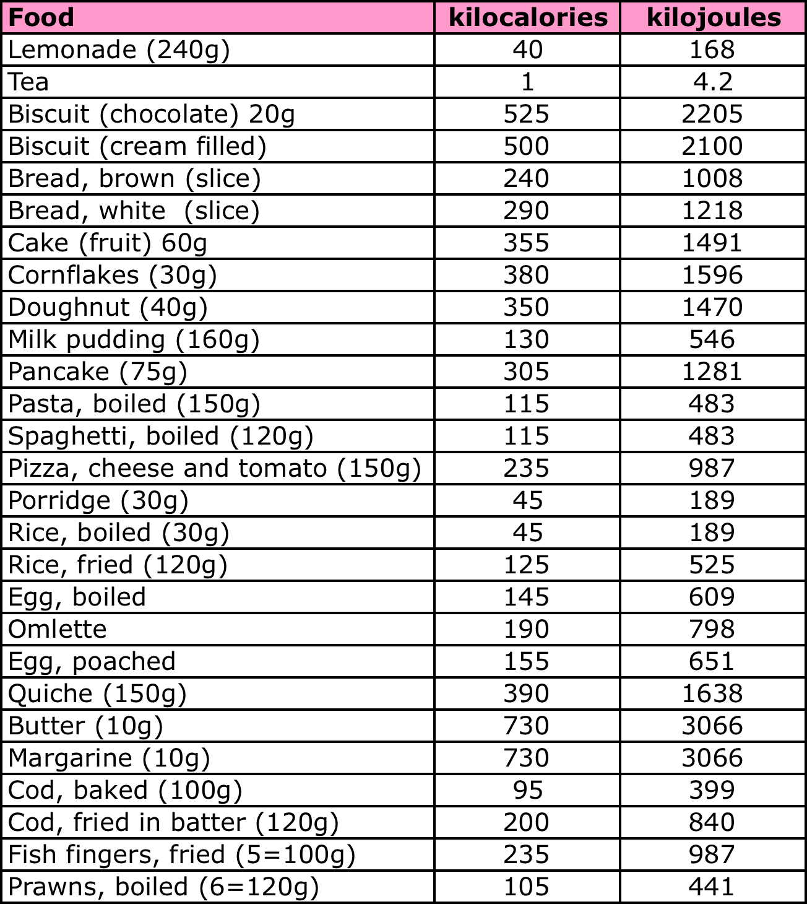Worksheet 1.1 cont. – Food energy chart

Worksheets 1.2 – Diaries
England | 
Breakfast
Two slices of toast
Butter 10 g
Tea (2 cups)
Lunch
Glass of orange juice
Sandwich
Packet of crisps
Apple
Dinner
Fish (fried)
Chips
Peas
Yoghurt
Glass of Cola (× 2)
Other
Bar of chocolate
Bottle of cola

Netherlands | 
Breakfast
Two slices of bread with chocolate sprinkles
Butter 10 g
Tea and orange juice
Lunch
Three ham and cheese sandwiches
Milk
Apple
Bar of chocolate
Dinner
Meat balls
Cooked potatoes
Cooked vegetables
Custard
Water
Other
Chips
Cola

Slovakia | 
Breakfast
Bread 2 slices
Butter and strawberry jam
Milk with instant chocolate powder
Lunch
Chicken soup with pasta
Fried chicken breast with rice
Carrot salad with apricots
Fruit juice
Dinner
Scrambled eggs (3 eggs) with onion
Bread 2 slices
Other
2 ham and cheese sandwiches
Apple
Wafer
Chips
Blackberry yoghurt
Roll

Spain | 
Breakfast
A glass of orange juice | 200 ml
A glass of milk with instant cacao | 250 ml of milk, 5 g of instant cacao
A toast with olive oil on | 50 g of white bread  5 ml of olive oil on
Lunch
Paella | Ingredients for four people:  - 1 red pepper  - 2 medium-sized tomatoes  - 100g peas  - 350g rice  - 2 cloves of garlic  - a sprig of parsley  - 25 ml of olive oil  - 800ml of water  - 800g of pork meat
An orange
Dinner
Tomato salad | (2 medium-sized tomatoes, salt and 25 ml of olive oil)
Grilled haddock and mashed potatoes | 150g of fish, 100g of potatoes
1 yoghurt
Other
Jam sandwich with 5 ml of olive oil (as a snack at 11.00am)
A glass of milk with instant chocolate powderand a piece of cake (as a snack at 6.00pm)

Germany | 
Breakfast
Cereal with yogurt and fruit
A cup of herbal tea
Lunch
Boiled sausages (2) with sauerkraut (cabbage) and mashed potatoes
Dinner
Whole-grain bread
Sausage, cheese
Raw vegetables (carrots, cucumbers, radish)
Other
A snickers bar
An apple

Worksheet 1.3 – Energy intake
Calculate the total amount of energy that a typical personconsumes perday. Calculate the amount of energy for each item of food, and identify all of the ingredientsof different meals (such as milk on cereals for breakfast).

Food | Energy per 100g (Cal) | Energy per 100g (kJ) | Amount (g) | Energy (Cal) | Energy (kJ)

Worksheet 1.4 – Calorie needs
Calculate how much energy different people use in a typical day. Record your results in the tables provided below.

Simple method for calculating daily calorie needs (note these formulae are for adults – you may wish to consider how and why they may be different for younger people):

Males: weight (kg) $´$ 24 $´$ Activity Factor
Females: 0.9 $´$ weight (kg) $´$ 24 $´$ Activity Factor

Activity Factor (AF):
Sedentary | 1 | No exercise + at school or home most of the day
Light active | 1.2 | Regular exercise 3 times/week + desk job or at home most of the day
Active | 1.4 | Daily exercise + work on feet most of the day
Very active | 1.5 | Daily intense exercise + construction work most of the day

Name | Gender | Weight | Activity Factor | Calorie need
James
Antonio
Jenny
Marta
Maria
Sonja

Worksheet 1.4 cont.
Complex method for calculating daily calorie needs that takes account of height and age as well as weight.
Males: Activity Factor $´$ (66.47 + 13.75 $´$ weight (kg) + 5 $´$ height (cm) – 6.76 $´$ age (years))
Females: Activity Factor $´$ (655.1 + 9.65 $´$ weight (kg) + 1.84 $´$ height (cm) – 4.68 $´$ age (years))
Activity Factors:
 | Male | Female
Resting | 1.0 | 1.0 | Sleeping, reclining
Sedentary | 1.3 | 1.3 | Minimal movement, mainly sitting, lying
Light active | 1.6 | 1.5 | Light activity involving walking
Moderate | 1.7 | 1.6 | Light manual labour
Very active | 2.1 | 1.9 | Agricultural work, military duty, some construction work.
Extremely active | 2.4 | 2.2 | Athletes with daily strenuous training, construction workers, miners.

Name | Gender | Weight | Height | Age | Activity factor | Calorie need
James
Antonio
Jenny
Marta
Maria
Sonja

Worksheet 1.5 – People Profiles
 |  |  | 
Name | James |  | Name | Antonio
Age | 29 |  | Age | 42
Occupation | Builder |  | Occupation | Office worker
Weight | 78 kg |  | Weight | 82 kg
Height | 182 cm |  | Height | 191 cm

 |  |  | 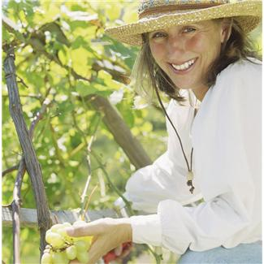
Name | Jenny |  | Name | Marta
Age | 22 |  | Age | 36
Occupation | Dancer |  | Occupation | Farm worker
Weight | 62 kg |  | Weight | 65 kg
Height | 171 cm |  | Height | 165 cm

 |  |  | 
Name | Maria |  | Name | Sonja
Age | 32 |  | Age | 24
Occupation | Engineer |  | Occupation | Athlete
Weight | 65 kg |  | Weight | 61 kg
Height | 173 cm |  | Height | 165 cm

Worksheet 1.6 – Energy output
You have already calculated the calorie need for several people. In the table below you can see how many calories they have eaten today. Suggest a suitable level of exercise and how long they should spend exercising to make their energy input and output balanced. If their input is insufficient, suggest what else they should eat.

Name | Energy input(kJ)
James | 32 567
Antonio | 18 213
Jenny | 9 605
Marta | 12 435
Maria | 16 215
Sonja | 25 331

The typical energy output for different exercises is given in the table below.

Exercise | Calories burned (kg / hour) | Exercise | Calories burned (kg / hour)
Cycling (moderate) | 8.0 | Tennis (general) | 5.0
Running (10 mph) | 16.0 | Walking (moderate) | 3.5
Track running | 10.0 | Walking (very brisk) | 4.0
Skateboarding | 5.0 | Weight lifting / body building | 6.0
Football(competitive) | 10.0 | Volleyball (competitive) | 4.0
Swimming (laps) | 10.0 | Swimming (leisurely) | 4.0
Aerobic Dancing | 8.0 | Ice skating | 5.5
Basketball | 6.5 | Roller skating | 7.5
Circuit weight training | 11.0 | Jogging | 8.0
Football | 7.0 | Cross-country Skiing | 10.0
Horse riding | 3.0 | Volleyball | 4
Worksheets for task 2
Worksheet 2.1 - Calorimeter
Describe the equipment.What you can see in the picture? What parts does it consist of? What do you think it can be used for? What is the purpose of eachpart?

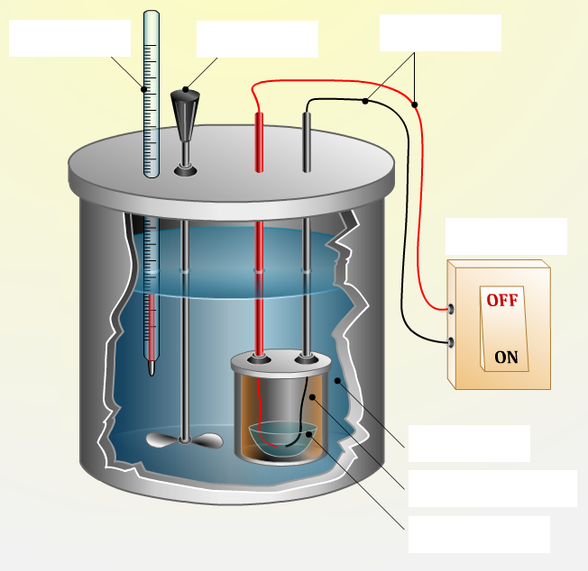

Worksheet 2.2 - Experiment
Observe how the amount of released energy changes depending on the amount of food burned. Do all food types release the same amount of energy? Why not? Which contain the most energy and which the least? Given that 1 calorie equals 4.184 J, calculate the energy in Joules as well.
Food | Amount (g) | Initial temperature (ºC) | Final temperature  (ºC) | Difference  (ºC) | Energy (cal) | Energy (kJ)
Bread | 0.2
Bread | 0.4
Bread | 0.6
Bread | 0.8
Bread | 1.0
Cereal | 0.2
Cereal | 0.4
Cereal | 0.6
Cereal | 0.8
Cereal | 1.0
Peanuts | 0.2
Peanuts | 0.4
Peanuts | 0.6
Peanuts | 0.8
Peanuts | 1.0

Worksheet for task 3
Worksheet 3.1 – Student diary
Date: …………………………..
Meal | Food | Amount (g)
Breakfast
Snack
Lunch
Afternoon tea
Dinner
Supper
Comments:

Worksheets for task 4
Worksheet 4.1 – Caloric pyramid 1
Choose one particular day from your diary. Mark where foods you ate lie on the caloric pyramid.

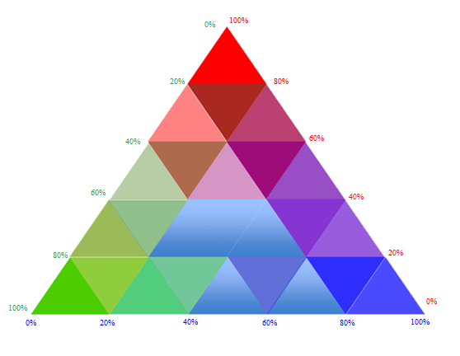
Fats
Carbohydrates
Proteins

Worksheet 4.2 - Carbohydrates 1
Discuss these facts about carbohydrates.

To obtain 100g of honey, bees must collect nectar from one million flowers, which takes about 150,000 trips by bees to the flowers. Honey isalmost 38% fructose and up to 33% glucose.
Annually, about 100 billion tons of cellulose is created in living organisms on earth. This is the most frequent substance produced by living organisms.
The average human being has 250 to 400g of glycogen in reserve. For athletes, this can be almost 800g. This reserve for athletes is used in 30 - 90 minutes of physical activity.
For a human working in a sedentary job, the ratio of proteins, lipids and carbohydrates in food should be 1:2:5, while for a hard-working human (energy output over 20.93 MJ per 24 hours) this ratio should be 1:3:4.

Worksheet 4.3 - Carbohydrates 2
- Annually, 148 millions of tons of sugar are produced in the world. Calculate how much sugar is available per person per year: .................................................................
- What foods can most quickly restore our reserve of glycogen?

- Why does honey get solidified under certain conditions? How can we make it liquid again?

- Match the names of carbohydrates with pictures of which foods are their main source.

LACTOSE, MALTOSE, SACCHAROSE, GLUCOSE, FRUCTOSE, GALACTOSE, STARCH, GLYCOGEN, CELLULOSE

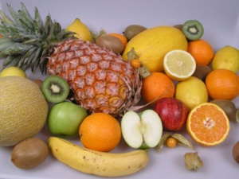 | 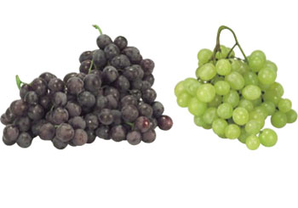 | 
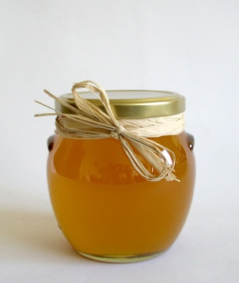 | 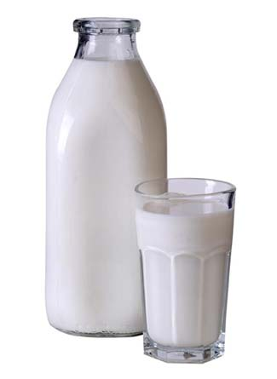 | 
 | 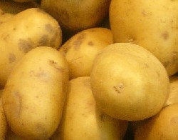 | 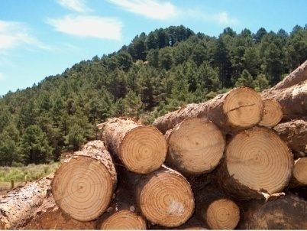

Worksheet 4.4 – Fats 1
Discuss these facts about fats.
We should not omit animal fats from our menu. Useful substances are formed from unsaturated acids found in milk and dairy products, and these substances produce mucous that can reduce the risks of developing colon and rectal cancers. A large amount of vitamins is dissolved in animal fats.
Yogurt with 0% fat may not be suitable for people following a diet because they are often over-sweetened by sugar, and from that, the human body is easily able to produce fat.
Not all bees are able to produce wax. Only workerbees between the 13th and 17th day of their life. After that, they lose this ability.
Fats should comprise a maximum of 20-35% of an adult’s daily dose of nutrients. This represents about 50-105g of fats per day (depending on gender, physical load and age).

Worksheet 4.5 – Fats 2
- What are the consequences of an excess intake of animal fats in food?
.....................................................................................................................................
.....................................................................................................................................
.....................................................................................................................................
.....................................................................................................................................
.....................................................................................................................................

- What health risks are connected to the excess consumption of fats?
. ...................................................................................................................................
.....................................................................................................................................
.....................................................................................................................................
.....................................................................................................................................

- Where does fat accumule in the human body?
. ...................................................................................................................................
.....................................................................................................................................
.....................................................................................................................................
.....................................................................................................................................
.....................................................................................................................................

- Based on your own research, find out how much fat there is in 5 differenttypes of oil. Record your results in a table and producegraphs for comparison. (In the bar chart shown here, the height of the bar corresponds to the fat content per 100g.)

- What does BMI stand for?
......................................................................................................................................
- What does it mean?
......................................................................................................................................
......................................................................................................................................
......................................................................................................................................
- Which type of fat - vegetable or animal - is most useful tothe human body?
......................................................................................................................................
......................................................................................................................................

Worksheet 4.6 – Proteins 1
Discuss these facts about proteins.
According to the World Health Organisation (WHO), idealprotein consumption is 1g per 1kg of body mass per day; for children this may be increased up to 4 g per day. Of the overall intake of proteins, about half should befrom proteins of animal origin.
No plant has all the basic, irreplaceable amino acids that the human body needs. The closest to this are legumes, mainly soya, that miss only one of these amino acids.
Collagen fibres have high tensile strength. A bunch of fibres with a cross-section of 1 mm² is able to withstand a load up to 50 kg! Collagen is also added commonly into cosmetics like shampoo, conditioner or skin cream. The reason is that in such preparations, collagen can add strength to hair and skin, enhancing their features. (Thus, it prevents wrinkles because the skin becomes more elastic).
Why can cheetahs run at a speed of up to 130 km/h? Why can eagles fly at a speed of up to 300km/h? Why do we grow? Why can we become ill? Why can we recover from diseases? Why can we think? Why are we able to learn? For all of these, proteins are needed.
One of the most deadly viruses of the past thirty years is called human immunodeficiency virus, abbreviated as HIV, which caused the worldwide spread of the disease AIDS (Acquired Immune Deficiency Syndrome), that is currently thought to be incurable. Though HIV is transmitted mainly through blood and some other body liquids; sexual intercourse is the most frequent means of transmission. Among the highest risk groups are those who frequently change sexual partners and groups of drug addicts who share needles to inject themselves.

Worksheet 4.7 – Proteins 2
- Why is it very dangerous when the temperature of the human body rises above 40°C?
.....................................................................................................................................
.....................................................................................................................................
.....................................................................................................................................
.....................................................................................................................................
- Why are proteins important for children and adolescents, and also for athletes
and bodybuilders?
. .....................................................................................................................................
.....................................................................................................................................
.....................................................................................................................................
.....................................................................................................................................

- Add the correct labels to the graph according to the recommended daily intake:
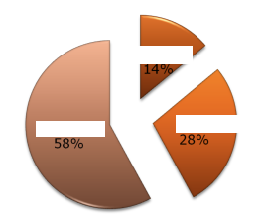
Proteins
Carbohydrates
Fats

- What other nutrients do humans need, even though they are not a source of energy?
.......................................................................................................................................
.......................................................................................................................................
.......................................................................................................................................
.................................................................................................................................................

Worksheet for task 5
Worksheet 5.1 – Experiments

Carry out these experiments following the instructions. Record your findings in the following observation sheet. Write P when the sample testspositive for a particular nutrient, N when it testsnegative, X when the sample was not used in the experiment.

Sample | Sugar | Starch | Proteins | Fats
Apple | P | N | X | N
Worksheet 5.1 cont. – Description of experiments

1st experiment: Testing for the presence of fructose - Fehling reaction

Principle: Fehling reagents I and II are special solutions that can be used to identify particular sugars in foods, and in urine as well. Glucose and fructose are so-called “simple sugars”. When they are dissolved in water and mixed with Fehling reagents, a reaction occurs. This is evidenced by the formation of a red sediment.
Generally, this reaction is used to demonstrate the presence of reducing sugars. However this reaction also occurs with other substances. It does not, though, occur with sucrose which is a so-called “two-fold” sugar. This simply means that sucrose is a combination of two simple sugars and also that it does not react with Fehling reagents. When sucrose is heated for a longer period of time, it splits into glucose and fructose and a slight positive reaction is visible.
Equipment: Test tube rack, test tubes, test tube holder
Chemicals: Distilled water, Fehling I reagent and Fehling II reagent, solution of glucose, solution of saccharose, solution of fructose, samples of foods (e.g. water extract of plant material, fruit, milk, samples of lemonades and fruit juices)
Procedure:
- Prepare control samples in test tubes from solutions of glucose, fructose, saccharose.
- First, add the Fehling reagent to the individual samples and place thetest tubes into abeaker of hot water. Observe any changes and note them down.
- Using your samples (fruit, milk, etc.) repeat the same procedure. Compare these results with the control samples.
Observation: In anytest tube where a saccharide is present, the originally blue Fehling reagent changes colour to red brown (thisis caused by the presence of copper cations).

2nd experiment: Testing for the presence of starch

Equipment: Dropper, knife, Petri dish
Chemicals: Tincture of iodine, samples of foods (e.g. potato, butter, banana)
Procedure:
- Prepare a piece of banana, butter and potato on Petri dishes
- Using the dropper, addsome drops of iodine tincture
Observation:Iodine reacts with starch causing it to change colour to blue-violet.

3rd experiment: Testing for the presence of proteins in pea seeds
Principle: Coagulation of proteinsarises through the effects of solutions of acids, alkalis and heavy metal salts. This process is called ‘denaturation of proteins’. During this process, defects in the spatial arrangement of macromolecules are caused. These changes usually result in a loss of function of proteins.
Equipment: Mortar, beaker, test tubes, test tube rack, dropper, funnel, filterpaper.
Chemicals: Concentrated nitric acid, water, samples of foods (e.g. dried pea seed, meat broth, solution of gelatine, solution of egg white, fruit juice)
Procedure:
- Mash the dried pea seed in the mortar thoroughly and put this powder into the beaker. Add water and leave it for at least 3 hours, then pass the mixture through a filter.
- Place the food samples into separate test tubes.
- Add 2 ml of concentrated nitric acid.
- Heat carefully to boiling point.
Observation: Aftera while, all test tubes (except the fruit juice) should have a noticeable yellow colour, indicating the presence of proteins.

4th experiment: Testing for the presence of fats by greasy spot
Principle: The presence of fats as reserve substances stored in parts of vegetables, especially seeds, can be proven by the‘greasy spot’ test. When drops are deposited on paper, water and essential oils evaporate quickly leaving no marks.. Spots remain if the sample contains fats or fatty oils.
Equipment: Sheet of paper, glass rod, weight (200 g).
Chemicals: Samples of foods (e.g. animal fat, chocolate, fruit, seeds containing fat - rapeseed, poppy seed, nuts)
Procedure:
- Fold a sheet of paper in half. Using the glass rod, first drop some water on the paper and then add a very small amount of fat.
- For each food sample, fold a sheet of paper in half, insert the sample between the folds of paper and then, using the weight, press firmly. Hold the paper up to the light.
Observation: In all cases, the paper gets darker and when held up against the light, it becomes transparent. The spot of water dries quickly - no traces of it remain, the paper will be coloured in the case of fruit, while greasy spots will not dry out.
Note: After adding solution Sudan III, fatty or oily spots on the paper discolour to be red.
Worksheets for task 7
Worksheet 7.1 – Analysing your own food diary

Calculate how much carbohydrate, fat and protein have you consumed during each meal, determining the energy value of each ingredient. Calculate theshare of energy you took in at breakfast, break, lunch, during the afternoon and dinner, or supper. Use the table to record your findings.
You might need these values in your calculations:
1 g of fat contains 38 kJ of energy.
1 g of carbohydrate and 1 g of protein each contain 17.2 kJ.
Date: ………………................

Course | Food | Amount  (g) | Proteins  (g) | Carbohydrates  (g) | Fats  (g) | Energy
Breakfast
Breakfast | Total
Break (snack)
Break (snack) | Total
Lunch
Lunch | Total
After-noon
After-noon | Total
Dinner
Dinner | Total
Supper
Supper | Total
Total

Worksheet 7.1 cont.
For each day in your diary mark where your intake for the whole day lies on the caloric pyramid.
Fats
Carbohydrates
Proteins

Compare the data found with the recommended daily amountsfor each of the nutrients. Which day fits the best?
Guidelines:
45% to 65% of calories eaten should come from carbohydrates.
20% to 35% of calories eaten should come from fat.
10% to 35% of calories eaten should come from protein.
Nutrition factor | Children |  | Adolescent boys |  | Adolescent girls
Nutrition factor | 11 - 14 years |  | 15 - 18 years |  | 15 - 18 years
 | Boys | Girls | Sedentary | Light active | Sedentary | Light active
Energy/kJ | 10,500 | 10,000 | 12,500 | 15,000 | 9,600 | 11,500
Proteins/g | 50 | 52 | 60 | 69 | 50 | 55
Fats/g | 80 | 75 | 85 | 100 | 65 | 80
Carbohydrates/g | 397 | 377 | 496 | 602 | 378 | 453
Worksheet for task 9
Worksheet 9.1 – Designing amenu
Day: …………………………..

For 1 portion
Course | Ingredients | Amount  (g) | Proteins  (g) | Carbohydrates  (g) | Fats  (g) | Energy
Starter
Starter | Total
Main course
Main course | Total
Salad
Salad | Total
Dessert
Dessert | Total
Drink
Drink | Total
Total

Worksheets for task 10
Worksheet 10.1 – Designing the shopping list
Use the table for calculatingasuitable quantityof ingredients for shopping
Ingredients | Amount for  1 portion  (g) | Amount for the canteen | Usual package size | Number of packages needed

Worksheet 10.2 – Comparing prices
Use the table to record prices in different shops
Ingredients | Usual package size | Number of packages | Shop 1 |  | Shop 2
Ingredients | Usual package size | Number of packages | Price per unit | Total price | Price per unit | Total price

Worksheet Appendix

Resource1– Eating at school



Meals rich in fat, salt or saccharides will be banned in the English schools
The ban, from September 2005, has been announced by Education Secretary Ruth Kelly at the Labour Party conference. Vending machines in schools will not be allowed to sell chocolates, crisps or fizzy drinks. The School Meals Review Panel next week will give details of the nutritional standards for ingredients to be allowed in school meals.
"I am absolutely clear that the scandal of junk food served every day in school canteens must end." said Ms Kelly.
FOODS THAT SHOULD BE BANNED
- Burgers and sausages from 'meat slurry' and 'mechanically recovered meat'
- Sweets, including chewing gum, liquorice, mints, fruit pastilles, toffees and marsh mallows
- Chocolates, chocolate bars and wafers/biscuits
- Snacks such as crisps, tortilla chips, salted nuts, onion rings and rice crackers

Resource 2 – List of possible internet websites

http://www.chimicare.org/blog/?cat=1
http://www.personal-development.com/yasha/life-is-chemistry.htm
http://www.natsabe.it/magazine/dettaglioarticolo.asp?IDMagazineArticolo=156
http://chemistry.about.com/od/chemistryfaqs/f/onionscry.htm
http://www.silviamar.com/Spanish/Documentos/lactosa.htm
http://www.uned.es/pea-nutricion-y-dietetica-I/guia/guianutr/enzimas.htm
http://www.silviamar.com/Spanish/Documentos/amor.htm
http://www.silviamar.com/Spanish/Documentos/colesterol.htm
http://www.chimicare.org/curiosita/?p=370
http://www.silviamar.com/Spanish/Documentos/leche.htm
http://www.chimicare.org/curiosita/zuccheri
http://www.kaloricketabulky.cz
http://www.akv.sk
www.chudnutie-ako.sk
www.vaha.sk
http://www.asu.sk/potraviny2.htm,
http://www.suite101.com/content/what-does-organic-meal-really-mean-a129743)

