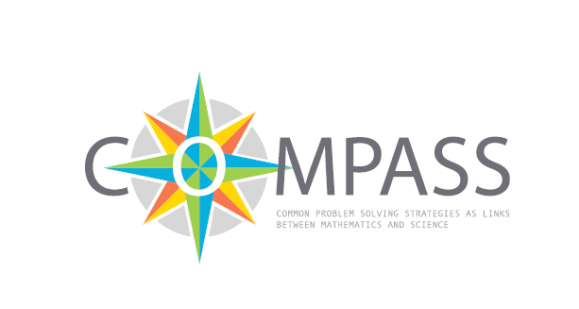
We are what we eat?
Abstract
This module explores the flow of energy in the human body. Students explore the food they consume and the energy that they use in general day-to-day activity and in any additional exercise they do. They also look at the contribution that different nutrients make to the energy provided by different foods.
Students will eventually consider how they might eat a more balanced and healthy diet and how much exercise they might need to do to use the energy they consume in the food they eat.
Aspect | Description
Mathematical content | - proportionality  - percentages, fractions, ratios  - use of diagrams, charts and tables for data representation  - analysing data
Scientific content | - energy in food and energy flow  - meaning of calories, calorimeter  - carbohydrates, fats, proteins as nutrients and as components in food  - constituents of a balanced diet  - experimental work
Age of students | 14-16
Number of lessons in mathematics | 4
Number of lessons in science | Physics 1  Chemistry 2  Biology 3

1. Overview of the teaching unit

1.1 The situation
There is much concern that young people today are becoming obese at an early age because of what they eat.
Many countries across Europe are very concerned about the situation and are controlling what school pupils eat in the meals they provide in schools. For example, in England school lunches are subject to strict nutritional guidelines and there are controls over what pupils can buy from vending machines.


Meals rich in fat, salt or carbohydrates will be banned in the English schools
The ban, from September 2005, has been announced by Education Secretary Ruth Kelly at the Labour Party conference. Vending machines in schools will not be allowed to sell chocolates, crisps or fizzy drinks. The School Meals Review Panel next week will give details of the nutritional standards for ingredients to be allowed in school meals.
"I am absolutely clear that the scandal of junk food served every day in school canteens must end," said Ms Kelly.
FOODS THAT SHOULD BE BANNED
- Burgers and sausages from 'meat slurry' and 'mechanically recovered meat'
- Sweets, including chewing gum, liquorice, mints, fruit pastilles, toffees and marsh mallows
- Chocolates, chocolate bars and wafers/biscuits
- Snacks such as crisps, tortilla chips, salted nuts, onion rings and rice crackers

You can find this introductory newspaper article as a worksheet in the appendix (Resource 1).

1.2 Guiding questions
- Which components of food are healthy and which are not? Why should we care about this?
- What are the effects of the individual components of food on the human body?
- What do our families eat? What are the likely effects of what we eat?
- How can we ensure that the energy we get from food is used up by the exercise we undertake?

1.3 Final product

Design a poster where you analyse your typical food intake. Compare your food intake and exercise with what is recommended.

Design a menu for your school canteen that takes into account recommendations about healthy eating.

1.4 Suggestions
You may wish to consider typical diets for your country and compare these with those for other countries. You can find typical menus from other countries in worksheets 1.2 (Food-Worksheet pages 3-7).

1.5 The task plan
Task | Science | Mathematics
1 |  | Task 1 Mathematics: Introduction - Energy in food.  How much energy should you consume per day.
2 | Task 2 Physics: Energy in food.  How can we find out how much energy there is in food?
3 | Task 3 Biology: What are the constituent components of foods?  Discussion about eating. Designing diaries to record diet data.
4 | Task 4 Biology: Do you know about carbohydrates, fats and proteins?  Production of a poster of what pupils eat during the day. Placing different kinds of food on the caloric pyramid.
5 | Task 5 Chemistry: Testing for the presence of carbohydrates, fats, proteins in foods. Experimental work in groups.
6 | Task 6 Chemistry: What about your daily diet?  Summarising data obtained from diaries.
7 |  | Task 7 Mathematics: What do we eat? Calculation of amounts of individual nutrients and energy consumed in foods. Evaluation of diaries, calculation of energy consumed.
8 |  | Task 8 Mathematics: Do we eat properly?  Statistical evaluation and designing a poster.
9 | Task 9 Biology: Designing a menu for the school canteen  Looking back, summarising and applying the knowledge.
10 |  | Task 10 Mathematics: How to buy food in the most effective way?  Finding out the current prices of food and comparing statistically.
2. Description of the tasks

2.1 Introduction: Mathematics – Task 1: Energy in food
There is much concern in European countries about obesity today – in other countries of the world the reverse is true with many people starving because they do not get enough to eat.
The problem is that we all need a daily intake of energy from what we eat to provide the energy we need for what we do. If we do a lot of exercise on a particular day then we will need more energy than on a day that we spend relaxing.
Mathematical content
- Calculations
- Use of formulas using words
- Use of spreadsheets possible
Scientific content
- General information about energy in food and energy flow
Outcomes
Students consider what they eat and the energy this provides, the energy that they use when exercising and then devise what they think would be a suitable menu for school lunches.
It is worth emphasising that, throughout the mathematics tasks, we will be modelling reality and there is plenty of room for variation in answers and approaches.
Explore the food energy chart resource with students (see worksheet 1.1). Issues that you need to raise are how we will have to use proportional reasoning to calculate the total amount of energy that someone consumes for any particular item of food, and how they will have to identify all of the ingredients in different meals (such as milk on cereals for breakfast) and add these together. Use one of a number of possible menus that are provided in the classroom resources (see worksheets 1.2) or ask your students to recall what they have eaten the previous day.
Students should complete the spreadsheet or table provided (see worksheet 1.3). When they have completed the data (food consumption and finding the typical energy content for a standard portion of a particular food using the food energy chart) they should calculate their total energy consumption for the day. This will involve them in proportional reasoning. For example, if you eat one apple you typically consume 35 kilocalories, so if you eat two apples then you have to double this value (of course, many calculations will be more difficult than this). Using the spreadsheet allows you to consider a formula for this, allowing an opportunity to generalise from particular examples to give:
Energy consumption = energy per unit  number of units consumed.
Activity 1 for students:
Explore the food energy chart resource. (see worksheet 1.1)
Look at some packaged foods to see how much energy intake these foods provide for a typical portion.

In the next task students explore the amount of energy that they, or a typical person, might take in due to the food they eat in a day.
Activity 2 for students:
Calculate the total amount of energy that a typical person consumes per day. Calculate the amount of energy for each item of food, and identify all of the ingredients of different meals (such as milk on cereals for breakfast).

At a very elementary level, energy input and output is a matter of energy flow. As a simple equation in words we can say: energy in – energy out = energy gain or loss.
If, on a particular day, you use more energy than you gain from food, then you will possibly lose weight as your body draws on its energy reserves. On the other hand, if you take in more energy than you use, then you will possibly gain weight.
Students will have an opportunity to quantify energy flow by considering the energy supplied by food and the energy used in various forms of exercise. In this task students calculate how much energy different people use in a typical day using formulae (see worksheet 1.4). These are given “in words” as opposed to abstract algebra. You may wish to use the people profiles (see worksheet 1.5).
Activity 3 for students:
Use the people profiles to calculate how much energy they use/need in a typical day using the formulae given.

Activity 4 for students:
For people who have a greater energy intake than energy consumption, explore how much exercise they would need to do to use up their excess energy consumption.
(see worksheet 1.6)

By now students have had an opportunity to see if the person they have been considering is taking in more or less energy per day than they need. They now have an opportunity to consider the effect that doing some exercise might have. You will need to emphasise that the values in the table (worksheet 1.6) need to be multiplied by the weight (mass) of the person involved and the number of hours he or she spends doing exercise to find the energy used.

For people who have a greater energy intake than energy consumption, students can now explore how much exercise they would need to do to use up their excess energy consumption. Of course there are many different options available – they might like to explore these.

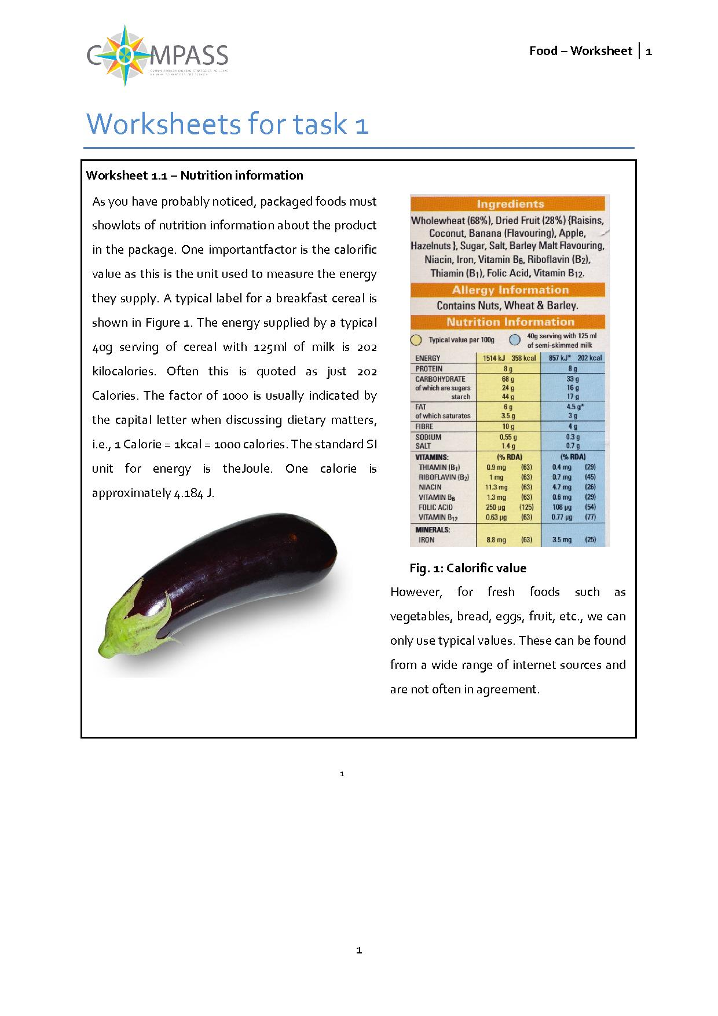
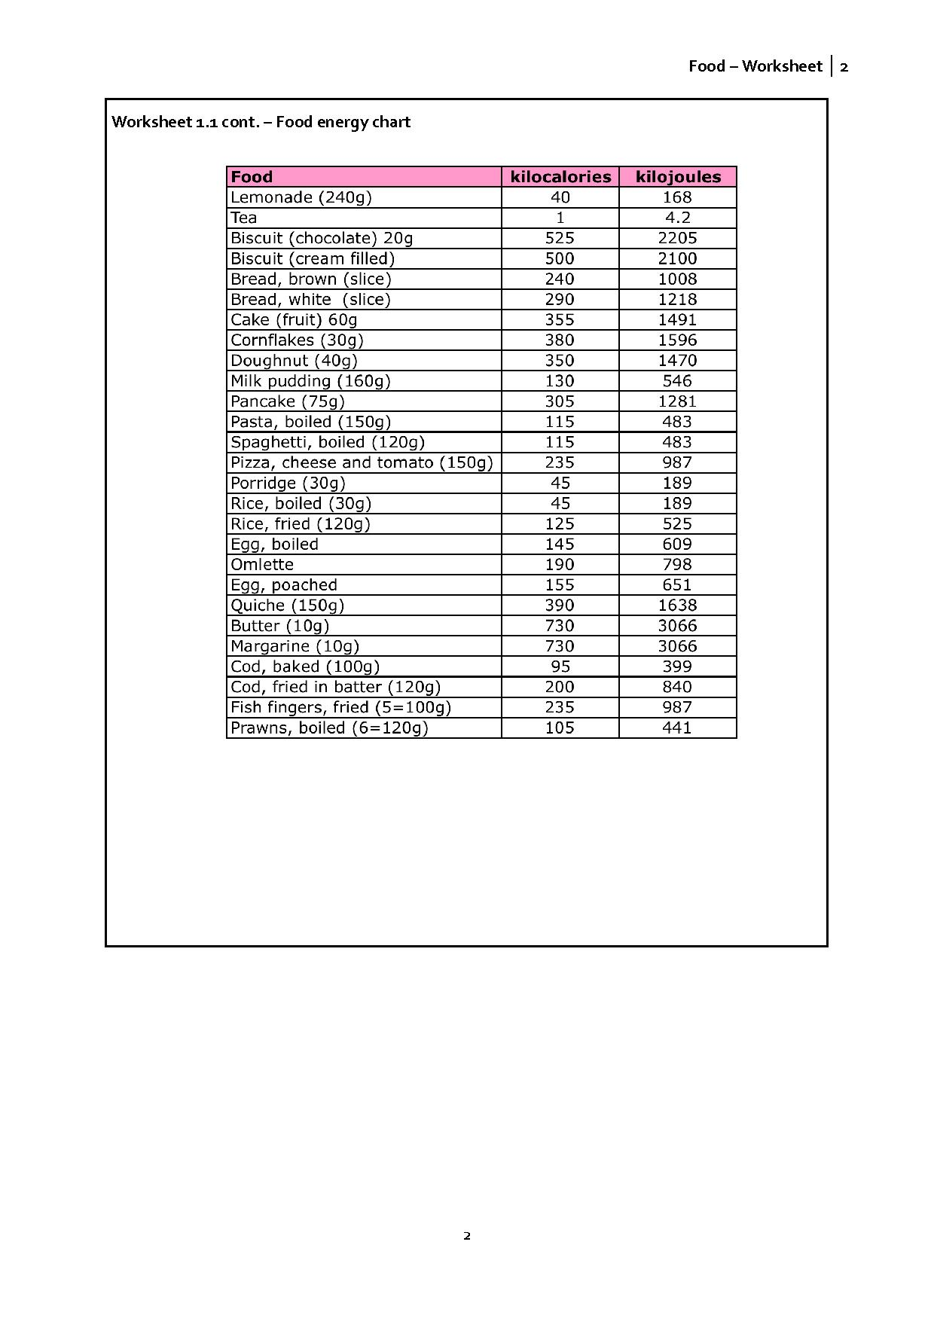
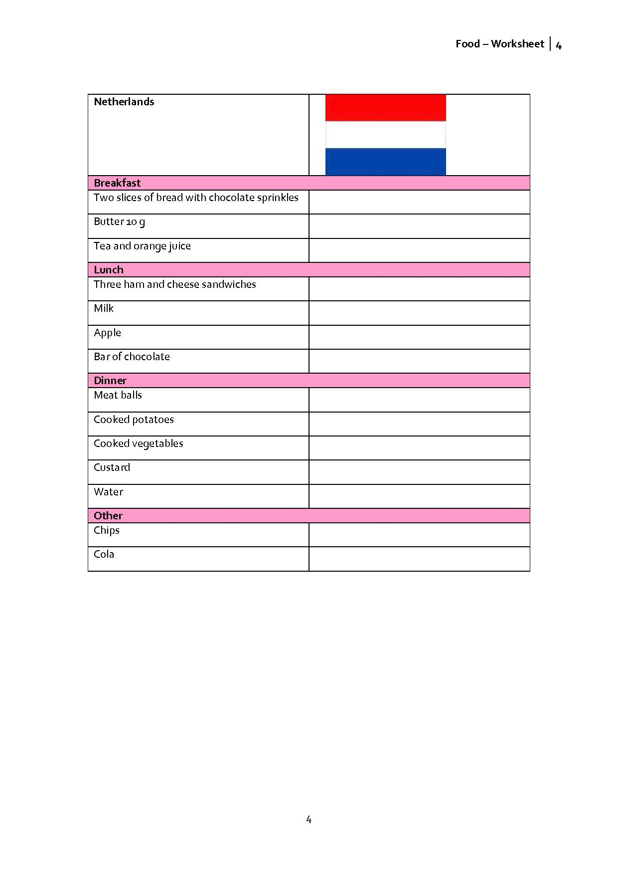
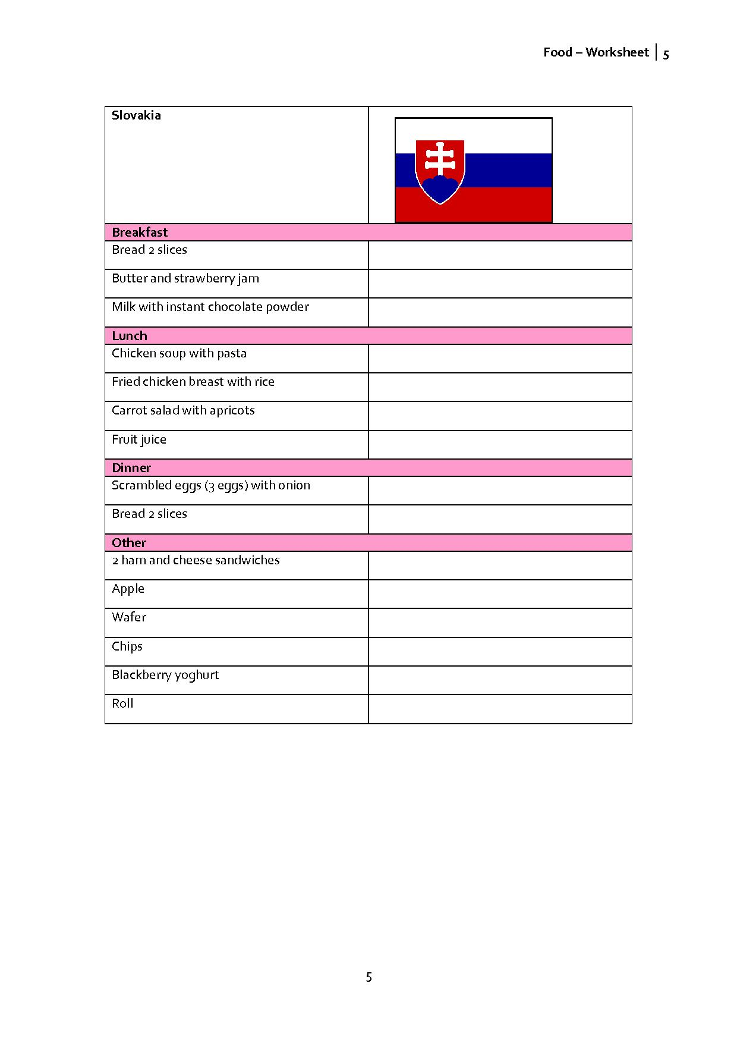
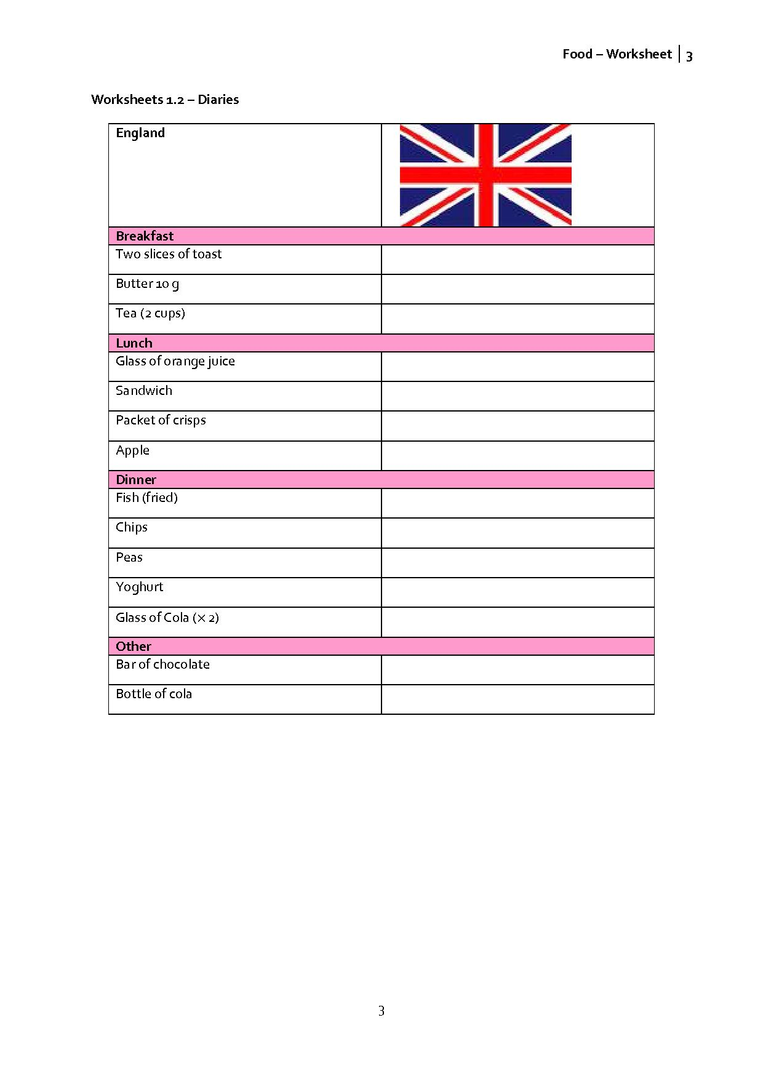
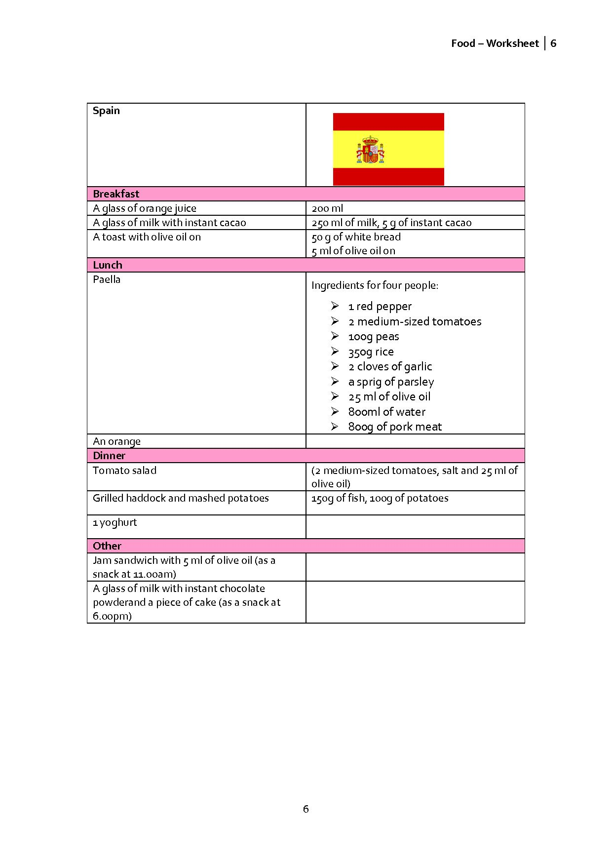
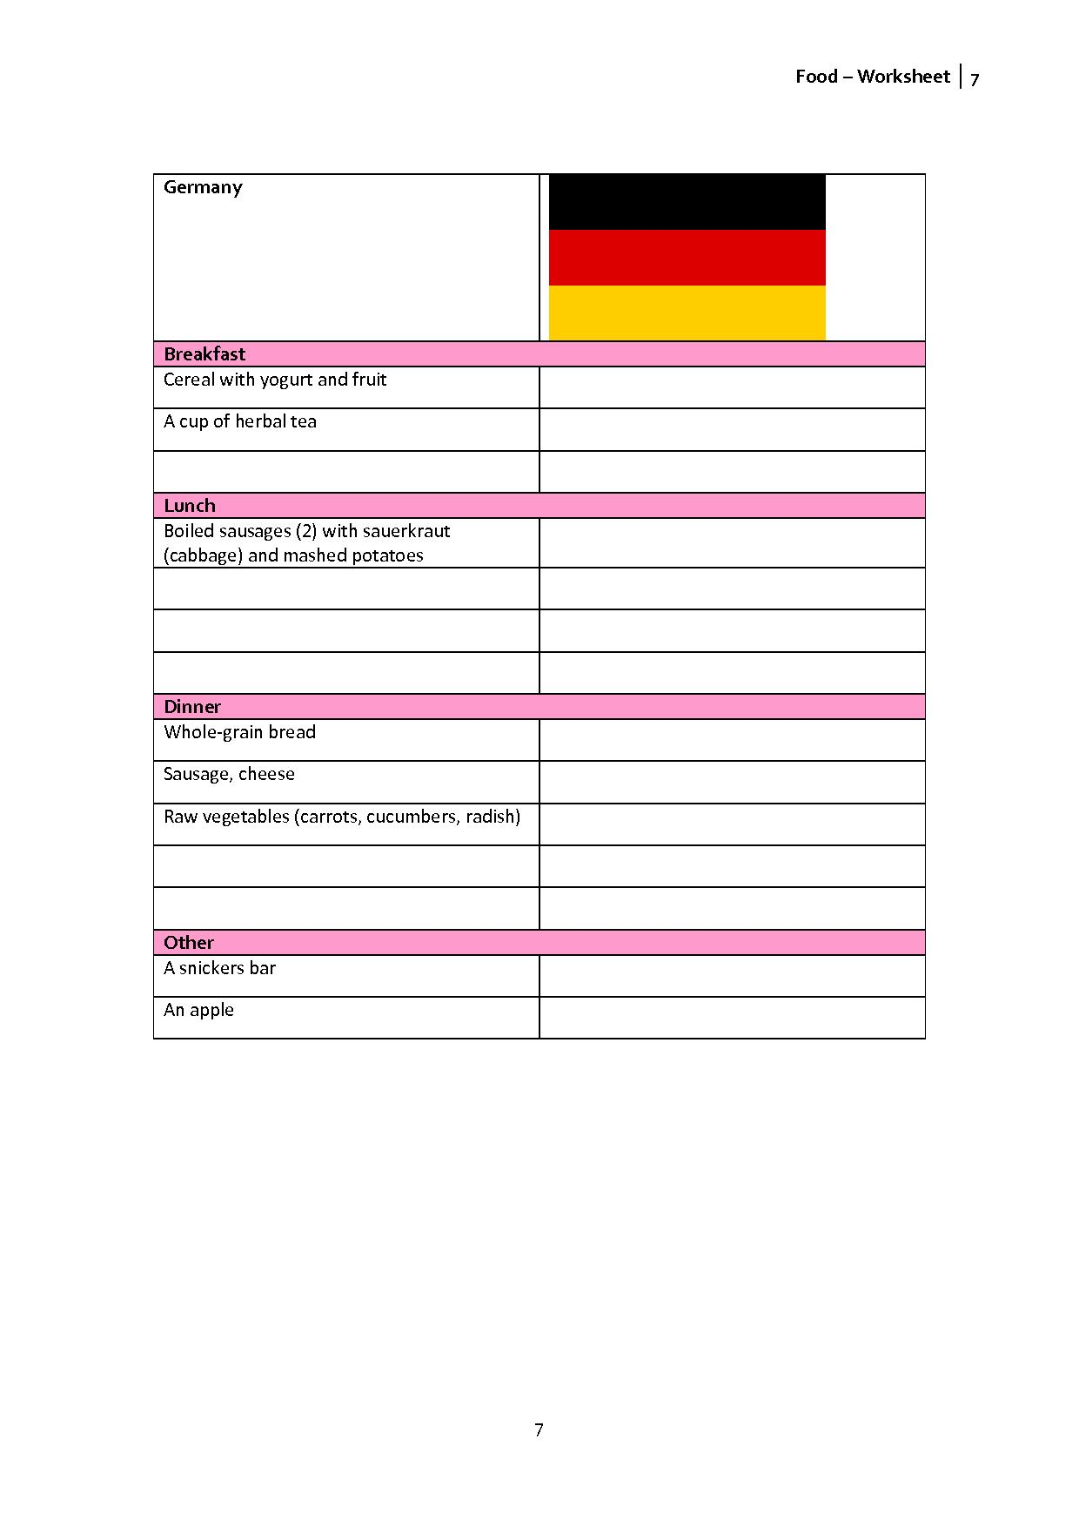
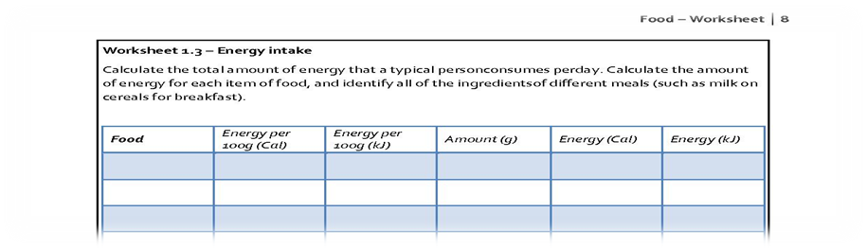
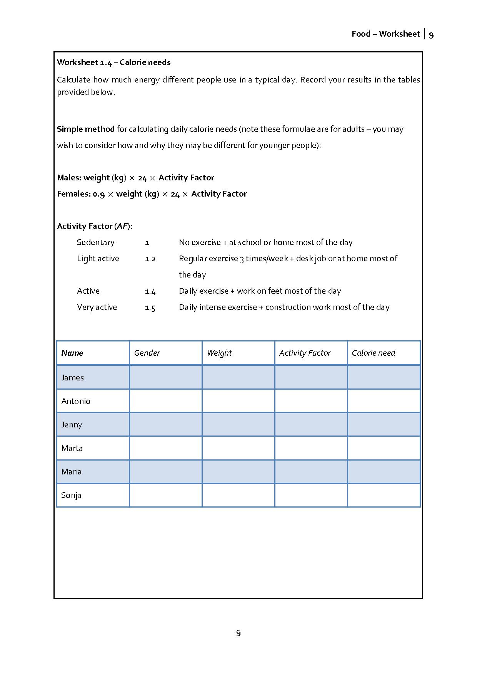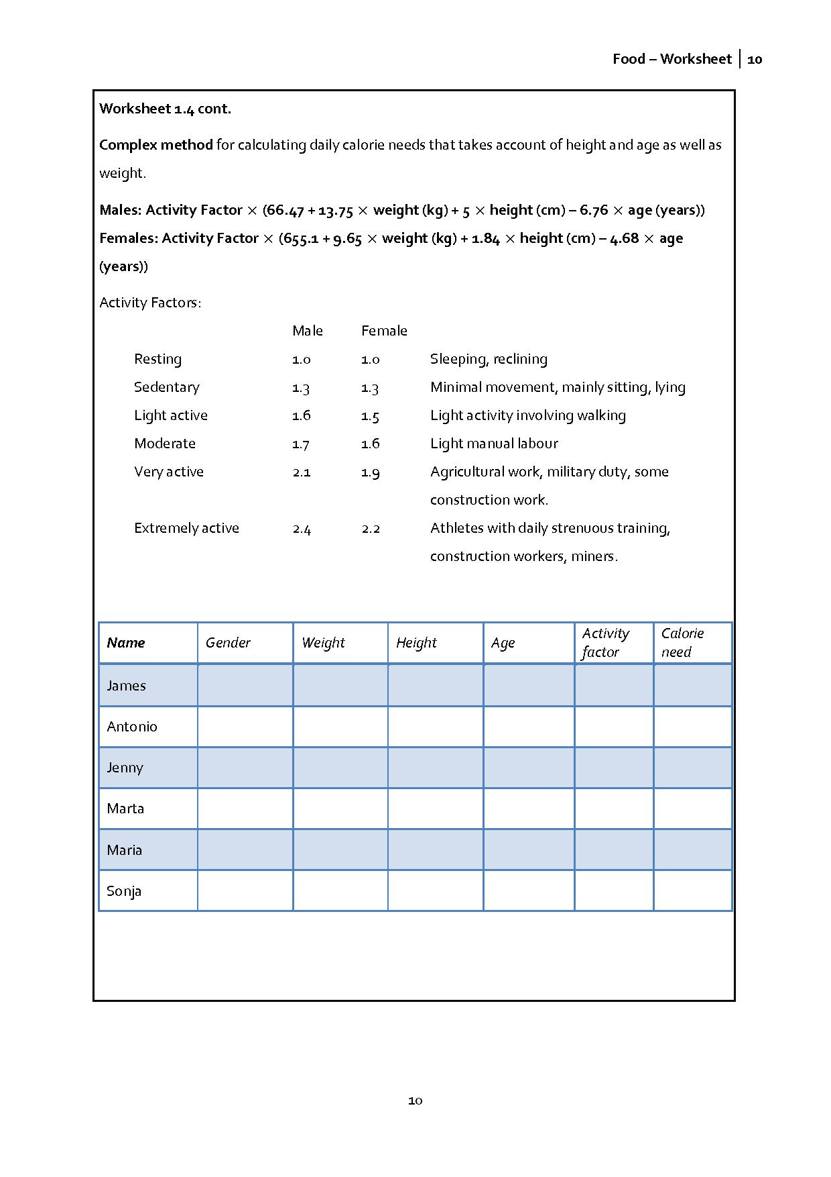
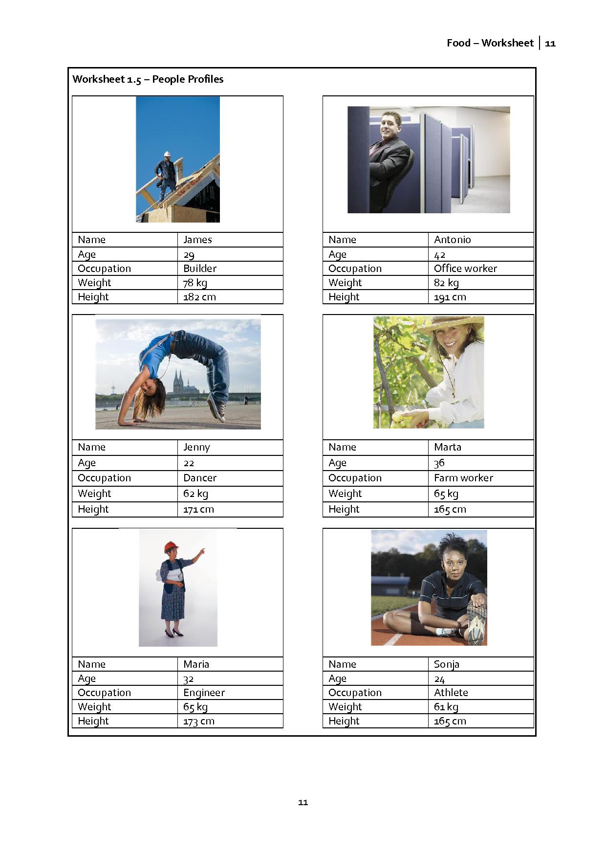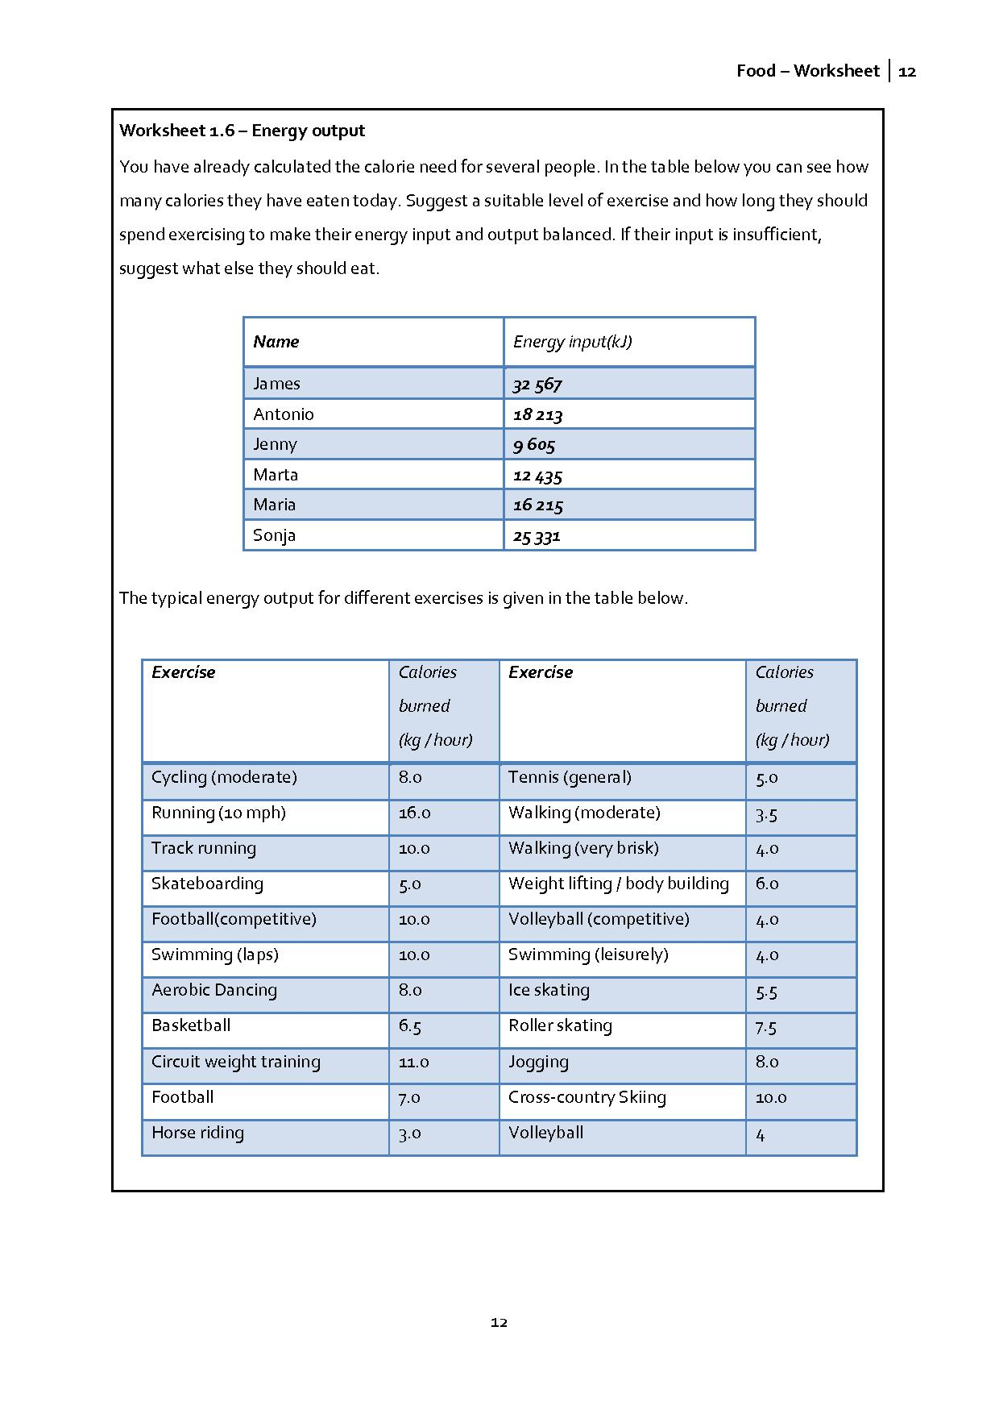

2.2 Physics – Task 2: How do you find out how much energy is stored in different types of food?
In this task the method for measuring how much chemical energy is stored in different types of food will be shown to students.
Mathematical content
- Proportionality
Scientific content
- Energy
- Calorimeter
- Calorie
- Joule
Outcomes
The goal of this experiment is to determine the amount of chemical energy stored in food by burning it and capturing the heat given off by simulating an experiment.

Activity 1 for students: Brainstorming
Based on the information “One calorie will raise the temperature of 1g water by 1ºC” try to find a way how to measure the energy captured in food.

The basic idea of a calorimeter is to capture the released heat energy with a reservoir of water, which has a high capacity for absorbing heat. The temperature of the water reservoir is measured at the beginning and at the end of the experiment. The increase in the temperature (in °C) times the mass of the water (in g) will give you the amount of energy captured by the calorimeter, in calories.

Activity 2 for students
www.compass-project.eu/applets/#1
In groups of 3-4 describe the equipment you can see in the picture. What parts does it consist of? Can you construct similar one?
(see worksheet 2.1)

You may want to carry out the experiment as a demonstration instead of using the applet. Similar equipment can be constructed from two cans, a glass rod, piece of cork, needle and heat resistant mat. In the real experiment there are several sources of inaccuracy (e.g., it is not possible to insulate the cans completely) which should be discussed with students.
Activity 3 for students:
Observe how the amount of released energy changes according to the amount of food burned. Do all kinds of food release the same amount of energy? Why not? Which contains the most energy and which the least?
(see worksheet 2.2)

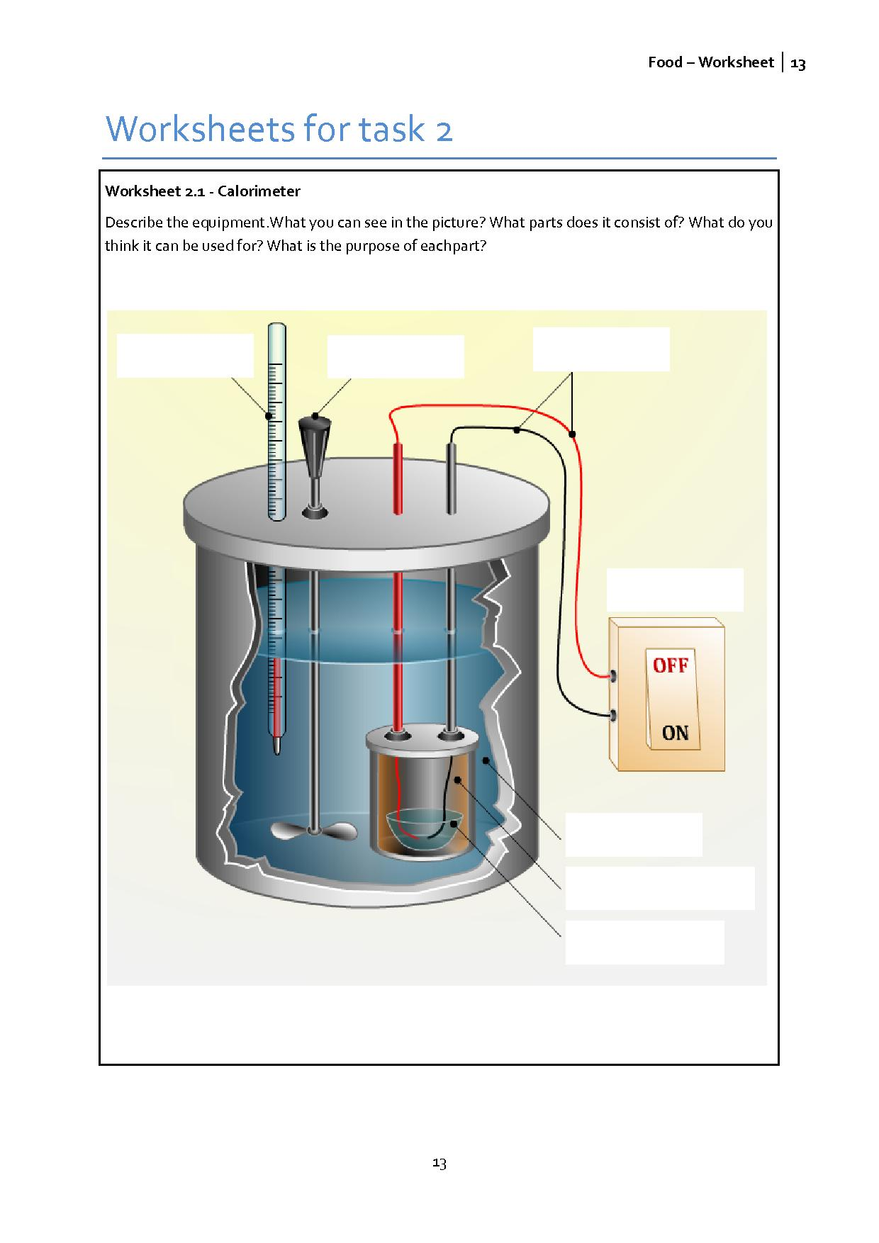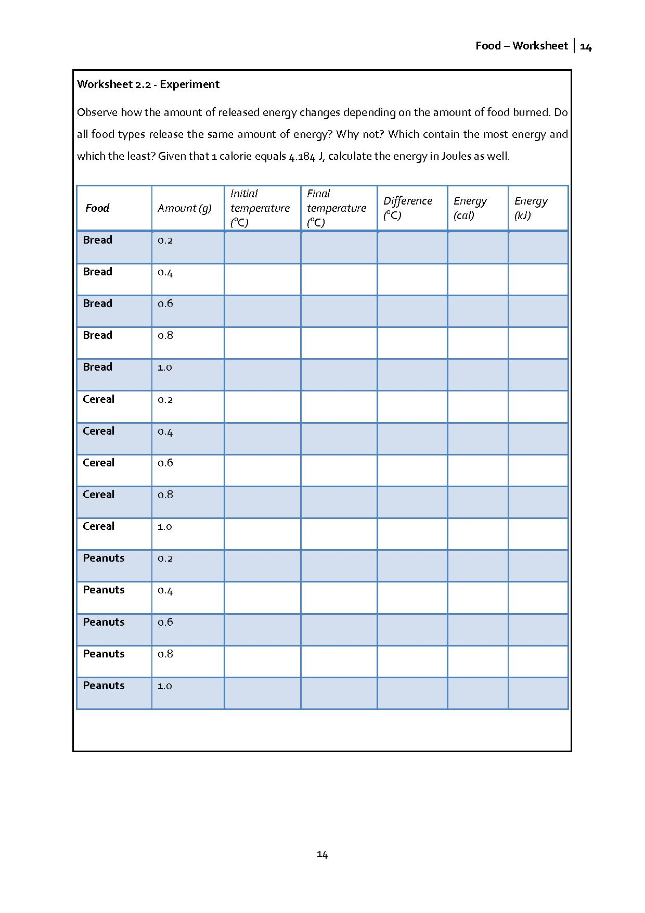

2.3 Biology – Task 3: What are the constituent component of foods?
This task aims to provide you as the teacher with background information about what your group knows about the issues that the unit addresses; for example, you will learn about what pupils already know about healthy eating, what scientific terms they know and feel comfortable using, etc.
Mathematical content
- Calculations
- Use of formulas in words
- Use of spreadsheets possible
- Diagrammatic representations of data
Scientific content
- General information about carbohydrates, fats and proteins.
Outcomes
Discussion about eating. Designing diaries to record diet data.

Activity 1 for students
Distribute stickers to individual students who will initially work on their own and then in groups of 3 or 4.
Students write down all of the different foods they ate during the previous day.
In groups of 3 or 4 they share information about what they ate yesterday.

Students devise some possible menus for school lunch for a single day. Students should produce a poster of this and give reasons for their choices.
After the group work, you can use the posters to stimulate a whole class discussion. You may wish to use news articles such as that from the BBC (see Resource 1) – but it will be helpful if you use a news article about nutrition from your own country, region or school.
Pupils may find out some further information from the internet. You can find a list of websites in the appendix (see Resource 2).
Activity 2 for students
Students keep a diary of what they eat for one week.
Worksheet 3.1 gives a diary with a table for each day in which students can record exactly what they eat. At the end of each day there is a space for comments in which they can reflect on what they have eaten. For example, they may wish to comment on how healthy they think their diet was.
Explain what you want them to do.

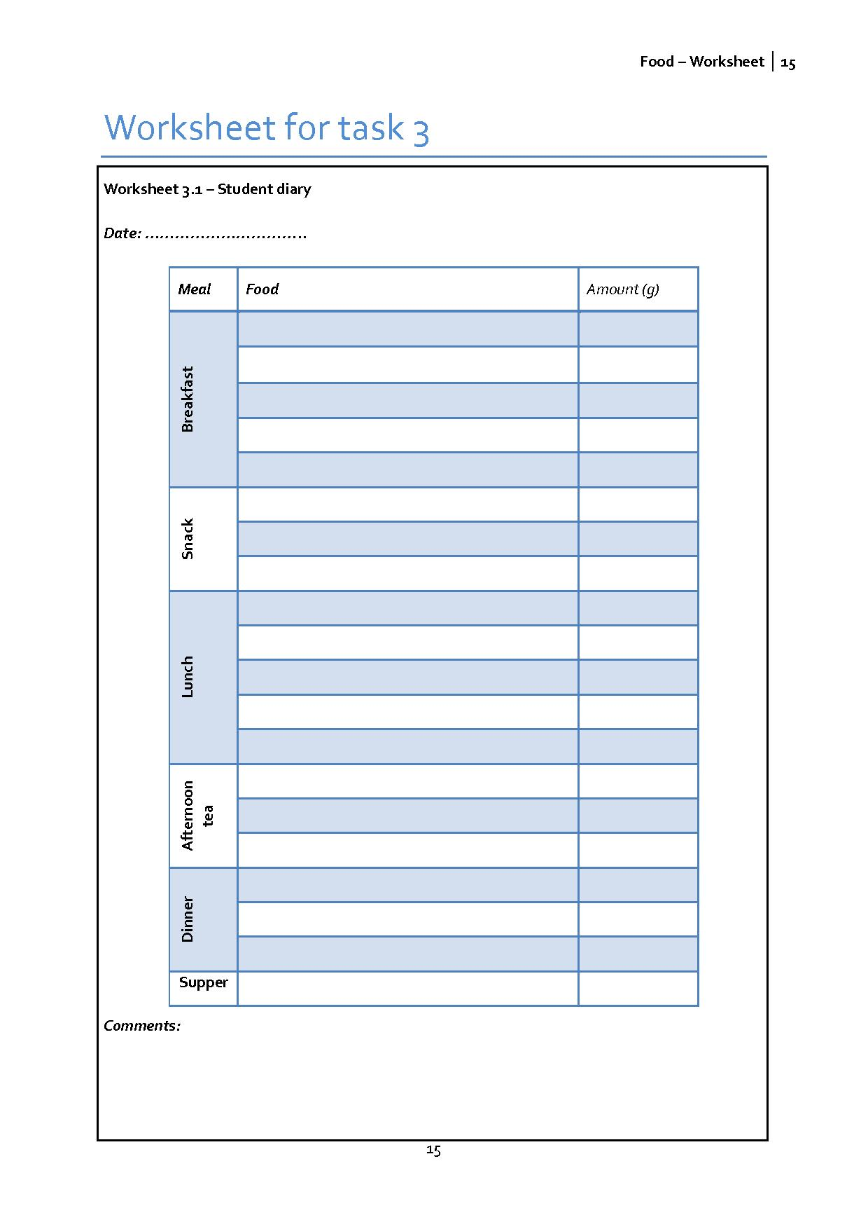

2.4 Biology – Task 4: Do you know about carbohydrates, fats and proteins?
The aim of this task
Students are introduced to the idea that foods are made up of three types of nutrients, carbohydrates, fats and proteins, and explore the composition of different foods in terms of these three types of nutrients. The caloric pyramid is introduced in this task and is used as a central idea throughout the rest of the module.
Contribution to the overall question
Understanding of the key concepts introduced in this task is central to understanding the key idea that there are different types of nutrients in foods and they make different contributions to our diets. The caloric pyramid is used throughout to assist understanding.
Mathematical content
- The caloric pyramid requires understanding of ideas of percentages, fractions and ratios and introduces a novel means of representing data.
Scientific content
- Understanding of carbohydrates, proteins and fats as nutrients and the composition of these in typical foods.
Outcomes
Introduce information about the three types of nutrients: carbohydrates, proteins and fats.
The key ideas are presented in the worksheets 4.2, 4.4, and 4.6. You may distribute these to students as a summary they can refer to during the next activity.

Introduce the caloric pyramid as a device that students can use to show approximately the make-up of common foods in terms of carbohydrates, proteins and fats. Students complete their worksheets (see worksheet 4.1) and discuss the information about how carbohydrates, proteins and fats contribute to energy intake.

Activity 1 for students
Students are working in groups of 3 or 4 and decide where they think common foods should be situated on a copy of the caloric pyramid.

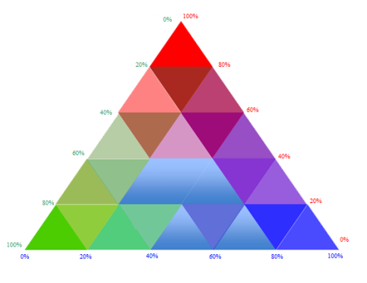
There is lot of interesting and important information about these macro-nutrients. Some facts about them are presented in worksheets 4.2-4.7. Students may need to carry out research on the Internet or using textbooks to answer some of the questions.
Activity 2 for students
Students discuss this interesting information about carbohydrates, fats and proteins and fill in the worksheets 4.2-4.7.

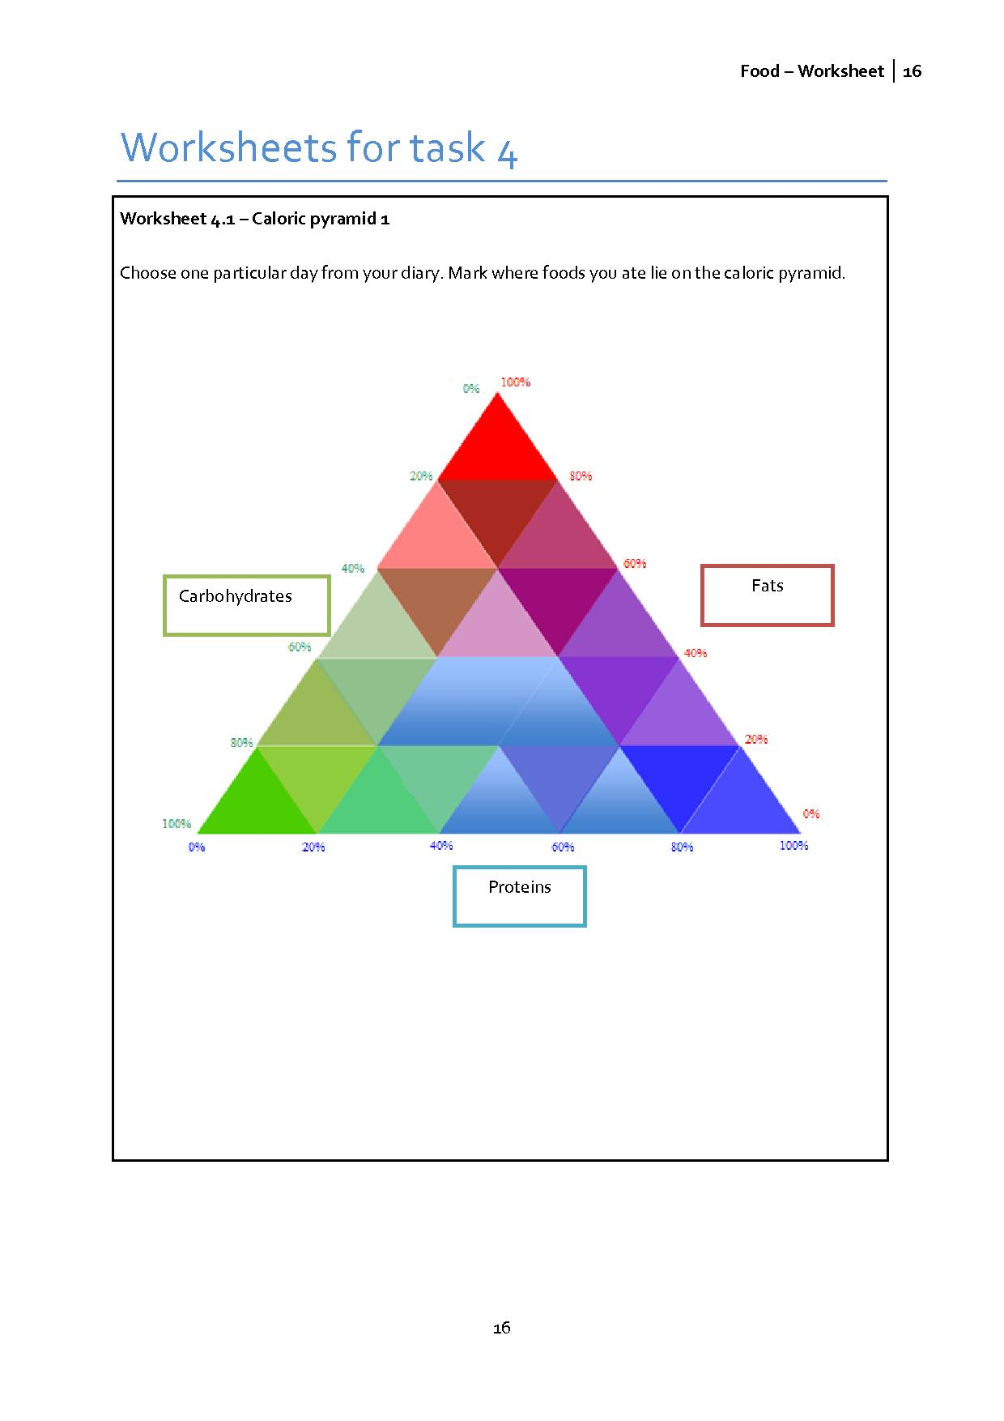

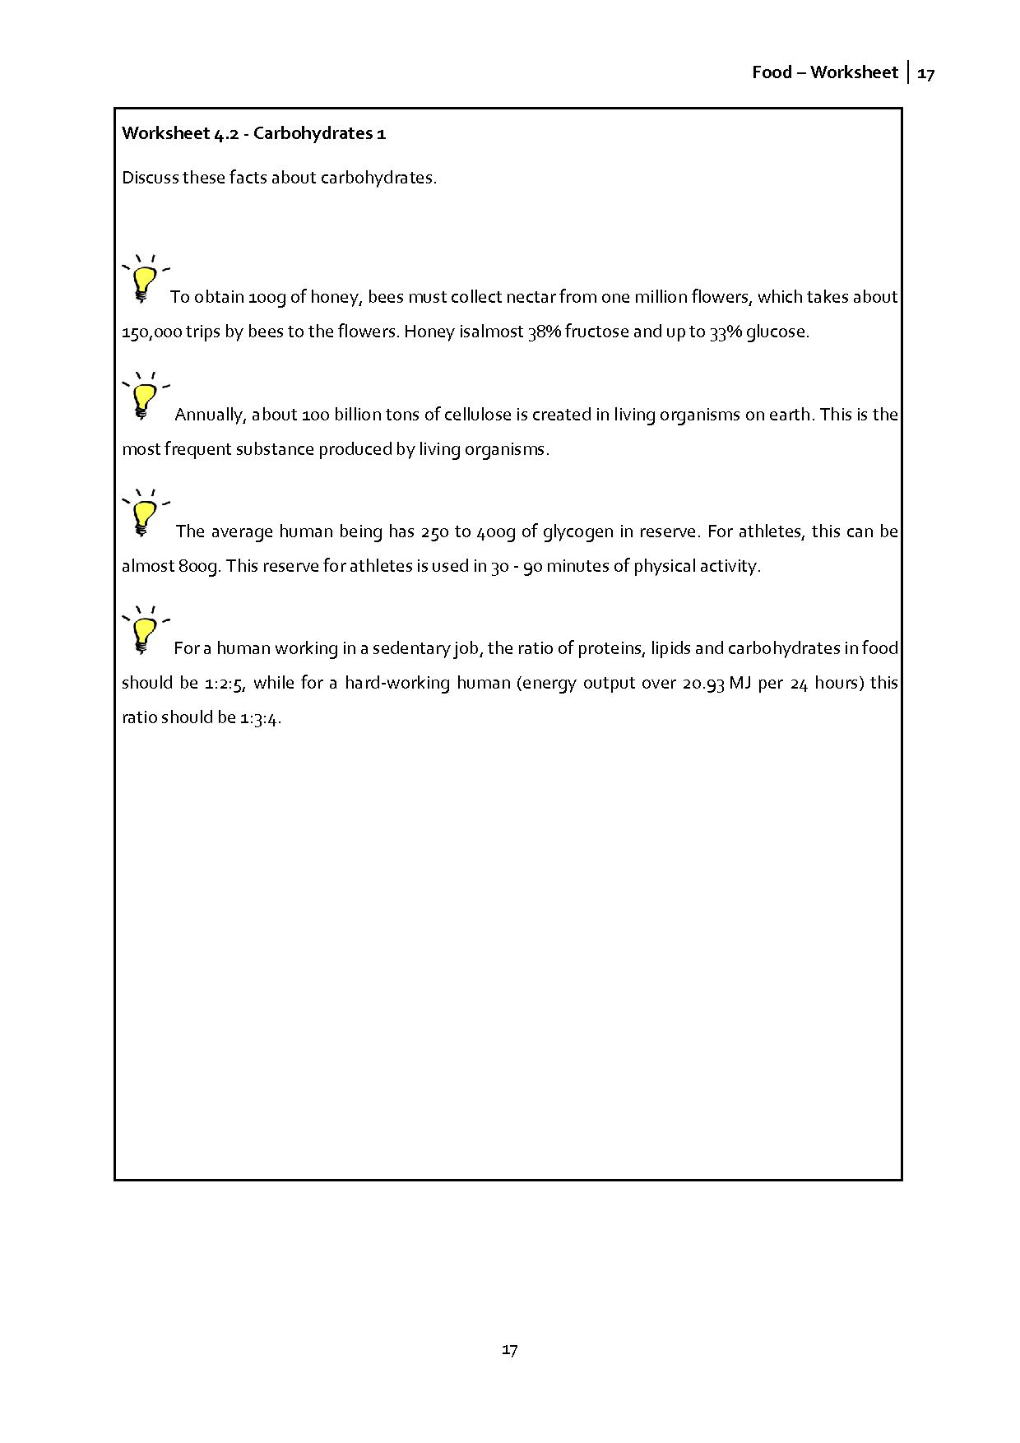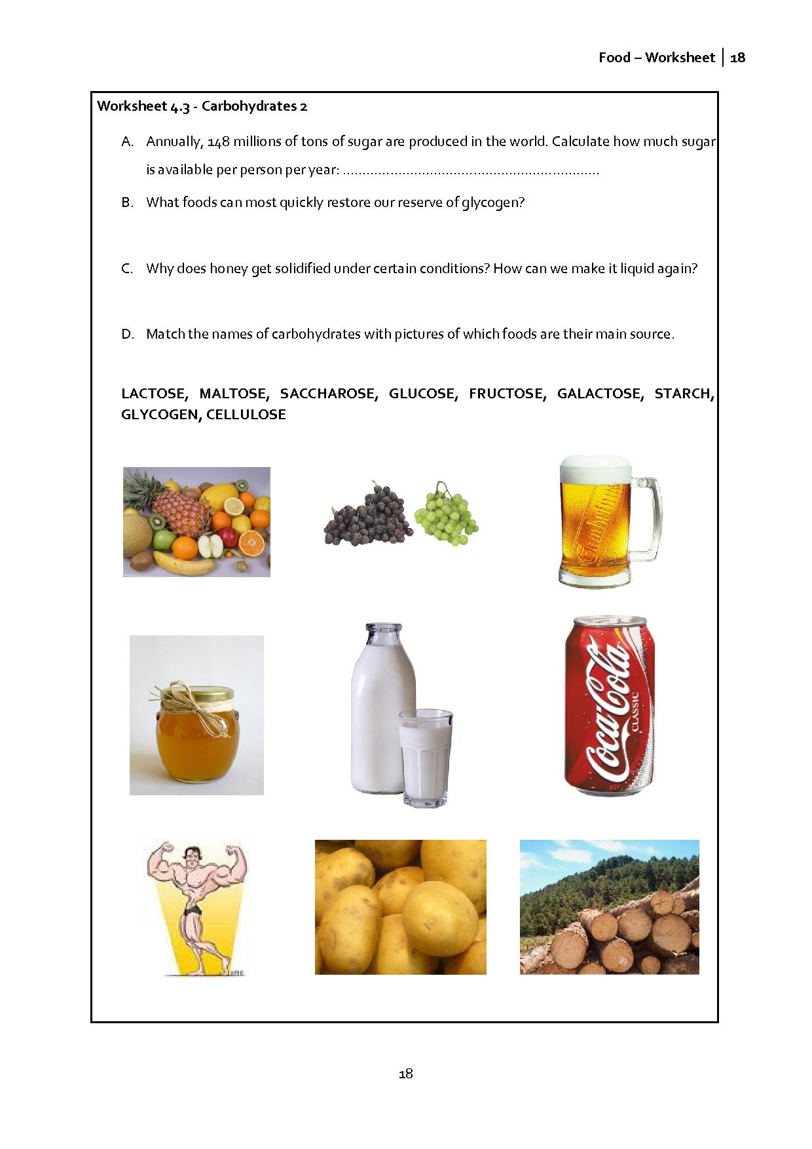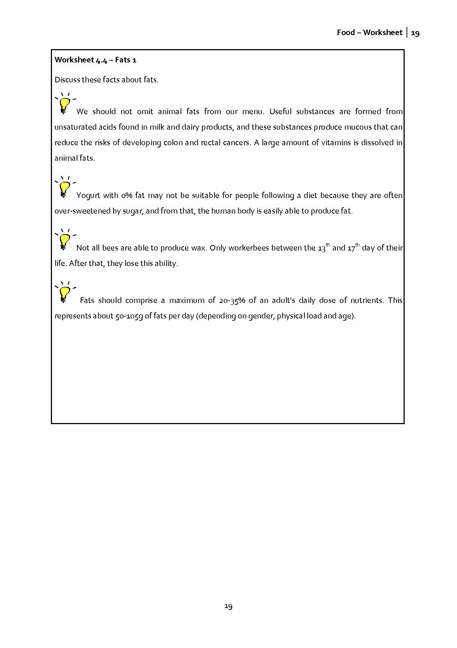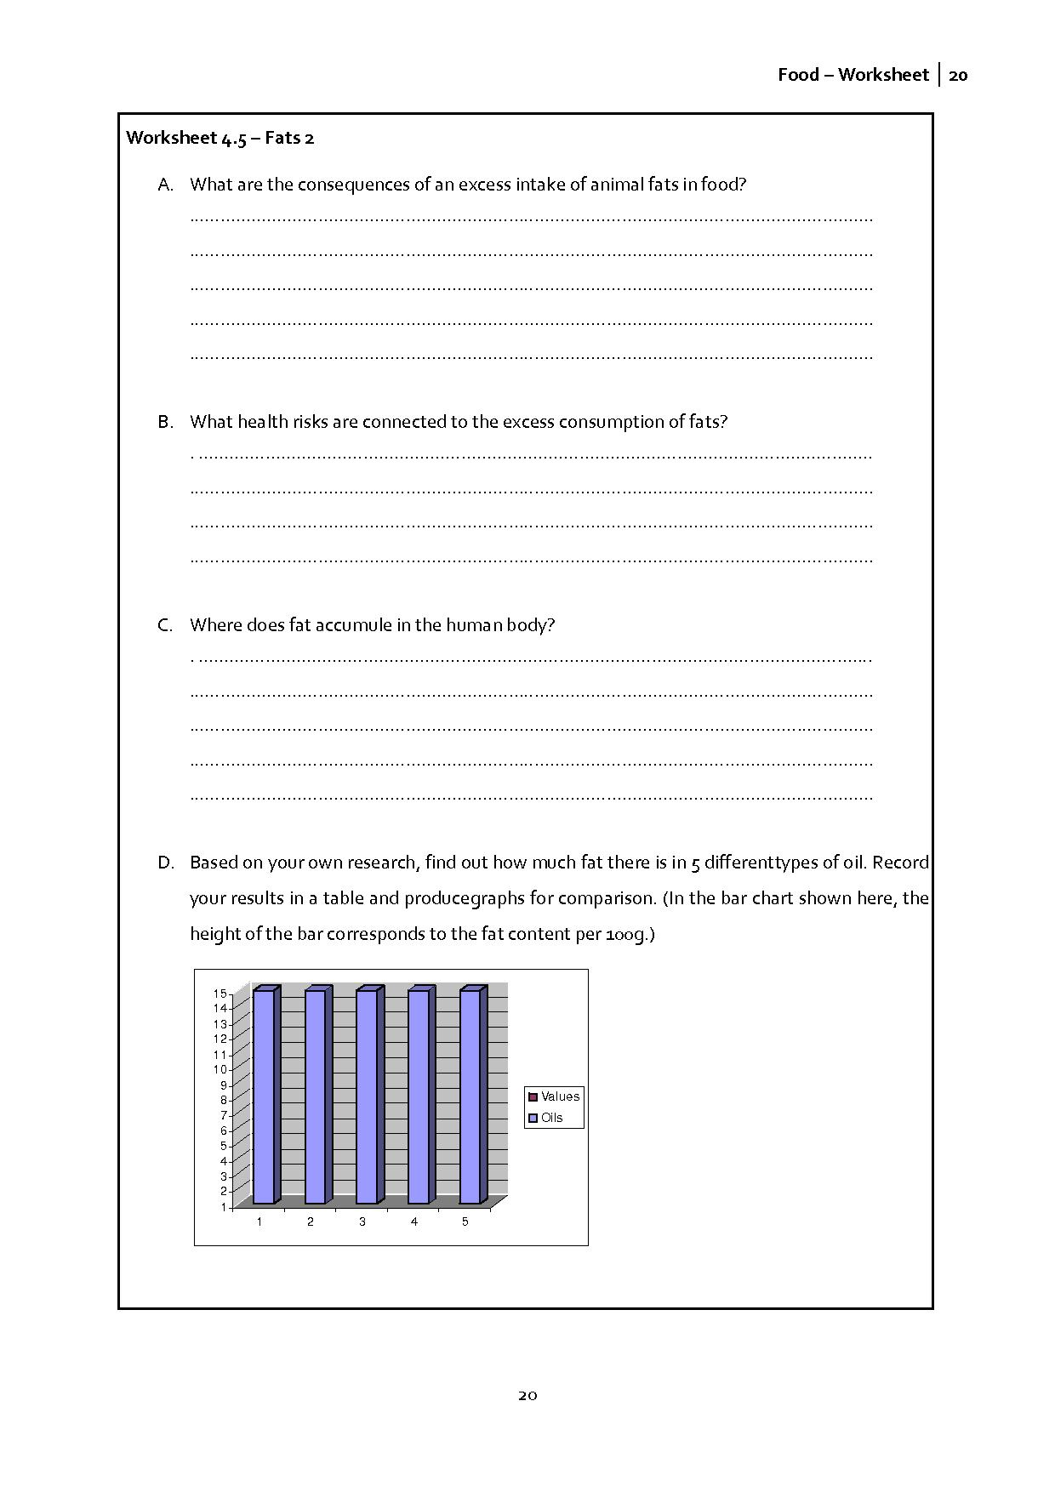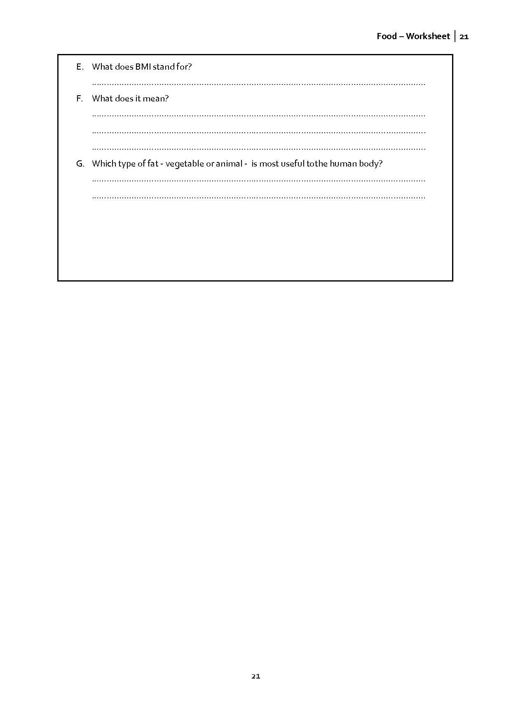

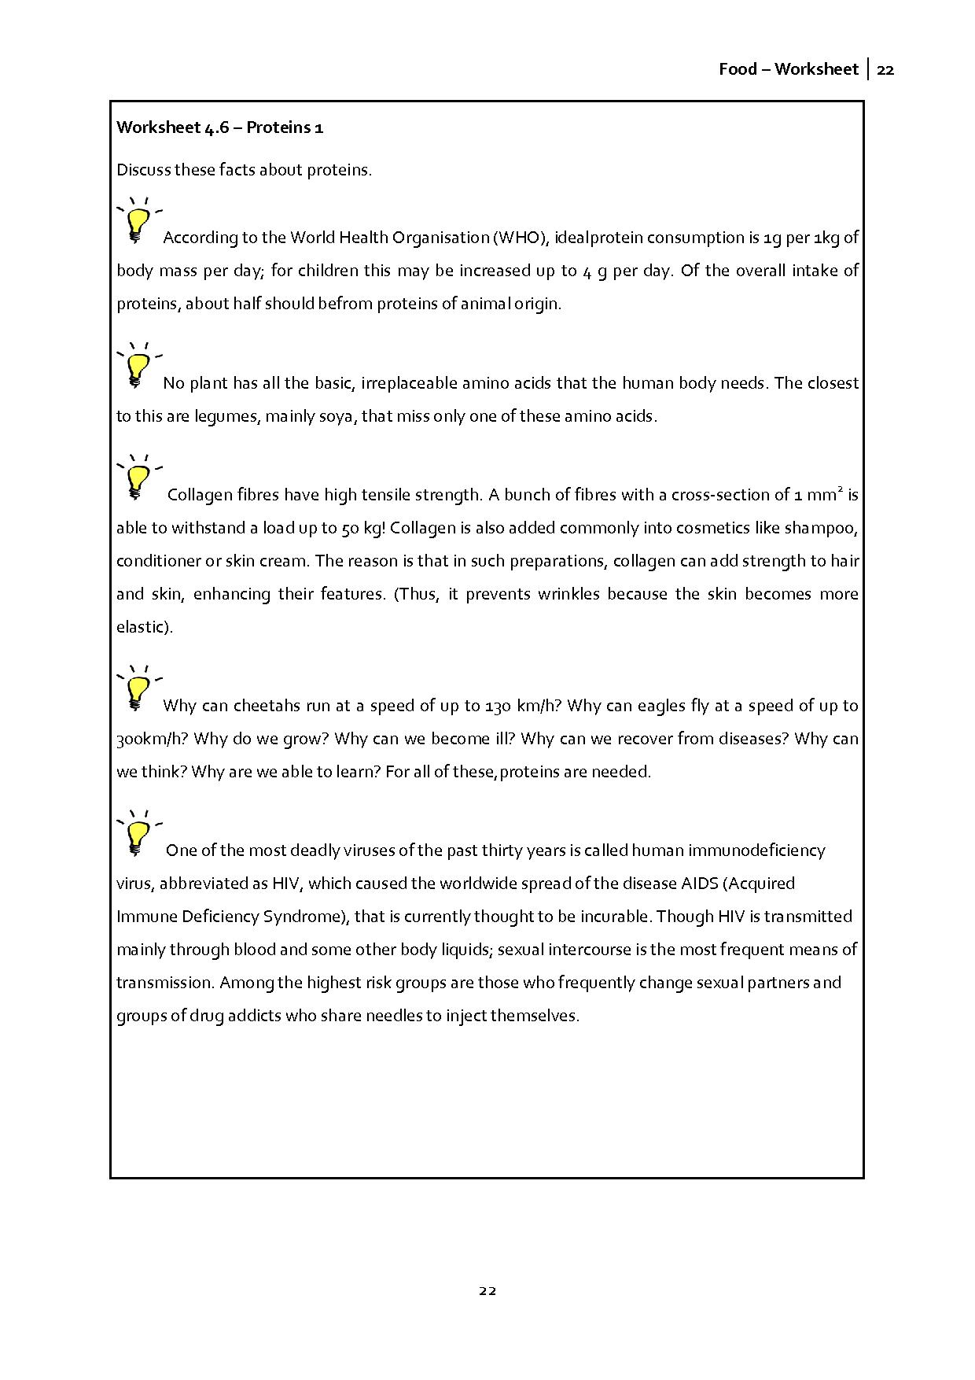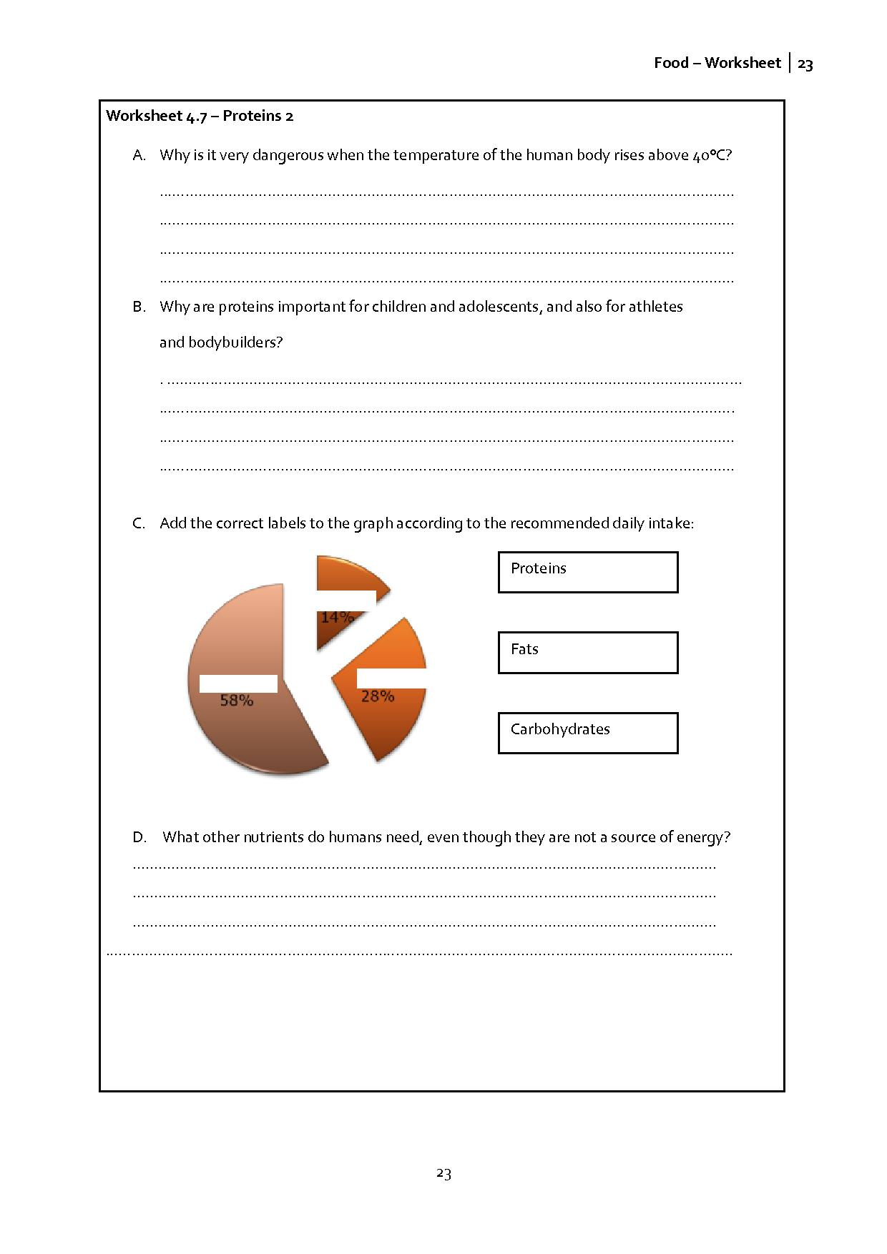

2.5 Chemistry – Task 5: Testing for the presence of carbohydrates, fats, proteins in foods
The aim of this task
To identify the constituent nutrients of some foods
Scientific content
- Students will complete some scientific experiments gaining experience of experimental methods. The outcomes of the experiments will allow them to identify the constituent nutrients of some foods.
Outcomes
Experience of working experimentally and learning about the nutrient composition of various foods.

Introduce the four different experiments that we can use to test for the presence of different nutrients in foods (see worksheet 5.1). Ask your students to work with a food of their choice and decide which experiment to use to investigate the presence of the nutrients they think it contains.

Activity 1 for students:
Students work in pairs to carry out the experiments to test for the presence of nutrients in different foods that they have chosen from their diaries. Alternatively you can supply appropriate foods that you choose and the solutions the students need to work with.
They should write a report of their method and results in the usual way.

You can use the outcomes of the experiments to discuss whether or not there were any surprise results. For example, chocolate should give a positive result to show it contains some of each of the nutrients (carbohydrates, proteins, fats).
Note for experiment 1: It is enough to mention to pupils that these reactions serve to prove the presence of saccharides and are typical for all monosaccharides. (We do not introduce the concept of reduction reaction effects yet.)

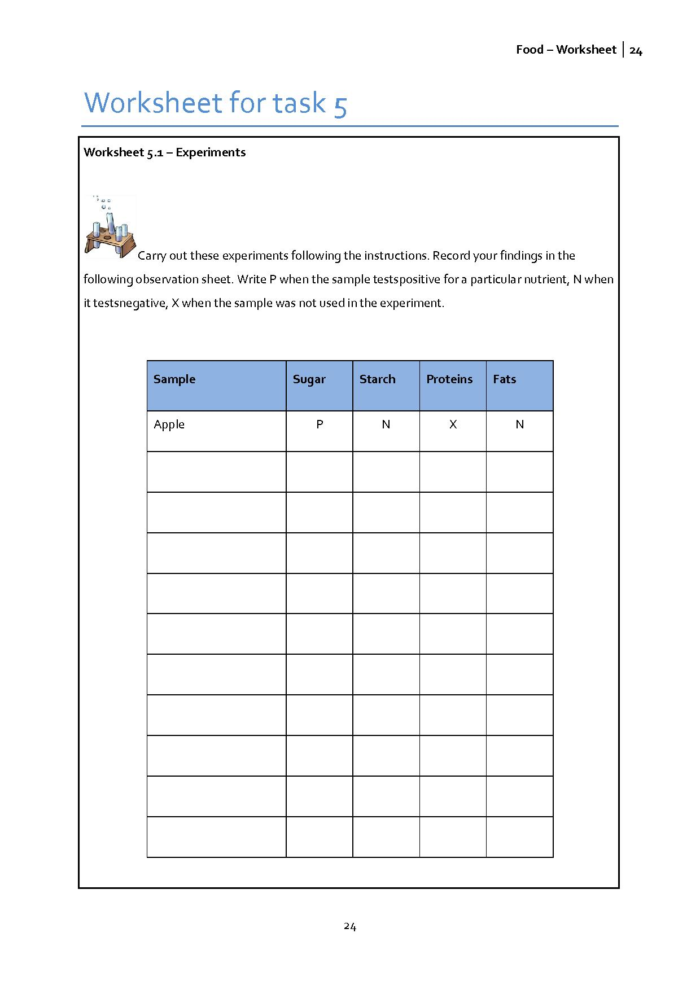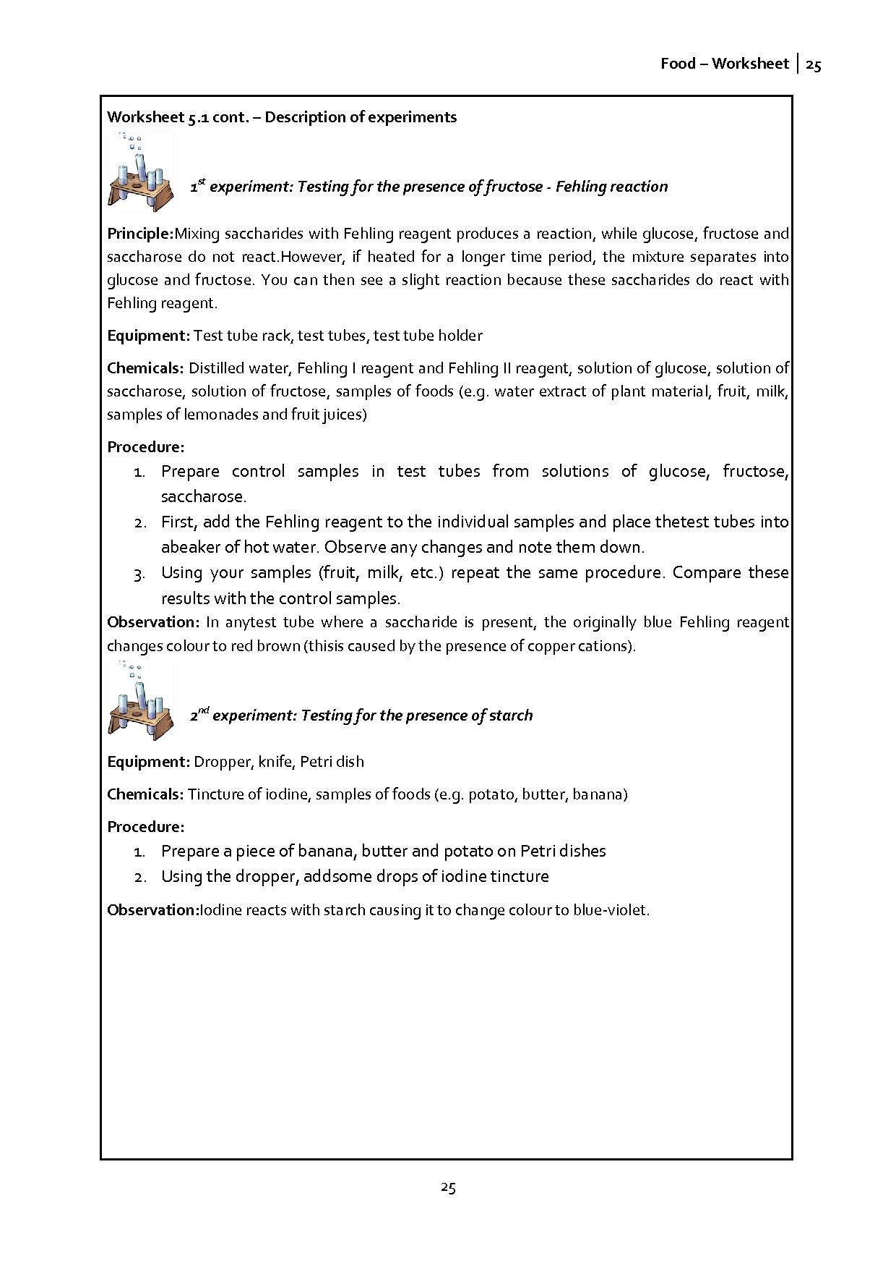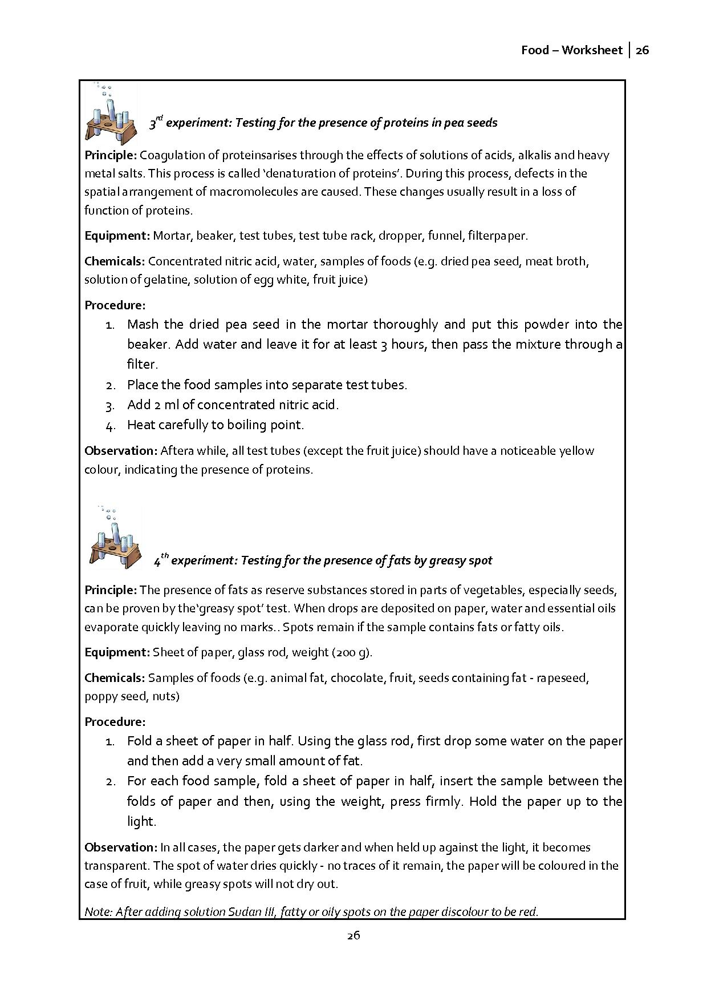

2.6 Chemistry – Task 6: What about your daily diet?
The aim of this task
The students summarise new knowledge while critically analysing their eating habits. They should sort the food from their daily diaries according to the carbohydrate, fats and protein content. They should also consider whether their food is healthy or unhealthy.
Scientific content
- General information about carbohydrates, fats and proteins.
Outcomes
While discussing in groups during the design of the poster, students will improve their knowledge about saccharides, fats and proteins.

Activity 1 for students: Discussion about your own food diary
During the lesson, groups of 4-5 pupils collectively design posters. The posters should give overviews of eating habits of the group, what do pupils eat at meals for breakfast, breaks, lunch, snacks and dinner.
Every poster will be discussed in class.

2.7 Mathematics – Task 7: Can numbers tell us what we eat?
The aim of this task
The main aim of this task is to give students an independent view on their eating habits. They should contrast their own data with recommended daily amounts.
Mathematical content
- Students will calculate and analyse data obtained from their diaries.
Outcomes
Students will gain a more detailed view on their eating habits. They can contrast their findings with guideline recommendations given in worksheet 7.1.

Activity 1 for students: Evaluation of diaries
Using your diaries, calculate how much carbohydrate, fats and protein you have consumed for each ingredient, determining their energy value. Calculate what share of energy you have taken in at breakfast, break, lunch, afternoon and dinner or supper.
Compare the data found with the recommended daily amount of individual nutrients.

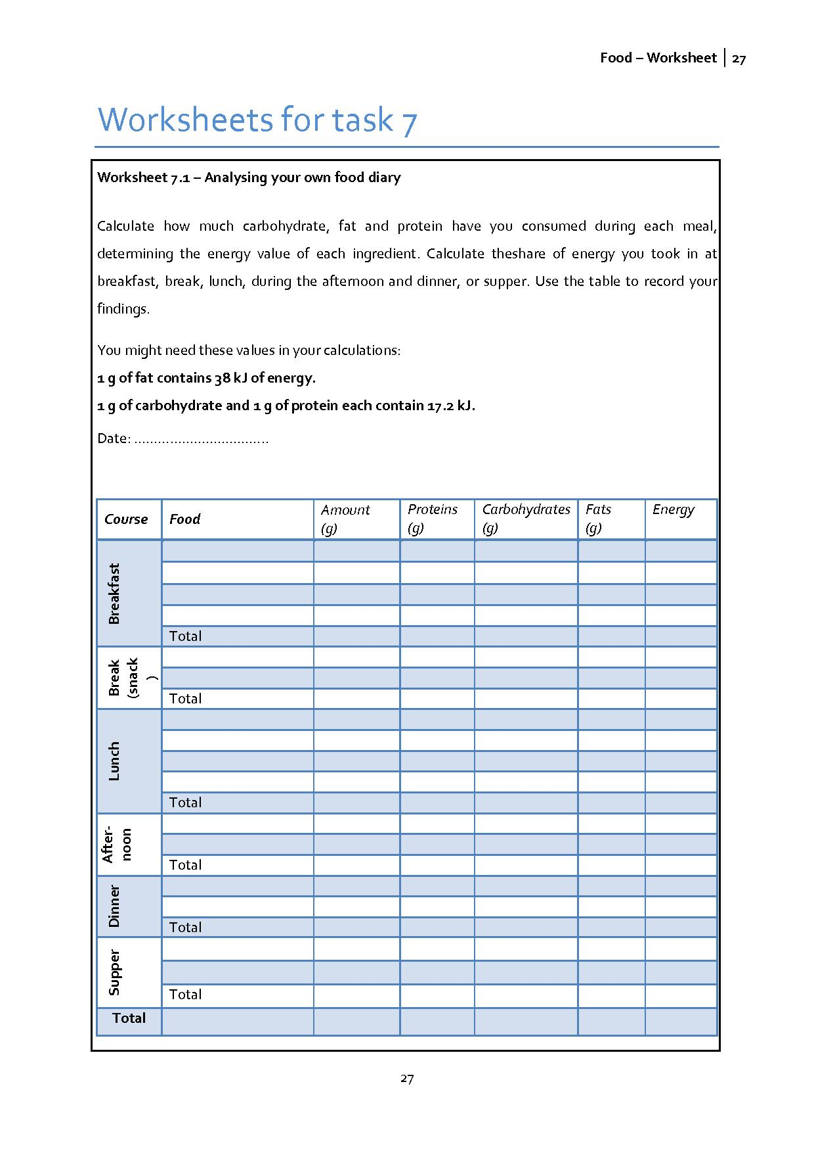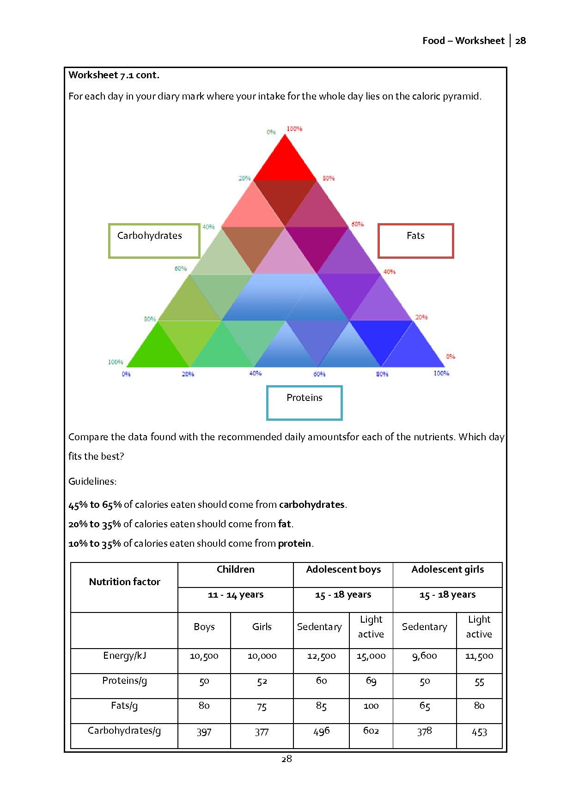

2.8 Mathematics – Task 8: Do we eat properly?
The aim of this task
Students in groups should look for an appropriate way to summarise a large amount of information. They will compare different forms of charts, tables, etc.
Mathematical content
- Data representation, charts, tables
Outcomes
Students will deal with different ways of presenting data and evaluate their effectiveness. They will compare their intake from day to day, and with each other.

Activity 1 for students: Statistical evaluation
Process and statistically evaluate the data collected. Produce a suitable graph to present the relative amounts of individual macro-nutrients and energy taken in during one week.
Find a suitable graphical representation also for displaying these data for all members of the group.
Design a poster summarising your findings using appropriate graphs and/or diagrams.

Activity 2 for students: Discussion
Based on your results up to this point, evaluate your eating habits. Think about how you could make improvements to your diet.
Calculate the amount of carbohydrates, fats, proteins and energy that would be suitable for a lunch menu in the school canteen.

2.9 Biology – Task 9: Designing a menu
The aim of this task
This task aims to allow students to summarise the knowledge they have gained throughout the whole module. By designing a menu, students should use all the facts they have learnt. They should consider the appropriate proportion of nutrients and the total amount of energy. The portions have to be big enough, and the food, tasty enough.
Mathematical content
- Calculations
- Percentages
Scientific content
- Carbohydrates, proteins, fats
- Energy in food
Outcomes
Students will apply their new knowledge to their daily diet.

Activity 1 for students: Designing a menu
We have found out which nutrients are necessary for human beings, where they occur, what food we have, what is missing from it, and what we should avoid. It would be wrong not to apply it in practice.
Within your group, design a menu for one week for your school canteen. Together, select the most suitable options to provide a balanced and nutritious menu.
You can consult the canteen chef and show him/her your menu.
(see worksheet 9.1)

Possible extension: Try to find a balanced breakfast and dinner to add to the lunch menu to achieve the balanced rate of macro-nutrients and energy intake for an entire day.

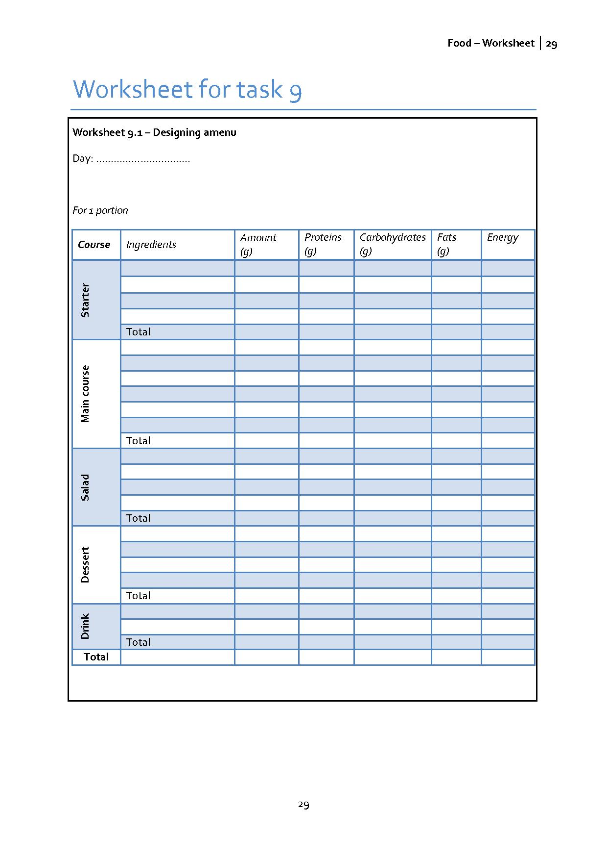
2.10 Mathematics – Task 10: Shopping
The aim of this task
Students should ground the previous task in reality in these activities. Some of their suggested menus may be too expensive to implement in school. This task should highlight this issue.
Mathematical content
- Calculations
Outcomes
Students will apply their new skills in presenting data and in dealing with a larger quantity of data.

Activity 1 for students: Calculations for shopping
Using the menu you have created, calculate the quantity of ingredients required for cooking for one week. Each group will do this for their own menu.
Every group should investigate the price of ingredients in separate market chains, process their data in the form of charts and tables, and jointly evaluate the best value supermarket for food shopping.
(see worksheet 10.1 and 10.2)

If the pupils are split into groups, they can consult the school’s canteen menu for the week and propose new menus differing from week to week or month to month using the menus produced by all the groups. Pupils could influence the school menu according to their own findings and tastes.

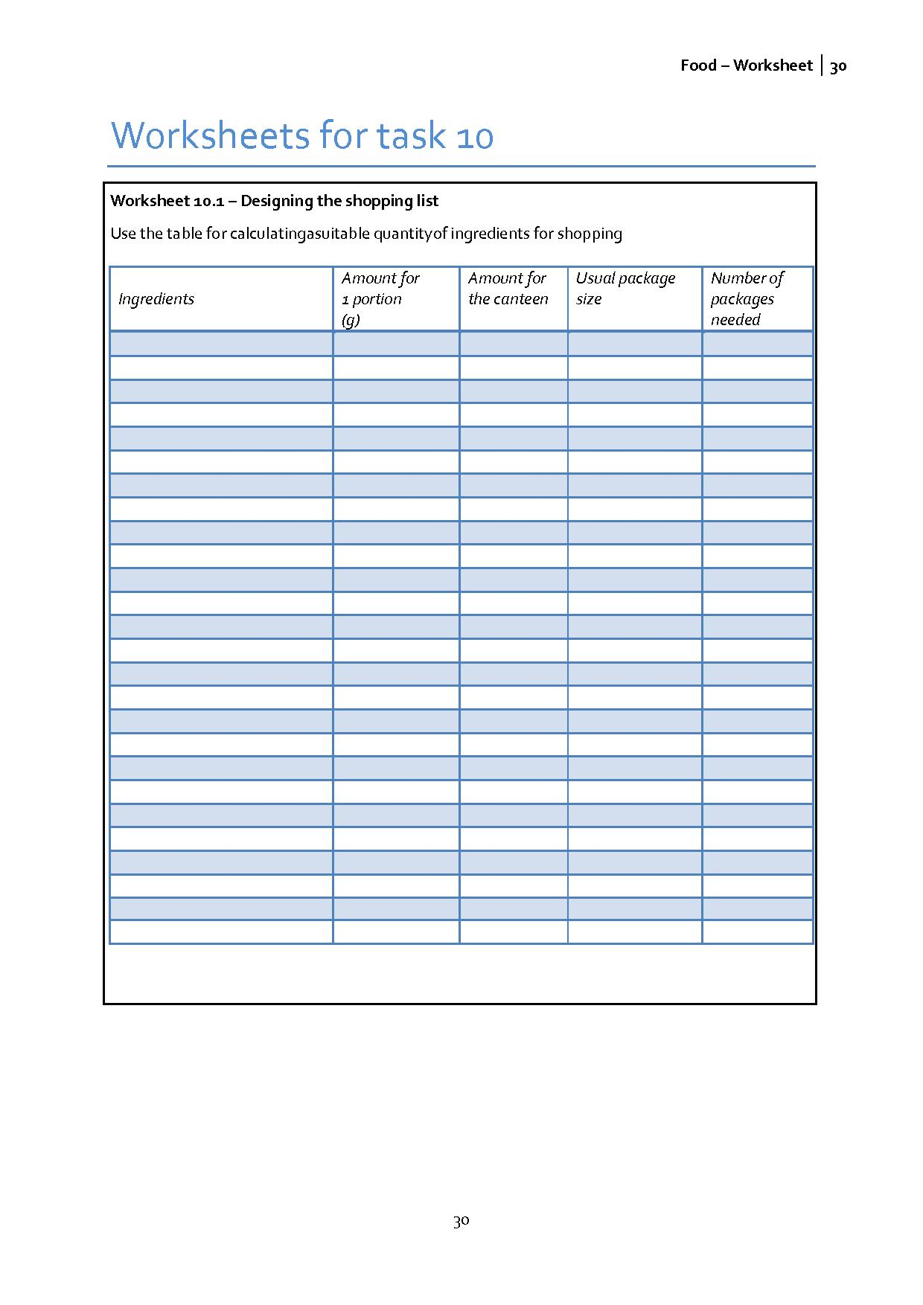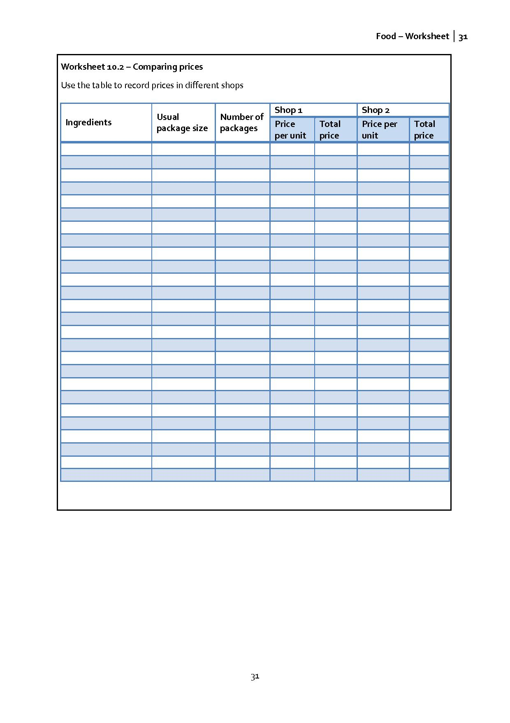

3. Appendix
