Worksheets for task 1
Information sheet 1.1
From 2012 on stores will only be allowed to sell energy saving lights
Ban: EU abolishes conventional light bulb
Already in summer the plans of the EU slowly became public. Now experts from the 27 states of the EU determined the exact time frame for the ban of light bulbs. The conventional light bulb is supposed to disappear from all stores by 2012. In 2009 the EU already bans especially powerful light bulbs. The European parliament as well as the council of ministers still has to agree.
During their conference on December 8th 2008 the authorities of the eco-design-control committee of the EU decided that the light bulb will be abolished step by step starting in 2009, ending in 2012. The initiative for all this comes from the European Commission.
Ban on selling light bulbs step by step, starting in 2009
Using old light bulbs won’t be prohibited. Selling them will be. Already in September 2009 the EU will forbid selling light bulbs using more than 100 watt. In the beginning of 2010 light bulbs using more than 40 watt are supposed to disappear from the stores. From the end of 2012 on only compact fluorescent lights that are rather known as energy saving lights and efficient halogen bulbs will be sold.
According to the EU the people in the EU member states will save close to 40 terawatt by switching to the energy saving bulbs. This corresponds to the power consumption of Romania or eleven million households. Ten 500-megawatt power plants could be closed. In addition to that the CO2 emission would be reduced by 15 tons a year.
From a newspaper article,Dec 9th 2008

Panic buys before saying farewell to the light bulb
… run on light bulbs
The ban of 100 watt light bulbs and of matt bulbs throughout the EU from September 1st on has caused a run on lights bulbs in Germany during the last couple of weeks…’There is an immense run on light bulbs’, said a speaker of the hardware store chain ‘Praktiker’. Since the beginning of July the demand on matt bulbs as well as 100 watt bulbs which won’t be produced anymore has increased by almost 600 percent.
From another newspaper article, August 28th 2009

Will energy saving lights be banned soon?
By Norbert Lossau, August 27th 2009, 4am
They contain quicksilver which the UN will ban globally – light emitting diodes (LED) are the alternative in the long run.
Berlin – The EU-ban of light bulbs using 100 watt or more as well as matt bulbs and halogen bulbs is knocking on our door. After September 1st stores are only allowed to sell their stock. Until 2012 the ban will be expanded step by step to all light bulbs using more than 25 watt…
It’s already quite obvious though that the energy saving lights will only be a temporary solution. All energy saving lights contain mercury which is a highly poisonous heavy metal legacy. At the EU summit conference of the ministers for the environment in February it was decided to prohibit the technical usage of mercury globally. If this country recognized that decision and made it law, would the energy saving lights be illegal and would have to be banned - like lights bulbs are being banned right now.[…]
‘Producers are asked to improve their energy saving lights.’ wants the assistant BUND –chairman Klaus Brunsmeier. He probably isn’t just talking about the quicksilver issue. He also means the radio wave hazard.[…]
It’s already obvious though which technology will replace energy saving lights no matter how much quicksilver it contains: light emitting diodes.
They are even more efficient, last for a long time and don’t have the radio wave hazard.
You can already buy LEDs with a socket.
From another newspaper article, August 27th 2009

Worksheet 1.1

- What reasons are stated by the author for the ban of conventional light bulbs?

- Are you familiar with the terms “100 Watt” and “40 Watt”? What do they mean?

- What is the meaning of the physical unit “megawatt”?

- What do you think “light bulbs produce CO₂” means? Do they really produce wastegas?

Worksheets for task 2
Worksheet 2 - The light effect
Look at the worksheet 2.1 “Light Bulb” and 2.2“Energy Saving Lights” and try to answer following questions:
- Which part of the bulb is 'responsible' for the emission of light?
- Through which part of the bulb does the electrical current enter the bulb?
- Whydo you think light bulbs are less efficient?
- Imagine you hadto teach a group of small children (age 8-10) how light bulbs work and the problems associated with them. Try to explain to them how energy-saving lamps work.
Try to find evidence for or against the ban on light bulbs.

Worksheet 2.1 - Light Bulb
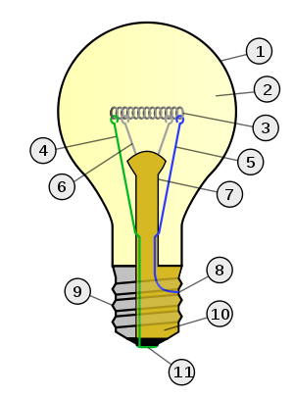
- Glass bulb
- Low pressure inert gas (argon, neon, nitrogen)
- Tungsten filament
- Contact wire (goes out of stem)
- Contact wire (goes into stem)
- Support wires
- Stem (glass mount)
- Contact wire (goes out of stem)
- Cap (sleeve)
- Insulation (vitrite)
- Electrical contact
On the outside, the light bulb consists of 2 parts: A glass bulb and a screw cap, which is connected to an electrical current source. The current passes through a filament which is connected to the electrical current source with contact wires. The glowing filament is made of a special metal called Tungsten, which is able to withstand very high temperatures before melting. It is located in a gas-filled glass bulb and heats up to a temperature between 2,500°C and 3,000°C. At thesetemperatures, the filament begins to glow very brightly. This is called light emission. The physical unit for measuring the brightness of light emission is called the Lumen (abbreviation lm). The number of Lumens per watt tells youthe light efficiency of a bulb. The efficiency of the bulb depends on its size and construction and is usually 8 to 20 lm/W. Only about 5% of the provided electrical power is converted into light. The other 95% is converted to heat which warms up the light bulb’s surroundings. Common light bulbs last about 1,000 hours.
Fig. 1: Light bulb

Worksheet 2.2– Energy Saving Lights
Energy saving lights are compact fluorescent lamps that have an integrated control gear. The mainadvantage of energy saving lights compared to light bulbs is their higher efficiency. They convert about 25% of the suppliedelectrical energyinto light. Compact fluorescent lamps are therefore much more efficientthan conventional light bulbs, which only have an efficiency of 5%. Fluorescent lamps work by passing the electrical current through gas under certain conditions. In fluorescent lamps the electrons are sent through a gas mixed with mercury.
The mercury within the gas-filled glass bulb evaporates under high pressure when the light is switched on. The pressure is created initially by pre-heating the bulb, then maintained by the heat generated during use (self-heating). This is why energy saving lights cannot provide their entire luminance from the moment they are switched on.
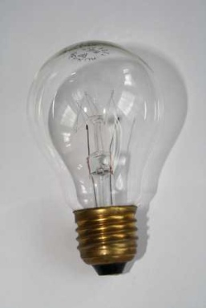 | 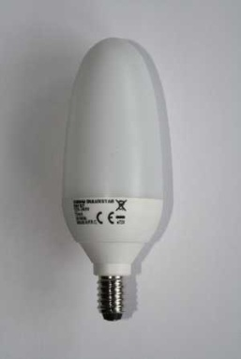
Fig. 2: Light bulb (left) and energy saving bulb (right).
In fluorescent lamps, electrons are sent through gas mixedwith mercury. The electrons bounce against mercury atoms and release energy that discharges as ultraviolet radiation. The phosphor coat on the inside of the glass bulb converts the UV radiation into visible light. In order to operate, fluorescent lamps control gears are used. Those have a starter for the ignition and a choke (coil) in order to limit the electrical current. Electrical control gears are the most efficient ones available since they allow an immediate flicker-free start. Additionally, the operating cycles donot influence the control gears’ durability.
When using energy saving lights one has to be aware of the fact that they can contain other dangeroussubstances besides the mercury in the glass bulb. These could be in the lamp itself, the starter or the electronics. For example in earlylamps lead, chromate and cadmium were used (production before July 2006). These substances are now prohibited. Furthermore, for ecological reasons, it is prohibited to throw energy saving lights into the regular rubbish or a glass recycling bin. The lights belong to hazardous waste. This means inoperable energy saving lights must be discarded professionally and separate from regular rubbish. The raw materials such as mercury, copper, aluminium and tin as well as the phosphor can be recycled. Mercury can only be recycled, though, if the glass bulb is unbroken and it hasnot yet evaporated.

Worksheets for task 3
Worksheet 3– Efficiency
Using a grease spot photometer, check the manufacturer’s information in terms of the brightness (illumination level) of a compact fluorescent light (energy saving light) compared to a standard light bulb.
Materials
- Optical bench
- 2 sockets for slider
- 3 light bulbs (one with the same input rating as the manufacturer’s information, one with a smaller input rating, one with a greater input rating)
- power supply unit
- 2 sliders
- grease spot photometer on a slider
- gloves (to change hot light bulbs)
- multiple socket with power button (optionally with fuse)
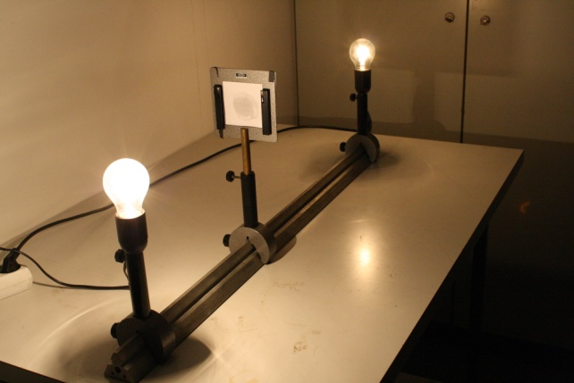 | 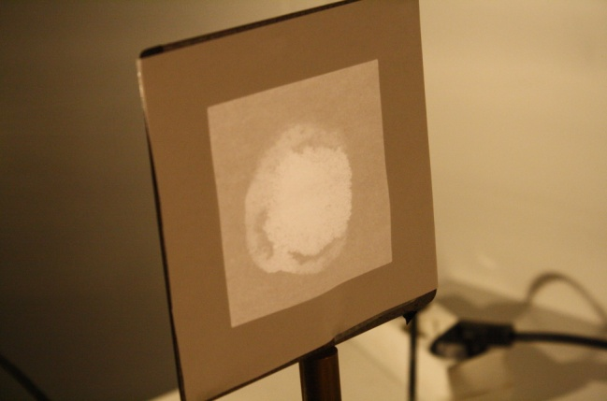
Fig. 1: Entire assembly | Fig. 2: Grease spot photometer
The experiment should be prepared one to two hours before starting since it cannot be carried out until the grease spot has dried.
Preparation
Fixthe compact fluorescent light and the firstlight bulb on the optical bench separated bya distance of 1m. Put the slider with the grease spot photometer in between the two lights. Ensure it can be moved (Fig. 1). The lights and the grease spot need to be at the same height. Darkenthe room.
Method
Move the grease spot photometer slowly between the lights. Depending from which side you look at the grease spot, the luminous spot appears darker or lighter (see Fig. 2) than the paper surrounding it. There is a certain positionof 2-3cm, where the grease spot seems to disappear. In this position, the brightness of the different light bulbs is equal. This ‘equilibrium-position’ needs to be determined. Note down the location of the screen and repeat the experiment with a different light bulb. Because of the possible risk of burns due to the hot light bulbs, gloves are required.

