Ban on traditional light bulbs
Abstract
Why have traditional light bulbs been abolished by the EU?
In Germany, as in many other European countries, conventional light bulbs are to be abolished. From 2009 to 2012 the light bulbs will vanish from shops in stages, starting with the most powerful ones. This task aims to provide students the opportunity to discover why the EU introduced this change whilst exploring relevant mathematical and scientific content.

Aspect | Description
Mathematical content | Proportionality, calculation with variables, modelling
Scientific content | Efficiency, production of light, luminous intensity, light spectrum
Age of students | 14 – 15
Number of lessons in mathematics | 4 – 6
Number of lessons in science | 4 – 6
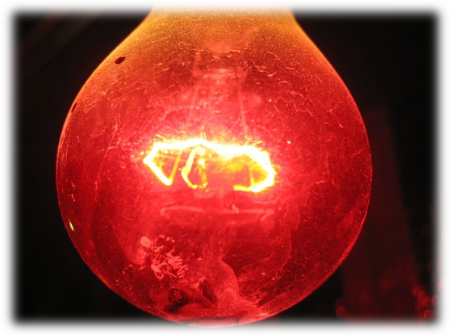(http://commons.wikimedia.org/wiki/File:Darkness_Light_bulb_2.jpg)
1. Overview of the teaching unit

1.1 The situation
In Germany, as in many other European countries, conventional light bulbs are to be abolished. From 2009 to 2012 the light bulbs will vanish from shops in stages, starting with the most powerful ones. But energy-saving bulbs are not necessarily the solution for all (energy) problems. Among other things, energy-saving bulbs contain the heavy metal mercury and their manufacturing is much more energy-intensive than the production of conventional light bulbs (see, for example, newspaper articles for task 1). To deliver a well-founded judgement for or against the abolition of light bulbs, you need to take a differentiated look at the background to this problem.

1.2 Guiding questions
- What are the differences between light bulbs and energy-saving bulbs from a physical point of view?
- Are energy-saving bulbs really more efficient?
- How much money can a family or a school save by using energy-saving lamps?
- How much energy can be conserved if you take a global position (e.g., by a town, a country, a continent, etc.)?
- How many power plants could be closed as a result of the energy savings (as calculated for the question above)?

1.3 Final product
At the end of the teaching unit, students will carry out a debate about the pros and cons of abolishing traditional light bulbs. By doing so they will learn to use the physical and mathematical knowledge they gained during this teaching unit to make a decision on a political issue. They will learn that political discussions are based on knowledge and insight. However, they do not lead automatically to decisions. Decisions always contain subjective aspects.

1.4 Materials for experiment (task 3)
- Optical bench
- 2 sockets for slider
- 3 light bulbs (one with the same input rating as the manufacturer’s information, one with a smaller input rating, one with a greater input rating)
- power supply unit
- 2 sliders
- grease spot photometer on a slider
- gloves (to change hot light bulbs)
- multiple socket with power button (optionally with fuse)
1.5 The task plan
Task Number | Mathematics | Physics
1 | Task 1: Introduction to the context  - Why were light bulbs banned?  - Why was there a run on light bulbs?
2 |  | Task 2: What are the differences between light bulbs and energy-saving bulbs from a physical point of view?  Look into the construction of a light bulb and an energy-saving light bulb and how they work.  Which physical principles play an important role? Explain and compare the construction and workings using models and conducting experiments.  Possible extension: Investigate the light spectrum of each light. Look into the impact of lights on humans.
3 |  | Task 3: What is the difference in efficiency between light bulbs and energy-saving lights?  Investigate the efficiency of a light bulb and an energy-saving light. Look into information about efficiency and compare the various lights to each other. Investigate the light intensity of the various types of lights using for example the grease spot photometer.
4 | Task 4: What amount of cost saving is possible by using energy-saving lights?  Calculate the costs for the illumination of an apartment for a family of four. Compare light bulbs with energy saving lights.  Alternatively:  Calculate the costs for the illumination of our school. Compare light bulbs with energy saving lights.
5 | Task 5: Costs depending on various factors  Graphs, linear functions, intersections
6 | Task 6: Global benefit  How much energy can be conserved by the people living in the EU?
7 | Tasks 7: Finalisation: Debate about the pros and cons of banning the traditional light bulb

2. Description of the tasks
2.1 Task 1 – Introduction into the overarching question
The aim of this task
- Introduction to the context for students
Scientific content
- Physical unit for energy (Watt)
- CO₂ emission from power plants
Outcomes
- Students should develop background information about the ban of conventional light bulbs.
Students are introduced to the problem of limited resources (in this case, electrical energy) and the resulting ban of conventional light bulbs in the European Union. The teacher should hand out some newspaper articles (see worksheet for task 1) commenting on and describing the ideas behind this action.
This introduction aims to raise students’ awareness of the problem and have them reflect on the situation.
Activity 1 for students
Please read the articles from information sheet 1.1. Then discuss with your neighbour the following questions:
- What reasons are stated by the author for the ban of conventional light bulbs?
- Are you familiar with the terms “100 Watt”, “40 Watt”? What do they mean?
- Describe the physical unit “megawatt”
- What do you think “light bulbs produce CO₂” means? Do they really produce waste gas?
- You can share your ideas and results with your neighbour.
- Take some notes for a later group discussion.
Now that you have exchanged ideas with your neighbour, organise yourself into groups of 5-6 students and compare your ideas and results (about 15 minutes).
Each group should prepare a short poster highlighting their main ideas.
After the group discussions are finished, each group should select a speaker to present their results to the class (10 minutes).
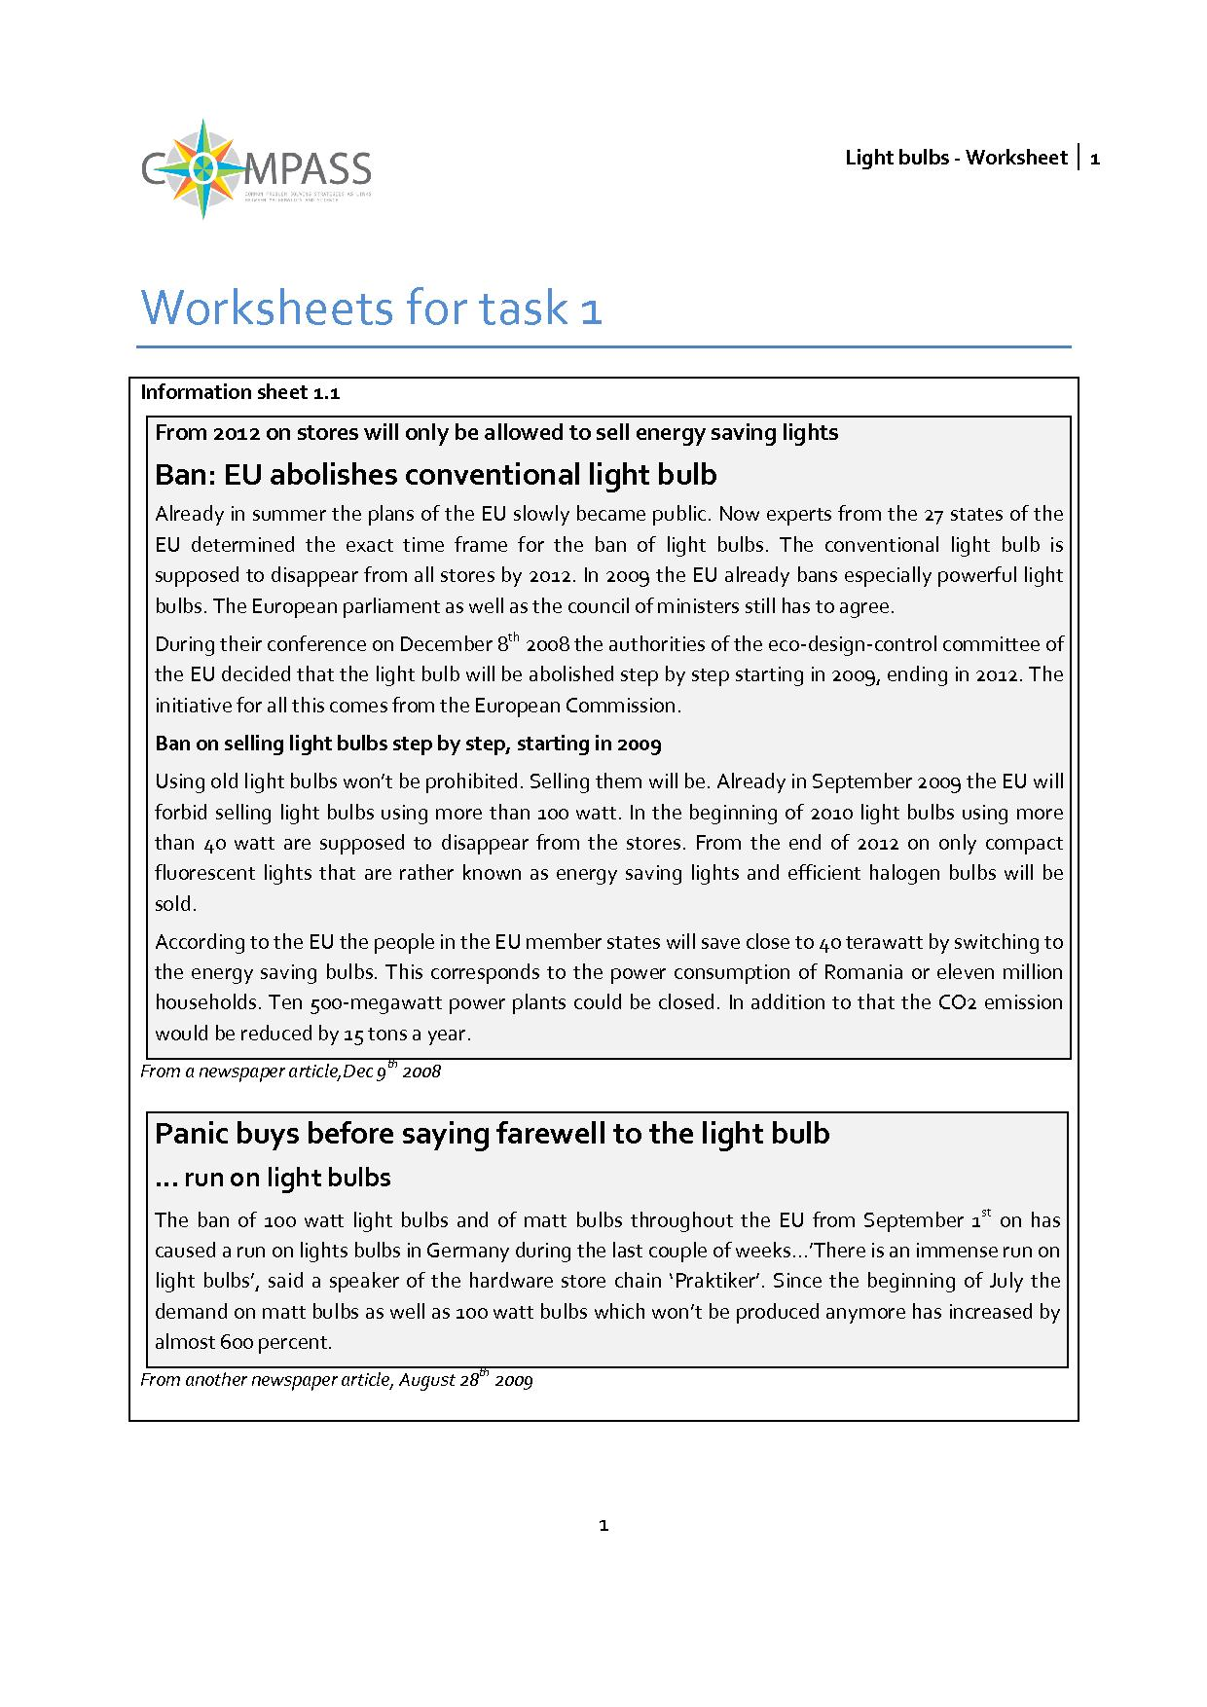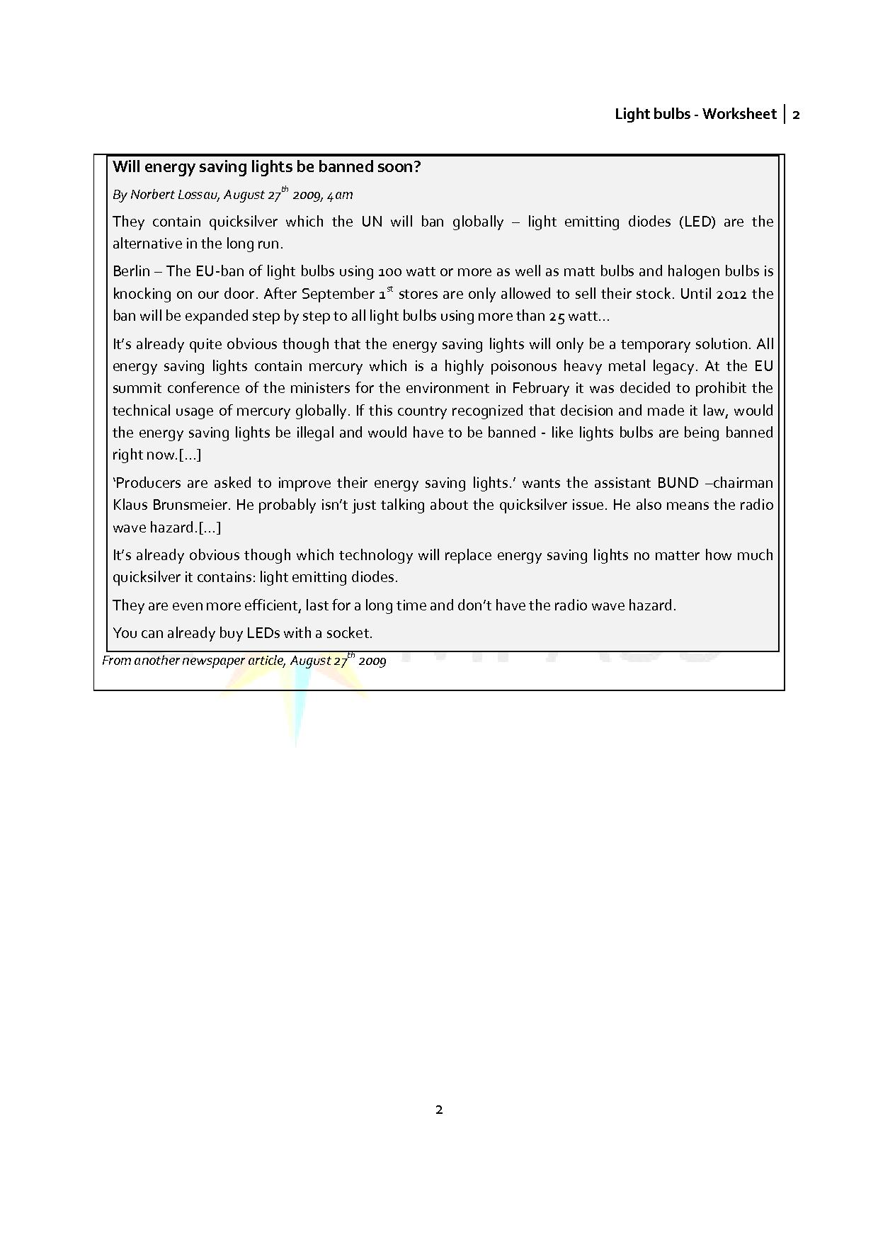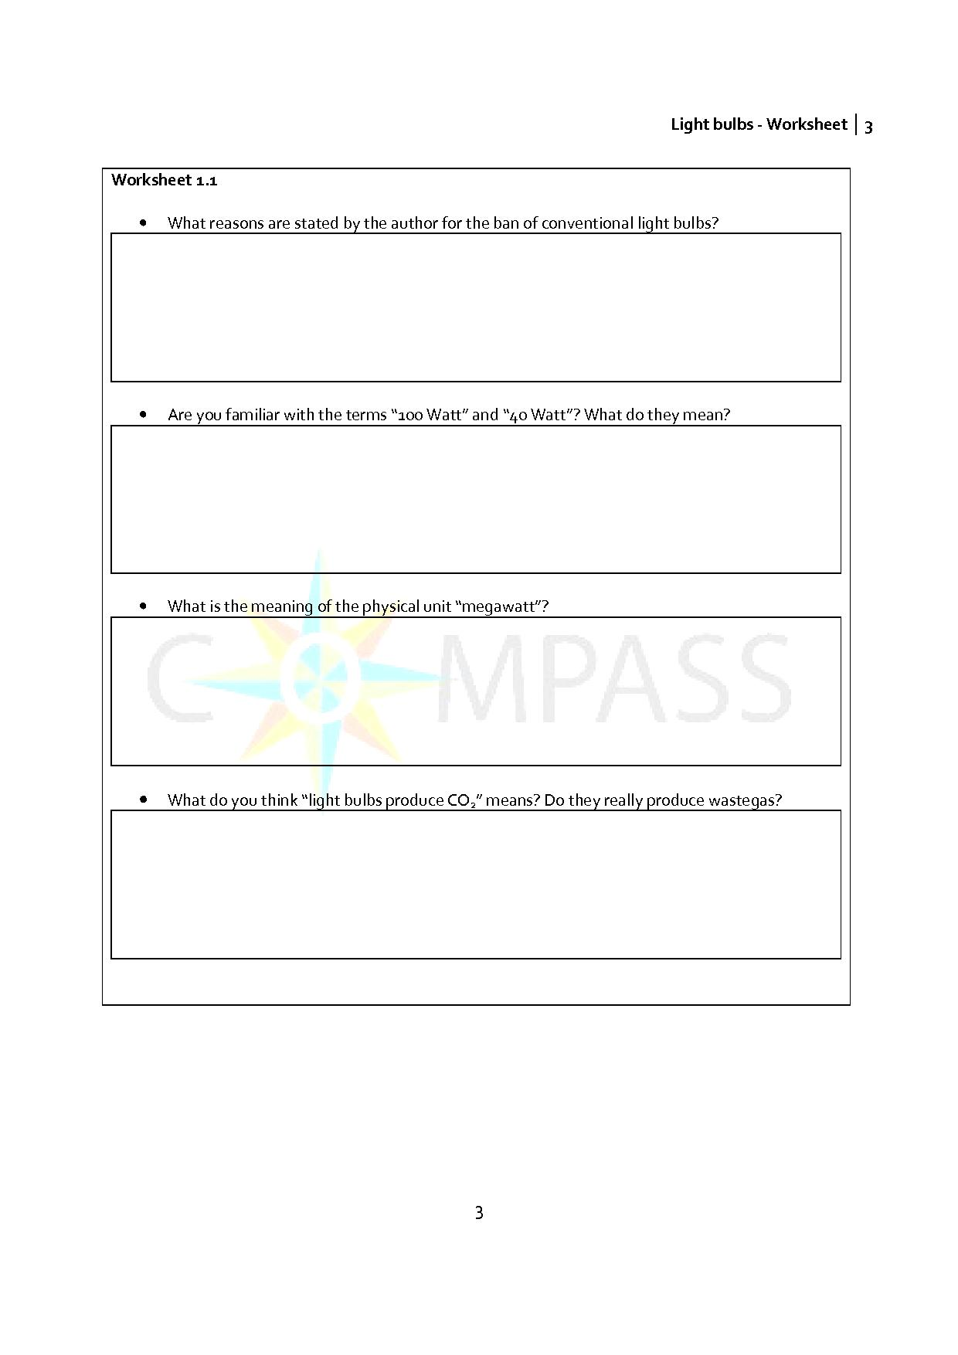
2.2 Physics – Task 2: The Light Effect
The aim of this task
- What are the differences between light bulbs and energy-saving bulbs from a physical point of view?
Contribution to the overall question
- During the investigation of the different types of bulbs, students learn that energy-saving bulbs contain highly toxic mercury, providing an argument against the ban of conventional bulbs.
Scientific content
- Production of light (light effect)
- Assembly of both regular and energy-saving bulbs
Outcomes
- Students will be familiar with the construction of the different bulbs and how they work. They are aware of the hazardous components in the energy-saving bulb (notably, mercury).

Activity 1 for students
Look at the worksheet 2.1 “Light Bulbs” and 2.2 “Energy Saving Lights” and try to answer following questions:
- Which part of the bulb is 'responsible' for the emission of light?
- Through which part of the bulb does the electrical current enter the bulb?
- Why do you think light bulbs are less efficient?
- Imagine you had to teach a group of small children (age 8-10) how light bulbs work and the problems associated with them. Try to explain to them how energy-saving lamps work.
Try to find evidence for or against the ban of light bulbs.
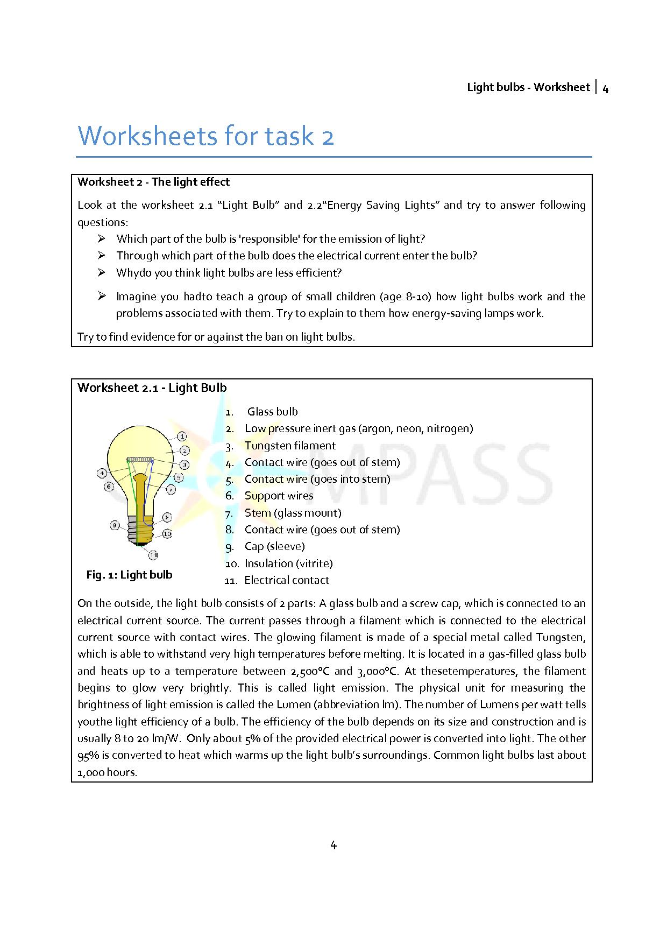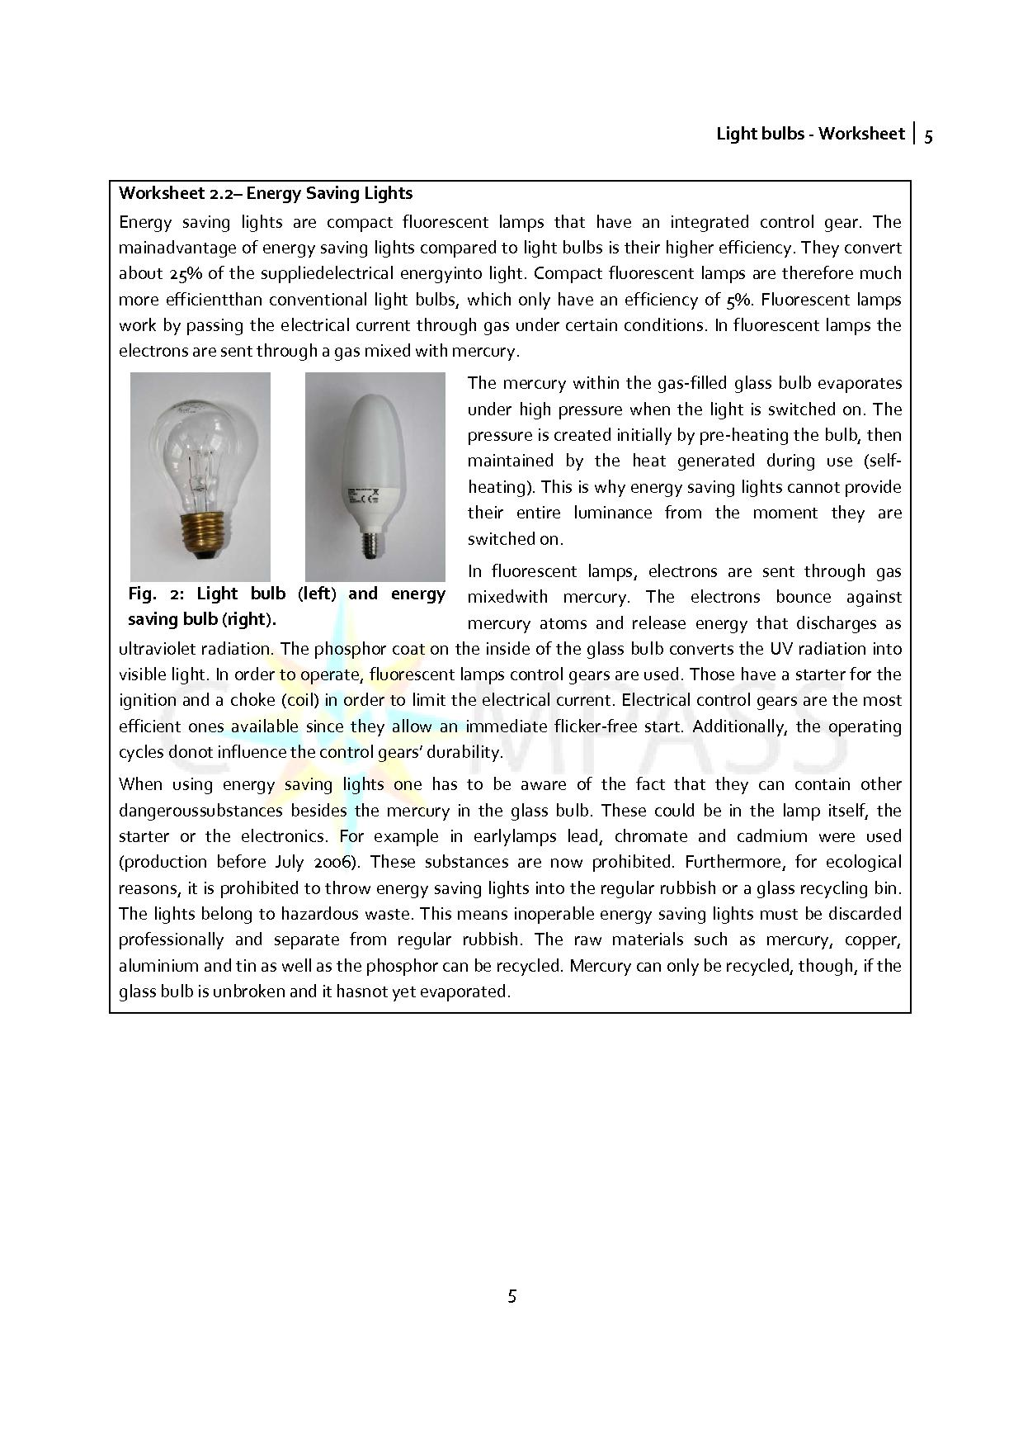
Arguments against the ban of light bulbs include the health hazard posed by the use of mercury and lead in conventional light bulbs as well as the problem of disposing the lights safely.
Depending on the time available, students can conduct an additional set of experiments in order to investigate the light spectrum of each light. The run on light bulbs might make sense after having conducted these experiments. While conventional light bulbs produce a continuous spectrum, energy saving lights do not. Therefore, the light from each bulb is perceived differently by people. Conventional light bulbs are considered warmer and more pleasant which is why people still prefer them. As a result people have been stockpiling conventional light bulbs. Research concerning visual perception of the different light bulbs can therefore form part of the discussion.

In addition to the workings of light bulbs and energy-saving lamps, the different spectra, caused by the different means of producing the light, can be compared with each other.
As a prerequisite, students should already know that with a prism, white light can be split into its different components. If there is no spectrometer available in school, students may build one using easily accessible materials. Full instructions can be found at:
http://astro.u-strasbg.fr/~koppen/spectro/mk2be.html.

Optional activity for students: analyse and compare the spectra
Examine the spectra of both a conventional light bulb and an energy-saving lamp with a spectrometer.
- Describe the two spectra.
- How do they differ from each other?
- Can you imagine how this may have consequences on how the light is perceived? Give reasons for your opinion.

When viewing the light from a conventional light bulb with a spectrometer, you see a continuous spectrum similar to that of the sun. This is because light resulting from the glow of a filament has a continuous energy distribution, which in turn leads to a continuous spread of wavelengths.
With an energy-saving lamp, on the other hand, you see a line spectrum that consists of only a certain amount of distinctly differentiated coloured lines (they are different depending on the type of the lamp). The colour and location of the lines are determined by the energy transitions, which are generated by the collision of electrons and, e.g., mercury atoms.
By comparing the spectra using a spectrometer, students can see clearly that the light from a conventional bulb and an energy-saving lamp differ fundamentally. Presumably, this has consequences on the (subconscious) perception of the “light quality”: The light from energy-saving lamps can be perceived as “unnatural” or “less pleasant”, whereas the light from a conventional light bulb, with a spectrum similar to the sun’s, does not cause these perceptions.
Possible initial arguments for discussion could be:

‘For’ the banning of light bulbs | ‘Against’ the banning of light bulbs
 | Health risks due to use of mercury
 | Problems due to the disposal of energy-saving lights as hazardous waste
 | Light is less ‘pleasant’
 | …

2.3 Physics – Task 3: Efficiency
The aim of this task
- Comparison of the efficiency of light bulbs and energy-saving lamps using a grease spot photometer
Contribution to the overall question
- Students learn that energy saving lamps are indeed more efficient than incandescent light bulbs.
Scientific content
- Luminous intensity, efficiency
In the first task there were no arguments supporting the banning of conventional light bulbs. A further discussion can be started by the logo on the package of energy-saving lamps, which is definitely eye-catching:
Activity 1 for students
According to the logo, energy saving lamps last longer and use less power. A 40 watt light bulb can be replaced by a 7 watt energy saving light.
- Is that kind of advertisement physically correct?
- 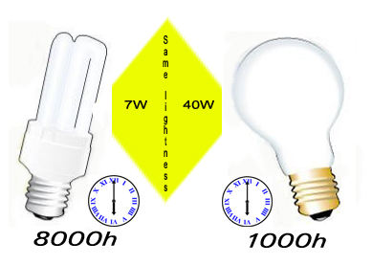What problems can arise when focusing entirely on energy-saving lamps from now on?
Fig. 1: Light bulbs

Having students discuss the two questions above can be part of the final discussion where the arguments for and against the ban are looked at.
In order to enable students to answer these questions, the next step is an experimental investigation of light efficiency. These experiments investigate which light bulb’s luminous intensity is greater. Below is a comparison between the brightness of a light bulb and the brightness of energy-saving lamp.

Energy-saving lamp vs. light bulb
Comparison of their brightness using a grease spot photometer; comparison of efficiency. Please refer to work sheet 3 for task 3.
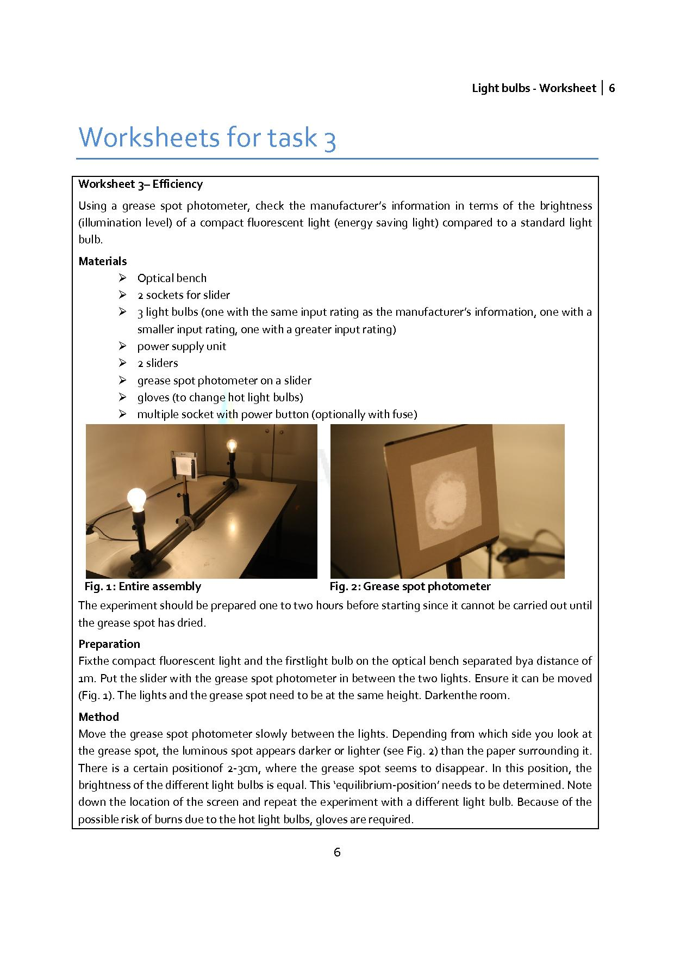
Results
The table below shows the results of the experiment using compact fluorescent lamps (7, 25, 40, 60 and 75 Watts) at one end and a conventional light bulb at the other end. The position where the grease spot blends in with its surroundings is 50cm if both lights have the same luminous intensity. Otherwise the position is closer to the light with the lower luminous intensity.
The experiment confirms the manufacturer’s information. It states that the illumination level of a 7 watt compact fluorescent light corresponds to the illumination level of a 40 watt conventional light bulb.

Power of bulb (in Watts) | Location of the photometer (in cm)
75  60  40  25 | 40  45  50  67

Alternative
Since the luminous intensity is inversely proportional to the square of the distance, students might not recognise the correlation between distance and lightness. To avoid this, you could set the grease spot in the 50 cm position and observe which energy saving lamps are as bright as regular bulbs. In the end, the result might look like the following:
Light bulb |  | Energy-saving lamp
Power | Energy consumption after 1000hours | Power | Energy consumption after 1000hours
25 W | 25 kWh | 5 W | 5 kWh
40 W | 40 kWh | 7 W | 7 kWh
60 W | 60 kWh | 11 W | 11 kWh
75 W | 75 kWh | 15 W | 15 kWh
100 W | 100 kWh | 20 W | 20 kWh
125 W | 125 kWh | 25 W | 25 kWh

Students should work out that for the same luminous intensity a conventional light bulb of greater power is needed than with an energy-saving light (e. g. 100 W light bulb vs. 20 W energy-saving lamp).
If students understand the term “efficiency”, they can deepen this understanding by carrying out a short (internet) investigation. By doing this, students could also compare the manufacturing costs of light bulbs and energy-saving lamps.

Activity 2 for students
- What is the meaning of “efficiency” of a light source?
- What is the efficiency of a) a conventional light bulb b) an energy-saving lamp?
- How much energy do you need for manufacturing a) a conventional light bulb b) an energy-saving lamp?

You should find the following data:
 | Energy used for production | Efficiency
Light bulb | 1MJ | 5%
Energy saving light | 10MJ | 25%

Results
In summary, it can be stated that the energy balance of the energy-saving lamp, considering the energy needed to manufacture it, is positive compared to conventional light bulbs. Producing an energy-saving lamp takes about ten times as much energy as producing a conventional light bulb, which might suggest that conventional light bulbs are preferable. However, when you include running costs, this barely makes a difference: Even a 25W bulb requires 20kWh more over 1000 hours of use compared to its 5W energy-saving equivalent. As 1 kWh is equivalent to 3.6 MJ, this means the conventional bulb requires 72 MJ more than an energy-saving lamp over its lifetime. Furthermore, after 1000 hours of use, the incandescent lamp has to be replaced while the energy saving lamp should still run for another 7000 hours.

An argument supporting the ban on light bulbs can be based on this experiment. There are always various criteria, though, which have to be considered and balanced in order to make a reasonable decision. Further arguments for and against the banning of conventional light bulbs should be collected during further tasks.
Summary of the findings so far:
‘For’ the banning of light bulbs | ‘Against’ the banning of light bulbs
Durability: 1000 hours compared to 8000 hours for energy-saving lamps | Health risks due to use of mercury
Efficiency: 5% compared to 25% for energy-saving lamps | Problems due to the disposal of energy-saving lights as hazardous waste
… | Light is less ‘pleasant’
 | …

2.4 Mathematics – Task 4: Micro perspective
The aim of this task
- How much of a cost saving is possible using energy-saving lamps?
Contribution to the overall question
- Energy saving from two perspectives:
  - Micro perspective: How will it help me if I use different bulbs?
  - Macro perspective: How does it affect society?
Mathematical content
The Maths lesson focuses on the following questions: How much of a saving could a household make if it replaced conventional light bulbs with energy-saving lamps? As an alternative to a fictitious household, students could calculate their parents’ savings or the savings of the school. In this case the students look at the issue (banning of light bulbs) from the micro perspective.
- mathematical modelling
- linearity
Micro perspective: Private savings
Activity 1 for students
- Calculate the lighting costs of a family of four with conventional light bulbs and energy-saving lamps.
- Calculate the lighting costs for your school. Compare conventional light bulbs and energy-saving lamps.

The efficiency of the bulbs was calculated in one of the physics lessons. Here the students need to do research on how much energy-saving lamps cost compared to light bulbs. Furthermore, they should find out how much 1KWh electricity costs.
We make the following assumptions:
Due to the construction of an energy-saving lamp, it takes more energy to produce it than for a conventional light bulb. The energy-saving lamp therefore costs €8.00, which is a lot more expensive than a conventional light bulb which usually costs €1.00. 1KWh energy costs about 17cents.
Students could answer one of the questions, or be split into groups working on one or other of the questions, or the whole class could tackle both questions in order. It would also be possible to set the question regarding household lighting costs for homework.
We start by taking a look at the first question. A brainstorming session, where possible solutions are collected and presented on the blackboard or OHP is a nice way to start in class. Students can work in groups and develop a plan based on the results of the brainstorming session. It may be the case that students do not know what kind of lighting they have in each of their rooms at home. As a consequence, students may need to collect data at home: What kind of bulbs are in each room? How long is each light switched on every day on average? Here, students should discuss seasonal differences. Summer and winter may be less suited for data collection. It makes sense to pick a week in spring or autumn. Alternatively, students could also look at all four seasons and think about when it gets dark and how long the lights would be switched on for.
If the groups make a detailed plan for the calculation beforehand, students can make the calculation for their household after having collected the appropriate data. Alternatively, groups could also meet again after having collected the data and perform the calculation together.

Possible result:
Taking a 4-room apartment as a basis and assuming the following arrangement of lights:
Room | Light | Duration of use
Living room | 1 ceiling light (100W) | 2h
 | 2 floor lamp (60W) | 1h in total
Bedroom | 1 ceiling light (100W) | 2h
 | 2 bedside lamps (60W) | 1h in total
Children bedroom | 1 ceiling light (100W) | 2h
 | 1 desk light (60W) | 1h
 | 1 bedside lamp (60W) | 0.5h
Office | 1 ceiling light (100W) | 1h
 | 1 desk light (60 W) | 1h
 | 1 reading lamp (60 W) | 0.5h
Bathroom | 1 ceiling light (100W) | 1h
 | 2 lights on the mirror (60 W) | 2h in total
Kitchen | 1 ceiling light (100W) | 2h
 | Other lights 3 ·100 W | 1h
Hall | 1 ceiling light (100W) | 1h

The total consumption a month is 30·(12h · 100W + 7h · 60W) = 48.6 KWh ≈ 49 KWh which costs €8.00. If energy-saving lamps are used in all rooms instead, the total consumption would be
30 · (12h · 20W + 7h · 11W) = 9.6 KWh which costs €1.60.
The saving per month is quite obvious already. It increases if more lights are used in the apartment or if they are switched on for longer. An example of this would be decorative lights on walls or wall units. If the apartment has windowless rooms or really dark rooms more lights are needed as well.
Energy-saving lamps do not make sense, though, if switched on and off a lot of times. The lamp only starts saving energy after having been turned on for a certain amount of time.
According to the information given above, an energy-saving lamp costs eight times as much as a conventional light bulb, but it also lasts 8 times as long. That means even without looking at the energy savings there are no additional costs associated with using energy-saving lamps.
Some of the students’ solutions can be presented at the end. Here, it is important that students’ different ideas are encouraged. Students can either present their solutions orally or make posters and have their peers look at these during a ‘gallery walk’.
The second question concerning the school’s lighting costs can be answered similarly. Its arrangement is probably not as clear as it is in the apartment at home. Firstly, students should make a plan. This is a good opportunity to deepen the students’ understanding of the process and to repeat the process to students who are not familiar with it. One option to use in this case is ‘Think-pair-share’. First the students think for themselves, second they discuss their ideas with their neighbour and finally the class discusses the plan together.
Students have a variety of options for the basis of the calculation: They can either count the rooms, assuming the same lighting in each room and the same duration that the lights are switched on, or they can find out the lighting of each room specifically and estimate the duration that the lights are switched on.

The calculations show that it seems to make sense economically both from the perspective of an individual as well as the owner of a single building, to switch to energy-saving lamps. However, we have looked only at one specific model (or two, depending on the time available), namely a household with four persons and estimated daily use (and, if time allowed, a school). What happens if these conditions vary?
2.5 Mathematics – Task 5: Costs depending on various variables
The aim of this task
- Investigate the lighting costs depending on the number of light bulbs/energy-saving lamps
- Consequences of initial costs and energy costs
Contribution to the overall question
- Costs for an individual household
  - Explore the situation with changing variables
Mathematical content
- Reasoning / interpreting / evaluation / communication / understanding straight line graphs and graphical representations
We will now look at different models and thus will vary the number of the bulbs, the initial costs, etc.
In order to explore effect of these variables in more detail, students should work with an ICT applet. In order to understand the effects, students have to explore the applet first. Students should explore graphical representations of the cost of running different types of light bulbs. This provides a realistic model in which they can investigate the key features of straight line graphs and graphical representations of the solution of simultaneous equations.
As well as focussing on linear equations and graphs, students can develop their skills in reasoning, interpreting, evaluating, communicating and understanding graphical representations of situations that can be modelled by linear functions.
Here again, we deal with the question of the costs for an individual household. In contrast to the task before one fixed model is not used, but the applet explores how the situation changes if with changing variables.

Mathematical enquiry process skills
Fundamental to using these materials is to give students the opportunity to enquire, investigate and explore independently. Students will have the opportunity to work in two different research environments where they can adjust variables to see what effect this has on graphs of costs plotted against time.
We would like to encourage students to:
predict – test – explain
that is, to pose a question and predict the outcome before they use the research environment to test this, and then explain why their prediction was correct or not. Of course in the case of incorrect predictions students should be encouraged to try again.
Modelling Issues
The research environments model, in a simplified way, the costs of running two types of light bulbs: ‘normal’ and Energy saving. It is assumed that the purchase cost of light bulbs is fixed (as set by the sliders) and the cost of running each type of bulb per day is also fixed (again by setting the sliders). This means that, unlike a real situation, the bulbs are used for the same length of time each day and electricity costs never vary.

Research environment: Light bulb (www.compass-project.eu/applets/#6)
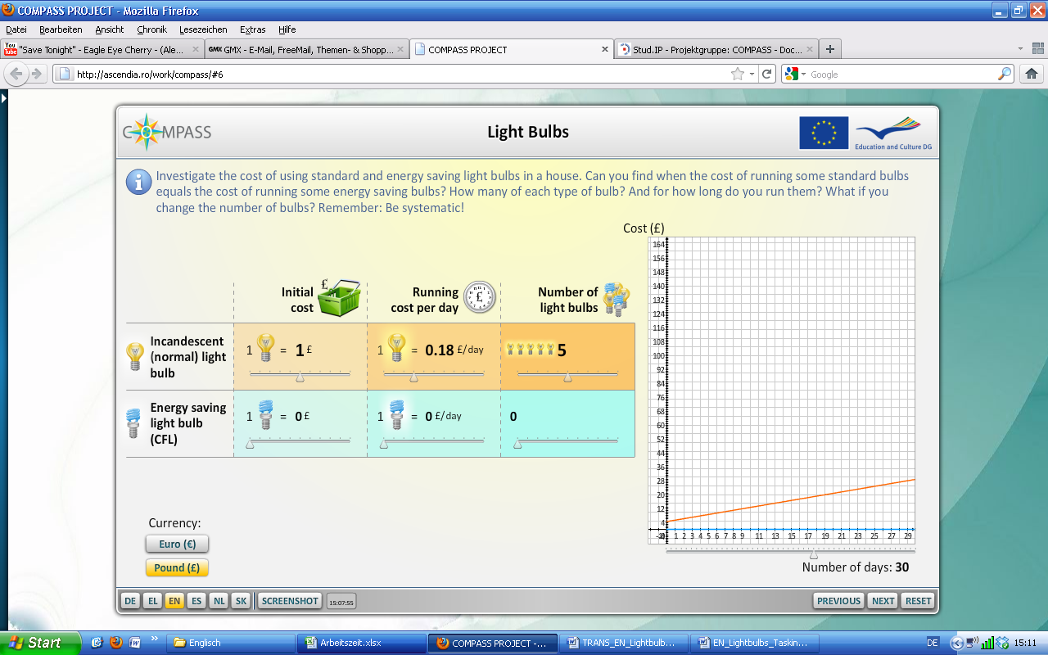

The sliders can be used to vary three parameters for both ‘normal’ and energy-saving light bulbs:
- The number between 0 and 5;
- The initial cost between £0 and £10.00.
- The running cost between 0 and 10 pence per day. (only up to 5 for energy saving)
You can also choose to display the cumulative cost over 1 to 100 days (this affects the scaling of the horizontal axis).
A graph is plotted for the total cost of running the selected number of light bulbs with the cost of the ‘normal’ and energy saving bulbs shown as separate lines.

Activity 1 for Students
www.compass-project.eu/applets/#6
Set all values for the energy saving bulbs to zero (as in the following diagram).
Now investigate the effect of varying the parameters for the ‘normal’ bulbs on the graph.
Try to predict changes before you use the research environment, then observe the outcome of your changes and explain your prediction.

This task asks students to focus on how the features of a straight line representation are connected with the structural features of the situation it represents. In other words, to explore how the intercept on the vertical axis represents the initial cost of a bulb and the gradient of the straight line represents the running cost per day.
Do this by asking students to set all values for the energy saving bulbs to zero (as in the previous diagram).
They should then investigate the effect of varying the parameters for the ‘normal’ bulbs on the graph.
Throughout students should
predict – test – explain
That is, to predict the outcome of changing one of the values before they use the research environment to test this. When they have carefully observed the outcome they should explain why their prediction was correct or not.
Ask students to make a summary of what they find out – they might like to do this by making a poster.
Now ask students to set the sliders at zero for the ‘normal’ bulbs and repeat their tests for the energy saving bulbs. They should check their summary of what they have found out so far and use their new tests to either confirm their conclusions or modify them in the light of their new findings.

Extension activity:
Students might be asked to give a formula for the cost, C pounds of running a light bulb for n days. Depending on their familiarity with algebra you may choose to ask them to do this using ‘informal algebra’ – it may be possible for some students to work with a spreadsheet to arrive at a formula.

The next task focuses on the idea of how simultaneous equations might be graphically represented and that the solution is given by the point of intersection.

Activity 2 for students
www.compass-project.eu/applets/#6
What is being represented by the following situation?
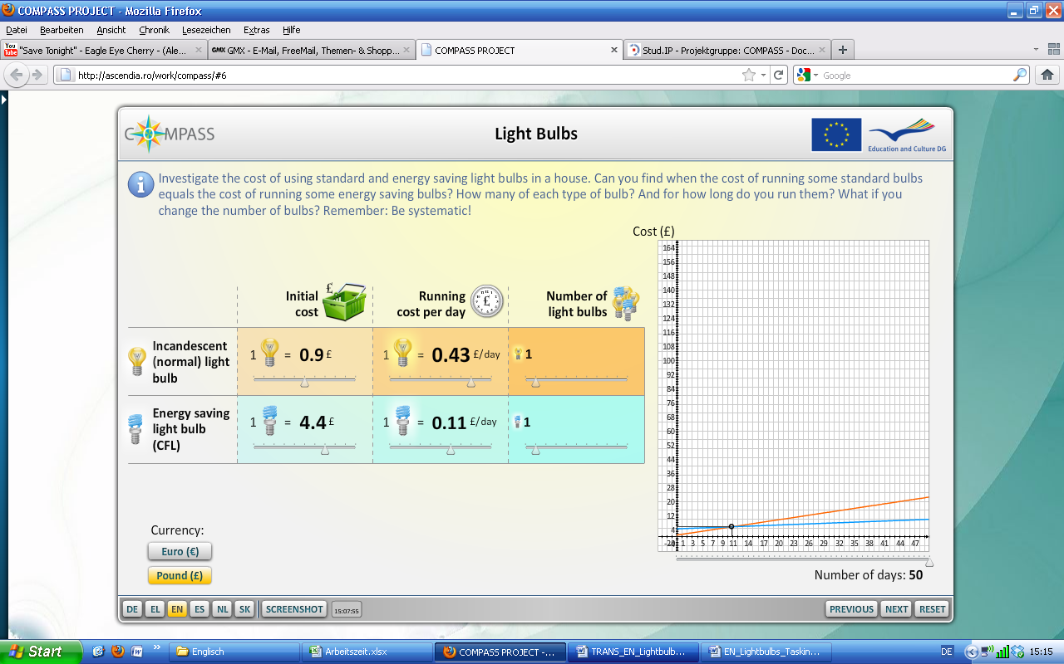
What is significant about the point where the lines cross?

Rather than to carry out algebraic manipulation to solve simultaneous equations (although capable students should do so), the intention is to come to a conceptual understanding that when we have two situations that can be modelled by straight lines, the two variables being graphed have the same value in each model at the point of intersection.
Ask students to explore the situation, perhaps asking them to find out what is necessary for the lines to cross and the reverse – what is necessary for the lines not to cross. Again, you might ask students to make a summary (poster) of their findings.

Extension activities:
For the initial situation given here ask students, working in groups, to use calculations to find the number of days and the cost at the point where the cost of running the ‘normal’ and energy saving bulbs is the same. For some this may prove a considerable challenge, but allow students to proceed in solving this using their own methods. Encourage them to make a poster of their solution.
Set a challenge: Can groups find values for the variables that result in the costs being the same after 50 days? Can they find one set of values? Another? And another?
What about after 25 days? 100 days? How can this situation be expressed in a formula?
Within a class discussion, the following aspects should be considered:
- Where is the point at which the costs are the same when considering current prices?
- What would happen if the initial costs for energy saving light bulbs were lower?
- What further means of reducing costs exists? How could they be expressed in the applet?

This research environment (www.compass-project.eu/applets/#6) shows the total cost of running ‘normal’ and energy saving light bulbs together – plotted as a single line on one graph.
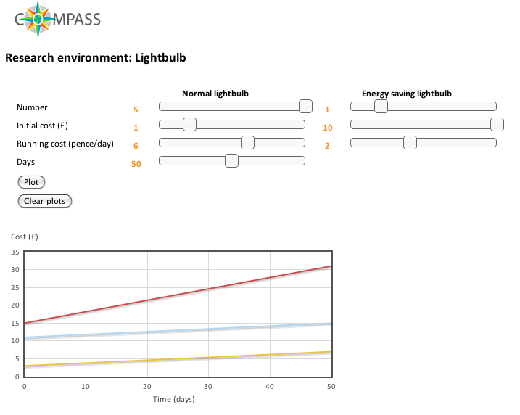
It can be used to confirm calculations that you might ask students to make. For example:

Activity 3 for students
www.compass-project.eu/applets/#6
In a house, if you have 5 ‘normal’ bulbs and only one energy saving bulb, with each normal bulb costing £1 to buy and 6 pence per day to run, and each energy saving bulb costing £10 to buy and 2 pence per day to run what will be the total lighting cost be after 100 days of use?
How would the total cost be affected by reducing the cost of buying energy saving bulbs?
Could you halve the total cost? If so, how?

Finally, ask students to look at their home and collect the data required for working with the applet:

Activity 4 for students
- How many light bulbs are used? How many energy saving bulbs?
- What did you pay for the bulbs initially?
- How high are the running costs?
- How high are the costs currently?
- How could these costs be reduced?

Encourage them to think of possibilities to reduce the costs which would suit them or their parents.
However, apart from cost, another aspect has to be considered: In spite of potentially higher costs many people would like to continue using light bulbs because they prefer the warm light no matter of the higher energy costs as shown by the run on light bulbs (see newspaper articles for task 1). Their decision was restricted by the new EU law. Does that decision make any sense? To answer that question we have to change perspective and move from the individual point of view to the global level. That means switching from the micro perspective to the macro perspective.

2.6 Mathematics – Task 6: Macro perspective: Perspective of society
The aim of this task
- How does society and humanity gain from the change to the law?
- How much energy can be saved across the whole of the European Union?
Contribution to the overall question
- Macro perspective: How does it affect society?
Mathematical content
See task 4

Activity 1 for students
The first newspaper article says:
“According to the EU the people in the EU member states will save close to 40 terawatt by switching to the energy saving bulbs. This corresponds to the power consumption of Romania or eleven million households. Ten 500-megawatt power plants could be closed. In addition to that the CO₂ emission would be reduced by 15 tons a year.”

If the numbers are correct, it seems society mainly benefits ecologically from the change.
- How can the EU state that people in EU countries would save 40 terawatts?
- Does that go along with the statement that as a result ten 500-megawatt power plants could be closed?
- Would the CO₂ emissions really be reduced that much?
- Are there any numbers regarding CO₂emissions that could confirm its reduction?
In order to be able to answer those questions, we need to carry out some research.
- How many people live in the EU?
- How many megawatts are in one terawatt?
- How high are CO₂ emissions per person? (the focus here is only on emissions due to powering light bulbs)

The students could carry out a web search, e.g., at home.

Activity 2 for students
First of all the article doesn’t make clear the time frame during which the 40 terawatts are saved. Does the article talk about one year? Furthermore, the article uses terawatt instead of terawatt hours. Is that correct?

This problem can either be solved in a maths lesson or the students can ask the physics teacher.
Results
The result of asking the physics teacher is: Power is measured in Watts and can be calculated using “current · voltage”. Energy consumption is measured in kWh (KiloWatt Hours) or TWh (TeraWattHours). Thus, the information in the article is simply incorrect. Since the time frame during which the 40 terawatts are saved is not stated, assume it is one year.

A possible solution could be as follows:
Currently about 490,000,000 people live in the EU. Forty terawatts are equivalent to 40,000 gigawatts, 40,000,000 megawatts or 40,000,000,000 kilowatts.
40,000,000,000 / 490,000,000 ≈ 80 kilowatts. So according to the article, 80 kilowatts can be saved per person.

How does this result compare with the calculations above?
We calculated that a family of four would save about 40 kWh per month. Consequently, one person would save 10 kWh per month (this is an estimate even if the proportional model does not apply) which is 120 kWh per year.
According to our calculation, one person would save 120 kWh per year yet the article states 80 kWh. Since both numbers are based on estimates they cannot be the same. Yet, the order (approximate size) is comparable.
Now look at the next statistic: Since 40 TWh are equivalent to 40,000,000 MWh, it seems contradictory that ten 500 Megawatt power stations can be closed. It seems mathematically correct though when we take a closer look:
10 · 500 MW · 24h · 365 = 43,800,000 MWh = 43.8 TWh ≈ 40 TWh

What about the CO₂ emissions?
The article mentions that the CO₂ emission could be reduced by 15 million tons a year. It should be taken into consideration, though, that the CO₂ emission varies depending on the source of energy used by each power plant. Online you can find numbers for Germany from 2007 when 604g CO₂ per 1 kWh were emitted (http://de.wikipedia.org/wiki/Kraftwerk). Using simple proportionality, you can calculate that 24 million tons would be emitted when generating 40 TWh. That is higher than the number stated in the article but its order of magnitude is comparable. Possible differences can be based on the fact that Europe as a whole has a lower CO₂ emission per 1 KWh due to a different energy mix.
These numbers might not satisfy a physicist because they are only simple estimates. They do not consider technical aspects nor show how CO₂ emissions were calculated. It would be possible to go into greater detail during a physics lesson if there is time available but this is not required. Simply checking information through research and putting the numbers in perspective should help to guide the students towards a critical reflection on the underlying arguments.
2.7 Task 7 – Finalisation: Returning to the overarching question
The aim of this task
- Using all the information collected during previous lessons to discuss whether the banning of light bulbs was a prudent decision.
- An insight into decision making based on facts, and that there are never clear answers to such decisions but rather arguments on both sides have to be weighed against each other.
Outcomes
Students can present their findings in different ways:
- A class debate where they use their results to argue for or against the ban.
- Writing an article for a student newspaper where they describe the arguments for and against the ban.
By the end of the interdisciplinary teaching unit, ideally, both teachers should go back to the basic question: Why were light bulbs banned in the EU?
A list of arguments collected during class may look as follows:
‘For’ the banning of light bulbs | ‘Against’ the banning of light bulbs
Durability: 1000 hours compared to 8000 hours for energy-saving lamps | Health risks due to the use of mercury
Efficiency: 5% compared to 25% for energy-saving lamps | Professional disposal of energy-saving lamps is necessary since they are considered hazardous waste
Macro perspective: ten 500 megawatt power plants could be closed in Europe | Light is less ‘pleasant’
Much less CO₂ emission

After having collected arguments for the debate about the ban, students can present them during a discussion as it would take place in Parliament.

Students learn that a clear decision is not possible since there will always be reasons both for and against the use of conventional light bulbs. This might raise awareness in students that political decisions do not follow directly from scientific evidence but contain a subjective component.
It should also become apparent that there are different perspectives that can be taken up: If you think of the public debate on light bulbs and energy-saving lamps, it shows that some people only argue from a position of how it benefits them (I like the light better), while others may suggest that it is also important to look at global consequences. It is of course also important to be critical about the introduction of energy-saving lamps since they contain mercury as well. This suggests that the debate will not end here but can be continued as the third newspaper article shows. LED lighting may be the future.
An alternative to the class discussion is, for example, asking students to write an article for a newspaper or a pupil magazine, in which they describe the arguments for and against about the banning of light bulbs.

