Worksheets for task 1
Information sheet 1.1
Air pollution comes from many types of engines, industries, and commercial operations. Pollution sources that move, such as cars, trucks, airplanes, and trains, are known as "mobile sources." Examples of all other (non-mobile) sources of air pollution include power plants, factories, and manufacturing processes.
About 27% of the energy we use goes to transporting people and goods from one place to another. Gasoline is used mainly by cars and motorcycles; diesel fuel is used mainly by trucks, buses, and trains. Together, gasoline and diesel, made up 94% of all the energy used for transportation in the EU in 2009.
There is currently a push to develop vehicles that run on blended fuels or fuels other than petroleum products. Today, there are some vehicles that run on electricity, natural gas, propane, and ethanol. Hybrid-electric vehicles combine the benefits of gasoline engines and electric motors by reducing the amount of fuel required to move a vehicle.
Mobile sources pollute the air through combustion and fuel evaporation. These emissions contribute greatly to air pollution worldwide and are the primary cause of air pollution in many urban areas.
Road transport contributes about one-fifth (22%) of the EU's total emissions of carbon dioxide (CO2), the main greenhouse gas. While emissions from other sectors are generally falling, those from road transport have continued to increase since 1990. Specifically, in EU emissions from the transport sector increased continuously between 1995 and 2005 (+17.3%), due to high growth in both passenger and freight transport by road and count for the 22% of the total Greenhouse emissions. Eager to tackle climate change, the European Commission has a comprehensive strategy designed to help the EU reach its long-established objective of limiting average CO₂ emissions from new cars to 120 grams per km by 2012.
You can help reduce air pollution from mobile sources in a number of different ways:
- One of the best ways to help reduce air pollution is to drive less. Try an alternative means of transportation such as buses, trains, or bicycles. Choose to commute to work by carpooling, vanpooling, telecommuting, or by using public transportation.
- Although many of us depend on our vehicles for work and pleasure, we can still take some smart actions to reduce emissions, such as using clean fuels.
Retrieved and modified from Eurostat Publications

During the 1990s, regulations requiring an approach to "zero emissions" from vehicles increased interest in new battery technology. Battery systems that offer higher energy density became the subject of joint research by federal and auto industry scientists.
Solar cars were first built by universities and manufacturers. The sun energy collector areas proved to be too large for consumer cars, however that is changing. Development continues on solar cell design and car power supply requirements such as heater or air-conditioning fans.
Retrieved and modified from About.com



Toyota's third-generation Prius, due at dealerships this spring, will have an optional solar panel on its roof. The panel will power a ventilation system that can cool the car without help from the engine, Toyota says. But it's a long way from the 2010 Prius to a solar-powered car, experts told CNN. Most agree that there just isn't enough space on a production car to get full power from solar panels.
Solar Power Cars
A solar vehicle is an electric vehicle powered by solar electricity. This is obtained from solar panels on the surface (generally, the top or window) of the vehicle or using a solar jacket in electric bicycles. Photovoltaic (PV) cells convert the sun's energy directly into electrical energy.
Solar cars combine technology typically used in the aerospace, bicycle, alternative energy and automotive industries. The design of a solar vehicle is severely limited by the amount of energy input into the car. Most solar cars have been built for the purpose of solar car races. Exceptions include solar-powered cars and utility vehicles.
Solar cars depend on PV cells to convert sunlight into electricity. In fact, 51% of sunlight actually enters the Earth's atmosphere. Unlike solar thermal energy which converts solar energy to heat for either household purposes, industrial purposes or to be converted to electricity, PV cells directly convert sunlight into electricity. When sunlight (photons) strike PV cells, they excite electrons and allow them to flow, creating an electrical current. PV cells are made of semiconductor materials such as silicon and alloys of indium, gallium and nitrogen. Silicon is the most common material used and has an efficiency rate of 15-20%.
Retrieved and modified from cnn.com

Additional Information can be obtained from the following websites:

(Websites below are in English and Greek. Please use websites in locallanguages as appropriate)

http://www.solarenergy.org
http://www.winstonsolar.org
http://www.greenpeace.org/greece/137368/137396/138618
http://el.wikipedia.org/wiki/solar
http://1gym-ag-arask.att.sch.gr/environment/iliako/energy/iliaki/index.htm
http://www.energolab.gr/index.asp?c=26

Worksheet 1.1

- What are the main causesof air pollution? What is the Greenhouse effect?

- How large is the contributionof transportation to total energy consumption?

- What do CO₂ emissions mean for the environment? How are these related to vehicle use?

- How do photovoltaic units work?

- How do Solar Cars work?

Worksheets for task 2
Worksheet 2– The power generated by Photovoltaic Units
Look at worksheets 2.1 “Photovoltaic Unit Surface” and 2.2“Light and Photovoltaic Unit Angle” and try to calculate how many PV units are needed to operate a model solar car.

Worksheet 2.1–Photovoltaic Unit Surface

- Using the material toolkit provided, construct the model shown below. The aim of this activity is to measure the power of the PV unit and how it is related to itssurface area.
Fig1. Measuring the power generated by a PV unit.

- Repeat the experiment and complete the table below, with your results
Surface Area (cm²) | Power (Watt)

- Plot the points from your table above and draw a graph using the axes below to show the relationship between the surface area of the PV unit and its power.
- What is the relationship between the PV unit’s surface area and itspower?
...............................................................................................................................................
...............................................................................................................................................
...............................................................................................................................................
...............................................................................................................................................
- Based on the shape of the graph produced, what can you conclude about the relationship of the area tothe power of aPV unit?
...............................................................................................................................................
...............................................................................................................................................
...............................................................................................................................................
...............................................................................................................................................

Worksheet 2.2– Photovoltaic Unit and Light Angle
The aim of this activity is to measure the power of the PV unit and how it is related to the angle of the incident light, when the surface area of the PV unit remains the same. Use the same modelas for task 2.1.
- Complete the table below, with your measurements.
Angle (⁰) | Power (Watt)
10
30
60
90

- Plot the points from your table and draw a graph using the axes below to show the relationship between the angle of the incident light and the PV unit’s power.
- What is the relationship between the angle of the incident light and the unit’s power?
.........................................................................................................................................
.........................................................................................................................................
........................................................................................................................................
.........................................................................................................................................
Worksheets for task 3
Worksheet 3.1

- It is important that you know exactly how much material is needed for your model solar car. Especially forcar manufacturers, these calculations are of great interest due to the high cost of the metals used.
- Before working it out for your model car, you will calculate the surface area of a popular car. In the pictures below you will find different views of a car.
- Your task is to calculate the metal needed for producing this car. Remember that images are scaled, so you first need to define the scale factor.

Scale factor: ………………………………………

Show your calculations here:

- These pictures can be found in the Car Shape.ggb file. You can open this file using Geogebra.
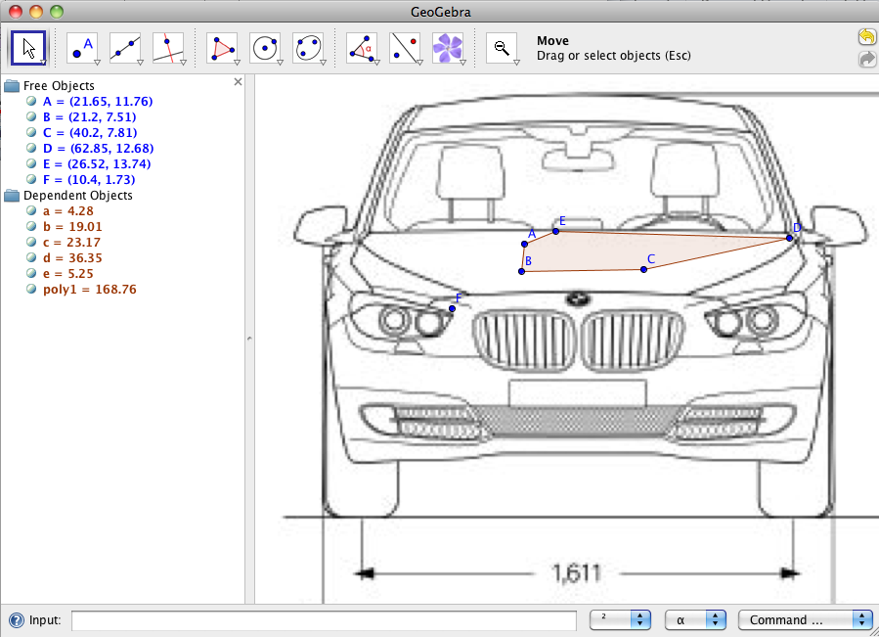
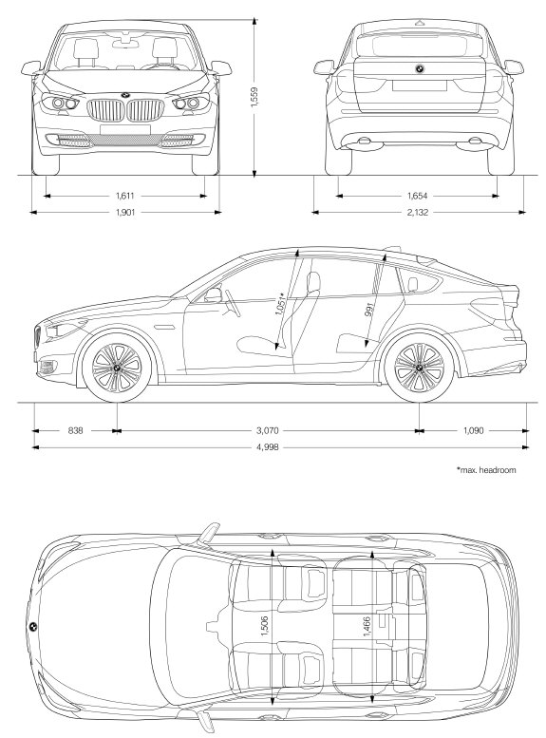

- Explain how you will combine the pictures to calculate the surface area of the car in the box below.

- Now move into software’s environment and measure the surface area of the car. Show your calculations in the box below (remember to use the scale factor).

- Now think of your Model Car.
Can you make an estimate of your model car’s surface area, based on your measurements of the real car? Show your working in the box below.

Worksheets for task 4
Worksheet 4.1

Now it is time to make your model car. In this task you will design how your car will look. You need to design a net of your car usinga single piece of material, in order to avoid using heavy connections and joints.

For this activity you will use Dalest Nets software. The interface is shown in the image below.

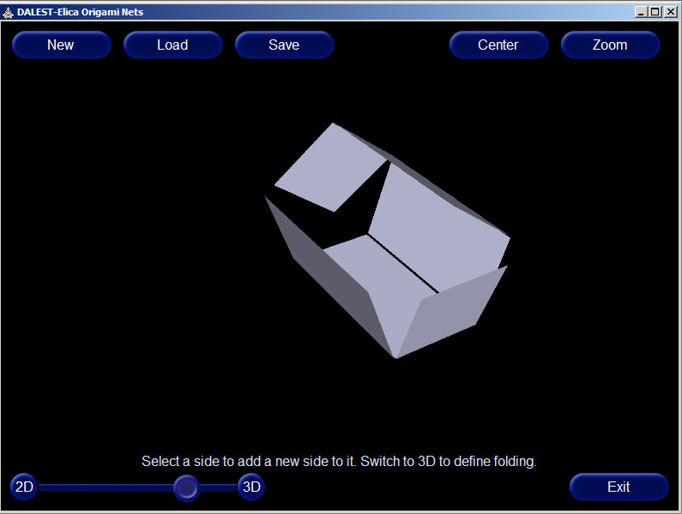

Basic instructions for using the software:
Creating a new net:
- click the [New] button
- click in the middle of the screen
- select the first object of the net

Attaching an object to the net:
- click on the object to which you want to attach
- all free edges will be marked by red dots
- click on the red dot of the edge to which you want to attach
- select the new object

Rotating the net:
- drag it with the left mouse button
Folding/unfolding the net:
- click on the [3D] button to completely fold the net
- click on the [2D] button to completely unfold the net
- slide the slider thumb between the [2D] and [3D] buttons to manuallycontrol the folding process
To set the folding angle between two objects
- make sure you are in 3D mode
- select an object and enter its angle in the text field at the top of the screen (this field will appear only in 3D mode)
To set the folding angle interactively
- make sure you are in 3D mode
- select an object with the right mouse button and drag it. Dragging will actually change the folding angle in real time
To set the folding angle at a predefined angle
- make sure you are in 3D mode
- double click on an object with the right mouse button
- select the desired angle from the menu
To load/save a net:
- use the [Load] and [Save] buttons

- Before starting to use the software, draw the net of your car in the box below.
- You need to build the net of your car. The net will help you identify all necessary pieces of material needed for constructing your model car. Use the Dalest Nets software.

- Fold the net, in such a way as to make a 3D image of your model car.
Note: Use the 2D-3D slider and setthe folding angle. If you would like to manually fold a piece of the net, click, hold and rotate using the right mouse button. Save the 3D image, using the Save button, in your folder.

- List below the difficulties you faced during the construction of the 3D image of your model car.

....................................................................................................................................
....................................................................................................................................

....................................................................................................................................

....................................................................................................................................

5. Draw your model car net and 3D image in the space below.

Worksheets for task 5
Worksheet 5.1
- Two gears are connected as shown in the picture below.

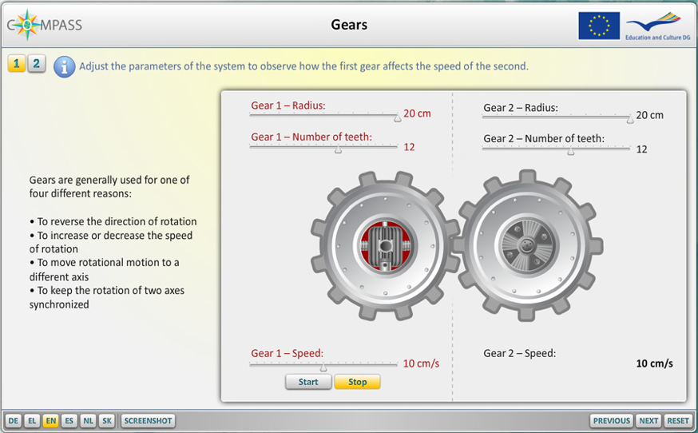

What is the relationship between the number of teeth of the two gears and their speed?
Write your hypothesis here.
..................................................................................................................................................
..................................................................................................................................................
.................................................................................................................................................

- Use the Gears Applet (Screen 1) to investigate the effect of changing the number of teeth. Experiment with different numbers of teeth and complete the following table.
Gear 1 |  | Gear 2
no of Teeth | Speed | no of Teeth | Speed

- Was your hypothesis correct? If not, why not?
..................................................................................................................................................
..................................................................................................................................................
..................................................................................................................................................
..................................................................................................................................................

Worksheet 5.2
- Two gears are now connected as shownin the picture below.

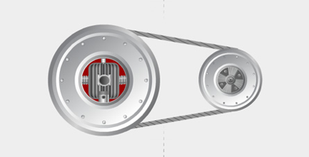

What is the relationship between the radius of the two gears and their speed?
Write your hypothesis here.
..................................................................................................................................................
..................................................................................................................................................
.................................................................................................................................................

.................................................................................................................................................

- Use the Gears Applet (Screen 2) to investigate the effect of radius on speed. Experiment with different gear radii and complete the following table.
Gear 1 |  | Gear 2
Radius | Speed | Radius | Speed

- Was your hypothesis correct? If not, why not?
..................................................................................................................................................
..................................................................................................................................................
..................................................................................................................................................
- How are you going to connect the gears in your car?
Design the transmission of your car in the box below.

Worksheets for task 6
Worksheet 6.1
- Open the Car_price.ggb file.
Based on the data in the file, use the software’s spreadsheet capabilities to calculate people’s interest in relation to the car’s saleprice. Show your results here.

- Plot the data using Cartesian coordinates, in the software’s geometry environment. Save your work in your folder.
- What is the best possible saleprice for the car? Refer to your calculations to support your answer. .....................................................................................................................................................

.....................................................................................................................................................

.....................................................................................................................................................

- Write a letter to the company’s sales manager, explaining how you reached your results. Try to convince her/him that your method is appropriate for not only this case, but also for similar problems in finding the best possible saleprice.
................................................................................................................................................................
................................................................................................................................................................
................................................................................................................................................................
................................................................................................................................................................
................................................................................................................................................................
................................................................................................................................................................
................................................................................................................................................................
................................................................................................................................................................
................................................................................................................................................................
................................................................................................................................................................
................................................................................................................................................................
................................................................................................................................................................
................................................................................................................................................................

