Worksheets for task 1
Information sheet 1.1
Are we facing a global water shortage? There is increasing evidence of a growing world water shortage. The World Bank reports that 80 countries now have water shortages that threaten health and economies while 40 percent of the world (more than 2 billion people) has no access to clean water or sanitation. According to the International Water Management Institute, nearly one-third of the world's inhabitants don't have reliable access to clean water, supplies are either unsafe, unaffordable or just not there. Some 3 million people - most of them children - die every year from diseases spread by contaminated water.
It should be self-evident that population growth is the prime culprit behind the growing global water shortage. In only 60 years, the number of people on the planet has ballooned from 2.5 billion to 6.5 billion. All those mouths need food - and generating all that food requires enormous quantities of water. Seventy per cent of all the water humans use goes to support agriculture.
And all of the economic developments that the technocrats of every country are assuming - a growing population, longer life expectancy, an improved standard of living would, if they happened, greatly raise the peril. As people's living standards rise - they demand more meat in their diet. The numbers then change - in the wrong direction. Growing a ton of grain requires 1,000 tons of water; a ton of beef takes 15,000. According to the World Bank, world-wide demand for water is doubling every 21 years, more in some regions. Water supply cannot remotely keep pace with demand, as populations soar and cities explode, the world water shortage will grow exponentially.

Retrieved and modified from http://www.peak-oil-technology.com/global-water-shortage.html

The Mediterranean: the desert closes in
The Mediterranean, considered to be the Southern border of Europe, lacks water and suffers from desertification. According to the former president of the European society of the earth conservation (EECS), José Luis Rublo, ‘Europe is in transition and will greatly suffer from global rewarming’.
According to the Convention of the United Nations to combat desertification (CCD), deserts take up 36 million square kilometres of the planet and, every year, they swallow up about 24 000 million tons of farming land. Egypt suffers most from water shortages and deserts make up 90% of the surface of the country, towns and treeless areas take up 9.75%, water 0.25% and forests 0%, according to Eumedstat. But the EU countries are also under threat. Spain is the most arid country in Europe: 66% of its surface is exposed to desertification. Portugal and Greece also suffer from similar problems. In Portugal 66% of the total land will be arid before 2026.

Known causes
The causes of water shortages are well known. ‘The overexploitation of the land is one of the oldest causes of water shortages. In Europe, man has been farming for the last 8000 years,’ states José Luis Rubio. ‘Mass tourism, high population density and industrial concentration’ also worsen the situation. Last absurdity of the modern world, golf courses: in January 2006, Spain had 308 golf courses. Ten months later, the number of golf greens had reached 324 and 65% of these were situated in the arid areas of the country. This is the Spanish paradox, they dry their lands to create an oasis of green vegetation.
Juan José Ibáñez, expert of biology and science at the CSIC, warns that ‘replanting trees in the Mediterranean could diminish biodiversity’ and adds that ‘paleontological and palynological experiences demonstrate the replanting schemes have only worked in the mountains’. Maybe the solution to curb water shortages is to reduce water consumption. One means is of course to increase the price of water. Germany boasts the most expensive square metre of water (1.80 Euros), Spain is the cheapest (0,77 per square metre of water).

Retrieved and modified from http://www.cafebabel.co.uk/article/18682/europe-warns-of-water-shortages.html

Greece struggles with water shortage
Water shortages have hit much of Greece, particularly the Aegean islands, at the height of the summer tourist season. The problem has been exacerbated by increased consumption of water during a record heat wave that swept southern Europe last month and caused some of the water in reservoirs to evaporate. Greece has experienced water shortages before, but the trouble this year is unprecedented.
The EU environment commissioner, Stavros Dimas, a Greek, would not say what measures the authorities should take. But he said that "water shortages are a major problem because they have an immediate impact on citizens and on industries that rely on water." An estimated €24 million, or $33 million, for infrastructure projects was released to the islands earlier this year but paperwork had prevented it from being spent.
The problem of dwindling water resources is not limited to the islands: Greece is one of the driest countries in Europe. Water reserves have fallen by about 30 percent in Athens, where half of the country's population of 10 million lives, and are at their lowest level in five years, the state water board said. "The crisis on the islands is a very small part of a general problem in Greece," said the director of the Greek office of Greenpeace, Nikos Charalambides. He blames wasteful agricultural practices but also an ambitious government plan for increasing tourism. "It is outrageous to plan the creation of golf courses and swimming pools when water tanks are running dry, and we don't have the resources to cultivate water-hungry crops like cotton."

Retrieved and modified from http://www.nytimes.com

An Island Paradise Faces an Alarming Water Shortage
There is trouble in paradise, as the popular tourist island of Cyprus faces a severe water shortage, with its reservoirs currently standing at around 9% full. The country has had many years of low levels of rainfall, and the possibility of more years is looming.
Water has always been a valuable commodity on the Mediterranean island, which has one of the world’s highest concentrations of reservoirs. The country is used to regular periods of drought due to its location and climate, but there has been a sharp decrease in rain in the past 35 years. Since 1972, rainfall has decreased 20% and runoff into reservoirs has decreased by 40%. The same period has seen a rise in temperature. In the last 100 years, the temperature rose by almost 2 degrees Fahrenheit, while rainfall per year dropped by three inches. Authorities lay the blame on global warming.
Costas Papastavros, head of the Cypriot national climate change unit, said: "Climate change is clearly evidenced in Cyprus. Climate change is not only about a rise in temperature, but also about extreme weather conditions, and drought is one of them. Desertification is also becoming a serious problem. It is not just that we do not have water in dams for irrigation, but we are looking at a decline in the productivity of soil, and we have a tremendous problem."
The demand for water in Cyprus, for now, outstrips supply. Experts estimate the island will need almost 180 million cubic feet of water until the new year. Kouris, one of the island’s largest and most important dams, currently stands less than 2.5% full, with 3.23 million tons of water. The island is increasingly relying on desalinization plants for water, but they can only provide 45% of demand, and their operation is energy heavy. Officials, further, signed a contract with a shipping company to use oil tankers for supplying Cyprus with water from other countries. The tanker supply program will continue until a permanent solution to the problem will be reached.
Cyprus is looking at a bleak vision for the future. Officials believe the island will have to adapt to the changes wrought by global warming. They believe only significant changes in farming practice, as well as water management, will save the island.

Retrieved and modified from http://www.nytimes.com
Worksheet 1.1

- What are the mains reasons for the global water shortage? You can also elaborate on reasons that are not mentioned in the provided texts.

- What is desertification and how it is related to water shortage?

- List a number of strategies that can be used to provide people with access to freshwater. Do not narrow your answer to those appear in the provided text.

- List a number of strategies and attitudes that can be adopted to save water.

Worksheets for task 2
Worksheet 2.1 – Water Cycle

- The picture below represents the water (hydrologic) cycle. Working with your peer, try to identify the processes of the water cycle marked with arrows.

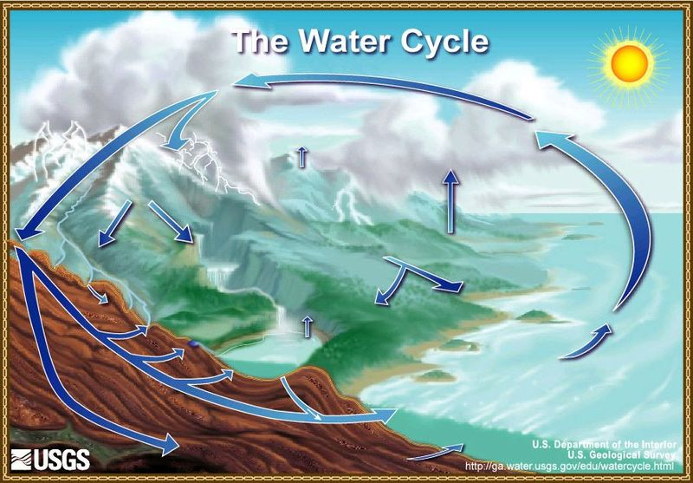

- Which are the water phases during water cycle?

- List all processes that take place during water cycle. Briefly explain these processes.
Preview an animation of the Water Cycle at: http://earthguide.ucsd.edu/earthguide/diagrams/watercycle/index.html
http://prof.danglais.pagesperso-orange.fr/animations/watercycle/watercycle.htm

- Draw a model for the water cycle. How this is related (similarities and differences) to the water cycle model you completed in the first activity?

Worksheet 2.2– Water Cycle and Harmful Elements

- Look carefully at the water cycle model presented below and identify the main components evaporation, condensation, and precipitation.

- List all possible harmful elements that might enter the water cycle and affect the water quality and identify during which process / component this takes place.

Worksheets for task 3
Worksheet 3.1

- Observe carefully the two bottles presented below. One bottle contains tap water and the other one water from a nearby lake.
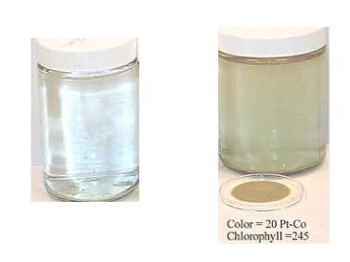

Find similarities and differences between the two bottles of water.

Similarities | Differences

- Can you predict the reason for the differences between the two bottles?

- How can you decide whether the lake water quality is good enough for the living organisms they live in the lake?

Worksheet 3.2

- Which of the following living organisms have you found in the lake?
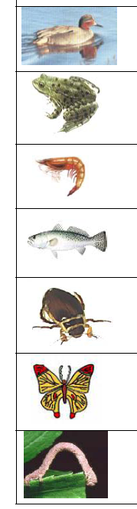 Ducks

Frogs

Shrimps

Trouts

Worms

Butterflies

Cockroaches

- Have you found other living organisms that are not listed above?

Worksheet 3.3

Run the experiments listed below and answer the following question.

Alkalinity
- Fill the test tube with 5ml of water
- Add the tablet (pill) T-2311 in water
- Close and shake the tube. The solution will take a blue-green colour
- Fill the syringe with the solution Alkalinity Titration Reagent B
- Empty the syringe into the test tube
- The solution is starting to get a purple-red colour
- Note the final colour of the solution and find the corresponding measure of alkalinity

Phosphates
- Fill the test tube with water until the indicator 10ml
- Use the pipette to add phosphate Acid (Phosphate Acid Reagent)
- Turn off the tube and shake for 10 seconds
- Use the spoon to add 0.1 grams the substance Phosphate Reducing Reagent
- Close and Shake the tube to dissolve this substance in water
- Wait 5 minutes
- Place the tube in the comparative table (Phosphate Comparator 3122) and note the numerical entry corresponding coloured water

pH
- Fill the test tube with 5ml of water
- Add 5 drops of solution you have been given
- Close and shake the tube
- Wait 30 seconds
- Place the tube in the comparative table and record the value shown in the corresponding colour

Nitrates
- Fill the test tube with 5ml of water
- Add a tablet (pill) NITRATE 1
- Close and shake the tube to dissolve the pill in the water
- Add a tablet (pill) NITRATE 2
- Close and shake the tube to dissolve the pill
- Wait 5 minutes
- Place the tube in the comparative table and Note the number on the corresponding colour
Temperature
- Put the thermometer in the water for 60 seconds
- Record the temperature

The values indicated below represent “accepted” values for the quality of the water in lakes and rivers.
- Alkalinity
Lakes and Rivers: 2 – 10 μg/L
- Phosphates
Lakes: 10 – 15 μg/L
Rivers: 20 – 25 μg/L
- pH
Lakes and Rivers: 6.5 – 8.0
- Nitrates
Lakes: 350 μg/L
Rivers: 250 - 350 μg/L

Is water quality good enough for the living organisms? Explain your answer.

Worksheets for task 4
Worksheet 4.1 – Design your Drinking Water Solution!

You will work in groups of three or four. Your task is to engineer a new, alternative source of drinking water. Be creative, pioneer, but also suggest a feasible idea!

- Draw how your new process or technology will look like. You are encouraged to analyze your proposal and identify input and output parts, and process.

- It is important to analyse your solution from a cost-benefit perspective and also how your solution might harm the environment. You also might want to think how much it will cost to turn the plan into reality and whether the benefits to the public be worth the cost.

………………………………………………………………………………………………...

………………………………………………………………………………………………...

………………………………………………………………………………………………...

………………………………………………………………………………………………...

………………………………………………………………………………………………...

………………………………………………………………………………………………...

………………………………………………………………………………………………...

………………………………………………………………………………………………...

………………………………………………………………………………………………...

………………………………………………………………………………………………...

………………………………………………………………………………………………...

………………………………………………………………………………………………...

Show your calculations here, if needed.

Based on your findings, you have to prepare a 6-8 minute presentation to present your solution to the class for discussion and feedback. Remember that your aim is to convince your classmates that your solution is the best possible!

Desalination
Seawater desalination, a process that removes salt from water, will create an additional source of public supply water and ease some of the stress on traditional water supplies, especially the groundwater aquifers. The most common process of desalination involves using high pressure to force salty water through a semi-permeable membrane into tanks where it separates into clean water and brine (salt) by product. This process is called reverse osmosis. Two traditional drawbacks to desalination have been the high cost of the energy needed to operate the plants and the safe disposal of the plant's highly concentrated brine by-product. Researchers are finding new ways to desalinate water with greater energy efficiency and to dilute the brine and return it safely to the sea so that it doesn't harm marine life.

Aquifer Storage and Recovery
The Aquifer Storage and Recovery (ASR) process involves taking water from a river during periods of high flow, purifying it, and then pumping it into underground aquifers. Researchers have discovered that aquifers can serve as safe and inexpensive water-holding vessels with enormous capacity. The ASR process uses the same pumps and wells that currently draw water out of the ground. Later, during dry periods, it is recovered from the ground water, treated and used for public supply.

Surface Water
Water from rivers provides in many countries million gallons of drinkable water per day. The water is treated and then used for public supply. The use of surface water must be carefully managed to protect natural resources from damage.

Reclaimed Water
Reclaimed water is defined as water having received treatment at least twice in a wastewater treatment plant. Reclaimed water is currently used to water lawns and landscapes (particularly at golf courses and cemeteries), to cool power plants, and to recharge groundwater supplies. Although it is often clean enough to drink, it is kept out of the public water supply.

Storm water
Water that flows across land as a result of rainfall is called stormwater. Once it is collected, stored and treated, it can be used much like reclaimed water. Stormwater also can be made to flow into constructed wetlands where it provides habitat and aesthetic benefits. In many counties, water from rain is collected and storaged in dams. This method is among the core ones used for many years in a number of dry countries and islands in the Mediterranean area.

Conservation
As useful as all of these methods are, nothing tops conservation as a means of preserving water resources. Many countries promote conservation through several programs that teach students and community members ways to save water.
Worksheet 4.2– Build your own desalination plant!
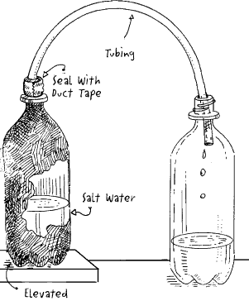
1. In a clear pitcher, mix 1/2 cup of salt in a quart of water.
2. Pour the salt water into the black 1.5 litre bottle.
3. Attach the clear tubing to both 1.5-liter bottles and secure with duct tape. See diagram on reverse.
4. Set both bottles in a sunny window. Place the black bottle higher than the clear bottle.
5. After several days, water will have moved from the black bottle to the clear bottle.
6. In order to show the change in the saltiness of the water without tasting it, try the low-tech egg test. In a bowl of salt water, a raw egg will float; in fresh water, it will sink. Use the egg test before and after the activity to note the change in the water's salinity.

Explain to a classmate that missed today’s experiment how did you manage to get fresh water from a salty water mixture.
………………………………………………………………………………………………...

………………………………………………………………………………………………...

………………………………………………………………………………………………...

………………………………………………………………………………………………...

………………………………………………………………………………………………...

………………………………………………………………………………………………...

Worksheet 4.3 – Desalination in action!
Over the last 50 years in seaside population centres where drinking water is scarce, desalination plants have been built that turn salt water into fresh water.
One way to purify salt water is through a process called distillation. Distillation means heating the water until it boils and turns into steam. The steam is then collected in a separate container. When the steam cools and returns to liquid form, it is pure enough to drink. The problem with this method is that it requires a vast amount of energy to produce small amounts of purified water. The expense of the energy has caused most places to seek alternatives other than saltwater distillation.
In desalination seawater is drawn from the sea through an inlet structure 1-3 kilometres out to sea. The water is gravity fed to the plant. The water entering the tunnel actually flows at a lower rate than the surrounding currents meaning fish and marine life will not be pulled into the inlet structure.
The seawater first passes through a drum screen to remove particles larger than three millimetres. The water is then pre-treated to remove minute suspended solids. A coagulant is added to the water causing the solids to clump together. The water then slowly passes through settlement tanks containing coal and sand, which filter out the solids.
The method used to desalinate water is called reverse osmosis. Though reverse osmosis may sound difficult, the process itself is actually simple. High pressure pushes salt water through a membrane. A membrane is made from material that allows liquid but not solids (like salt) to pass through it. After the water has passed through the membrane, what is left is purified water and a brine by-product (salt). Reverse osmosis is expensive - though cheaper than distillation.
Two traditional drawbacks to desalination include the high cost of the energy needed to operate the plants and the safe disposal of the brine. These factors have made researchers find new ways to desalinate water with greater energy efficiency and to dilute the brine and return it safely to the sea so that it doesn't harm marine life.

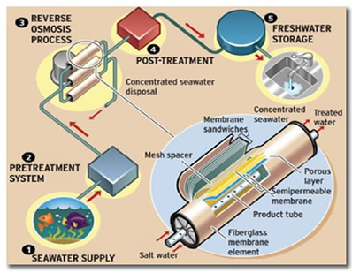
(From http://www.h2oindustries.com.au/desalination.html)

- Which desalination process does your model most closely resemble, distillation or reverse osmosis?

2. Do you believe the benefits of desalination are worth the extra cost?

Worksheets for task 5
Worksheet 5.1

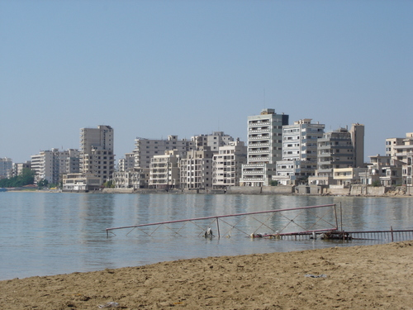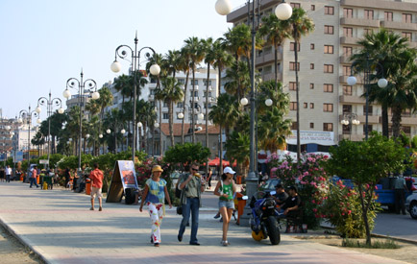

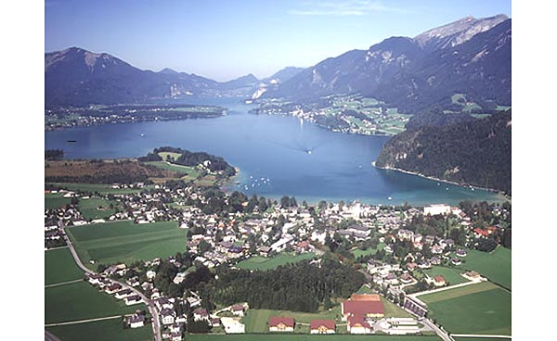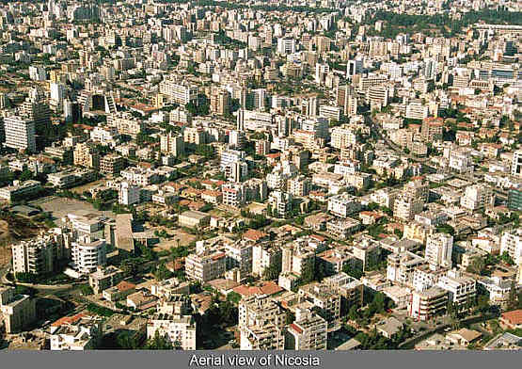
(Photos from City Municipalities’ websites with permission for non-commercial purposes)

Four cities have decided to build one desalination plant to serve in a fair way their needs. Find the optimal location for the plant, and document your solution.

You can use various hypotheses (e.g., cities population and landscape).

You can use Geogebra software for modelling your problem. Geogebra can be freely downloaded from http://www.geogebra.org

- Use the text below to document the assumptions you will use in modelling the problem.

- What is your hypothesis for the optimal place for the desalination plant?

- Use Geogebra to model your problem. Test your hypothesis and use your explorations to support your solution. Try to generalize your results!
{Use the space below to take snapshots from your work in Geogebra’s environment}

- Write a letter, documenting your solution and trying to convince your classmates that your solution is the best possible and can count for all possible city positions.

Worksheets for task 6
Worksheet 6.1
Cypriot officials decided to sign a contract with a nearby country, to import more than 12 million cubic metres over the summer period starting at the end of June. Officials will also sign a contract with a shipping company to use oil tankers for supplying Cyprus with water. The tanker supply program will continue until a permanent solution to the problem will be reached. The water will be pumped directly into the main water supply pipelines with any surplus going to the reservoirs.
Cyprus Water Board needs to decide from which country Cyprus will import water for the next summer period. Using the information provided, assist the Board in making the best possible choice.
Lebanon, Greece, Syria and Egypt expressed their willingness to supply Cyprus with water. Water Board have received information about the water price, how much water they can supply Cyprus with during summer, tanker oil cost and the port facilities. Information is presented below.
Write a letter explaining the method you used to make your decision so that the Board can use your method for selecting the best available option for now, but also for the future when the Board will have to take similar decisions.

Available information is presented below.

Country | Water Supply per week (metric tons) | Water Price  (metric ton) | Tanker Capacity (metric tons) | Tanker  Oil cost  per 100 km | Port Facilities for Tankers
Egypt | 3 000 000 | € 4.00 | 30 000 | € 20 000 | Average
Greece | 4 000 000 | € 2.00 | 50 000 | € 25 000 | Very Good
Lebanon | 2 000 000 | € 5.20 | 30 000 | € 20 000 | Average
Syria | 3 000 000 | € 5.00 | 30 000 | € 20 000 | Good

- Use Google Earth to find major ports in each country and calculate the distance between Lemesos (Cyprus major port) and other countries’ ports.

- Make the necessary calculations to select the best possible place to buy water from. Show your work in the text below, and explain your steps. If you decide to work in a spreadsheet environment, make a screenshot of your work below.

- Write a letter to the Water Management Board, indicating how you solved the problem. Try to document that your solution is the best possible and explicitly document the approach you used to solve the problem.

Worksheets for task 7
Worksheet 7.1

- List your daily activities that are related to water consumption and identify ways to save water.

- List the daily activities of your family and identify ways to save water.

- Using the lists you created in previous questions, try to complete the table below in order to calculate how much water you and your family can save in a year.

Activity | Action | Persons | Water amount saved

4. How much water can you and your family save in one year, if you adopt the attitudes and actions listed above?

